Name : T.Praveen kumar
Reg.No : 192472234
Programming Java
Immutable Factory Collections

Introduction
Java provides factory methods such as List.of() for creating collections easily. These collections are immutable, which means their elements cannot be added, removed, or replaced after creation. If a development team attempts to modify a list created using List.of(), Java throws an UnsupportedOperationException. The problem occurs because the factory-created list does not support modification. To solve the problem, the team must either keep the collection immutable or create a mutable collection such as an ArrayList when modification is required.

Aim
To demonstrate why UnsupportedOperationException occurs when modifying an immutable factory-created list and implement two valid solutions depending on whether mutability is required.

Pseudocode
START
Import List and ArrayList
Create an immutable list using List.of()
Display the immutable list
Attempt to add an element to the immutable list
Catch UnsupportedOperationException
Display the reason for the exception
Create another list using List.of() when immutability is required
Create a mutable ArrayList using the immutable list
Add a new element to the mutable list
Display the modified mutable list
END

Main Code
import java.util.ArrayList;
import java.util.List;
public class ImmutableFactoryCollections {
public static void main(String[] args) {
List<String> immutableList = List.of("Java", "Python", "C++");
System.out.println("Immutable List: " + immutableList);
try {
immutableList.add("JavaScript");
} catch (UnsupportedOperationException e) {
System.out.println("Exception: Cannot modify the List.of() collection.");
}
List<String> fixedImmutableList =
List.of("Java", "Python", "C++");
System.out.println("\nFix 1 - Immutable List: " + fixedImmutableList);
System.out.println("The list is kept unchanged.");
List<String> mutableList =
new ArrayList<>(immutableList);
mutableList.add("JavaScript");
System.out.println("\nFix 2 - Mutable List: " + mutableList);
}
}

Sample Output
Immutable List: [Java, Python, C++]
Exception: Cannot modify the List.of() collection.
Fix 1 - Immutable List: [Java, Python, C++]
The list is kept unchanged.
Fix 2 - Mutable List: [Java, Python, C++, JavaScript]

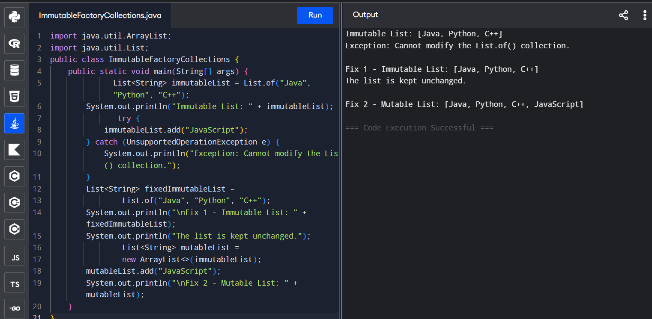

Conclusion
List.of() creates an immutable list, so operations such as add(), remove(), and set() are not supported and can cause UnsupportedOperationException. If the collection should remain unchanged, the immutable factory collection should be used directly. If elements must be added or removed, a mutable collection such as ArrayList should be created from the factory-created list. Therefore, the correct solution depends on whether the application requires immutability or modification.

