Name: T.Praveen Kumar
Reg.No : 192472234
Programming Java
Collection Factory Methods vs Traditional Constructors

Introduction
Java provides collection factory methods such as List.of(), Set.of(), and Map.of() to create collections with concise syntax. Traditional constructors such as new ArrayList<>(), new HashSet<>(), and new HashMap<>() create collections that are generally mutable. Factory-created collections are intended for convenient creation of fixed, unmodifiable collections, while traditional constructors are useful when elements need to be added, removed, or updated.

Aim
To investigate JDK collection factory methods and evaluate their differences from traditional constructors based on syntax, mutability, null handling, and intended use.

Pseudocode
START
Create a list using List.of()
Create a list using new ArrayList<>()
Display both lists
Compare their syntax
Try to modify the List.of() collection
Check the resulting exception
Modify the ArrayList collection
Display the modified collection
Compare null handling
Display the intended use of both approaches
END

Main Code
import java.util.ArrayList;
import java.util.List;
public class CollectionFactoryComparison {
public static void main(String[] args) {
List<String> factoryList = List.of("Java", "Python", "C++");
List<String> constructorList =
new ArrayList<>(List.of("Java", "Python", "C++"));
System.out.println("Factory Method List: " + factoryList);
System.out.println("Constructor List: " + constructorList);
try {
factoryList.add("JavaScript");
} catch (UnsupportedOperationException e) {
System.out.println(
"Factory List: Modification is not allowed."
);
}
constructorList.add("JavaScript");
System.out.println(
"Constructor List after adding: " + constructorList
);
try {
List<String> nullList = List.of("Java", null);
} catch (NullPointerException e) {
System.out.println(
"Factory Method: Null elements are not allowed."
);
}
List<String> nullConstructorList = new ArrayList<>();
nullConstructorList.add("Java");
nullConstructorList.add(null);

System.out.println(
"Constructor List with null: " + nullConstructorList
);
}
}

Sample Output
Factory Method List: [Java, Python, C++]
Constructor List: [Java, Python, C++]
Factory List: Modification is not allowed.
Constructor List after adding: [Java, Python, C++, JavaScript]
Factory Method: Null elements are not allowed.
Constructor List with null: [Java, null]
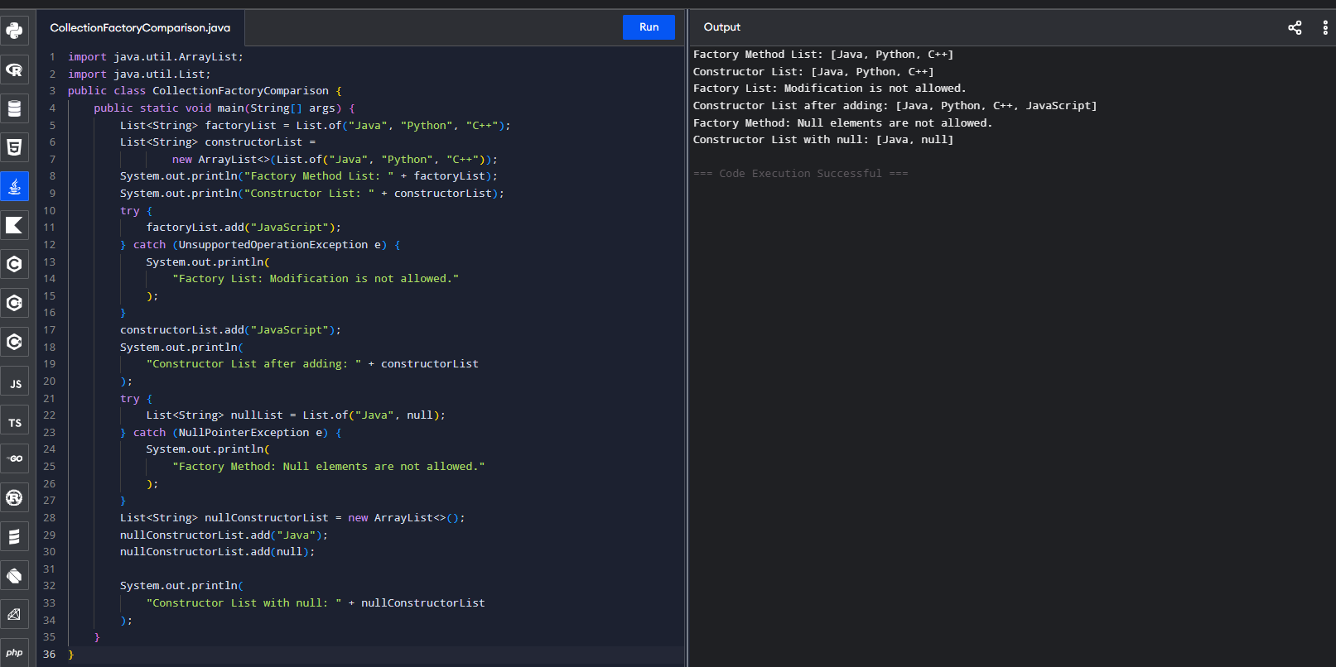

Conclusion
Collection factory methods provide shorter and cleaner syntax for creating unmodifiable collections. Traditional constructors are more suitable when the collection must be modified after creation. Factory methods also reject null elements, whereas ArrayList can contain null values. Therefore, the choice depends on whether the collection is intended to remain fixed or requires modification.

