FLOWGORITHM

- Read a hexadecimal digit as a character (0-9 or A-F) and display its decimal equivalent using a selection structure.

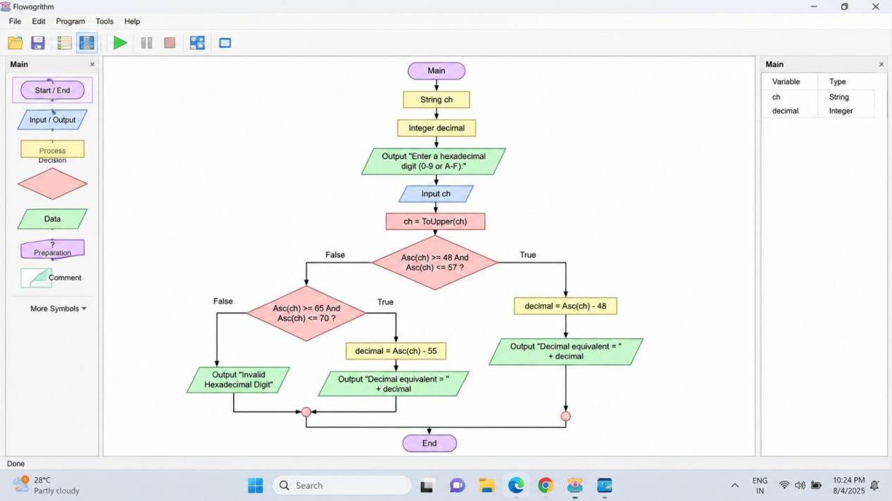

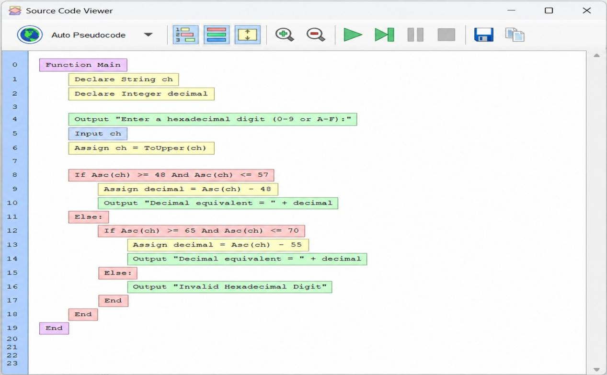

- Read an integer N and display all palindrome numbers from 1 to N.

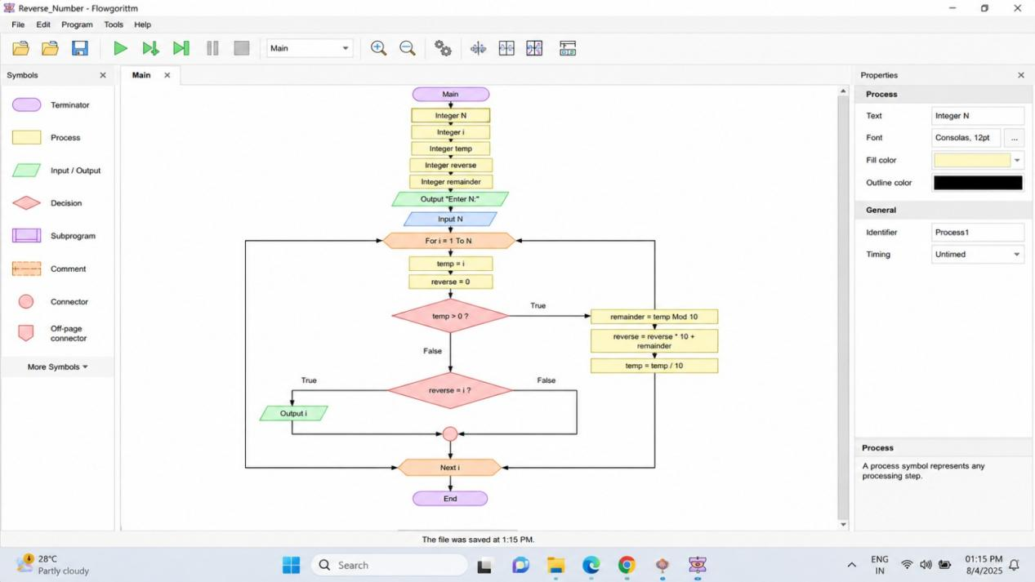

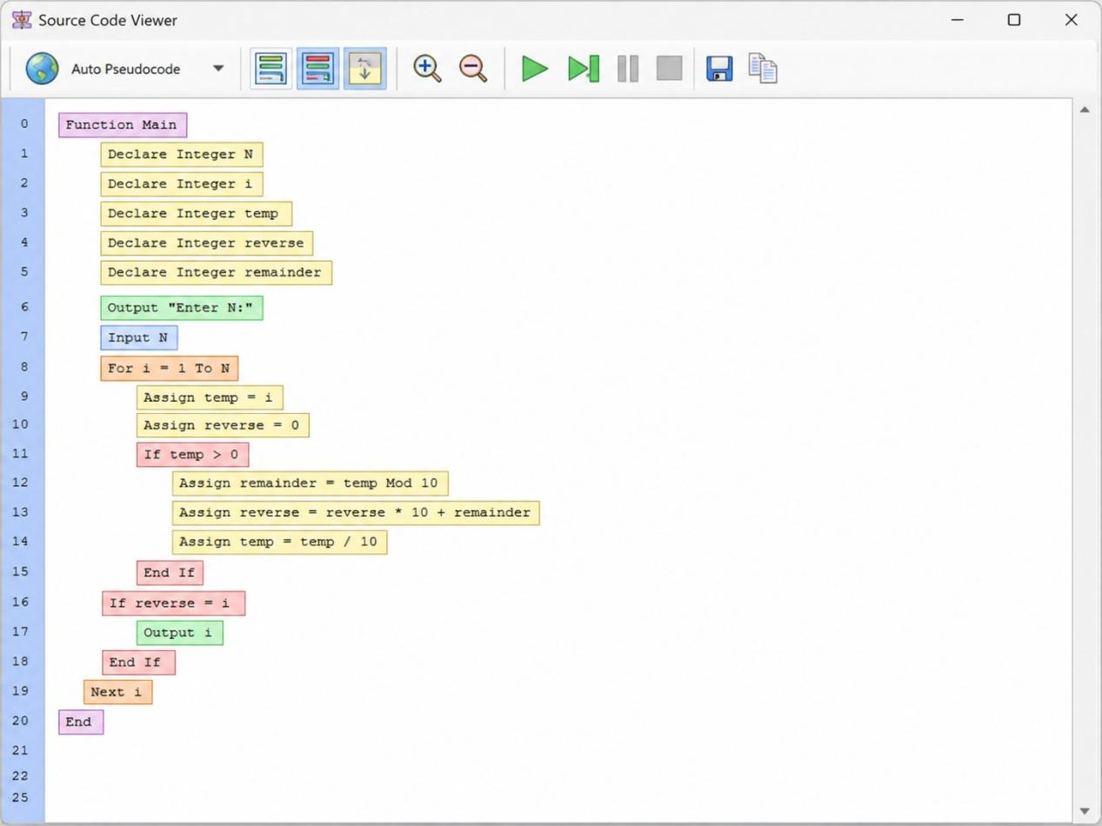

- Create a function calculateBMI and another function bmiCategory. Process the height and weight of several people stored in arrays.

