**Learn Hub – Online Learning Platform using MERN**

**INTRODUCTION**

**Learn Hub** is a full-stack **Online Learning Platform (OLP)** built using the **MERN** stack – MongoDB, Express.js, React.js, and Node.js. This platform is designed to create a dynamic, real-time, and responsive learning environment that enables students to learn effectively, teachers to manage content effortlessly, and admins to oversee and maintain the platform seamlessly.

It replicates the features of widely-used e-learning systems and integrates modern development tools to ensure scalability, flexibility, and a smooth user experience.

**Key Features**

* **User Roles**:
  + **Admin**: Full control over courses, users, and platform operations.
  + **Teacher**: Can create, edit, delete, and manage courses and sections.
  + **Student**: Can browse, enroll, learn at their pace, and get certified.
* **Authentication**:
  + JWT-based secure login.
  + Role-based access control (Admin, Teacher, Student).
* **Course Management**:
  + Teachers can add/update/delete courses and manage sections.
* **Progress Tracking**:
  + Students can resume learning where they left off.
  + Completed modules are tracked and stored.
* **Payments & Certification**:
  + Access to both free and paid courses.
  + Certificates generated after successful completion.
* **Responsive UI**:
  + Built with React, Material UI, Bootstrap, and other modern UI kits.

**Scenario-Based Case Study**

**Scenario: Sarah Learns Web Development**

1. **User Registration**: Sarah signs up using her email and password.
2. **Course Discovery**: She browses available courses, filtering by category.
3. **Enrollment**: She finds a course titled *"Web Development Fundamentals"*, reads its description, and enrolls.
4. **Learning**: Sarah accesses the course modules, watches videos, and does assignments at her own pace.
5. **Interaction**: She participates in live webinars and discussions.
6. **Completion**: Upon finishing, she receives a digital certificate.
7. **Advanced Courses**: She later buys an advanced course using the integrated payment system.
8. **Teacher's Role**: John, a teacher, creates and manages advanced courses.
9. **Admin Role**: Admin manages users, monitors platform activity, and ensures integrity.

**TECHNICAL ARCHITECTURE**

Learn Hub is designed using a **client-server architecture**, with a **React.js frontend** and an **Express.js backend**, connected via **RESTful APIs** using **Axios**.

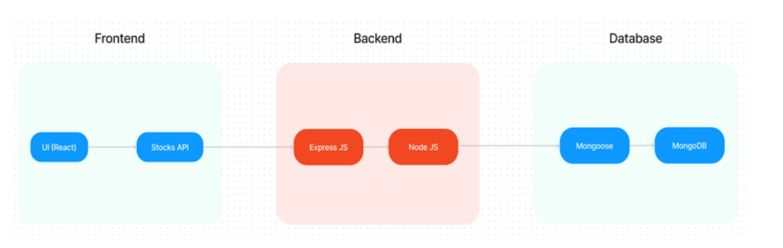

* **Frontend**:
  + React.js (via Vite)
  + Bootstrap, Material UI, Ant Design
  + Axios for API calls
* **Backend**:
  + Node.js + Express.js
  + Mongoose for MongoDB interactions
  + JWT for authentication
  + Multer for file uploads
  + dotenv for environment configuration
* **Database**:
  + MongoDB stores user data, course info, and progress tracking.

This stack enables smooth, real-time interactions and scalable performance.

**ER Diagram**

**Collections:**

**Users**

* _id
* name
* email
* password
* type (Admin/Teacher/Student)

**Courses**

* _id
* userID (references teacher)
* C_title
* C_description
* C_categories
* C_educator
* sections
* C_price
* enrolled

**PRE-REQUISITES**

Before starting development, ensure the following are installed:

**✔ Vite**

npm create vite@latest

**✔ Node.js and npm**

* Download from: <https://nodejs.org/en/download>

**✔ Express.js**

npm install express

**✔ MongoDB**

* Download: [MongoDB Community](https://www.mongodb.com/try/download/community)

**✔ React.js**

* Guide: [React Docs](https://reactjs.org/docs/create-a-new-react-app.html)

**✔ Other Tools:**

* mongoose, jsonwebtoken, bcryptjs, dotenv, multer, cors, nodemon

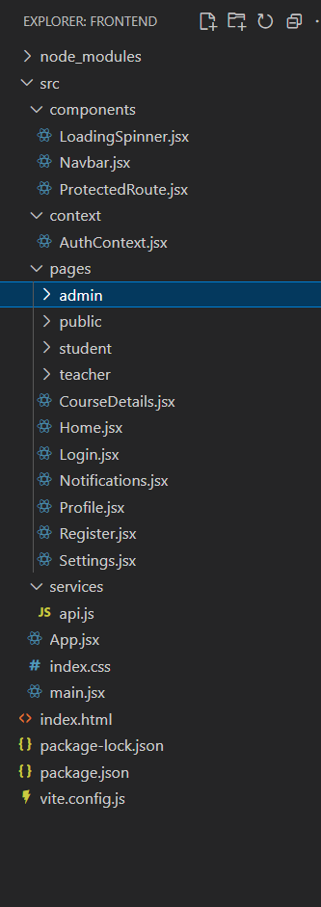**PROJECT STRUCTURE**

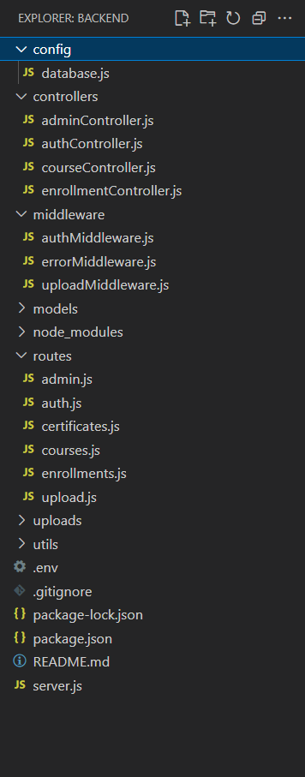

**SETUP INSTRUCTIONS**

**Clone the Repository:**

git clone https://github.com/PRAVEENM282/OLP-Learnhub

**Install Dependencies:**

cd frontend

npm install

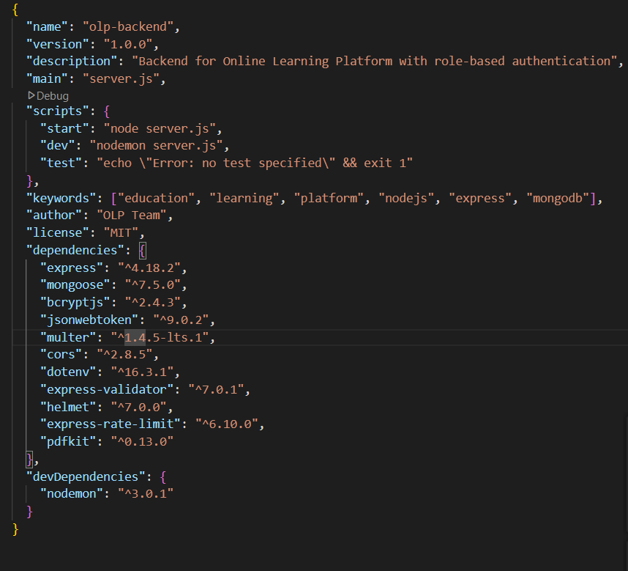cd ../backend

npm install

**Add .env in backend:**

PORT=5000

MONGO_URI=<your-mongodb-uri>

JWT_SECRET=<your-jwt-secret>

**Run Development Servers:**

# In backend/

npm start

# In frontend/

npm run dev

Access frontend at http://localhost:5172

**APPLICATION FLOW**

* **Student**:
  + Register/Login → Browse Courses → Enroll (Free/Paid) → Learn → Get Certificate
* **Teacher**:
  + Create Course → Add Sections → Track Enrollments
* **Admin**:
  + Manage Courses and Users → Monitor All Activity

**MILESTONES**

**📌 Milestone 1 – Setup & Configuration**

* Folder structure for frontend/backend
* Install all dependencies
* Environment setup with .env

**📌 Milestone 2 – Backend Development**

* Setup Express server
* JWT auth via middleware
* Mongoose models for users & courses

**📌 Milestone 3 – Database Integration**

* Connect MongoDB with Mongoose
* Create schemas: User, Course, Enrollment

**📌 Milestone 4 – Frontend Development**

* Build UI with React + MUI + Bootstrap
* 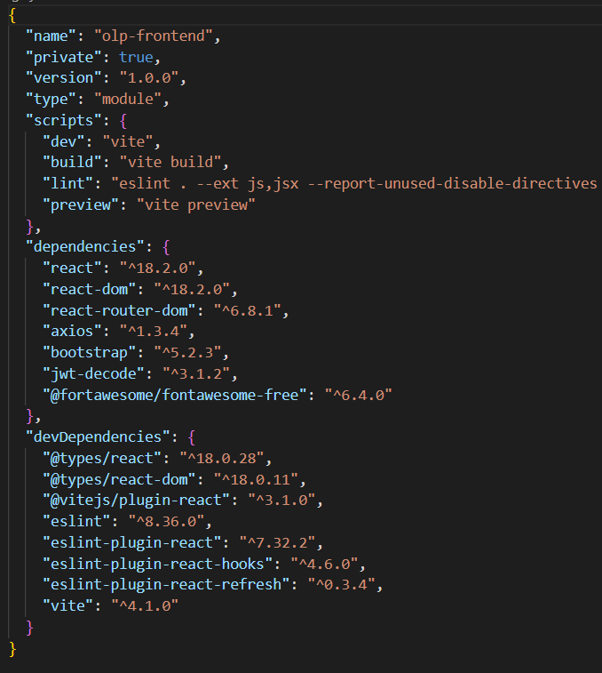Axios integration with backend APIs

**📌 Milestone 5 – Project Implementation**

* Test all user flows (Register → Learn → Certificate)
* Final bug fixes & UI polish

**UI SNAPSHOTS**

* Landing Page

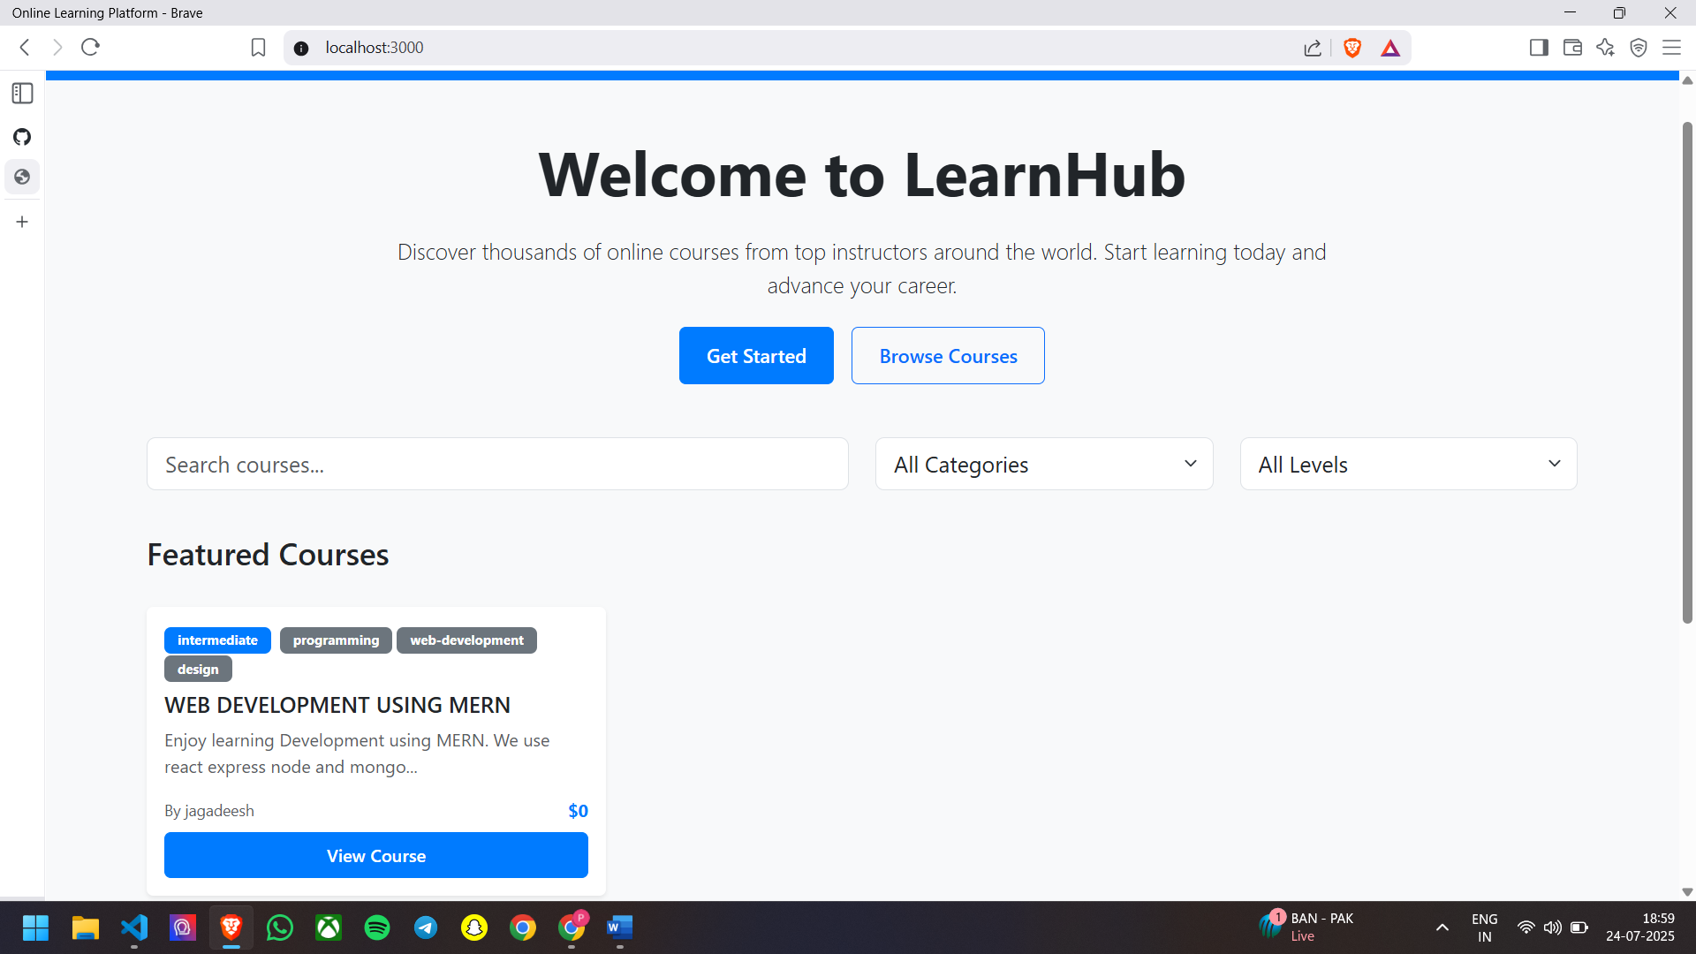

* Register Page

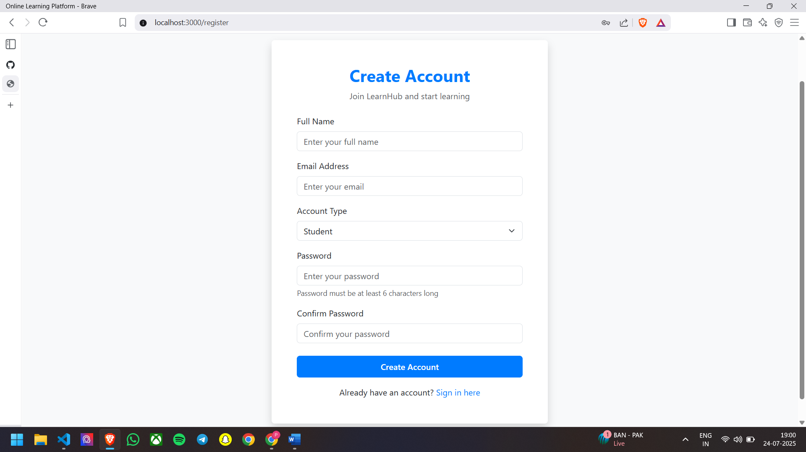

* 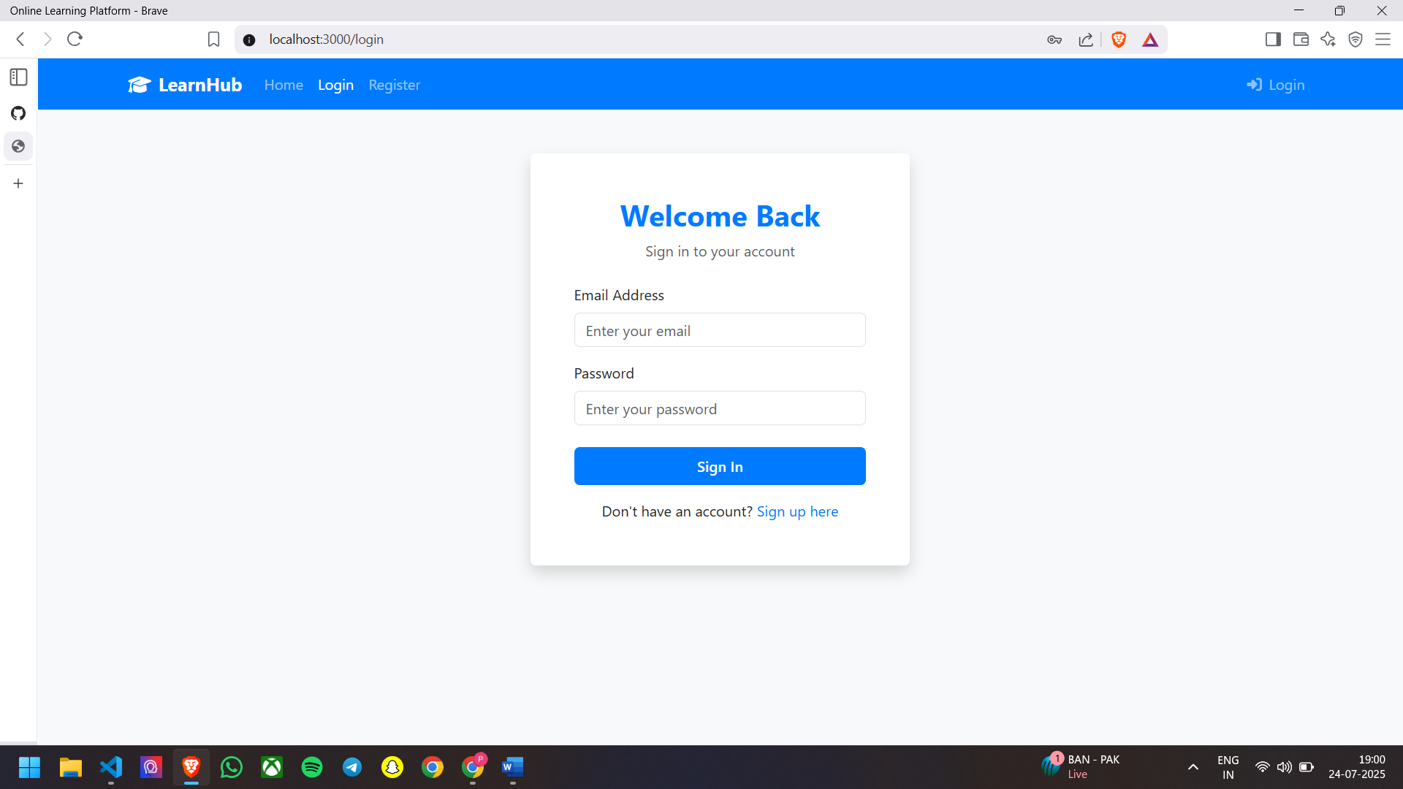Login Page
* 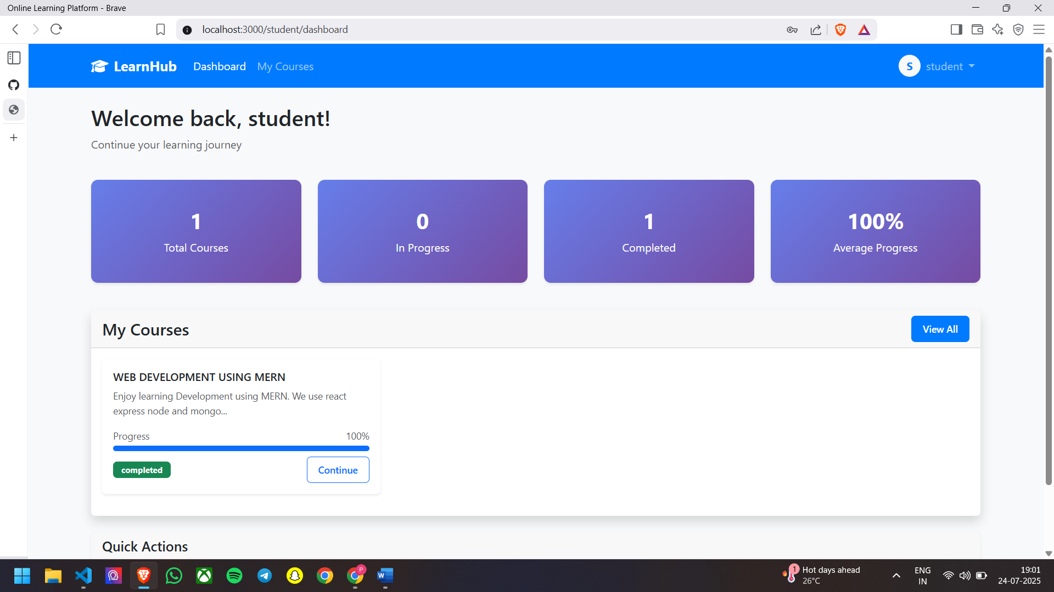Student Dashboard
* 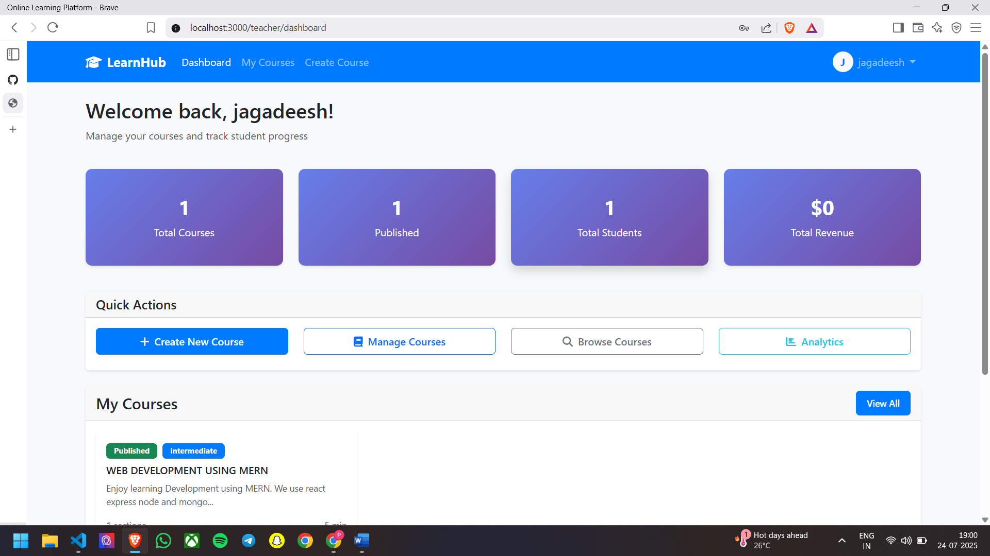Teacher Dashboar
* 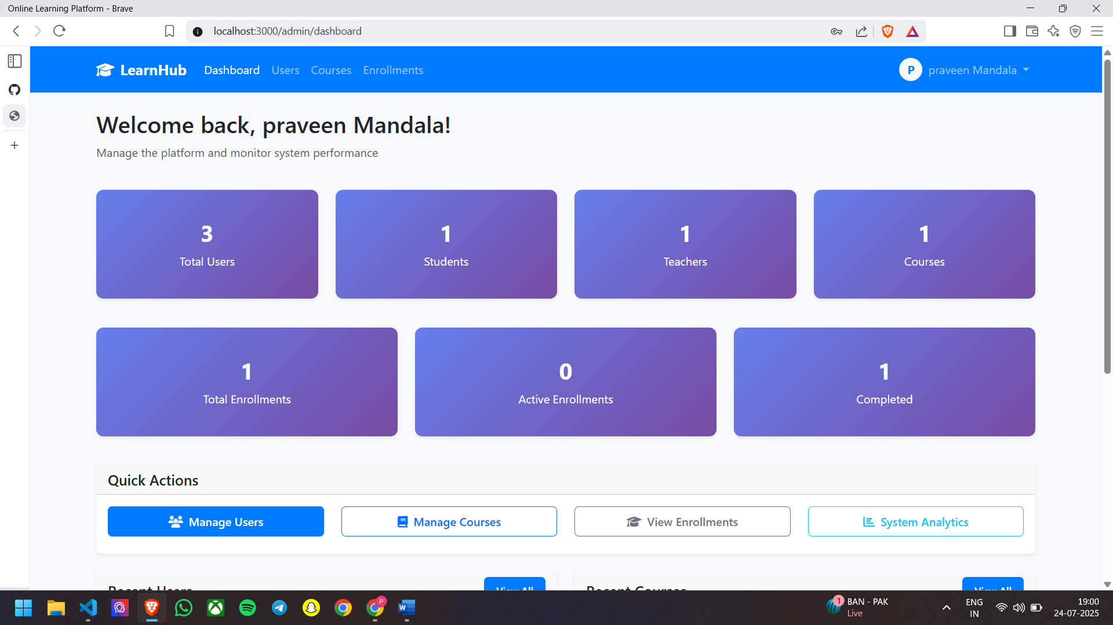Admin Dashboard

**CONCLUSION**

**Learn Hub** provides a robust foundation for building modern, real-time online education systems. With modularity, scalability, and responsiveness at its core, it is suitable for academic institutions, coaching centers, and online educators.

**🔗 GitHub Repository:**

<https://github.com/PRAVEENM282/OLP-Learnhub>

**Video Link :** [**https://drive.google.com/file/d/1dK6hAyP45lbIhOZhY9_rtKgaJ_RtTvxE/view?usp=drive_link**](https://drive.google.com/file/d/1dK6hAyP45lbIhOZhY9_rtKgaJ_RtTvxE/view?usp=drive_link)