Project Report: ML-Powered Service Recommendation System
Developer: PRAVIN KUMAR AC
Date: February 1, 2026
Project Type: Machine Learning / Recommendation Engine

1. Project Overview
The ML Service Recommendation System is an intelligent marketplace engine designed to match users with the most suitable services. By analyzing user-specific preferences such as business type, budget, language, and location, the system uses Machine Learning to provide ranked recommendations.
2. System Architecture
The project follows a modular Machine Learning pipeline:
- Data Ingestion: Loads the service marketplace dataset (CSV).
- Feature Encoding: Categorical data is transformed into numerical vectors using One-Hot Encoding.
- Similarity Engine: The core model uses Cosine Similarity to measure the distance between the user’s requirements and the available services.
- Ranking & Scoring: The system calculates a Match Score (0 to 1) and identifies the "Top 3" highest-scoring services.
- Interactive UI: A front-end built with Streamlit allows users to input data and view results in real-time.
3. Methodology
Feature Engineering
Since the model cannot process text like "E-commerce" or "Remote" directly, we use One-Hot Encoding. This creates a binary vector for each category, allowing the algorithm to perform mathematical comparisons.

Similarity Measurement
We chose Cosine Similarity as our primary algorithm. It measures the cosine of the angle between two non-zero vectors. In this project, it determines how closely a service's features align with a user’s preferences regardless of the scale of the data.
Explainability
To satisfy the requirement for "Explainable Recommendations," the system compares the specific fields of the user input with the recommended service attributes to generate human-readable reasons (e.g., "Matches your budget and location").
4. Visual Proof (Screenshots)
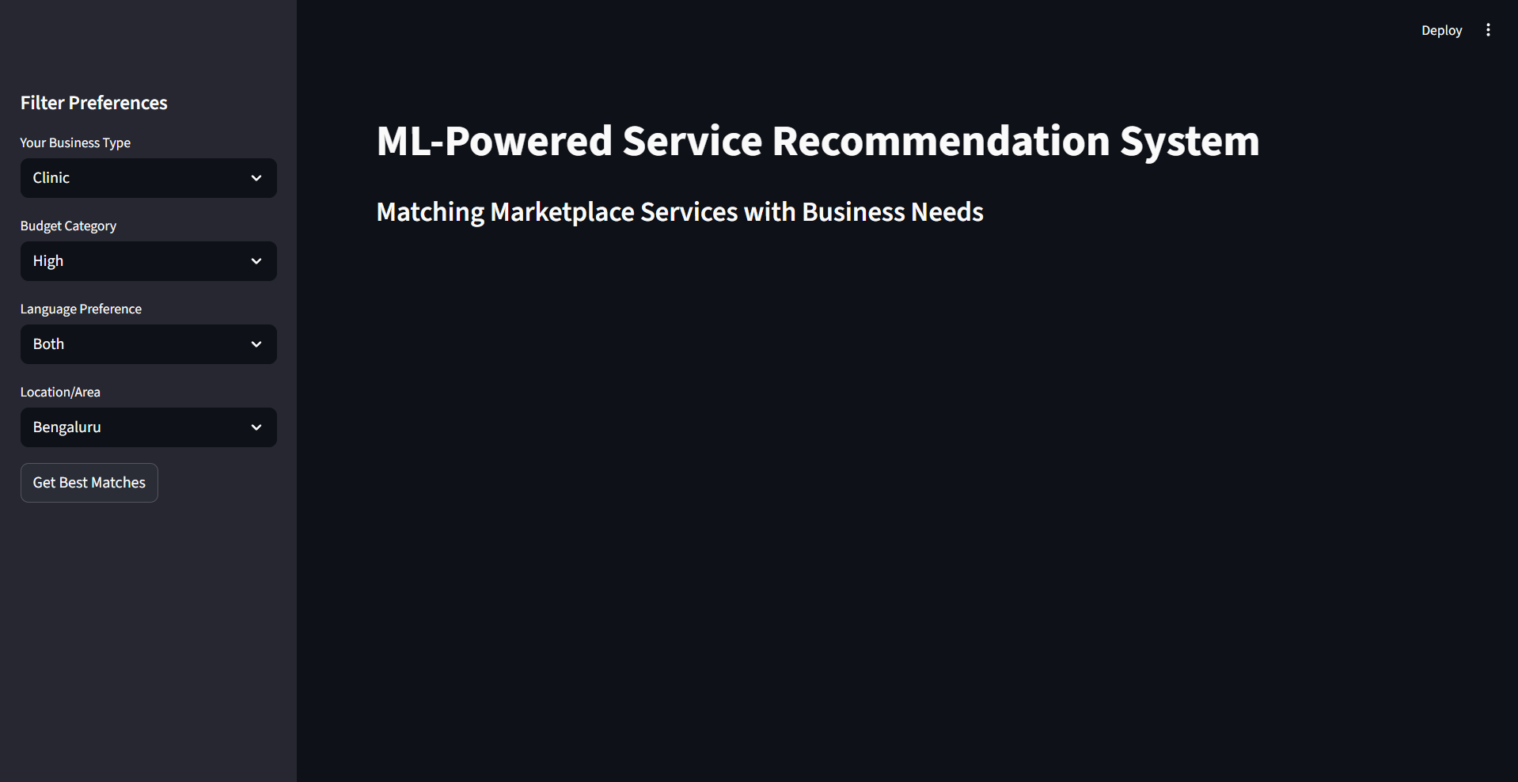Description: This screenshot shows the Streamlit sidebar where the user selects their Business Type, Budget, Language, and Location.
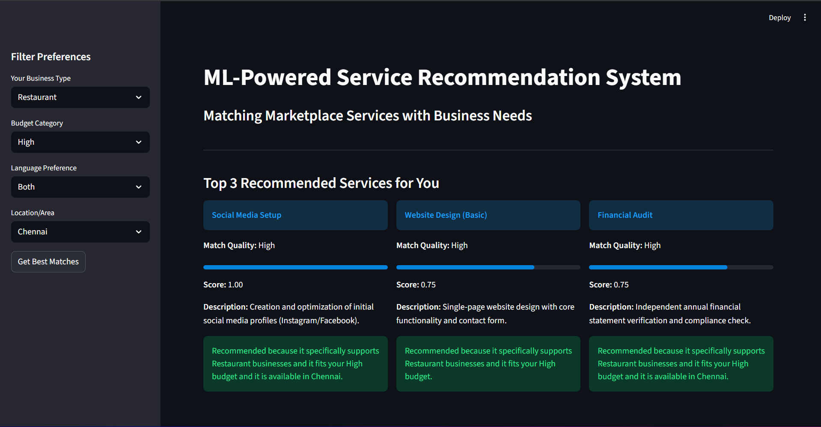 Description: This screenshot shows the "Top 3 Recommended Services" with their Match Scores and the "Match Quality" tag (High/Medium).
5. Implementation Details
- Language: Python 3.x
- Key Libraries: pandas (Data manipulation), scikit-learn (ML Similarity Engine), streamlit (Web Interface).
- Dataset: service_recommendation_data (1).csv (1,000 service records).
6. Access Link
Project Source Files (Google Drive): Access the ML Service Recommendation Ecosystem

