Response Function Library - draft
Paul O’Brien

This document outlines the response function library (rfl), developed to utilize the PRBEM Response Format to perform common calculations, such as the energy and pitch-angle response of a sensor with a given orientation.

The instrument coordinate axes are a right-handed system, s₀, s₁, s₂, with s₀ parallel to particles traveling into the instrument boresight. A polar angle, THETA (θ) measures declination from s₀. An azimuth or longitude angle PHI (φ) measures the angle in the s₁-s₂ plane from s₁ to s₂. Rotations between instrument coordinates and magnetic field coordinates (pitch angle α and gyrophase β) will be performed with attitude information provided in the Level 1 files. Polar angles α, θ range from 0 to 180º, while φ and β range from 0 to 360º. The instrument coordinates are given in the Level 1 file as S0_LAT, S0_LON, S1_LAT, S1_LON, S2_LAT, S2_LON.

These quantities define the response function R below:
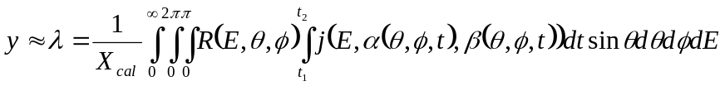
When energy and angular response are separable, we have:
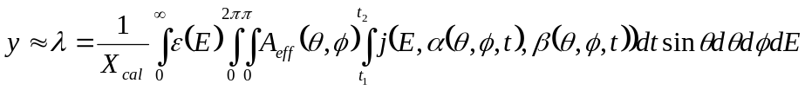
We usually wish to compute weights h_{ijk}, such that the integral can be replaced by a sum:
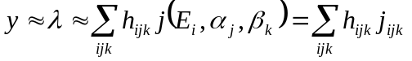
This is particularly helpful for inversion and data assimilation.

Manipulations to define h_{ijk} explicitly:
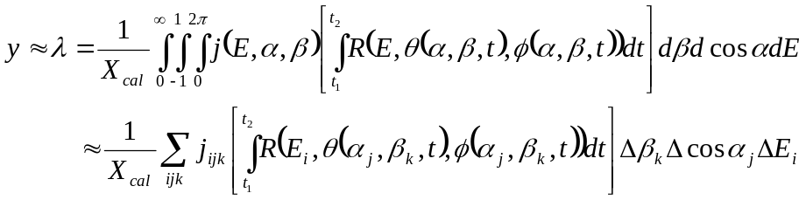

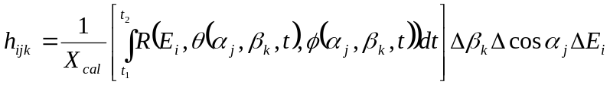
When we assume gyrotropy, i.e., j(E,α), we have:
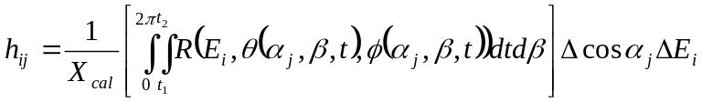
When we also assume bounce symmetry, i.e., j(E,α) = j(E,π-α), our α grid is limited to [0,π/2], and we have:

We will need conversions between magnetic angles (α,β) and instrument angles (θ,φ). Basis vectors for the magnetic coordinate systems are (c,d,b), where b is the magnetic field direction, c defines the direction for β=0, and d completes the right-handed system. Basis vectors for the instrument coordinates are (s₁,s₂,s₀), defined above. Arbitrary vectors in the two frames are given by:
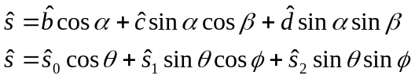
The normal incidence direction s₀ has pitch angle α₀ and gyrophase β₀, while the magnetic field has colatitudes α₀ and longitude φ_{b} in the instrument frame:
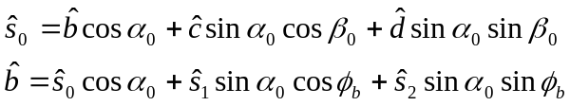
The figure below illustrates the case for β₀=0. Note that for α₀=0, β₀=0, φ_{b}=0, the s₀ axis is parallel to the b axis, the s₁ axis is anti-parallel to the c axis, and the s₂ axis is anti-parallel to the d axis. This anti-parallel topology arises from the choice of having s₀ in the first octant of the c-d-b coordinates, and b in the first octant of the s₁-s₂-s₀ coordinates. Also note that b-c-d coordinates are equivalent to c-d-b coordinates, and s₀-s₁-s₂ coordinates are equivalent to s₁-s₂-s₀ coordinates, but we have followed the convention of having the polar axis as the third coordinate.
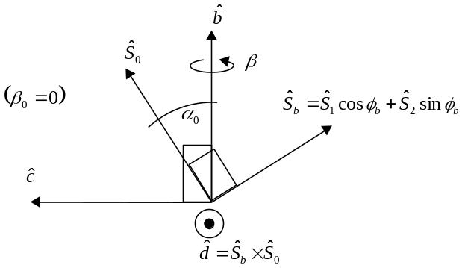

The two coordinate systems are related to each other by a set of Euler rotations: First, a rotation of π-β₀ around the s₀ axis, the α₀ around the s₁ axis, and finally φ_{b} around the s₀ axis.
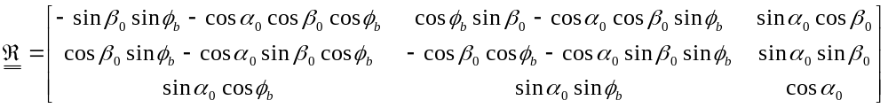
The matrix 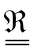 provides a rotation from the instrument basis to the magnetic basis, while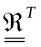does the reverse. The coordinate frames are aligned, and is the identity matrix, when α₀=0, β₀=π, φ_{b}=0.

The transform from α,β to θ,φ coordinates is:
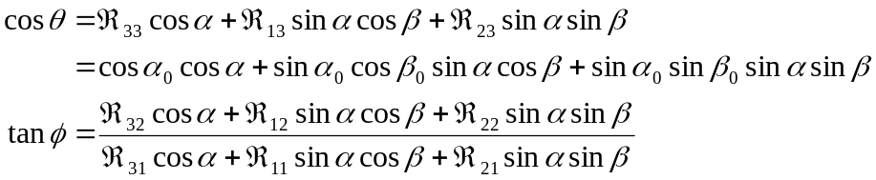

The transform from θ,φ to α,β coordinates is:
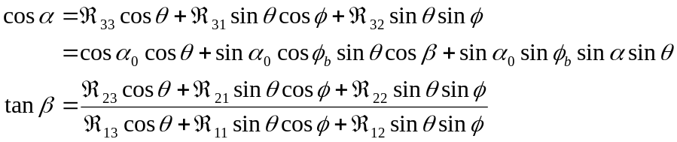
Implementation notes:

- The angles φ and β should be computed with a 4-quadrant arctangent function (“atan2” in most languages).
- Where R contains any delta functions or discontinuities, analytical formulas for integration/interpolation to h_{ijk} must be used to ensure that Σ h_{ijk} preserves the implied (or supplied) energy-geometric factor.

List of Functions

The routines below loosely define the functional interface for the response function library. The routines are structured wherever possible to support implementation with object-oriented programming. The library provides routines to populate the numerical integrations weights for Cartesian grids in energy and angle. The angle can be specified either in instrument coordinates (theta, phi) or magnetic coordinates (alpha, beta). The two coordinate frames are related to each other by the angles alpha0, phib, which can be computed given the first two instrument axes and the magnetic field vector in a common coordinate system. The weights returned can be used in a single, double, or triple sum, depending on the assumed geometry. The following hierarchy shows how to compose weights for 3-D, 2-D, or 1-D integrals.(Whenever possible, the sums below should be replaced by integrals to allow for analytical expressions and high-precision integrals where desired).

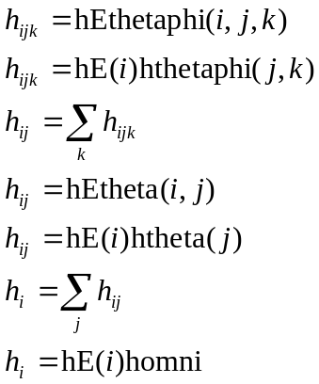(update)
Options allows user to specify numerical integration method: e.g., plateau or trapezoidal rule. (Note: if using trapezoidal rule beta and phi grids should include both 0 and 360 if integrating over all beta or phi, and time list should include both endpoints). A geometry mismatch (e.g., calling a routine for cylindrically symmetric geometries with an instrument that has rectangular geometry) will cause undefined outputs and the return of an error result code. The syntax below should be adapted to each language in which it is implemented.

- [inst_info,result_code] = load_inst_info(FileName,FileType); Populates an inst_info object from file FileName. Supported file types are .cdf, .hd5, .xml (and native, e.g., .mat)
- [alpha0,beta0,phib,result_code] = rfl_vectors_to_euler_angles(B,C,S0,S1); Compute pitch angle (alpha0) and gyrophase angle (beta0) of boresight and longitude of B (phib), the Euler angles of the Euler rotations for converting between instrument coordinates and magnetic coordinates. All four inputs are 3-vectors in some common Cartesian coordinate system (e.g., Cartesian GEI). B is parallel to the magnetic field, C defines the B-C plane, in which beta=0. S0 points into the instrument, parallel to normally incident particles. S1 defines the S0-S1 plane in which phi=0. Vectors need not have unit length, and neither B-C nor S0-S1 need to be orthogonal.
- [alpha0,beta0,phib,result_code] = rfl_latlon_to_euler_angles(Blat,Blon,Clat,Clon,S0lat,S0lon,S1lat,S1lon); Same as vectors_to_euler_angles, except B,C, S0, S1 specified by angle pairs. All three angle pairs are degrees latitude and longitude in some common spherical coordinate system (e.g., spherical GEO).
- [theta,phi,result_code] = alphabeta2thetaphi(alpha,beta,alpha0,beta0,phib); Convert pitch angle and gyrophase to instrument angles. When theta=0, phi=0.
- [alpha,beta,result_code] = thetaphi2alphabeta(theta,phi,alpha0,beta0,phib); Convert instrument angles to pitch angle and gyrophase. When alpha=0, beta=0

In a class/object model, the following functions are the required methods for each class
- [hEalphabeta,result_code] = make_hEalphabeta(inst_info,Egrid,alphagrid,betagrid,t,alpha0,beta0,phib,options); Compute weights for triple numerical integral over E, alpha, beta, assuming no symmetries (NEW PARAMETERS)
- [hEalpha,result_code] = make_hEalpha(inst_info,Egrid,alphagrid,t,alpha0,options); Compute weights for double numerical integral over E, alpha, assuming gyrotropy (NEW)
- [hE,result_code] = make_hEiso(inst_info,Egrid,t,options); Compute weights for numerical integral over energy, assuming isotropy (RENAMED)
- A make_hEthetaphi function might still be useful. It’s not so clear that a make_hEtheta function would be useful.
- It would probably also be good to provide R(E,theta,phi), e.g., for plotting rather than integrating. If E/theta/phi are not the same size, then some attempt can be made to use ndgrid to make a 3-D grid on which to evaluate R.

Need to remove old matlab routines. Need to explain how to deal with h(E,alpha,beta) when we also have j(E,U,V) and U(E,alpha,beta) and V(E,alpha,beta) (e.g., U = K, V = Phi, or V = h_min)

Still need to specify formulae for A for disk, slab, cylindrical telescope, and rectangular telescope. Also, need formulae for trapezoidal and plateau weights

The table below provides the main expressions needed to compute weights for the various integrals using a trapezoidal rule (although most expressions are invariant to the choice of numerical integration technique).

Sensor Type | Integral for λ | Weights
Energy-Angle Codependent
Arbitrary geometry | 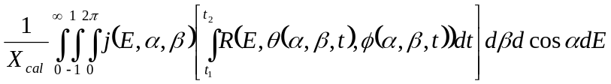 | 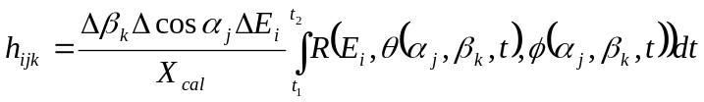
Arbitrary geometry | 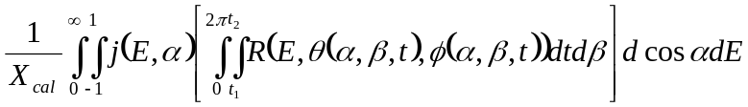 | 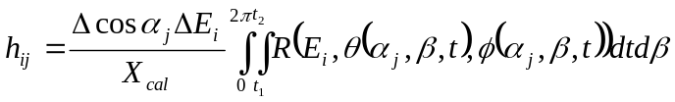
Arbitrary geometry | 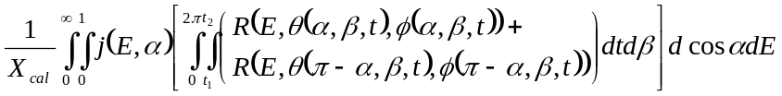 | 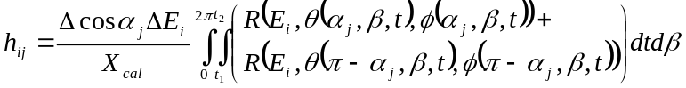
Arbitrary geometry | 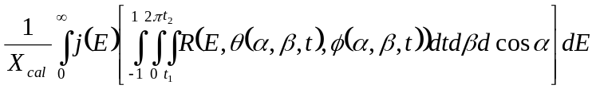 | 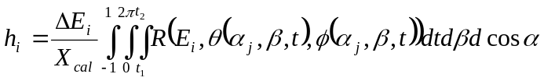
Cylindrically symmetric | 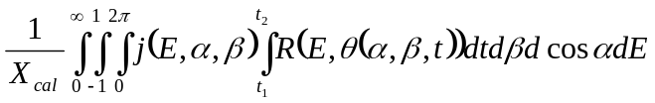 | 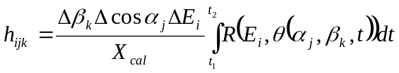
Cylindrically symmetric | 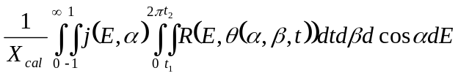 | 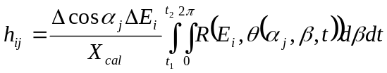
Cylindrically symmetric | 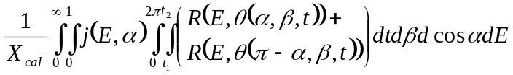 | 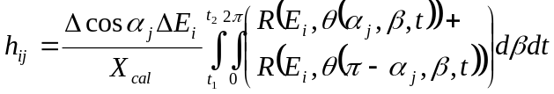
Cylindrically symmetric | 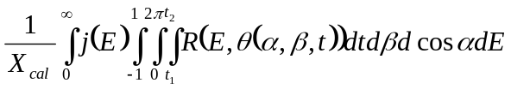 | 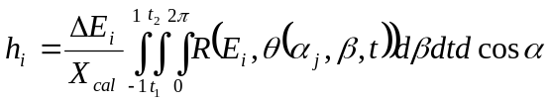
Angular Response (see notes)
Arbitrary geometry | 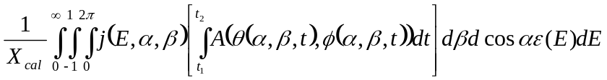 | 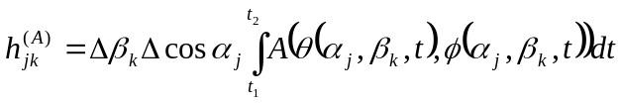
Arbitrary geometry | 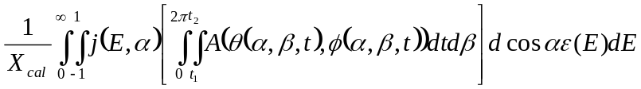 | 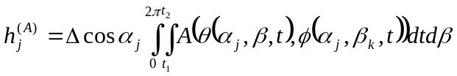
Arbitrary geometry | 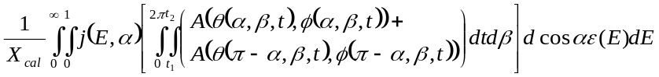 | 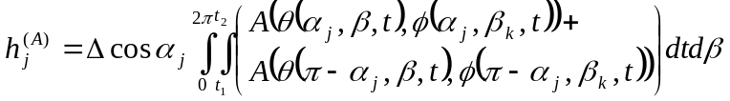
Arbitrary geometry | 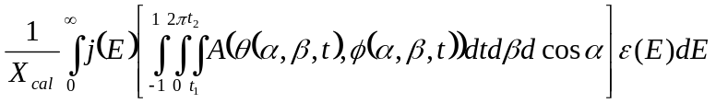 | 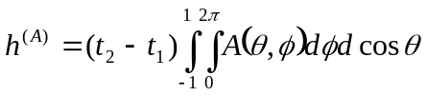
Cylindrically symmetric | 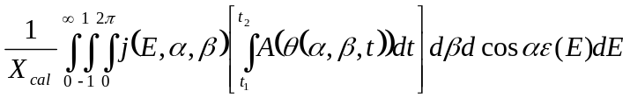 | 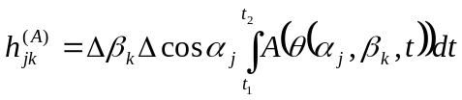
Cylindrically symmetric | 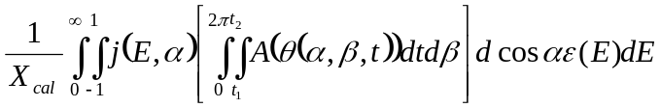 | 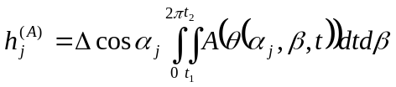
Cylindrically symmetric | 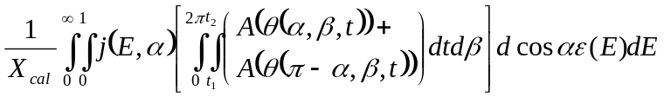 | 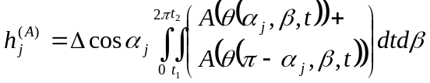
Cylindrically symmetric | 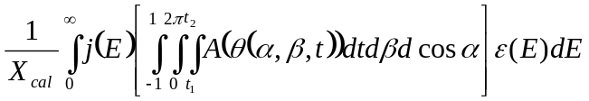 | 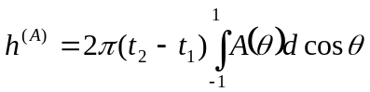
Omni, bidirectional (true omni) | 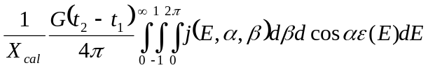 | 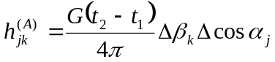
Omni, bidirectional (true omni) | 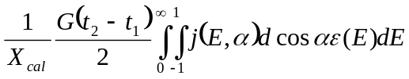 | 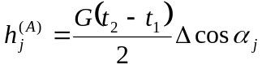
Omni, bidirectional (true omni) | 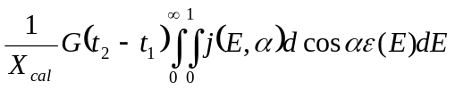 | 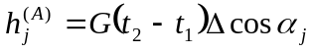
Omni, bidirectional (true omni) | 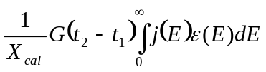 | 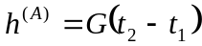
Omni, non-bidirectional (half omni) | 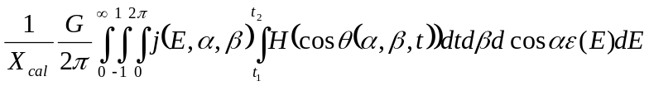 | 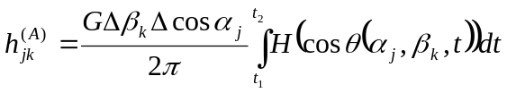 (see note 2)
Omni, non-bidirectional (half omni) | 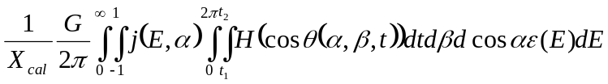 | 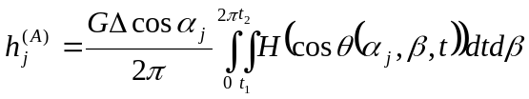
Omni, non-bidirectional (half omni) | 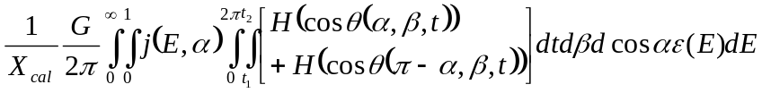
Omni, non-bidirectional (half omni) | 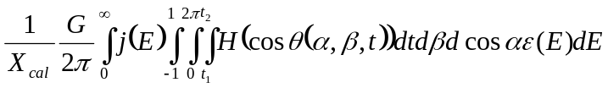
Pinhole | 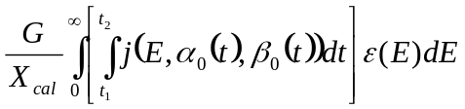 | 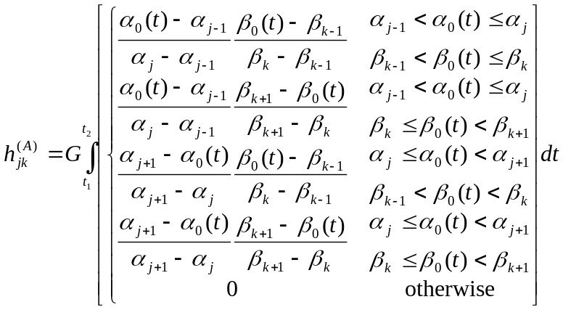
Pinhole | 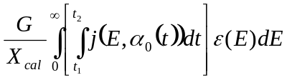 | 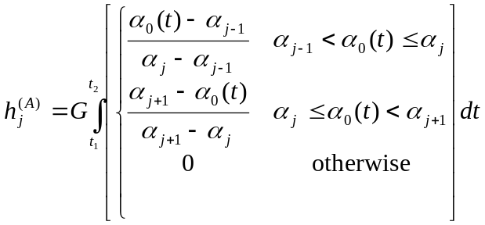 (see note 3)
Pinhole | 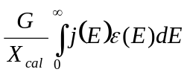 | 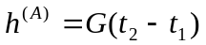
Energy Response (see notes)
(Narrow) differential channel | 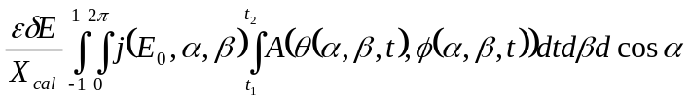 | 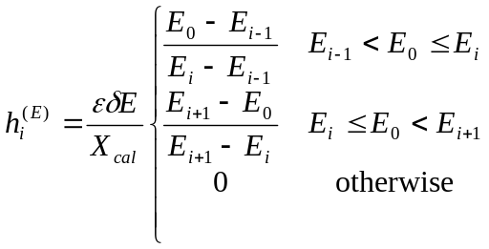
(Narrow) differential channel | 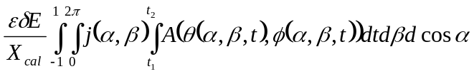 | 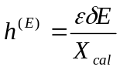
Wide (differential) channel | 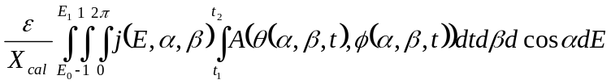 | 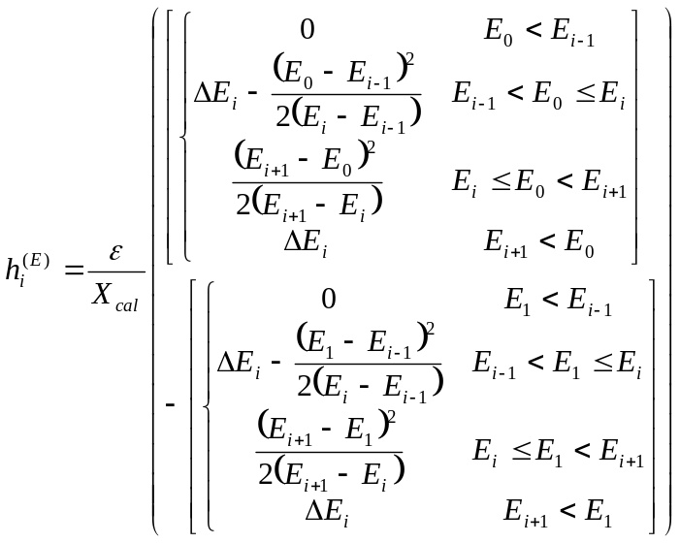
Wide (differential) channel | 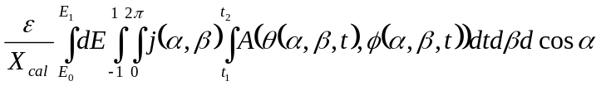 | 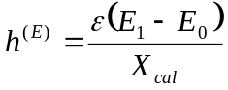
Integral channel | 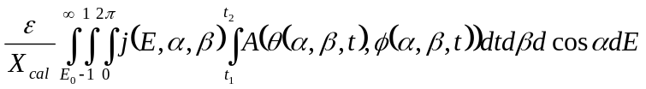 | 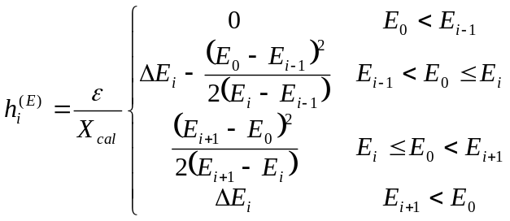
Integral channel | 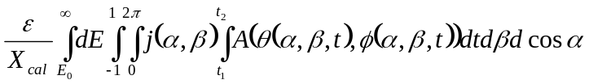 | 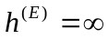
*Notes:
- For separable energy/angle response, we define 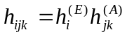, or 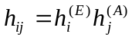 in the gyrotropic case. X_{cal} goes into the Energy weights, and time goes into the angular weights.
- H(x) is the Heaviside step function, with value 0 for x<0 and 1 for x≥1.
- For the pinhole case, with the gyrotropic assumption, the acute boresight pitch angle (α₀) should be used, i.e., min(α₀,π-α₀).

