**PERT分析**

杨溢

31601372

2018-12-12

#### REQUIREMENT 3: PERT as a method to schedule the Project

1. *Develop a PERT Activity on Node diagram for the project (This diagram must specify the critical path and duration of the CP,*

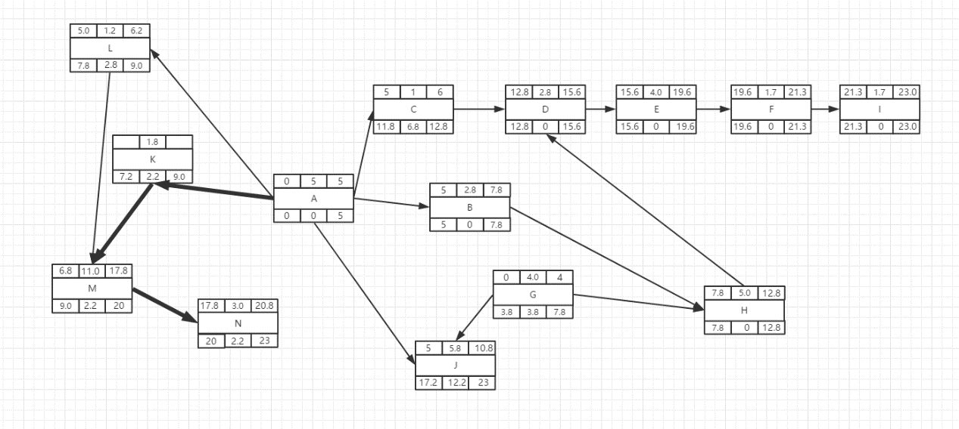

途中加粗为关键路径。

持续时间是23天

1. *Construct a table which identifies: Activity, duration, Early Start, Early Finish, Late Start, Late Finish, and Slack (Float), and Activity Standard Deviation (round to 1 decimal place),*

|  |  |  |  |  |  |  |  |
| --- | --- | --- | --- | --- | --- | --- | --- |
| **活动** | **期望的持续时间（t）** | **早开始** | **早完成** | **迟开始** | **迟完成** | **浮动时间** | **标准偏差（s）** |
| A | 5 | 0 | 5 | 0 | 5 | 0 | 0.3 |
| B | 2.8 | 5 | 7.8 | 5 | 7.8 | 0 | 1.2 |
| C | 1 | 5 | 6 | 11.2 | 12.8 | 6.8 | 0 |
| D | 2.8 | 12.8 | 15.6 | 12.8 | 15.6 | 0 | 1.2 |
| E | 4 | 15.6 | 19.6 | 15.6 | 19.6 | 0 | 1 |
| F | 1.7 | 19.6 | 21.3 | 19.6 | 21.3 | 0 | 0.7 |
| G | 4 | 0 | 4 | 3.8 | 7.8 | 3.8 | 0.3 |
| H | 5 | 7.8 | 12.8 | 7.8 | 12.8 | 0 | 1.3 |
| I | 1.7 | 21.3 | 23 | 21.3 | 23 | 0 | 0.7 |
| J | 5.8 | 5 | 10.8 | 17.2 | 23 | 12.2 | 0.5 |
| K | 1.8 | 5 | 6.8 | 7.2 | 9 | 2.2 | 0.2 |
| L | 1.2 | 5 | 6.2 | 7.8 | 9 | 2.8 | 0.2 |
| M | 11 | 6.8 | 17.8 | 9 | 20 | 2.2 | 0.3 |
| N | 3 | 17.8 | 20.8 | 20.0 | 23.0 | 2.2 | 0.3 |

1. *What can you conclude about the project duration from analysis of the PERT network diagram?,*

大项目的工期估算和进度控制非常复杂，需要将CPM和PERT结合使用，用CPM求出关键路径，再对关键路径上的各个活动用PERT估算完成期望和方差，最后得出项目在某一时间段内完成的概率。

任何项目都有不可压缩的最小周期。

*(d) What are the primary concerns that a PM must consider in using PERT for project scheduling?*

标识出项目的关键路径，以明确项目活动的重点，便于优化对项目活动的[资源分配](http://wiki.mbalib.com/wiki/%E8%B5%84%E6%BA%90%E5%88%86%E9%85%8D)。

若想缩短项目完成时间，节省成本时，就要把考虑的重点放在关键路径上。

在[资源分配](http://wiki.mbalib.com/wiki/%E8%B5%84%E6%BA%90%E5%88%86%E9%85%8D)发生矛盾时，可适当调动非关键路径上活动的资源去支持关键路径上的活动，以最有效地保证项目的完成进度。