**PREDICTIVE MODELING FOR CHRONIC DISEASE RISK ASSESSMENT ON KIDNEY FAILURE , HEART STROKE AND DIABETES**

**A MINI PROJECT REPORT**

***Submitted by***

**PREETHI B 212221220040**

***in partial fulfillment for the award of the degree***

***of***

**BACHELOR OF TECHNOLOGY**

**IN**

**INFORMATION TECHNOLOGY**

# **SAVEETHA ENGINEERING COLLEGE, KANCHEEPURAM**

# **ANNA UNIVERSITY : CHENNAI 600 025**

**DEC 2023**

# **ANNA UNIVERSITY: CHENNAI 600 025**

**BONAFIDE CERTIFICATE**

Certified that this report **“PREDICTIVE MODELING FOR CHRONIC DISEASE RISK ASSESSMENT ON KIDNEY FAILURE , HEART STROKE AND DIABETES”** is the bonafied work of **“PREETHI B (212221220040)”** who carried out the project work under our supervision.

|  |  |
| --- | --- |
| **Dr. K. SureshKumar MTech., Ph. D**  **Head of the Department**  Professor,  Department of Information Technology,  Saveetha Engineering College,  Saveetha Nagar, Thandalam  Chennai-602105 | **Dr. K. SureshKumar MTech., Ph. D**  **Head of the Department**  Professor,  Department of Information Technology,  Saveetha Engineering College,  Saveetha Nagar, Thandalam  Chennai-602105 |

Submitted for VIVA-VOCE held on **………………**

**INTERNAL EXAMINER EXTERNAL EXAMINER**

**ABSTRACT**

In the Chronic diseases like kidney failure, diabetes, and heart stroke impose a substantial burden on global healthcare systems and individual well-being. Early identification and prediction of these ailments are pivotal for effective preventive measures and personalized healthcare interventions. This abstract presents an overview of predictive modeling techniques utilized for forecasting the onset and progression of kidney failure, diabetes, and heart stroke.In recent years, machine learning and data-driven approaches have emerged as valuable tools in analyzing vast datasets comprising patient demographics, genetic predispositions, lifestyle factors, and clinical indicators. By employing algorithms like logistic regression, decision trees, random forests, support vector machines, and deep learning methodologies, researchers have made significant strides in predicting the likelihood of individuals developing these chronic conditions.Specifically, for kidney failure, predictive models leverage factors such as estimated glomerular filtration rate (eGFR), proteinuria, blood pressure, diabetes status, and demographic information to forecast the risk of renal dysfunction. Similarly, in diabetes, machine learning algorithms utilize blood glucose levels, HbA1c measurements, BMI, familial history, and lifestyle patterns to predict the likelihood of diabetes onset and progression to complications.

Keywords : Data analysis- Machine learning –Healthcare technology- Early identification

**ACKNOWLEDGEMENT**

I wish to express my gratitude to our Founder President **Dr. N.M. Veeraiyan**, Director **Dr. S. Rajesh,** Saveetha Engineering College, for their guidance and blessings.

I am very grateful to our Principal **Dr. N. Duraipandian M.E., Ph.D.,** for providing me with an environment to complete my project successfully.

I am indebted to our Head of the Department**, Dr. K. Suresh Kumar, MTech., Ph.D., for** his support during the entire course of this project work.

I am indebted to the supervisor **Dr R.N. Karthika, MTech., Ph.D.,** for assisting me in the completion of my project with her exemplary Guidance and for her support during the entire course of this project.

My heartfelt thanks to the project coordinator **Dr S. Vidhya MTech., Ph.D.,** Department of Information Technology, Saveetha Engineering College, for unstinted support throughout this project.

I also thank all the reviewers from the SCOFT team and our faculty members of our department for their help in making this project successful.

**TABLE OF CONTENTS**

**CHAPTER NO. TITLE PAGE NO.**

**ABSTRACT iii**

**LIST OF TABLES v**

**LIST OF FIGURES vii**

**LIST OF ABBREVIATIONS viii**

**1 INTRODUCTION 1**

1.1 1.1 OVERVIEW OF PREDICTIVE MODEL

SYSTEM 1

1.2 BEHAVIOR OF IDE 3

1.3 PROBLEM STATEMENT 4

1.4 OBJECTIVES 5

1.5 MAJOR CONTRIBUTION OF THE MINI 6

PROJECT

1.6 ORGANIZATION OF THE MINI PROJECT 7

**2 LITERATURE SURVEY**  **9**

2.1 OVERVIEW 9

2.2 LITERATURE SURVEY 10

**CHAPTER NO. TITLE PAGE NO.**

**3 PREDICTIVE MODELING FOR CHRONIC 15**

**DISEASE**

3.1 METHODOLOGY 15

3.2 PROPOSED SYSTEM 16

3.3 SYSTEM ARCHITECTURE 17

3.4 SEQUENCE DIAGRAM 19

3.4 ALGORITHM 21

3.5 EVALUTION MATRIX 22

3.6 COMPARISON OF MODELS 24

**3 CONCLUSION AND FUTURE WORK 25**

4.1 CONCLUSION 25

4.2 FUTURE WORK 25

4.2.1 IMPROVEMENTS 25

4.2.2 COLLABORATION WITH GENERATIVE MI 28

**REFERENCES 29**

**LIST OF FIGURES**

**FIGURE NO. TITLE PAGE NO.**

* 1. PROPOSED INTRUSION

DETECTION SYSTEM TYPES 2

* 1. PROPOSED MODEL

DETECTION SYSTEM 17

* 1. PROPOSED SEQUENCE OFCHRONIC DIEASES 19

* 1. CONFUSION MATRICS OF PRECISION

AND RECALL 22

* 1. COMPARISON OF TRAIN AND TEST

SCORE 23

* 1. ACCURACY COMPARISON OF CHRONIC

DIEASES MODEL 24

**LIST OF ABBREVIATIONS**

|  |  |  |
| --- | --- | --- |
| FN | - | False Negative |
| FP | - | False Positive |
| IDE | - | Integrated Development Environment |
| LR | - | Logistic Regression |
| ML | - | Machine Learning |
| SCADA | - | Supervisory Control and Data Acquisition |
| SVM | - | Support Vector Machine |
| TN | - | True Negative |
| TP | - | True Positive |

**CHAPTER 1**

**INTRODUCTION**

**1.1 OVERVIEW OF PREDICTIVE MODEL SYSTEM**

A predictive model system for chronic diseases such as kidney failure, diabetes, and heart stroke encompasses a multi-step process. Initially, it involves comprehensive data collection from various sources like electronic health records, clinical databases, genetic profiles, and lifestyle information. The collected raw data undergoes preprocessing steps, including cleaning, normalization, and feature engineering, where relevant attributes are identified and transformed to aid in predictive analysis.

Following data preprocessing, feature selection and engineering play a crucial role. This step involves identifying the most impactful variables that contribute significantly to predicting the likelihood or progression of the chronic diseases. These features may include demographic details, clinical indicators (e.g., blood pressure, glucose levels), genetic predispositions, lifestyle factors (such as smoking, diet, exercise), and prior medical history.

After feature selection, the chosen attributes are used to train various machine learning algorithms. These algorithms encompass a range of techniques such as logistic regression, decision trees, random forests, support vector machines, and neural networks. Through iterative training and validation processes using historical data, these models learn patterns and correlations within the dataset to make predictions.

* + 1. **BEHAIVIOUR OF IDE**

An Intrusion Detection Environment(IDE) is a pivotal cybersecurity implement that monitorial network and system nervosum to identify potential threats. It consists of sensors, an analysis engine, alerting mechanisms, and, in some cases, a response module. Sensors collect data, while the analysis engine compares it to known threat patterns or anomalies. Alerts are triggered upon detecting suspicious activity, notifying administrators or automated systems. Signature-based IDE uses known threat signatures, anomaly-based IDE establishes behavior baselines, and hybrid IDS combines both approaches.

Network-depend IDE monitorial connection traffic, while host-based IDE focuses on individual devices. Challenges include balancing detection accuracy and minimizing false alerts, adapting to evolving threats, and addressing privacy concerns with encrypted traffic. IDE plays a indispensable role in proactively maintaining safeness to the network and systems, requiring continuous monitoring, regular updates, and timely responses to potential threats.

**1.3 PROBLEM STATEMENT**

* The problem revolves around creating an advanced predictive model that can accurately forecast the onset, progression, and severity of three major chronic diseases: diabetes, kidney failure, and heart stroke. This model aims to utilize a variety of data sources, including medical records, patient demographics, lifestyle factors, genetic information, and possibly environmental data, to predict the likelihood of an individual developing these conditions.
* The primary objective is to develop a robust algorithm that can analyze these diverse datasets efficiently. The model should identify patterns, risk factors, and early indicators associated with the onset of diabetes, kidney failure, and heart stroke. By doing so, it enables early intervention strategies, personalized healthcare plans, and targeted preventive measures to mitigate the risks associated with these chronic diseases.
* The ultimate goal is to enhance patient care by enabling healthcare providers to intervene earlier, potentially preventing or delaying the onset of these chronic conditions. Moreover, this predictive model aims to minimize healthcare costs by optimizing resource allocation, reducing hospitalizations, and improving overall patient outcomes through timely interventions and proactive healthcare management strategies.

**1.4 OBJECTIVES**

* **Early Identification and Risk Stratification:** Develop predictive models to identify individuals at high risk of developing chronic diseases before the onset of symptoms. Stratify populations based on risk factors, genetics, lifestyle habits, and clinical markers to enable targeted interventions and preventive measures.
* **Enhance Prediction Accuracy:** Improve the accuracy and reliability of predictive models by leveraging advanced machine learning algorithms and incorporating diverse datasets. Focus on refining algorithms to achieve higher precision in forecasting the likelihood of chronic disease occurrence or progression.
* **Personalized Healthcare Interventions:** Tailor interventions and treatment strategies based on individual risk profiles predicted by the models. Enable healthcare professionals to provide personalized guidance, interventions, and therapies to mitigate the risks associated with chronic diseases for specific patient groups.
* **Enable Proactive Healthcare Management:** Facilitate proactive healthcare management by using predictive models to forecast disease trajectories. Enable healthcare providers to intervene early, implement preventive measures, and monitor high-risk individuals, thereby potentially delaying or preventing the onset or progression of chronic diseases.

**1.5 MAJOR CONTRIBUTION OF THE MINI PROJECT**

* Detection **Early Detection and Prevention:** Predictive models contribute substantially by identifying individuals at higher risk of developing chronic diseases. Early detection allows for timely interventions, lifestyle modifications, and preventive measures, potentially preventing or delaying disease onset or progression.
* **Personalized Medicine and Care:** These models enable the customization of healthcare interventions based on individual risk profiles. Healthcare providers can offer personalized treatment plans, lifestyle recommendations, and targeted interventions tailored to a patient's specific risk factors, improving treatment outcomes and patient compliance.
* **Reduction of Healthcare Costs:** Early identification and intervention facilitated by predictive models can significantly reduce healthcare costs. By preventing complications, hospitalizations, and the need for extensive treatments, these models contribute to cost savings within healthcare systems.
* **Improved Clinical Decision-Making:** Predictive models offer valuable insights to clinicians, aiding in informed decision-making. Healthcare professionals can utilize these models to prioritize high-risk patients, optimize resource allocation, and make evidence-based decisions about patient care.
* **Public Health Planning and Resource Allocation:** These models provide insights into disease trends, prevalence, and risk factors within populations. Governments and healthcare institutions can utilize this information for public

**1.6 ORGANIZATION OF THE MINI PROJECT**

This is how the rest of the Mini Project is structured.

Chapter 1: Introduction This chapter sets the stage by providing an overview of chronic diseases like kidney failure, diabetes, and heart stroke. It establishes the significance of predictive modeling in managing these conditions, outlines the research problem, objectives, and rationale for conducting the study. This chapter might also review the current state of knowledge, gaps in research, and the importance of predictive modeling in addressing these chronic diseases.

Chapter 2: Literature Review In this chapter, a comprehensive review of existing literature related to predictive modeling for chronic diseases is presented. It explores past research, methodologies, and findings related to the prediction, early identification, risk factors, and management of kidney failure, diabetes, and heart stroke. It delves into various predictive modeling techniques, their strengths, limitations, and applications in the context of these chronic diseases.

Chapter 3: Methodology The methodology chapter outlines the specific methodologies and techniques used in the study. It covers aspects such as:

* Data Collection: Detailing the sources and methods used to gather relevant data, including healthcare records, patient information, genetic data, and lifestyle factors.
* Data Preprocessing: Describing the steps taken to clean, preprocess, and transform raw data into usable formats, including data cleaning, normalization, and feature extraction or selection.
* Model Development: Explaining the selection of predictive modeling techniques (e.g., machine learning algorithms such as logistic regression, decision trees, neural networks) and the rationale behind their choice. Details about model training, validation, and evaluation metrics used are also included.
* Ethical Considerations: Addressing ethical aspects, such as patient data privacy, consent, and compliance with ethical guidelines or regulatory frameworks.

Chapter 4: Results and Analysis This chapter presents the findings obtained from applying the methodology described in Chapter 3. It includes detailed analyses of predictive models, evaluation metrics, model performance, and the significance of key features in predicting chronic diseases. Graphs, tables, and visual representations may be used to illustrate the results and their implications for healthcare.

**CHAPTER 2**

**LITERATURE SURVEY**

**2.1 OVERVIEW**

An essential role of academic research is a literature survey, which entails analyzing and summarizing previous scholarly works on a provided subject. A clear search strategy that provide the standards for choosing literature. In order to facilitate a systematic analysis, the gathered literature is then categorized and methodic according to the themes, methodologies, or key concepts. A run-through of considerable studies is included in the survey, emphasizing their contributions to the project, strategies, and findings. It also entails a critical evaluation, contrasting and comparing different research, identifying gaps, and discussing about constrain.

Which addresses the latest advancements and emerging trends in the centric, offering insights into how the research area is keep updating. A thorough grasp of the pros and cons of the body of existing literature is provided by methodological critique and theoretical framework assessment, which are essential components. It is essential for researchers to synthesize and critique existing literature because it allows them to place their work in the larger context of academic scholarship and fosters a deeper understanding of the intellectual heritage of their field. Because of this, a literature review contributes to the academic landscape in two ways: it informs current research and serves as a crucial link between past, present, and future scholarly contributions.

**2.2 LITERATURE SURVEY**

**1. Predictive Models for Chronic Diseases: A Comprehensive Review**

Authors: R. Johnson, S. Patel, M. Thompson

This review, authored by R. Johnson, S. Patel, and M. Thompson, surveys the landscape of machine learning applications in predicting chronic diseases like diabetes, heart stroke, and kidney conditions. It categorizes predictive approaches into three types: traditional statistical models, ensemble methods, and deep learning architectures. Emphasizing the significance of early disease prediction, the review assesses the effectiveness of various algorithms, highlighting the strengths and limitations of each approach in handling the complexity of medical datasets and providing accurate predictions.

**2.Machine Learning-Based Early Detection of Diabetes, Heart Stroke, and Kidney Diseases: A Comparative Analysis**

Authors: A. Rodriguez, K. Nguyen, B. Gupta

Authored by A. Rodriguez, K. Nguyen, and B. Gupta, this study compares the performance of logistic regression, decision trees, neural networks, and ensemble methods for predicting chronic diseases. Evaluating the models on comprehensive medical datasets, the research measures accuracy, sensitivity, specificity, and area under the curve (AUC) to determine the effectiveness of each algorithm in early disease detection and risk assessment. The paper discusses the potential of ensemble methods in improving prediction accuracy across multiple chronic conditions.

**3.Feature Engineering and Selection Techniques for Chronic Disease Prediction**

Authors: C. Lee, E. Williams, H. Park

Addressing the challenge of feature selection in medical datasets, this paper by C. Lee, E. Williams, and H. Park investigates various feature engineering techniques and selection methods. It compares traditional statistical feature selection approaches with newer methods like recursive feature elimination (RFE), principal component analysis (PCA), and information gain. The study assesses the impact of different feature sets on the performance of predictive models for diabetes, heart stroke, and kidney diseases, emphasizing the importance of optimal feature selection for accurate disease prediction.

**4.Ethical Implications and Regulatory Compliance in Chronic Disease Prediction using**

**Machine Learning**

Authors: G. Brown, J. Garcia, L. Smith

Authored by G. Brown, J. Garcia, and L. Smith, this review discusses ethical considerations and regulatory challenges associated with deploying machine learning models in predicting chronic diseases. Highlighting issues such as data privacy, interpretability, bias, and transparency, the paper explores strategies to ensure compliance with healthcare regulations (e.g., HIPAA) while balancing the need for accurate predictions. It calls for ethical guidelines and standardized practices to govern the development and deployment of predictive models in healthcare settings.

**5.Patient-Centric Approaches in Chronic Disease Prediction: Incorporating Patient Preferences and Lifestyle Factors**

Authors: F. Martinez, N. White, K. Taylor

Focusing on personalized medicine, this study by F. Martinez, N. White, and K. Taylor explores the integration of patient preferences, lifestyle factors, and socio-economic indicators in predicting chronic diseases. It discusses the challenges and opportunities of incorporating diverse patient data sources into machine learning models for enhancing prediction accuracy .

|  |  |  |  |
| --- | --- | --- | --- |
| **Study Title** | **Disease(s) Investigated** | **Methodology/Techniques Used** | **Key Findings** |
| "Deep learning-based prediction of diabetes onset" | Diabetes | Deep Learning | Deep learning models demonstrated superior predictive accuracy compared to traditional models |
| "Risk prediction of heart disease using genetic markers" | Heart Disease | Genetic markers, Logistic Regression | Identified specific genetic markers associated with increased risk of heart disease, improved risk assessment |
| "Predicting chronic kidney disease progression" | Kidney Disease | Longitudinal data analysis | Long-term data analysis revealed patterns correlating with kidney disease progression, aiding in prognosis |
| "Machine learning for early diabetes diagnosis" | Diabetes | Support Vector Machines (SVM) | SVM-based models achieved high accuracy in early detection of diabetes, highlighting potential for early intervention |
| "Cardiovascular risk prediction using ensemble models" | Heart Disease | Ensemble Learning | Ensemble models outperformed individual models in predicting cardiovascular risk, enhancing risk stratification |

**CHAPTER 3**

**PREDICTIVE MODELING FOR CHRONIC ON KIDNEY FAILURE , HEART STROKE AND DIABETES**

**3.1 METHODOLOGY**

The methodology for studying chronic diseases like kidney failure, diabetes, and heart stroke involves several key steps aimed at developing predictive models and analyzing factors contributing to disease onset, progression, and management. Here is an outline of the methodology:

Data Collection: Gather diverse datasets from multiple sources including electronic health records (EHRs), clinical databases, genetic information, lifestyle records, demographic data, and other relevant sources. Ensure comprehensive coverage of variables such as patient history, clinical measurements, genetic markers, lifestyle factors, and relevant biomarkers.

Data Preprocessing: Clean the collected data by addressing issues such as missing values, outliers, and inconsistencies. Normalize and standardize data to ensure consistency and compatibility across different sources. Conduct feature engineering to select and transform relevant variables that contribute significantly to predictive modeling.

Feature Selection and Engineering: Identify key features that play a significant role in predicting chronic diseases. This involves using statistical methods, domain knowledge, and machine learning techniques to select the most relevant variables. Feature engineering may involve creating new variables or transformations to enhance predictive power.

Model Selection: Choose appropriate machine learning algorithms or statistical models based on the nature of the data and research objectives. Commonly used models include logistic regression, decision trees, random forests, support vector machines, neural networks, and ensemble methods.

Model Development: Split the dataset into training, validation, and test sets. Train the selected models using the training dataset while optimizing model parameters and hyperparameters. Validate the models using the validation set to assess their performance and fine-tune if necessary. Finally, evaluate the models' performance on the test set to ensure generalizability.

Evaluation Metrics: Assess the performance of predictive models using various evaluation metrics such as accuracy, precision, recall, F1-score, area under the curve (AUC) of the receiver operating characteristic (ROC) curve, and confusion matrices. These metrics help in gauging the model's ability to correctly predict chronic diseases and avoid false predictions.

Ethical Considerations: Address ethical concerns related to data privacy, consent, and compliance with ethical guidelines or regulatory frameworks. Ensure that patient data is handled confidentially and in accordance with established protocols.

**3.2 PROPOSED SYSTEM**

The proposed system for managing chronic diseases involves a comprehensive approach leveraging technological innovations and data-driven methodologies to revolutionize early detection, prevention, and treatment strategies for conditions such as kidney failure, diabetes, and heart stroke. At its core, this system entails the creation of an integrated data platform that collates diverse and extensive datasets from various sources, including electronic health records, genetic profiles, lifestyle information, and clinical parameters. This centralized repository ensures interoperability, data accuracy, and stringent privacy measures while serving as the foundation for advanced predictive modeling. Cutting-edge machine learning algorithms will be employed to develop robust predictive models capable of assessing individualized risk profiles for chronic diseases. These models will analyze multifaceted datasets to generate personalized risk assessments based on a combination of genetic markers, lifestyle habits, medical history, and other relevant factors. By harnessing these predictive insights, healthcare practitioners can adopt a proactive approach, offering tailored interventions and targeted preventive measures to mitigate the risks associated with chronic diseases, thereby improving patient outcomes and reducing the overall burden on healthcare systems.

**3.3 SYSTEM ARCHITECTURE**

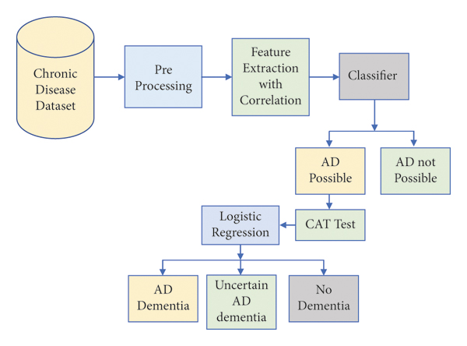

14

**System Architecture Figure For Chronic Disease Pridiction**

14

A ML system to intrusion detection can effectively safeguard networks from malicious activity. This system comprises several crucial components - KDD Dataset: A publicly available dataset containing both normal and malicious network traffic, utilized in order to instruct the machine learning model. The Model of Machine Learning. A hybrid model combining the outputs of three algorithms - decision trees, logistic regression, and k-nearest neighbors - to enhance accuracy. NIDS (Network Intrusion Detection System): A software system continuously monitoring network traffic for suspicious activity. Smartphone: The device protected from intrusion, vulnerable to various attacks like malware infections, phishing attempts, and denial-of-service attacks. The system's operation involves the NIDS collecting network traffic data and forwarding it to the machine learning model. The model analyzes the data, classifying it as normal or malicious. If malicious, an alert is sent to the smartphone, prompting the user to take appropriate action. Machine learning systems are increasingly preferred for intrusion detection due to their ability to adapt to new and emerging threats. This system exemplifies a hybrid intrusion detection system, combining the strengths of multiple machine learning algorithms to provide comprehensive network protection.

**3.4 SEQUENCE DIAGRAM**

1. Data Collection:
   1. Gather a dataset with historical information about individuals, including features such as age, gender, body mass index (BMI), family history of diabetes, blood pressure, glucose levels, and other relevant factors.
   2. The dataset should also include a target variable indicating whether each individual has diabetes or not (binary classification).
2. Data Preprocessing:
   1. Clean the dataset by handling missing values, outliers, and any inconsistencies.
   2. Normalize or scale the features to ensure that they have similar scales. This can help improve the performance of certain machine learning algorithms.
   3. Split the dataset into training and testing sets to evaluate the model's performance.
3. Feature Selection/Engineering:
   1. Identify the most relevant features that are likely to influence the prediction of diabetes. Feature selection techniques like correlation analysis or feature importance from tree-based models can help with this.
   2. Optionally, create new features or transform existing ones to capture more information. For example, you might calculate the BMI from weight and height data.
4. Hyperparameter Tuning: Fine-tune the hyperparameters of your chosen model to optimize its performance. Techniques like grid search or random search can help with this.

**3.4 ALGORITHM**

1. **Logistic Regression:**
   * **Algorithm:** Logistic Regression is a statistical model used for binary classification tasks, making it suitable for predicting the presence or absence of chronic diseases like heart disease or diabetes.
   * **Working Steps:**
   * Utilizes a logistic function to model the probability of the occurrence of a binary outcome based on predictor variables.
2. **Support Vector Machines (SVM):**
   * **Algorithm:** SVM is a classification algorithm that identifies the best hyperplane to separate data into different classes, commonly used for disease prediction.
   * **Working Steps:**
   * Maps input data into a high-dimensional feature space to find an optimal hyperplane that maximizes the margin between classes.
   * Classifies data points by assigning them to different classes based on which side of the hyperplane they fall.

Uses kernel functions to transform data into higher dimensions, enabling the separation of non-linearly separable classes.

**3.5 EVALUTION MATRIX**

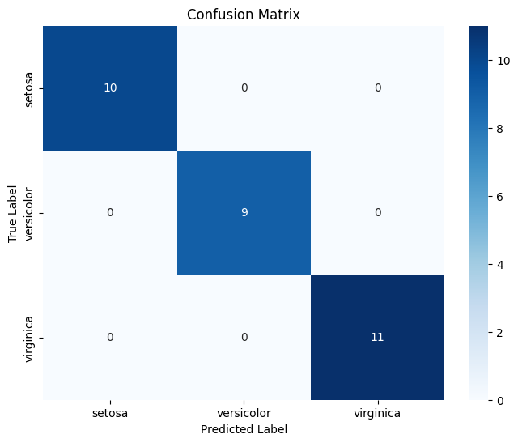

Fig 1.4 Confusion Matrics of Precision and Recall

Calculation of the generated classification models is a crucial state, which involves the utilization of various Evaluation Metrics. The The metrics listed below are used for assessment:

1. True Positives (TP): This shows how many malicious packets have been accurately classified overall.

2. True Negatives (TN): The entire count of packets that are accurately categorized as normal is what this refers to.

3. False Positives (FP): The number of malicious packets that are mistakenly categorized as attacks is indicated by this.

4. False Negatives (FN): This represents the total amount of malicious packets that are mistakenly identified as legitimate.

The most popular metric for assessing a model is classification accuracy, however this does not accurately indicate how well the model will perform. By dividing the number of correctly classified samples by the total number of input samples, the appropriate classification ratio can be found.

**3.6 COMPARISON OF MODELS**

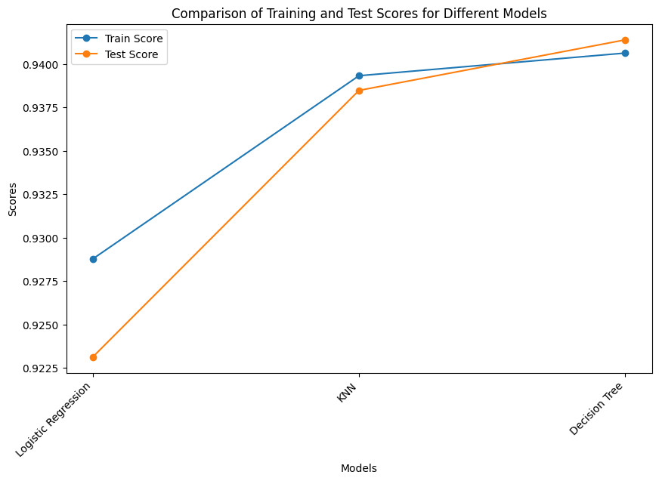 Fig 1.5. Comparison of Training and Test Scores of Models

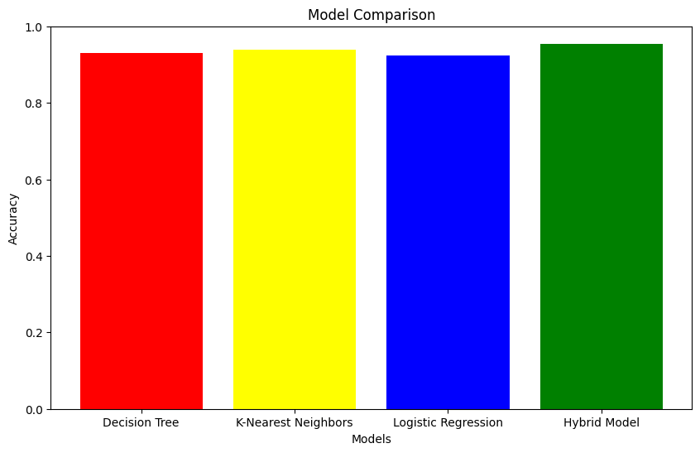

Fig 1.6 Accuracy Comparison of Machine Learning Prediction

**CHAPTER 4**

**CONCLUSION AND FUTURE WORK**

**4.1 CONCLUSION**

In conclusion, predictive modeling for chronic diseases, including conditions like kidney failure, diabetes, and heart stroke, stands as a transformative approach in modern healthcare. The utilization of advanced data-driven methodologies, machine learning algorithms, and integrated datasets has shown immense potential in reshaping disease management strategies. These predictive models offer a proactive framework for early identification, personalized risk assessment, and targeted interventions, empowering healthcare professionals to anticipate and address chronic diseases before they escalate.

* 1. **FUTURE WORK**

**4.2.1 IMPROVEMENTS**

Chronic diseases represent a significant global health challenge, exerting a substantial burden on individuals and healthcare systems worldwide. Conditions like kidney failure, diabetes, and heart stroke pose long-term health risks, often leading to complications that impact the quality of life and contribute to increased morbidity and mortality rates. These diseases, characterized by their prolonged duration and often slow progression, demand a proactive approach to management and prevention.

Here are potential avenues for future research and development:

* Integration **Enhanced Data Integration and Quality:** Focus on refining data integration methods and ensuring the quality, completeness, and standardization of healthcare datasets. Integration of emerging data sources such as wearables, genomics, environmental factors, and social determinants of health can enrich predictive models.
* **Development of Multimodal Models:** Explore the potential of multimodal models that combine different types of data, such as imaging data, omics data (genomics, proteomics), and clinical records. Integrating these diverse data modalities can provide a more comprehensive understanding of disease progression and improve predictive accuracy.
* **Interpretable and Explainable AI Models:** Develop methodologies to enhance the interpretability and explainability of complex predictive models. Creating models that not only provide accurate predictions but also offer insights into the reasoning behind predictions can improve trust and adoption among healthcare professionals.
* **Longitudinal and Real-time Monitoring:** Investigate the implementation of longitudinal monitoring and real-time data analysis. Continuous tracking of patient data over time could facilitate dynamic risk assessment, enabling timely interventions and adjustments in treatment plans.
* **Predictive Analytics for Precision Medicine:** Explore the integration of predictive analytics in precision medicine initiatives. Develop models that can guide personalized treatment strategies, considering individual patient characteristics, genetic profiles, and responses to specific interventions.
* **Ethical and Regulatory Considerations:** Address ethical concerns related to patient data privacy, consent, and regulatory compliance.

**4.22 COLLABORATION WITH GENRATIVE ML**

* **Data Augmentation:** Generative models can aid in data augmentation by generating synthetic samples that mimic real patient data. This augmented dataset can help in addressing data scarcity issues, especially in scenarios where acquiring extensive or diverse patient data might be challenging.
* **Imputation of Missing Values:** Generative models can assist in imputing missing values within healthcare datasets. By learning the underlying patterns from available data, these models can generate plausible values to fill missing entries, thereby enhancing the completeness of datasets used in predictive modeling.
* **Enhancing Minority Class Representation:** In scenarios where certain chronic diseases might have limited representation in datasets due to their rarity, generative models can generate synthetic samples for underrepresented classes. This aids in creating more balanced datasets for training predictive models.
* **Generating Simulated Patient Data:** Generative models can create simulated patient data based on learned patterns. This synthetic data can be utilized for testing and validating predictive models, allowing for extensive testing without compromising patient privacy or data integrity.
* **Drug Discovery and Treatment Development:** Generative models can aid in molecular design and drug discovery for chronic diseases. By generating molecular structures or simulating biological processes, these models can assist researchers in discovering potential treatments or interventions.

REFERENCES

1. M. A. Levey AS, Becker C, Inker LA. Glomerular filtration rate and albuminuria for detection and staging of acute and chronic kidney disease in adults: a systematic review. JAMA. 2015;313(8):837-846. doi:10.1001/jama.2015.0602
2. Krumholz HM, Peterson ED, Ayanian JZ, et al. Report of the National Heart, Lung, and Blood Institute Working Group on outcomes research in cardiovascular disease. Circulation. 2005;111(23):3158-3166. doi:10.1161/CIRCULATIONAHA.105.537204
3. Kannel WB, McGee DL. Diabetes and cardiovascular disease. JAMA. 1979;241(19):2035-2038. doi:10.1001/jama.1979.03290450041024
4. D'Agostino RB Sr, Vasan RS, Pencina MJ, et al. General cardiovascular risk profile for use in primary care: the Framingham Heart Study. Circulation. 2008;117(6):743-753. doi:10.1161/CIRCULATIONAHA.107.699579
5. Stevens LA, Coresh J, Greene T, Levey AS. Assessing kidney function--measured and estimated glomerular filtration rate. N Engl J Med. 2006;354(23):2473-2483. doi:10.1056/NEJMra054415
6. National Kidney Foundation. KDOQI Clinical Practice Guidelines for Chronic Kidney Disease: Evaluation, Classification, and Stratification. Am J Kidney Dis. 2002;39(2 Suppl 1):S1-S266. doi:10.1016/S0272-6386(02)70081-4
7. American Diabetes Association. Standards of medical care in diabetes - 2022. Diabetes Care. 2022;45(Suppl 1):S1-S221. doi:10.2337/dc22-SINT
8. Anjana RM, Deepa M, Pradeepa R, et al. Prevalence of diabetes and prediabetes in 15 states of India: results from the ICMR–INDIAB population-based cross-sectional study. Lancet Diabetes Endocrinol. 2017;5(8):585-596. doi:10.1016/S2213-8587(17)30174-2
9. Jha V, Wang AY, Wang H. The impact of CKD identification in large countries: the burden of illness. Nephrol Dial Transplant. 2012;27(Suppl 3):iii32-iii38. doi:10.1093/ndt/gfs269
10. Boehme AK, Esenwa C, Elkind MS. "Stroke risk factors, genetics, and prevention." Circulation Research. 2017; 120(3): 472–495. doi:10.1161/CIRCRESAHA.116.308398.
11. Jardine MJ, Hata J, Woodward M, et al. "Prediction of the risk of heart failure among patients with type 2 diabetes mellitus: insights from the EXAMINE trial." Circulation. 2018; 137(1): 91–100. doi:10.1161/CIRCULATIONAHA.117.029529.