Generated on: 2026-01-20 22:40:38

Executive Summary
"The newly opened café in town offers a functional, no-frills dining experience suitable for a quick lunch break" The interior design is minimal, focusing more on casual comfort than elaborate decor. While the food was not exceptionally gourmet, it served its purpose well.

Visual Analysis
Sentiment Overview
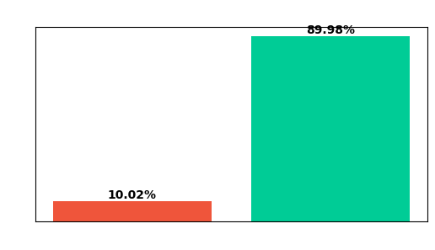

Word Clouds
Word Cloud (dominant)
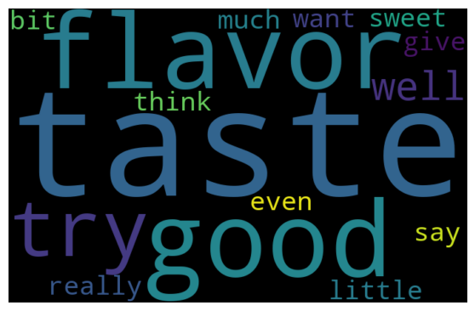

Dominant Topic Keywords
taste, good, flavor, try, well, really, much, little, think, give, want, say, even, bit, sweet

Key Insights
- The customer feedback is largely positive, indicating a strong customer experience.
- Customers specifically loved the food quality.

Actionable Recommendations
- Leverage these positive reviews in your marketing campaigns and social media.
- Identify the most praised dishes and highlight them as 'Chef's Specials' or bestsellers.

