

**Applied Project (CSAT-CSAC)**

**Researcher Management**

**Instructor: William Pourmajidi**

**Group: CPL-5559-CSAT-CSAC-0098-V2**

**Date:02/July/2020**

**Student Name: Student ID:**

**Jasveer Kaur Cheema C0726681**

**Parampreet Kaur C0744528**

**Sukhdeep Singh C0754215**

**Sonia Dhunna C0738121**

**INDEX**

**1. Introduction**

**Screenshot of page 1.1**

**Screenshot of database 1.2**

**Screenshot of GitHub 1.3**

**Reference 1.4**

**1.1 screenshot of the pages and functionalities:**

* **Request access Function:**

When a regular user does login, they will see an access request button.

Let's start with regular user login.

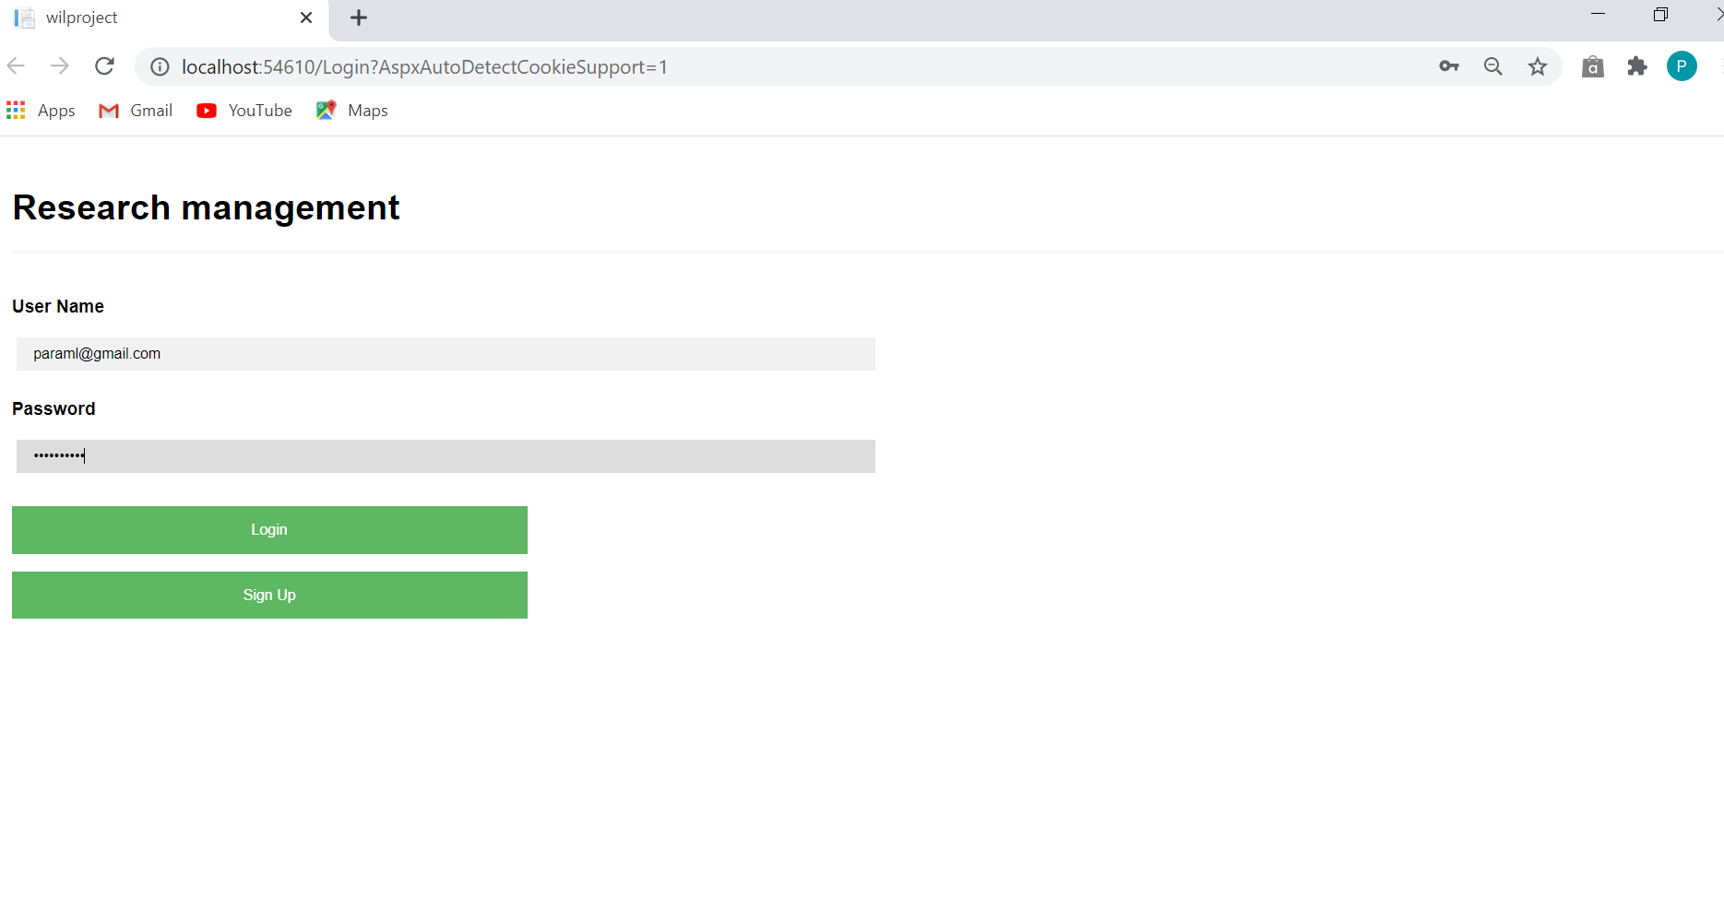

Following is the screenshot of database of that person before making request the department is Food Microbiology we will change this to virology:

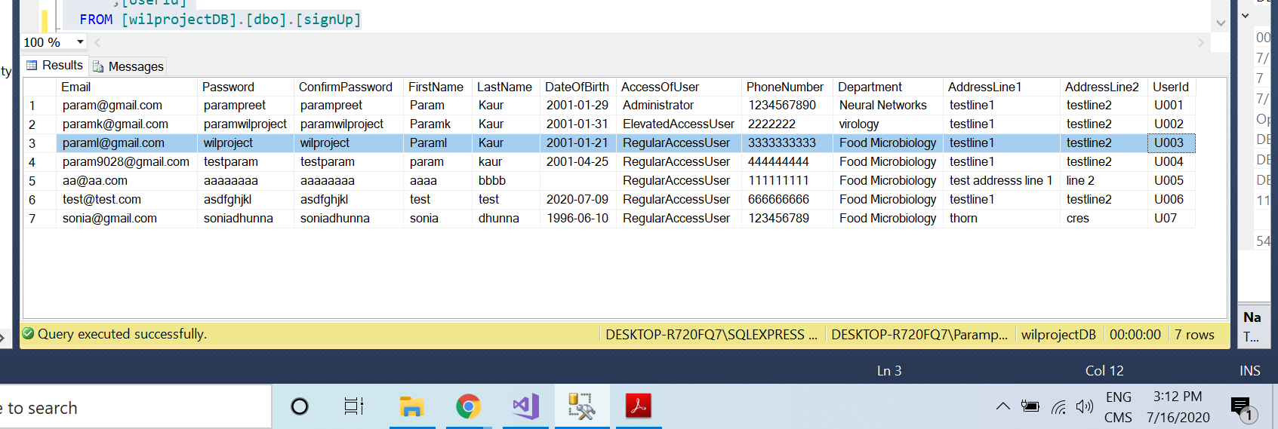

Here we can see the access request button in the following

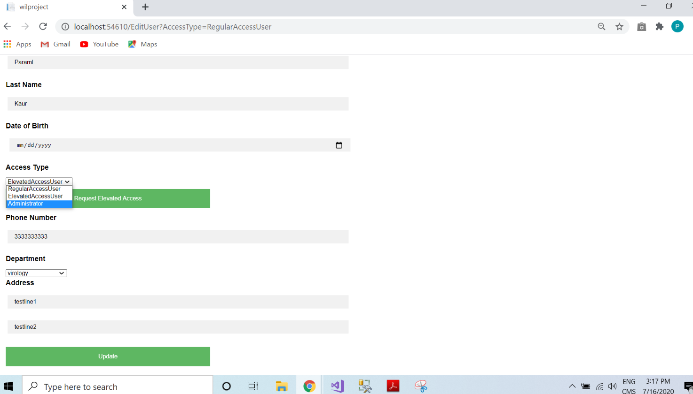

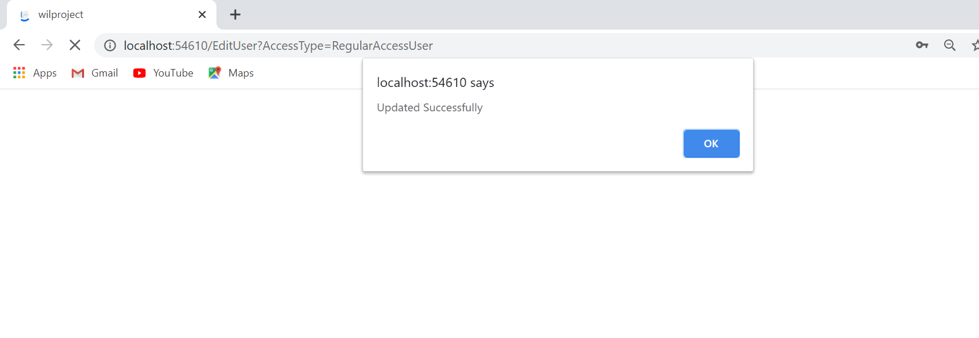

After making the request for department the request saved in the database with the pending status

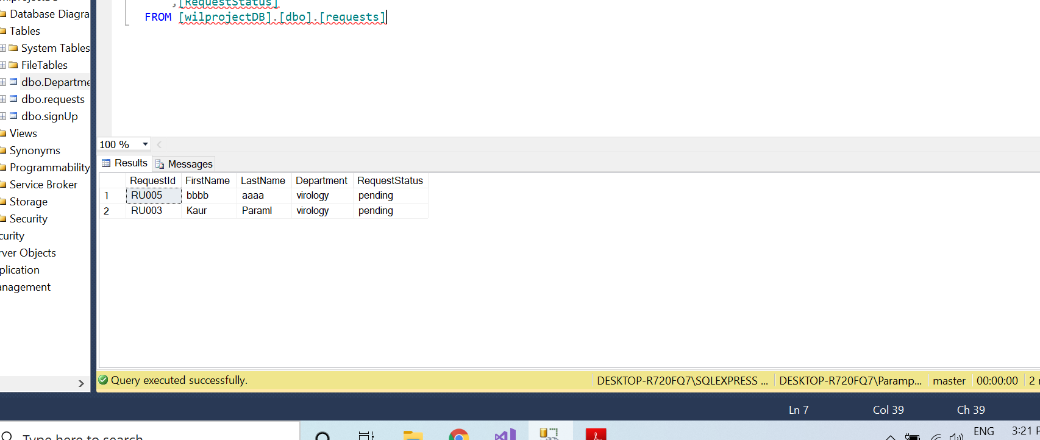

After this Admin will change their access and department according to their request what they are requested for:

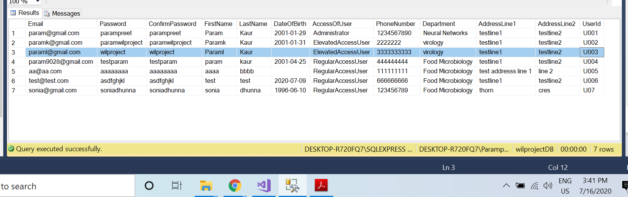Above we can see the values are changed their department and access type.

* **Search user function:**

Here we can search the user by their user name as well as their department:

First search with department

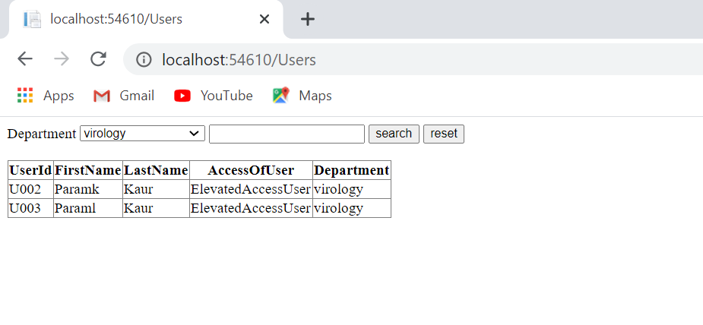

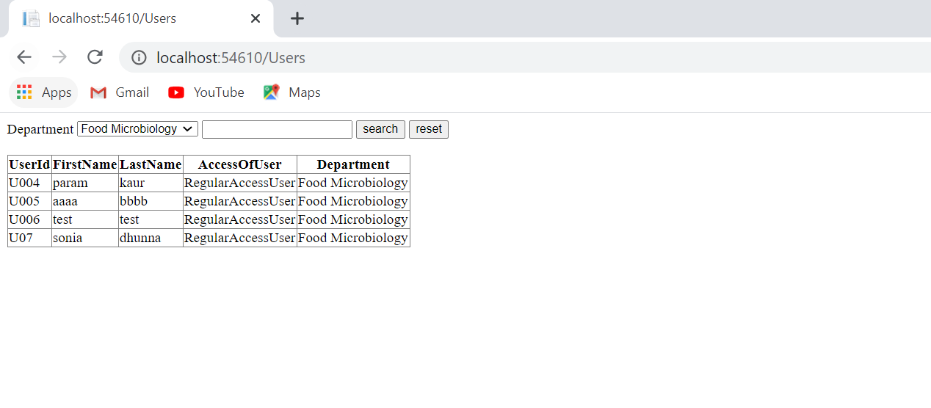

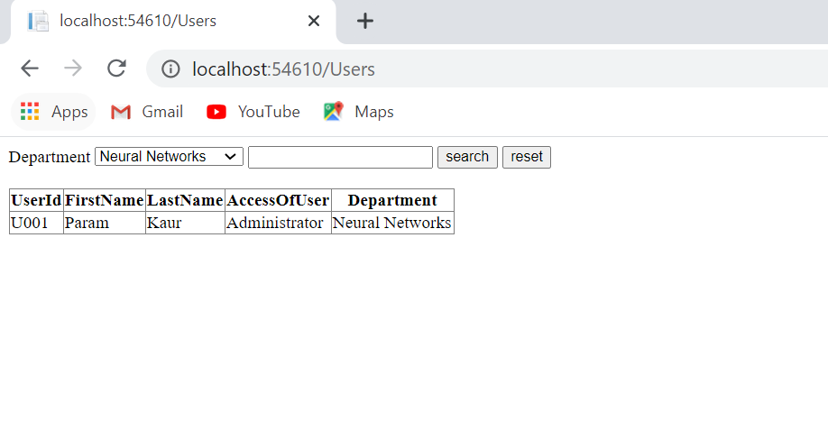

Following searched by username:

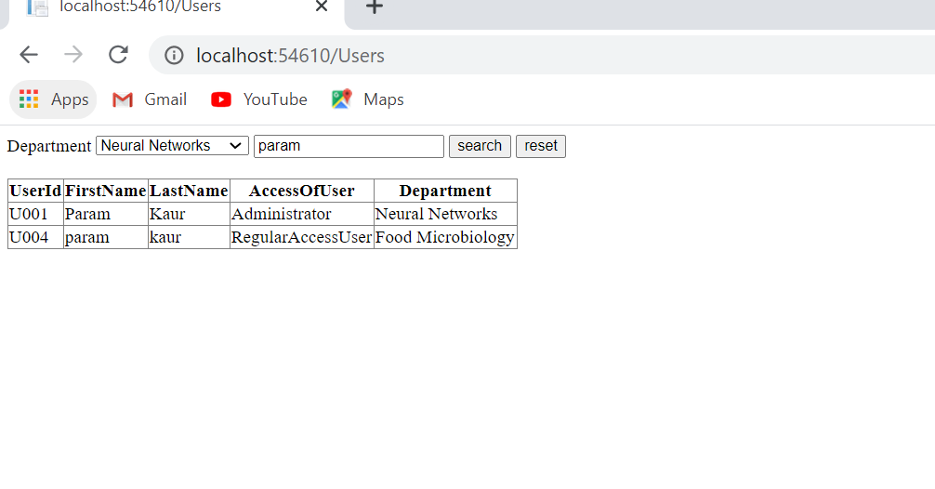

So, this the search function and how it works.

* **Sort function:**

By clicking on the heading of the tables the data will sorted in ascending or descending.

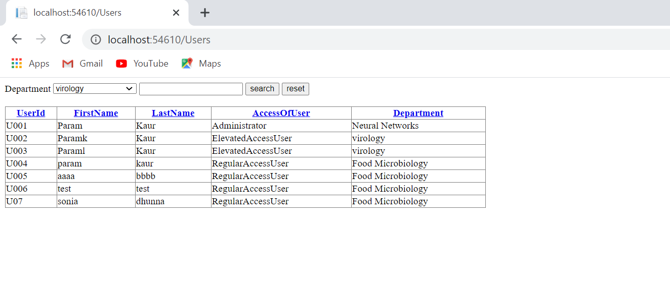

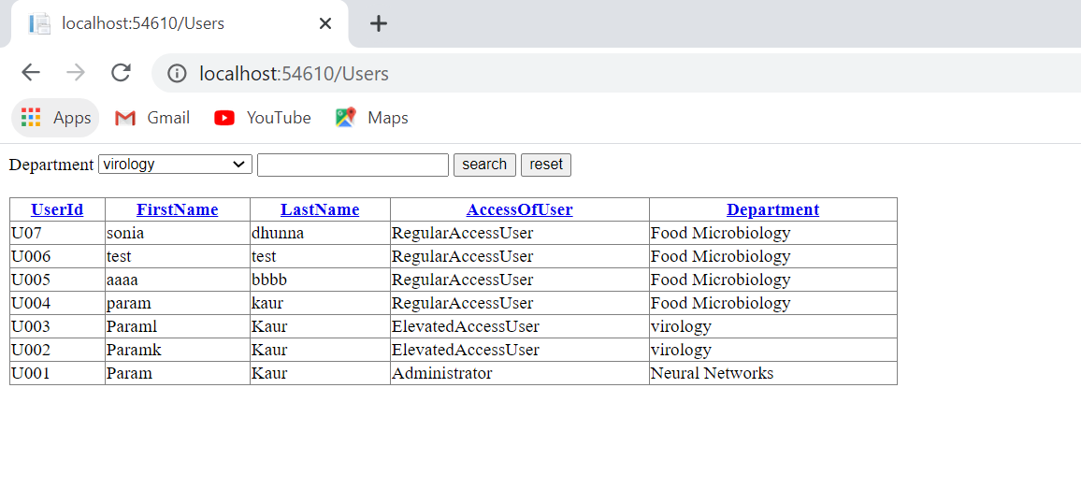

**1.2 screenshots of database:**

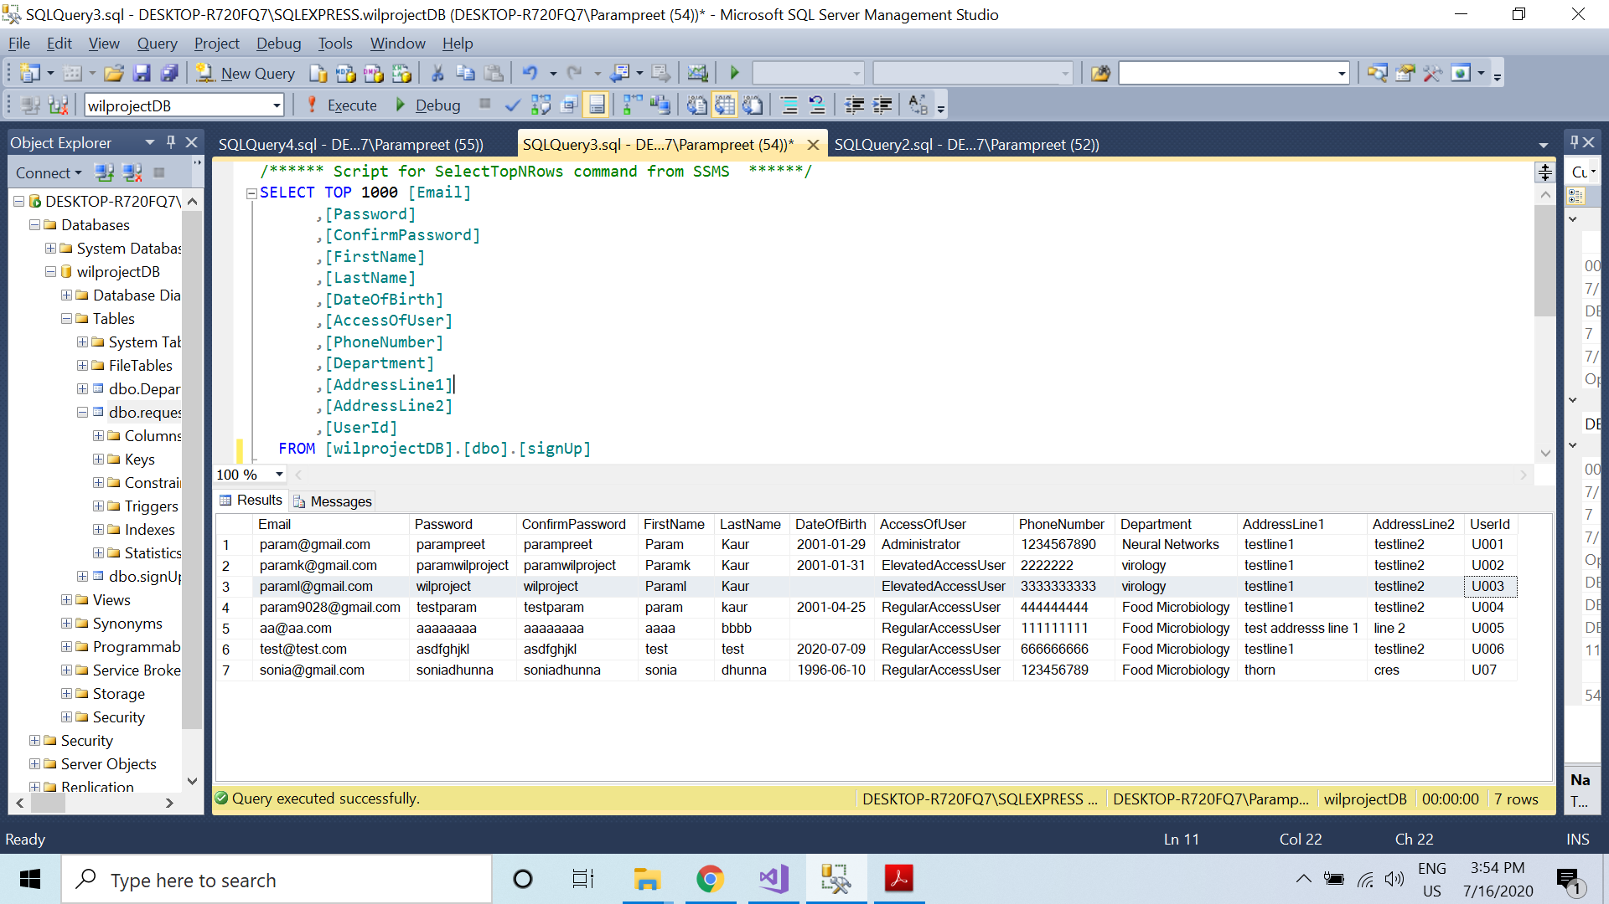

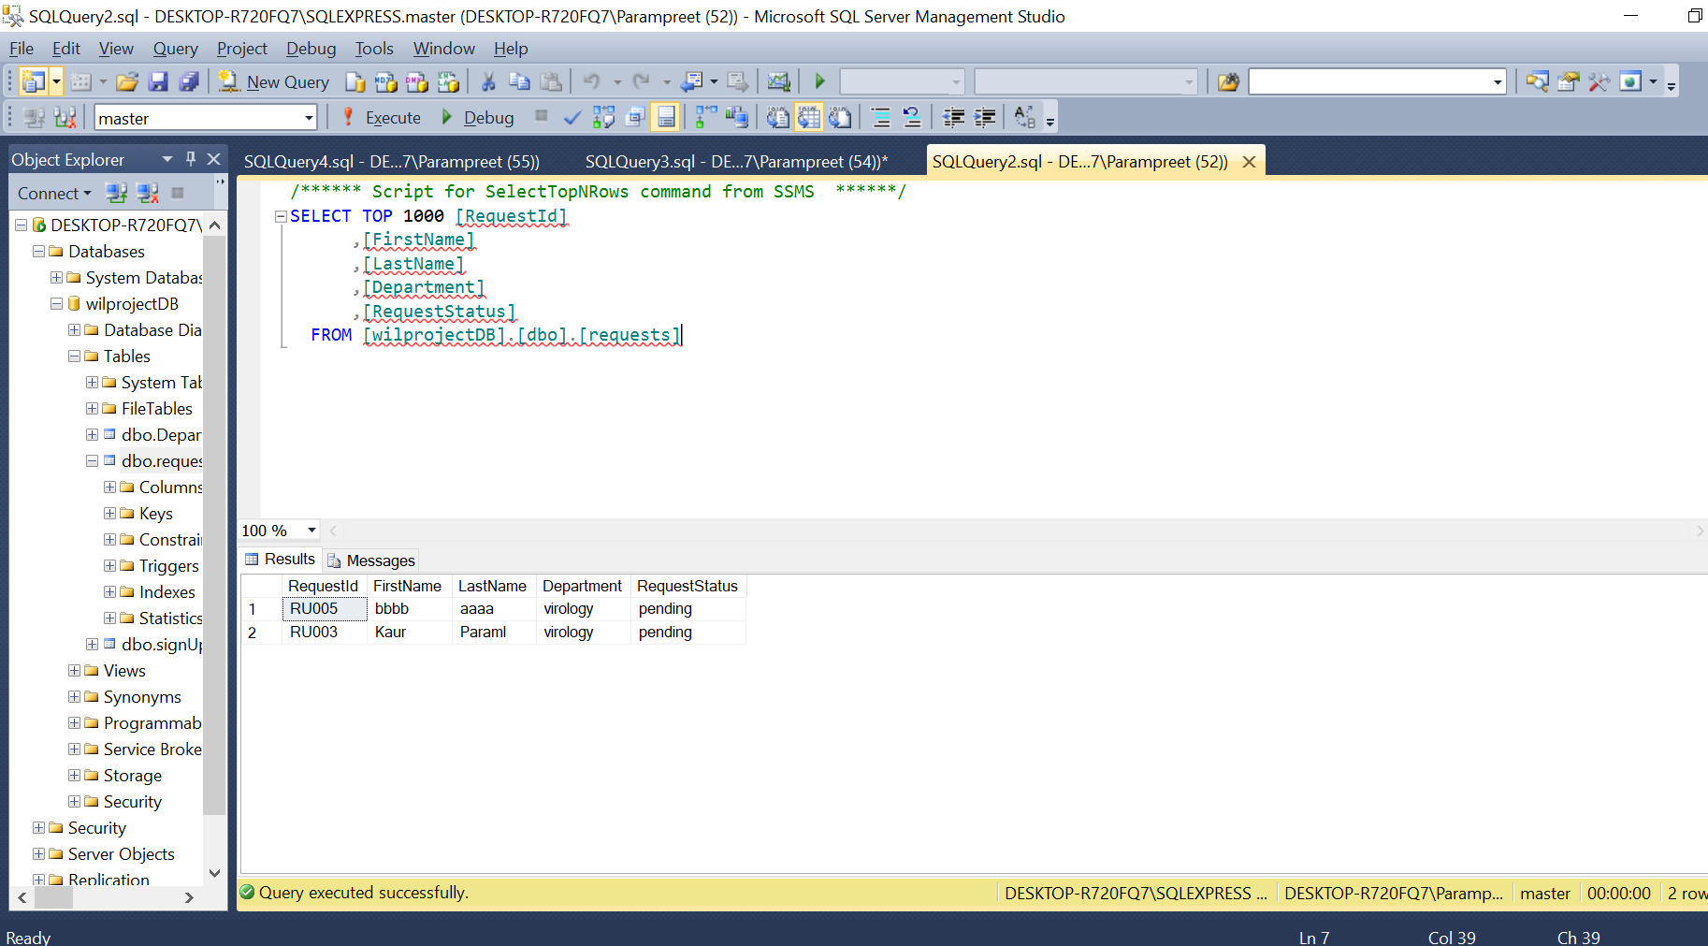

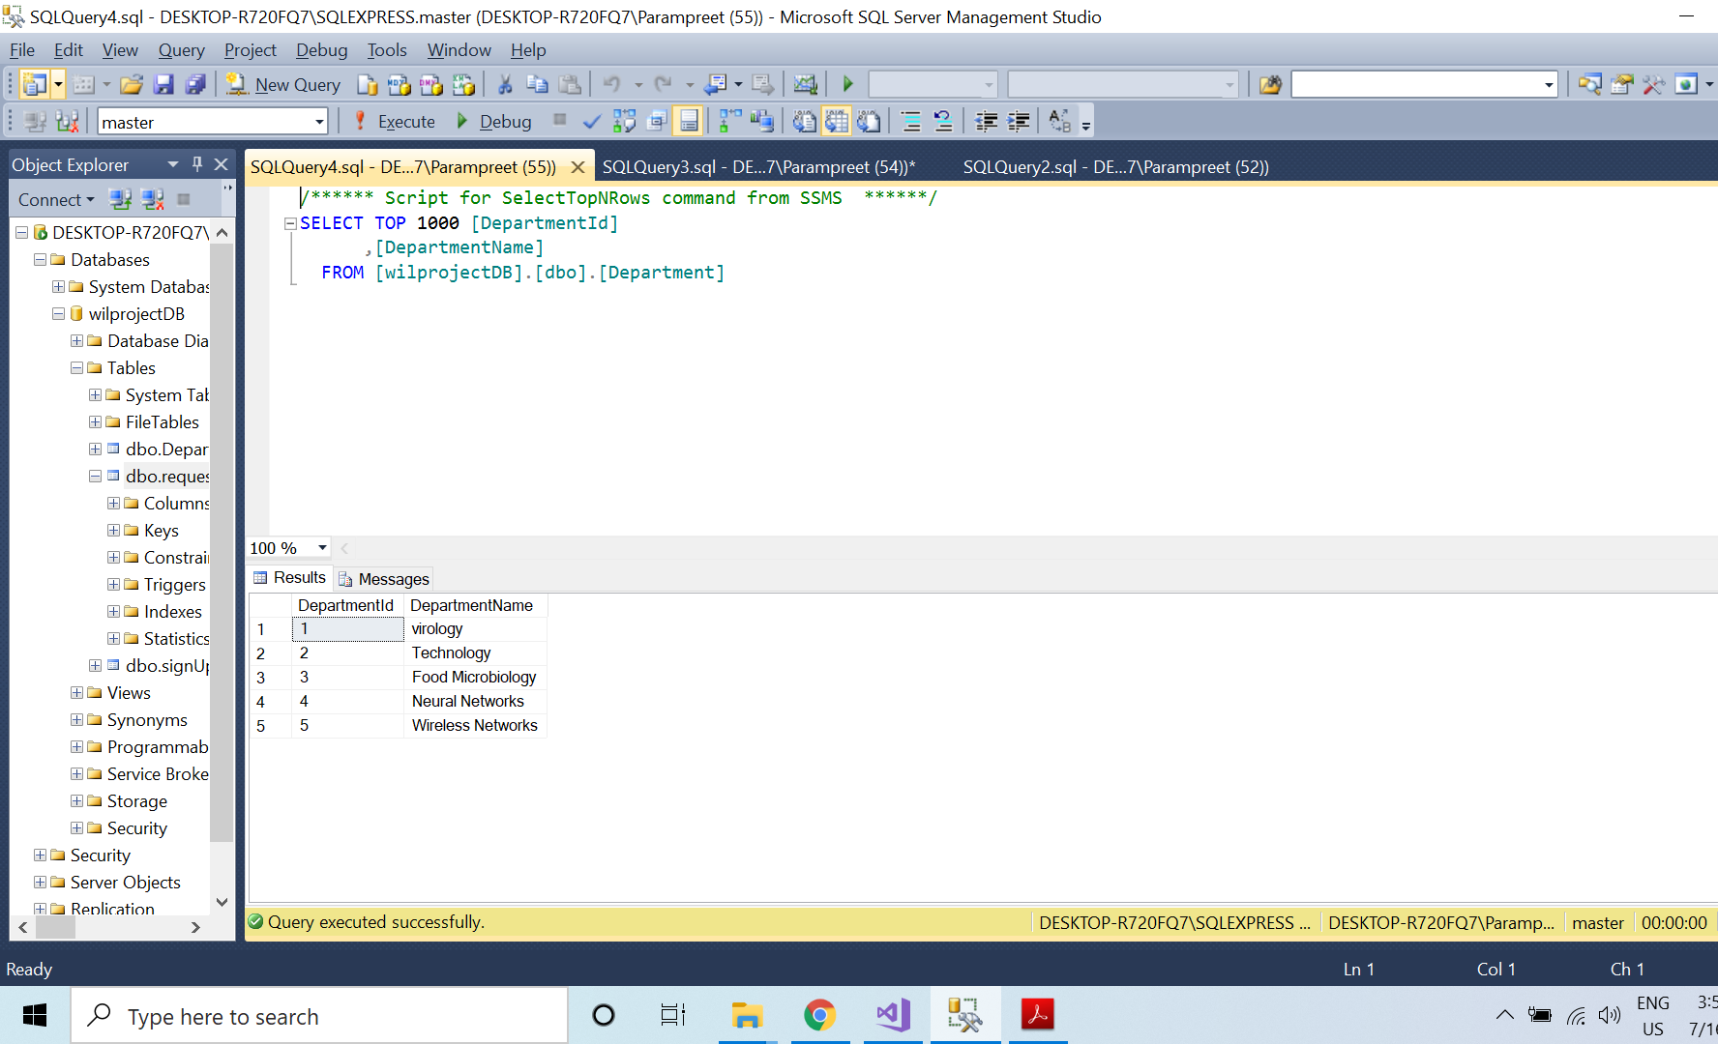

**1.3 GitHub Screenshot:**

**1.4 reference:**