Program 1. Perform the following DB operations using Cassandra.

1. Create a key space by name Employee

CREATE KEYSPACE Employee WITH REPLICATION = {

... 'class' : 'SimpleStrategy', 'replication_factor' : 1

... };

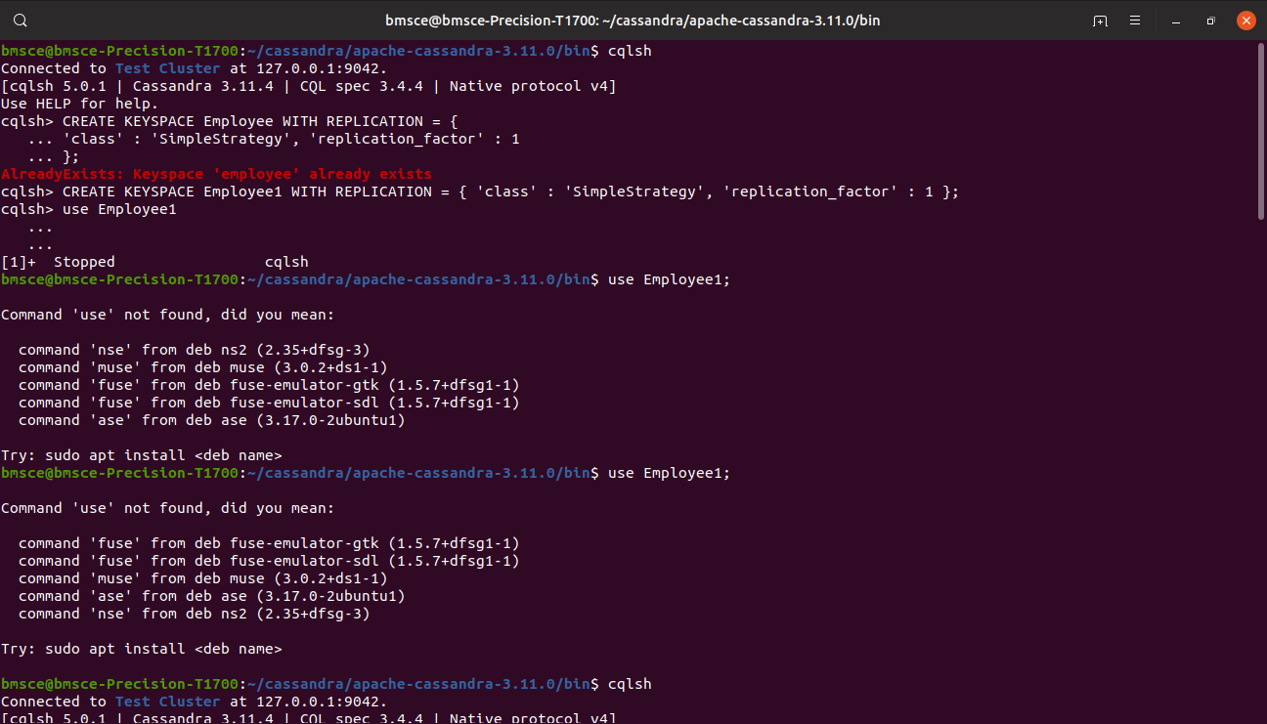

2. Create a column family by name Employee-Info with attributes Emp_Id Primary Key, Emp_Name, Designation, Date_of_Joining, Salary, Dept_Name

CREATE TABLE Employee_info(

... Emp_Id int PRIMARY KEY,

... Emp_Name text,

... Designation text,

... Date_of_joining timestamp,

... Salary double,

... Dept_Name text

... );

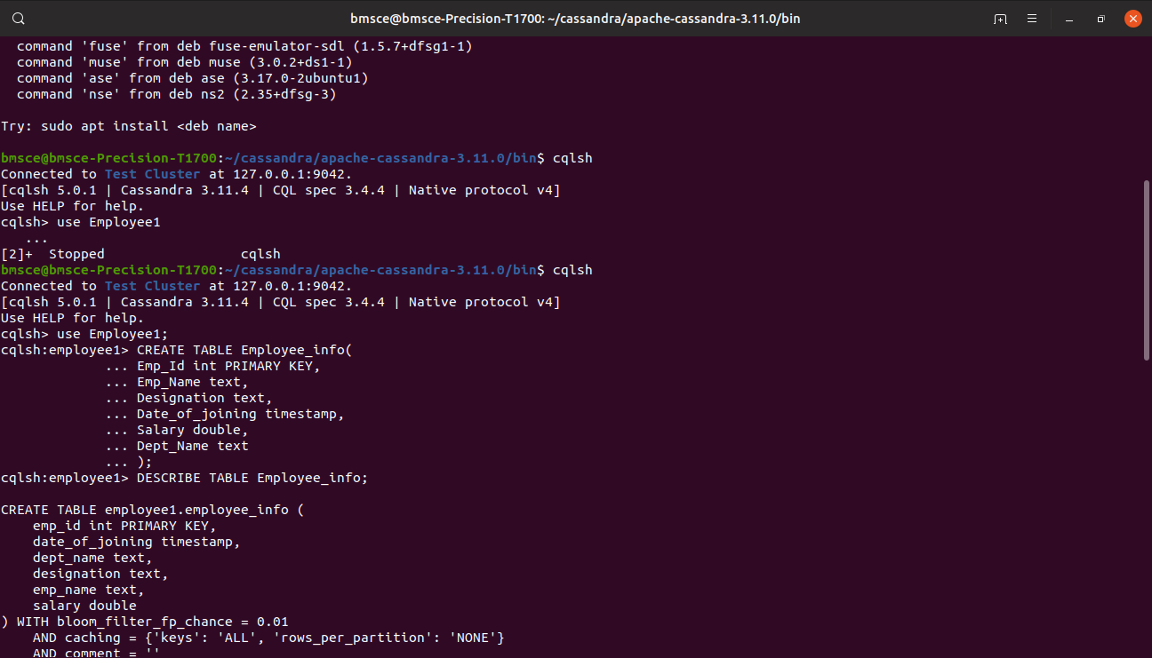

3. Insert the values into the table in batch

BEGIN BATCH

... INSERT INTO Employee_info(Emp_Id,Emp_Name,Designation,Date_of_joining,Salary,Dept_Name)

... VALUES(1,'Prema','Manager','2023-08-28',50000,'Executive')

... INSERT INTO Employee_info(Emp_Id,Emp_Name,Designation,Date_of_joining,Salary,Dept_Name)

... VALUES(121,'Pooja','Product-Manager','2023-08-28',60000,'Product-Management')

... INSERT INTO Employee_info(Emp_Id,Emp_Name,Designation,Date_of_joining,Salary,Dept_Name)

... VALUES(118,'Prathiksha','Design-Lead','2023-09-28','70000','Design')

... INSERT INTO Employee_info(Emp_Id,Emp_Name,Designation,Date_of_joining,Salary,Dept_Name)

... VALUES(119,'Prathibha','CTO','2024-09-28','70000','Development')

... INSERT INTO Employee_info(Emp_Id,Emp_Name,Designation,Date_of_joining,Salary,Dept_Name)

... VALUES(116,'Prateek.G','Sales-Manager','2022-09-28','80000','Sales')

... APPLY BATCH;

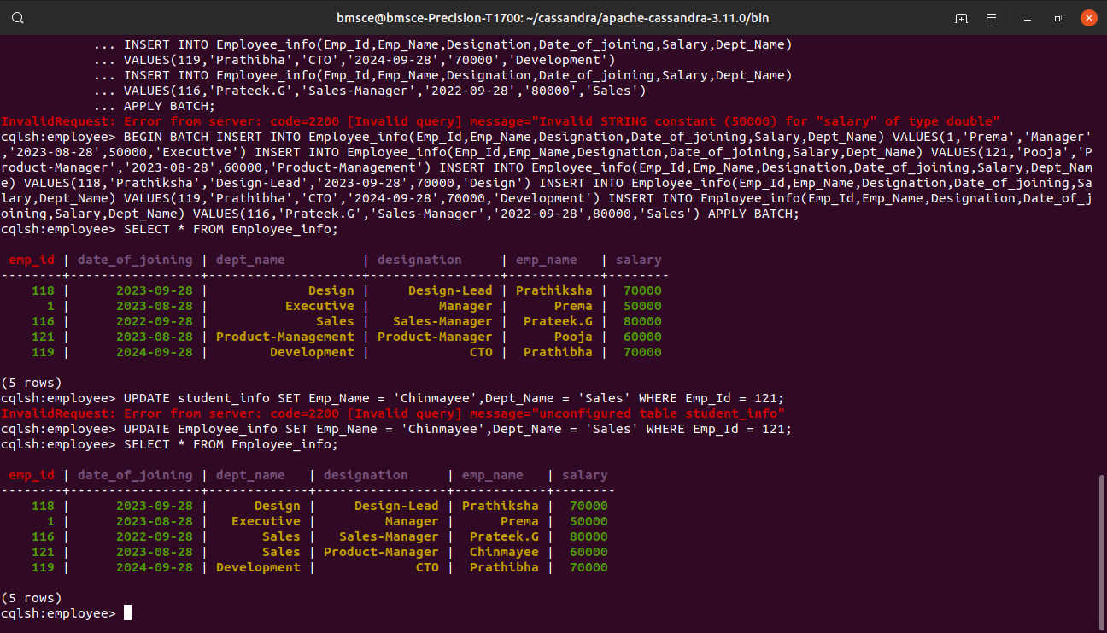

4. Update Employee name and Department of Emp-Id 121

UPDATE Employee_info SET Emp_Name = 'Chinmayee',Dept_Name = 'Sales' WHERE Emp_Id = 121;



5. Sort the details of Employee records based on salary  
6. Alter the schema of the table Employee_Info to add a column Projects which stores a set of Projects done by the corresponding Employee.  
7. Update the altered table to add project names.  
8 Create a TTL of 15 seconds to display the values of Employees.