Lab6:-

WAP to Implement Singly Linked List with following operations

a) a) Create a linked list. b) Deletion of first element, specified element and last element in

the list. c) Display the contents of the linked list.

Program:-

#include<stdio.h>

#include<stdlib.h>

struct node

{

int info;

struct node *link;

};

typedef struct node *NODE;

NODE getnode()

{

NODE x;

x=(NODE)malloc(sizeof(struct node));

if(x==NULL)

{

printf("mem full\n");

exit(0);

}

return x;

}

void freenode(NODE x)

{

free(x);

}

NODE insert_front(NODE first,int item)

{

NODE temp;

temp=getnode();

temp->info=item;

temp->link=NULL;

if(first==NULL)

return temp;

temp->link=first;

first=temp;

return first;

}

NODE delete_front(NODE first)

{

NODE temp;

if(first==NULL)

{

printf("List is empty!Can't delete an item'\n");

return first;

}

temp=first;

temp=temp->link;

printf("The Item deleted at front-end is = %d\n",first->info);

free(first);

return temp;

}

NODE insert_rear(NODE first,int item)

{

NODE temp,cur;

temp=getnode();

temp->info=item;

temp->link=NULL;

if(first==NULL)

return temp;

cur=first;

while(cur->link!=NULL)

cur=cur->link;

cur->link=temp;

return first;

}

NODE delete_rear(NODE first)

{

NODE cur,prev;

if(first==NULL)

{

printf("List is empty cannot delete\n");

return first;

}

if(first->link==NULL)

{

printf("Item deleted is %d\n",first->info);

free(first);

return NULL;

}

prev=NULL;

cur=first;

while(cur->link!=NULL)

{

prev=cur;

cur=cur->link;

}

printf("Item deleted at rear-end is %d",cur->info);

free(cur);

prev->link=NULL;

return first;

}

NODE delete_pos(int pos,NODE first)

{

NODE cur;

NODE prev;

int count,flag=0;

if(first==NULL || pos<0)

{

printf("invalid position\n");

return NULL;

}

if(pos==1)

{

cur=first;

first=first->link;

freenode(cur);

return first;

}

prev=NULL;

cur=first;

count=1;

while(cur!=NULL)

{

if(count==pos){flag=1;break;}

count++;

prev=cur;

cur=cur->link;

}

if(flag==0)

{

printf("invalid position\n");

return first;

}

printf("item deleted at given position is %d\n",cur->info);

prev->link=cur->link;

freenode(cur);

return first;

}

void display(NODE first)

{

NODE temp;

if(first==NULL)

printf("List empty cannot display items\n");

for(temp=first;temp!=NULL;temp=temp->link)

{

printf("%d\t",temp->info);

}

}

int main()

{

int item,choice,pos;

NODE first=NULL;

for(;;)

{

printf("\n 1:Insert_front\t 2:Delete at first position\t 3:Insert_rear\t 4:Delete at last position\t 5:Delete at any position\t 6:Display_list\t 7:Exit\n");

printf("Enter the choice\n");

scanf("%d",&choice);

switch(choice)

{

case 1:printf("Enter the item at front-end\n");

scanf("%d",&item);

first=insert_front(first,item);

break;

case 2:first=delete_front(first);

break;

case 3:printf("Enter the item at rear-end\n");

scanf("%d",&item);

first=insert_rear(first,item);

break;

case 4:first=delete_rear(first);

break;

case 5:printf("enter the position\n");

scanf("%d",&pos);

first=delete_pos(pos,first);

break;

case 6:display(first);

break;

default:exit(0);

break;

}

}

}

Output Screenshot:-

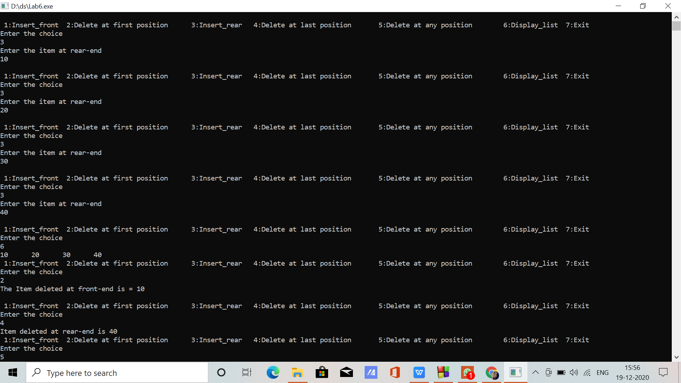

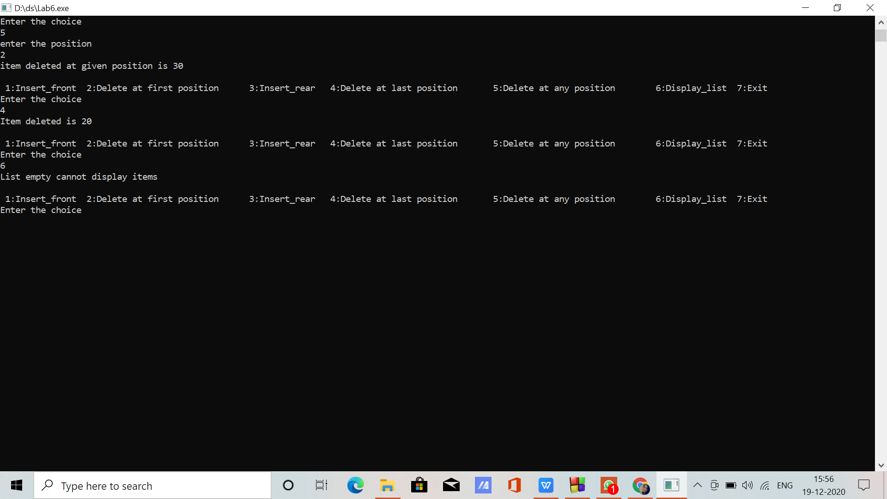

Written pictures:-