EXTRA PROGRAMS LAB.1:
FIRST PROGRAM
Sum of odd and even:

PROGRAM:
import.java.util*;
class Even_Odd{
public static void main(String args[]){
int n,SumO=0,SumE=0;
Scanner in = new Scanner(System.in);
System.out.println("Enter the size of the array ");
n=in.nextInt();
int arr[]=new int[n];
System.out.println("Enter the elements");
for(int i=0;i<n;i++)
arr[i]=in.nextInt();

for(int i=0;i<n;i++)
{
if(arr[i]%2==0)
{
SumE+=arr[i];
}
else
{
SumO+=arr[i];
}
}
System.out.println("Sum of even numbers in an array"+SumE);
System.out.println("Sum of odd numbers in an array"+SumO);
}
OUTPUT:
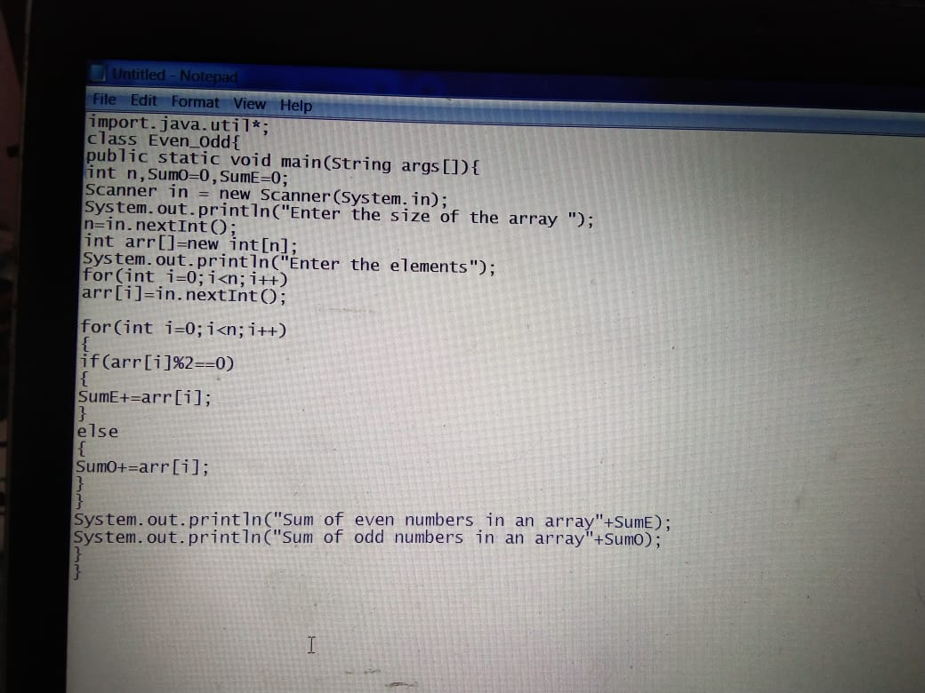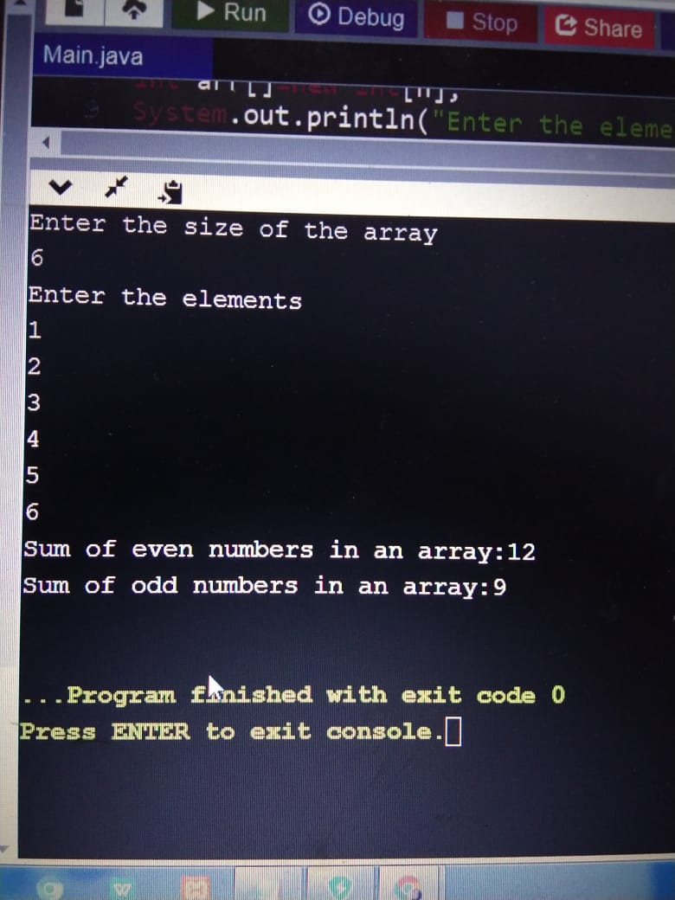
2ND EXTRA PROBLEM
Program on no of positive,negative and zero numbers :
PROGRAM:
import java.util.*;
class Main{
public static void main(String args[]){
int n,count_p=0,count_n=0,count_z=0;
Scanner in=new Scanner(System.in);
System.out.println("Enter the size of the array");
n=in.nextInt();
int arr[]=new int[n];
System.out.println("Enter the elements");
for(int i=0;i<n;i++)
{
arr[i]=in.nextInt();
}
for(int i=0;i<n;i++)
{
if(arr[i]>0)
{
count_p++;
}
else if(arr[i]<0)
{
count_n++;
}
else
{
count_z++;
}
}
System.out.println("No of positive numbers in an array:"+count_p);
System.out.println("No of negative numbers in an array:"+count_n);
System.out.println("No of zeros in an array:"+count_z);
}
}
OUTPUT:
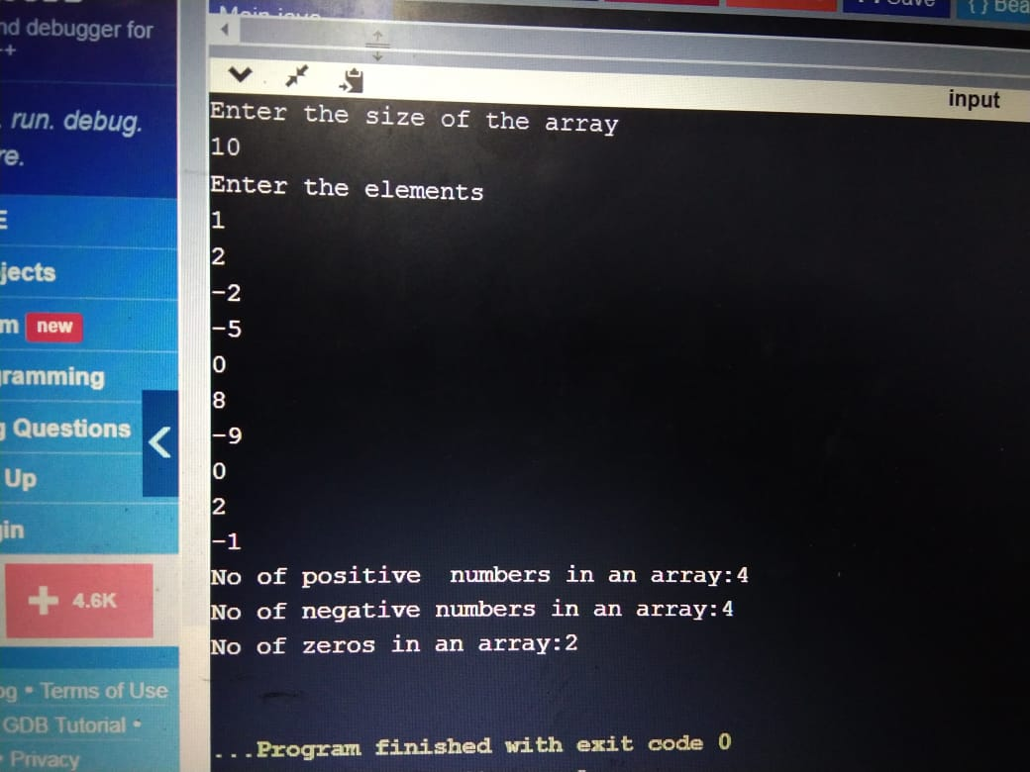

EXTRA PROBLEM 4
PROGRAM ON EVEN AND ODD APPLICATION :
PROGRAM :
import java.util.*;
class Main{
public static void main(String args[]){

int n;
int j=0,k=0,sum=0;

Scanner in=new Scanner(System.in);
System.out.println("Enter the size of the array");
n=in.nextInt();
int A[]=new int[n];
int B[]=new int[n];
int C[]=new int[n];
System.out.println("Enter the elements");
for(int i=0;i<n;i++)
{
A[i]=in.nextInt();
}

for(int i=0;i<n;i++)
{
if(A[i]%2==0)
{
C[j]=A[i];
j++;

}
else
{
B[k]=A[i];
k++;

}
}
System.out.println("Even array elements:");
for(int i=0;i<j;i++)
{
System.out.println(+C[i]);
}
System.out.println("Odd array elements:");
for(int i=0;i<k;i++)
{
System.out.println(+B[i]);
}
for(int i=0;i<j ;i++)
{
sum+=C[i];
}
System.out.println("Sum of even array :"+sum);
double average = sum/j;
System.out.println("Average of even array :"+average);
int min= C[0];
int max = C[0];
for(int i=0;i<j;i++)
{
if(C[i]>=max)
{
max = C[i];
}
if(C[i]<=min)
{
min = C[i];
}
}
System.out.println("Maxium and Minimum among even array is :"+max+" "+min);

}
}
OUTPUT:
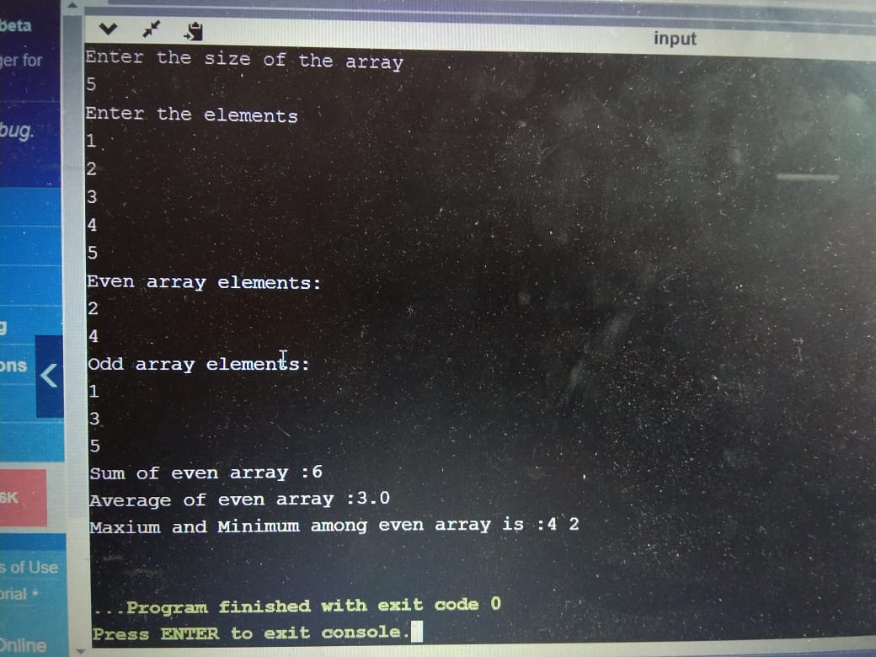
EXTRA PROGRAM :
PROGRAM ON SUPER MARKET BILL:

import java.util.*;
class Main{
public static void main(String[] args){
int n;
double totalbill=0.0,finalbill=0.0;
Scanner in=new Scanner(System.in);
System.out.println("Enter total number of items");
n=in.nextInt();
double rate[]=new double[n];
int quat[]=new int[n];
System.out.println("Enter both rate and quantity");

for(int i=0;i<n;i++)
{
rate[i]=in.nextDouble();
quat[i]=in.nextInt();
}

for(int i=0;i<n;i++)
{
totalbill+=(rate[i]*quat[i]);
}
System.out.println("Totalbill after counting is "+totalbill);

if(totalbill>=10000)
{
finalbill=(totalbill-(totalbill*0.05));
System.out.println("Finalbill after discount :"+finalbill);
}
else if(totalbill>=7500)
{
finalbill=(totalbill-(totalbill*0.03));
System.out.println("Finalbill after discount :"+finalbill);
}
else if(totalbill>=5000)
{
finalbill=(totalbill-(totalbill*0.02));
System.out.println("Finalbill after discount :"+finalbill);
}
else
{
System.out.println("Finalbill after discount :"+totalbill);
}
}
}

OUTPUT:
