Game Design Document

Fill up the following document

1. Write the title of your project.

VOLTRON- THE GAME

1. What is the goal of the game?

KEITH – (Playing Character)

His mission is to defeat the galra enemies against him by using his limited weapons.

Defeat Zarkon.

Rescue the Black lion.

1. Write a brief story of your game.

Zarkon the ruler of a ruthless empire --- THE GALRA EMPIRE has counquered 3/4th of the universe. He was once a paladin of the black lion, the head of voltron which is the legendary defender of the uiverse, though his and his wife’s greed for pure quintesence(a substance very powerful and life itlsef)corupted there souls.

Now, Zarkon is trying to take back the control on the black lion again,but Keith has to rescue the black lion, who has been predicted to be the next paladin of the black lion by Allura, the princess of Altea.

1. Which are the playing characters of this game?

Playing characters

KIETH - main player

Non playing character

Galra army

Zarkon (Galra Emperor).

Black lion (to be rescued by Keith).

Allura (princess of Altea)

|  |  |  |
| --- | --- | --- |
| Number | Character Name | What can this character do? |
| 1 | Keith | shoot lasers, stealth(invisibility, faster), shield.  cannot breathe in outer space |
| 2 | Galra Army | shoot lasers(powerful than Keith)  move very fast |
| 3 | Zarkon | shoot lasers  has long sword  has wings  can breathe in outer space  very huge in height |
| 4 | Black Lion | Head of the most powerful weapon VOLTRON, needs to be rescued |
| 5 | Allura | Updating Keith about the enemy’s where abouts |

1. Which are the Non-Playing Characters of this game?

Non playing character

Galra army

Zarkon (Galra Emperor).

Black lion (to be rescued by Keith).

Allura (princess of Altea)

|  |  |  |
| --- | --- | --- |
| Number | Character Name | What can the character do? |
| 1 | Galra Army | shoot lasers(powerful than Keith)  move very fast |
| 2 | Zarkon | shoot lasers  has long sword  has wings  can breathe in outer space  very huge in height |
| 3 | Black Lion | Head of the most powerful weapon VOLTRON, needs to be rescued |
| 4 | Allura | Updating Keith about the enemy’s where abouts |

Draw your imagination of this game. What does this game look like?

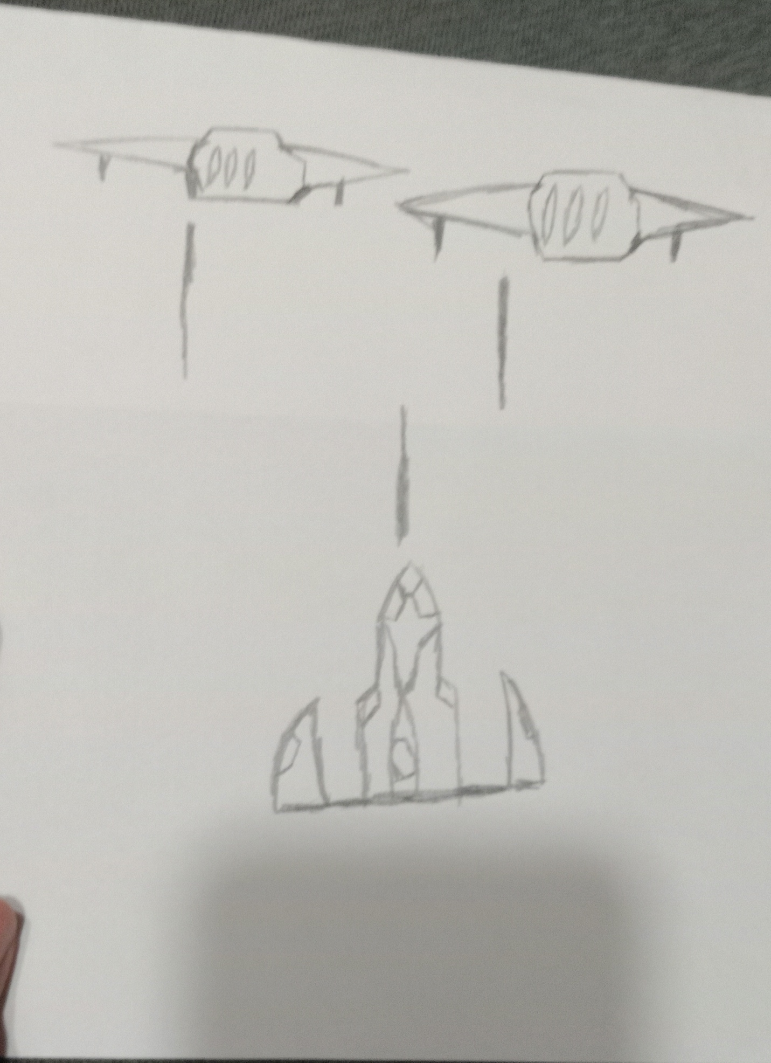

How do you plan to make your game engaging?

Make the game balanced

Keep the game interesting and suspenseful