**Premnath M**

**727721EUIT115**

**CA-2**

**Question 1:**

package Question1;

import org.testng.Assert;

import org.testng.annotations.AfterMethod;

import org.testng.annotations.BeforeMethod;

import org.testng.annotations.Test;

import io.github.bonigarcia.wdm.WebDriverManager;

import org.openqa.selenium.By;

import org.openqa.selenium.Keys;

import org.openqa.selenium.WebDriver;

import org.openqa.selenium.chrome.ChromeDriver; import org.openqa.selenium.chrome.ChromeOptions;

public class Question1 {

WebDriver driver; @Test(priority=1) public void Mandatory() {

ChromeOptions co=new ChromeOptions(); co.addArguments("--remote-allow-origins=*"); WebDriverManager.chromedriver().setup(); driver=new ChromeDriver(co);

driver.navigate().to("https://www.trivago.in/"); driver.manage().window().maximize();

System.out.println(driver.getTitle());

Assert.assertEquals(driver.getTitle(), "trivago.in - Compare hotel prices

worldwide");

}

@Test(priority=2) public void tc01(){

driver.findElement(By.xpath("//*[@id=\"input-auto-complete\"]")).sendKeys("Pondicherry");

driver.findElement(By.xpath("//*[@id=\"input-auto-complete\"]")).sendKeys(Keys.ENTER);

}

@Test(priority=3) public void tc02() throws InterruptedException { driver.findElement(By.xpath("//*[@id=\"__next\"]/div[1]/div[1]/section/div[2]/div[3]/div/div[1]/fieldse t/button[1]")).click();

Thread.sleep(3000); driver.findElement(By.xpath("//time[@datetime=\"2023-05-01\"]")).click(); driver.findElement(By.xpath("//time[@datetime=\"2023-05-06\"]")).click();

}

@Test(priority=4) public void tc03(){

driver.findElement(By.xpath("//button[@data-testid=\"adults-amount-plus-button\"]")).click();

}

@Test(priority=5)

public void tc04() throws InterruptedException { Thread.sleep(3000); driver.findElement(By.xpath("//input[@id=\"checkbox-13\"]")).click();

driver.findElement(By.xpath("//button[@data-testid=\"search-button\"]")).click(); Thread.sleep(30000);

}

@Test(priority=6) public void tc05() throws InterruptedException { driver.findElement(By.xpath("//label[@data-title=\"Hotel\"]")).click(); Thread.sleep(3000);

// button[@title="All"]/span

}@Test(priority=7) public void tc06() { driver.findElement(By.xpath("//button[@title=\"All\"]/span")).click();

}

}

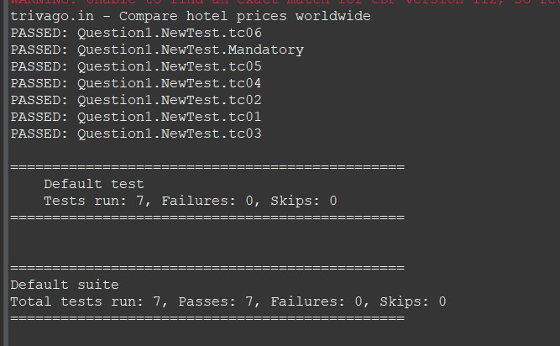

**Question 2:**

|  |
| --- |
| **package Question1;** |
| **import java.util.List;** |
| **import org.openqa.selenium.By;** |
| **import org.openqa.selenium.WebDriver;** |
| **import org.openqa.selenium.WebElement;** |
| **import org.openqa.selenium.chrome.ChromeDriver;** |
| **import org.openqa.selenium.chrome.ChromeOptions;** |
| **import org.openqa.selenium.support.ui.Select;** |
| **import org.testng.annotations.Test;** |
| **import io.github.bonigarcia.wdm.WebDriverManager;** |
| **public class Question2 {** |
| **WebDriver driver;** |
| ***@Test*(priority=1)** |
| **public void Mandatory() throws InterruptedException {** |
| **ChromeOptions co=new ChromeOptions();** |
| **co.addArguments("--remote-allow-origins=*");** |
| **WebDriverManager.*chromedriver*().setup();** |
| **driver=new ChromeDriver(co);** |
| **driver.navigate().to("** |
| **https://www.trivago.in/en-IN/lm/hotels-pondicherry-india?search=101-2;101-5;10** |
| **1-53;101-6;101-9;200-64948;dr-20230501-20230506");** |
| **driver.manage().window().maximize();** |
| **Thread.*sleep*(35000);** |
| **System.*out*.println(driver.getTitle());** |
|  |
| **driver.findElement(By.*xpath*("//button[@data-testid=\"search-button\"]")).click** |
| **();** |
| **}** |

|  |
| --- |
| ***@Test*(priority=2)** |
| **public void tc01() {** |
| **Select select=new** |
| **Select(driver.findElement(By.*xpath*("//select[@id=\"sorting-selector\"]")));** |
| **select.selectByIndex(3);** |
| **}** |
| ***@Test*(priority=3)** |
| **public void tc02() {** |
|  |
| **System.*out*.println(driver.findElements(By.*xpath*("//button[@data-testid=\"item-** |
| **name\"]")).get(0).getText()+" ");** |
|  |
| **}** |
| ***@Test*(priority=4)** |
| **public void tc03() throws InterruptedException {** |
| **Select select=new** |
| **Select(driver.findElement(By.*xpath*("//select[@id=\"sorting-selector\"]")));** |
| **select.selectByIndex(1);**  **Thread.*sleep*(3000);** |
| **}** |
| ***@Test*(priority=5)** |
| **public void tc04() {** |
| **List<WebElement>** |
| **names=driver.findElements(By.*xpath*("//button[@data-testid=\"item-name\"]/span"** |
| **));** |
| **for(WebElement ele:names)** |
| **System.*out*.print(ele.getText()+" ");** |
| **System.*out*.println();** |
| **}** |

|  |
| --- |
| ***@Test*(priority=6)** |
| **public void tc05() {** |
| **System.*out*.println("Stays found :** |
| **"+driver.findElement(By.*xpath*("//*[@id=\"__next\"]/div[1]/main/div[5]/div[3]/d** |
| **iv/div[2]/div[1]/div/div[2]/div[2]/div/div/div[1]/span[2]/strong")).getText())** |
| **;** |
| **}** |
| ***@Test*(priority=7)** |
| **public void tc06() {** |
| **System.*out*.println("Booking sites reached:** |
| **"+driver.findElement(By.*xpath*("** |
| **//*[@id=\"__next\"]/div[1]/main/div[5]/div[3]/div/div[2]/div[1]/div/div[2]/div** |
| **[2]/div/div/div[2]/span[2]/strong\n")).getText());** |
|  |
| **}** |
| **}** |

