5.Ordered lists

<html>

<head><title>LISTS</title>

</head>

<body>

<h1>ORDERED LISTS</h1>

<h2>List of programming languages<br></h2>

<ol>

<li>C</li>

<li>C++</li>

<li>JAVA</li>

<li>PYTHON</li>

<li>RUBY</li>

<li>KOTLIN</li>

<li>R</li></ol>

</body>

</html>

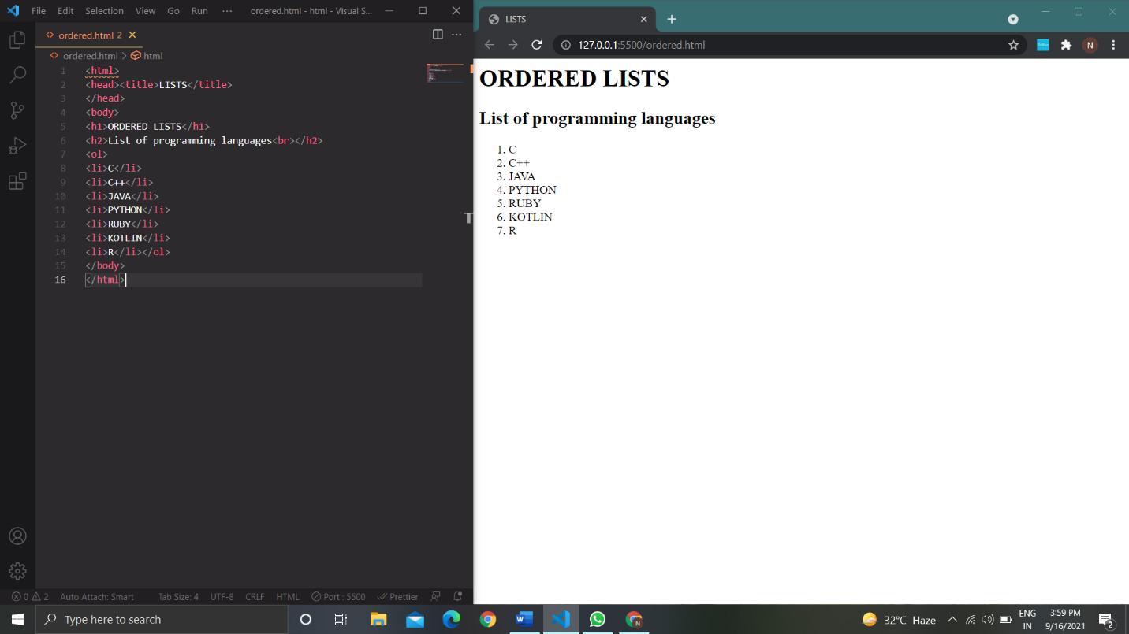

6.unordered lists

<html>

<head><title>LISTS</title>

</head>

<body>

<h1>UNORDERED LISTS</h1>

<h2>List of programming languages<br></h2>

<ul>

<li>C</li>

<li>C++</li>

<li>JAVA</li>

<li>PYTHON</li>

<li>RUBY</li>

<li>KOTLIN</li>

<li>R</li></ul>

</body>

</html>

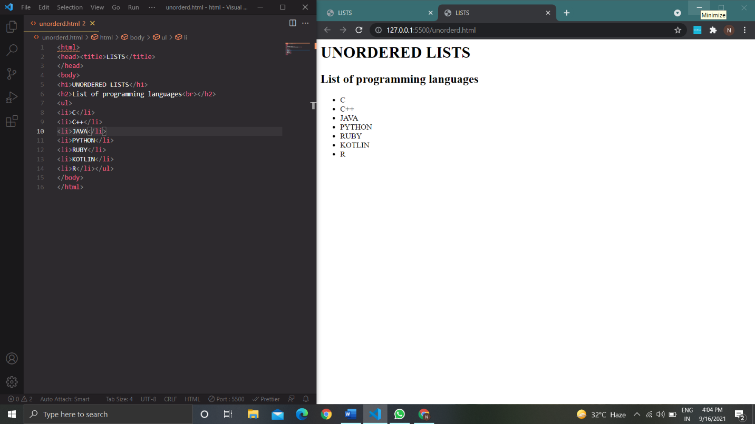

Definition lists

<html>

<head><title>LISTS</title>

</head>

<body>

<h1>DEFINITION LISTS</h1>

<h2>List of programming languages<br></h2>

<dl>

<dt>C</dt>

<dd>developed by Dennies M.Ritchie</dd>

<dd>in 1972 at Bell Laboratories.</dd>

<dt>C++</dt>

<dd>developed by Bjarne Stroustrup</dd>

<dd>in early 1980's</dd>

<dt>JAVA</dt>

<dd>developed by James Gosling</dd>

<dd>in 1995</dd>

<dt>PYTHON</dt>

<dd>developed by Guido van Rossum</dd>

<dd>in 1991</dd>

<dt>RUBY</dt>

<dd>developed by Yukihiro “Matz” Matsumoto</dd>

<dd>in mid 1990's</dd>

<dt>KOTLIN</dt>

<dd>developed by JetBrains</dd>

<dd>in february 2016</dd>

<dt>R</dt>

<dd>developed by Robert Gentleman and Ross Ihaka</dd>

<dd>first appeared in August 1993</dd>

</dl>

</body>

</html>

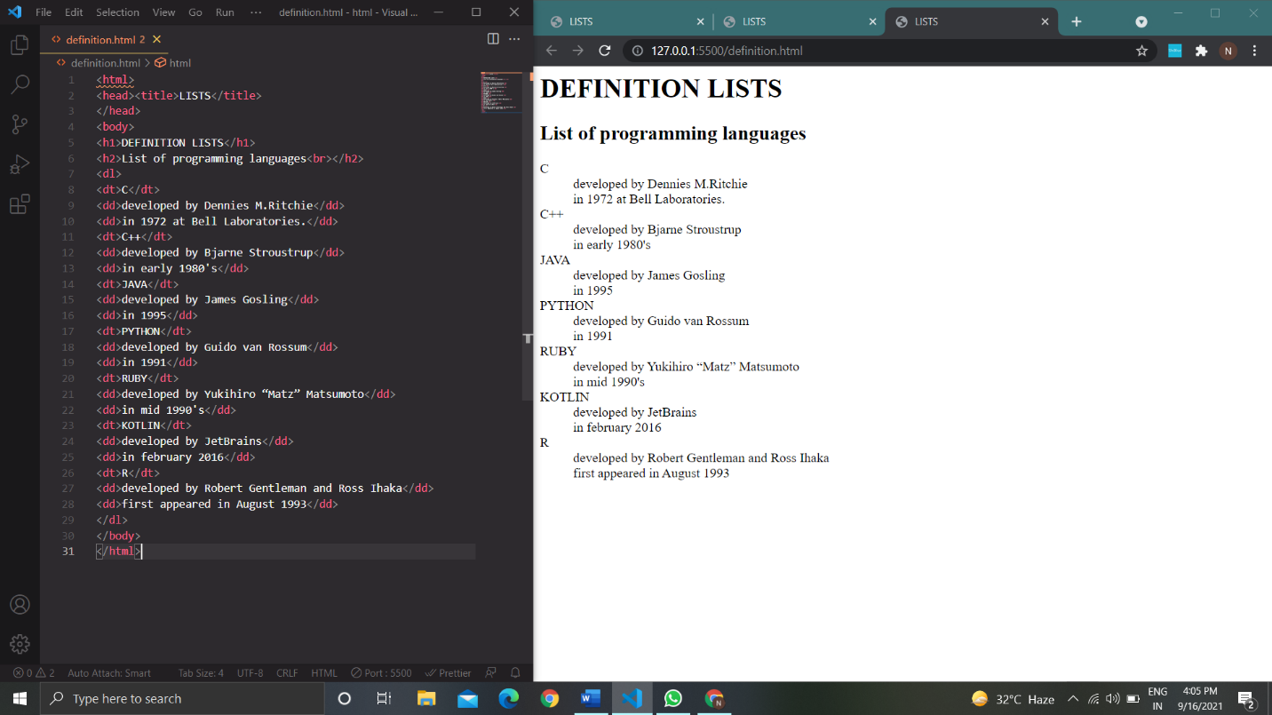

Nested lists

<html>

<head><title>LISTS</title>

</head>

<body>

<h1>NESTED LISTS</h1>

<h2>List of programming languages<br></h2>

<ol>

<li>C</li>

<ul>

<li>developed by Dennies M.Ritchie</li>

<li>in 1972 at Bell Laboratories.</li>

</ul>

<li>C++</li>

<ul>

<li>developed by Bjarne Stroustrup</li>

<li>in early 1980's</li>

</ul>

<li>JAVA</li>

<ul>

<li>developed by James Gosling</li>

<li>in 1995</li>

</ul>

<li>PYTHON</li>

<ul>

<li>developed by Guido van Rossum</li>

<li>in 1991</li>

</ul>

<li>RUBY</li>

<ul>

<li>developed by Yukihiro “Matz” Matsumoto</li>

<li>in mid 1990's</li>

</ul>

<li>KOTLIN</li>

<ul>

<li>developed by JetBrains</li>

<li>in february 2016</li>

</ul>

<li>R</li>

<ul>

<li>developed by Robert Gentleman and Ross Ihaka</li>

<li>first appeared in August 1993</li>

</ul>

</ul>

</body>

</html>

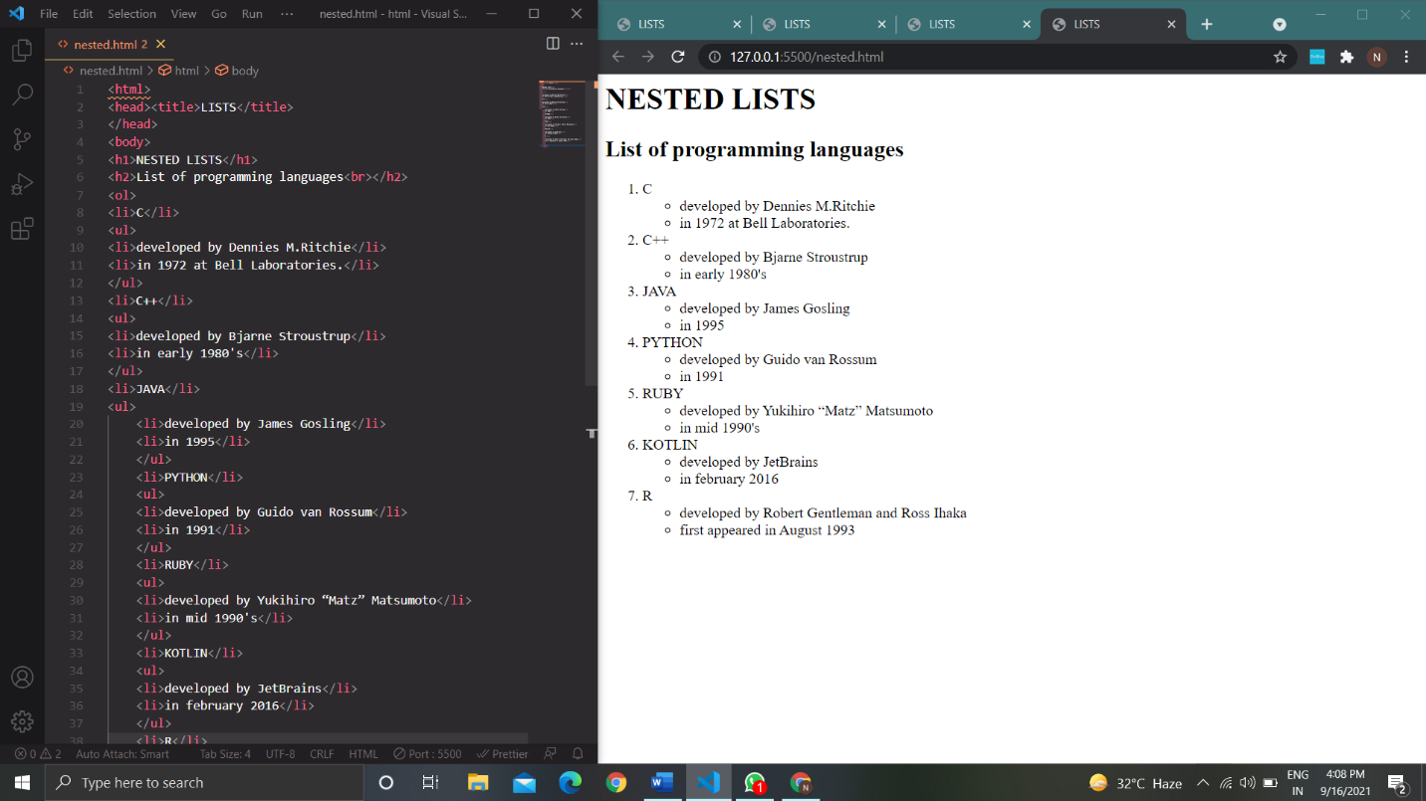

11.Forms

<html>

<head>

<title>COLLEGE APPLICATION</title>

</head>

<body>

<form>

<br>

<img src="welcome.jpg" height="100" width="300" alt="welcome to registration"><br>

<fieldset>

<legend>YOUR DETAILS HERE [CREATED BY 319126511095]</legend>

<label for="firstname">FIRST NAME:</label><input type="text" name="firstname"><br>

<br>

<label for="lastname">LAST NAME:</label> <input type="text" name="lastname"><br>

<br>

<label for="date of birth">Date Of Birth:</label> <input type="date" id="dob" name="dob"

min="1999-01-01" max="2006-01-01"><br>

<br>

<label for="father name">FATHER NAME:</label> <input type="text" name="fathername"><br>

<br>

<label for="father occupation">FATHER OCCUPATION:</label> <input type="text"

name="occupation"><br>

<br>

<label for="gender">GENDER:</label> <input type="radio" name="gender" value="male"/>Male

<input type="radio" name="gender" value="female"/>Female

<input type="radio" name="gender" value="Others"/>Others<br>

<br>

<label for="Income Per Annum">INCOME PER ANNUM:</label> <input type="radio"

name="income per annum" value="below5lac">Below 5 Lac

<input type="radio" name="income per annum" value="between 5to10 lac">Between 5to10 Lac

<input type="radio" name="income per annum" value="above 15 lac">Above 15 Lac<br>

<br>

<label for="eamcet">EAMCET RANK:</label> <input type="text" name="eamcet"><br>

<br>

<label for="mains">ALL INDIA JEE MAINS RANK:</label> <input type="text" name="jee"><br>

<br>

<label for="branch">INTRESTED BRANCHES:</label><br>

<input type="checkbox" name="BIOTECH" value="BIOTECH">

<label for="BIOTECCH">BIOTECH</label><br>

<input type="checkbox" name="CHEMICAL" value="CHEMICAL">

<label for="CHEMICAL">CHEMICAL</label><br>

<input type="checkbox" name="CIVIL" value="CIVIL">

<label for="CIVIL">CIVIL</label><br>

<input type="checkbox" name="CSE" value="CSE">

<label for="CSE">CSE</label><br>

<input type="checkbox" name="ECE" value="ECE">

<label for="ECE">ECE</label><br>

<input type="checkbox" name="EEE" value="EEE">

<label for="EEE">EEE</label><br>

<input type="checkbox" name="IT" value="IT">

<label for="IT">IT</label><br>

<input type="checkbox" name="MECH" value="MECH">

<label for="MECH">MECH</label><br>

<br>

<label for="category">CATEGORY:</label>

<select name="category" id="select_category" style="width:160px">

<option value="OC">OC</option>

<option value="OBC">OBC</option>

<option value="SC">SC</option>

<option value="ST">ST</option>

<option value="OTHER">OTHER</option>

</select>

<br>

<input type="submit" value="submit">

</fieldset>

</form>

</body>

</html>