public class Account {

private double balance = 500.00; // State/variable

public double getBalance(int accountId) { // Behaviour/method

// logic here

return balance;

}

public static void main(String[] args) { // main method

Account accnt = new Account(); // Object creation

double value = accnt.getBalance(123456); // Method invocation

System.out.println("The balance is: " + value);

}

}

Output

PS C:\Users\student\Desktop\javaoops> javac Account.java

PS C:\Users\student\Desktop\javaoops> java Account

The balance is: 500.0

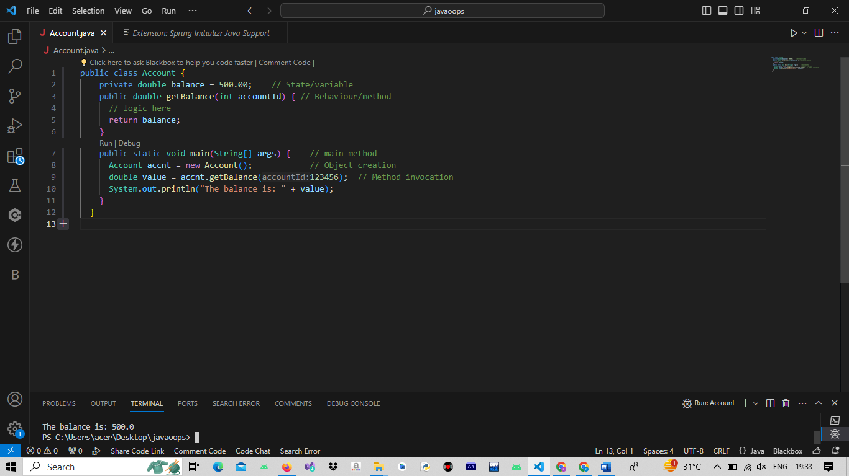////////////////////////////////////////////////////////////////////////////////////////////////////

class Aaccount {

private double balance = 500.00; // member data

public double getBalance(int x) { // member method

// logic here

return balance;

}

public static void main(String[] args) {

Aaccount accnt = new Aaccount(); // object creation

double value = accnt.getBalance(123456);

System.out.println("The balance is: " + value);

}

}

Output

PS C:\Users\student\Desktop\javaoops> javac Aaccount.java

PS C:\Users\student\Desktop\javaoops> java Aaccount

The balance is: 500.0

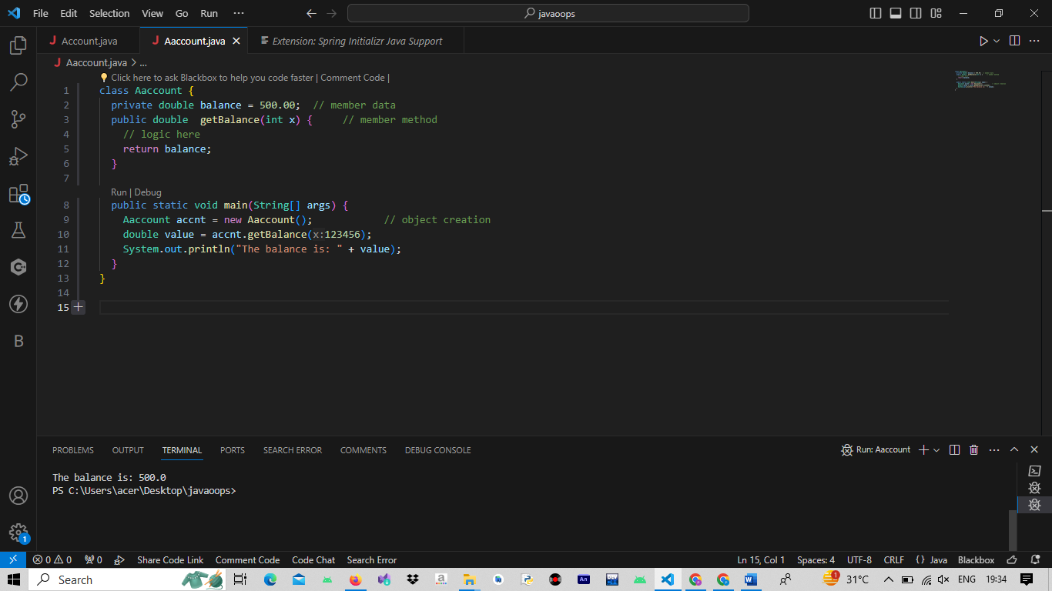///////////////////////////////////////////////////

public class Account {

private double balance = 500.00;

public double getBalance(int accountId) {

// logic here

return balance;

}

public static void main(String[] args) {

Account accnt = new Account();

double value = accnt.getBalance(123456);

System.out.println(accnt.balance);

System.out.println("The balance is: " + value);

}

}

Output

PS C:\Users\student\Desktop\javaoops> javac Account.java

PS C:\Users\student\Desktop\javaoops> java Account

500.0

The balance is: 500.0

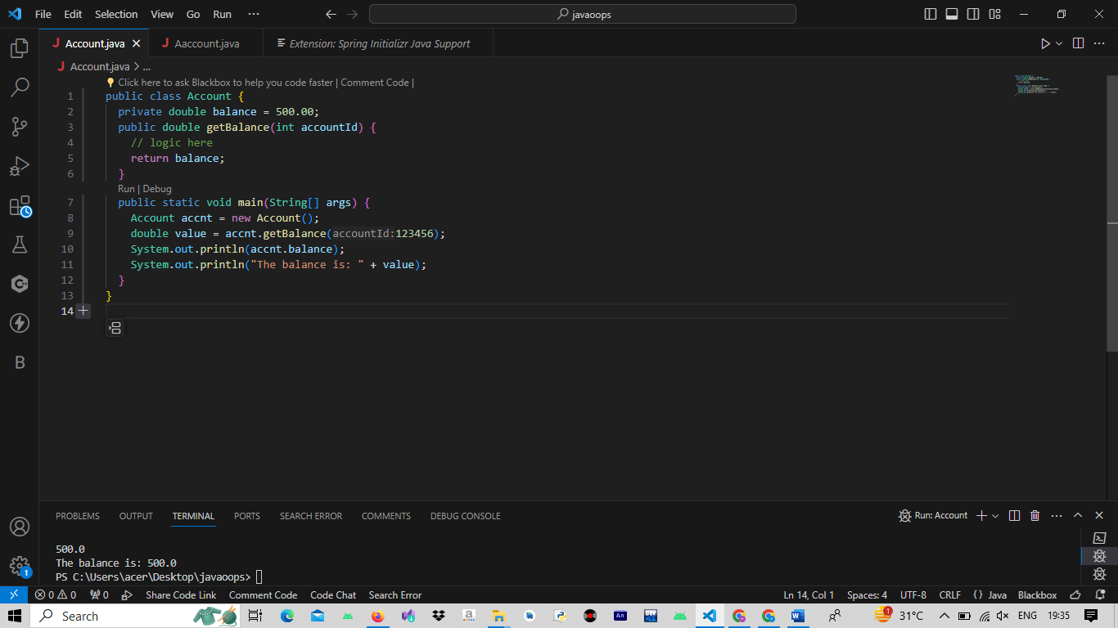

/////////////////////////

public class Account {

private double balance = 500.00; // instance variable

static int minimumBalance = 200; // static variable

public double getBalance(int accountId) {

int withdrawal = 500; // local variable

return balance - withdrawal;

}

public static void main(String[] args) {

Account accnt = new Account();

double value = accnt.getBalance(123456);

System.out.println(accnt.balance);

System.out.println("The balance is " + value);

}

}

PS C:\Users\student\Desktop\javaoops> javac Account.java

PS C:\Users\student\Desktop\javaoops> java Account

500.0

The balance is 0.0

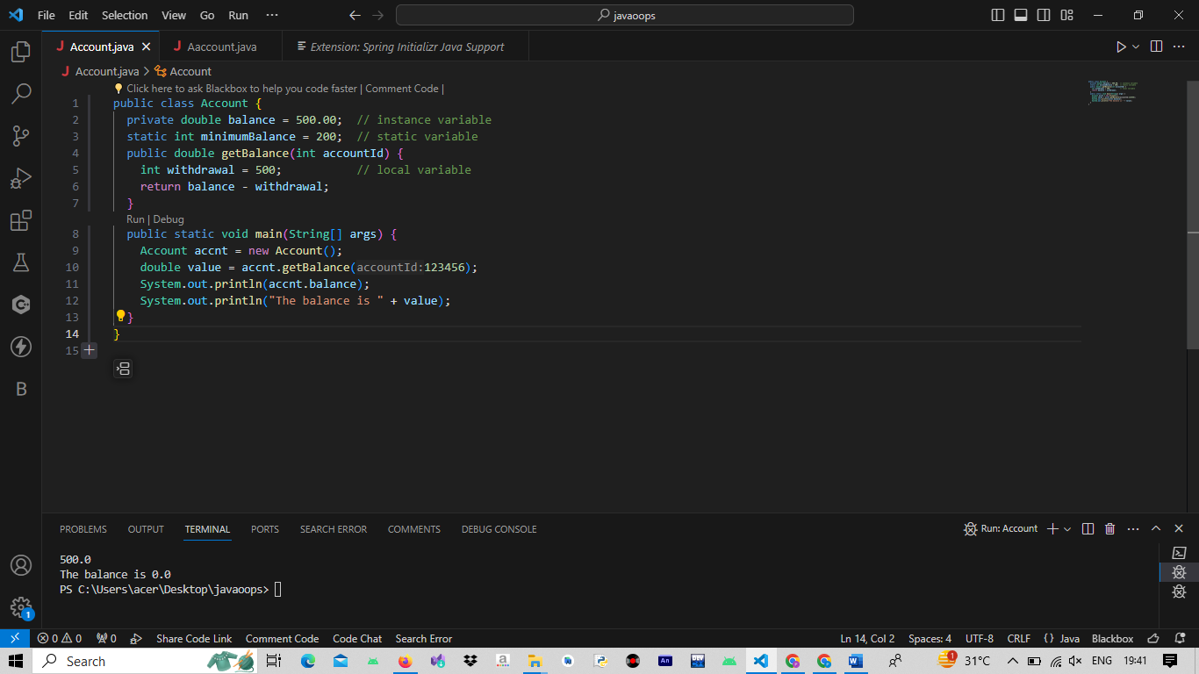

////////////////////////////////////////////

class Account {

public static void main(String[] args) {

double balance = 600;

System.out.println("Amount to withdraw");

double amount = 1500;

if(amount < 0 || amount > balance) {

System.out.println("Withdrawal has failed");

}

else {

balance -= amount;

System.out.println("Withdrawal has succeeded");

}

}

}

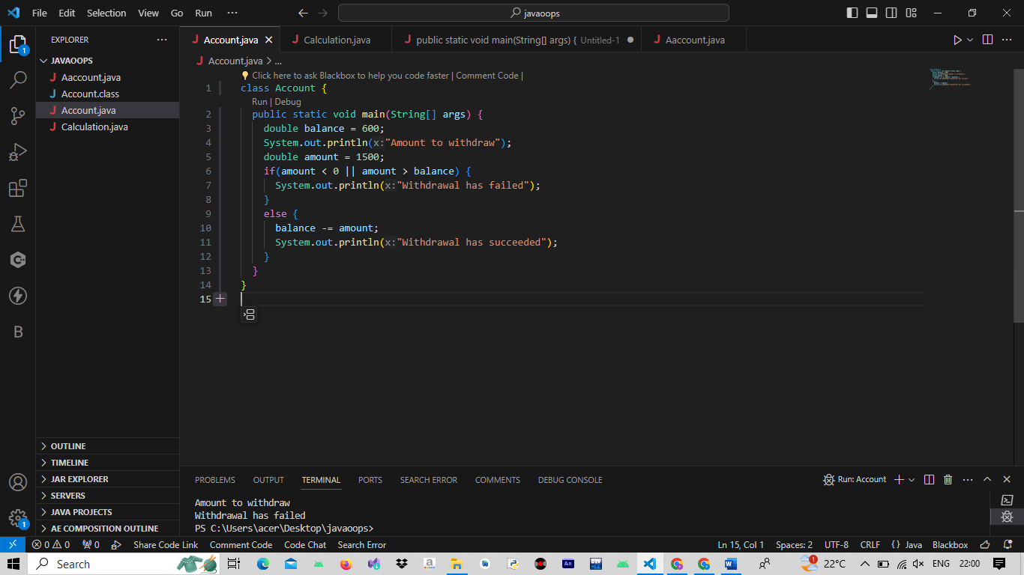

////////////////////////////////////////////////

class Account {

public static void main(String[] args) {

double balance = 2000;

System.out.println("Amount to withdraw");

double amount = 500, limit = 10000, minbal = 500;

if(amount <= limit && (balance - amount) > minbal) {

balance -= amount;

System.out.println("Withdrawal has succeeded");

}

}

}

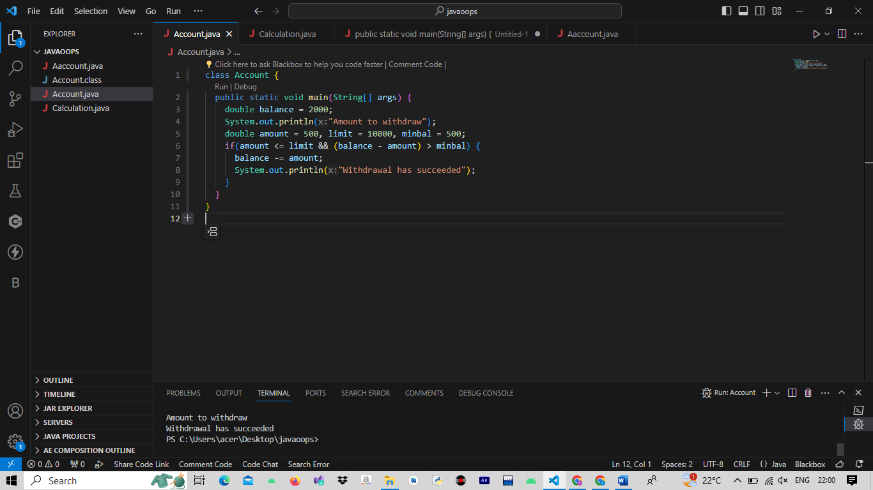

//////////////////////////////////////////////////////////////////

public class Calculation{

public static void main(String[] args){

double d = 234.04;

long l = (long)d; //explicit type casting

int i = (int)l; // explicit type casting

System.out.println("double value :"+d);

System.out.println("long value :"+l);

System.out.println("int value :"+i);

}

}

PS C:\Users\student\Desktop\javaoops> java Calculation

double value :234.04

long value :234

int value :234

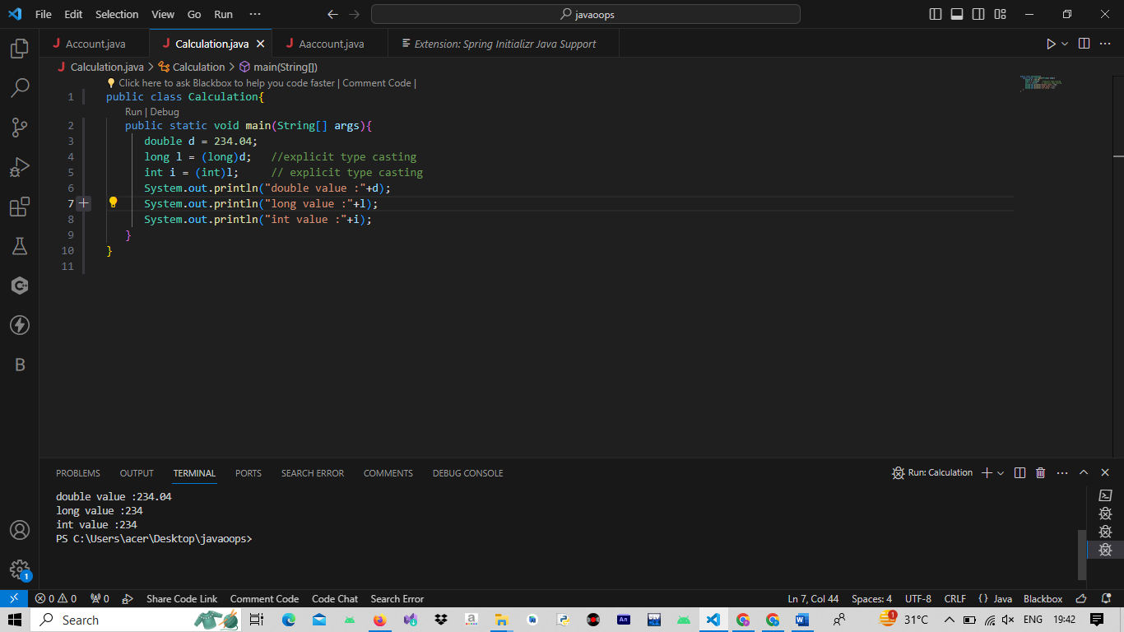

////////////////////////////////////////////////////

public class Calculation{

public static void main(String[] args){

int i = 300;

long l = i; //no explicit type casting

float f = l; //no explicit type casting

System.out.println("int value :"+i);

System.out.println("long value :"+l);

System.out.println("float value :"+f);

}

}

PS C:\Users\student\Desktop\javaoops> javac Calculation.java

PS C:\Users\student\Desktop\javaoops> java Calculation

int value :300

long value :300

float value :300.0

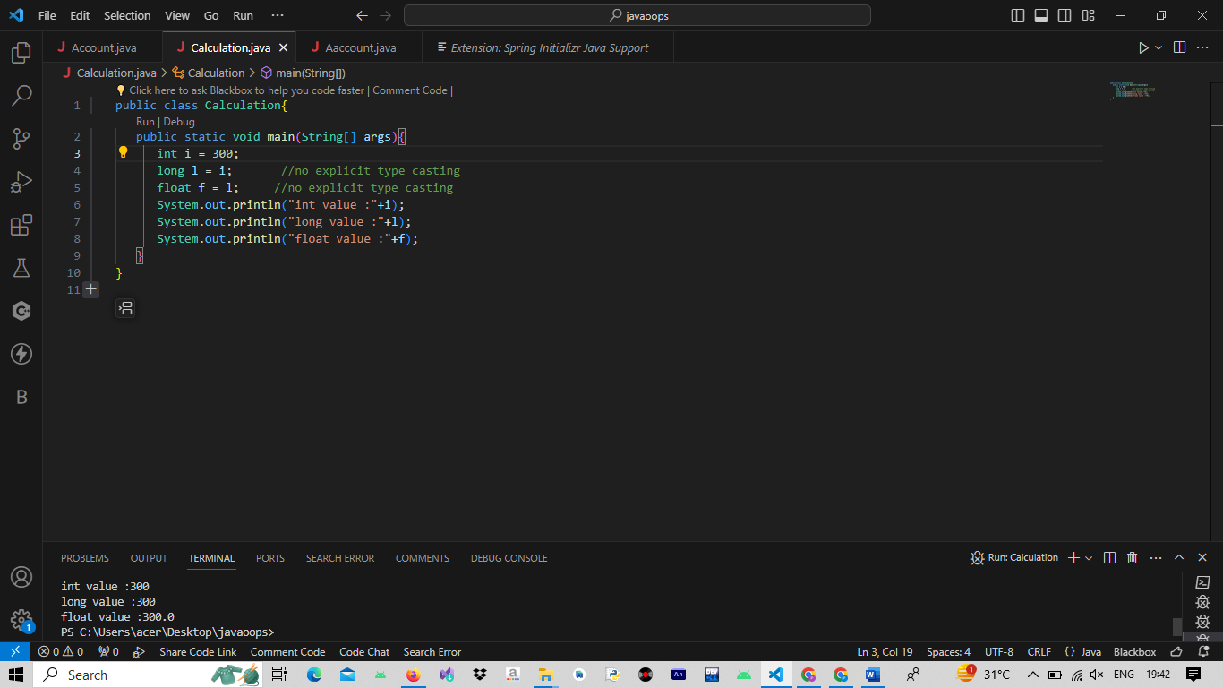

////////////////////////////////////////////////////////////

public class StudentTester {

private static class Student {

private int studentId;

private String name;

private float qualifyingExamMarks;

private char residentialStatus;

private int yearOfEngg;

// Getter and Setter methods for studentId

public int getStudentId() {

return studentId;

}

public void setStudentId(int studentId) {

this.studentId = studentId;

}

// Getter and Setter methods for name

public String getName() {

return name;

}

public void setName(String name) {

this.name = name;

}

// Getter and Setter methods for qualifyingExamMarks

public float getQualifyingExamMarks() {

return qualifyingExamMarks;

}

public void setQualifyingExamMarks(float qualifyingExamMarks) {

this.qualifyingExamMarks = qualifyingExamMarks;

}

// Getter and Setter methods for residentialStatus

public char getResidentialStatus() {

return residentialStatus;

}

public void setResidentialStatus(char residentialStatus) {

this.residentialStatus = residentialStatus;

}

// Getter and Setter methods for yearOfEngg

public int getYearOfEngg() {

return yearOfEngg;

}

public void setYearOfEngg(int yearOfEngg) {

this.yearOfEngg = yearOfEngg;

}

}

public static void main(String[] args) {

// Create an object of Student class

Student student1 = new Student();

// Use setter methods to set the values

student1.setName("Jacob");

student1.setStudentId(1001);

student1.setQualifyingExamMarks(80.0f);

student1.setYearOfEngg(3);

student1.setResidentialStatus('H'); // 'H' for Hosteller

// Use getter methods with proper escape sequences to display values

System.out.println("Output:");

System.out.println("Student Name : " + student1.getName());

System.out.println("Student Id : " + student1.getStudentId());

System.out.println("Qualifying marks : " + student1.getQualifyingExamMarks());

System.out.println("Year of Engineering: " + student1.getYearOfEngg());

System.out.println("Residential status : " + (student1.getResidentialStatus() == 'H' ? "Hostellers" : "Day Scholar"));

}

}