Breastfeeding behaviors predicted by neighborhood deprivation

Authors: Shannon C. Conrey, Katie M. Santanello, Allison R. Cline, Cole Brokamp, Alexandra M. Piasecki, Mary A. Staat, Daniel C. Payne, Ardythe L. Morrow

Breastfeeding (BF) confers many benefits, including reduced maternal and infant disease risk. Socio-economic status is associated with BF initiation and duration, but there is limited study of community-level predictors of BF. We analyzed data from a birth cohort in Cincinnati to examine the impact of residing in a low-SES neighborhood as a predictor of BF success.

Subject addresses from the Pediatric Respiratory & Enteric Viral Acquisition and Immunogenesis Longitudinal (PREVAIL) cohort (*n*=240), a CDC-sponsored birth cohort in Cincinnati, OH, were geocoded and assigned a Deprivation Index score, a composite of census-tract factors (population percentage ≤ federal poverty level, ≥ HS education, without health insurance, and on federal income assistance; median household income, and fraction of properties vacant). BF initiation and duration, determined via periodic surveillance, were compared by deprivation index quartile (DIQ) and score.

As expected, maternal race, income, education level, and marital status differed significantly by DIQ (all *p*<0.001). DIQ (Q1 to Q4, ranked from least to most neighborhood deprivation) was significantly associated with BF initiation (Q1 95.2%, Q2 93.1%, Q3 85.0%, Q4 71.7%*, p*<0.001) and BF at least 2 weeks (Q1 93.5%, Q2 87.9%, Q3 73.3%, Q4 56.7%, *p*<0.001). Kaplan Meier survival analysis found significant decreases in the median BF duration by increasing DIQ (Q1=300 days, Q2=144 days, Q3=93 days, Q4=62 days, *p*=0.004) and significantly different areas under the curve (*p*<0.001) based on comparison of all who initiated BF. Proportional hazard models including deprivation index score, maternal race, age, and marital status found that non-white mothers (*p*=0.002) and those with higher deprivation index scores (*p*=0.04) were at higher risk for early breastfeeding cessation. Cox models using deprivation index scores were concordant with models using only individual-level SES variables.

Women in low income neighborhoods, particularly women who identified as non-white, initiated and maintained BF at lower rates than women residing in higher income neighborhoods in the PREVAIL cohort. As maternal race combined with neighborhood DIQ predicted breastfeeding behavior as well as individual SES and demographic variables, neighborhood deprivation scores could be a powerful tool to target and locate breastfeeding support as a strategy to improve breastfeeding initiation and duration in high risk populations.

Character count 2460 with spaces

**Breastfeeding duration in days by deprivation index quartile**

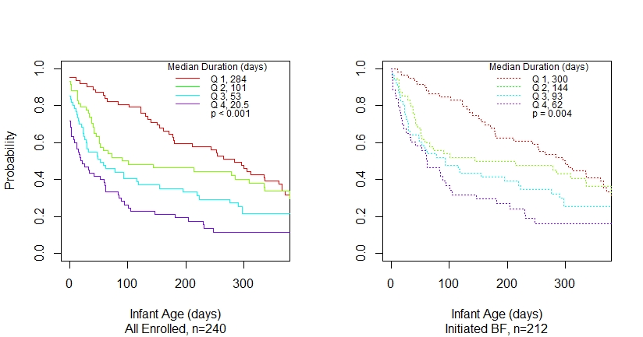

**Figure 1:** Kaplan Meier survival curves of breastfeeding duration in days by deprivation index quartile membership, with quartile 1 (Q1) representing the lowest deprivation/highest socio-economic status census tracts and quartile 4 (Q4) representing the highest deprivation/lowest socio-economic status census tracts. Areas under the curve are significantly different when comparing all enrolled (left, *p*<0.001) and those who initiated breastfeeding (right, *p*=0.004, log likelihood test).

**Cox proportional hazard models**

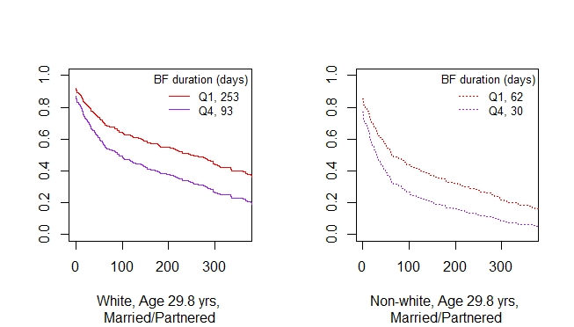

**Figure 2:** Cox proportional hazard models found significant differences in breastfeeding duration by maternal race (white or non-white, *p*=0.002) and deprivation index score (*p*=0.04) when controlling for maternal age and marital status (married/partnered or single). Plots show predicted probabilities of breastfeeding duration for a married/partnered white and non-white subject of the mean age of 29.8 years with the mean deprivation index score in the first (0.24) and fourth (0.68) quartiles.