JAINI NANDU

**SPORTS & PERFORMANCE PSYCHOLOGIST**

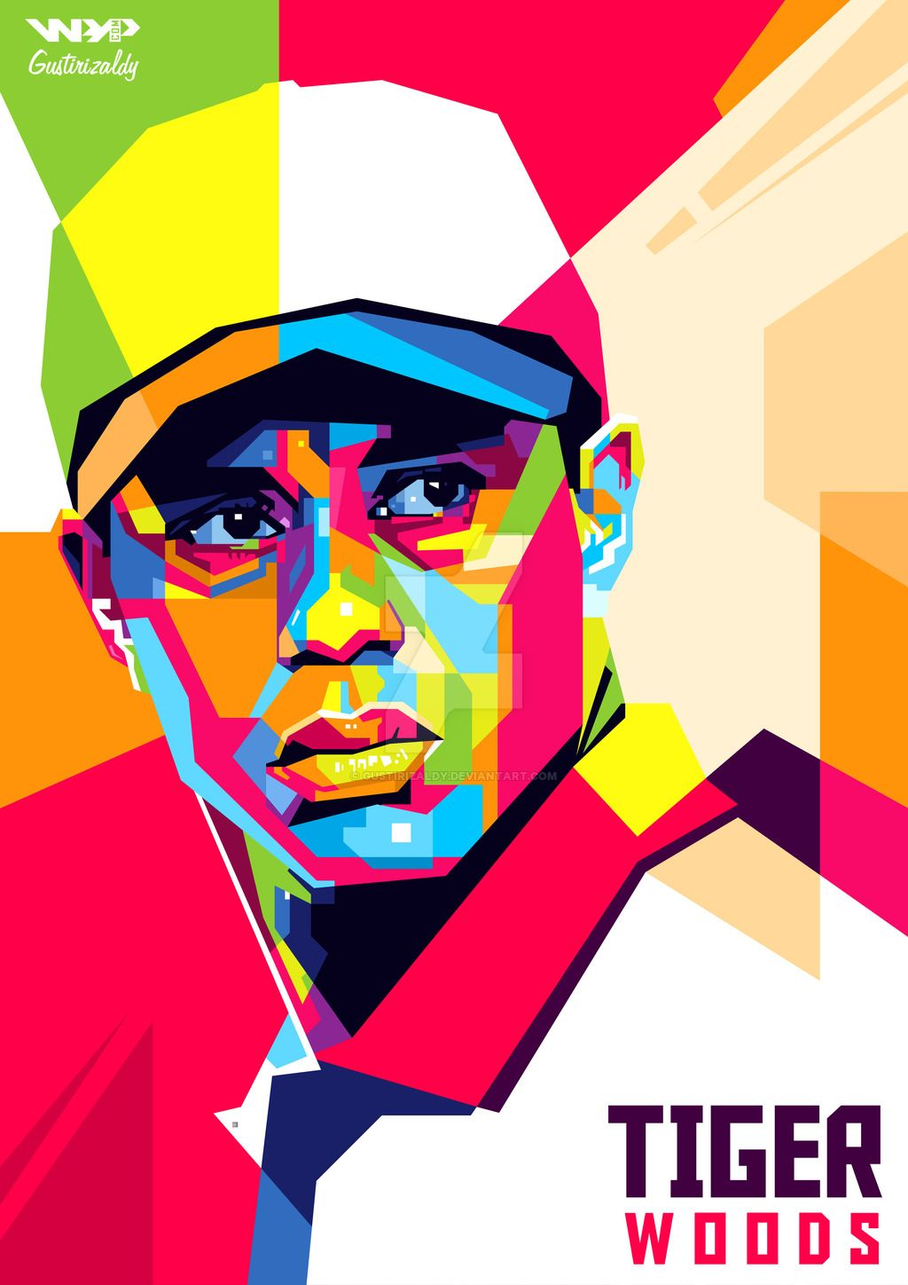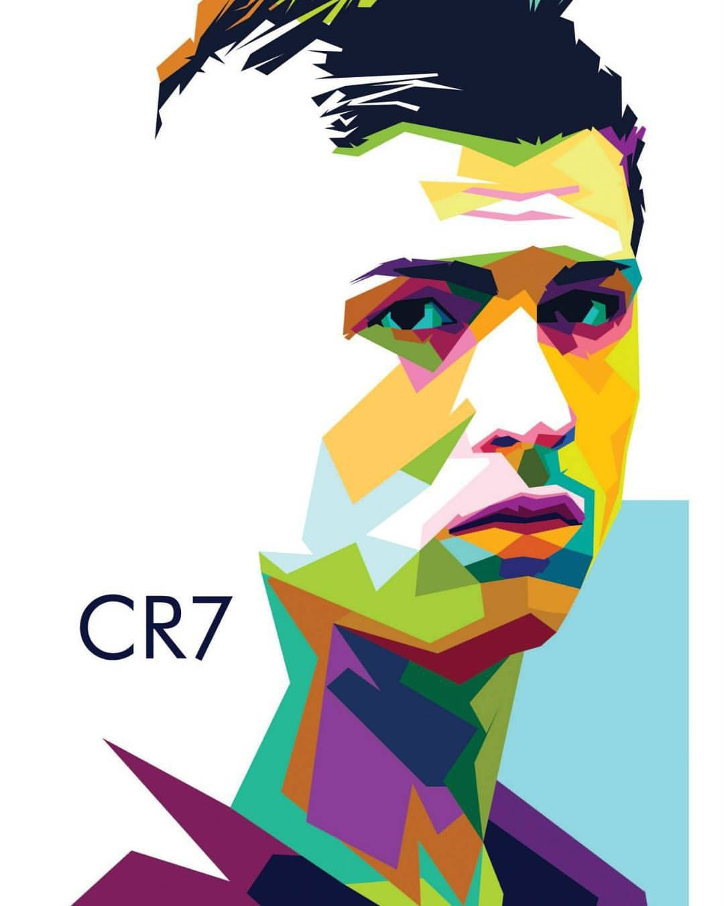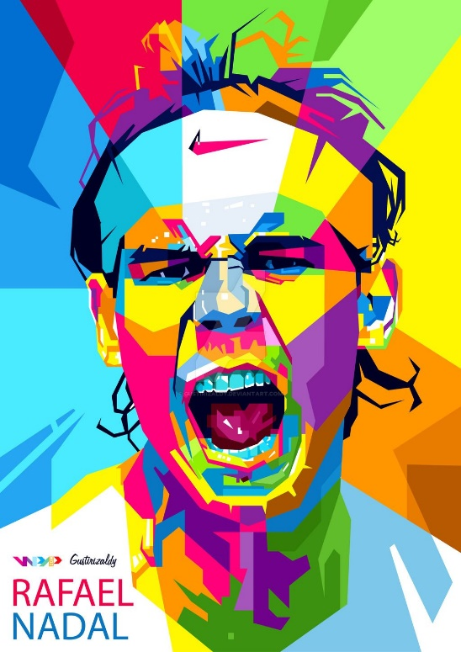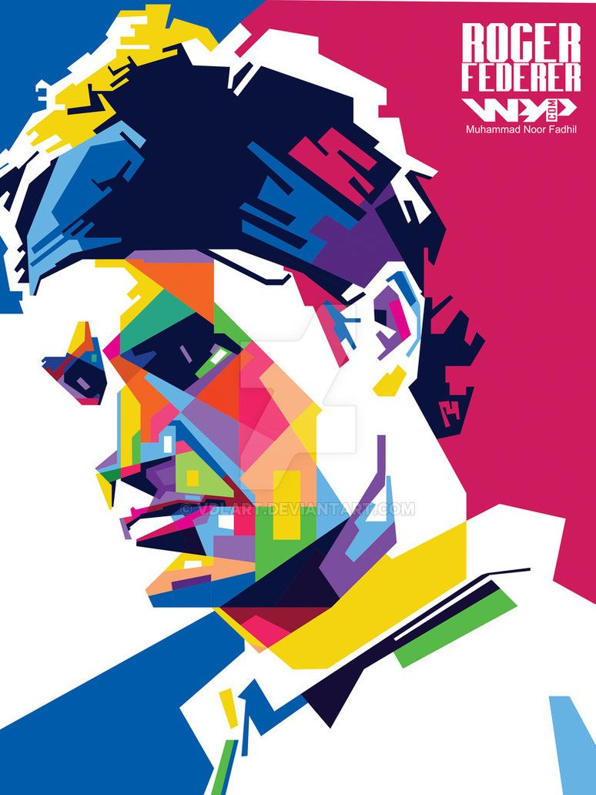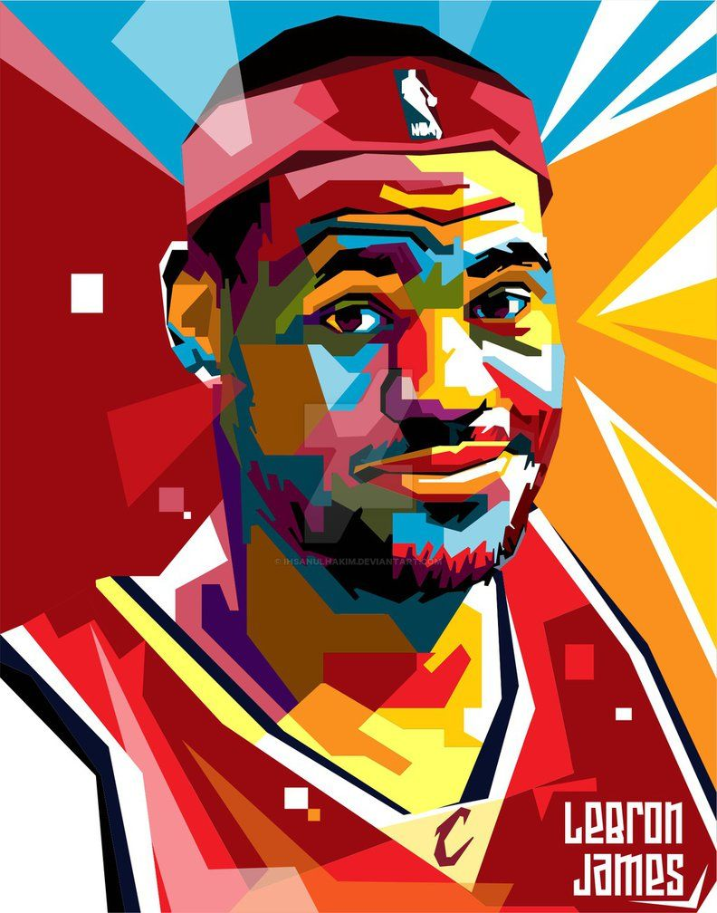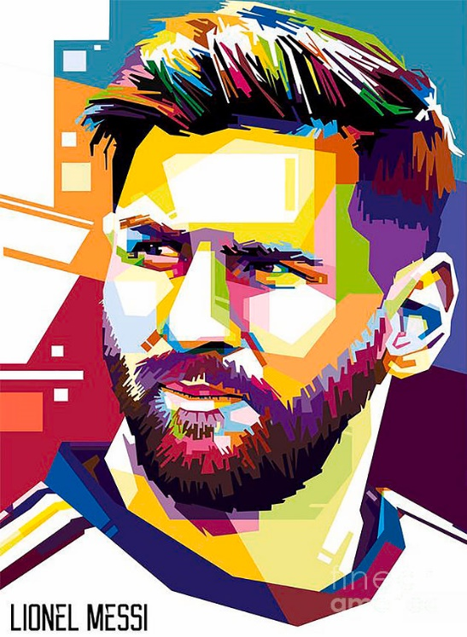

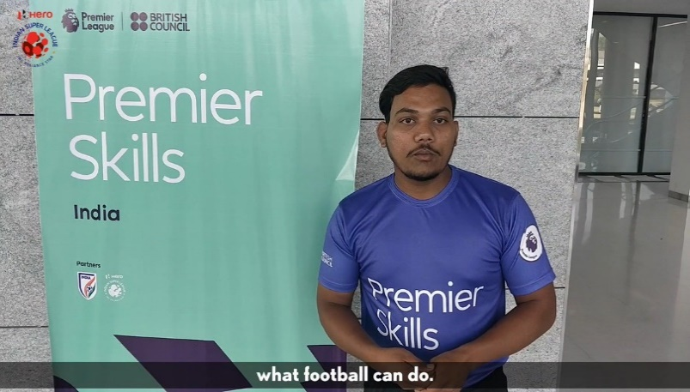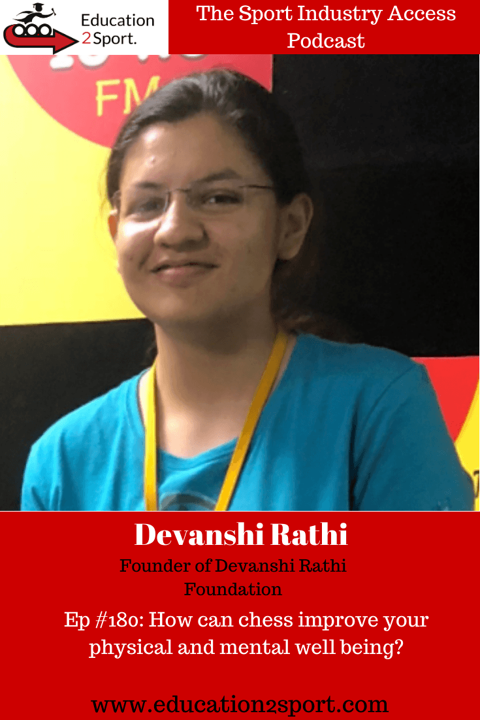

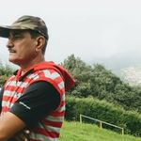 ’’

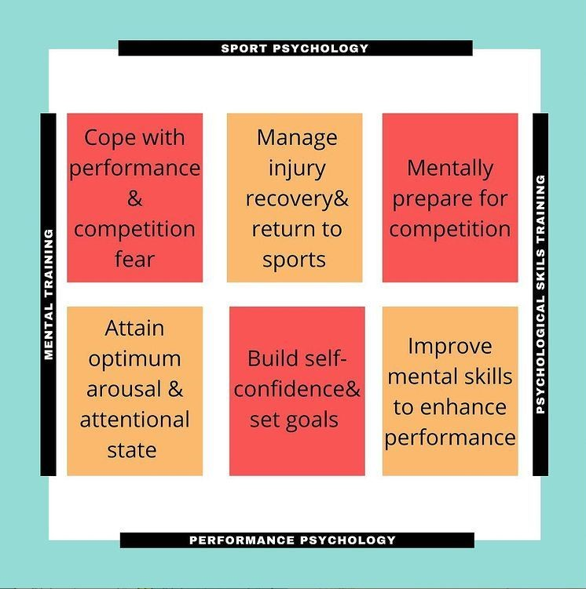





INSTAGRAM



* Deal with barriers that blocks exercise participation.
* Deal with body image & eating disorders.
* Increase Exercise motivation and enjoyment.

For Coaches

Click here

Email Symbol png download - 980*736 - Free Transparent Email png Download.  - CleanPNG / KissPNG Monday to Saturday – 10 am to 6 pm



* Deal with barriers that blocks exercise participation.
* Deal with body image & eating disorders.
* Increase Exercise motivation and enjoyment