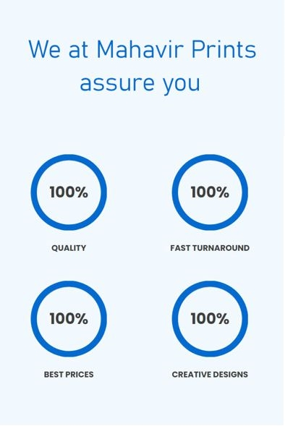



100 %

100 %

100 %

100 %

CREATIVE DESIGNS

BEST PRICES

QUALITY

FAST TURNAROUND

We at Mahavir Prints assure you



**Creative Designs 100%**

**Quality Prints 100%**

**Fast Turnaround 100%**

**Best Prices 100%**

