**NAZRI RESIDENCY**



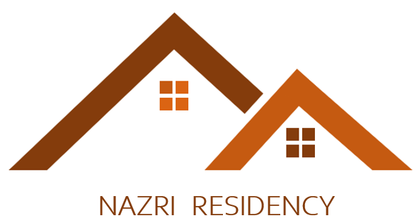



**NAZRI RESIDENCY**





**AZRI ESIDENCY**





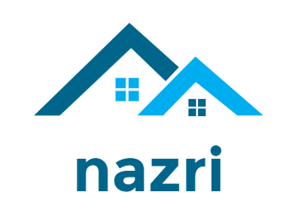



Total number of Apartments : 11

Type of rooms available : - 1 BHK

- 2BHK

Parking Facilities : Car Park - ₹1000/Month

Bike Park - Free

Rental Type : Long term basis

Wi-Fi Facilities : Free