PRIDE Converter design specification

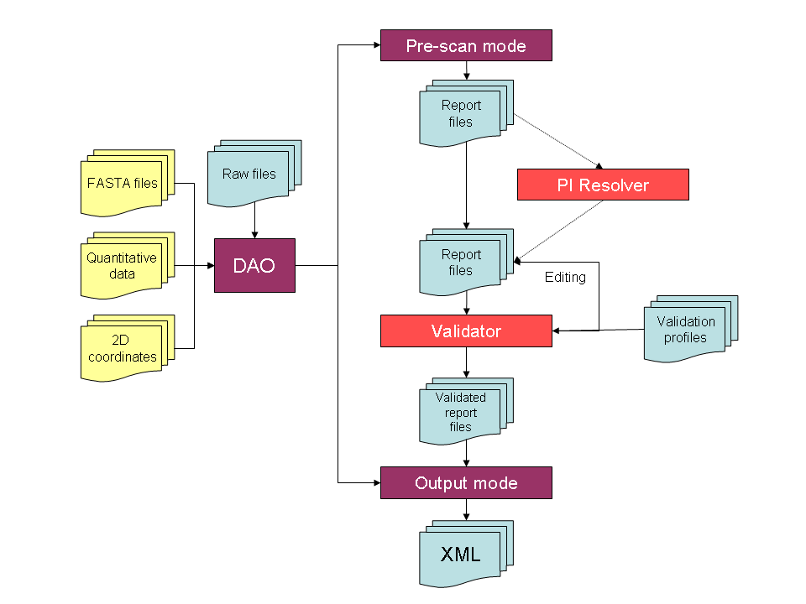

PRIDE Converter (PC) will work as a command-line application with two modes, pre-scan and output. In pre-scan mode, a search-engine-specific Data Accessor Object (DAO) will parse each raw file to extract as much information as possible prior to the actual conversion and output into XML files, done in the output mode. The DAO will require, at minimum, one raw search engine output file. Optional files for quantitative data annotations, 2D gel coordinates and FASTA files for unconventional protein accessions and sequences can also be used by the DAO, as required by either mode.

The pre-scan mode will produce one report file per input raw file. While this might lead to information duplication, this will simplify external scripting pipelines and manual data editing. The report files will contain as much information as can be extracted from the raw files and optional files and will include all annotated PTMs, metadata on samples, instrumentation, etc and information on protein inference. PC will implement a “default” setting that should cover most basic use-cases, where all peptide-to-protein assignments will be reported. Should the user wish to curate this date or apply a different algorithm, other protein inference resolvers could be applied as separate, optional, tools. The results from these algorithms will be stored in the report file, as well as the metadata indicating which algorithm was used.

The report files generated by the pre-scan mode can undergo several rounds of editing and validation using a validator module, configured for a specific target (minimum PRIDE standard, MIAPE, journal profiles, etc). The validation profile used will also be stored as metadata in the report files. Users can manually edit the report files after each iteration to add/edit/update any of the information mentioned above. Validation will occur prior to the actual time-consuming conversion.

Once the validation is completed to a satisfactory level, PC can be invoked in output mode. In this mode, it will use the validated report files and the DAO to generate well annotated and validated PRIDE XML file. The output mode can heavily re-use code written for the PRIDE XML dump code, which already uses the PRIDE JAXB object model to marshall out arbitrarily-large XML files in a streaming fashion, thus minimizing the memory requirements.

The design of PC is modelled on the unix toolchain design pattern, where each component is small and performs one single task efficiently. Tools can then be chained to produce a complex set of end results, depending on which tool is used. A further advantage of the toolchain design pattern is that all of the tools can be worked on independently of each other.

The PC GUI will be a completely separate component which will simply be a layer above the core PC API and will provide convenience mechanisms to edit the report files generated in the pre-scan mode and provide graphical feedback on validation status during the iterative validator runs. Users will have the possibility to edit fields across all report files at once or page through the reports to edit distinct fields.

Other tools will include a PRIDE XML merger tool, which can combine several XML files into a single output file while ensuring that all internal ID/IDREFs are coherently maintained and a PRIDE XML filter tool, which can remove spectra or identifications based on arbitrary criteria (spectrum “quality”, protein accession, number of peptides, etc). PRIDE cleaner can also have a PICR component to map submitted protein sequences to UPIs to reduce XML file size.

Execution plan

- Use PRIDE XML dump code to extract interfaces required to build JAXB object model
- Use output mode interfaces to define DAO data element requirements
- Define report format and syntax
- Implement PRIDE validator for minimum PRIDE standards
  - Other validation profiles can be written as required
- Define quantitative data format
- Define 2D gel coordinate format
- create DAO implementation for Mascot using the Mascot API as a prototype implementation
- Create DAO implementations for other formats in order of priority
  - We will need to create a repository of source files for each version of each supported software to create as wide a test-bed as possible.
  - We will need to investigate which existing APIs can be used, improved or written from scratch.

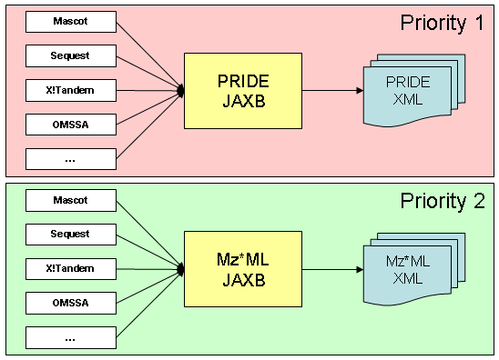

The execution plan will first focus on developing DAO implementations for PRIDE XML and then re-use these implementations as a starting point to generate Mz*ML. The reason for this is mostly pragmatic. We can already re-use a large volume of code to generate PRIDE XML and the PRIDE JAXB intermediate object model is already being used in anger and requires no additional work to make use of it. This is not the case for the Mz*ML APIs, where significant debugging work will probably be needed, above and beyond the DAO development work. If we have solid DAO implementations for the formats we wish to support, these can be used to minimize the development work to port them to the Mz*ML intermediate object model.

