Introducción

La presente investigación parte de la idea de determinar la solvencia financiera del sector o industria cementera de Bolivia, es decir, hasta que nivel haciende la capacidad de dicha industria para hacer frente a sus obligaciones, para lo cual en primer término se delimita el marco teórico con el objeto de restringir el concepto de solvencia financiera asociada a la capacidad de pago y comportamiento de pagos de cargos financieros del periodo 2007-01-31 a 2023-12-31. Respecto a la fuente de los datos corresponden a los estados financieros de las principales cementeras del país (SOBOCE, FANCESA y ITACAMBA). Los resultados son presentados por medio de series de tiempo y estadísticas de resumen, donde los cálculos son procesados mediante funciones construidas en el lenguaje de programación R, con el fin de determinar hasta qué punto podría endeudarse la industria restringido por sus flujos de efectivo generado por periodo, así también, se presenta algunos hechos particulares encontrados.

# Sustento teórico

Iniciando con el marco conceptual de los métodos aplicados para determinar la capacidad financiera del sector cementero de Bolivia, se nombra al denominado como “capacidad de pago”, sobre el cual no existe un consenso genérico o procedimiento único de como medir dicha magnitud, pero este puede entenderse como:

La probabilidad existente de que una empresa o un individuo puedan incumplir con el pago de sus deudas con uno o varios acreedores. Esta magnitud se usa como un indicador que trata de medir la solvencia de la compañía frente a sus deudas, capacitando para la toma de decisiones en relaciones de endeudamiento con los distintos acreedores. Es un indicador muy utilizado, habitualmente, en el sector bancario. La capacidad que tiene este para medir el rating crediticio de una persona, le lleva a ser utilizado de forma reiterada para la evaluación en la aprobación, o negación, de créditos. (Coll Morales, 2020)

Por lo tanto, en el presente trabajo la capacidad de pago equivale a la solvencia financiera observada o la capacidad de hacer frente a sus obligaciones financieras efectivamente registradas, es decir, esta magnitud refleja el comportamiento de los pagos histórico del deudor o industria. Por otro lado, se tiene el concepto de “capacidad de endeudamiento” que según Sánchez Galán (2024) “La capacidad de endeudamiento es la cantidad de deuda máxima que puede asumir un individuo o empresa sin llegar a tener problemas de solvencia”, donde dicha capacidad puede restringirse a la capacidad de generación de flujos de caja positivos, donde si la cuota de gastos financieros sobrepasa este monto la industria tendría problemas para hacer frente a sus obligaciones.

# Métodos

Continuando con los detalles técnicos de la presente investigación se circunscribió al estudio del sector o industria cementera del periodo 31-01-2007 al 31-12-2023, donde los datos utilizados de dicha industria cementera corresponden a agrupaciones por unidad de tiempo de los estados financieros de SOBOCE, FANCESA y ITACAMBA que representan a las principales empresas del sector en el país. Ahora bien, la capacidad de pago o comportamiento de pagos del sector fue representado por la comparación de las siguientes magnitudes:

Seguido de la capacidad de endeudamiento que fue representado por el flujo de efectivo generado en un periodo, donde dicho efectivo se debe entender como aquellos activos más líquidos que pueden ser convertidos en dinero en un periodo menor a un mes:

Así también, la frecuencia de todas las series de tiempo es de intervalo mensual a menos que se señale lo contrario, donde los valores perdidos se interpolan por el algoritmo de intercepción de Hyndman y Khandakar (2008).

# Resultados

## Capacidad de endeudamiento

Los flujos de efectivo generados por la industria cementera de Bolivia por actividades asociadas a activos, pasivos y patrimonio a lo largo del tiempo se ilustran a continuación.

**FIGURA** Flujos de efectivo y equivalentes de efectivo generados por activo (FGPA), pasivo (FGPP) y patrimonio (FGPPAT) de la industria cementera de Bolivia, periodo contenido 2007-01-31 – 2023-12-31   
 (Expresado en bolivianos)



Fuente: Elaboración propia.

Donde se aprecia que los egresos de efectivo corresponden principalmente a actividades de activos (Ver tabla ), que se puede correlacionar con la partida de activos fijos que debido a la naturaleza del sector cementero incrementan periodo tras periodo, es decir, a mayor activo fijo (propiedades, plantas, terrenos, maquinarias, mobiliarios, equipos de transporte, etc) mayor será la capacidad de producción, que de la mano de una diligente administración repercutirá en mayores ingresos operacionales.

Continuando con las fuentes de financiamiento, el sector en promedio es financiado en mayor medida por pasivos, teniendo las siguientes puntualidades:

* SOBOCE y FANCESA en la mayor parte de sus periodos fueron principalmente financiados por actividades asociadas al patrimonio.
* El aparente sesgo de estos resultados puede atribuirse, en primera instancia a que la empresa ITACAMBA es principalmente financiada en sus resultados históricos por sus pasivos y no por el patrimonio.
* El segundo elemento es que se observa que en los últimos periodos el sector en general a aumentado su posición en pasivos y una disminución en activos fijos.

Ahora bien, con los datos se señala que la industria cementera de Bolivia posee en promedio un flujo de efectivo mensual de Bs.- 1155547.98, es decir, si los cargos financieros mensuales del sector sobrepasan este umbral podría empezar a tener problemas de solvencia, manteniendo constante otros aspectos de ingeniería financiera como tasas variables, derivados, etc.

**TABLA** Tendencia y estadísticas de resumen de flujos de efectivo y equivalentes de efectivo generados por activo (FGPA), pasivo (FGPP) y patrimonio (FGPPAT), periodo contenido 2007-01-31 – 2023-12-31   
 (Expresado en bolivianos)

|  |  |  |  |  |
| --- | --- | --- | --- | --- |
| **TIPO DE ENTIDAD** | **PROMEDIO** | **CV** | **MINIMO** | **MAXIMO** |
| FGPA | -25 575 913.1207 | -5.7652 | -792 833 127.5746 | 371 750 024.6386 |
| FGPP | 13 766 449.4639 | 5.0460 | -121 292 932.5385 | 322 897 108.3828 |
| FGPPAT | 12 965 011.6409 | 7.4466 | -340 812 876.8436 | 324 114 365.6737 |
| FP | 1 155 547.9842 | 131.5094 | -304 633 632.5323 | 384 549 870.3908 |

Fuente: Elaboración propia.

## Comportamiento de pagos

Continuando con el comportamiento de pagos del sector, entendida como la relación entre gastos financieros respecto a los ingresos operacionales, estos se ilustran en la siguiente figura:

**FIGURA** Comportamiento de pagos de la industria cementera de Bolivia, periodo contenido 2007-01-31 – 2023-12-31   
 (Expresado en tanto por uno)

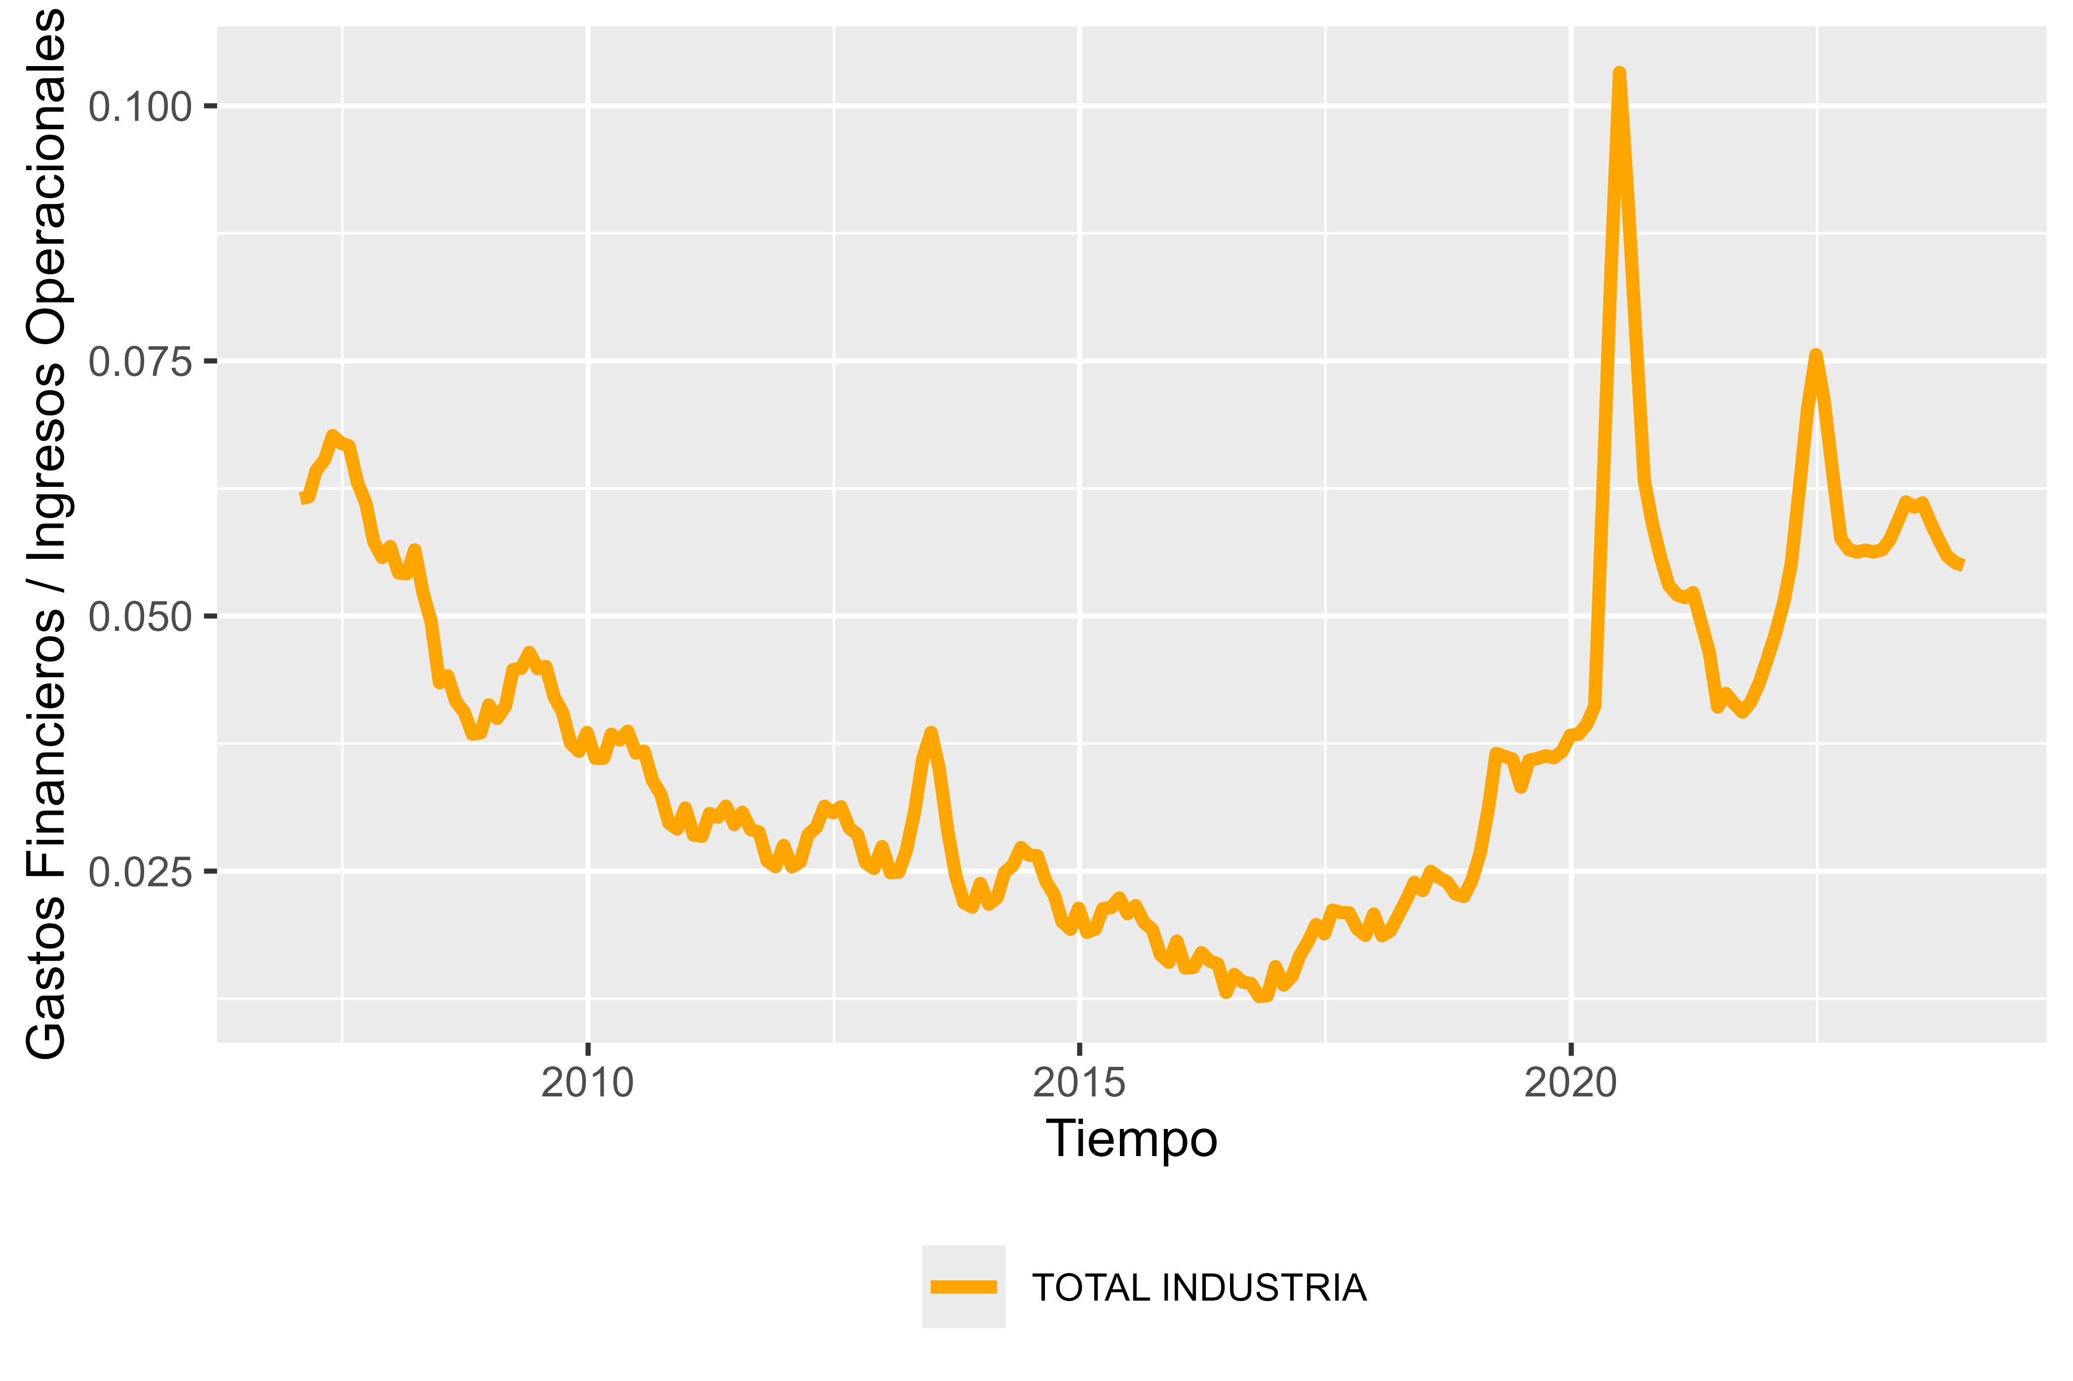

Fuente: Elaboración propia.

Donde los gastos financieros de la industria en general representan en promedio el 3.72% mensual sobre los ingresos operacionales, teniendo su pico más alto en la gestión 2020 alcanzando el 10.33%

**TABLA** Tendencia y estadísticas del comportamiento de pagos de la industria cementera de Bolivia, periodo contenido 2007-01-31 – 2023-12-31   
 (Expresado en tanto por uno)

|  |  |  |  |  |  |  |
| --- | --- | --- | --- | --- | --- | --- |
| **TIPO DE ENTIDAD** | **PROMEDIO** | **CV** | **MINIMO** | **MAXIMO** | **TENDENCIA** | **P(t)** |
| HISTORIAL PAGO | 0.0372 | 0.4591 | 0.0127 | 0.1033 | 0.0000 | 0.0350 |

Fuente: Elaboración propia.

Conclusión

Con base a los resultados encontrados, existe evidencia que sugiere: 1) La capacidad de endeudamiento de la industria cementera de Bolivia, haciende en promedio a Bs.- 1155547.98 mensual restringido o definido por el flujo de efectivo generado. 2) Que el comportamiento de pagos de cargos financieros del sector haciende al 3.72% mensual. 3) La industria empieza afrontar nuevos retos como el hecho de disminución de activos fijos y que el pasivo por primera vez como se observa en los últimos periodos es mayor que el patrimonio, donde debe evaluarse el efecto positivo o negativo de estas medidas.

Referencias bibliográficas

ASFI. (s. f.). Autoridad de Supervisión del Sistema Financiero. Recuperado 27 de abril de 2023, de <https://www.asfi.gob.bo/>

Coll Morales, F. (2020). Capacidad de pago. Recuperado 6 de marzo de 2024, de <https://economipedia.com/definiciones/capacidad-de-pago.html>

Hyndman, R. J., y Khandakar, Y. (2008). Automatic time series forecasting: the forecast package for R. *Journal of Statistical Software*, *27*(3), 1-22. <https://doi.org/10.18637/jss.v027.i03>

Sánchez Galán, J. (2024). Capacidad de endeudamiento: Qué es, y factores determinantes. Recuperado 6 de marzo de 2024, de <https://economipedia.com/definiciones/capacidad-de-endeudamiento.html>

Anexos

Composición de partidas principales de SOBOCE, FANCESA y ITACAMBA – Expresado en bolivianos

**FIGURA** Composición histórica de partidas de SOBOCE, periodo contenido 2007-01-31 – 2023-12-31

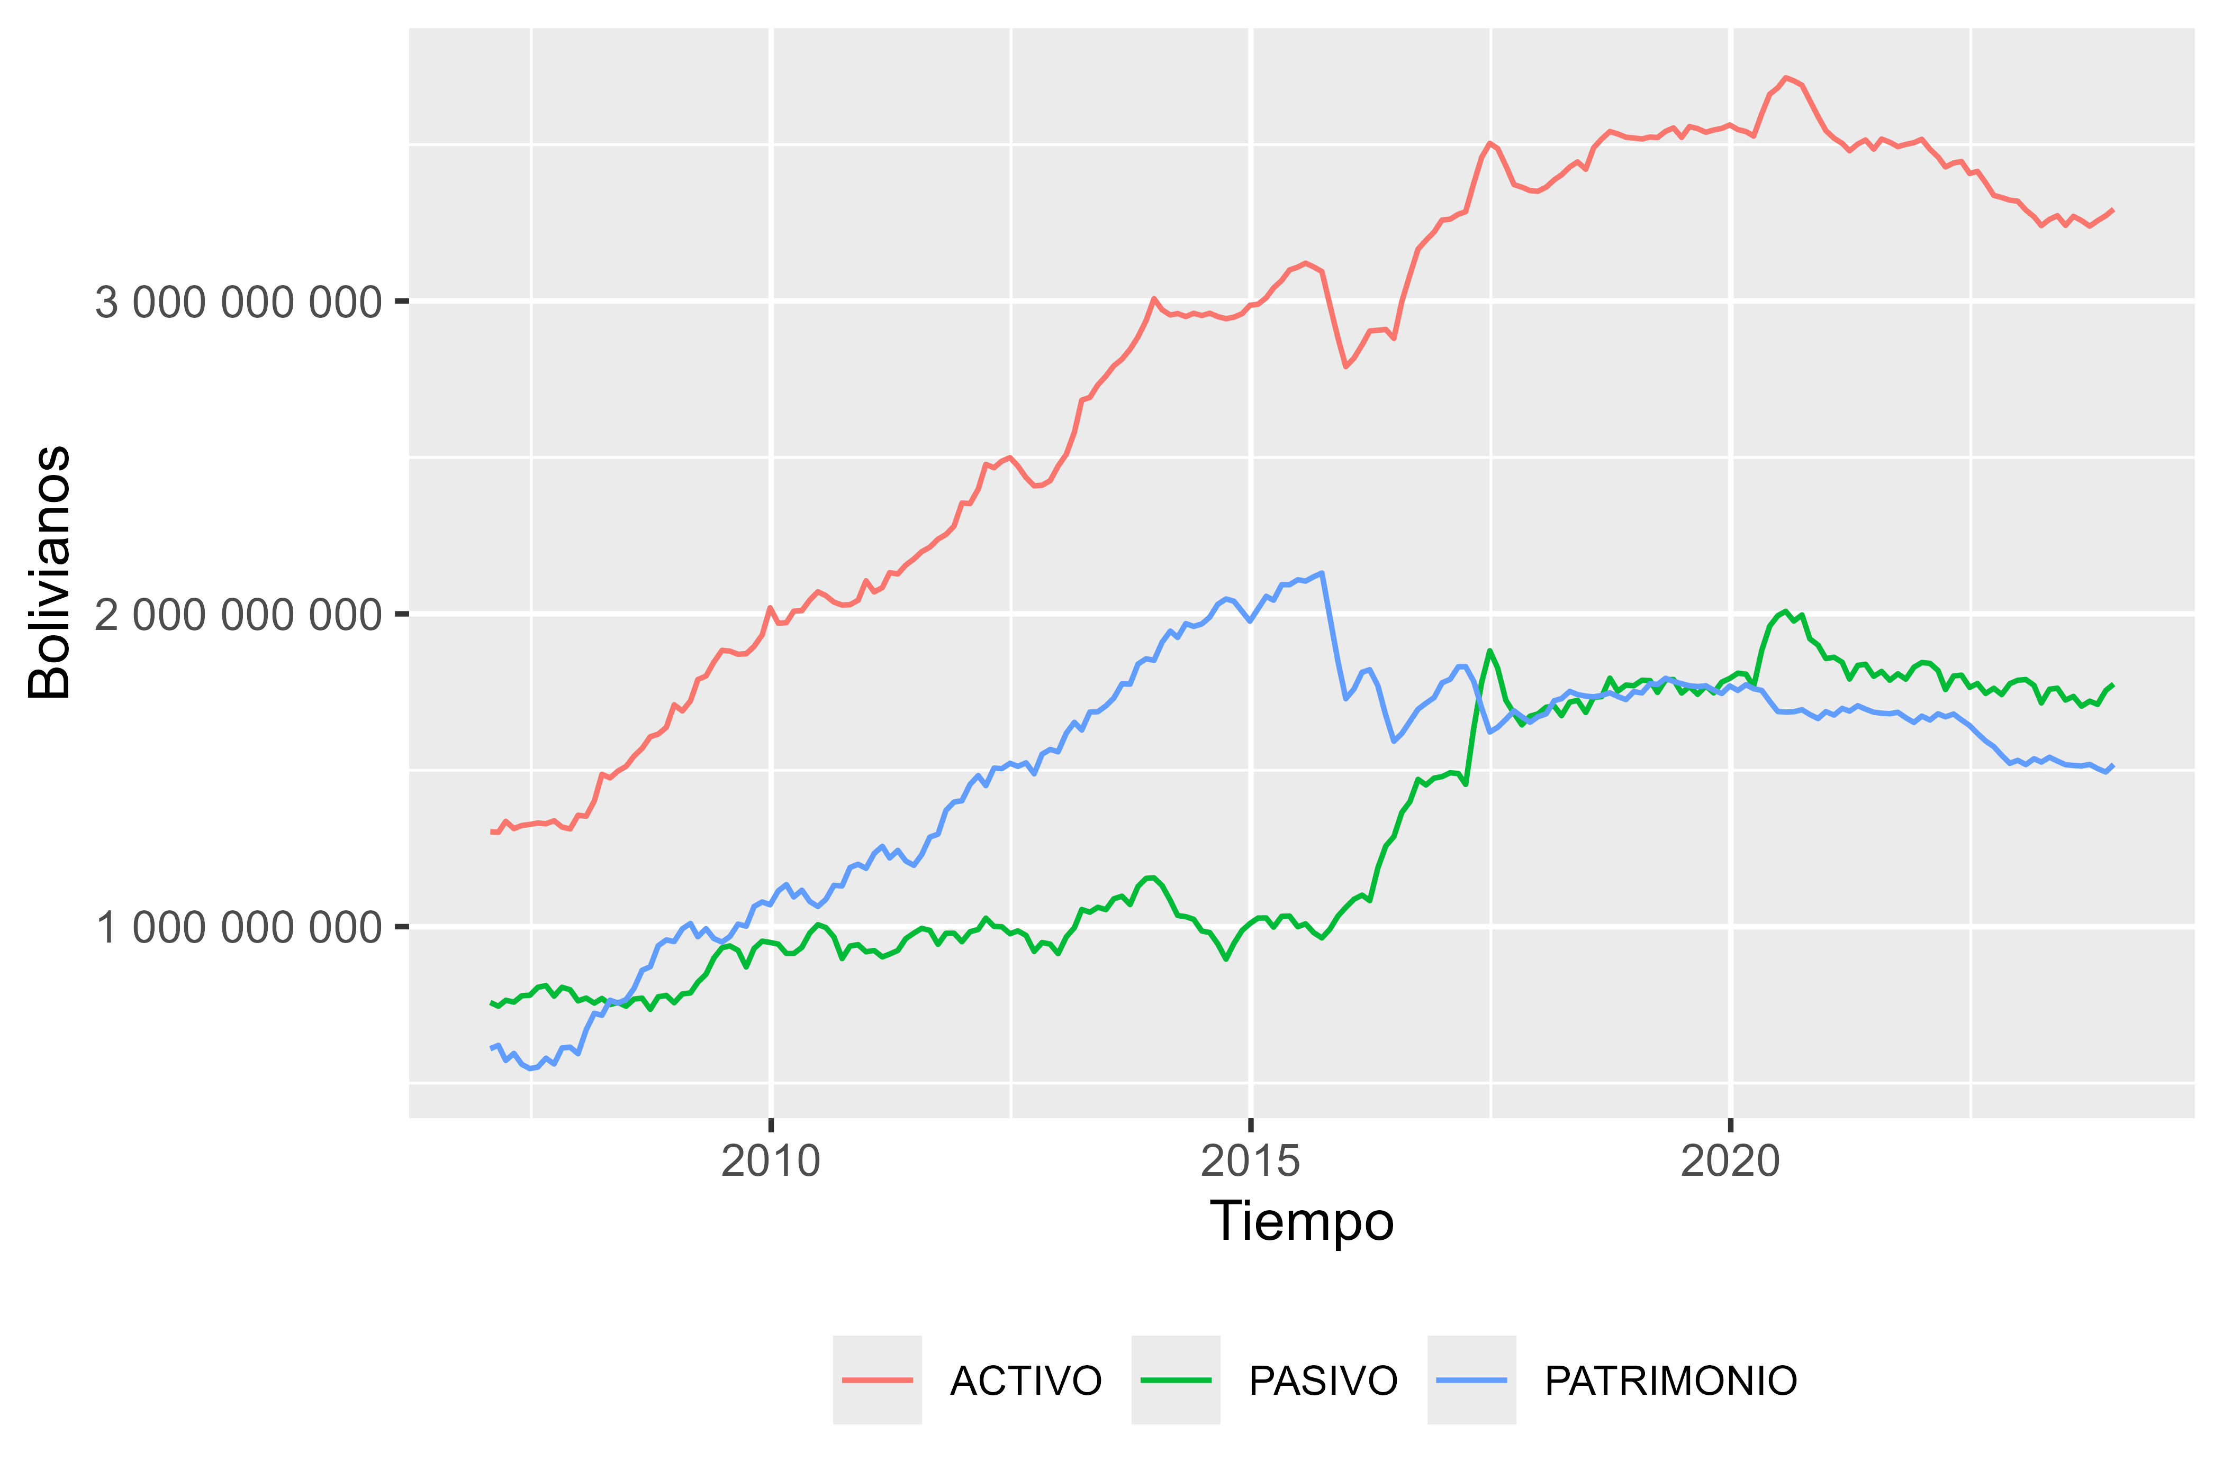

**Fuente:** Elaboración propia.

**FIGURA** Composición histórica de partidas de FANCESA, periodo contenido 2007-01-31 – 2023-12-31

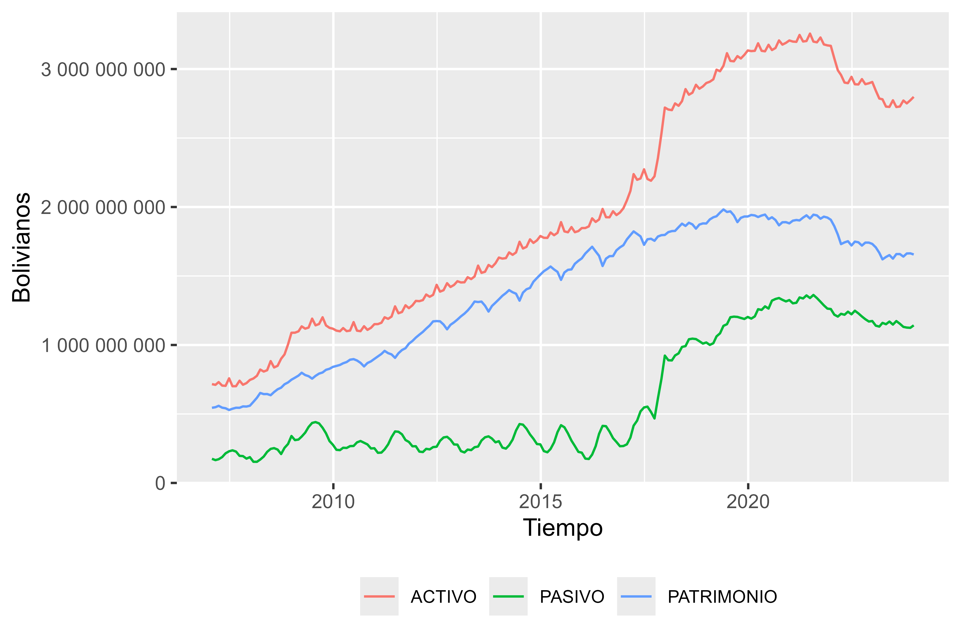

**Fuente:** Elaboración propia.

**FIGURA** Composición histórica de partidas de ITACAMBA, periodo contenido 2007-31-01 – 2023-12-31

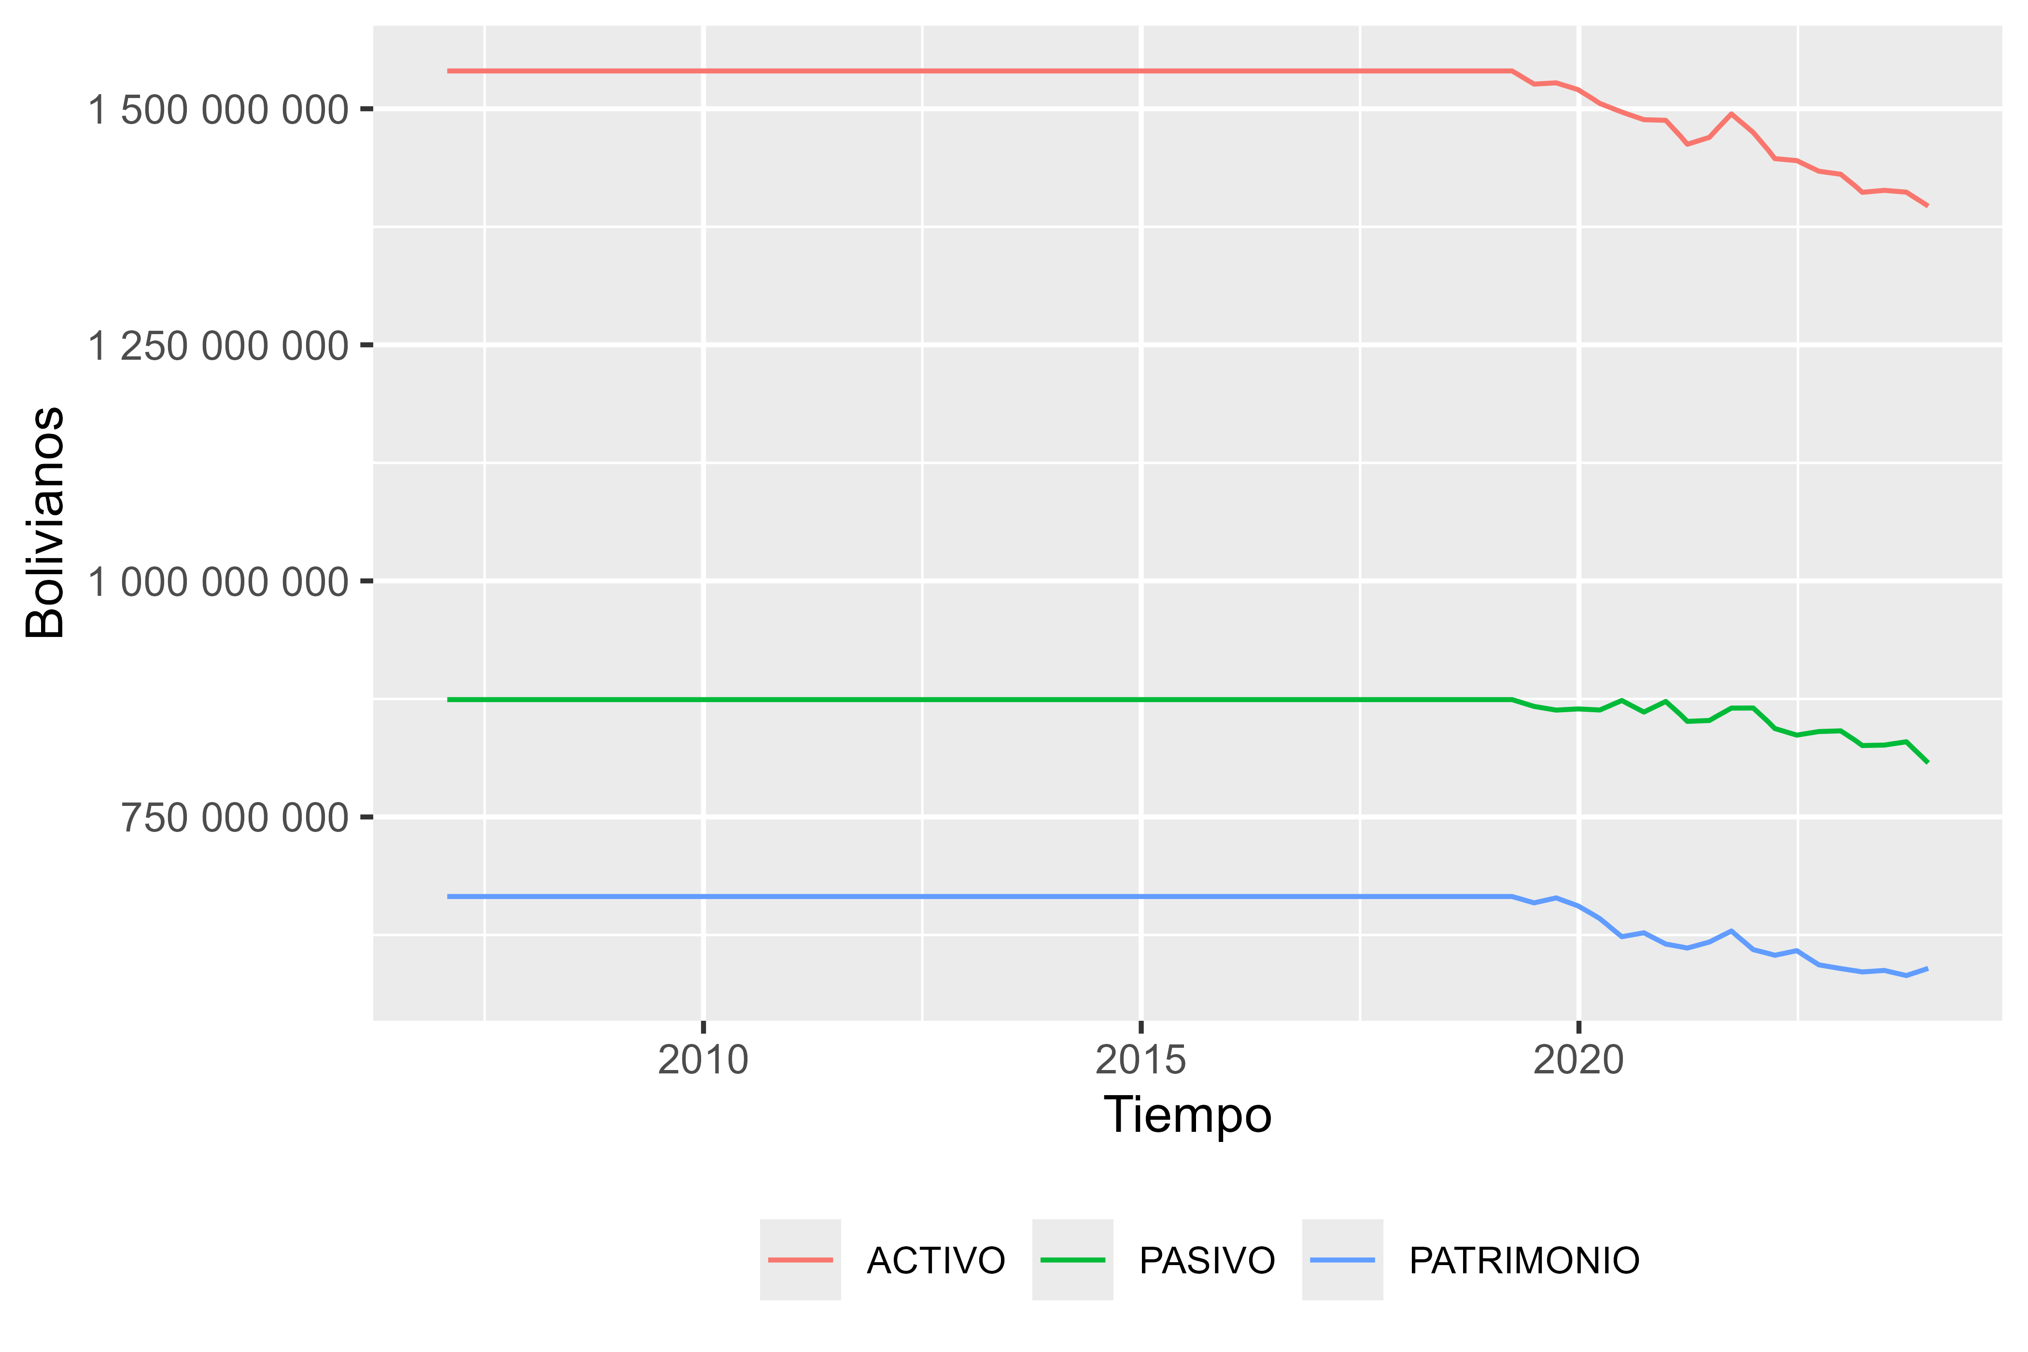

**Fuente:** Elaboración propia.

Variables presentadas en el articulo

* ACTIVO
* PASIVO
* PATRIMONIO

|  |  |  |  |  |
| --- | --- | --- | --- | --- |
| **FECHA** | **TIPO DE ENTIDAD** | **V1** | **V2** | **V3** |
| 2007-1-28 | TOTAL INDUSTRIA | 2118691321.88661 | 930441077.91208 | 1131996970.30224 |
| 2007-2-28 | TOTAL INDUSTRIA | 2131321900.47638 | 919076902.81086 | 1155805069.77006 |
| 2007-3-28 | TOTAL INDUSTRIA | 2067764914.62000 | 936551718.28000 | 1131213196.34000 |
| 2007-4-28 | TOTAL INDUSTRIA | 2066490586.41324 | 976505266.52530 | 1123712275.05835 |
| 2007-5-28 | TOTAL INDUSTRIA | 1984872565.39276 | 1038819667.25742 | 1072281147.70691 |
| 2007-6-28 | TOTAL INDUSTRIA | 2085097748.50000 | 1010313491.23000 | 1074784257.27000 |
| 2007-7-28 | TOTAL INDUSTRIA | 1910450559.69532 | 1049505465.76378 | 1025970079.74012 |
| 2007-8-28 | TOTAL INDUSTRIA | 1931479348.34608 | 1004644808.30399 | 1040013896.25178 |
| 2007-9-28 | TOTAL INDUSTRIA | 2079784472.22000 | 974166134.56000 | 1105618337.66000 |
| 2007-10-28 | TOTAL INDUSTRIA | 2055627390.82468 | 940969071.89572 | 1105039487.82306 |
| 2007-11-28 | TOTAL INDUSTRIA | 2165432111.01000 | 931152950.53582 | 1153287472.03452 |
| 2007-12-28 | TOTAL INDUSTRIA | 2102912646.38000 | 949632135.50000 | 1153280510.88000 |
| 2008-1-28 | TOTAL INDUSTRIA | 2313472509.30481 | 914992379.62174 | 1278459851.18853 |
| 2008-2-28 | TOTAL INDUSTRIA | 2349513200.42981 | 913070073.36388 | 1348148047.02387 |
| 2008-3-28 | TOTAL INDUSTRIA | 2308908320.69000 | 940213590.11000 | 1368694730.58000 |
| 2008-4-28 | TOTAL INDUSTRIA | 2331406393.69414 | 973164467.40296 | 1392291569.92635 |
| 2008-5-28 | TOTAL INDUSTRIA | 2272811639.88206 | 1028334238.01576 | 1371171872.45572 |
| 2008-6-28 | TOTAL INDUSTRIA | 2395586839.73000 | 992507534.69000 | 1403079305.04000 |
| 2008-7-28 | TOTAL INDUSTRIA | 2260606102.88717 | 1028484145.63993 | 1397902490.04920 |
| 2008-8-28 | TOTAL INDUSTRIA | 2320066997.01149 | 979286898.47188 | 1454739100.60350 |
| 2008-9-28 | TOTAL INDUSTRIA | 2507528173.97000 | 944973074.60000 | 1562555099.37000 |
| 2008-10-28 | TOTAL INDUSTRIA | 2573224944.20264 | 969671466.82458 | 1592804888.22218 |
| 2008-11-28 | TOTAL INDUSTRIA | 2773677612.60336 | 1018351575.93595 | 1671333896.45550 |
| 2008-12-28 | TOTAL INDUSTRIA | 2797682316.85000 | 1096896076.60000 | 1700786240.25000 |
| 2009-1-28 | TOTAL INDUSTRIA | 2984998126.98714 | 1085070542.80838 | 1776598285.45673 |
| 2009-2-28 | TOTAL INDUSTRIA | 2993471662.89531 | 1107188901.31538 | 1796361521.68864 |
| 2009-3-28 | TOTAL INDUSTRIA | 2924841621.52000 | 1158599915.26000 | 1766241706.26000 |
| 2009-4-28 | TOTAL INDUSTRIA | 2968922842.59426 | 1243915747.19046 | 1759380041.61636 |
| 2009-5-28 | TOTAL INDUSTRIA | 2931162102.84981 | 1351308513.27381 | 1707015509.40855 |
| 2009-6-28 | TOTAL INDUSTRIA | 3074295344.78000 | 1367532253.80000 | 1706763090.98000 |
| 2009-7-28 | TOTAL INDUSTRIA | 2902254087.56826 | 1387830838.17183 | 1680962266.63826 |
| 2009-8-28 | TOTAL INDUSTRIA | 2923414483.44153 | 1321835311.64763 | 1716319288.43521 |
| 2009-9-28 | TOTAL INDUSTRIA | 3073299109.76000 | 1271224648.00000 | 1802074461.76000 |
| 2009-10-28 | TOTAL INDUSTRIA | 3064466906.82536 | 1229355741.70525 | 1823236316.73317 |
| 2009-11-28 | TOTAL INDUSTRIA | 3191184698.64621 | 1212069327.87971 | 1892129776.42023 |
| 2009-12-28 | TOTAL INDUSTRIA | 3137329058.97000 | 1226207982.89000 | 1911121076.08000 |
| 2010-1-28 | TOTAL INDUSTRIA | 3284198809.49856 | 1173557989.96129 | 1983377246.63498 |
| 2010-2-28 | TOTAL INDUSTRIA | 3247489625.10833 | 1156113186.35143 | 1998580310.62740 |
| 2010-3-28 | TOTAL INDUSTRIA | 3131284165.97000 | 1169114441.82000 | 1962169724.15000 |
| 2010-4-28 | TOTAL INDUSTRIA | 3162692610.44950 | 1220283685.94811 | 1977026506.22335 |
| 2010-5-28 | TOTAL INDUSTRIA | 3108952147.57434 | 1293632974.02518 | 1944456211.65501 |
| 2010-6-28 | TOTAL INDUSTRIA | 3236376468.60000 | 1274565974.63000 | 1961810493.97000 |
| 2010-7-28 | TOTAL INDUSTRIA | 3041285250.92396 | 1301055808.66278 | 1910369047.31187 |
| 2010-8-28 | TOTAL INDUSTRIA | 3037244582.33557 | 1237142357.96181 | 1918075698.25666 |
| 2010-9-28 | TOTAL INDUSTRIA | 3164163645.75000 | 1189380891.08000 | 1974782754.67000 |
| 2010-10-28 | TOTAL INDUSTRIA | 3165648105.89181 | 1154295467.25193 | 1998030694.26159 |
| 2010-11-28 | TOTAL INDUSTRIA | 3305223699.70784 | 1145018627.75183 | 2067605582.37851 |
| 2010-12-28 | TOTAL INDUSTRIA | 3256590096.49000 | 1171130316.12000 | 2085459780.37000 |
| 2011-1-28 | TOTAL INDUSTRIA | 3436640642.34334 | 1129557899.60905 | 2172360589.46426 |
| 2011-2-28 | TOTAL INDUSTRIA | 3425518368.23303 | 1126839472.20490 | 2201245726.56669 |
| 2011-3-28 | TOTAL INDUSTRIA | 3332507121.91000 | 1155720507.52000 | 2176786614.39000 |
| 2011-4-28 | TOTAL INDUSTRIA | 3371916279.98001 | 1237721292.71578 | 2169006756.96569 |
| 2011-5-28 | TOTAL INDUSTRIA | 3322869584.15942 | 1342005231.65657 | 2111875613.82219 |
| 2011-6-28 | TOTAL INDUSTRIA | 3455247289.29000 | 1352647478.54000 | 2102599810.75000 |
| 2011-7-28 | TOTAL INDUSTRIA | 3308779387.77334 | 1377254749.33947 | 2105159143.06400 |
| 2011-8-28 | TOTAL INDUSTRIA | 3351183387.27645 | 1307362606.04386 | 2164974768.24236 |
| 2011-9-28 | TOTAL INDUSTRIA | 3526782620.34000 | 1254389567.51000 | 2272393052.83000 |
| 2011-10-28 | TOTAL INDUSTRIA | 3547305955.57042 | 1211044915.62946 | 2321488202.55154 |
| 2011-11-28 | TOTAL INDUSTRIA | 3708461563.39379 | 1194734939.93564 | 2415505644.60987 |
| 2011-12-28 | TOTAL INDUSTRIA | 3673755757.81000 | 1217748702.65000 | 2456007055.16000 |
| 2012-1-28 | TOTAL INDUSTRIA | 3892450969.84102 | 1197235300.22896 | 2554574894.89063 |
| 2012-2-28 | TOTAL INDUSTRIA | 3911450783.99496 | 1220263543.15081 | 2590842766.87417 |
| 2012-3-28 | TOTAL INDUSTRIA | 3843719993.51000 | 1274295014.47000 | 2569424979.04000 |
| 2012-4-28 | TOTAL INDUSTRIA | 3878192919.21669 | 1280405366.51638 | 2661224704.93204 |
| 2012-5-28 | TOTAL INDUSTRIA | 3818495450.51862 | 1306826743.36240 | 2699278904.64914 |
| 2012-6-28 | TOTAL INDUSTRIA | 3935429270.57000 | 1239809714.10000 | 2695619556.47000 |
| 2012-7-28 | TOTAL INDUSTRIA | 3736549533.11186 | 1302889609.14247 | 2671033179.97322 |
| 2012-8-28 | TOTAL INDUSTRIA | 3719945161.36090 | 1269155621.52084 | 2614351475.05379 |
| 2012-9-28 | TOTAL INDUSTRIA | 3857172865.18000 | 1255120551.00000 | 2602052314.18000 |
| 2012-10-28 | TOTAL INDUSTRIA | 3845947416.48554 | 1195582047.16633 | 2640884755.11058 |
| 2012-11-28 | TOTAL INDUSTRIA | 3995772357.57925 | 1165727990.42061 | 2721415005.60781 |
| 2012-12-28 | TOTAL INDUSTRIA | 3934481263.27000 | 1191096706.81000 | 2743384556.46000 |
| 2013-1-28 | TOTAL INDUSTRIA | 4189034214.79971 | 1177496863.98196 | 2853461484.28311 |
| 2013-2-28 | TOTAL INDUSTRIA | 4227662425.66738 | 1221842255.73326 | 2896806156.27471 |
| 2013-3-28 | TOTAL INDUSTRIA | 4174718399.47000 | 1296594641.56000 | 2878123757.91000 |
| 2013-4-28 | TOTAL INDUSTRIA | 4237632552.94969 | 1322723240.45422 | 3006935692.50417 |
| 2013-5-28 | TOTAL INDUSTRIA | 4200661771.51046 | 1367190735.20272 | 3077607860.46766 |
| 2013-6-28 | TOTAL INDUSTRIA | 4335551056.35000 | 1318440745.43000 | 3017110310.92000 |
| 2013-7-28 | TOTAL INDUSTRIA | 4190325884.01329 | 1406997119.70079 | 3084355960.41427 |
| 2013-8-28 | TOTAL INDUSTRIA | 4220781168.98182 | 1396434533.16047 | 3030274113.60113 |
| 2013-9-28 | TOTAL INDUSTRIA | 4425705371.53000 | 1408350676.06000 | 3017354695.47000 |
| 2013-10-28 | TOTAL INDUSTRIA | 4451960893.66819 | 1379892875.57641 | 3067857854.74229 |
| 2013-11-28 | TOTAL INDUSTRIA | 4659684922.78978 | 1383769293.08203 | 3156834340.81108 |
| 2013-12-28 | TOTAL INDUSTRIA | 4640995627.97000 | 1458769037.47000 | 3182226590.50000 |
| 2014-1-28 | TOTAL INDUSTRIA | 4833963360.78298 | 1350234837.13347 | 3297503584.63669 |
| 2014-2-28 | TOTAL INDUSTRIA | 4794130125.05351 | 1315361068.58735 | 3340977569.83533 |
| 2014-3-28 | TOTAL INDUSTRIA | 4631016990.31000 | 1308758931.83000 | 3322258058.48000 |
| 2014-4-28 | TOTAL INDUSTRIA | 4686779907.48383 | 1361539147.21383 | 3421327895.11338 |
| 2014-5-28 | TOTAL INDUSTRIA | 4610288296.53617 | 1429836334.18919 | 3462039827.27490 |
| 2014-6-28 | TOTAL INDUSTRIA | 4701786944.86000 | 1412918147.02000 | 3288868797.84000 |
| 2014-7-28 | TOTAL INDUSTRIA | 4531958142.31965 | 1411819324.14146 | 3469984314.37157 |
| 2014-8-28 | TOTAL INDUSTRIA | 4533422930.36702 | 1318999793.70014 | 3446980116.23575 |
| 2014-9-28 | TOTAL INDUSTRIA | 4709212590.23000 | 1247818278.19000 | 3461394312.04000 |
| 2014-10-28 | TOTAL INDUSTRIA | 4691041194.58076 | 1215272591.48215 | 3469301026.32626 |
| 2014-11-28 | TOTAL INDUSTRIA | 4853728397.68495 | 1213863943.27777 | 3511842425.22927 |
| 2014-12-28 | TOTAL INDUSTRIA | 4776186243.69000 | 1289593679.53000 | 3486592564.16000 |
| 2015-1-28 | TOTAL INDUSTRIA | 5017978600.22762 | 1211856897.08421 | 3600715761.13679 |
| 2015-2-28 | TOTAL INDUSTRIA | 5015097046.23033 | 1215332695.60106 | 3637679425.76920 |
| 2015-3-28 | TOTAL INDUSTRIA | 4857227931.27000 | 1244944763.62000 | 3612283167.65000 |
| 2015-4-28 | TOTAL INDUSTRIA | 4959546955.59051 | 1319989637.19345 | 3739787889.45685 |
| 2015-5-28 | TOTAL INDUSTRIA | 4897241858.58699 | 1407729558.09568 | 3808716568.95066 |
| 2015-6-28 | TOTAL INDUSTRIA | 4999104606.77000 | 1418207742.42000 | 3580896864.35000 |
| 2015-7-28 | TOTAL INDUSTRIA | 4813049890.48025 | 1418385484.15890 | 3793492212.58349 |
| 2015-8-28 | TOTAL INDUSTRIA | 4793948876.34433 | 1334201971.78320 | 3719015390.90768 |
| 2015-9-28 | TOTAL INDUSTRIA | 4949028688.26000 | 1270815759.83000 | 3678212928.43000 |
| 2015-10-28 | TOTAL INDUSTRIA | 4809795289.65762 | 1226573926.73344 | 3574513907.92671 |
| 2015-11-28 | TOTAL INDUSTRIA | 4850810581.57872 | 1212271952.65463 | 3501610929.86044 |
| 2015-12-28 | TOTAL INDUSTRIA | 4637814548.02000 | 1281152127.48000 | 3356662420.54000 |
| 2016-1-28 | TOTAL INDUSTRIA | 4934726209.14108 | 1221889880.28662 | 3489161204.50959 |
| 2016-2-28 | TOTAL INDUSTRIA | 4970226109.78441 | 1247327506.60057 | 3541439783.89022 |
| 2016-3-28 | TOTAL INDUSTRIA | 4822145843.70000 | 1288677462.95000 | 3533468380.75000 |
| 2016-4-28 | TOTAL INDUSTRIA | 4926790154.38992 | 1450010541.63364 | 3547870803.84938 |
| 2016-5-28 | TOTAL INDUSTRIA | 4838582057.26620 | 1614349328.41700 | 3505756706.63365 |
| 2016-6-28 | TOTAL INDUSTRIA | 4866777934.64000 | 1701834104.85000 | 3164943829.79000 |
| 2016-7-28 | TOTAL INDUSTRIA | 4823378639.17859 | 1785266580.52568 | 3399500705.02891 |
| 2016-8-28 | TOTAL INDUSTRIA | 4899766210.21509 | 1785447617.62756 | 3345003837.94790 |
| 2016-9-28 | TOTAL INDUSTRIA | 5135295647.21000 | 1795544198.96000 | 3339751448.25000 |
| 2016-10-28 | TOTAL INDUSTRIA | 5151288810.41338 | 1739641177.08937 | 3387988767.35978 |
| 2016-11-28 | TOTAL INDUSTRIA | 5333238016.66041 | 1703726730.34983 | 3482567047.86608 |
| 2016-12-28 | TOTAL INDUSTRIA | 5249827055.15000 | 1747203284.43000 | 3502623770.72000 |
| 2017-1-28 | TOTAL INDUSTRIA | 5591927441.77384 | 1729928097.81671 | 3628479043.41423 |
| 2017-2-28 | TOTAL INDUSTRIA | 5664117098.76814 | 1796999429.76893 | 3670496958.34216 |
| 2017-3-28 | TOTAL INDUSTRIA | 5524133983.27000 | 1869759152.29000 | 3654374830.98000 |
| 2017-4-28 | TOTAL INDUSTRIA | 5733103101.76692 | 2086270763.13285 | 3688841530.39641 |
| 2017-5-28 | TOTAL INDUSTRIA | 5720991525.96058 | 2296098742.84636 | 3668851231.49563 |
| 2017-6-28 | TOTAL INDUSTRIA | 5777541504.12000 | 2429438816.35000 | 3348102687.77000 |
| 2017-7-28 | TOTAL INDUSTRIA | 5620178297.46373 | 2391267671.37561 | 3552991862.48950 |
| 2017-8-28 | TOTAL INDUSTRIA | 5535503998.53924 | 2270940950.79850 | 3466730927.07069 |
| 2017-9-28 | TOTAL INDUSTRIA | 5594932605.48000 | 2149648018.26000 | 3445284587.22000 |
| 2017-10-28 | TOTAL INDUSTRIA | 5744994205.04737 | 2268928136.05107 | 3437468400.34071 |
| 2017-11-28 | TOTAL INDUSTRIA | 6046719200.17858 | 2398245545.08657 | 3491538093.81742 |
| 2017-12-28 | TOTAL INDUSTRIA | 6071792240.59000 | 2603206488.28000 | 3468585752.31000 |
| 2018-1-28 | TOTAL INDUSTRIA | 6361697962.45735 | 2546994413.43670 | 3573732103.72609 |
| 2018-2-28 | TOTAL INDUSTRIA | 6371195794.95678 | 2571672658.79741 | 3593962047.84083 |
| 2018-3-28 | TOTAL INDUSTRIA | 6154320325.20000 | 2598505760.32000 | 3555814564.88000 |
| 2018-4-28 | TOTAL INDUSTRIA | 6349896221.96585 | 2660504896.14327 | 3706941267.08749 |
| 2018-5-28 | TOTAL INDUSTRIA | 6311051474.78856 | 2713321143.55255 | 3804117776.94090 |
| 2018-6-28 | TOTAL INDUSTRIA | 6276121024.87000 | 2676299862.38000 | 3599821162.49000 |
| 2018-7-28 | TOTAL INDUSTRIA | 6285480620.26328 | 2800490036.52636 | 3768859759.47798 |
| 2018-8-28 | TOTAL INDUSTRIA | 6303840681.18007 | 2830195879.28028 | 3645547780.96720 |
| 2018-9-28 | TOTAL INDUSTRIA | 6427902778.27000 | 2837256357.95000 | 3590646420.32000 |
| 2018-10-28 | TOTAL INDUSTRIA | 6444317843.19699 | 2806655796.25104 | 3587257255.65264 |
| 2018-11-28 | TOTAL INDUSTRIA | 6575119026.45314 | 2765343070.08633 | 3648841119.86373 |
| 2018-12-28 | TOTAL INDUSTRIA | 6419937111.73000 | 2788134246.65000 | 3631802865.08000 |
| 2019-1-28 | TOTAL INDUSTRIA | 7239367440.24207 | 3040780602.88945 | 3955917230.75368 |
| 2019-2-28 | TOTAL INDUSTRIA | 7769061646.91603 | 3363677711.27228 | 4193758961.38735 |
| 2019-3-28 | TOTAL INDUSTRIA | 8058182021.57000 | 3685196141.41000 | 4372985880.16000 |
| 2019-4-28 | TOTAL INDUSTRIA | 8278968561.62901 | 3753775968.60132 | 4518251105.60786 |
| 2019-5-28 | TOTAL INDUSTRIA | 8251994508.10500 | 3810673650.09396 | 4610072944.66476 |
| 2019-6-28 | TOTAL INDUSTRIA | 8164134617.36000 | 3764388226.81000 | 4399746390.55000 |
| 2019-7-28 | TOTAL INDUSTRIA | 8177080420.64182 | 3874393332.87897 | 4546279621.29486 |
| 2019-8-28 | TOTAL INDUSTRIA | 8135308856.73041 | 3877602397.50300 | 4399312247.25792 |
| 2019-9-28 | TOTAL INDUSTRIA | 8160838459.30000 | 3836486945.92000 | 4324351513.38000 |
| 2019-10-28 | TOTAL INDUSTRIA | 8226953414.55396 | 3848185874.32829 | 4316545468.98566 |
| 2019-11-28 | TOTAL INDUSTRIA | 8370177210.90242 | 3828423182.56067 | 4376799601.99222 |
| 2019-12-28 | TOTAL INDUSTRIA | 8218081868.08000 | 3861217609.94000 | 4356864258.14000 |
| 2020-1-28 | TOTAL INDUSTRIA | 8495461013.73147 | 3829044669.63760 | 4425879065.73688 |
| 2020-2-28 | TOTAL INDUSTRIA | 8479393052.40945 | 3859713223.26610 | 4407716820.96702 |
| 2020-3-28 | TOTAL INDUSTRIA | 8219667412.88000 | 3889265793.30000 | 4330401619.58000 |
| 2020-4-28 | TOTAL INDUSTRIA | 8454404259.04464 | 4011792199.12198 | 4430978809.64855 |
| 2020-5-28 | TOTAL INDUSTRIA | 8438736511.16398 | 4123138422.64595 | 4478001161.97903 |
| 2020-6-28 | TOTAL INDUSTRIA | 8354175996.11000 | 4131460763.55000 | 4222715232.56000 |
| 2020-7-28 | TOTAL INDUSTRIA | 8386837430.02379 | 4240391484.97275 | 4383360860.91559 |
| 2020-8-28 | TOTAL INDUSTRIA | 8357197230.37243 | 4242953860.81152 | 4249391902.17791 |
| 2020-9-28 | TOTAL INDUSTRIA | 8385887674.99000 | 4197982565.26000 | 4187905109.73000 |
| 2020-10-28 | TOTAL INDUSTRIA | 8390578399.23218 | 4157480380.54446 | 4168656675.86097 |
| 2020-11-28 | TOTAL INDUSTRIA | 8463766779.14485 | 4082454600.74212 | 4216866883.97771 |
| 2020-12-28 | TOTAL INDUSTRIA | 8239599124.58000 | 4055008618.78000 | 4184590505.80000 |
| 2021-1-28 | TOTAL INDUSTRIA | 8503383639.72490 | 3993766303.22878 | 4268654281.40272 |
| 2021-2-28 | TOTAL INDUSTRIA | 8470053695.77488 | 3990883331.12644 | 4265590270.06301 |
| 2021-3-28 | TOTAL INDUSTRIA | 8189982227.43000 | 3987147070.08000 | 4202835157.35000 |
| 2021-4-28 | TOTAL INDUSTRIA | 8391808780.94901 | 4030433987.32454 | 4345022386.48450 |
| 2021-5-28 | TOTAL INDUSTRIA | 8340586739.96043 | 4063042685.67174 | 4433543326.53382 |
| 2021-6-28 | TOTAL INDUSTRIA | 8212412221.81000 | 3992805541.81000 | 4219606680.00000 |
| 2021-7-28 | TOTAL INDUSTRIA | 8244073043.64853 | 4078491135.39728 | 4395763660.71083 |
| 2021-8-28 | TOTAL INDUSTRIA | 8205776330.93083 | 4058236648.25042 | 4276203187.01515 |
| 2021-9-28 | TOTAL INDUSTRIA | 8216839740.27000 | 3987239334.53000 | 4229600405.74000 |
| 2021-10-28 | TOTAL INDUSTRIA | 8257880270.01150 | 3992430172.47635 | 4198783554.23685 |
| 2021-11-28 | TOTAL INDUSTRIA | 8358807269.99948 | 3960035440.42504 | 4234823809.30434 |
| 2021-12-28 | TOTAL INDUSTRIA | 8160313770.13000 | 3970227423.13000 | 4190086347.00000 |
| 2022-1-28 | TOTAL INDUSTRIA | 8333348448.86669 | 3886583871.72566 | 4206612251.46947 |
| 2022-2-28 | TOTAL INDUSTRIA | 8207518503.24203 | 3857602666.96056 | 4135929674.74647 |
| 2022-3-28 | TOTAL INDUSTRIA | 7832931885.62000 | 3827665592.42000 | 4005266293.20000 |
| 2022-4-28 | TOTAL INDUSTRIA | 8017036727.78498 | 3868161004.99183 | 4131033630.29475 |
| 2022-5-28 | TOTAL INDUSTRIA | 7946328687.79520 | 3898023843.80811 | 4203045263.41735 |
| 2022-6-28 | TOTAL INDUSTRIA | 7796540867.06000 | 3824068533.46000 | 3972472333.60000 |
| 2022-7-28 | TOTAL INDUSTRIA | 7796792817.22137 | 3907623544.95461 | 4117867189.45262 |
| 2022-8-28 | TOTAL INDUSTRIA | 7725209521.79022 | 3884415487.63454 | 3967119861.07954 |
| 2022-9-28 | TOTAL INDUSTRIA | 7698612732.49000 | 3809052005.06000 | 3889560727.43000 |
| 2022-10-28 | TOTAL INDUSTRIA | 7747535399.05109 | 3819302848.17256 | 3860100536.19171 |
| 2022-11-28 | TOTAL INDUSTRIA | 7852171012.43493 | 3790665123.38087 | 3897361718.66938 |
| 2022-12-28 | TOTAL INDUSTRIA | 7656199969.40000 | 3802496307.00000 | 3853703662.40000 |
| 2023-1-28 | TOTAL INDUSTRIA | 7865841481.08294 | 3733821384.90587 | 3891481735.40298 |
| 2023-2-28 | TOTAL INDUSTRIA | 7774885793.75640 | 3717794053.14135 | 3842101129.86832 |
| 2023-3-28 | TOTAL INDUSTRIA | 7433158286.83000 | 3700708270.77000 | 3732450016.06000 |
| 2023-4-28 | TOTAL INDUSTRIA | 7629922252.29298 | 3741872866.92816 | 3868718382.14426 |
| 2023-5-28 | TOTAL INDUSTRIA | 7570109047.95402 | 3772450534.47255 | 3951141629.36938 |
| 2023-6-28 | TOTAL INDUSTRIA | 7429100119.29000 | 3698246593.75000 | 3730853525.54000 |
| 2023-7-28 | TOTAL INDUSTRIA | 7462681398.53804 | 3782303405.47008 | 3907591974.57699 |
| 2023-8-28 | TOTAL INDUSTRIA | 7422553376.36651 | 3758778573.62273 | 3787762902.05522 |
| 2023-9-28 | TOTAL INDUSTRIA | 7423038244.40000 | 3681685717.84000 | 3741352526.56000 |
| 2023-10-28 | TOTAL INDUSTRIA | 7511238987.33915 | 3710145654.53997 | 3731496666.01732 |
| 2023-11-28 | TOTAL INDUSTRIA | 7650979153.67732 | 3698414025.42911 | 3788226446.33593 |
| 2023-12-28 | TOTAL INDUSTRIA | 7488924651.93000 | 3725030319.09000 | 3763894333.41000 |

Fuente: Elaboración propia.

* GASTOS FINANCIEROS
* INGRESOS OPERACIONALES
* ACTIVO - DISPONIBILIDADES

|  |  |  |  |  |
| --- | --- | --- | --- | --- |
| **FECHA** | **TIPO DE ENTIDAD** | **V4** | **V5** | **V6** |
| 2007-1-28 | TOTAL INDUSTRIA | -52703829.91494 | 637882901.69729 | 13138880.92244 |
| 2007-2-28 | TOTAL INDUSTRIA | -62795995.60452 | 902389567.43048 | 17022224.19105 |
| 2007-3-28 | TOTAL INDUSTRIA | -55317985.34000 | 860687341.17000 | 42623541.75000 |
| 2007-4-28 | TOTAL INDUSTRIA | -45175050.76353 | 728485432.45510 | 16188609.06174 |
| 2007-5-28 | TOTAL INDUSTRIA | -22436560.82231 | 448738909.01079 | 9183837.19516 |
| 2007-6-28 | TOTAL INDUSTRIA | -14017289.84000 | 209408438.71000 | 23158145.65000 |
| 2007-7-28 | TOTAL INDUSTRIA | -3261689.91235 | 136315543.84574 | 31917359.57076 |
| 2007-8-28 | TOTAL INDUSTRIA | -12156157.42601 | 254322450.77859 | 60848637.79628 |
| 2007-9-28 | TOTAL INDUSTRIA | -28105172.57000 | 460081021.93000 | 38639812.46000 |
| 2007-10-28 | TOTAL INDUSTRIA | -30073438.61753 | 573191323.77938 | 71804162.82242 |
| 2007-11-28 | TOTAL INDUSTRIA | -34032721.99964 | 615718695.58426 | 55450821.71067 |
| 2007-12-28 | TOTAL INDUSTRIA | -41872108.07000 | 737151564.04000 | 56127999.70000 |
| 2008-1-28 | TOTAL INDUSTRIA | -53222107.52802 | 967391001.68308 | 43723619.60468 |
| 2008-2-28 | TOTAL INDUSTRIA | -63155277.42181 | 1128186987.49783 | 50464579.75733 |
| 2008-3-28 | TOTAL INDUSTRIA | -55514530.62000 | 982860457.07000 | 78442351.27000 |
| 2008-4-28 | TOTAL INDUSTRIA | -44712798.03882 | 833907590.10598 | 51600930.72327 |
| 2008-5-28 | TOTAL INDUSTRIA | -21319439.46873 | 537488948.03198 | 43750700.76858 |
| 2008-6-28 | TOTAL INDUSTRIA | -12228378.83000 | 281431783.41000 | 57577132.33000 |
| 2008-7-28 | TOTAL INDUSTRIA | -1087470.93513 | 237517048.99924 | 60500197.31942 |
| 2008-8-28 | TOTAL INDUSTRIA | -9578106.96029 | 384496622.76746 | 84325066.29561 |
| 2008-9-28 | TOTAL INDUSTRIA | -25127666.57000 | 619273507.63000 | 56916649.75000 |
| 2008-10-28 | TOTAL INDUSTRIA | -27591586.39941 | 759854188.87230 | 80889075.59850 |
| 2008-11-28 | TOTAL INDUSTRIA | -32051381.74283 | 829897957.17534 | 55280928.01034 |
| 2008-12-28 | TOTAL INDUSTRIA | -40420246.55000 | 978947084.89000 | 46381191.10000 |
| 2009-1-28 | TOTAL INDUSTRIA | -53216499.78738 | 1236283960.57999 | 30604449.38534 |
| 2009-2-28 | TOTAL INDUSTRIA | -64622782.46225 | 1424296399.16574 | 33622401.53782 |
| 2009-3-28 | TOTAL INDUSTRIA | -58451407.70000 | 1306272697.26000 | 57396002.12000 |
| 2009-4-28 | TOTAL INDUSTRIA | -47902457.47290 | 1073970366.41616 | 36895307.86919 |
| 2009-5-28 | TOTAL INDUSTRIA | -24765810.63274 | 694281100.08176 | 34946833.98079 |
| 2009-6-28 | TOTAL INDUSTRIA | -15914605.61000 | 354899070.02000 | 55371167.65000 |
| 2009-7-28 | TOTAL INDUSTRIA | -5379936.97320 | 331598448.15885 | 61693572.31181 |
| 2009-8-28 | TOTAL INDUSTRIA | -14458309.32721 | 498986917.63937 | 89645646.89680 |
| 2009-9-28 | TOTAL INDUSTRIA | -30599981.22000 | 754218345.09000 | 66271254.00000 |
| 2009-10-28 | TOTAL INDUSTRIA | -32954367.62082 | 917377077.41338 | 93291273.03489 |
| 2009-11-28 | TOTAL INDUSTRIA | -37309487.71506 | 1010044913.90273 | 70667836.67062 |
| 2009-12-28 | TOTAL INDUSTRIA | -45602544.83000 | 1181817883.41000 | 64431756.90000 |
| 2010-1-28 | TOTAL INDUSTRIA | -56887885.74023 | 1449113575.27097 | 43320137.86570 |
| 2010-2-28 | TOTAL INDUSTRIA | -66805115.45491 | 1647278069.61857 | 40330637.60191 |
| 2010-3-28 | TOTAL INDUSTRIA | -59134510.67000 | 1539553883.38000 | 57235611.47000 |
| 2010-4-28 | TOTAL INDUSTRIA | -47769410.76234 | 1239781787.91927 | 47810113.81922 |
| 2010-5-28 | TOTAL INDUSTRIA | -23829249.88045 | 792767923.91244 | 56175841.27981 |
| 2010-6-28 | TOTAL INDUSTRIA | -14110151.82000 | 385952815.42000 | 88227288.63000 |
| 2010-7-28 | TOTAL INDUSTRIA | -3111931.91360 | 380767149.44315 | 92512782.25775 |
| 2010-8-28 | TOTAL INDUSTRIA | -11656279.30953 | 565703318.85862 | 119789889.47395 |
| 2010-9-28 | TOTAL INDUSTRIA | -27280310.72000 | 838607437.76000 | 95626615.32000 |
| 2010-10-28 | TOTAL INDUSTRIA | -29038213.88212 | 1013042789.88457 | 122256081.54047 |
| 2010-11-28 | TOTAL INDUSTRIA | -32815517.05516 | 1117128075.65365 | 99160366.94795 |
| 2010-12-28 | TOTAL INDUSTRIA | -40561356.58000 | 1300605454.84000 | 91497638.54000 |
| 2011-1-28 | TOTAL INDUSTRIA | -51550938.81596 | 1594312866.68327 | 77960985.96118 |
| 2011-2-28 | TOTAL INDUSTRIA | -61206217.31400 | 1819086312.37206 | 81368696.04855 |
| 2011-3-28 | TOTAL INDUSTRIA | -53263484.25000 | 1738118537.38000 | 103809705.97000 |
| 2011-4-28 | TOTAL INDUSTRIA | -43247017.94449 | 1381555705.73422 | 76742434.10250 |
| 2011-5-28 | TOTAL INDUSTRIA | -20668126.30358 | 877896272.48682 | 66705392.09534 |
| 2011-6-28 | TOTAL INDUSTRIA | -12246371.05000 | 414328198.31000 | 81654146.42000 |
| 2011-7-28 | TOTAL INDUSTRIA | -1808633.37496 | 432335603.99422 | 108516751.01555 |
| 2011-8-28 | TOTAL INDUSTRIA | -10843426.62233 | 639898353.23624 | 159720425.20202 |
| 2011-9-28 | TOTAL INDUSTRIA | -26974288.36000 | 935554043.48000 | 159369804.13000 |
| 2011-10-28 | TOTAL INDUSTRIA | -29077486.46694 | 1144999253.55449 | 220487646.43563 |
| 2011-11-28 | TOTAL INDUSTRIA | -33218750.90230 | 1284235226.75199 | 231798582.51444 |
| 2011-12-28 | TOTAL INDUSTRIA | -41359123.28000 | 1503149858.87000 | 257590550.47000 |
| 2012-1-28 | TOTAL INDUSTRIA | -53257957.41673 | 1812423817.40300 | 273991807.66476 |
| 2012-2-28 | TOTAL INDUSTRIA | -63851426.63654 | 2053023657.92126 | 305723506.00715 |
| 2012-3-28 | TOTAL INDUSTRIA | -56820897.55000 | 1988022082.03000 | 353989848.25000 |
| 2012-4-28 | TOTAL INDUSTRIA | -46685887.87525 | 1575228859.39819 | 339809180.88041 |
| 2012-5-28 | TOTAL INDUSTRIA | -23972713.44366 | 1015518092.55645 | 340443140.70793 |
| 2012-6-28 | TOTAL INDUSTRIA | -15208777.13000 | 495311334.45000 | 369236654.20000 |
| 2012-7-28 | TOTAL INDUSTRIA | -5140814.64511 | 531879664.99181 | 350728825.49847 |
| 2012-8-28 | TOTAL INDUSTRIA | -14328776.58409 | 757168411.03058 | 359975591.51324 |
| 2012-9-28 | TOTAL INDUSTRIA | -30594879.56000 | 1070542732.91000 | 316633242.61000 |
| 2012-10-28 | TOTAL INDUSTRIA | -32703663.66986 | 1282158526.00460 | 361143850.37722 |
| 2012-11-28 | TOTAL INDUSTRIA | -36827351.63718 | 1423605030.30447 | 355058754.99096 |
| 2012-12-28 | TOTAL INDUSTRIA | -45063148.75000 | 1644806135.49000 | 359033339.54000 |
| 2013-1-28 | TOTAL INDUSTRIA | -56310272.56069 | 1968624078.32388 | 374196648.46647 |
| 2013-2-28 | TOTAL INDUSTRIA | -66343015.81567 | 2224072675.39603 | 400496155.74981 |
| 2013-3-28 | TOTAL INDUSTRIA | -58725774.02000 | 2174059660.33000 | 440831651.00000 |
| 2013-4-28 | TOTAL INDUSTRIA | -47701797.64618 | 1656953046.63045 | 438786572.43633 |
| 2013-5-28 | TOTAL INDUSTRIA | -24083917.09410 | 993107946.11266 | 449340518.40653 |
| 2013-6-28 | TOTAL INDUSTRIA | -14208077.38000 | 368177489.19000 | 491223066.96000 |
| 2013-7-28 | TOTAL INDUSTRIA | -4006659.68757 | 482131110.33983 | 522148079.57788 |
| 2013-8-28 | TOTAL INDUSTRIA | -12845274.86201 | 783968601.19013 | 584241189.15770 |
| 2013-9-28 | TOTAL INDUSTRIA | -28744103.62000 | 1173884302.72000 | 592710364.16000 |
| 2013-10-28 | TOTAL INDUSTRIA | -30903886.93347 | 1411224707.18817 | 663519076.07144 |
| 2013-11-28 | TOTAL INDUSTRIA | -35055411.63344 | 1578435770.94387 | 682943287.90274 |
| 2013-12-28 | TOTAL INDUSTRIA | -43432178.70000 | 1825478476.24000 | 708020169.57000 |
| 2014-1-28 | TOTAL INDUSTRIA | -55228354.36199 | 2155372581.04821 | 641177845.35517 |
| 2014-2-28 | TOTAL INDUSTRIA | -65932842.15712 | 2416800972.99328 | 581354506.24222 |
| 2014-3-28 | TOTAL INDUSTRIA | -59002234.84000 | 2372449451.38000 | 534563886.14000 |
| 2014-4-28 | TOTAL INDUSTRIA | -48187574.98408 | 1853789659.28228 | 509405991.16871 |
| 2014-5-28 | TOTAL INDUSTRIA | -24779008.13319 | 1188242158.01580 | 496012019.75427 |
| 2014-6-28 | TOTAL INDUSTRIA | -14898152.49000 | 560963922.77000 | 512355531.32000 |
| 2014-7-28 | TOTAL INDUSTRIA | -4501238.73161 | 636848447.22909 | 509440669.84479 |
| 2014-8-28 | TOTAL INDUSTRIA | -12914201.49717 | 900123856.26523 | 536216696.00770 |
| 2014-9-28 | TOTAL INDUSTRIA | -28389825.73000 | 1251278297.63000 | 509274253.55000 |
| 2014-10-28 | TOTAL INDUSTRIA | -29893704.02285 | 1496758095.94004 | 580491916.00397 |
| 2014-11-28 | TOTAL INDUSTRIA | -33376526.06268 | 1672079415.42800 | 600325012.89628 |
| 2014-12-28 | TOTAL INDUSTRIA | -41174622.13000 | 1927447065.77000 | 616338295.94000 |
| 2015-1-28 | TOTAL INDUSTRIA | -52059340.22377 | 2279826603.05838 | 640473476.60578 |
| 2015-2-28 | TOTAL INDUSTRIA | -61931540.26880 | 2563883914.15345 | 661783513.15558 |
| 2015-3-28 | TOTAL INDUSTRIA | -54183535.14000 | 2541843010.27000 | 695122999.76000 |
| 2015-4-28 | TOTAL INDUSTRIA | -44251117.84750 | 1980352102.51136 | 689706759.50564 |
| 2015-5-28 | TOTAL INDUSTRIA | -21724790.74331 | 1271824263.23344 | 695219341.83112 |
| 2015-6-28 | TOTAL INDUSTRIA | -12512487.12000 | 600920173.57000 | 728894113.74000 |
| 2015-7-28 | TOTAL INDUSTRIA | -1844131.08459 | 674453889.83586 | 709107290.15786 |
| 2015-8-28 | TOTAL INDUSTRIA | -9756152.70180 | 934878098.26909 | 717555146.63579 |
| 2015-9-28 | TOTAL INDUSTRIA | -24733283.67000 | 1282982160.68000 | 672190000.45000 |
| 2015-10-28 | TOTAL INDUSTRIA | -26180300.02266 | 1562925233.99552 | 594446808.55342 |
| 2015-11-28 | TOTAL INDUSTRIA | -29593462.48278 | 1772680690.37933 | 465318985.61368 |
| 2015-12-28 | TOTAL INDUSTRIA | -37411959.69000 | 2062682542.88000 | 322905219.63000 |
| 2016-1-28 | TOTAL INDUSTRIA | -46818021.01189 | 2424829698.51832 | 352597713.68365 |
| 2016-2-28 | TOTAL INDUSTRIA | -55275209.40992 | 2719436233.66177 | 370499265.70758 |
| 2016-3-28 | TOTAL INDUSTRIA | -46058714.02000 | 2708503714.18000 | 402745126.93000 |
| 2016-4-28 | TOTAL INDUSTRIA | -37691661.25487 | 2105505653.36520 | 369026457.33791 |
| 2016-5-28 | TOTAL INDUSTRIA | -16670284.07826 | 1356054025.80818 | 348358389.95914 |
| 2016-6-28 | TOTAL INDUSTRIA | -8435805.65000 | 643765266.47000 | 351570821.65000 |
| 2016-7-28 | TOTAL INDUSTRIA | 2127336.74588 | 743707379.41770 | 374732045.66474 |
| 2016-8-28 | TOTAL INDUSTRIA | -5357389.53668 | 1030066308.15886 | 421622236.93116 |
| 2016-9-28 | TOTAL INDUSTRIA | -19767893.46000 | 1414155839.56000 | 418639866.51000 |
| 2016-10-28 | TOTAL INDUSTRIA | -21750508.73453 | 1680604746.60689 | 448472490.97039 |
| 2016-11-28 | TOTAL INDUSTRIA | -25557147.52797 | 1886899378.48424 | 430602149.61630 |
| 2016-12-28 | TOTAL INDUSTRIA | -33992818.45000 | 2174544109.36000 | 394575057.36000 |
| 2017-1-28 | TOTAL INDUSTRIA | -44797943.00584 | 2540292067.97454 | 450349134.24815 |
| 2017-2-28 | TOTAL INDUSTRIA | -54897029.28396 | 2839018037.65323 | 488791699.74288 |
| 2017-3-28 | TOTAL INDUSTRIA | -47268953.16000 | 2832764113.06000 | 543893433.58000 |
| 2017-4-28 | TOTAL INDUSTRIA | -39747782.92477 | 2177436674.35947 | 515266910.37118 |
| 2017-5-28 | TOTAL INDUSTRIA | -19511873.67826 | 1376239033.69377 | 501812769.00914 |
| 2017-6-28 | TOTAL INDUSTRIA | -11534757.23000 | 611746622.98000 | 507968936.83000 |
| 2017-7-28 | TOTAL INDUSTRIA | -2840443.53409 | 682731179.14742 | 458928517.73021 |
| 2017-8-28 | TOTAL INDUSTRIA | -11660377.98678 | 939651075.93757 | 429116690.12082 |
| 2017-9-28 | TOTAL INDUSTRIA | -27266758.37000 | 1304352324.07000 | 353372741.80000 |
| 2017-10-28 | TOTAL INDUSTRIA | -29570188.02335 | 1555156770.42250 | 471641617.61476 |
| 2017-11-28 | TOTAL INDUSTRIA | -33555518.60706 | 1755840283.36765 | 545889192.84372 |
| 2017-12-28 | TOTAL INDUSTRIA | -42393314.82000 | 2038960493.82000 | 597091596.87000 |
| 2018-1-28 | TOTAL INDUSTRIA | -52708451.34154 | 2386852284.68290 | 574660738.59001 |
| 2018-2-28 | TOTAL INDUSTRIA | -62517350.08149 | 2669207144.38645 | 529661606.54097 |
| 2018-3-28 | TOTAL INDUSTRIA | -54517996.37000 | 2648314606.07000 | 503465860.29000 |
| 2018-4-28 | TOTAL INDUSTRIA | -45584622.09659 | 2055679485.01951 | 477424757.92236 |
| 2018-5-28 | TOTAL INDUSTRIA | -23866894.88918 | 1318756812.08636 | 468503727.78659 |
| 2018-6-28 | TOTAL INDUSTRIA | -14355411.87000 | 621613406.51000 | 477452912.64000 |
| 2018-7-28 | TOTAL INDUSTRIA | -5818515.93751 | 672260974.62885 | 462954960.84958 |
| 2018-8-28 | TOTAL INDUSTRIA | -14764989.02641 | 911613866.29170 | 465852313.56587 |
| 2018-9-28 | TOTAL INDUSTRIA | -30400597.19000 | 1272206115.58000 | 425763931.70000 |
| 2018-10-28 | TOTAL INDUSTRIA | -33047509.19798 | 1487506723.71991 | 413504740.99526 |
| 2018-11-28 | TOTAL INDUSTRIA | -37288216.10439 | 1666192766.28791 | 359750440.49838 |
| 2018-12-28 | TOTAL INDUSTRIA | -46472132.92000 | 1929074814.50000 | 284059639.33000 |
| 2019-1-28 | TOTAL INDUSTRIA | -75073173.47011 | 2465721232.83900 | 310656840.26747 |
| 2019-2-28 | TOTAL INDUSTRIA | -103281076.92045 | 2938286136.61855 | 315919727.91185 |
| 2019-3-28 | TOTAL INDUSTRIA | -113599637.87000 | 3109336138.63000 | 342130218.81000 |
| 2019-4-28 | TOTAL INDUSTRIA | -88400872.58543 | 2398989591.43060 | 317020070.75206 |
| 2019-5-28 | TOTAL INDUSTRIA | -50348140.44417 | 1545938142.43103 | 310977685.31109 |
| 2019-6-28 | TOTAL INDUSTRIA | -24447755.09000 | 735743134.45000 | 321066658.34000 |
| 2019-7-28 | TOTAL INDUSTRIA | -21034667.96252 | 829408146.77007 | 302332373.15302 |
| 2019-8-28 | TOTAL INDUSTRIA | -35072839.27683 | 1114558991.60572 | 299156137.91295 |
| 2019-9-28 | TOTAL INDUSTRIA | -55702834.81000 | 1534407200.35000 | 255940554.22000 |
| 2019-10-28 | TOTAL INDUSTRIA | -62584369.86285 | 1744156339.04091 | 283658902.45262 |
| 2019-11-28 | TOTAL INDUSTRIA | -70971593.78219 | 1930797279.99537 | 272408331.68674 |
| 2019-12-28 | TOTAL INDUSTRIA | -84392692.23000 | 2203411811.52000 | 240321940.17000 |
| 2020-1-28 | TOTAL INDUSTRIA | -100401446.85375 | 2534043673.05978 | 225086779.72276 |
| 2020-2-28 | TOTAL INDUSTRIA | -116146177.44427 | 2801347460.69852 | 189304764.07327 |
| 2020-3-28 | TOTAL INDUSTRIA | -113968691.44000 | 2767977560.05000 | 174502602.62000 |
| 2020-4-28 | TOTAL INDUSTRIA | -89684026.99264 | 2013948977.36366 | 220069316.40904 |
| 2020-5-28 | TOTAL INDUSTRIA | -52518164.42505 | 1117997201.93620 | 284680580.70406 |
| 2020-6-28 | TOTAL INDUSTRIA | -27486460.84000 | 266174703.44000 | 363550730.10000 |
| 2020-7-28 | TOTAL INDUSTRIA | -22599543.47472 | 290197737.87469 | 367318280.03609 |
| 2020-8-28 | TOTAL INDUSTRIA | -35164691.74858 | 506758824.19339 | 384820757.10522 |
| 2020-9-28 | TOTAL INDUSTRIA | -54307410.06000 | 857784825.71000 | 363272699.07000 |
| 2020-10-28 | TOTAL INDUSTRIA | -61357438.92239 | 1083083594.89045 | 356493596.56406 |
| 2020-11-28 | TOTAL INDUSTRIA | -69895466.99502 | 1285328251.36470 | 311252882.63814 |
| 2020-12-28 | TOTAL INDUSTRIA | -83454632.08000 | 1574150195.24000 | 245186907.29000 |
| 2021-1-28 | TOTAL INDUSTRIA | -98555486.27917 | 1893959104.25242 | 247841047.87038 |
| 2021-2-28 | TOTAL INDUSTRIA | -113378076.72398 | 2151174498.62441 | 229907305.25086 |
| 2021-3-28 | TOTAL INDUSTRIA | -110245576.48000 | 2108557418.19000 | 232985667.77000 |
| 2021-4-28 | TOTAL INDUSTRIA | -86897580.07107 | 1699762126.21961 | 221912687.87581 |
| 2021-5-28 | TOTAL INDUSTRIA | -50641154.27841 | 1149825350.56715 | 229861046.37660 |
| 2021-6-28 | TOTAL INDUSTRIA | -26500890.07000 | 645290906.08000 | 250193325.10000 |
| 2021-7-28 | TOTAL INDUSTRIA | -21712573.86004 | 696759734.27805 | 282567968.23925 |
| 2021-8-28 | TOTAL INDUSTRIA | -34377455.24689 | 941829784.58543 | 326853287.02753 |
| 2021-9-28 | TOTAL INDUSTRIA | -53605652.49000 | 1321132301.38000 | 333076884.06000 |
| 2021-10-28 | TOTAL INDUSTRIA | -63396513.65536 | 1530435124.17452 | 353931806.14826 |
| 2021-11-28 | TOTAL INDUSTRIA | -74657684.37472 | 1716737919.29309 | 336832424.39505 |
| 2021-12-28 | TOTAL INDUSTRIA | -90927605.51000 | 1990237467.30000 | 298920041.10000 |
| 2022-1-28 | TOTAL INDUSTRIA | -114401305.00115 | 2332042924.15298 | 295492401.29605 |
| 2022-2-28 | TOTAL INDUSTRIA | -137598637.57988 | 2611579501.47791 | 271573778.50345 |
| 2022-3-28 | TOTAL INDUSTRIA | -142827316.00000 | 2591662667.75000 | 268737185.52000 |
| 2022-4-28 | TOTAL INDUSTRIA | -112693930.99747 | 1976967785.91623 | 259016604.05179 |
| 2022-5-28 | TOTAL INDUSTRIA | -69641454.49147 | 1221466593.35143 | 268359251.89071 |
| 2022-6-28 | TOTAL INDUSTRIA | -38695635.91000 | 511787594.95000 | 289496699.13000 |
| 2022-7-28 | TOTAL INDUSTRIA | -37691011.05133 | 613508487.74518 | 300645530.28432 |
| 2022-8-28 | TOTAL INDUSTRIA | -54137295.09518 | 909158747.03257 | 323121214.24455 |
| 2022-9-28 | TOTAL INDUSTRIA | -77136880.84000 | 1339199385.77000 | 307913298.95000 |
| 2022-10-28 | TOTAL INDUSTRIA | -86613404.03205 | 1548814330.94995 | 350923800.91936 |
| 2022-11-28 | TOTAL INDUSTRIA | -97550526.93806 | 1735668547.22892 | 356207788.62109 |
| 2022-12-28 | TOTAL INDUSTRIA | -113487050.12000 | 2010082775.97000 | 340783994.63000 |
| 2023-1-28 | TOTAL INDUSTRIA | -132008357.17044 | 2354732206.00495 | 335046671.47983 |
| 2023-2-28 | TOTAL INDUSTRIA | -150247823.61944 | 2637436781.99711 | 308951094.97511 |
| 2023-3-28 | TOTAL INDUSTRIA | -150505072.44000 | 2621067010.69000 | 304007472.95000 |
| 2023-4-28 | TOTAL INDUSTRIA | -117338785.77938 | 2030253412.65511 | 290415604.90616 |
| 2023-5-28 | TOTAL INDUSTRIA | -71242745.49555 | 1298968676.84022 | 295928857.08160 |
| 2023-6-28 | TOTAL INDUSTRIA | -37243958.00000 | 613923312.00000 | 312646136.17000 |
| 2023-7-28 | TOTAL INDUSTRIA | -36166008.93944 | 673192678.65689 | 331620332.83742 |
| 2023-8-28 | TOTAL INDUSTRIA | -52536754.69688 | 926717331.11200 | 361335847.85058 |
| 2023-9-28 | TOTAL INDUSTRIA | -75450788.00000 | 1314790275.98000 | 353745886.11000 |
| 2023-10-28 | TOTAL INDUSTRIA | -85097118.12272 | 1543430616.44466 | 331517869.13124 |
| 2023-11-28 | TOTAL INDUSTRIA | -96194338.11936 | 1749549526.78332 | 271791127.45870 |
| 2023-12-28 | TOTAL INDUSTRIA | -112281651.00000 | 2043590394.73000 | 191461847.47000 |

Fuente: Elaboración propia.