**Embedded Systems with IoT Lab (18BCS-0ES31L)**

**Submitted by: Pankaj singh shah**

**Roll No.: 190BTCCSE024**

**Submitted to: Professor Antim Dev Mishra**

|  |  |  |  |
| --- | --- | --- | --- |
| **S. No.** | **Project Name** | **Date** | **Signature/Remark** |
| 1 | Interface a LED with the micro-controller chip ATMEGA328 in Proteus and WAP in IDE to simulate the circuit. | 17th September 2021 |  |
| 2 | Interface 3 LED with the micro-controller chip ATMEGA328 in Proteus and WAP in IDE to simulate the circuit as a traffic light controller. | 24th September 2021 |  |
| 3 | Interface a 16X2 LCD with the microcontroller chip ATMEGA328 in Proteus and WAP in IDE to simulate the circuit. |  |  |
| 4 | Interface a led with respect to light sensor hence creating an Automatic Street light. | 1st October 2021 |  |
| 5 | Interface a Temperature sensor (LM35) with the micro-controller chip ATMEGA328 and lighting a led in Proteus and WAP in IDE to simulate the circuit. | 8th October 2021 |  |
| 6 | Interface a LED with the micro-controller chip ATMEGA328 in Proteus and WAP in IDE to simulate the circuit to fade the luminosity of the LED. | 22nd October 2021 |  |
| 7 | Interface an ultrasonic sensor with atmega328 in Proteus and WAP in IDE to simulate the circuit. |  |  |
| 8 |  |  |  |
| 9 |  |  |  |
|  |  |  |  |
|  |  |  |  |

**PROJECT NO. 1**

**AIM:** Interface a LED with the micro-controller chip ATMEGA328 in Proteus and WAP in IDE to simulate the circuit.

**APPARATUS REQUIRED:** PROTEUS: ATMEGA 328, capacitors, crystal, led

ARDUINO IDE

**THEORY:**

1. PROTEUS: The Proteus Design Suite is a proprietary software tool suite used primarily for electronic design automation. The software is used mainly by electronic design engineers and technicians to create schematics and electronic prints for manufacturing printed circuit boards.
2. ATMEGA 328: ATMEGA328P is an 8-bit microcontroller based on AVR RISC architecture. It is the most popular of all AVR controllers as it is used in ARDUINO boards.
3. CAPACITOR: Capacitors are used to store electric charges.
4. CRYSTAL: Crystal oscillator soldered on an Arduino development board provides a clock signal to microcontroller Atmega328. This provides a square wave signal which determines the time required for each T state. As in general the Arduino board has 16Mhz frequency crystal hence takes 1/16 use C to run 1 T state.
5. LED: A light-emitting diode (LED) is a semiconductor light source that emits light when current flows through it.
6. ARDUINO IDE: The Arduino Integrated Development Environment is a cross-platform application that is written in functions from C and C++. It is used to write and upload programs to Arduino compatible boards.

**BLOCK DIAGRAM:**

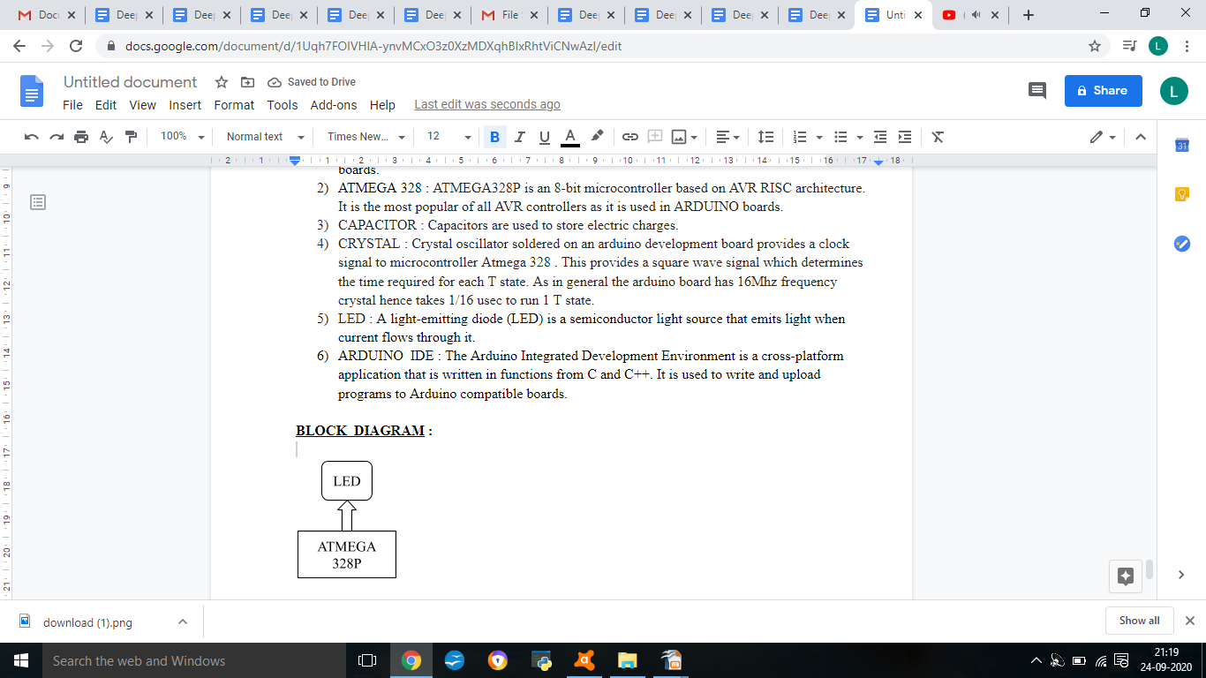**PROCEDURE:**

* Open Proteus window.
* Select ‘New Project’ and give suitable project name and location to the project. A design sheet will be opened.
* Select the ‘component mode’ button and select ATMEGA328P, LED, crystal oscillator and capacitors. Place them at an appropriate distance apart.
* Change the frequency of crystal to 16 MHz and capacitance to 22 μF.
* Make connections by left clicking from one terminal to another.
* Start Arduino IDE and write the code.
* Export the code to the compiled binary.
* Left click ATMEGA328P and export the compiled file in edit properties.
* Click the start button in the leftmost corner.
* The required output will be shown on the screen.

**CODE:**

void setup () {

pinMode (12, OUTPUT);

}

void loop () {

digitalWrite (12, HIGH);

delay (100);

digitalWrite (12, LOW);

delay (100);

}

**SIMULATION CIRCUIT:**

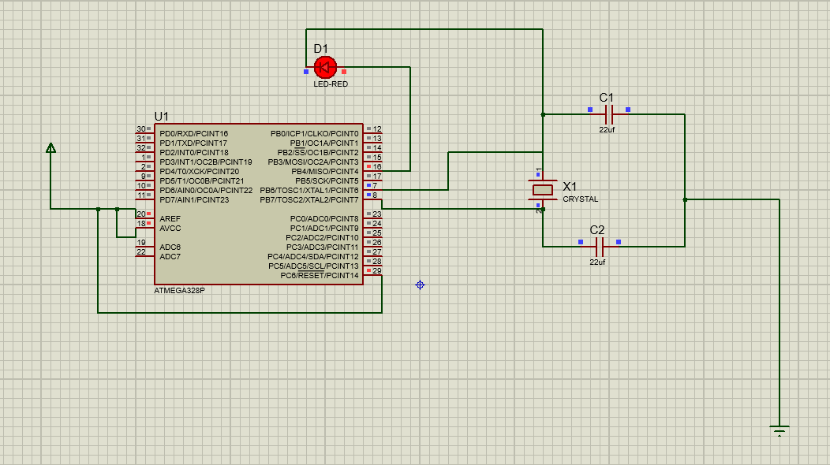

**RESULT:**

LED was lit successfully.

**PRECAUTIONS:**

* Place the components a distance apart.
* Make the circuit neat and clean.
* Keep a check so that no wire short-circuits.

**PROJECT NO. 2**

**AIM:** Interface 3 LED with the micro-controller chip ATMEGA328 in Proteus and WAP in IDE to simulate the circuit as a traffic light controller.

**APPARATUS REQUIRED:** PROTEUS: ATMEGA328, capacitors, crystal, led

ARDUINO IDE

**THEORY:**

1. PROTEUS: The Proteus Design Suite is a proprietary software tool suite used primarily for electronic design automation. The software is used mainly by electronic design engineers and technicians to create schematics and electronic prints for manufacturing printed circuit boards.
2. ATMEGA 328: ATMEGA328P is an 8-bit microcontroller based on AVR RISC architecture. It is the most popular of all AVR controllers as it is used in ARDUINO boards.
3. CAPACITOR: Capacitors are used to store electric charges.
4. CRYSTAL: Crystal oscillator soldered on an Arduino development board provides a clock signal to microcontroller Atmega328. This provides a square wave signal which determines the time required for each T state. As in general the Arduino board has 16Mhz frequency crystal hence takes 1/16 use C to run 1 T state.
5. LED: A light-emitting diode (LED) is a semiconductor light source that emits light when current flows through it.
6. ARDUINO IDE: The Arduino Integrated Development Environment is a cross-platform application that is written in functions from C and C++. It is used to write and upload programs to Arduino compatible boards.

**PROCEDURE:**

* Open Proteus window.
* Select ‘New Project’ and give suitable project name and location to the project. A design sheet will be opened.
* Select the ‘component mode’ button and select ATMEGA328P, LED, crystal oscillator and capacitors. Place them at an appropriate distance apart.
* Change the frequency of crystal to 16 MHz and capacitance to 22 μF.
* Make connections by left clicking from one terminal to another.
* Start Arduino IDE and write the code.
* Export the code to the compiled binary.
* Left click ATMEGA328P and export the compiled file in edit properties.
* Click the start button in the leftmost corner.
* The required output will be shown on the screen.

**CODE:**

#include<LiquidCrystal.h>

LiquidCrystal lcd(5,4,3,2,1,0);

int red =10,green=8, yellow=9;

void setup() {

pinMode(red,OUTPUT);

pinMode(green,OUTPUT);

pinMode(yellow,OUTPUT);

lcd.begin(16,2);

lcd.clear();

lcd.setCursor(0,0);

lcd.print("PANKAJ SINGH");

lcd.setCursor(0,1);

lcd.print(" 190BTCCSE024");

delay(100);

lcd.clear();

}

void loop() {

lcd.setCursor(0,0);

lcd.print("RED GREEN YELLOW");

lcd.setCursor(0,1);

lcd.print("ON ");

digitalWrite(red,HIGH);

digitalWrite(green,LOW);

digitalWrite(yellow,LOW);

delay(100);

lcd.setCursor(0,1);

lcd.print(" ON");

digitalWrite(red,LOW);

digitalWrite(green,HIGH);

delay(100);

lcd.setCursor(0,1);

lcd.print(" ON");

digitalWrite(green,LOW);

digitalWrite(yellow,HIGH);

delay(100);

}

**SIMULATION CIRCUIT:**

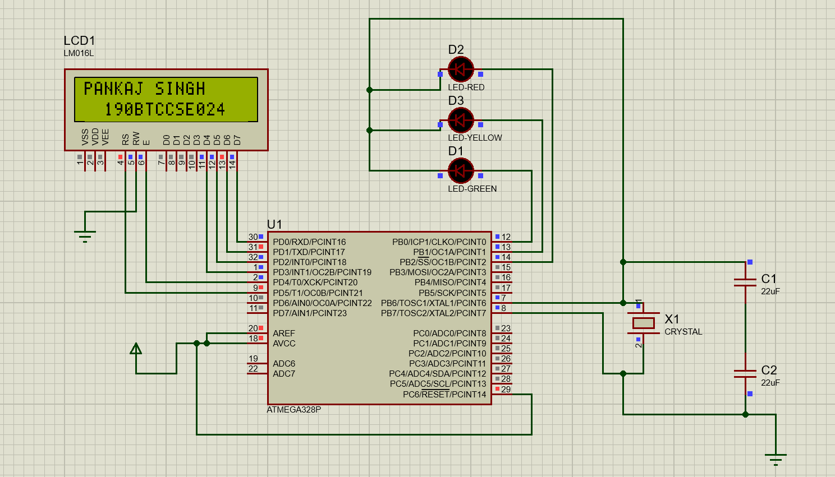

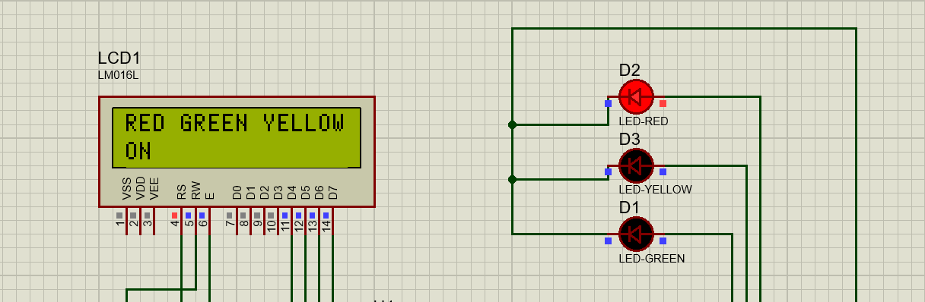

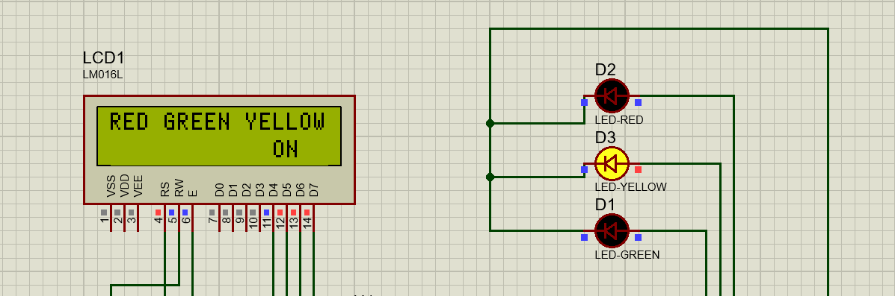

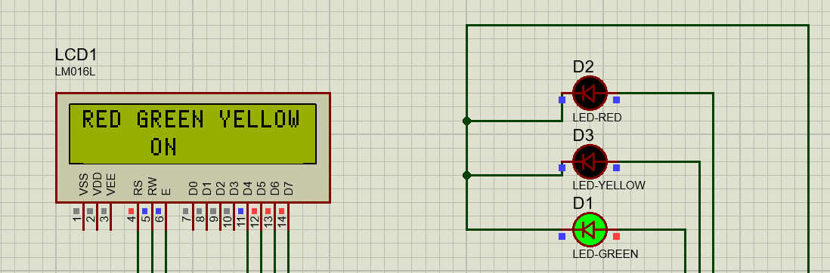

**RESULT:**

Traffic light controller was working perfectly.

**PRECAUTIONS:**

* Place the components a distance apart.
* Make the circuit neat and clean.
* Keep a check so that no wire short-circuits.

**PROJECT NO. 3**

**AIM:** Interface a 16X2 LCD with the microcontroller chip ATMEGA328 in Proteus and WAP in IDE to simulate the circuit.

**APPARATUS REQUIRED:** PROTEUS: ATMEGA 328, capacitors, crystal, lcd 16X2

ARDUINO IDE

**THEORY:**

1. PROTEUS: The Proteus Design Suite is a proprietary software tool suite used primarily for electronic design automation. The software is used mainly by electronic design engineers and technicians to create schematics and electronic prints for manufacturing printed circuit boards.
2. ATMEGA 328: ATMEGA328P is an 8-bit microcontroller based on AVR RISC architecture. It is the most popular of all AVR controllers as it is used in ARDUINO boards.
3. CAPACITOR: Capacitors are used to store electric charges.
4. CRYSTAL: Crystal oscillator soldered on an Arduino development board provides a clock signal to microcontroller Atmega328. This provides a square wave signal which determines the time required for each T state. As in general the Arduino board has 16Mhz frequency crystal hence takes 1/16 use C to run 1 T state.
5. LCD 16X2: A 16x2 LCD display is a very basic module and is very commonly used in various devices and circuits. A 16x2 LCD means it can display 16 characters in a line.
6. ARDUINO IDE: The Arduino Integrated Development Environment is a cross-platform application that is written in functions from C and C++. It is used to write and upload programs to Arduino compatible boards.

**PROCEDURE:**

* Open Proteus window.
* Select ‘New Project’ and give suitable project name and location to the project. A design sheet will be opened.
* Select the ‘component mode’ button and select ATMEGA328P, LED, crystal oscillator and capacitors. Place them at an appropriate distance apart.
* Change the frequency of crystal to 16 MHz and capacitance to 22 μF.
* Make connections by left clicking from one terminal to another.
* Start Arduino IDE and write the code.
* Export the code to the compiled binary.
* Left click ATMEGA328P and export the compiled file in edit properties.
* Click the start button in the leftmost corner.
* The required output will be shown on the screen.

**CODE:**

#include<LiquidCrystal.h>

LiquidCrystal lcd(13,12,8,9,10,11);

void setup() {

lcd.begin(16,2);

lcd.clear();

delay(10);

}

void loop() {

lcd.setCursor(0,0);

lcd.print("hellow");

delay(50);

lcd.setCursor(4,1);

lcd.print("How are you");

delay(50);

}

**SIMULATION CIRCUIT:**

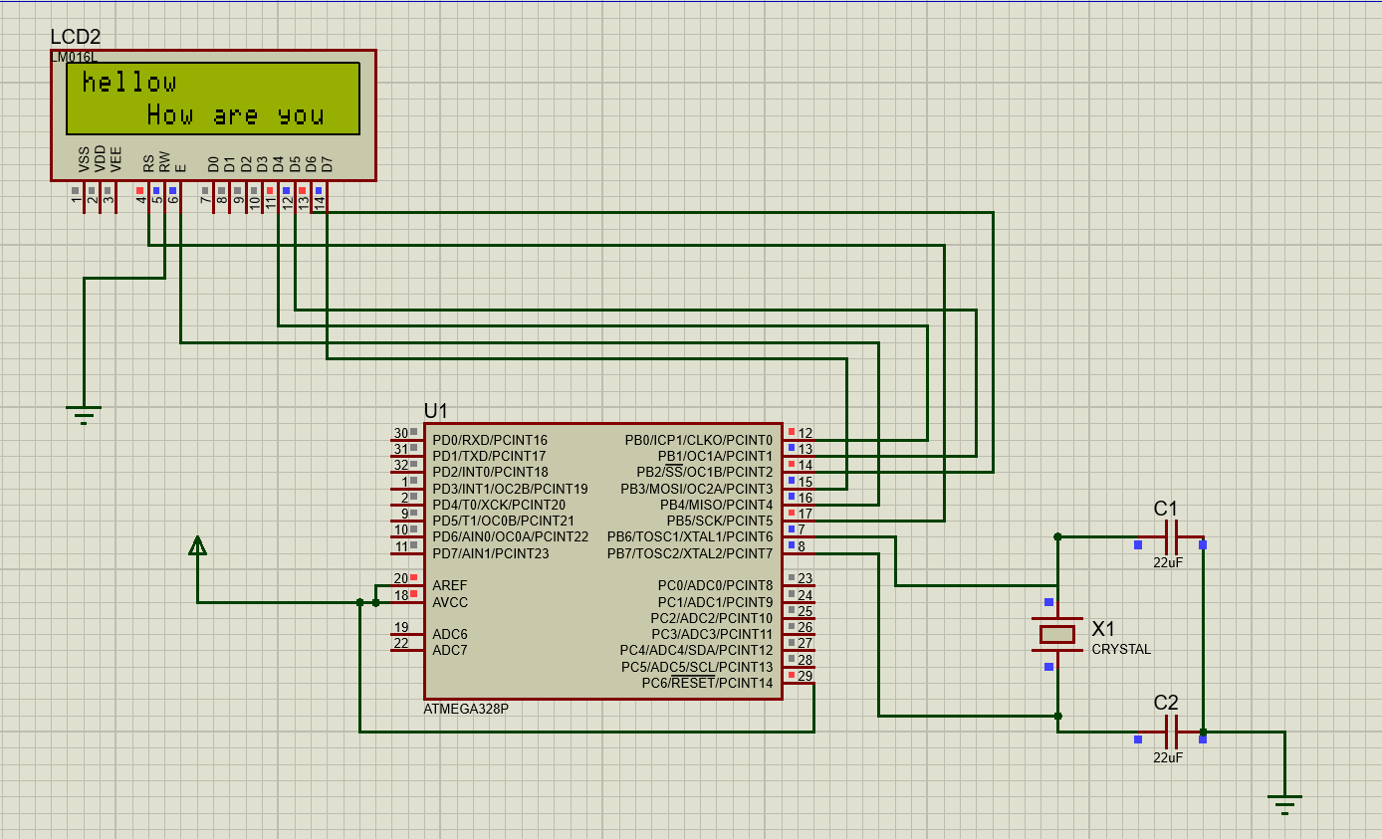

**RESULT:**

LCD was printing correct input.

**PRECAUTIONS:**

* Place the components a distance apart.
* Make the circuit neat and clean.
* Keep a check so that no wire short-circuits.

**PROJECT NO. 4**

**AIM:** Interface a led with respect to light sensor hence creating an Automatic Street light.

**APPARATUS REQUIRED:** PROTEUS: ATMEGA 328, capacitors, crystal, led, light sensor (LDR1)

ARDUINO IDE

**THEORY:**

1. PROTEUS: The Proteus Design Suite is a proprietary software tool suite used primarily for electronic design automation. The software is used mainly by electronic design engineers and technicians to create schematics and electronic prints for manufacturing printed circuit boards.
2. ATMEGA 328: ATMEGA328P is an 8-bit microcontroller based on AVR RISC architecture. It is the most popular of all AVR controllers as it is used in ARDUINO boards.
3. CAPACITOR: Capacitors are used to store electric charges.
4. CRYSTAL: Crystal oscillator soldered on an Arduino development board provides a clock signal to microcontroller Atmega328. This provides a square wave signal which determines the time required for each T state. As in general the Arduino board has 16Mhz frequency crystal hence takes 1/16 use C to run 1 T state.
5. LED: A light-emitting diode (LED) is a semiconductor light source that emits light when current flows through it.
6. LDR: A light sensor.
7. ARDUINO IDE: The Arduino Integrated Development Environment is a cross-platform application that is written in functions from C and C++. It is used to write and upload programs to Arduino compatible boards.

**PROCEDURE:**

* Open Proteus window.
* Select ‘New Project’ and give suitable project name and location to the project. A design sheet will be opened.
* Select the ‘component mode’ button and select ATMEGA328P, LED, crystal oscillator and capacitors. Place them at an appropriate distance apart.
* Change the frequency of crystal to 16 MHz and capacitance to 22 μF.
* Make connections by left clicking from one terminal to another.
* Start Arduino IDE and write the code.
* Export the code to the compiled binary.
* Left click ATMEGA328P and export the compiled file in edit properties.
* Click the start button in the leftmost corner.
* The required output will be shown on the screen.

**CODE:**

#include<LiquidCrystal.h>

int led=0,ldr=A0,senvalue=0;

LiquidCrystal lcd(13,12,8,9,10,11);

void setup() {

pinMode(led,OUTPUT);

pinMode(ldr,INPUT);

lcd.begin(16,2);

lcd.clear();

lcd.setCursor(0,0);

lcd.print("PANKAJ SINGH");

lcd.setCursor(0,1);

lcd.print(" 190BTCCSE024");

delay(100);

lcd.clear();

}

void loop() {

senvalue=analogRead(ldr);

lcd.clear();

if(senvalue>100)

{

digitalWrite(led,HIGH);

lcd.setCursor(5,1);

lcd.print("LED ON");

}

else

{

digitalWrite(led,LOW);

lcd.setCursor(5,1);

lcd.print("LED Off");

}

delay(100);

}

**SIMULATION CIRCUIT:** 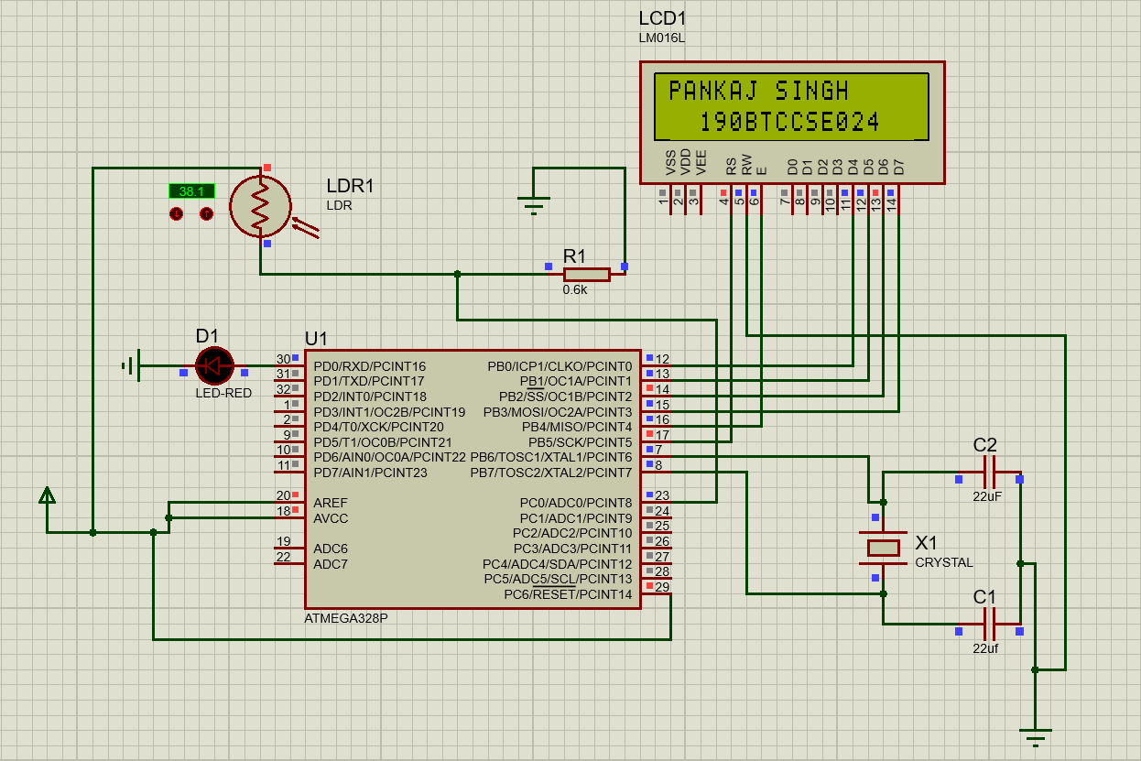

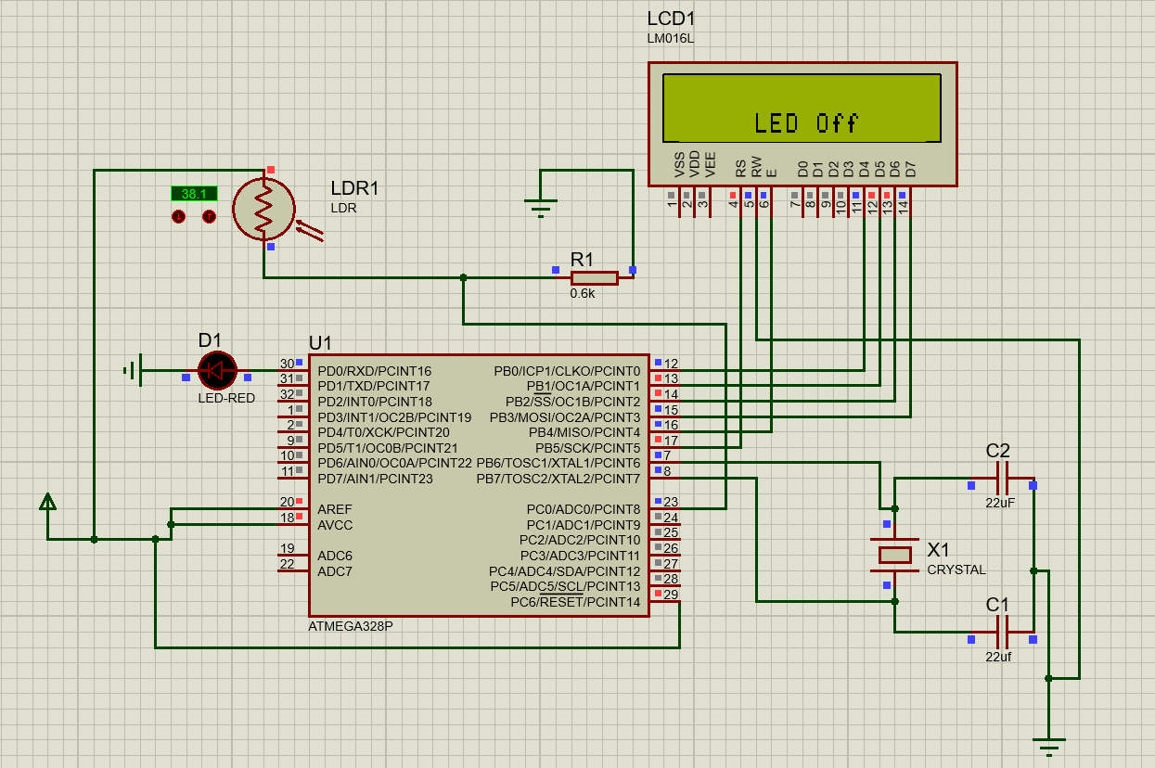

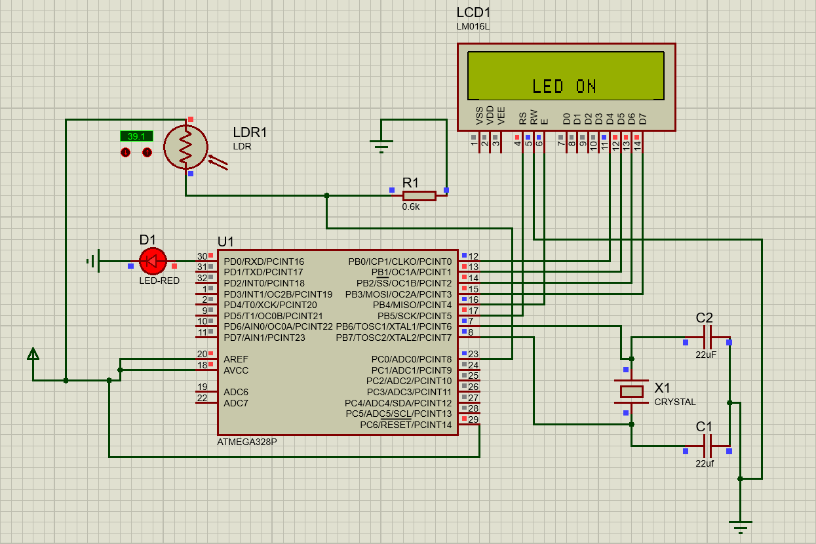

**RESULT:**

Automatic street light was perfectly working with intensity 39.

**PRECAUTIONS:**

* Place the components a distance apart.
* Make the circuit neat and clean.
* Keep a check so that no wire short-circuits.

**PROJECT NO. 5**

**AIM:** Interface a Temperature sensor (LM35) with the micro-controller chip ATMEGA328 and lighting a led in Proteus and WAP in IDE to simulate the circuit.

**APPARATUS REQUIRED:** PROTEUS: ATMEGA 328, capacitors, crystal, led, Temperature sensor

ARDUINO IDE

**THEORY:**

1. PROTEUS: The Proteus Design Suite is a proprietary software tool suite used primarily for electronic design automation. The software is used mainly by electronic design engineers and technicians to create schematics and electronic prints for manufacturing printed circuit boards.
2. ATMEGA 328: ATMEGA328P is an 8-bit microcontroller based on AVR RISC architecture. It is the most popular of all AVR controllers as it is used in ARDUINO boards.
3. CAPACITOR: Capacitors are used to store electric charges.
4. CRYSTAL: Crystal oscillator soldered on an Arduino development board provides a clock signal to microcontroller Atmega328. This provides a square wave signal which determines the time required for each T state. As in general the Arduino board has 16Mhz frequency crystal hence takes 1/16 use C to run 1 T state.
5. LM35: The LM35 series are precision integrated-circuit temperature devices with an output voltage linearly proportional to the Centigrade temperature, scaling at 10mV per degree celcius.
6. ARDUINO IDE: The Arduino Integrated Development Environment is a cross-platform application that is written in functions from C and C++. It is used to write and upload programs to Arduino compatible boards.

**PROCEDURE:**

* Open Proteus window.
* Select ‘New Project’ and give suitable project name and location to the project. A design sheet will be opened.
* Select the ‘component mode’ button and select ATMEGA328P, LED, crystal oscillator and capacitors. Place them at an appropriate distance apart.
* Change the frequency of crystal to 16 MHz and capacitance to 22 μF.
* Make connections by left clicking from one terminal to another.
* Start Arduino IDE and write the code.
* Export the code to the compiled binary.
* Left click ATMEGA328P and export the compiled file in edit properties.
* Click the start button in the leftmost corner.
* The required output will be shown on the screen.

**CODE:**

#include<LiquidCrystal.h>

int tsen=A0,red=12,green=13;

float temp;

LiquidCrystal lcd(5,4,3,2,1,0);

void setup() {

pinMode(red,OUTPUT);

pinMode(green,OUTPUT);

lcd.begin(16,2);

lcd.clear();

lcd.setCursor(0,0);

lcd.print("PANKAJ SINGH");

lcd.setCursor(0,1);

lcd.print(" 190BTCCSE024");

delay(100);

lcd.clear();

}

void loop() {

temp=analogRead(tsen);

temp=(temp*4.88)/10;

if(temp>=40)

{

lcd.setCursor(0,0);

lcd.print("CRITICAL TEMP ");

digitalWrite(red,HIGH);

digitalWrite(green,LOW);

}

else

{

lcd.setCursor(0,0);

lcd.print("OPTIMUM TEMP ");

digitalWrite(green,HIGH);

digitalWrite(red,LOW);

}

}

**SIMULATION CIRCUIT:**

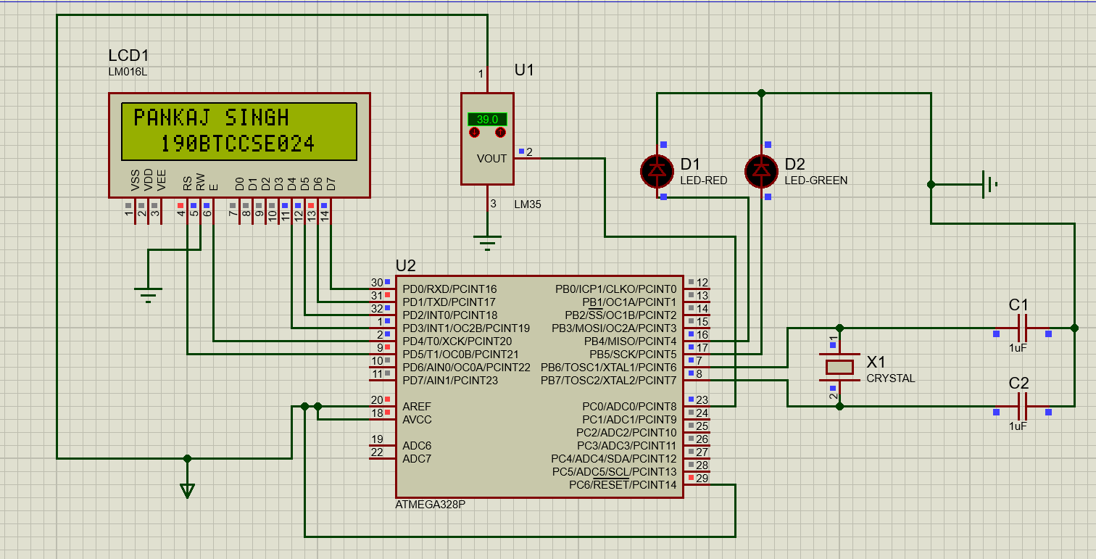

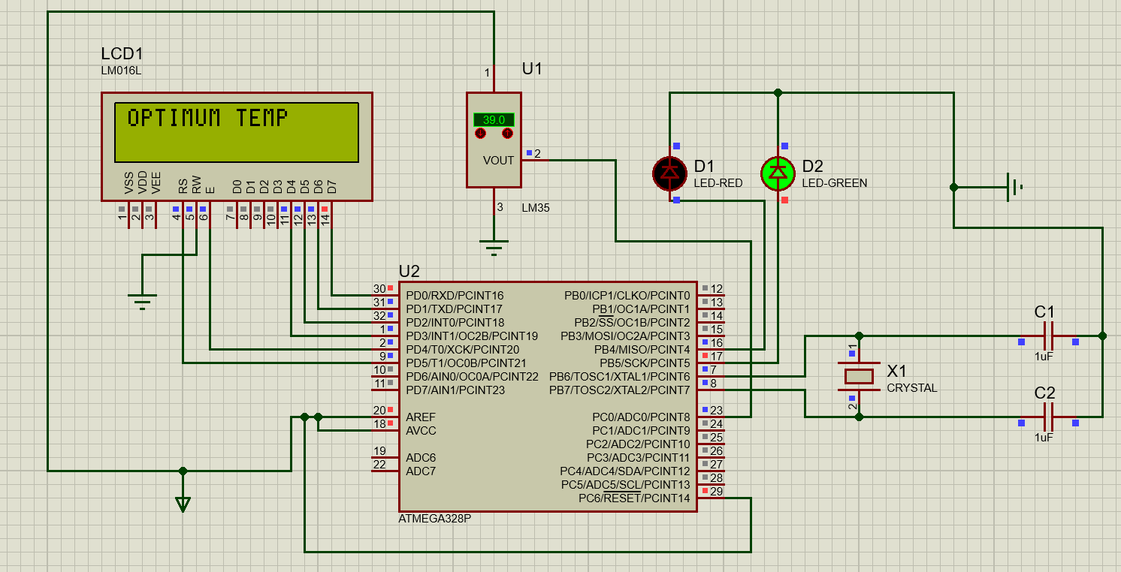

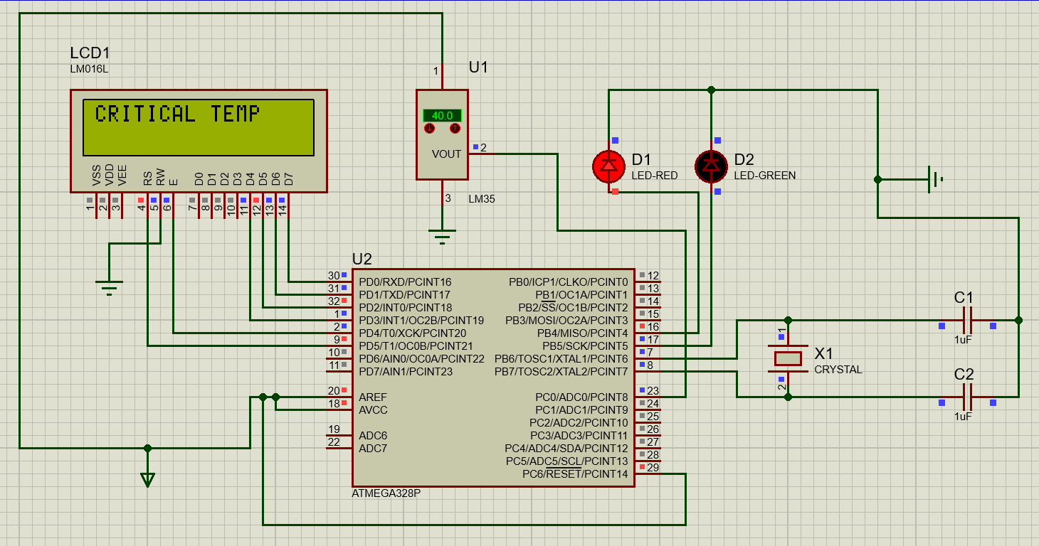

**RESULT:**

Led red was switched on at 40 degrees and off below 40 hence circuit worked perfectly.

**PRECAUTIONS:**

* Place the components a distance apart.
* Make the circuit neat and clean.
* Keep a check so that no wire short-circuits.

**PROJECT NO. 6**

**AIM:** Interface a LED with the micro-controller chip ATMEGA328 in Proteus and WAP in IDE to simulate the circuit to fade the luminosity of the LED.

**APPARATUS REQUIRED:** PROTEUS: ATMEGA 328, capacitors, crystal, led

ARDUINO IDE

**THEORY:**

1. PROTEUS: The Proteus Design Suite is a proprietary software tool suite used primarily for electronic design automation. The software is used mainly by electronic design engineers and technicians to create schematics and electronic prints for manufacturing printed circuit boards.
2. ATMEGA 328: ATMEGA328P is an 8-bit microcontroller based on AVR RISC architecture. It is the most popular of all AVR controllers as it is used in ARDUINO boards.
3. CAPACITOR: Capacitors are used to store electric charges.
4. CRYSTAL: Crystal oscillator soldered on an Arduino development board provides a clock signal to microcontroller Atmega328. This provides a square wave signal which determines the time required for each T state. As in general the Arduino board has 16Mhz frequency crystal hence takes 1/16 use C to run 1 T state.
5. LED: A light-emitting diode (LED) is a semiconductor light source that emits light when current flows through it.
6. ARDUINO IDE: The Arduino Integrated Development Environment is a cross-platform application that is written in functions from C and C++. It is used to write and upload programs to Arduino compatible boards.

**PROCEDURE:**

* Open Proteus window.
* Select ‘New Project’ and give suitable project name and location to the project. A design sheet will be opened.
* Select the ‘component mode’ button and select ATMEGA328P, LED, crystal oscillator and capacitors. Place them at an appropriate distance apart.
* Change the frequency of crystal to 16 MHz and capacitance to 22 μF.
* Make connections by left clicking from one terminal to another.
* Start Arduino IDE and write the code.
* Export the code to the compiled binary.
* Left click ATMEGA328P and export the compiled file in edit properties.
* Click the start button in the leftmost corner.
* The required output will be shown on the screen.

**CODE:**

#include<LiquidCrystal.h>

int led=9;

LiquidCrystal lcd(5,4,3,2,1,0);

void setup() {

pinMode(9,OUTPUT);

lcd.begin(16,2);

lcd.clear();

lcd.setCursor(0,0);

lcd.print("PANKAJ SINGH");

lcd.setCursor(0,1);

lcd.print(" 190BTCCSE024");

delay(100);

lcd.clear();

}

void loop() {

int fading;

lcd.setCursor(0,0);

lcd.print("Led Intensity");

for(fading=100;fading<=255;fading+=5)

{

lcd.setCursor(0,1);

lcd.print("INCREASING ");

analogWrite(led,fading);

delay(5);

}

delay(50);

for(fading=255;fading>=100;fading-=5)

{

lcd.setCursor(0,1);

lcd.print(" DECREASING");

analogWrite(led,fading);

delay(5);

}

}

**SIMULATION CIRCUIT:**

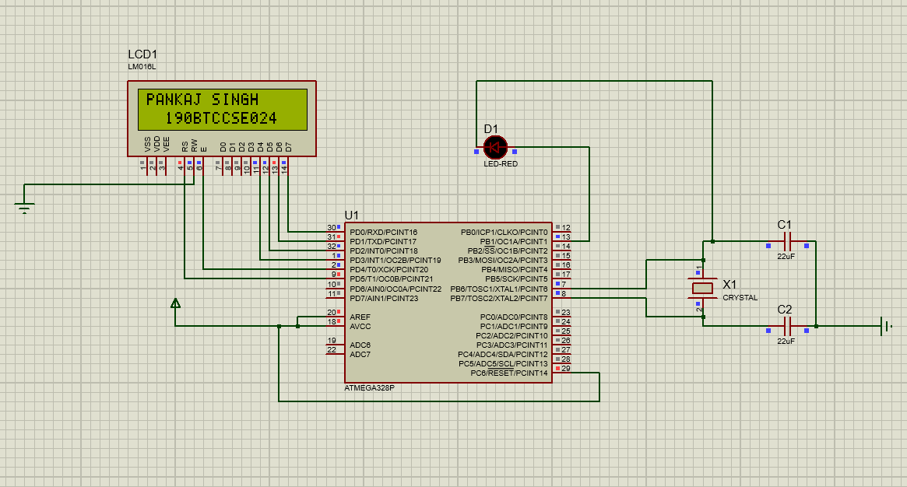

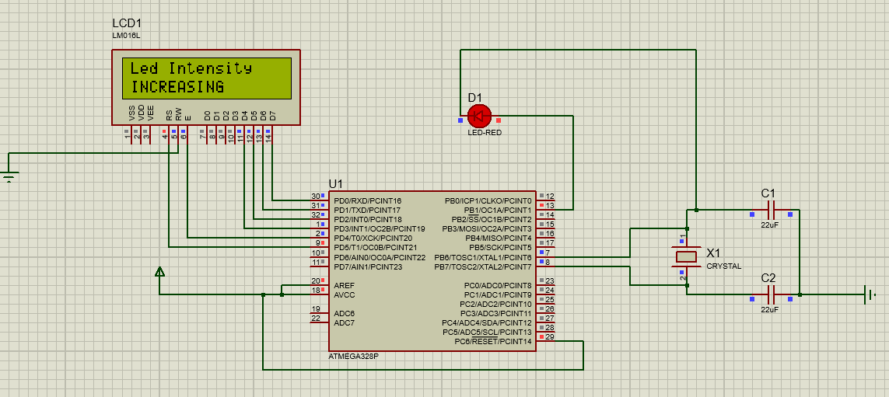

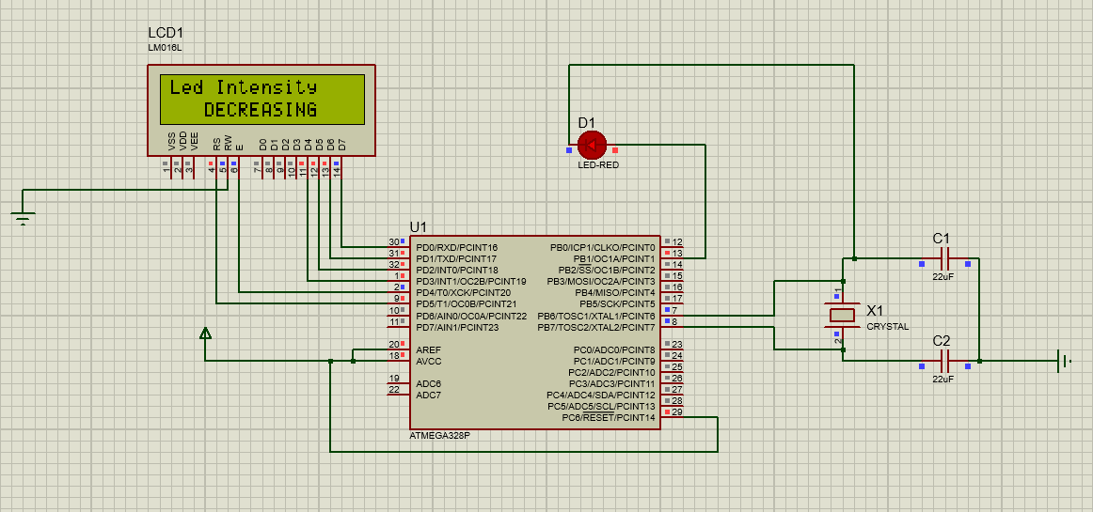

**RESULT:**

Intensity of LED was increasing and decreasing with respect to time.

**PRECAUTIONS:**

* Place the components a distance apart.
* Make the circuit neat and clean.
* Keep a check so that no wire short-circuits.

**PROJECT NO. 7**

**AIM:** Interface an ultrasonic sensor with atmega328 in Proteus and WAP in IDE to simulate the circuit.

**APPARATUS REQUIRED:** PROTEUS: ATMEGA 328, capacitors, crystal, led, ultrasonic sensor

(HCSR04),

ARDUINO IDE

**THEORY:**

1. PROTEUS: The Proteus Design Suite is a proprietary software tool suite used primarily for electronic design automation. The software is used mainly by electronic design engineers and technicians to create schematics and electronic prints for manufacturing printed circuit boards.
2. ATMEGA 328: ATMEGA328P is an 8-bit microcontroller based on AVR RISC architecture. It is the most popular of all AVR controllers as it is used in ARDUINO boards.
3. CAPACITOR: Capacitors are used to store electric charges.
4. CRYSTAL: Crystal oscillator soldered on an Arduino development board provides a clock signal to microcontroller Atmega328. This provides a square wave signal which determines the time required for each T state. As in general the Arduino board has 16Mhz frequency crystal hence takes 1/16 use C to run 1 T state.
5. LED: A light-emitting diode (LED) is a semiconductor light source that emits light when current flows through it.
6. Ultrasonic sensor (HCSR04): An ultrasonic sensor is an electronic device that is typically used for distance measurement and/or object detection.
7. ARDUINO IDE: The Arduino Integrated Development Environment is a cross-platform application that is written in functions from C and C++. It is used to write and upload programs to Arduino compatible boards.

**PROCEDURE:**

* Open Proteus window.
* Select ‘New Project’ and give suitable project name and location to the project. A design sheet will be opened.
* Select the ‘component mode’ button and select ATMEGA328P, LED, crystal oscillator and capacitors. Place them at an appropriate distance apart.
* Change the frequency of crystal to 16 MHz and capacitance to 22 μF.
* Make connections by left clicking from one terminal to another.
* Start Arduino IDE and write the code.
* Export the code to the compiled binary.
* Left click ATMEGA328P and export the compiled file in edit properties.
* Click the start button in the leftmost corner.
* The required output will be shown on the screen.

**CODE:**

#include<LiquidCrystal.h>

LiquidCrystal lcd(5,4,3,2,1,0);

int ledg=8,ledr=11,tr=9,ecco=10,idis;

float dis;

void setup() {

pinMode(ledr,OUTPUT);

pinMode(ledg,OUTPUT);

pinMode(tr,OUTPUT);

pinMode(ecco,INPUT);

lcd.begin(16,2);

lcd.setCursor(0,0);

lcd.print("PANKAJ SINGH");

lcd.setCursor(3,1);

lcd.print("190BTCCSE024");

delay(100);

lcd.clear();

}

void loop() {

digitalWrite(tr,HIGH);

delay(10);

digitalWrite(tr,LOW);

dis=pulseIn(ecco,HIGH,10000);

lcd.setCursor(1,1);

lcd.print(dis);

dis=dis*0.343;

idis=dis;

if(idis==0){

digitalWrite(ledg,LOW);

digitalWrite(ledr,HIGH);

}

else{

digitalWrite(ledr,LOW);

digitalWrite(ledg,HIGH);

}

lcd.setCursor(0,0);

lcd.print("distance =");

lcd.print(dis);

}

**SIMULATION CIRCUIT:**

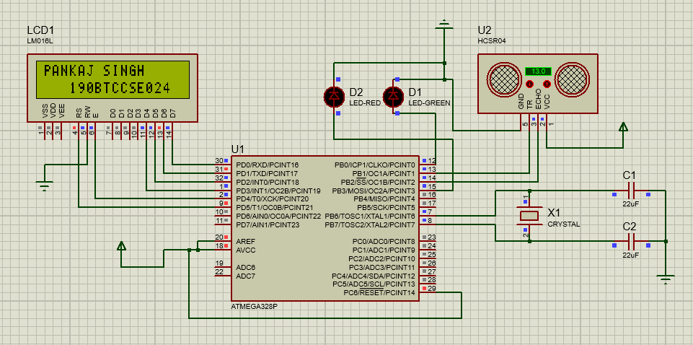

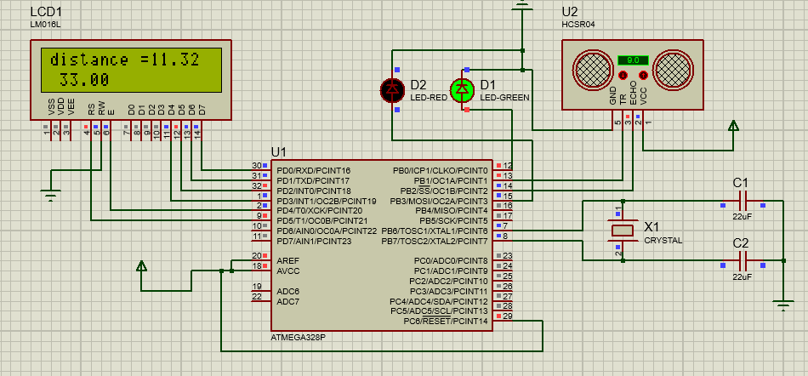

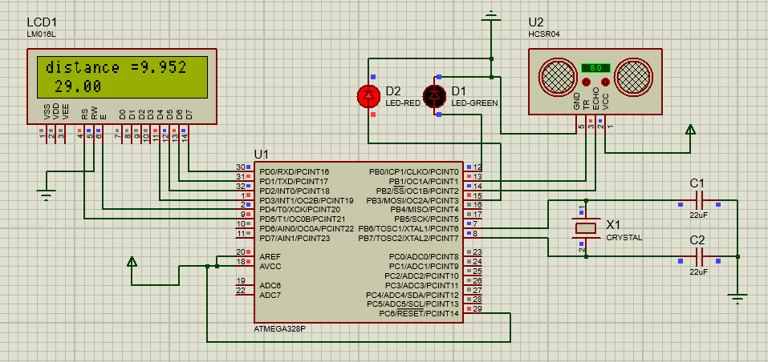

**RESULT:**

Distance was been printed on LCD and critical distance was measured within accepted values.

**PRECAUTIONS:**

* Place the components a distance apart.
* Make the circuit neat and clean.
* Keep a check so that no wire short-circuits.