Lab-1

- Describe operating system
Operating system is an interface between user and the hardware. It is a system software which manages the computer hardware and the resources and provides services.
2.Types of operating system
The types of operating system are as follows: -
- Single user OS -it a single user os and it stores the date in the same drive for any amount of user uses it.
- Multi user OS -It allows multiple user to access a single system with one os.it stores the data differently for different users.
- Batch OS -it is the first os of the second gen computers which works on first in first out strategy. It is very slow and inefficient type of os.
- Real time OS -Real time os uses the real time applications where processing is done in small quanta of time. RTOS is well synchronized and is more efficient than any other os as it works on time sharing strategy as well.
3.Features of operating system
• Handling I/O operations
• Manipulation of the file system
• Program Execution
• Resources management
• Error detection and handling
• Data security
4.Architecture of Linux
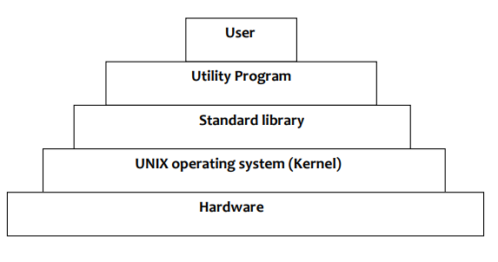
Hardware – it contains the physical devices as CPU, memory, I/O devices etc.
Kernel --it is the central program which have full access to the resources of the os.
Std library—it is the collection of different files and contains set of procedures.
Utility prog-these are the programs which helps the os to run properly and smoothly.
User -- User is someone who uses the os and interact with the system.
5.Shell and kernel
Shell— When a user gives his Command for Performing Any Operation, then the Request Will goes to the Shell Parts,
The Shell Parts is also called as the Interpreter which translate the Human Program into the Machine
Language and then the Request will be transferred to the Kernel. So that Shell is just called as the interpreter
of the Commands which Converts the Request of the User into the Machine Language. Some examples of
shells are MS-DOS Shell (command.com), csh, ksh, PowerShell, sh, and tcsh
Kernel— The kernel is the central component of a computer operating systems. The only job performed by the kernel
is to the manage the communication between the software and the hardware. A Kernel is at the nucleus of a
computer. It makes the communication between the hardware and software possible. While the Kernel is the
innermost part of an operating system, a shell is the outermost one. examples are linux kernel.

COMMAND LIST
