**CREATE A CHATBOT USING PYTHON**

**NAME:A.PRINCE SUNDAR**

**REG.NO:952821106028**

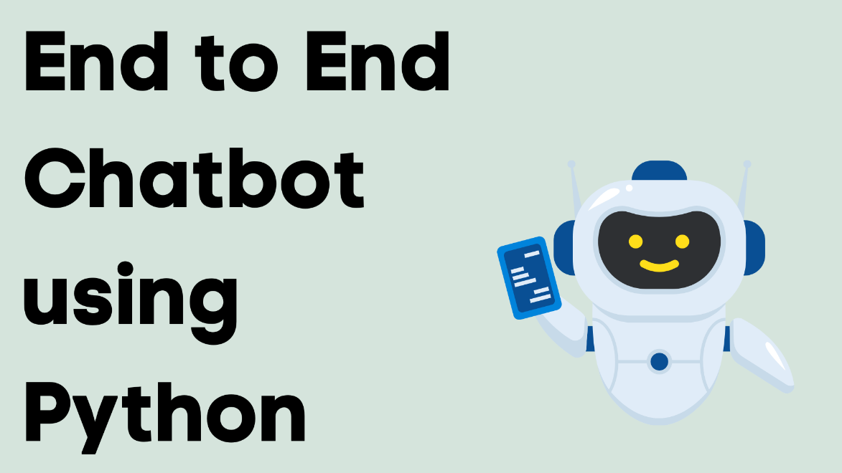

**INTRODUCTION**

Chatbots are computer programs designed to simulate conversation with human users, and they have become increasingly popular in various applications, from customer support to personal assistants. Python is an excellent choice for building chatbots due to its simplicity, versatility, and the availability of powerful natural language processing (NLP) libraries and frameworks

.

**LOADING AND PREPROCESSING THE DATA :**

Creating a chatbot typically involves loading and preprocessing data before training the model. In this example, I'll show you how to load and preprocess text data using Python. For the sake of simplicity, I'll assume you have a dataset of conversation pairs. You can use libraries like TensorFlow, PyTorch, or Hugging Face Transformers for more advanced chatbot development.

**Import necessary libraries:**

You'll need libraries like “numpy”, “pandas”, and “sklearn” for data preprocessing. Additionally, you may need to install libraries for natural language processing, like “nltk” or “spaCy”

**SOURCE CODE:**

import numpy as np

import pandas as pd

import nltk

from sklearn.model_selection import train_test_split

from sklearn.feature_extraction.text import CountVectorizer

from sklearn.preprocessing import LabelEncoder

**Load the data:**

You should have a dataset containing conversation pairs, typically in a CSV or text file. Here, we assume your dataset has two columns: "user" and "bot," where "user" contains user input and "bot" contains the bot's response**.**

data = pd.read_csv('your_dataset.csv')

**Preprocess the data:**

Data preprocessing is a crucial step to prepare your data for training. It typically includes tokenization, text cleaning, and converting text to numerical format.

# Tokenize the text

data['user'] = data['user'].apply(nltk.word_tokenize)

data['bot'] = data['bot'].apply(nltk.word_tokenize)

vectorizer = CountVectorizer()

X = vectorizer.fit_transform(data['user'])

**Split the data:**

You should split your data into training and testing sets to evaluate your chatbot's performance.

X_train, X_test, y_train, y_test = train_test_split(X, data['bot'], test_size=0.2, random_state=42)

**Label encoding** (if you have predefined responses):

If you have predefined bot responses, you might want to label-encode them.

label_encoder = LabelEncoder()

y_train_encoded = label_encoder.fit_transform(y_train)

y_test_encoded = label_encoder.transform(y_test)

**Importance of chatbot using python:**

**Improved Customer Service:**

Chatbots can provide 24/7 customer support, answering frequently asked questions and handling routine queries. This enhances customer satisfaction and reduces response time, making it an essential tool for businesses.

**Cost-Efficiency:**

By automating customer support and handling routine tasks, chatbots can significantly reduce operational costs. Businesses can allocate resources more efficiently and free up human agents to focus on more complex issues**.**

**Scalability:**

Python, with its robust ecosystem and libraries, is an excellent choice for building chatbots that can scale with ease. This means they can handle a growing number of user interactions without a proportional increase in costs.

**Data Collection and Analysis:**

Chatbots can gather user data, preferences, and feedback, which can be valuable for understanding customer behavior and improving products or services. Python has strong data analysis and machine learning libraries, making it easier to process and extract insights from this data.

**Personalization:**

Python-powered chatbots can be highly customizable and offer personalized experiences to users. By analyzing user data, chatbots can tailor responses and recommendations to individual preferences.

**Automation:**

Chatbots can automate a wide range of tasks, from appointment scheduling and order tracking to data retrieval and content recommendations. This automation streamlines processes, making businesses more efficient.

**Reduced Human Error:**

Chatbots perform tasks consistently and without human error, which is especially important in industries like healthcare, finance, and manufacturing, where precision is critical.

**Enhanced User Engagement:**

Well-designed chatbots can engage users in a conversational manner, making interactions more enjoyable and user-friendly. This can lead to higher user engagement and better user retention.

**Multilingual Support:**

Python's natural language processing (NLP) libraries make it easier to develop chatbots that can understand and communicate in multiple languages, expanding their reach to a global audience.

**Cross-Platform Compatibility:**

Python-based chatbots can be integrated with various messaging platforms, websites, and mobile apps, making them versatile and accessible to users on their preferred channels**.**

**Quick Development:**

Python is known for its simplicity and readability, which allows for faster development and easier maintenance of chatbot code.

**AI and Machine Learning Integration:**

Python offers a wide range of libraries for AI and machine learning, enabling chatbots to learn and adapt over time, becoming more intelligent and capable of handling complex tasks.

**Analytics and Performance Monitoring:**

Python provides tools and libraries for monitoring and analyzing the performance of chatbots, allowing for continuous improvement and optimization**.**

**Challenges Involved In Loading And Preprocessing In**

**ChatBot Using Python:**

**Data Quality:**

Inconsistent and noisy data: Chatbot training data can be messy, with varying user inputs, typos, and informal language. Preprocessing must handle these inconsistencies.

**Data Quantity:**

Insufficient data: Gathering enough conversational data to train an effective chatbot can be a challenge, especially for specialized or niche domains.

**Tokenization:**

Choosing the right tokenization strategy: Tokenization can be complex, especially when dealing with languages that don't use spaces between words, like Chinese or Thai.

**Stop Words and Special Characters:**

Removing or retaining stop words and special characters: Deciding whether to remove common words (stop words) or special characters can impact the chatbot's understanding of user input.

**Data Labeling:**

Manually labeling training data: If you're creating a supervised chatbot, manually labeling conversation data can be time-consuming and error-prone.

**Handling Imbalanced Data:**

In some cases, you might have an imbalance in the data, with certain intents or responses being underrepresented. Balancing the data for effective training can be challenging.

**Ambiguity and Synonyms:**

Handling word ambiguity and synonyms: Some words or phrases may have multiple meanings, and synonyms can make intent recognition challenging.

**Context Preservation:**

Maintaining context in conversations: Chatbots need to understand the context of a conversation, which can be challenging, especially when dealing with long conversations or complex user queries.

**Named Entity Recognition (NER):**

Identifying and extracting named entities (e.g., dates, locations, names) from text can be challenging, as it often requires additional NLP techniques and models.

**Training Data Variability:**

Chatbots should be exposed to a wide range of conversational scenarios and user inputs, which may require augmenting or diversifying the training data.

**Overfitting and Underfitting:**

Balancing model complexity: Overfitting (when the model learns the training data too well but fails to generalize) and underfitting (when the model is too simple) are common challenges in training chatbot models.

**Memory and State Management:**

Developing chatbots with memory and state management to maintain context over multi-turn conversations can be complex and require careful design.

**Multi-Lingual Support:**

Handling multiple languages can add complexity to chatbot preprocessing and language understanding.

**Privacy and Security:**

Ensuring that personal or sensitive information shared in conversations is not mishandled is a critical consideration. Proper data anonymization is often necessary.

**Testing and Evaluation:**

Evaluating the chatbot's performance and fine-tuning it to achieve desired levels of accuracy and user satisfaction can be an ongoing challenge.

**Model Selection and Hyperparameter Tuning:**

Choosing the right NLP model, architecture, and hyperparameters can be complex, and it often involves experimentation.

**Integration with Deployment Platforms:**

Integrating the chatbot into various platforms and maintaining compatibility can pose technical challenges.

**SOME COMMEN PREPROCESSING TASK INCLUDED:**

**Text Cleaning:**

Removing HTML tags, if present.

Lowercasing all text to ensure uniformity.

Removing special characters and punctuation.

Handling contractions (e.g., converting "I'm" to "I am").

Removing extra white spaces.

**SOURCE CODE**:

import re

def clean_text(text):

text = text.lower()

text = re.sub(r'<.*?>', '', text)

text = re.sub(r'[^a-zA-Z0-9]', ' ', text)

text = re.sub(r'\s+', ' ', text)

return text

**Tokenization:**

Splitting the text into individual words or tokens.

**SOURCE CODE**:

import nltk

nltk.download('punkt')

def tokenize_text(text):

return nltk.word_tokenize(text)

**Stop Words Removal:**

Removing common words (stop words) like "the," "is," "and," etc., which do not carry much meaning.

**SOURCE CODE**:

from nltk.corpus import stopwords

nltk.download('stopwords')

stop_words = set(stopwords.words('english'))

def remove_stop_words(tokens):

return [word for word in tokens if word not in stop_words]

**Lemmatization or Stemming**:

Reducing words to their base form (lemmas) or stems to simplify text processing.

**SOURCE CODE**:

from nltk.stem import WordNetLemmatizer

nltk.download('wordnet')

lemmatizer = WordNetLemmatizer()

def lemmatize_tokens(tokens):

return [lemmatizer.lemmatize(word) for word in tokens]

**Entity Recognition:**

Identifying and tagging entities like names, dates, locations, etc., using Named Entity Recognition (NER) techniques.

**Handling Emoji and Emoticons:**

Recognizing and handling emojis or emoticons commonly used in conversational text.

**Handling Abbreviations and Acronyms:**

Expanding abbreviations and acronyms to their full forms.

Word Sense Disambiguation:

Resolving word ambiguity when a word has multiple meanings based on context.

**Normalization:**

Normalizing text to a standard form, like converting numbers to words or vice versa.

**Spell-Checking:**

Detecting and correcting typos in the text using libraries like pyspellchecker.

**Diversity and Data Augmentation:**

Diversifying training data by including a wide range of conversational scenarios.

Augmenting data through paraphrasing or data synthesis to increase the dataset's size. Entity Recognition:

Identifying and tagging entities like names, dates, locations, etc., using Named Entity Recognition (NER) techniques.

**Handling Emoji and Emoticons:**

Recognizing and handling emojis or emoticons commonly used in conversational text.

**Handling Abbreviations and Acronyms:**

Expanding abbreviations and acronyms to their full forms.

**Word Sense Disambiguation**:

Resolving word ambiguity when a word has multiple meanings based on context.

**Normalization:**

Normalizing text to a standard form, like converting numbers to words or vice versa.

**Spell-Checking**:

Detecting and correcting typos in the text using libraries like pyspellchecker.

**Diversity and Data Augmentation:**

Diversifying training data by including a wide range of conversational scenarios.

Augmenting data through paraphrasing or data synthesis to increase the dataset's size.

**Conclusion:**

In conclusion, building a chatbot using Python offers a powerful and flexible solution. Python's rich ecosystem of libraries, natural language processing tools like NLTK and spaCy, and frameworks like Rasa or ChatterBot make it well-suited for chatbot development. With advanced techniques such as machine learning and deep learning, you can create intelligent and context-aware chatbots. Additionally, Python's ease of integration with web frameworks and APIs allows you to deploy chatbots on various platforms, making it a popular choice for chatbot development**.**