WEEK 1 DATA SCIENCE PROJECT

Project Planning & Strategy Design
Student Academic Performance Prediction and Analysis Using Python
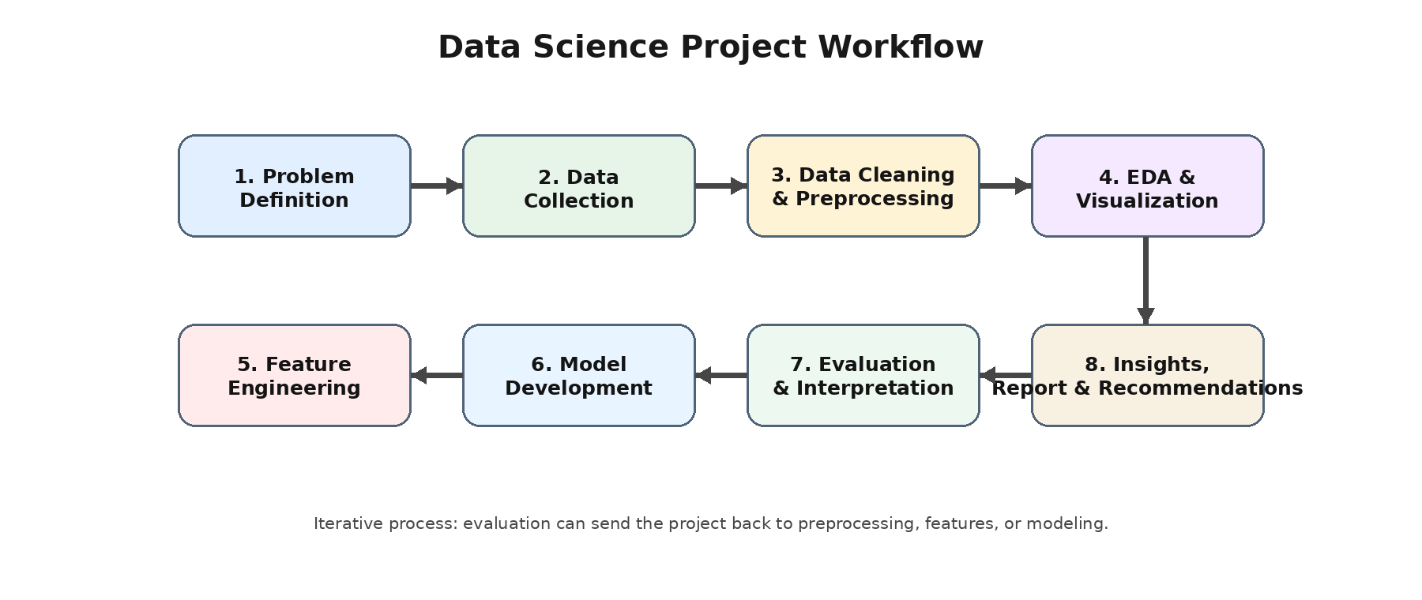
Prepared by: Prince Arya
Program: B.Tech – Computer Science & Engineering
Project Type: Hypothetical Data Science Project
Planned Effort: 33 Hours
Week 1 Deliverable

Executive Summary
This document presents a structured plan for a hypothetical data science project focused on understanding and predicting student academic performance using Python. The project is designed to demonstrate the complete data science lifecycle—from problem definition and data collection through data preparation, exploratory analysis, feature engineering, machine learning, evaluation, interpretation, and reporting.
The project will use academic and contextual variables such as attendance, study time, assessment scores, previous performance, and other appropriate non-sensitive attributes to identify patterns associated with student outcomes. The plan deliberately separates prediction from intervention: the model is intended to support analysis and early identification of academic patterns, not to make high-stakes decisions about students.
The proposed work is allocated approximately 33 hours and uses accessible Python tools including Pandas, NumPy, Matplotlib, Seaborn, and Scikit-learn in Jupyter Notebook or Google Colab.

1. Project Background and Introduction

1.1 Problem Statement
Educational institutions generate information about student attendance, assessments, study habits, course performance, and engagement. When this information is examined systematically, it can reveal patterns that are difficult to identify through manual review. The proposed project will analyze such information and develop a predictive model for an academic performance indicator.
The hypothetical problem is: “Can available academic and behavioral indicators be used to understand and estimate a student's final academic performance?” The project will investigate which variables are most associated with the target outcome and compare several machine learning approaches.

1.2 Motivation and Justification
- Manual analysis of many student records can be time-consuming and may miss relationships between variables.
- Data visualization can make performance patterns, distributions, and relationships easier to understand.
- A predictive model can provide an analytical estimate that can be evaluated using objective metrics.
- The project provides a practical beginner-to-intermediate example of the complete Python-based data science workflow.
- Insights can help demonstrate how data can support evidence-based academic analysis while keeping human judgment involved.

2. Project Objectives and Scope

2.1 Objectives
- Define a reproducible data science workflow for student performance analysis.
- Identify appropriate data fields and design a practical data collection strategy.
- Clean and preprocess the planned dataset so it is suitable for analysis and modeling.
- Perform exploratory data analysis (EDA) to identify distributions, relationships, trends, and potential anomalies.
- Engineer and select meaningful features without introducing data leakage.
- Develop and compare multiple baseline machine learning models.
- Evaluate model performance using suitable regression metrics and error analysis.
- Interpret important factors and communicate findings through charts and a final report.

2.2 In-Scope
Area | Included in the project
Data | Academic, attendance, study/engagement, assessment, and other appropriate contextual variables.
Preparation | Missing-value handling, duplicate checks, validation, encoding, scaling where required.
EDA | Descriptive statistics, distributions, correlations, group comparisons, and visualizations.
Modeling | Baseline model plus Decision Tree and Random Forest/other suitable regression model.
Evaluation | Train/test strategy, MAE, RMSE, R², residual/error review, and model comparison.
Reporting | Visual insights, methodology, limitations, findings, and recommendations for future work.

2.3 Out-of-Scope
- Production deployment of the model as a live institutional system.
- Collection of personally identifiable or sensitive student information beyond what is necessary for analysis.
- Automated decisions about admission, grading, disciplinary action, or student eligibility.
- Real-time streaming data pipelines and cloud-scale infrastructure.
- Clinical, psychological, or other high-stakes conclusions about students.
- Guaranteeing that predictions will be correct for every individual.

3. Proposed Data and Data Collection Strategy
Because Week 1 is a planning exercise, no dataset is required. For a later technical phase, the project would use either a suitable public educational dataset or a carefully designed synthetic dataset. The source would be documented, and the final project would record its data dictionary and provenance.
Planned Variable | Example Type | Purpose
Attendance Percentage | Numeric | Measure participation/attendance pattern.
Study Hours per Week | Numeric | Represent study effort.
Assignment Average | Numeric | Measure continuous assessment performance.
Midterm Score | Numeric | Provide an earlier academic performance indicator.
Previous Performance | Numeric | Capture prior academic outcome where available.
Course/Subject Category | Categorical | Allow group-level comparisons.
Final Score / Target | Numeric | Target variable for prediction.

3.1 Data Quality Checks
- Verify column names, data types, valid ranges, and units.
- Identify missing values and decide whether to impute, retain, or exclude them based on context.
- Check duplicate records and inconsistent categories.
- Detect impossible or suspicious values, such as percentages outside 0–100.
- Inspect class/category balance if a categorical target is considered later.
- Document every transformation so the workflow remains reproducible.

4. Methodology and Strategy
The project will follow an iterative lifecycle. Findings from evaluation may require returning to data preparation, feature engineering, or model selection.
Figure 1. Planned end-to-end data science workflow.

4.1 Stage 1 – Problem Definition
Define the target variable, intended users of the analysis, assumptions, constraints, and success criteria. The initial target will be a continuous academic performance measure such as final score, making regression the primary modeling formulation.

4.2 Stage 2 – Data Collection
Identify a suitable public or synthetic dataset containing the planned variables. Record the source, license/usage conditions, field definitions, collection context, and known limitations.

4.3 Stage 3 – Data Cleaning and Preprocessing
Load the data with Pandas, inspect its structure, standardize data types, remove or resolve duplicates, handle missing values, validate ranges, encode categorical variables, and scale numerical variables when required by the selected algorithm.

4.4 Stage 4 – Exploratory Data Analysis
Use descriptive statistics and visualizations to understand distributions and relationships. Planned visualizations include histograms, box plots, scatter plots, correlation heatmaps, and group comparisons. EDA will also be used to identify outliers and possible data leakage.

4.5 Stage 5 – Feature Engineering
Create only features that are available at the intended prediction point. Examples may include attendance bands, combined assessment averages, or normalized study-effort indicators. Highly redundant or leakage-prone features will be reviewed.

4.6 Stage 6 – Model Development
Create a simple baseline first, then train multiple candidate models. A planned sequence is Linear Regression, Decision Tree Regressor, and Random Forest Regressor. The exact final models will depend on data quality and assumptions.

4.7 Stage 7 – Evaluation
Metric | Purpose
MAE | Average absolute prediction error; easy to interpret in target units.
RMSE | Penalizes larger errors more strongly than MAE.
R² | Indicates the proportion of target variance explained by the model relative to a baseline.
Residual Analysis | Checks systematic errors and whether performance differs across ranges/groups.
The dataset will be divided into training and testing data before final evaluation. Cross-validation may be used on the training set for model selection. The test set will remain isolated until final comparison to reduce optimistic evaluation.

4.8 Stage 8 – Interpretation and Reporting
Results will be communicated through concise charts, metric tables, model interpretation, limitations, and practical recommendations. Conclusions will distinguish observed relationships from causal claims.

5. Proposed Project Architecture
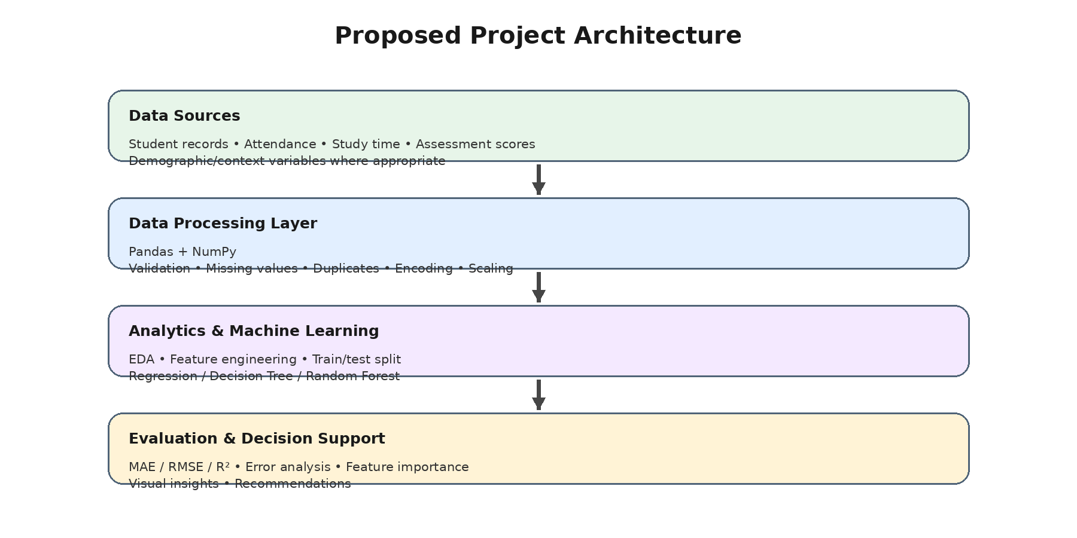
Figure 2. Proposed technical architecture for the planned project.

6. Timeline and 33-Hour Work Allocation
Phase | Activities | Hours
1. Planning | Problem definition, requirements, assumptions, success criteria | 3
2. Data Strategy | Source identification, data dictionary, collection and quality plan | 4
3. Preprocessing | Cleaning rules, missing values, duplicates, encoding, validation | 5
4. EDA | Descriptive statistics, plots, relationships, anomaly review | 5
5. Feature Engineering | Feature creation, selection, leakage checks | 3
6. Modeling | Baseline + candidate regression models, training workflow | 5
7. Evaluation | MAE/RMSE/R², error analysis, comparison and interpretation | 3
8. Documentation | Charts, methodology notes, findings, report structure | 3
9. Final Review | Quality check, formatting, reproducibility and submission | 2
TOTAL |  | 33

7. Tools, Technologies and Libraries
Tool / Library | Planned Use
Python | Primary programming language for analysis and modeling.
Jupyter Notebook / Google Colab | Interactive development, experimentation, documentation, and visualization.
Pandas | Data loading, cleaning, transformation, grouping, and tabular analysis.
NumPy | Numerical operations and array-based computation.
Matplotlib | Core plotting and customized visualizations.
Seaborn | Statistical visualizations and exploratory charts.
Scikit-learn | Preprocessing, model training, cross-validation, and evaluation metrics.
Git / GitHub | Version control and project organization, if available.

7.1 Planned Project Structure
student-performance-project/
├── data/ # dataset or documented data source
├── notebooks/ # EDA and modeling notebooks
├── src/ # reusable preprocessing/model code
├── reports/ # charts and final report
├── README.md # project overview and instructions
└── requirements.txt # Python dependencies

8. Expected Outcomes
- A documented and reproducible Python-based data science workflow.
- A cleaned and analysis-ready dataset in the technical implementation phase.
- EDA charts showing important distributions, relationships, and potential anomalies.
- A comparison of multiple predictive models using consistent evaluation metrics.
- An interpretable summary of factors associated with the target outcome.
- A final report that communicates findings, limitations, and potential next steps.

8.1 Expected Benefits
Benefit | Description
Analytical understanding | Shows how academic variables relate to observed performance patterns.
Early analytical signal | A model may identify patterns worth further investigation, without replacing human judgment.
Reproducibility | A documented Python workflow allows the analysis to be repeated and improved.
Skill development | Demonstrates practical use of Python, statistics, visualization, and machine learning.
Decision support | Provides structured evidence that educators or analysts could consider alongside other information.

9. Anticipated Challenges and Mitigation Strategies
Challenge | Potential Impact | Mitigation
Missing data | Can reduce usable observations or introduce bias. | Profile missingness; use justified imputation or exclusion; document decisions.
Outliers / invalid values | May distort statistics and model training. | Validate ranges, investigate unusual records, and use appropriate transformations or robust methods.
Data leakage | Can produce unrealistically strong test results. | Define the prediction point; fit transformations only on training data; review every feature.
Overfitting | Model may perform well on training data but poorly on unseen data. | Use cross-validation, regularization/pruning where appropriate, and a held-out test set.
Limited dataset size | Results may be unstable or not generalize well. | Use simpler models, cross-validation, uncertainty discussion, and avoid excessive feature complexity.
Feature bias | Some variables may reflect structural differences rather than actionable factors. | Review feature meaning, document limitations, and avoid high-stakes automated decisions.
Interpretability | Complex models may be difficult to explain. | Compare with interpretable baselines and use feature-importance/error analysis carefully.
Reproducibility | Different environments can produce inconsistent results. | Record package versions, random seeds, preprocessing steps, and project structure.

10. Evaluation and Success Criteria
The project will be considered successful when the following requirements are met:
- All major data science lifecycle stages are documented and logically connected.
- The data collection and quality strategy is clearly defined.
- Preprocessing decisions are justified and reproducible.
- EDA contains meaningful visual and statistical analysis rather than only raw tables.
- At least one baseline and additional candidate models are planned and compared.
- Evaluation uses appropriate metrics and avoids using the test set for repeated model tuning.
- Results and limitations are communicated clearly without overstating causality or predictive certainty.
- The final documentation includes the workflow and architecture diagrams.
- The complete plan fits within the planned 33-hour effort.

11. Risk, Ethics and Responsible Data Use
Student-related data can contain sensitive information. The technical implementation should therefore use only the minimum information required for the project, remove direct identifiers where possible, and follow the source's usage conditions. Access should be limited to authorized project participants.
Predictions should be treated as analytical estimates rather than definitive judgments about individual students. The project should avoid using the model as an automated mechanism for grading, admission, disciplinary action, or other high-stakes decisions. Model performance should be checked across relevant groups when the dataset supports such analysis.

12. Deliverables
Deliverable | Description
Project Plan | This document containing background, objectives, scope, methodology, timeline, tools, risks, and outcomes.
Workflow Diagram | Visual representation of the end-to-end data science lifecycle.
Architecture Diagram | Visual representation of data, processing, modeling, and evaluation layers.
Future Notebook | Planned Jupyter/Colab notebook for data loading, EDA, preprocessing, modeling, and evaluation.
Final Findings | Planned summary of model results, insights, limitations, and recommendations after technical execution.

13. Conclusion
This Week 1 plan establishes a structured foundation for a Python-based data science project on student academic performance. It defines the problem, objectives, boundaries, data strategy, analytical workflow, modeling approach, evaluation framework, timeline, tools, expected outcomes, and risk controls.
The most important principle of the project is to maintain a clear connection between the business/analytical question and each technical step. Data should be collected and prepared according to the question, models should be evaluated with appropriate metrics, and conclusions should reflect the limitations of the data and methodology. The next phase can therefore proceed from this plan into practical Python implementation.

Appendix A – Planned Technical Workflow Checklist
- □ Define target variable and prediction point
- □ Document dataset source and data dictionary
- □ Load and inspect data with Pandas
- □ Validate data types and ranges
- □ Check duplicates and missing values
- □ Perform exploratory data analysis
- □ Identify possible leakage and redundant features
- □ Engineer/select features
- □ Split data into training and test sets
- □ Build baseline model
- □ Train candidate models
- □ Evaluate using MAE, RMSE, and R²
- □ Review residuals and model errors
- □ Document insights and limitations
- □ Prepare final report and reproducible project structure

