Website Tree of Food related websites , Root A:-

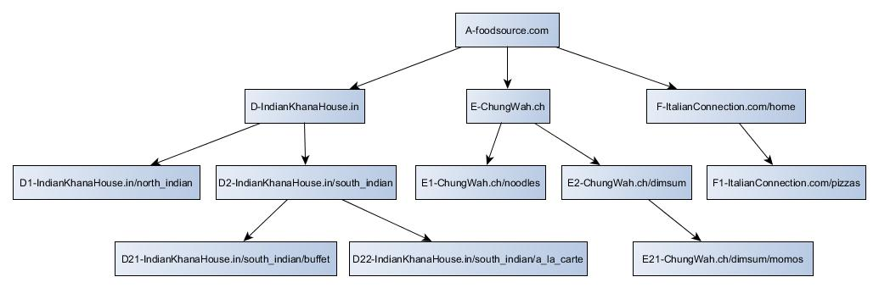

Website Tree of Books related websites , Root B:-

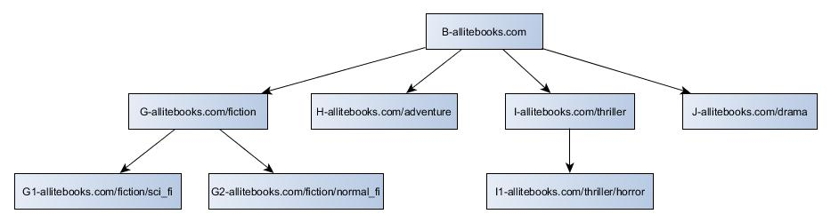

Website Tree of Shopping related websites , Root C:-

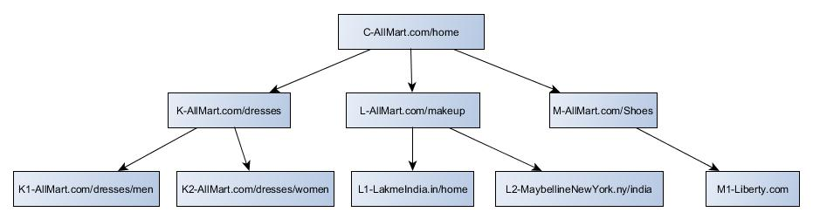

Website Tree of Electronics related websites , Root Q:-

