Array of dataset values





Review text at first position



POS tagging of 50000th review



Negative Phrase tokens generated using Negative of Adjectives(noa) and Negative of Verbs(nov)

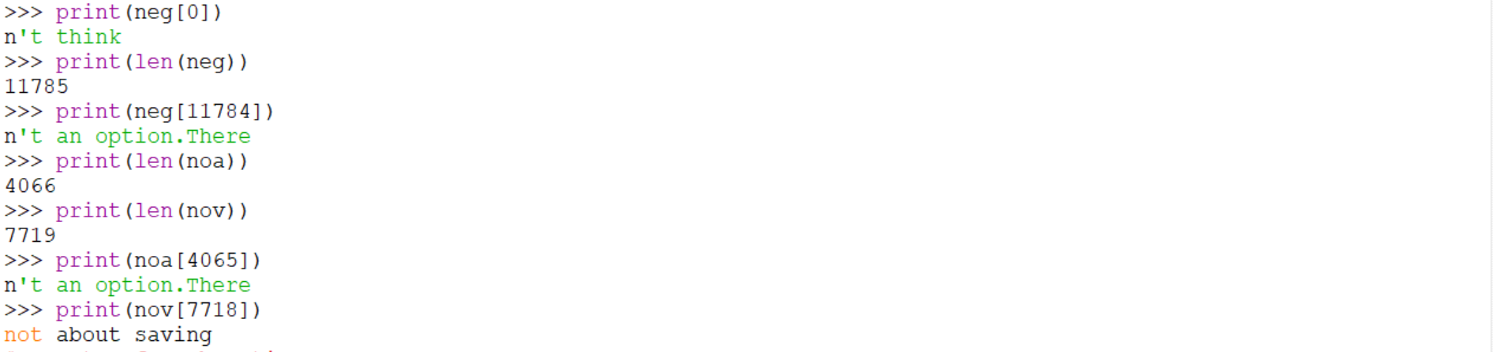

Gamma ratios

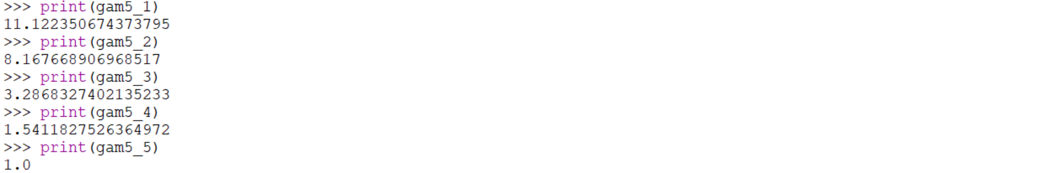

Positive word token from dataset



Occurrences of word and phrase tokens in review dataset

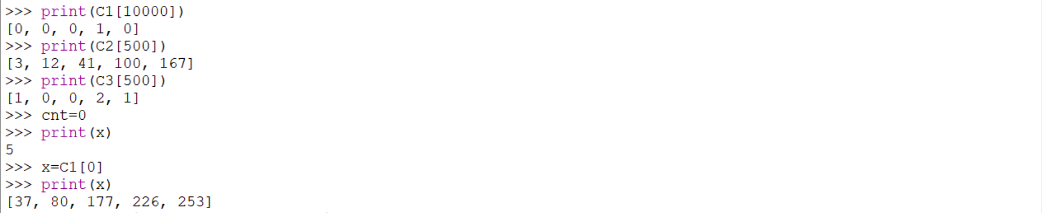

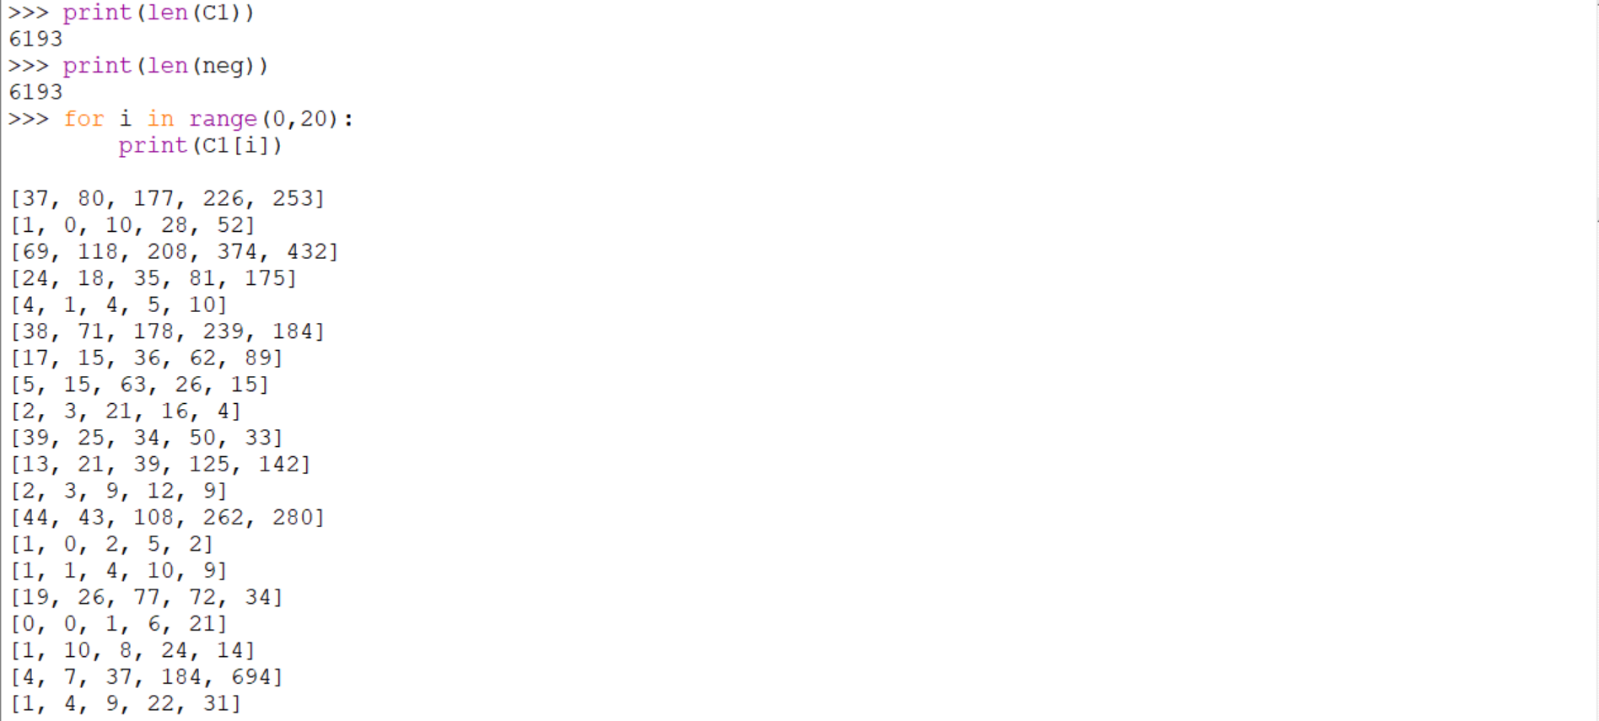



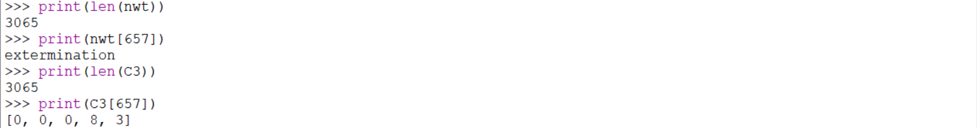

Sentiment Scores of word and phrase tokens







Means of Sentiment scores of word and phrase tokens







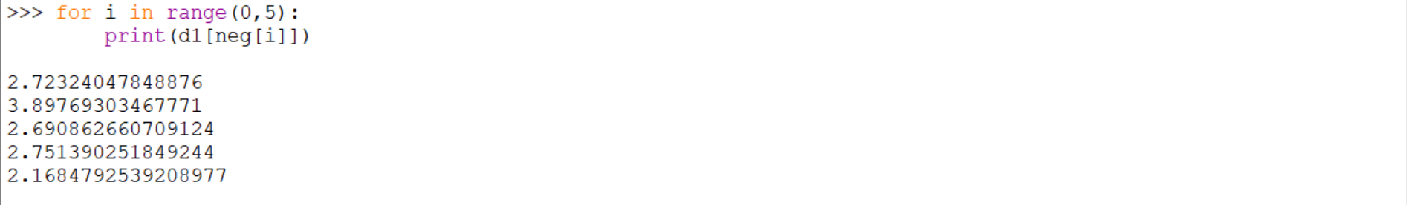

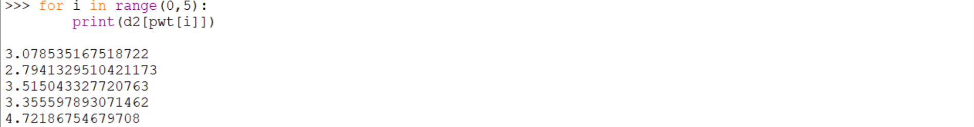

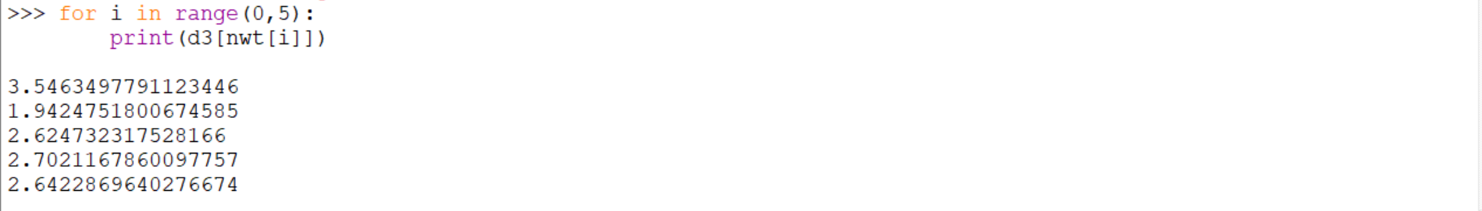

Generated Feature Vectors

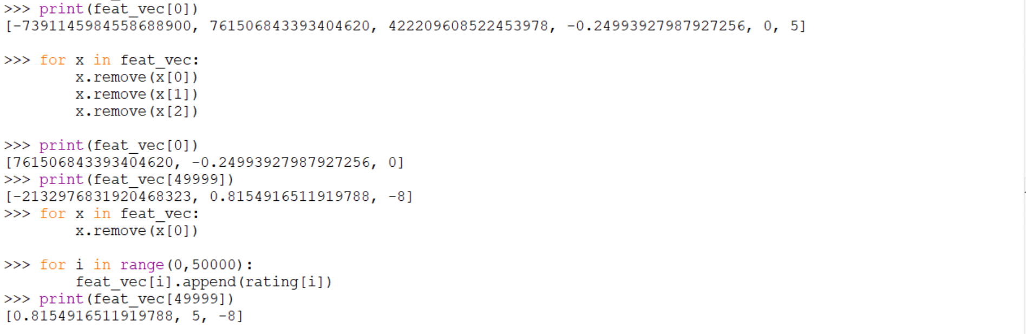

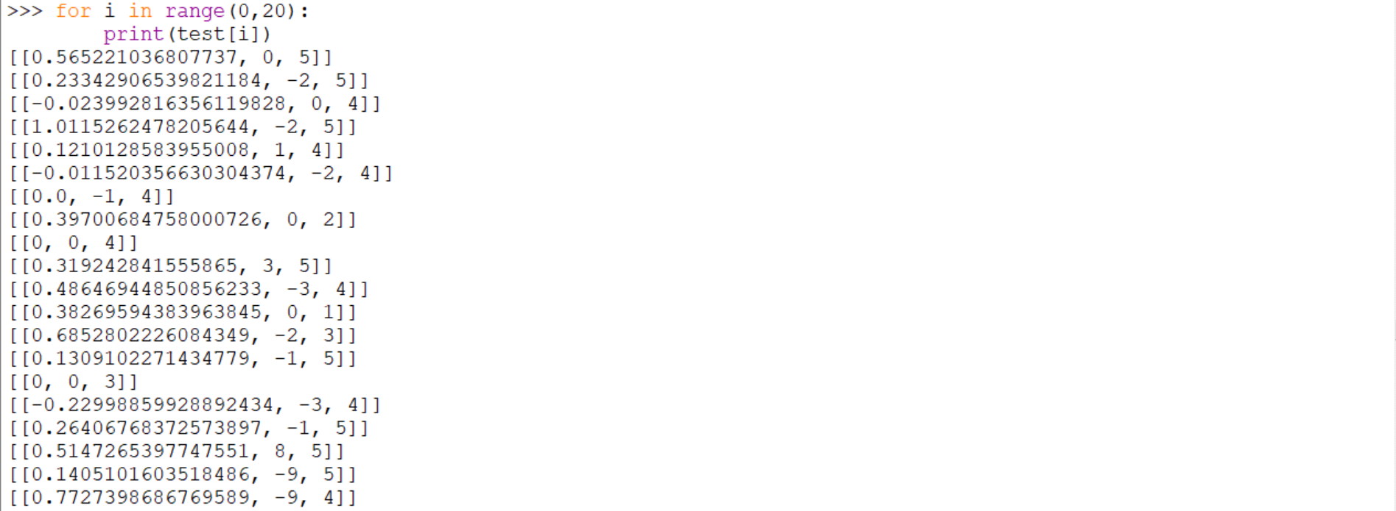

Outputs predicted by Naïve Bayes Classifier

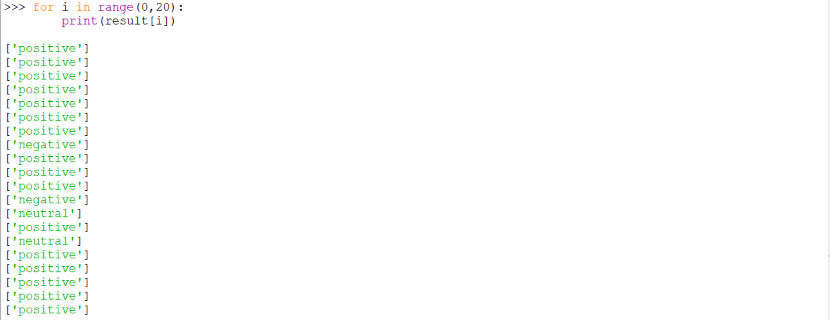

Outputs predicted by Random Forest Classifier

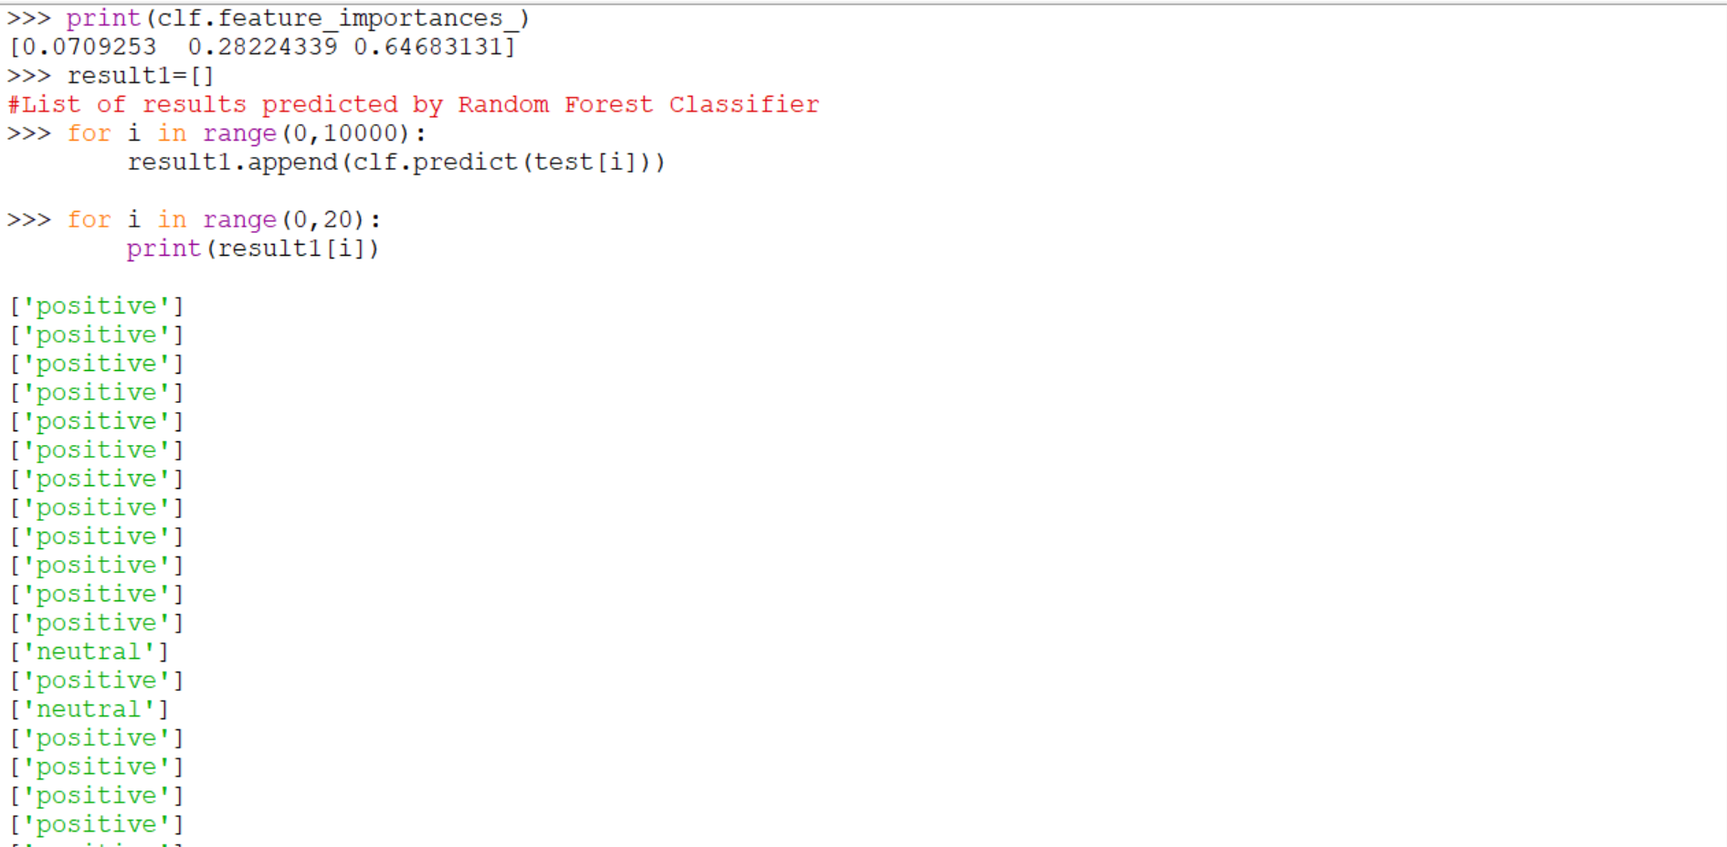

Outputs predicted by SVM Classifier

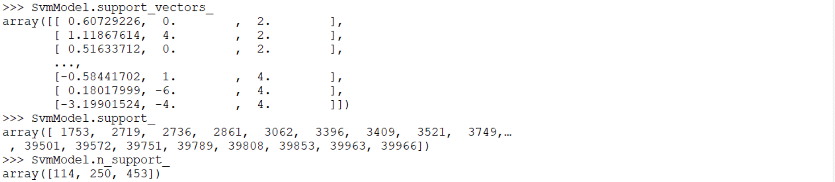

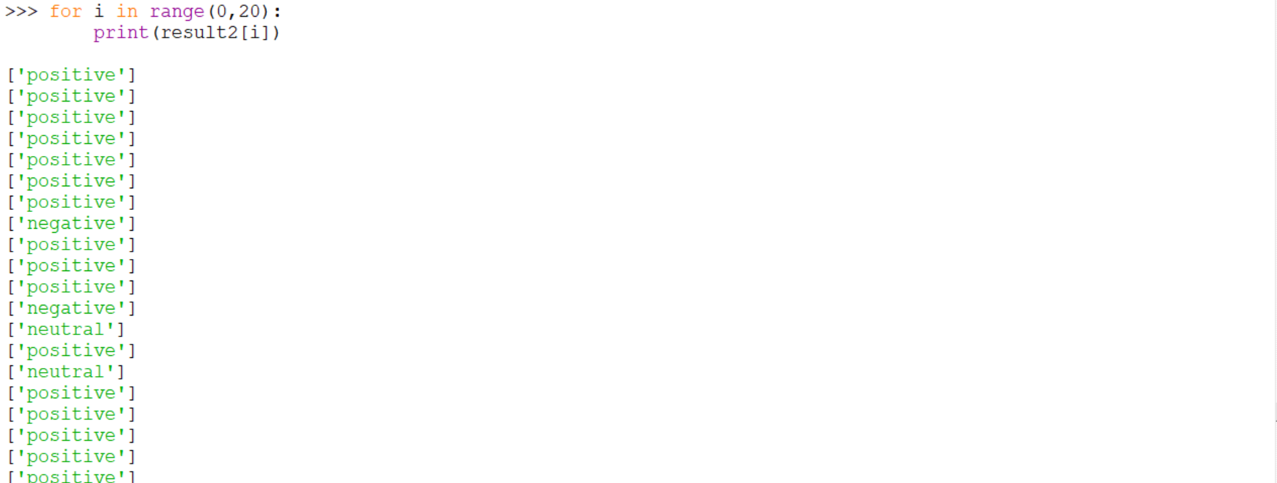

Sentiment Polarity categorization of 3 classifiers

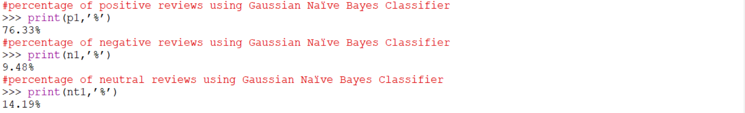

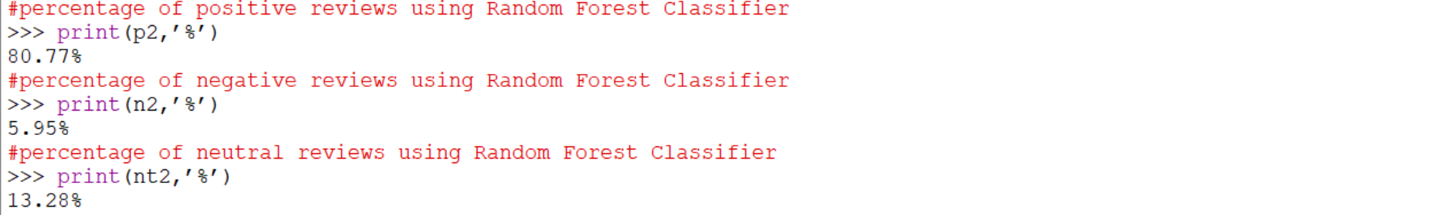

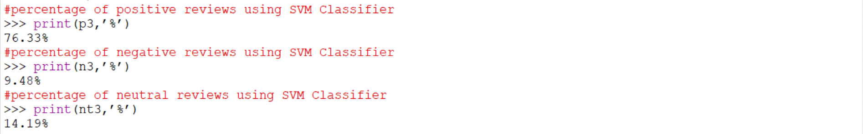

List of correct outputs

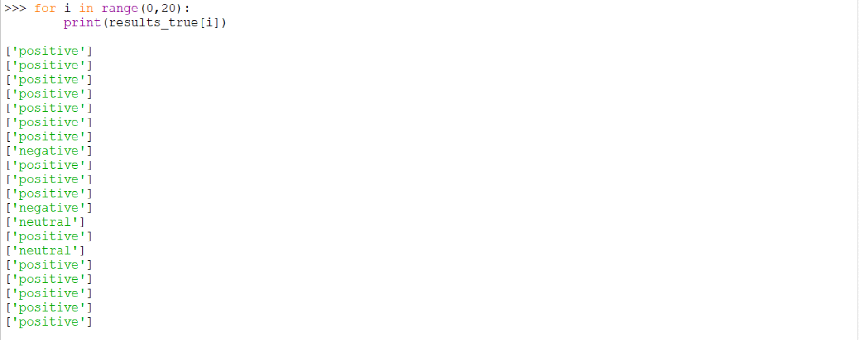

F1 scores of 3 classifiers

