Step 1: Upload Your Images
Upload the images you want to process.

Step 2: Feature Selection
Select all available options.

Step 3: Training
Create or rename the label names as needed. By default, there are two labels. You can create as many labels as required for your application.

Step 4: Prediction Export
The Prediction Export option will initially be inactive.
To activate it:
- First, create a mask for one image.
- Click Prediction Export.
- Select “Choose Export Setting.”
- The export settings will then appear below the images.
- Configure the settings according to the example shown below.

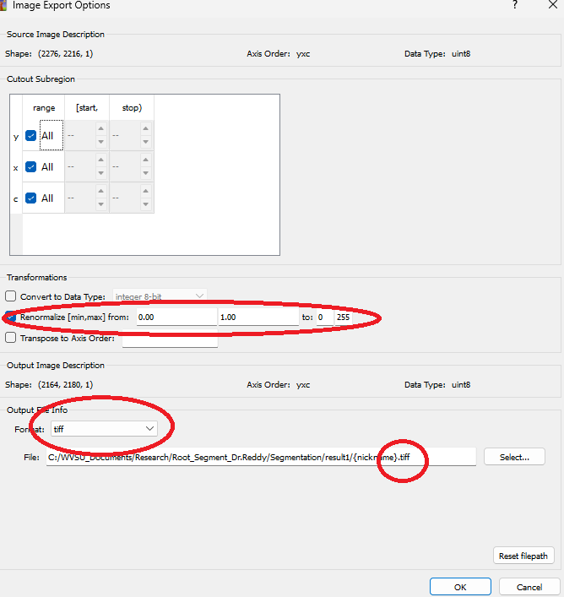

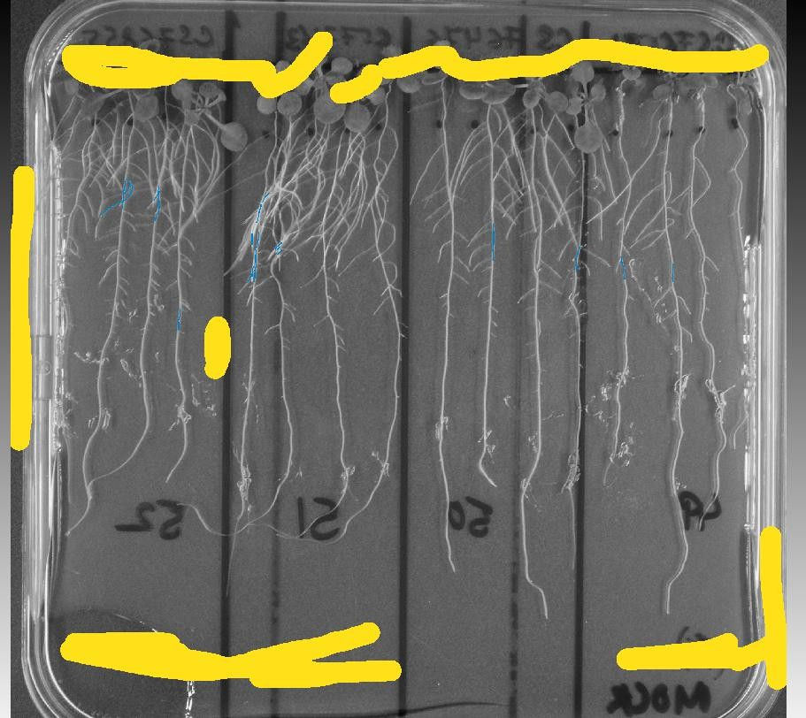

After extracting from



My software gave this



- Batch Processing upload all images and process all files

