**Digital Nurture 3.0 I Deep Skilling (WEEK 1 SOLUTIONS)**

**Superset ID:5021661**

**Name: Priya Hazra**

**Module 1 - Design Patterns and Principles**

**Exercise 1: Implementing the Singleton Pattern**

**CODE:**

**SingletonTest.java**

**public class SingletonTest {**

**public static void main(String[]args) {**

**Logger logger1 =Logger.getInstance();**

**logger1.log("This is the first log message.");**

**Logger logger2 =Logger.getInstance();**

**logger2.log("This is the second log message.");**

**if (logger1 == logger2) {**

**System.out.println("Both logger instance are the same.");**

**}else {**

**System.out.println("Logger instances are different.");**

**}**

**}**

**}**

**Logger.java**

**public class Logger {**

**private static Logger instance;**

**private Logger() {**

**}**

**public static Logger getInstance() {**

**if (instance == null) {**

**instance = new Logger();**

**}**

**return instance;**

**}**

**public void log(String message) {**

**System.out.println("Log Message:" + message);**

**}**

**}**

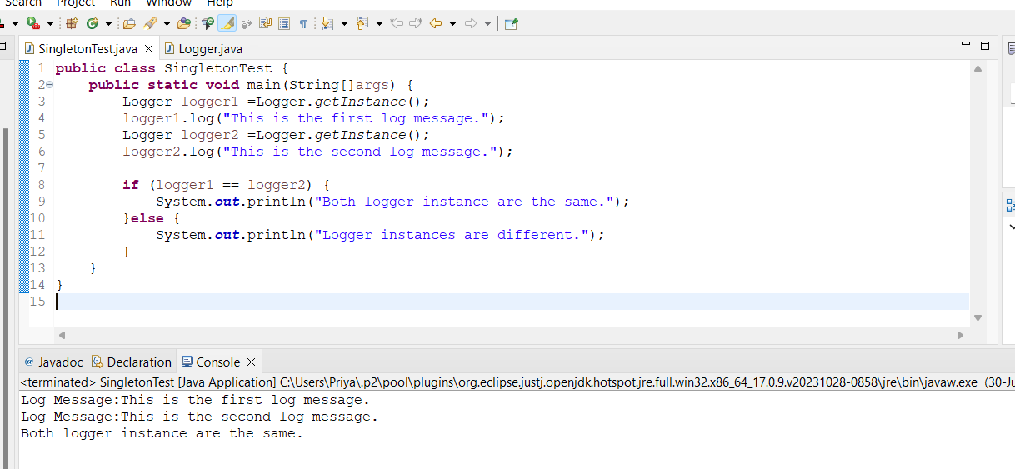

**Exercise 2: Implementing the Factory Method Pattern**

**Code:**

**Document.java**

**public interface Document {**

**void open();**

**void close();**

**}**

**DocumentFactory.java**

**public abstract class DocumentFactory {**

**public abstract Document createDocument();**

**}**

**ExcelDocument.java**

**public class ExcelDocument implements Document {**

**@Override**

**public void open() {**

**System.out.println("Opening Excel document.");**

**}**

**@Override**

**public void close() {**

**System.out.println("Closing Excel document.");**

**}**

**}**

**ExcelDocumentFactory.java**

**public class ExcelDocumentFactory extends DocumentFactory {**

**@Override**

**public Document createDocument() {**

**return new ExcelDocument();**

**}**

**}**

**FactoryMethodTest.java**

**public class FactoryMethodTest {**

**public static void main(String[] args) {**

**DocumentFactory wordFactory = new WordDocumentFactory();**

**Document wordDoc = wordFactory.createDocument();**

**wordDoc.open();**

**wordDoc.close();**

**DocumentFactory pdfFactory = new PdfDocumentFactory();**

**Document pdfDoc = pdfFactory.createDocument();**

**pdfDoc.open();**

**pdfDoc.close();**

**DocumentFactory excelFactory = new ExcelDocumentFactory();**

**Document excelDoc = excelFactory.createDocument();**

**excelDoc.open();**

**excelDoc.close();**

**}**

**}**

**PdfDocument.java**

**public class PdfDocument implements Document {**

**@Override**

**public void open() {**

**System.out.println("Opening PDF document.");**

**}**

**@Override**

**public void close() {**

**System.out.println("Closing PDF document.");**

**}**

**}**

**PdfDocumentFactory.java**

**public class PdfDocumentFactory extends DocumentFactory {**

**@Override**

**public Document createDocument() {**

**return new PdfDocument();**

**}**

**}**

**WordDocument.java**

**public class WordDocument implements Document {**

**@Override**

**public void open() {**

**System.out.println("Opening Word document.");**

**}**

**@Override**

**public void close() {**

**System.out.println("Closing Word document.");**

**}**

**}**

**WordDocumentFactory.java**

**public class WordDocumentFactory extends DocumentFactory {**

**@Override**

**public Document createDocument() {**

**return new WordDocument();**

**}**

**}**

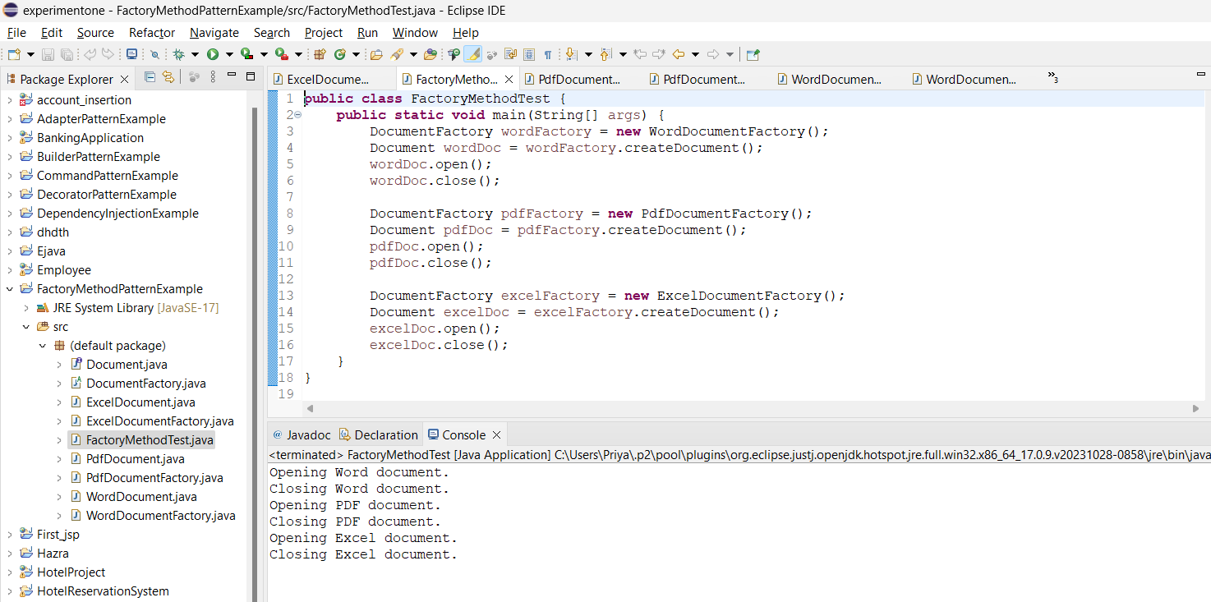

**Exercise 3: Implementing the Builder Pattern**

**Computer.java**

public class Computer {

private String CPU;

private String RAM;

private String storage;

private String graphicsCard;

private String operatingSystem;

private Computer(Builder builder) {

this.CPU = builder.CPU;

this.RAM = builder.RAM;

this.storage = builder.storage;

this.graphicsCard = builder.graphicsCard;

this.operatingSystem = builder.operatingSystem;

}

@Override

public String toString() {

return "Computer [CPU=" + CPU + ", RAM=" + RAM + ", storage=" + storage +

", graphicsCard=" + graphicsCard + ", operatingSystem=" + operatingSystem + "]";

}

public static class Builder {

private String CPU;

private String RAM;

private String storage;

private String graphicsCard;

private String operatingSystem;

public Builder setCPU(String CPU) {

this.CPU = CPU;

return this;

}

public Builder setRAM(String RAM) {

this.RAM = RAM;

return this;

}

public Builder setStorage(String storage) {

this.storage = storage;

return this;

}

public Builder setGraphicsCard(String graphicsCard) {

this.graphicsCard = graphicsCard;

return this;

}

public Builder setOperatingSystem(String operatingSystem) {

this.operatingSystem = operatingSystem;

return this;

}

public Computer build() {

return new Computer(this);

}

}

}

**BuilderPatternTest.java**

public class BuilderPatternTest {

public static void main(String[] args) {

Computer basicComputer = new Computer.Builder()

.setCPU("Intel i5")

.setRAM("8GB")

.setStorage("256GB SSD")

.build();

System.out.println("Basic Computer: " + basicComputer);

Computer gamingComputer = new Computer.Builder()

.setCPU("Intel i9")

.setRAM("32GB")

.setStorage("1TB SSD")

.setGraphicsCard("NVIDIA RTX 3080")

.setOperatingSystem("Windows 10")

.build();

System.out.println("Gaming Computer: " + gamingComputer);

Computer workstationComputer = new Computer.Builder()

.setCPU("AMD Ryzen 9")

.setRAM("64GB")

.setStorage("2TB SSD")

.setGraphicsCard("NVIDIA Quadro RTX 5000")

.setOperatingSystem("Linux")

.build();

System.out.println("Workstation Computer: " + workstationComputer);

}}

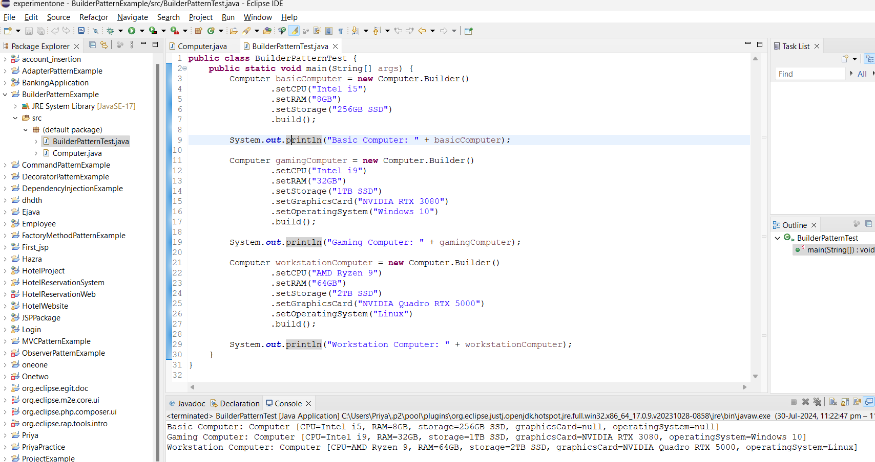

**Exercise 4: Implementing the Adapter Pattern**

**CODE:**

**AdapterPatternTest.java**

public class AdapterPatternTest {

public static void main(String[] args) {

PayPal payPal = new PayPal();

PaymentProcessor payPalProcessor = new PayPalAdapter(payPal);

payPalProcessor.processPayment(100.00);

Stripe stripe = new Stripe();

PaymentProcessor stripeProcessor = new StripeAdapter(stripe);

stripeProcessor.processPayment(200.00);

Paytm paytm = new Paytm();

PaymentProcessor squareProcessor = new PaytmAdapter(paytm);

squareProcessor.processPayment(300.00);

}

}

**PaymentProcessor.java**

public interface PaymentProcessor {

void processPayment(double amount);

}

**PayPal.java**

public class PayPal {

public void sendPayment(double amount) {

System.out.println("Processing payment of Rs" + amount + " through PayPal.");

}

}

**PayPalAdapter.java**

public class PayPalAdapter implements PaymentProcessor {

private PayPal payPal;

public PayPalAdapter(PayPal payPal) {

this.payPal = payPal;

}

@Override

public void processPayment(double amount) {

payPal.sendPayment(amount);

}

}

**Paytm.java**

public class Paytm {

public void pay(double amount) {

System.out.println("Processing payment of Rs" + amount + " through Paytm.");

}

}

**PaytmAdapter.java**

public class PaytmAdapter implements PaymentProcessor {

private Paytm paytm;

public PaytmAdapter(Paytm paytm) {

this.paytm = paytm;

}

@Override

public void processPayment(double amount) {

paytm.pay(amount);

}

}

Stripe.java

public class Stripe {

public void makePayment(double amount) {

System.out.println("Processing payment of Rs" + amount + " through Stripe.");

}

}

**StripeAdapter.java**

public class StripeAdapter implements PaymentProcessor {

private Stripe stripe;

public StripeAdapter(Stripe stripe) {

this.stripe = stripe;

}

@Override

public void processPayment(double amount) {

stripe.makePayment(amount);

}

}

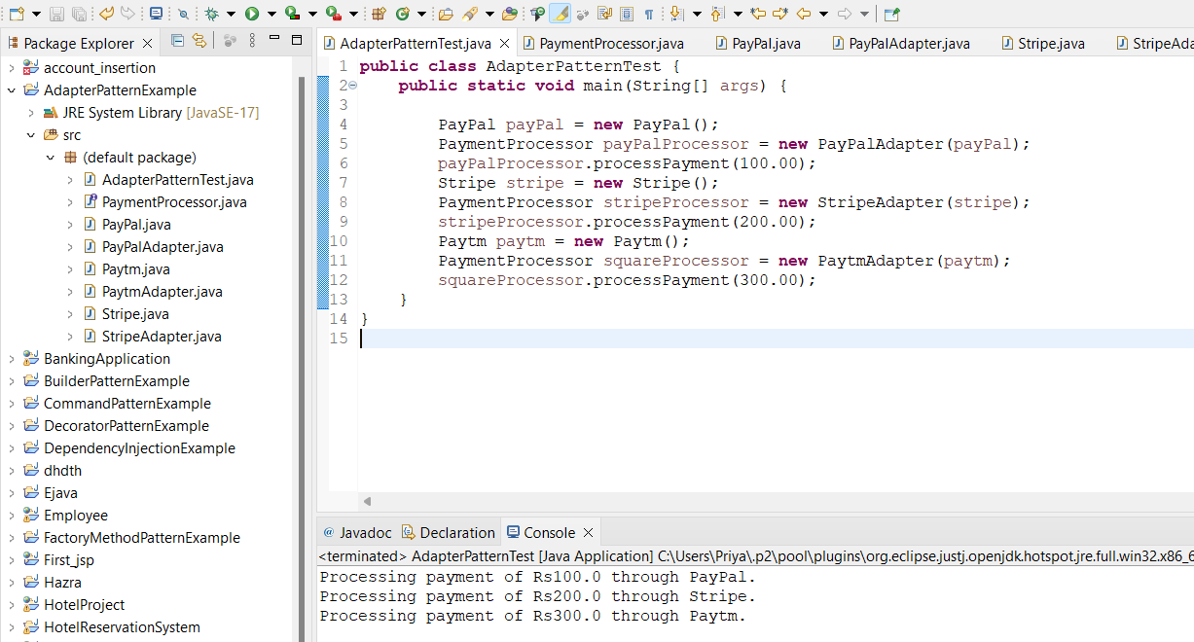

**Exercise 5: Implementing the Decorator Pattern**

**CODE:**

**EmailNotifier.java**

public class EmailNotifier implements Notifier {

@Override

public void send(String message) {

System.out.println("Sending Email: " + message);

}

}

**Notifier.java**

public interface Notifier {

void send(String message);

}

**NotifierDecorator.java**

public abstract class NotifierDecorator implements Notifier {

protected Notifier wrappedNotifier;

public NotifierDecorator(Notifier notifier) {

this.wrappedNotifier = notifier;

}

@Override

public void send(String message) {

wrappedNotifier.send(message);

}

}

**SlackNotifierDecorator.java**

public class SlackNotifierDecorator extends NotifierDecorator {

public SlackNotifierDecorator(Notifier notifier) {

super(notifier);

}

@Override

public void send(String message) {

super.send(message);

sendSlackMessage(message);

}

private void sendSlackMessage(String message) {

System.out.println("Sending Slack message: " + message);

}

}

**SmsNotifierDecorator.java**

public class SMSNotifierDecorator extends NotifierDecorator {

public SMSNotifierDecorator(Notifier notifier) {

super(notifier);

}

@Override

public void send(String message) {

super.send(message);

sendSMS(message);

}

private void sendSMS(String message) {

System.out.println("Sending SMS: " + message);

}

}

**TestDecoratorPattern.java**

public class TestDecoratorPattern {

public static void main(String[] args) {

Notifier emailNotifier = new EmailNotifier();

Notifier smsNotifier = new SMSNotifierDecorator(emailNotifier);

Notifier slackNotifier = new SlackNotifierDecorator(smsNotifier);

System.out.println("Sending notifications through Email, SMS, and Slack:");

slackNotifier.send("This is a test message.");

}

}

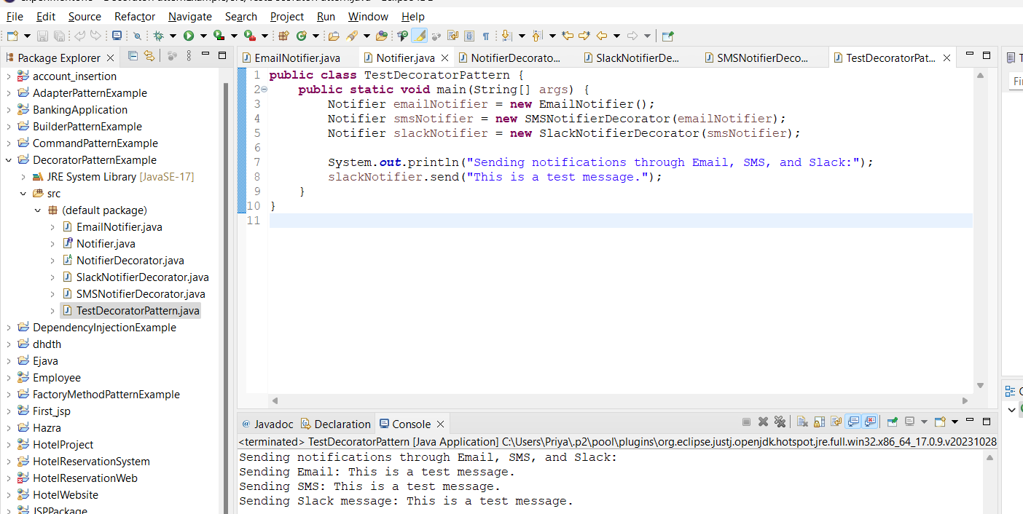

**Exercise 6: Implementing the Proxy Pattern**

**CODE:**

**Image.java**

public interface Image {

void display();

}

**ProxyImage.java**

public class ProxyImage implements Image {

private String imageUrl;

private RealImage realImage;

public ProxyImage(String imageUrl) {

this.imageUrl = imageUrl;

}

@Override

public void display() {

if (realImage == null) {

realImage = new RealImage(imageUrl);

}

realImage.display();

}

}

**RealImage.java**

public class RealImage implements Image {

private String imageUrl;

public RealImage(String imageUrl) {

this.imageUrl = imageUrl;

loadImageFromRemoteServer();

}

private void loadImageFromRemoteServer() {

System.out.println("Loading image from remote server: " + imageUrl);

}

@Override

public void display() {

System.out.println("Displaying image: " + imageUrl);

}

}

**TestProxyPattern.java**

public class TestProxyPattern {

public static void main(String[] args) {

Image image1 = new ProxyImage("http://example.com/image1.jpg");

Image image2 = new ProxyImage("http://example.com/image2.jpg");

image1.display();

System.out.println("");

image1.display();

System.out.println("");

image2.display();

System.out.println("");

image2.display();

}

}

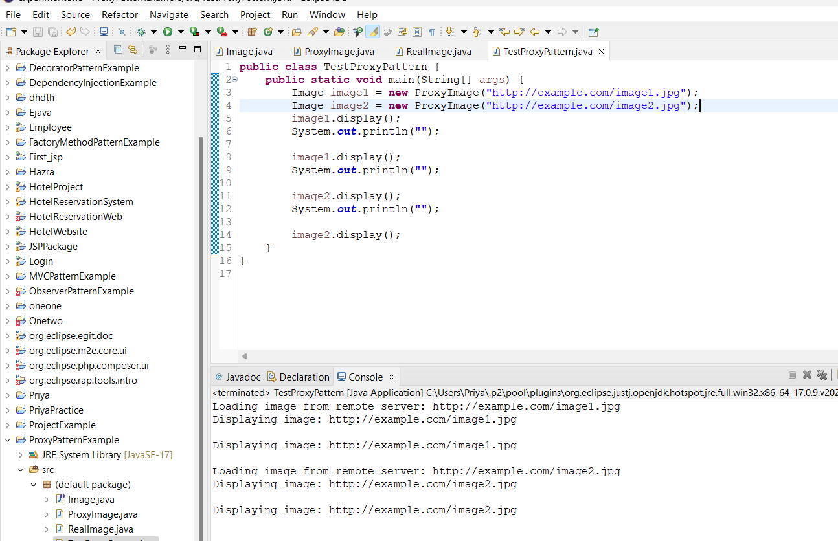

**Exercise 7: Implementing the Observer Pattern**

**Code:**

**MobileApp.java**

public class MobileApp implements Observer {

private String name;

public MobileApp(String name) {

this.name = name;

}

@Override

public void update(double stockPrice) {

System.out.println(name + " received stock price update: " + stockPrice);

}

}

**Observer.java**

public interface Observer {

void update(double stockPrice);

}

**Stock.java**

import java.util.ArrayList;

import java.util.List;

public interface Stock {

void registerObserver(Observer observer);

void removeObserver(Observer observer);

void notifyObservers();

}

**StockMarket.java**

import java.util.ArrayList;

import java.util.List;

public class StockMarket implements Stock {

private List<Observer> observers;

private double stockPrice;

public StockMarket() {

observers = new ArrayList<>();

}

@Override

public void registerObserver(Observer observer) {

observers.add(observer);

}

@Override

public void removeObserver(Observer observer) {

observers.remove(observer);

}

@Override

public void notifyObservers() {

for (Observer observer : observers) {

observer.update(stockPrice);

}

}

public void setStockPrice(double stockPrice) {

this.stockPrice = stockPrice;

notifyObservers();

}

}

**TestObserverPattern.java**

public class TestObserverPattern {

public static void main(String[] args) {

StockMarket stockMarket = new StockMarket();

Observer mobileApp = new MobileApp("MobileApp1");

Observer webApp = new WebApp("WebApp1");

stockMarket.registerObserver(mobileApp);

stockMarket.registerObserver(webApp);

stockMarket.setStockPrice(100.50);

stockMarket.setStockPrice(101.00);

stockMarket.removeObserver(mobileApp);

stockMarket.setStockPrice(102.00);

}

}

**WebApp.java**

public class WebApp implements Observer {

private String name;

public WebApp(String name) {

this.name = name;

}

@Override

public void update(double stockPrice) {

System.out.println(name + " received stock price update: " + stockPrice);

}

}

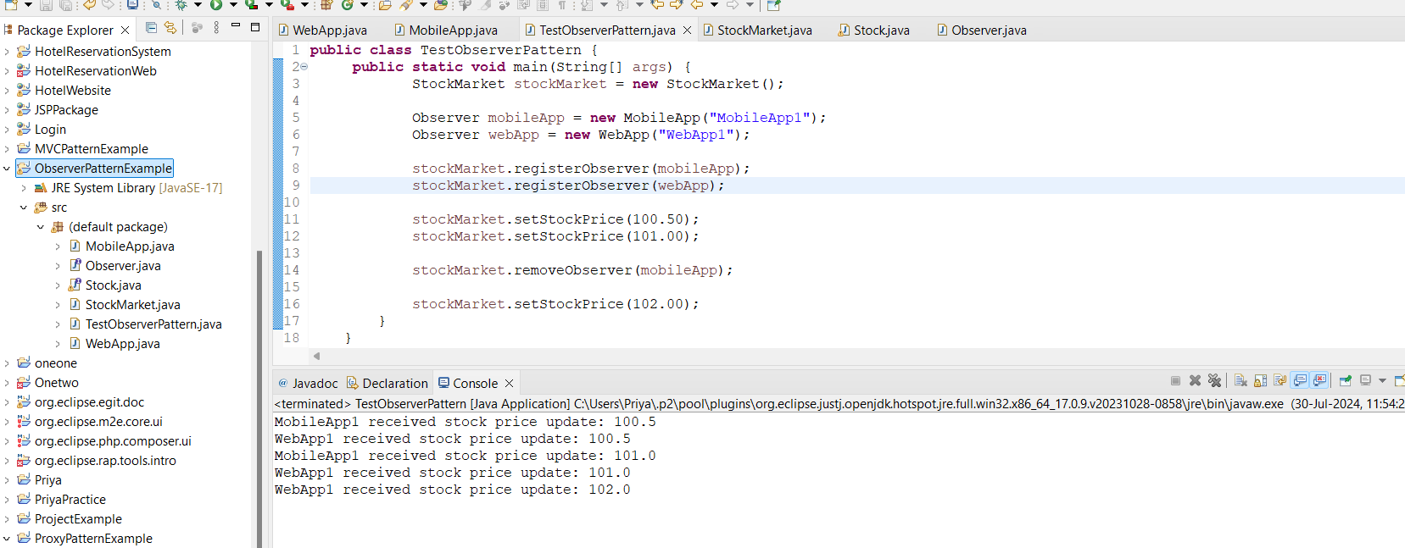

**Exercise 8: Implementing the Strategy Pattern**

**Code:**

**CreditCardPayment.java**

public class CreditCardPayment implements PaymentStrategy {

private String name;

private String cardNumber;

public CreditCardPayment(String name, String cardNumber) {

this.name = name;

this.cardNumber = cardNumber;

}

@Override

public void pay(int amount) {

System.out.println("Paid " + amount + " using Credit Card.");

}

}

**PaymentContent.java**

public class PaymentContext {

private PaymentStrategy paymentStrategy;

public PaymentContext(PaymentStrategy paymentStrategy) {

this.paymentStrategy = paymentStrategy;

}

public void executePayment(int amount) {

paymentStrategy.pay(amount);

}

}

**PaymentStrategy.java**

public interface PaymentStrategy {

void pay(int amount);

}

**PayPalPayment.java**

public class PayPalPayment implements PaymentStrategy {

private String email;

public PayPalPayment(String email) {

this.email = email;

}

@Override

public void pay(int amount) {

System.out.println("Paid " + amount + " using PayPal.");

}

}

**TestStrategyPattern.java**

public class TestStrategyPattern {

public static void main(String[] args) {

PaymentStrategy creditCard = new CreditCardPayment("John Doe", "1234567890123456");

PaymentStrategy paypal = new PayPalPayment("john.doe@example.com");

PaymentContext paymentContext = new PaymentContext(creditCard);

paymentContext.executePayment(100); // Output: Paid 100 using Credit Card.

paymentContext = new PaymentContext(paypal);

paymentContext.executePayment(200); // Output: Paid 200 using PayPal.

}

}

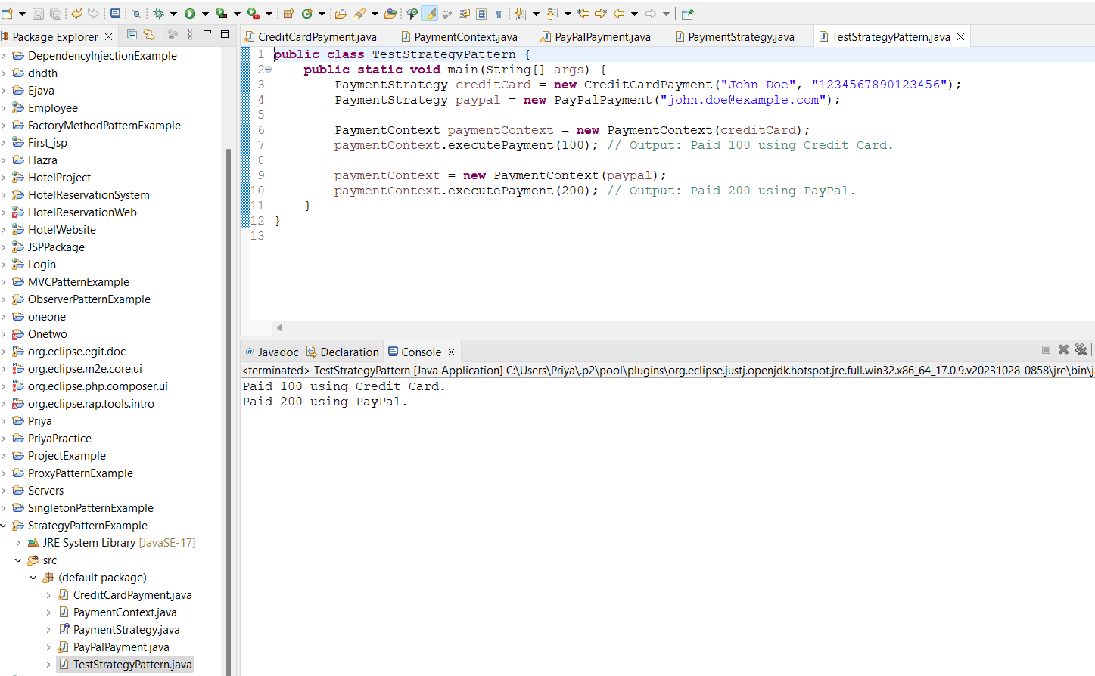

**Exercise 9: Implementing the Command Pattern**

**Code:**

**Command.java**

public interface Command {

void execute();

}

**Light.java**

public class Light {

public void turnOn() {

System.out.println("The light is ON");

}

public void turnOff() {

System.out.println("The light is OFF");

}

}

**LightOffCommand.java**

public class LightOffCommand implements Command {

private Light light;

public LightOffCommand(Light light) {

this.light = light;

}

@Override

public void execute() {

light.turnOff();

}

}

**LightOnCommand.java**

public class LightOnCommand implements Command {

private Light light;

public LightOnCommand(Light light) {

this.light = light;

}

@Override

public void execute() {

light.turnOn();

}

}

**RemoteControl.java**

public class RemoteControl {

private Command command;

public void setCommand(Command command) {

this.command = command;

}

public void pressButton() {

command.execute();

}

}

**TestRemoteControl.java**

public class TestRemoteControl {

public static void main(String[] args) {

Light light = new Light();

Command lightOn = new LightOnCommand(light);

Command lightOff = new LightOffCommand(light);

RemoteControl remote = new RemoteControl();

remote.setCommand(lightOn);

remote.pressButton();

remote.setCommand(lightOff);

remote.pressButton();

}

}

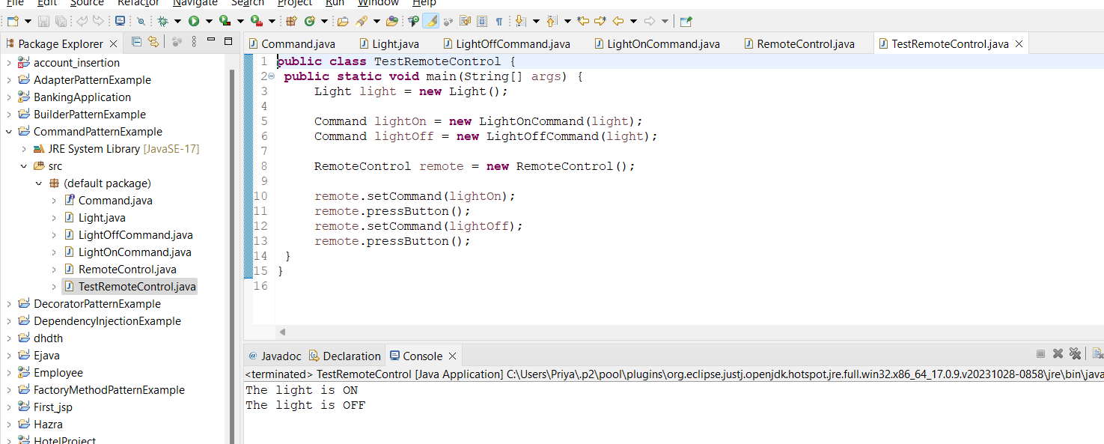

**Exercise 10: Implementing the MVC Pattern**

**Code:**

**Main.java**

public class Main {

public static void main(String[] args) {

Student student = new Student("PRIYA HAZRA", "2101020271", "A");

StudentView view = new StudentView();

StudentController controller = new StudentController(student, view);

controller.updateView();

controller.setStudentName("PRIYA HAZRA");

controller.setStudentId("2101020271");

controller.setStudentGrade("B");

controller.updateView();

}

}

**Student.java**

public class Student {

private String name;

private String id;

private String grade;

public Student(String name, String id, String grade) {

this.name = name;

this.id = id;

this.grade = grade;

}

public String getName() {

return name;

}

public void setName(String name) {

this.name = name;

}

public String getId() {

return id;

}

public void setId(String id) {

this.id = id;

}

public String getGrade() {

return grade;

}

public void setGrade(String grade) {

this.grade = grade;

}

}

**StudentController.java**

public class StudentController {

private Student model;

private StudentView view;

public StudentController(Student model, StudentView view) {

this.model = model;

this.view = view;

}

public void updateView() {

view.displayStudentDetails(model.getName(), model.getId(), model.getGrade());

}

public void setStudentName(String name) {

model.setName(name);

}

public String getStudentName() {

return model.getName();

}

public void setStudentId(String id) {

model.setId(id);

}

public String getStudentId() {

return model.getId();

}

public void setStudentGrade(String grade) {

model.setGrade(grade);

}

public String getStudentGrade() {

return model.getGrade();

}

}

**StudentView.java**

public class StudentView {

public void displayStudentDetails(String studentName, String studentId, String studentGrade) {

System.out.println("Student: ");

System.out.println("Name: " + studentName);

System.out.println("ID: " + studentId);

System.out.println("Grade: " + studentGrade);

}

}

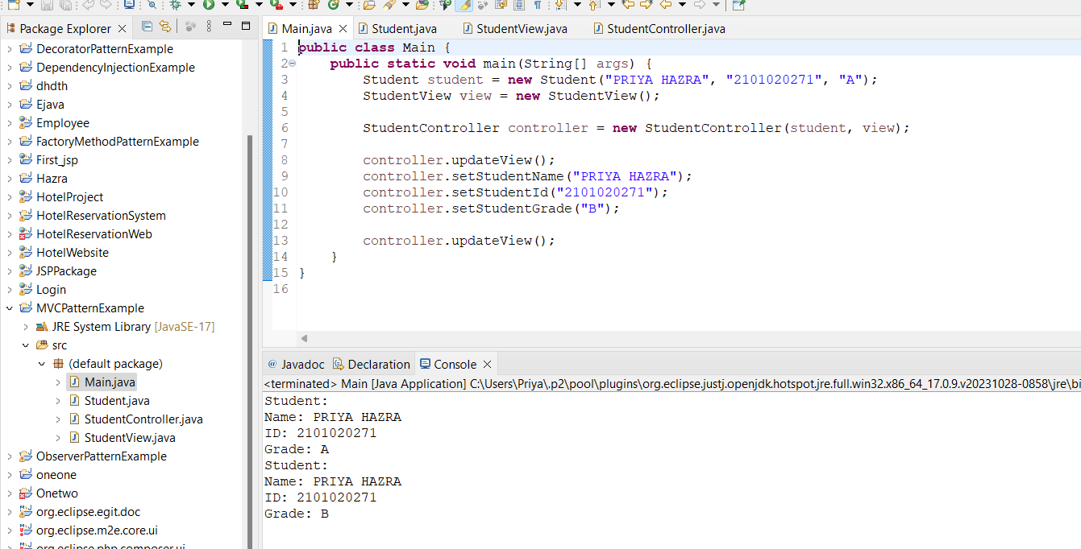

**Exercise 11: Implementing Dependency Injection**

Code:

**CustomerRepository.java**

public interface CustomerRepository {

String findCustomerById(int id);

}

**CustomerRepositoryIMPL.java**

public class CustomerRepositoryImpl implements CustomerRepository {

@Override

public String findCustomerById(int id) {

return "Customer with ID: " + id;

}

}

**CustomerService.java**

public class CustomerService {

private CustomerRepository customerRepository;

public CustomerService(CustomerRepository customerRepository) {

this.customerRepository = customerRepository;

}

public void printCustomer(int id) {

String customer = customerRepository.findCustomerById(id);

System.out.println(customer);

}

}

**Main.java**

public class Main {

public static void main(String[] args) {

CustomerRepository customerRepository = new CustomerRepositoryImpl();

CustomerService customerService = new CustomerService(customerRepository);

customerService.printCustomer(1);

}

}

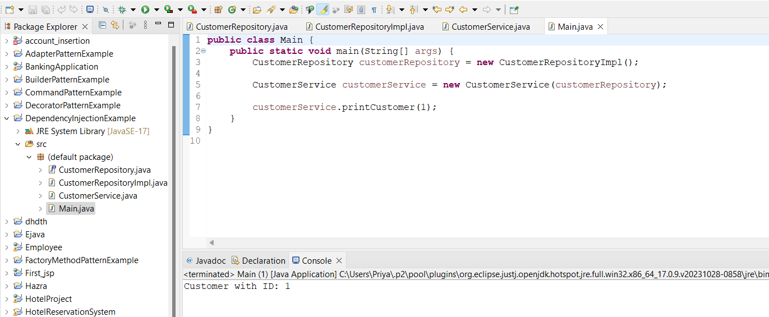

**Week 1_Algorthms_Data Structures**

**Exercise 1: Inventory Management System**

Data structures and algorithms improve performance, scalability, and resource management in inventory systems.

Key structures include **ArrayList** for fast indexed access, **HashMap** for quick retrieval with unique keys, and **TreeMap** for sorted keys with log-time operations.

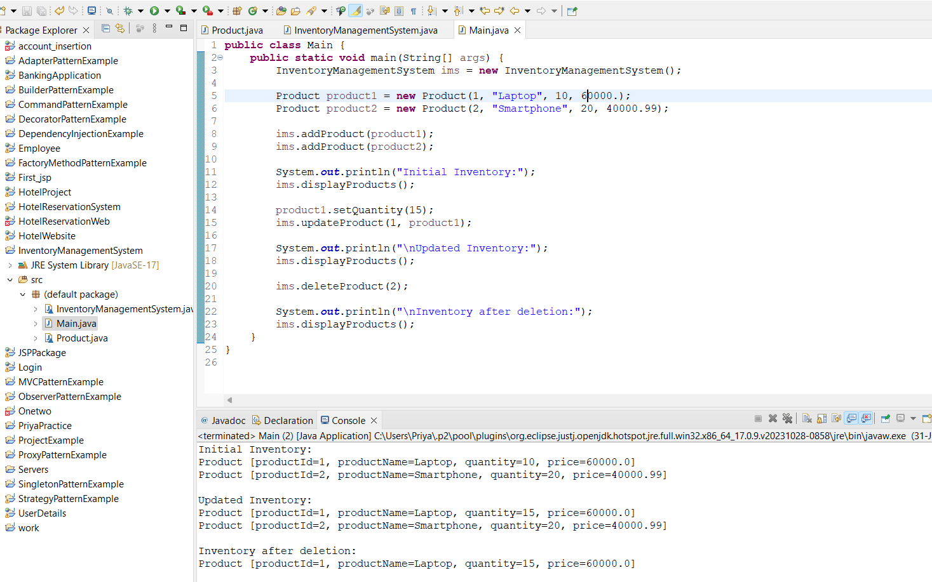

CODE:

**Product.java**

**class** Product {

**private** **int** productId;

**private** String productName;

**private** **int** quantity;

**private** **double** price;

**public** Product(**int** productId, String productName, **int** quantity, **double** price) {

**this**.productId = productId;

**this**.productName = productName;

**this**.quantity = quantity;

**this**.price = price;

}

**public** **int** getProductId() {

**return** productId;

}

**public** **void** setProductId(**int** productId) {

**this**.productId = productId;

}

**public** String getProductName() {

**return** productName;

}

**public** **void** setProductName(String productName) {

**this**.productName = productName;

}

**public** **int** getQuantity() {

**return** quantity;

}

**public** **void** setQuantity(**int** quantity) {

**this**.quantity = quantity;

}

**public** **double** getPrice() {

**return** price;

}

**public** **void** setPrice(**double** price) {

**this**.price = price;

}

@Override

**public** String toString() {

**return** "Product [productId=" + productId + ", productName=" + productName + ", quantity=" + quantity + ", price=" + price + "]";

}

}

**InventoryManagementSystem.java**

**import** java.util.HashMap;

**import** java.util.Map;

**class** InventoryManagementSystem {

**private** Map<Integer, Product> inventory;

**public** InventoryManagementSystem() {

**this**.inventory = **new** HashMap<>();

}

**public** **void** addProduct(Product product) {

inventory.put(product.getProductId(), product);

}

**public** **void** updateProduct(**int** productId, Product updatedProduct) {

**if** (inventory.containsKey(productId)) {

inventory.put(productId, updatedProduct);

} **else** {

System.***out***.println("Product not found!");

}

}

**public** **void** deleteProduct(**int** productId) {

**if** (inventory.containsKey(productId)) {

inventory.remove(productId);

} **else** {

System.***out***.println("Product not found!");

}

}

**public** **void** displayProducts() {

**for** (Product product : inventory.values()) {

System.***out***.println(product);

}

}

}

**Main.java**

**public** **class** Main {

**public** **static** **void** main(String[] args) {

InventoryManagementSystem ims = **new** InventoryManagementSystem();

Product product1 = **new** Product(1, "Laptop", 10, 60000.);

Product product2 = **new** Product(2, "Smartphone", 20, 40000.99);

ims.addProduct(product1);

ims.addProduct(product2);

System.***out***.println("Initial Inventory:");

ims.displayProducts();

product1.setQuantity(15);

ims.updateProduct(1, product1);

System.***out***.println("\nUpdated Inventory:");

ims.displayProducts();

ims.deleteProduct(2);

System.***out***.println("\nInventory after deletion:");

ims.displayProducts();

}

}

**Time Complexity**

Using a **HashMap**:

* **Adding a Product**: O(1) on average
* **Updating a Product**: O(1) on average
* **Deleting a Product**: O(1) on average

**Optimization**: Adjusting the load factor, implementing batch operations, and using indexing methods like B-trees for large datasets.

**Exercise 2: E-commerce Platform Search Function**

**Asymptotic Notation:**

* **Big O Notation**: Describes algorithm efficiency based on input size.
  + O(1): Constant time
  + O(n): Linear time
  + O(log n): Logarithmic time
  + O(n^2): Quadratic time

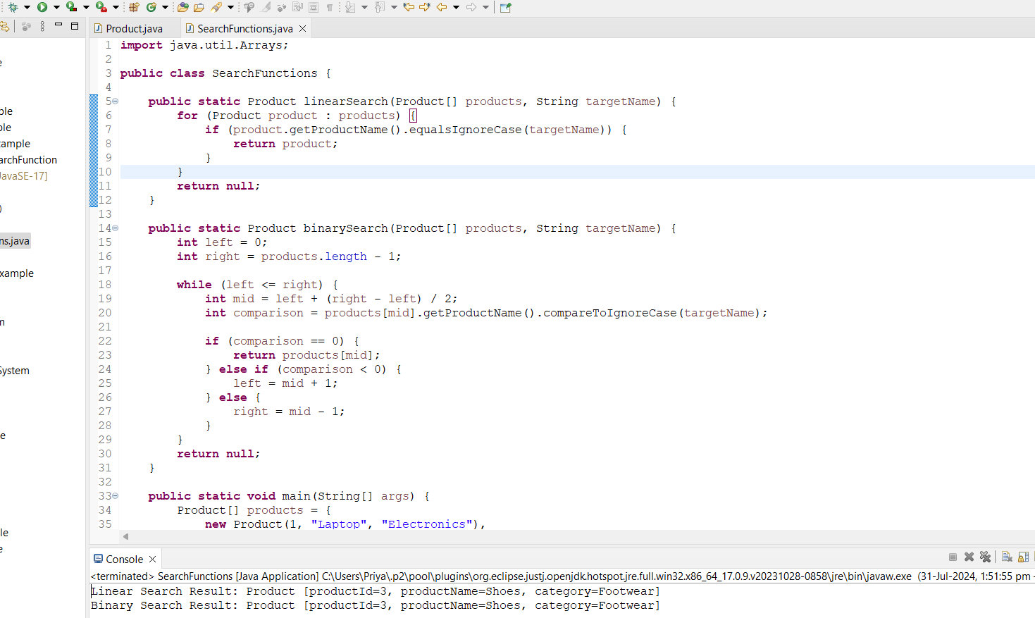

CODE:

**SearchFunctions.java**

**import** java.util.Arrays;

**public** **class** SearchFunctions {

**public** **static** Product linearSearch(Product[] products, String targetName) {

**for** (Product product : products) {

**if** (product.getProductName().equalsIgnoreCase(targetName)) {

**return** product;

}

}

**return** **null**;

}

**public** **static** Product binarySearch(Product[] products, String targetName) {

**int** left = 0;

**int** right = products.length - 1;

**while** (left <= right) {

**int** mid = left + (right - left) / 2;

**int** comparison = products[mid].getProductName().compareToIgnoreCase(targetName);

**if** (comparison == 0) {

**return** products[mid];

} **else** **if** (comparison < 0) {

left = mid + 1;

} **else** {

right = mid - 1;

}

}

**return** **null**;

}

**public** **static** **void** main(String[] args) {

Product[] products = {

**new** Product(1, "Laptop", "Electronics"),

**new** Product(2, "Smartphone", "Electronics"),

**new** Product(3, "Shoes", "Footwear"),

**new** Product(4, "T-shirt", "Clothing")

};

Product foundProduct = *linearSearch*(products, "Shoes");

System.***out***.println("Linear Search Result: " + foundProduct);

Arrays.*sort*(products, (p1, p2) -> p1.getProductName().compareToIgnoreCase(p2.getProductName()));

foundProduct = *binarySearch*(products, "Shoes");

System.***out***.println("Binary Search Result: " + foundProduct);

}

}

**Product.java**

**public** **class** Product {

**private** **int** productId;

**private** String productName;

**private** String category;

**public** Product(**int** productId, String productName, String category) {

**this**.productId = productId;

**this**.productName = productName;

**this**.category = category;

}

**public** **int** getProductId() {

**return** productId;

}

**public** String getProductName() {

**return** productName;

}

**public** String getCategory() {

**return** category;

}

@Override

**public** String toString() {

**return** "Product [productId=" + productId + ", productName=" + productName + ", category=" + category + "]";

}

}

**Time Complexity**:

* Linear Search:
  + Best Case: O(1) (target is the first element)
  + Average Case: O(n) (target is in the middle)
  + Worst Case: O(n) (target is last or not found)
* Binary Search:
  + Best Case: O(1) (target is the middle element)
  + Average Case: O(log n)
  + Worst Case: O(log n)

**Algorithm Suitability**:

* Linear Search: Simple but inefficient for large datasets.
* Binary Search: Efficient for large, sorted datasets; requires sorting (O(n log n)) if not pre-sorted.

Exercise 3: Sorting Customer Orders

**Sorting Algorithms:**

* Bubble Sort:
  + Description: Compares and swaps adjacent elements repeatedly.
  + Complexity: Best: O(n), Average/Worst: O(n^2)
* Insertion Sort:
  + Description: Builds sorted array by inserting each element into its correct position.
  + Complexity: Best: O(n), Average/Worst: O(n^2)
* Quick Sort:
  + Description: Divides and sorts based on a pivot element.
  + Complexity: Best/Average: O(n log n), Worst: O(n^2)
* Merge Sort:
  + Description: Divides, sorts, and merges arrays.
  + Complexity: Best/Average/Worst: O(n log n)

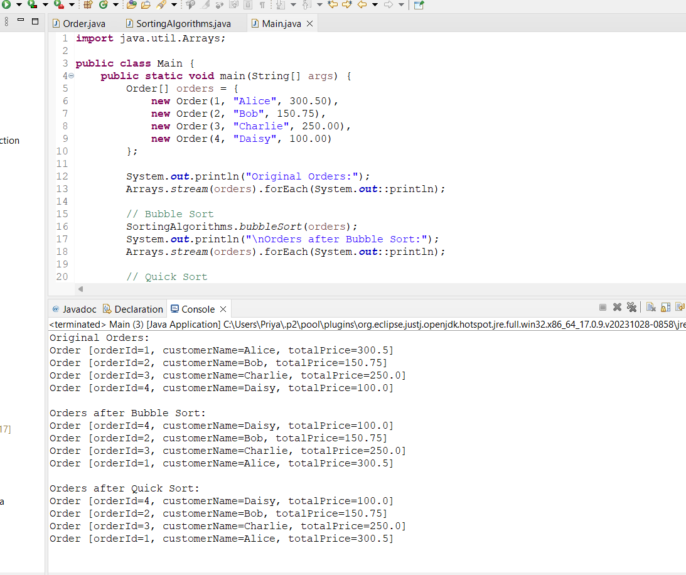

**CODE:**

**Order.java**

**public** **class** Order {

**private** **int** orderId;

**private** String customerName;

**private** **double** totalPrice;

**public** Order(**int** orderId, String customerName, **double** totalPrice) {

**this**.orderId = orderId;

**this**.customerName = customerName;

**this**.totalPrice = totalPrice;

}

**public** **int** getOrderId() {

**return** orderId;

}

**public** String getCustomerName() {

**return** customerName;

}

**public** **double** getTotalPrice() {

**return** totalPrice;

}

@Override

**public** String toString() {

**return** "Order [orderId=" + orderId + ", customerName=" + customerName + ", totalPrice=" + totalPrice + "]";

}

}

**SortingAlogorithms.java**

public class SortingAlgorithms {

public static void bubbleSort(Order[] orders) {

int n = orders.length;

for (int i = 0; i < n - 1; i++) {

for (int j = 0; j < n - i - 1; j++) {

if (orders[j].getTotalPrice() > orders[j + 1].getTotalPrice()) {

Order temp = orders[j];

orders[j] = orders[j + 1];

orders[j + 1] = temp;

}

}

}

}

public static void quickSort(Order[] orders, int low, int high) {

if (low < high) {

int pi = *partition*(orders, low, high);

*quickSort*(orders, low, pi - 1);

*quickSort*(orders, pi + 1, high);

}

}

private static int partition(Order[] orders, int low, int high) {

double pivot = orders[high].getTotalPrice();

int i = (low - 1);

for (int j = low; j < high; j++) {

if (orders[j].getTotalPrice() <= pivot) {

i++;

Order temp = orders[i];

orders[i] = orders[j];

orders[j] = temp;

}

}

Order temp = orders[i + 1];

orders[i + 1] = orders[high];

orders[high] = temp;

return i + 1;

}

}

**Main.java**

**import** java.util.Arrays;

**public** **class** Main {

**public** **static** **void** main(String[] args) {

Order[] orders = {

**new** Order(1, "Alice", 300.50),

**new** Order(2, "Bob", 150.75),

**new** Order(3, "Charlie", 250.00),

**new** Order(4, "Daisy", 100.00)

};

System.***out***.println("Original Orders:");

Arrays.*stream*(orders).forEach(System.***out***::println);

// Bubble Sort

SortingAlgorithms.*bubbleSort*(orders);

System.***out***.println("\nOrders after Bubble Sort:");

Arrays.*stream*(orders).forEach(System.***out***::println);

// Quick Sort

Order[] ordersForQuickSort = {

**new** Order(1, "Alice", 300.50),

**new** Order(2, "Bob", 150.75),

**new** Order(3, "Charlie", 250.00),

**new** Order(4, "Daisy", 100.00)

};

SortingAlgorithms.*quickSort*(ordersForQuickSort, 0, ordersForQuickSort.length - 1);

System.***out***.println("\nOrders after Quick Sort:");

Arrays.*stream*(ordersForQuickSort).forEach(System.***out***::println);

}

}

**Time Complexity:**

* Bubble Sort:
  + Best: O(n), Average/Worst: O(n^2)
* Quick Sort:
  + Best/Average: O(n log n), Worst: O(n^2) (with poor pivot choice)

**Why Quick Sort is Preferred**:

* Efficiency: Faster average performance (O(n log n)).
* Space Usage: More space-efficient (in-place sort).
* Practical Performance: Better for large datasets despite worst-case scenario.

Exercise 4: Employee Management System

**Array Representation in Memory:**

* Storage: Elements are stored in contiguous memory locations.
* Address Calculation: Uses base address and element size for address computation.

Advantages:

* Random Access: O(1) time for direct access.
* Cache Friendliness: Contiguous memory improves performance.
* Ease of Iteration: Efficient traversal.

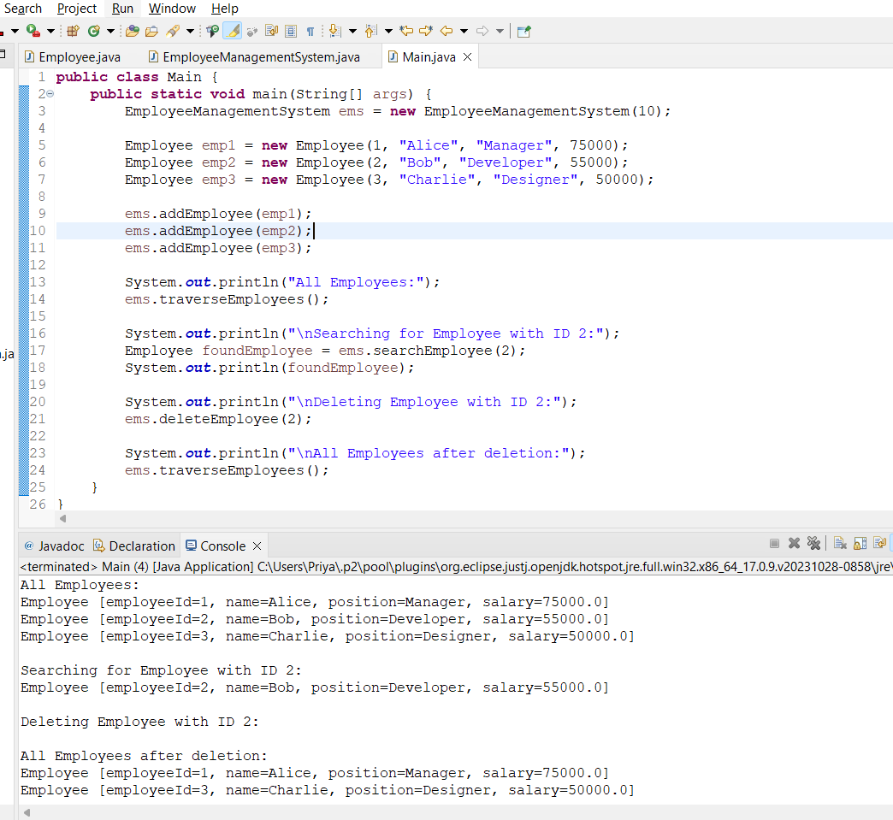

**CODE:**

**Employee.java**

**public** **class** Employee {

**private** **int** employeeId;

**private** String name;

**private** String position;

**private** **double** salary;

**public** Employee(**int** employeeId, String name, String position, **double** salary) {

**this**.employeeId = employeeId;

**this**.name = name;

**this**.position = position;

**this**.salary = salary;

}

// Getters and setters

**public** **int** getEmployeeId() {

**return** employeeId;

}

**public** **void** setEmployeeId(**int** employeeId) {

**this**.employeeId = employeeId;

}

**public** String getName() {

**return** name;

}

**public** **void** setName(String name) {

**this**.name = name;

}

**public** String getPosition() {

**return** position;

}

**public** **void** setPosition(String position) {

**this**.position = position;

}

**public** **double** getSalary() {

**return** salary;

}

**public** **void** setSalary(**double** salary) {

**this**.salary = salary;

}

@Override

**public** String toString() {

**return** "Employee [employeeId=" + employeeId + ", name=" + name + ", position=" + position + ", salary=" + salary + "]";

}

}

**EmployeeManagementSystem.java**

**public** **class** EmployeeManagementSystem {

**private** Employee[] employees;

**private** **int** size;

**private** **int** capacity;

**public** EmployeeManagementSystem(**int** capacity) {

**this**.capacity = capacity;

**this**.employees = **new** Employee[capacity];

**this**.size = 0;

}

**public** **void** addEmployee(Employee employee) {

**if** (size < capacity) {

employees[size] = employee;

size++;

} **else** {

System.***out***.println("Cannot add employee, array is full.");

}

}

**public** Employee searchEmployee(**int** employeeId) {

**for** (**int** i = 0; i < size; i++) {

**if** (employees[i].getEmployeeId() == employeeId) {

**return** employees[i];

}

}

**return** **null**;

}

**public** **void** traverseEmployees() {

**for** (**int** i = 0; i < size; i++) {

System.***out***.println(employees[i]);

}

}

**public** **void** deleteEmployee(**int** employeeId) {

**int** index = -1;

**for** (**int** i = 0; i < size; i++) {

**if** (employees[i].getEmployeeId() == employeeId) {

index = i;

**break**;

}

}

**if** (index != -1) {

**for** (**int** i = index; i < size - 1; i++) {

employees[i] = employees[i + 1];

}

employees[size - 1] = **null**;

size--;

} **else** {

System.***out***.println("Employee not found.");

}

}

}

**Main.java**

**public** **class** Main {

**public** **static** **void** main(String[] args) {

EmployeeManagementSystem ems = **new** EmployeeManagementSystem(10);

Employee emp1 = **new** Employee(1, "Alice", "Manager", 75000);

Employee emp2 = **new** Employee(2, "Bob", "Developer", 55000);

Employee emp3 = **new** Employee(3, "Charlie", "Designer", 50000);

ems.addEmployee(emp1);

ems.addEmployee(emp2);

ems.addEmployee(emp3);

System.***out***.println("All Employees:");

ems.traverseEmployees();

System.***out***.println("\nSearching for Employee with ID 2:");

Employee foundEmployee = ems.searchEmployee(2);

System.***out***.println(foundEmployee);

System.***out***.println("\nDeleting Employee with ID 2:");

ems.deleteEmployee(2);

System.***out***.println("\nAll Employees after deletion:");

ems.traverseEmployees();

}

}

Time Complexity:

* Add Operation: O(1) (at the end)
* Search Operation: O(n) (worst case)
* Traverse Operation: O(n)
* Delete Operation: O(n) (due to element shifting)

Limitations:

* Fixed Size: Costly resizing.
* Inefficient Deletion: Element shifting is inefficient.
* Memory Allocation: Contiguous memory can be problematic.

**When to Use Arrays:**

* Small to Medium Datasets: Efficient with size constraints.
* Random Access: Ideal for direct access.
* Simple Iteration: Suitable for efficient traversal.

**Exercise 5: Task Management System**

A singly linked list allows one-way traversal with each node pointing to the next, while a doubly linked list allows two-way traversal with nodes pointing to both the next and previous nodes.

In a linked list, adding, searching, traversing, and deleting tasks each have a worst-case time complexity of O(n) due to traversal requirements. Linked lists offer advantages over arrays with dynamic sizing, more efficient insertions/deletions, and better memory utilization by allocating memory only for needed nodes.

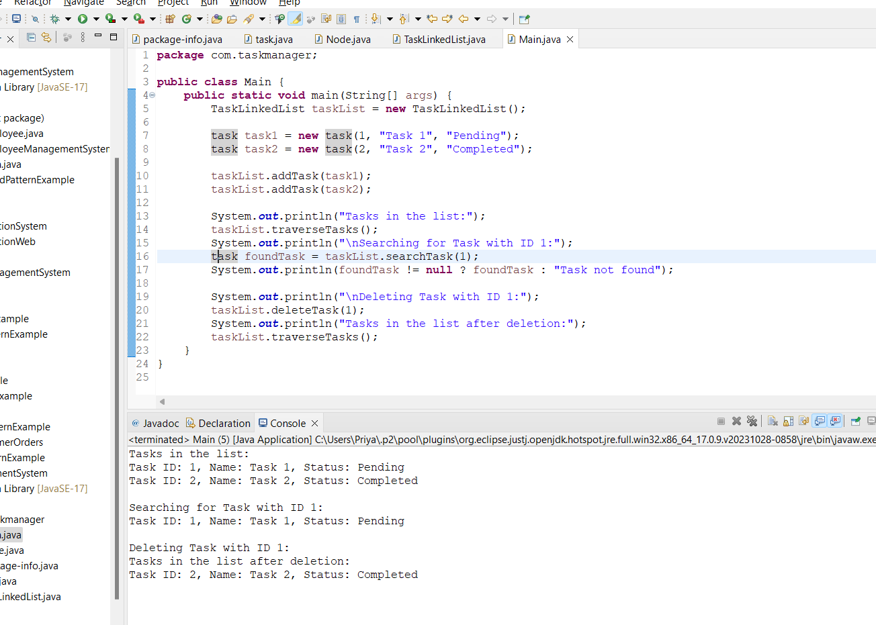

**CODE:**

**Package-info.java**

**package** com.taskmanager;

**Node.java**

**package** com.taskmanager;

**public** **class** Node {

task task;

Node next;

**public** Node(task task) {

**this**.task = task;

**this**.next = **null**;

}

}

**task.java**

**package** com.taskmanager;

**public** **class** task {

**private** **int** taskId;

**private** String taskName;

**private** String status;

**public** task(**int** taskId, String taskName, String status) {

**this**.taskId = taskId;

**this**.taskName = taskName;

**this**.status = status;

}

**public** **int** getTaskId() {

**return** taskId;

}

**public** String getTaskName() {

**return** taskName;

}

**public** String getStatus() {

**return** status;

}

@Override

**public** String toString() {

**return** "Task ID: " + taskId + ", Name: " + taskName + ", Status: " + status;

}

}

**Main.java**

**package** com.taskmanager;

**public** **class** Main {

**public** **static** **void** main(String[] args) {

TaskLinkedList taskList = **new** TaskLinkedList();

task task1 = **new** task(1, "Task 1", "Pending");

task task2 = **new** task(2, "Task 2", "Completed");

taskList.addTask(task1);

taskList.addTask(task2);

System.***out***.println("Tasks in the list:");

taskList.traverseTasks();

System.***out***.println("\nSearching for Task with ID 1:");

task foundTask = taskList.searchTask(1);

System.***out***.println(foundTask != **null** ? foundTask : "Task not found");

System.***out***.println("\nDeleting Task with ID 1:");

taskList.deleteTask(1);

System.***out***.println("Tasks in the list after deletion:");

taskList.traverseTasks();

}

}

**Exercise 6: Library Management System**

Linear search checks each element one by one with a time complexity of O(n) and is suitable for unsorted or small datasets. Binary search, with a time complexity of O(log n), efficiently finds elements in a sorted array by dividing the search interval in half, making it ideal for large, sorted datasets.

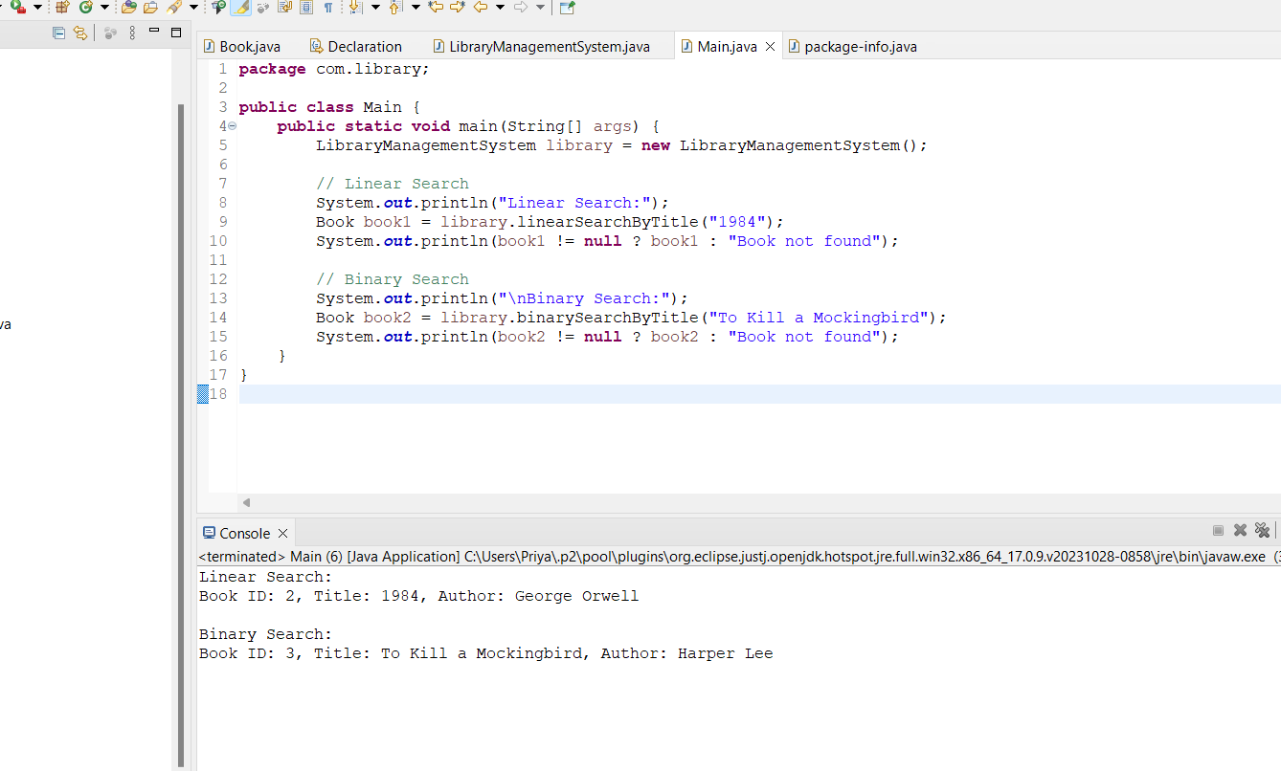

Code:

Book.java

**package** com.library;

**public** **class** Book {

**private** **int** bookId;

**private** String title;

**private** String author;

**public** Book(**int** bookId, String title, String author) {

**this**.bookId = bookId;

**this**.title = title;

**this**.author = author;

}

**public** String getTitle() {

**return** title;

}

@Override

**public** String toString() {

**return** "Book ID: " + bookId + ", Title: " + title + ", Author: " + author;

}

}

**LibraryManagementSystem.java**

**package** com.library;

**import** java.util.ArrayList;

**import** java.util.Collections;

**import** java.util.Comparator;

**import** java.util.List;

**public** **class** LibraryManagementSystem {

**private** List<Book> books;

**public** LibraryManagementSystem() {

books = **new** ArrayList<>();

books.add(**new** Book(1, "The Great Gatsby", "F. Scott Fitzgerald"));

books.add(**new** Book(2, "1984", "George Orwell"));

books.add(**new** Book(3, "To Kill a Mockingbird", "Harper Lee"));

}

**public** Book linearSearchByTitle(String title) {

**for** (Book book : books) {

**if** (book.getTitle().equalsIgnoreCase(title)) {

**return** book;

}

}

**return** **null**;

}

**public** Book binarySearchByTitle(String title) {

Collections.*sort*(books, Comparator.*comparing*(Book::getTitle));

**int** left = 0;

**int** right = books.size() - 1;

**while** (left <= right) {

**int** mid = left + (right - left) / 2;

Book midBook = books.get(mid);

**int** comparison = midBook.getTitle().compareToIgnoreCase(title);

**if** (comparison == 0) {

**return** midBook;

} **else** **if** (comparison < 0) {

left = mid + 1;

} **else** {

right = mid - 1;

}

}

**return** **null**;

}

}

**package** com.library;

**public** **class** Main {

**public** **static** **void** main(String[] args) {

LibraryManagementSystem library = **new** LibraryManagementSystem();

// Linear Search

System.***out***.println("Linear Search:");

Book book1 = library.linearSearchByTitle("1984");

System.***out***.println(book1 != **null** ? book1 : "Book not found");

// Binary Search

System.***out***.println("\nBinary Search:");

Book book2 = library.binarySearchByTitle("To Kill a Mockingbird");

System.***out***.println(book2 != **null** ? book2 : "Book not found");

}

}

Linear search has a time complexity of O(n), requiring a check of each element in the worst case, and is best for small or unsorted datasets. Binary search, with a time complexity of O(log n), is faster for large, sorted datasets by repeatedly halving the search interval but requires pre-sorted data.

**Exercise 7: Financial Forecasting**

Recursion is a technique where a function calls itself to solve smaller instances of a problem, breaking it down into manageable sub-problems. It typically includes a base case (termination condition) and a recursive case (the function calling itself).

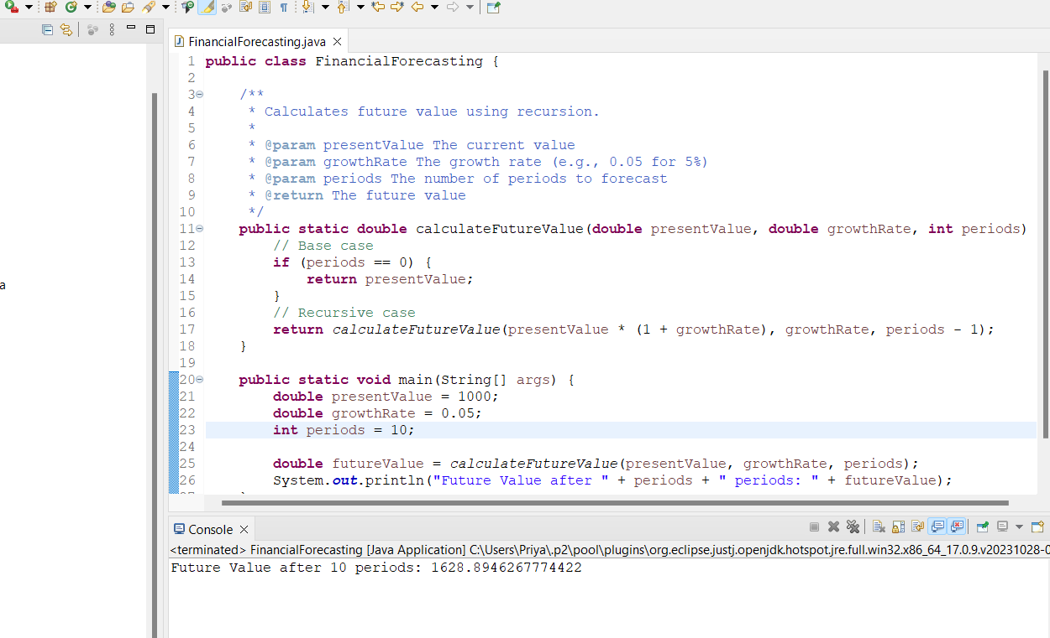

CODE:

**public** **class** FinancialForecasting {

/**

* Calculates future value using recursion.

*

* **@param** presentValue The current value

* **@param** growthRate The growth rate (e.g., 0.05 for 5%)

* **@param** periods The number of periods to forecast

* **@return** The future value

*/

**public** **static** **double** calculateFutureValue(**double** presentValue, **double** growthRate, **int** periods) {

// Base case

**if** (periods == 0) {

**return** presentValue;

}

// Recursive case

**return** *calculateFutureValue*(presentValue * (1 + growthRate), growthRate, periods - 1);

}

**public** **static** **void** main(String[] args) {

**double** presentValue = 1000;

**double** growthRate = 0.05;

**int** periods = 10;

**double** futureValue = *calculateFutureValue*(presentValue, growthRate, periods);

System.***out***.println("Future Value after " + periods + " periods: " + futureValue);

}

}

Recursive algorithms for financial forecasting typically have a time complexity of O(n), with each period requiring a single recursive call until reaching the base case. To optimize and avoid excessive computation, memoization can be used to store and reuse results of sub-problems, reducing overall computation time. The trade-off is increased space complexity due to storing intermediate results, but it enhances time efficiency.