**Exercise1: Create a basic report to show a simple table of Abba songs**

Choose to load this data into a new report:

Input file name: List of Abba Songs.xls

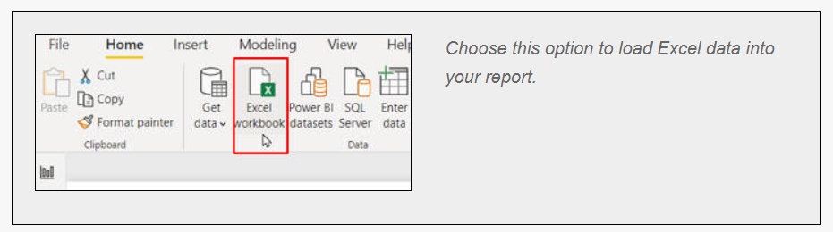

Give the song title and release year columns in the imported table better names, and hide the album column (no one talks about albums any more):

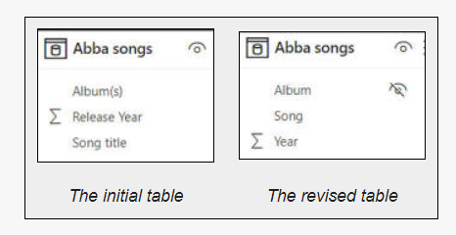

You should now be able to create this table:

Output:

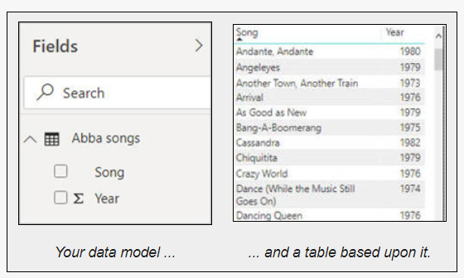

**Exercise2: Create a matrix and return some appropriate images above**

Using the **Age specific Genres.xlsx** file, create a matrix showing the **Count of films** by **Certificate** rating and **Genre**:

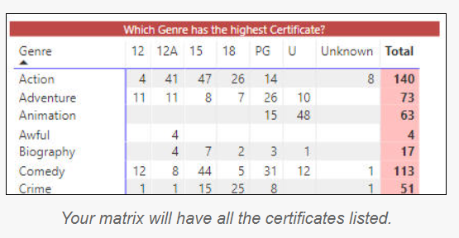

Notice how the certificates are in alphabetical order? CertificateID is in a more sensible order - use this to reorder the Certificate column:

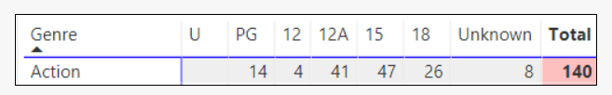

Lastly, to make the report a little more interesting add the images found in the above folder to the page like this:

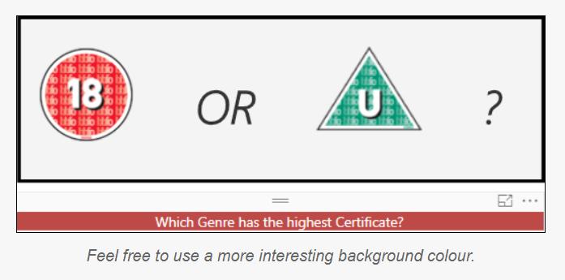

Output:

