**Exercise3: Create a report listing Game of Thrones episodes, importing two tables**

1. Create a new Power BI report, and load into it data from both worksheets:

2. Hide and rename columns to get a simpler data model:



1. Create a table to show average viewers by season:

Output:

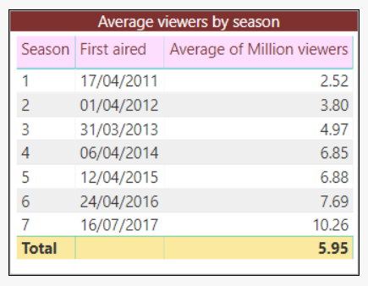

**Exercise4: Load a webpage of the best films, and use this to create a table**

1. Create a new Power BI Desktop file, and get a list of the top 1000 films of all time, as rated by They Shoot Pictures, Don't They?

<https://www.theyshootpictures.com/gf1000_all1000films_table.php>

Create a table to look something like this:

Output:



**Exercise5: Load 2 CSV files and one Excel workbook, and use this to report on films**

The input files are two in CSV format and one in Excel. Create a new Power BI report, and load these 3 files to create the data model:

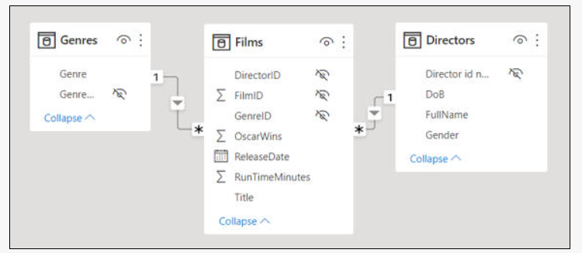

You'll have to create one of these relationships yourself. You should also hide the id fields, as no one will be interested in showing them in any report.

Rename the fields in the field well to make it more obvious what they represent:

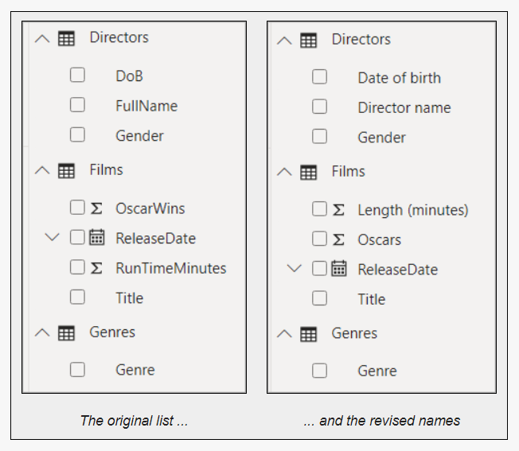

Output:

Table1:

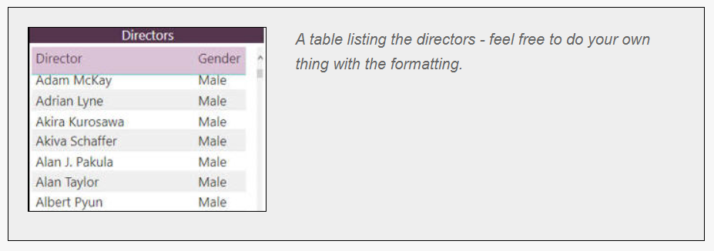

Table2:

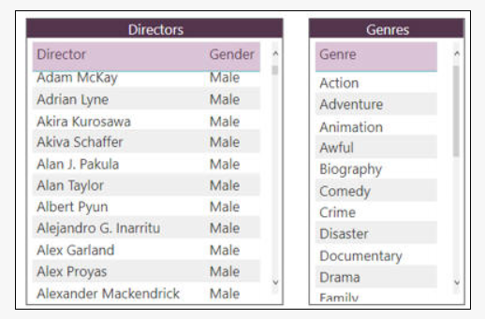

Table3:

Create a third table to list out the films made by the director (or genre) that you've selected:



The list of films you should see when you click on **Akira Kurosawa**.