**Exercise6: Load FTSE data, and create a report with a table, shape and image**

Create a new Power BI Desktop file, and get a list of the FTSE 100 shares.

You can find the link you need at this page of our website.

https://www.hl.co.uk/shares/stock-market-summary/ftse-100

Add the image, a shape, a table and a text box to get a report looking something like this:

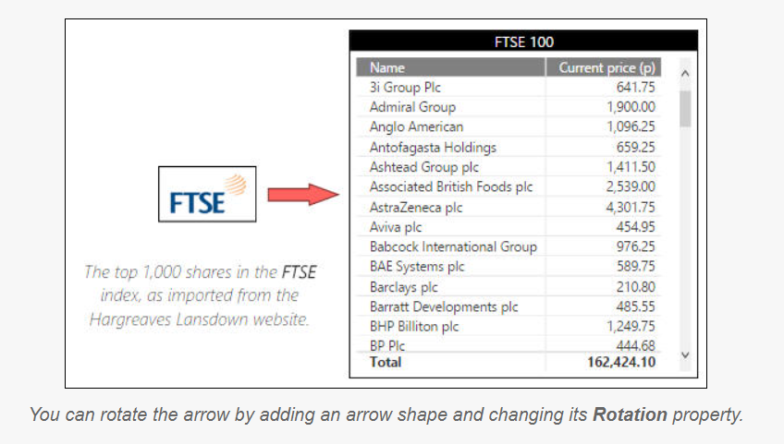

**Exercise7: Count the number of world events for each country and year**

Create a new Power BI report. Load the worksheets from the workbook in the above folder, and use them to create a data model:

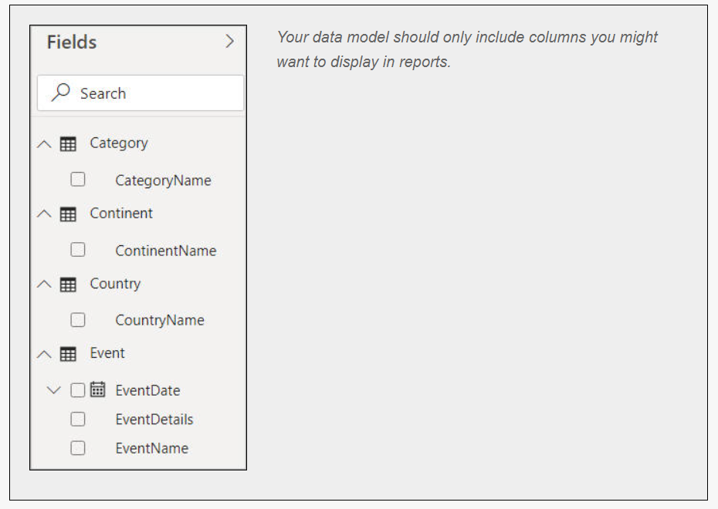

Now create a table and matrix, such that when you click on a continent (such as Africa for this example) you see the number of events in each of its countries, by year:

Output:

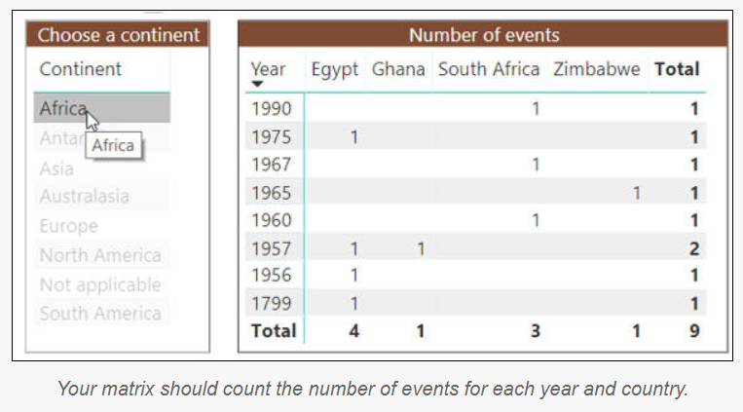

**Exercise8: Load example tables from a SQL Server database, and use them to create a matrix**

Create a new Power BI file, and run the SQL script to generate the Make-a-Mammal database.

Now load the following tables:

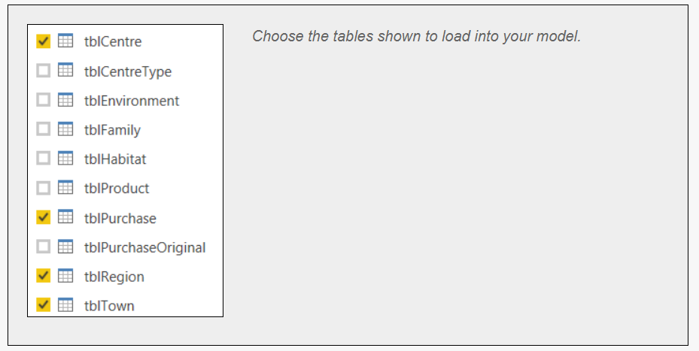

Hide columns and tables so that you see a tidier list of fields:

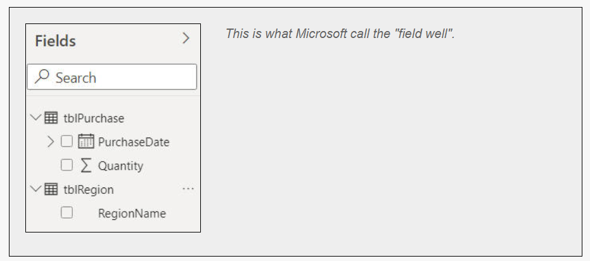

Create a matrix showing the average quantity sold by year/quarter and region:

