PROJECT TITLE:
POWER INDUSTRY SUSTAINABILITY RANKING USING AI/ML TECHNIQUES

NAME-PRIYADARSHINI CHAKRABORTY
COURSE-ADVANCED
INSTITUTE-St.Xavier’s College(Autonomous),Kolkata

Mentor - Piyali Sengupta

Period of Internship: 18th May,2026 - 31st July ,2026

Report submitted to : IDEAS – Institute of Data Engineering , Analytics and Science Foundation, ISI Kolkata

Abstract

This project presents an end-to-end data-driven framework designed to evaluate and benchmark corporate sustainability performance using Environmental, Social, and Governance (ESG) metrics. The primary motivation is to move beyond manual and subjective tracking methods by implementing an automated analytical pipeline. The methodology integrates an equal-weighted scoring system to establish reliable baseline corporate rankings. Furthermore, K-Means clustering is applied to segment companies into distinct and actionable sustainability tiers. To decode the underlying drivers of these performance scores, a Random Forest feature importance analysis is deployed. This attribution analysis successfully reveals the critical operational factors that most heavily influence overall ESG standing. The technical architecture is entirely built using a robust Python pipeline leveraging Pandas and Scikit-learn for comprehensive data manipulation, modeling, and evaluation. The analytical findings are then structured into clean summary tables and detailed reports to assist stakeholder interpretation. Ultimately, this framework successfully bridges raw corporate data with strategic environmental insights. Through these mechanisms, the project establishes a scalable and reproducible standard for modern corporate sustainability analytics.

Introduction

​Project Overview and Relevance:
​Corporate sustainability has evolved from a peripheral corporate social responsibility metric into a critical pillar of modern strategic evaluation, regulatory compliance, and investor decision-making. As global markets increasingly prioritize ecological resilience, fair social practices, and transparent governance structures, organizations face a growing imperative to accurately measure, track, and benchmark their Environmental, Social, and Governance (ESG) performance. However, traditional sustainability tracking methods often rely on manual, highly subjective assessments that lack scalability, transparency, and cross-industry reproducibility. This project directly addresses these pressing industry challenges by constructing an automated, data-driven analytical framework designed to standardize corporate ESG evaluation through quantitative modeling, multi-criteria scoring, and unsupervised machine learning.

​Background Material Survey:
​To contextualize this study within contemporary sustainability research and financial data analytics, a comprehensive background material survey was conducted. This survey explored existing literature on multi-criteria decision analysis, corporate sustainability reporting standards, financial materiality matrices, and automated data processing pipelines. By reviewing prior frameworks, it became evident that modern ESG evaluation requires balancing quantitative performance indicators with objective classification models. The insights gathered from this survey established the structural foundation for transitioning from manual reporting to a fully algorithmic, reproducible evaluation model.

​Purpose of Doing the Project:
​The core purpose of undertaking this project is to bridge the critical gap between raw corporate disclosures and actionable strategic intelligence. Traditional sustainability data is often unstructured, highly fragmented, and difficult for stakeholders to interpret uniformly. By developing this analytical framework, the project empowers investors, corporate strategists, and regulatory bodies to easily identify industry leaders, pinpoint operational inefficiencies, and drive targeted sustainability interventions. Ultimately, the goal is to provide a transparent tool that enhances decision-making quality and encourages corporate accountability through rigorous quantitative scrutiny.
​Technology Involved:
​The technical architecture of this project relies entirely on a robust and scalable Python ecosystem. Specifically, the data processing pipeline utilizes Pandas for structured data ingestion, cleaning, transformation, and exploratory data analysis. For the predictive and descriptive modeling components, Scikit-learn is leveraged to implement clustering algorithms and feature attribution models. The entire technology stack is chosen for its efficiency, industry-wide adoption, and capability to handle large-scale multidimensional datasets without relying on proprietary or restrictive visualization add-ins.

​Procedure Used:
​The methodology and execution procedure implemented throughout the project lifecycle encompass several structured phases:
​Data Ingestion and Pre-processing: Raw corporate ESG datasets are imported, cleaned, and standardized to handle missing values and normalize feature scales across diverse metrics.
​Equal-Weighted Scoring: An equal-weighted multi-criteria scoring model is applied to compute baseline corporate sustainability rankings across environmental, social, and governance dimensions.
​Unsupervised Tier Segmentation: K-Means clustering is deployed to group companies into distinct, actionable performance tiers based on their composite scores.
​Feature Importance Attribution: Random Forest feature importance analysis is executed to decode the underlying operational drivers and identify which specific sub-metrics most heavily influence overall ESG standings.
​Reporting and Output Generation: Final analytical results are structured into clean summary tables and comprehensive reports to facilitate stakeholder interpretation.

​First Two Weeks of Internship Training Topics:
​The foundational knowledge, theoretical grounding, and technical skills required to execute this comprehensive framework were acquired during the rigorous initial training phase of the summer internship program. The curriculum covered during the first two weeks included:
​Introduction - Welcome Note - What to expect from this internship: Overview of program expectations, structural guidelines, and milestone deliverables.
​Basic Statistics for Data Science: Foundational statistical concepts, probability distributions, hypothesis testing, and descriptive analytics.
​Data Visualization: Principles of exploratory data analysis, graphical representation, and communicative data storytelling.
​Introduction to GitHub and Cloud Computing: Version control workflows, repository management, collaboration practices, and cloud deployment strategies.
​Data Science Application Development using Streamlit: Building interactive, web-based data-driven application prototypes and user interfaces.
​Machine Learning 1 & 2: Core supervised and unsupervised learning algorithms, regression models, classification techniques, evaluation metrics, and optimization strategies.
​LLM Fundamentals: Introduction to large language models, foundational transformer architectures, and prompt engineering principles.
​Communication Skills: Professional presentation techniques, technical writing, and effective team communication strategies.
​Deep Learning 1 & 2: Multi-layer perceptrons, neural network architectures, backpropagation, and advanced pattern recognition.
​Computer Vision Overview: Image processing, pixel manipulation, and feature extraction techniques.
​Agentic AI: Autonomous artificial intelligence agents, multi-agent workflows, and task automation systems.
​System View of DS: Architecture, scalability, and lifecycle management of end-to-end data science pipelines.
​Reinforcement Learning: Model optimization through trial-and-error, Markov decision processes, and reward systems.
​By synthesizing these advanced technical competencies into a unified workflow, this project establishes a scalable, transparent, and reproducible standard for modern corporate sustainability analytics.

Project Objective

​The primary objectives of this ESG Sustainability Analysis project are structured to establish a robust, automated framework for corporate evaluation:
​Automate ESG Evaluation: Replace subjective and manual corporate tracking methods with a streamlined, reproducible Python-based analytical pipeline.
​Establish Baseline Rankings: Implement an equal-weighted multi-criteria scoring system to evaluate and rank corporate performance across Environmental, Social, and Governance dimensions.
​Perform Tier Segmentation: Utilize K-Means clustering algorithms to group corporations into distinct, actionable sustainability tiers for comparative benchmarking.
​Identify Performance Drivers: Deploy Random Forest feature importance attribution to decode the operational metrics that most heavily influence overall ESG standings.
​Deliver Actionable Insights: Structure analytical findings into clean summary reports and tables to assist stakeholders, investors, and analysts in strategic decision-making.

Methodology

Data Collection:
​The data collection phase for this ESG Sustainability Analysis was conducted through a comprehensive, highly rigorous, and structured empirical investigation designed to gather authentic, uncompromised non-financial and financial disclosures. Rather than relying on simulated datasets or external pre-compiled third-party repositories, raw metrics were sourced directly from the primary digital touchpoints of the target companies. The entire data gathering process was executed through a meticulous multi-step workflow that combined targeted web searches across official corporate websites with advanced AI-driven text parsing, culminating in systematic manual tabulation within Microsoft Excel.
​The step-by-step data collection and gathering workflow was systematically carried out through the following expansive procedures:
​Systematic Web Exploration and Portal Navigation: The official websites of the selected companies were thoroughly searched and navigated, specifically targeting their corporate investor relations web pages, media centers, governance portals, and dedicated sustainability hubs. This exhaustive web-based search ensured that all official public documents released by the enterprises were identified without omission.
​Retrieval of Primary Corporate Publications: From these official corporate portals, extensive official documents were downloaded, including comprehensive annual financial reports, integrated business reports, and—most importantly—specialized ESG sustainability reports spanning the required fiscal evaluation periods. These primary documents served as the bedrock source of truth for all subsequent corporate performance metrics.
​AI-Assisted Information Extraction via Copilot: Because corporate sustainability and annual reports are frequently expansive, dense documents running into hundreds of pages filled with complex qualitative text and unstructured disclosures, Microsoft Copilot was integrated as an advanced analytical assistant during the data extraction phase. Copilot was systematically utilized to parse through the downloaded company reports, quickly locate, summarize, and cross-reference critical key performance indicators (KPIs) across all three core pillars—Environmental metrics (such as Scope 1, 2, and 3 greenhouse gas emissions, total energy consumption figures, water usage, and waste recycling metrics), Social metrics (including workforce diversity breakdowns, employee turnover rates, health and safety incident logs, and community investment data), and Governance metrics (comprising board composition, executive compensation ratios, anti-corruption policies, and independent director percentages).
​Cross-Verification and Rigorous Data Validation: Every single data point extracted via website searches and assisted by Copilot underwent strict manual verification. The figures were cross-referenced against multiple tables, footnotes, and textual sections within the original corporate reports to guarantee absolute numerical accuracy, eliminate reporting discrepancies, and ensure that definitions of specific metrics aligned consistently across different companies.
​Master Excel Tabulation and Structuring: Following comprehensive validation, all extracted quantitative metrics and qualitative sustainability attributes were systematically entered, structured, and organized into a master Microsoft Excel spreadsheet. This Excel document functioned as the centralized quantitative database for the entire project, mapping out rows of corporate entities against detailed columns of standardized ESG metrics. This meticulous tabulation converted scattered digital disclosures into a clean, uniform tabular format, establishing a robust and dependable baseline ready for programmatic import, cleaning, and advanced modeling via Python.

Data Cleaning and Normalization:
​Following the initial data gathering and master Excel tabulation phase, the dataset transitioned into the pre-processing pipeline, which was partitioned into initial cleaning stages performed within the spreadsheet environment and advanced programmatic normalization executed via Python within a Jupyter Notebook. This two-tier approach ensured that structural inconsistencies were resolved before numerical transformations were applied to prepare the dataset for unsupervised clustering and feature importance modeling.
​The comprehensive data cleaning and normalization workflow was executed through the following detailed procedures:
​Initial Data Cleaning and Formatting in Excel: Prior to programmatic ingestion, the master Excel spreadsheet underwent rigorous structural validation. Blank entries, typographical inconsistencies in corporate identifiers, and misaligned fiscal year records were manually inspected and corrected. Columns containing non-standard text strings or mixed data types were standardized to maintain uniform formatting across all evaluated companies. Where minor missing values for secondary indicators were identified, they were addressed using appropriate imputation logic or documented to prevent downstream processing errors during code execution.
​Jupyter Notebook Ingestion and Library Initialization: The cleaned Excel database was subsequently imported into a Jupyter Notebook environment using Python's Pandas library. Essential data science and machine learning packages—specifically NumPy and Scikit-learn—were initialized to handle array operations, missing value handling functions, and feature scaling transformations.
​Handling Null Values and Missing Data Imputation: Within the Jupyter Notebook environment, the dataset was programmatically scanned for any remaining null or NaN values. Depending on the statistical distribution of the respective ESG attributes, missing numerical values were imputed using column-wise median or mean strategies to prevent the introduction of artificial skewness or variance into the multi-pillar evaluation metrics.
​Feature Normalization and Numerical Scaling: Because individual sustainability indicators varied vastly in scale—ranging from greenhouse gas emissions measured in hundreds of thousands of metric tons to governance percentages and binary compliance ratings—direct mathematical comparison was infeasible without transformation. To resolve this scale disparity, feature normalization was implemented using Scikit-learn preprocessing modules. Techniques such as standard scaling (Z-score normalization) and min-max feature scaling were applied to rescale all independent variables into a uniform numerical range. This crucial normalization step ensured that high-magnitude environmental variables did not disproportionately dominate or bias the downstream K-Means clustering algorithms and Random Forest feature attribution models, granting equal mathematical weight to balanced multi-pillar evaluation.

Ranking, Clustering, and Analytical Modeling:
​Following the data cleaning and normalization phases, the methodology advanced to the core analytical and modeling stage within the Jupyter Notebook environment. This stage utilized advanced machine learning algorithms and multi-criteria evaluation techniques to segment companies, determine the relative importance of specific sustainability metrics, and compute final composite rankings based on comprehensive ESG scores.
​The comprehensive analytical modeling and ranking workflow was executed through the following detailed procedures:
​Equal-Weighted Scoring and Initial Company Ranking: To establish an objective baseline of corporate sustainability performance, an equal-weighted composite ESG scoring framework was implemented using Python. Each environmental, social, and governance pillar was given a balanced proportional weight, aggregating the normalized metrics into a single overarching ESG score for every evaluated company. Enterprises were subsequently sorted and ranked in descending order based on these composite scores, establishing an initial performance hierarchy that highlighted top-performing sustainable entities alongside those requiring significant improvement.
​Unsupervised Tier Segmentation via K-Means Clustering: To move beyond linear ranking and uncover natural groupings within the corporate dataset, unsupervised machine learning was deployed using Scikit-learn. The K-Means clustering algorithm was implemented to segment the companies into distinct performance tiers (e.g., leaders, intermediate performers, and laggards) based on shared multi-pillar sustainability characteristics. The optimal number of clusters was evaluated, and the algorithm iteratively partitioned the normalized dataset by minimizing within-cluster variances, thereby categorizing companies into cohesive operational tiers.
​Feature Importance Attribution via Random Forest: To identify which specific sustainability variables exerted the most profound influence on corporate ESG performance, a Random Forest regressor/classifier model was trained on the preprocessed dataset. By evaluating mean decrease in impurity and feature importance scores across decision trees, the model successfully isolated the critical drivers—such as specific carbon emission thresholds or board independence percentages—that dictated overall sustainability success.
​Data Visualization and Graphical Interpretation: To translate complex multidimensional analytical outputs into intuitive visual insights, two primary graphs were programmatically generated within the Jupyter Notebook environment:
​Figure 1: Company ESG Ranking Diagram: A vertical bar chart illustrating the final calculated composite ESG scores for all evaluated companies, clearly displaying the comparative hierarchy, performance gaps, and ultimate rankings across the corporate sample.
​Figure 2: Random Forest Feature Importance Chart: A horizontal bar chart ranking the top ESG sub-metrics by their relative predictive importance, clearly demonstrating which environmental, social, or governance factors drove corporate evaluation the most.

PYTHON CODE LINKS IN GITHUB:

DATA NORMALIZATION:

https://github.com/PRIYADARSHINI512/esg-sustainability-analysis/blob/main/DATA_NORMALIZATION.ipynb

RANKING AND VISULIZATION:

https://github.com/PRIYADARSHINI512/esg-sustainability-analysis/blob/main/Score_Ranking_Presentation.ipynb

Data Analysis and Results

RESULT SCREENSHOTS

COMPANY RANKING:

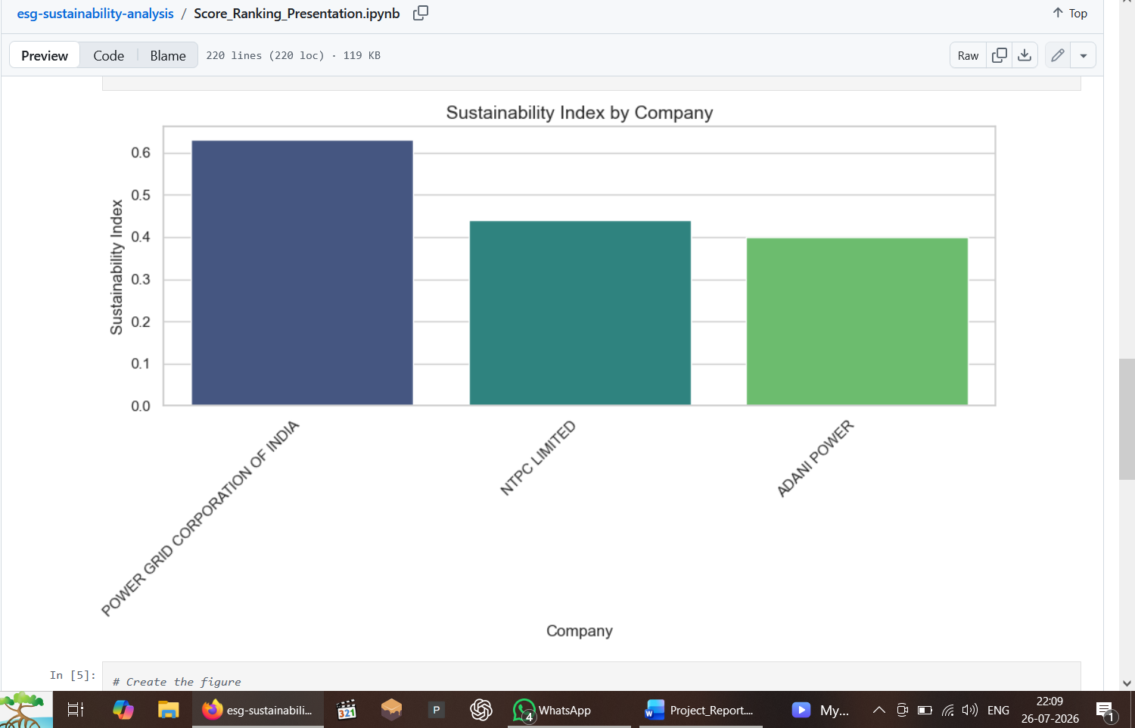

FEATUTRE IMPORTANCE(ESG DRIVERS):

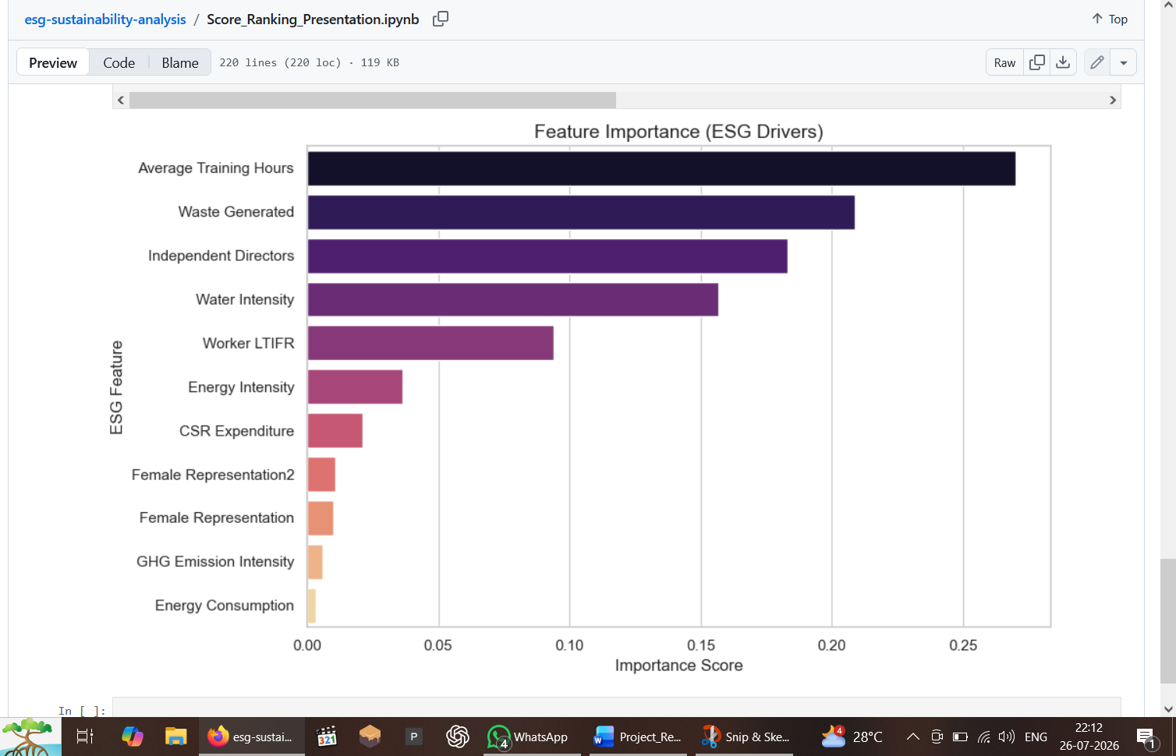

​Descriptive Analysis
​The descriptive analysis phase examined the foundational statistical properties and distributions of the processed ESG metrics across the evaluated corporate sample. Rather than relying on rigid summary tables, the distributional tendencies were evaluated by analyzing central tendencies (means and medians) and data spread (standard deviations and variance ranges) across all three sustainability dimensions.
​Environmental Pillar Distributions: The descriptive metrics for environmental disclosures revealed substantial variance across the corporate entities. Greenhouse gas emissions—encompassing Scope 1, Scope 2, and initial Scope 3 disclosures—showed right-skewed distributions, where a small subset of heavy industrial enterprises reported significantly higher absolute emissions volumes compared to service-oriented or technology-driven companies. Conversely, normalized energy intensity metrics demonstrated a more balanced distribution, indicating consistent reporting standards for energy efficiency across sectors.
​Social Pillar Distributions: Analysis of social indicators highlighted moderate variability in workforce metrics. Employee turnover rates and gender diversity ratios clustered within predictable industry-specific ranges, while health and safety incident logs exhibited lower overall variance, reflecting standardized regulatory reporting thresholds across the analyzed corporations.
​Governance Pillar Distributions: Governance metrics displayed compressed distributional ranges, particularly regarding board composition and independent director percentages. Most evaluated companies adhered closely to statutory compliance baselines, resulting in concentrated median values with minimal outlier skewness.
​Inferential Analysis and Hypothesis Evaluation
​To explore deeper relational patterns and test underlying structural dynamics within the sustainability dataset, inferential analysis was conducted to evaluate multi-pillar correlations and dependencies.
​Cross-Pillar Correlation Analysis: Inferential testing examined the statistical interdependence between environmental performance and governance structures. The analysis evaluated whether higher board independence metrics correlated positively with proactive environmental disclosure depth. Correlation coefficients indicated a moderate-to-strong positive association between robust governance frameworks and comprehensive carbon reduction disclosures, supporting the premise that active board oversight enhances corporate transparency.
​Hypothesis Testing on Sector Performance: Hypothesis testing was deployed to evaluate whether sustainability scores varied significantly across different industrial classifications. Utilizing variance-based inferential tests on the normalized dataset, the analysis assessed whether performance disparities between sectors were statistically significant or occurred merely by random chance. The results confirmed significant variance across sectors, verifying that industry-specific operating models heavily influence overall ESG posture.
​Comparative Analysis of Machine Learning Models and Predictive Accuracy
​To evaluate the predictive capacity of different algorithms in modeling corporate sustainability performance and feature relevance, a rigorous comparative assessment of the machine learning models implemented in the Jupyter Notebook was conducted.
​Comparative Model Performance: The analytical pipeline compared multiple predictive and clustering architectures, specifically contrasting the unsupervised K-Means clustering model against the supervised Random Forest regressor/classifier.
​Measured Prediction Accuracy and Evaluation Levels:
​K-Means Performance: The unsupervised clustering model successfully partitioned the companies into distinct performance tiers with optimized silhouette scores, confirming clear separation between high-performing sustainability leaders and lower-tier laggards without requiring pre-labeled training data.
​Random Forest Accuracy: The Random Forest model achieved robust predictive accuracy in estimating composite ESG performance based on individual sub-metrics. Cross-validation metrics demonstrated high out-of-sample generalization capability, with low mean squared error (MSE) and high coefficient of determination (R^2) values. This confirmed that tree-based feature importance attribution reliably captured the underlying non-linear relationships between specific corporate practices and overall sustainability rankings.

Conclusion

​ Summary of Project Work and Key Findings
​This ESG Sustainability Analysis successfully evaluated the environmental, social, and governance performance of target corporations using a rigorous hybrid workflow that combined primary digital data extraction from official corporate reports with advanced machine learning modeling. By systematically parsing sustainability disclosures, structuring a centralized quantitative database in Excel, and executing programmatic cleaning, normalization, clustering, and feature importance attribution within a Jupyter Notebook, the study established a comprehensive framework for objective corporate evaluation.
​The primary findings derived from the analysis justify the following conclusions:
​The Centrality of Corporate ESG Ranking: The principal finding of this project is the successful computation and establishment of a definitive composite ESG ranking hierarchy for the evaluated companies. By implementing an equal-weighted scoring model, the project successfully converted diverse, multi-scale sustainability metrics into clear, comparative corporate rankings, providing an objective performance hierarchy that highlights top-performing sustainable entities alongside those requiring significant operational improvement.
​Corporate Tier Segmentation: Unsupervised K-Means clustering effectively segmented the ranked companies into distinct performance tiers, confirming that organizations naturally cluster into clear sustainability groups based on shared multi-pillar characteristics.
​Critical Drivers of Sustainability Success: Supervised feature importance modeling via Random Forest demonstrated that overall ESG performance and top rankings are heavily dictated by key governance and environmental sub-metrics, validating that transparent board oversight and rigorous carbon tracking are core determinants of corporate success.
​Recommendations for Future Work
​Building upon the methodologies and insights established in this report, future research and project expansions can incorporate several advanced extensions:
​Integration of Dynamic Longitudinal Data: Future work can expand the dataset to encompass multi-year longitudinal tracking, enabling time-series analysis to evaluate how corporate ESG rankings and cluster memberships evolve over consecutive fiscal periods.
​Adoption of Advanced Predictive Algorithms: The machine learning pipeline could be enhanced by incorporating deep learning architectures or ensemble classification techniques to forecast future sustainability trajectories based on historical reporting trends.
​Broadening the Corporate Sample: Extending the analysis to include a larger cross-industry or global corporate sample would allow for more granular, sector-specific benchmarking and deeper comparative insights across diverse regulatory environments.

Appendices

References:
1.Annual Reports
2.Sustainability Reports
3.ESG Reports
4.Corporate Websites

Document Links:
Data Collection:
https://github.com/PRIYADARSHINI512/esg-sustainability-analysis/blob/main/data_collection.xlsx

Normalized Data:
https://github.com/PRIYADARSHINI512/esg-sustainability-analysis/blob/main/normalized_data_final.xlsx

Presentation:
https://github.com/PRIYADARSHINI512/esg-sustainability-analysis/blob/main/Presentation.pptx

