Payment Application – Testing Instructions
Base URL
http://localhost:8080

1. Overview
This document contains all the testing scenarios for the Payment Application, including:
- Payment creation
- Webhook registration
- Retry logic
- Asynchronous behavior
Use Postman or Swagger UI for testing. Verify database tables (payment, webhook, retry_webhook) after each operation.

2. Architectural Diagram
Purpose: Understand the system flow, API interactions, and asynchronous webhook calls.
Diagram Placeholder:
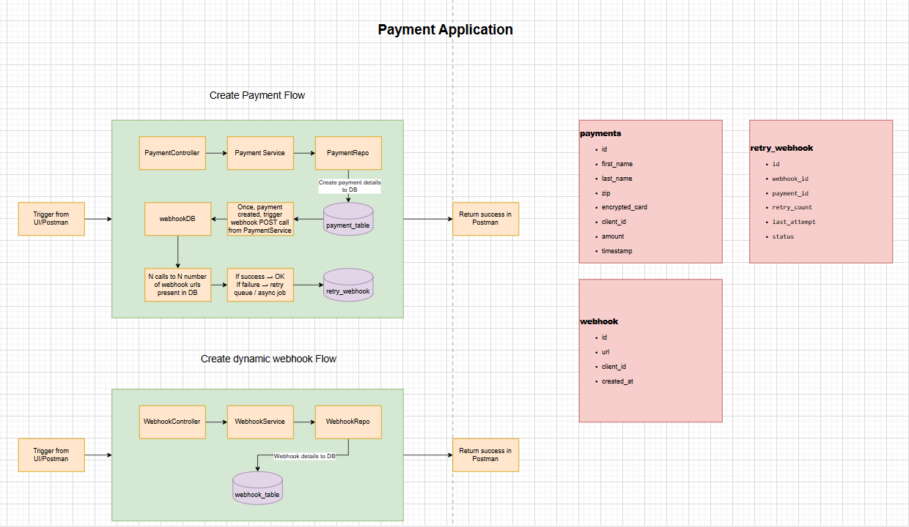
File has been attached under root_directory. You can open the file using Draw.io or the online editor at https://app.diagrams.net/.

3. Mock Webhook URL
Endpoint: /mockWebhook/receive
Purpose:
- For testing webhook integration only.
- Register this URL during webhook registration to simulate a successful external webhook.
- The system will asynchronously POST payment details to this URL after payment creation.
- Always returns 200 OK.

4. Testing Scenarios

Register Webhook
- API Endpoint: POST /api/webhooks
- Steps: Send a POST request with clientId and url.
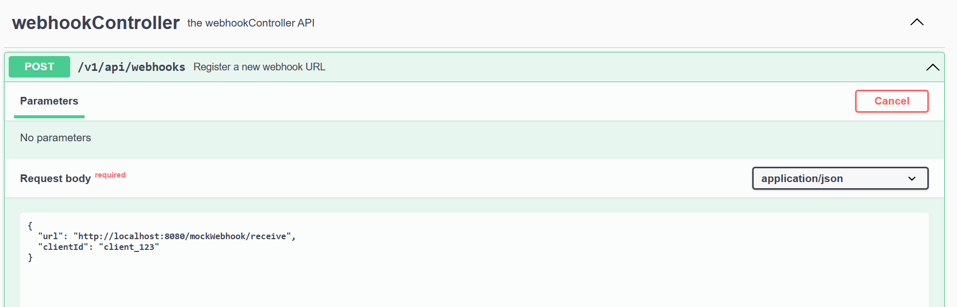
- Expected Result:
  - 201 Created, message: "Webhook registered successfully!"
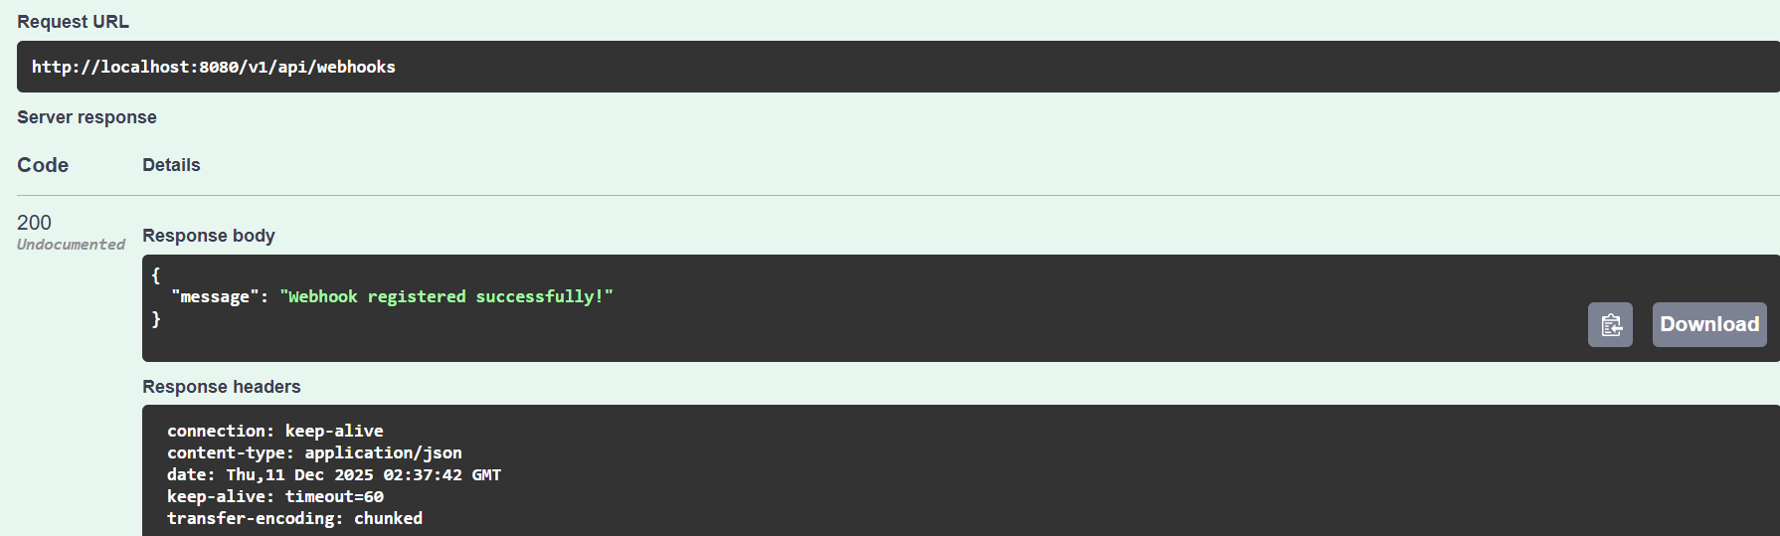
  - Verify in webhook table that the data is created.
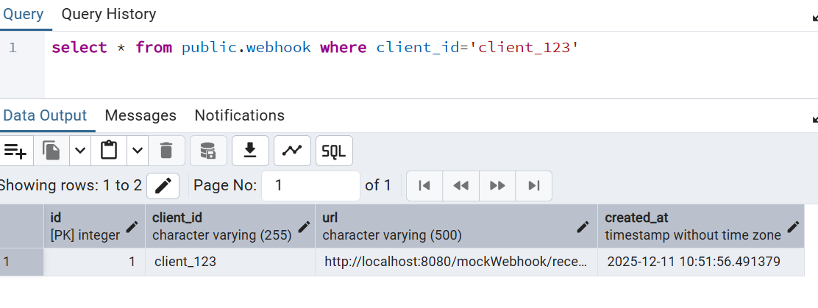

Create Payment with Registered Webhook
- API Endpoint: POST /api/payments
- Steps: Send a POST request with payment details for a client with a registered webhook.
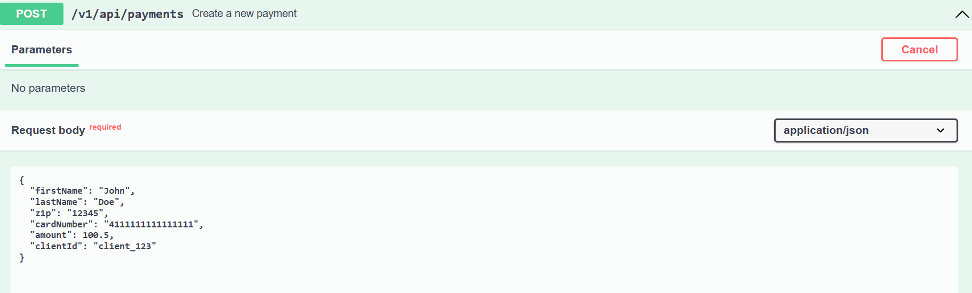
- Expected Result:
  - 201 Created, message: "Payment created successfully!"
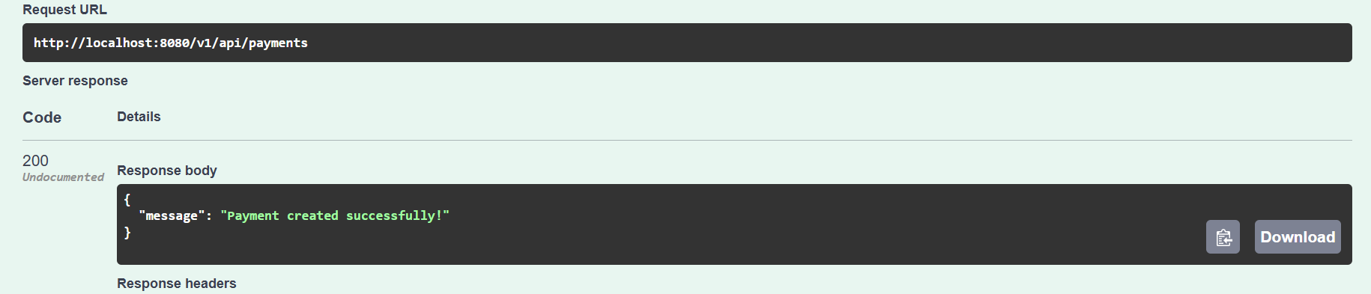
  - Webhook is called asynchronously, Check logs for asynchronous webhook calls.
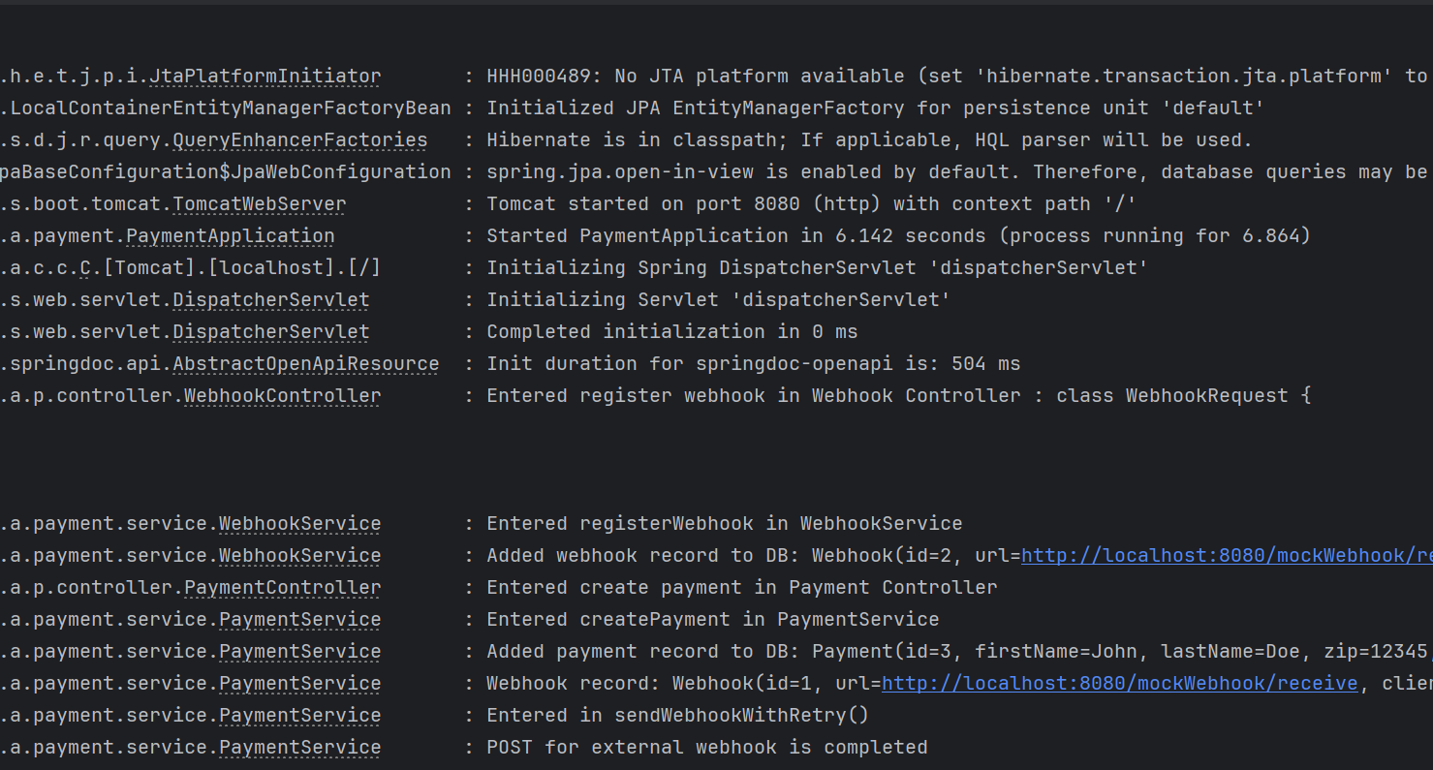
  - Verify entries in payment table and retry_webhook table.
    - payment table
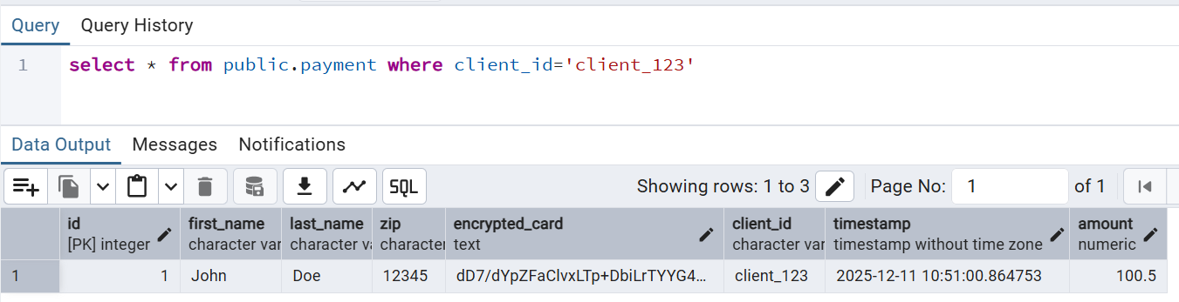
    - retry_webhook table
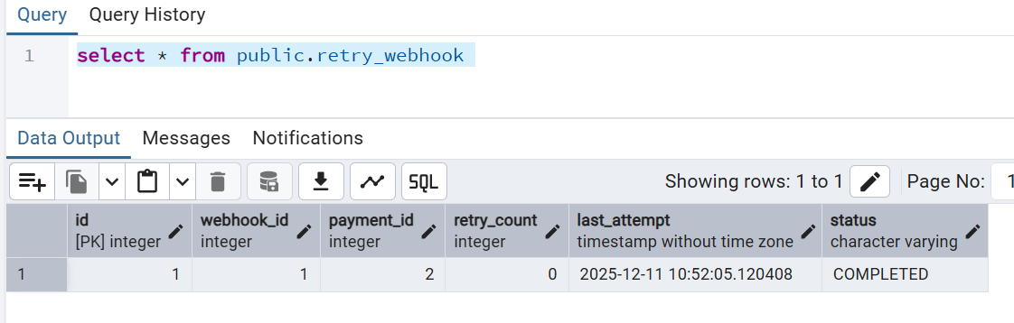

  - Note: Card number is stored in encrypted format.

Create Payment without Webhook
- API Endpoint: POST /api/payments
- Steps: Send a POST request with payment details for a client without a webhook.
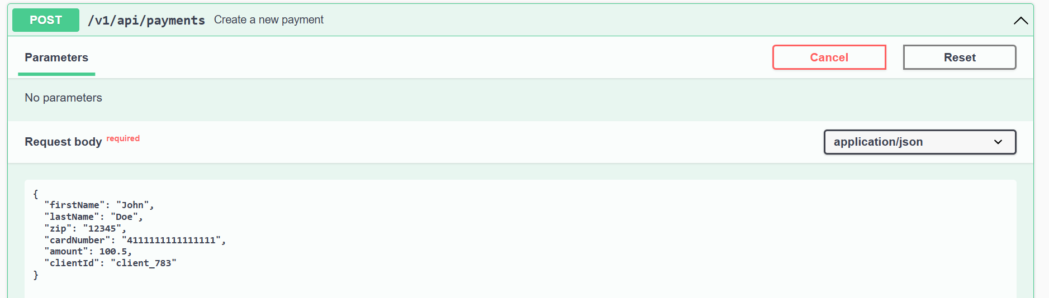
- Expected Result:
  - 201 Created, message: "Payment created successfully!"

  - Check logs for asynchronous behavior and error scenario
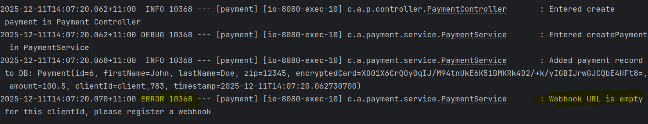
  - Verify entries in payment table (no webhook will be called).
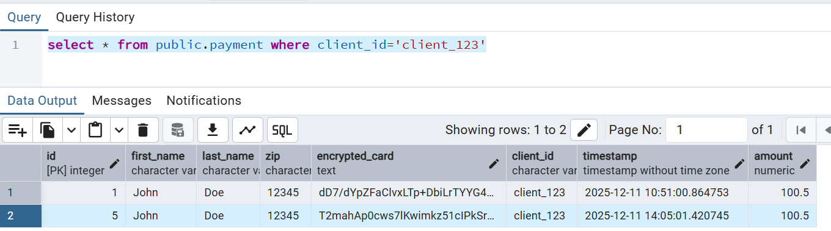
  - Note: Card number is stored in encrypted format.

Retry Webhook on Failure
- API Endpoint: POST /api/payments
- Steps:
  - Register a failing webhook URL.
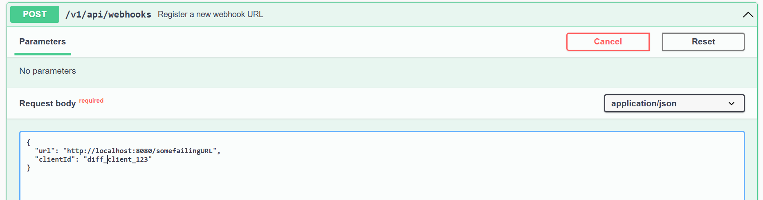
  - Create a payment with that client_id
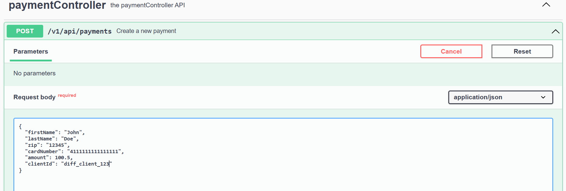

- Expected Result:
  - Payment will be created
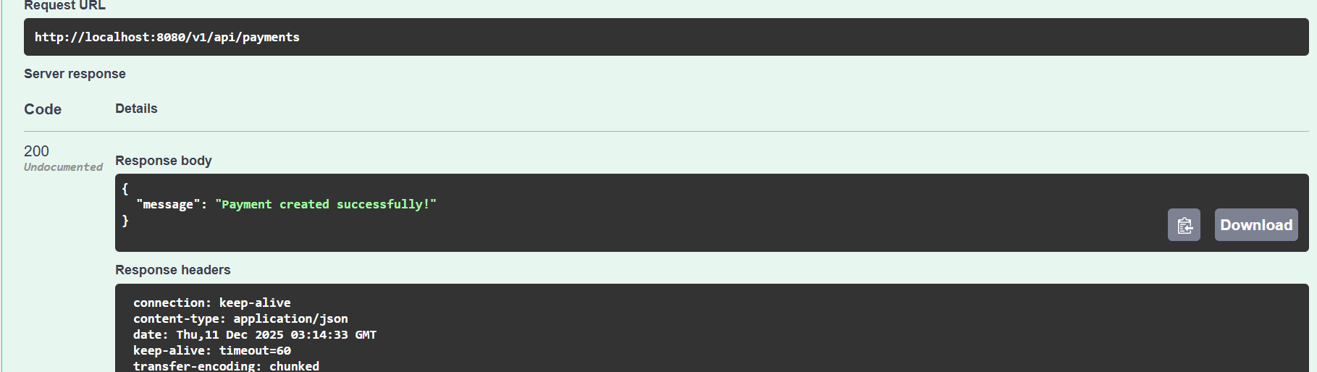
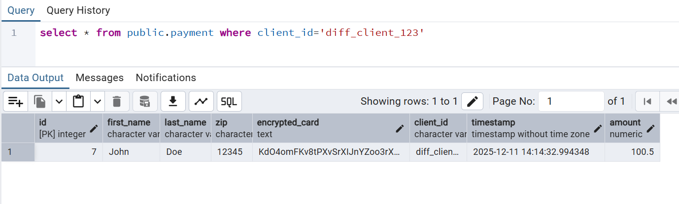
  - retry_webhook table is updated.
    - First_few_tries (Retry count increments on each failure and status will be pending)
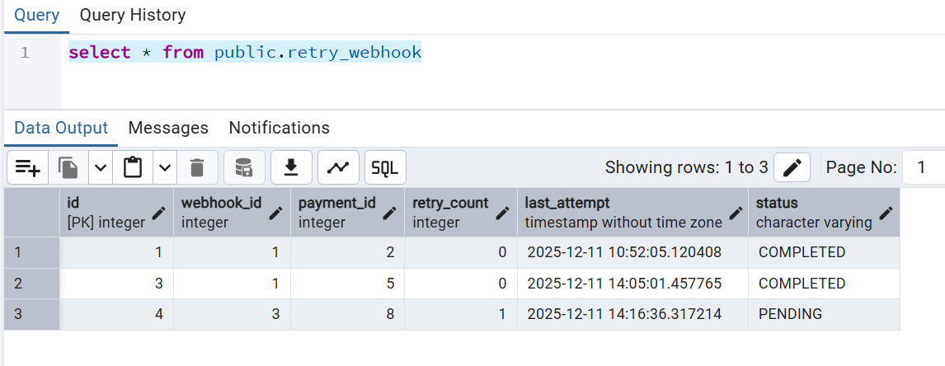
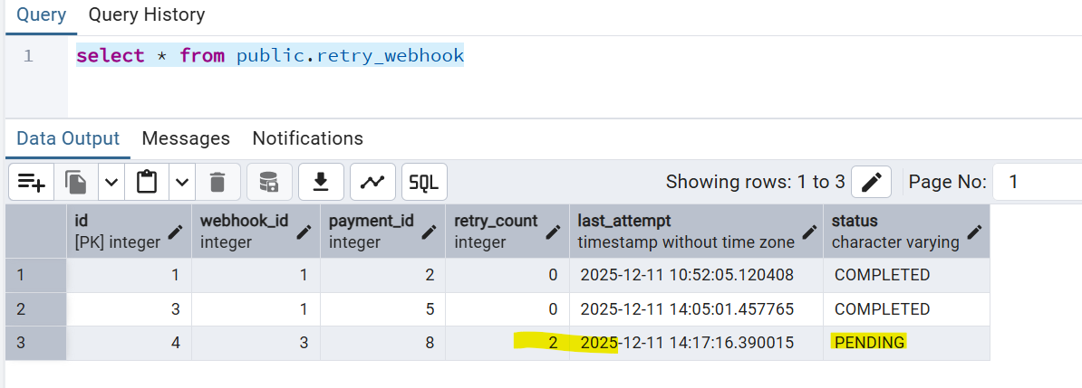
    - Failed after maximum retry , the last_attempt timestamp and status are updated.
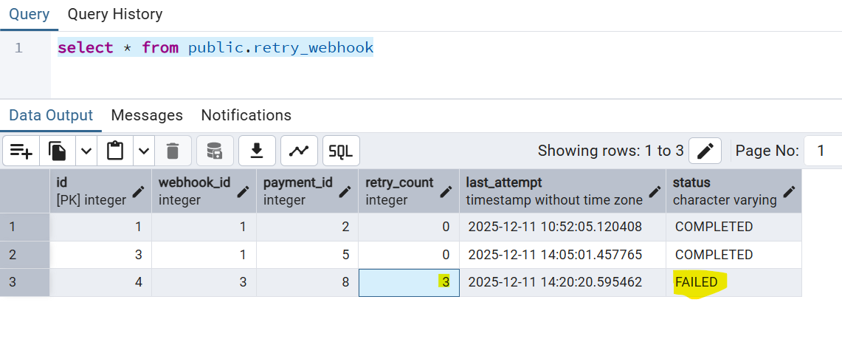
  - Check logs for detailed debugging
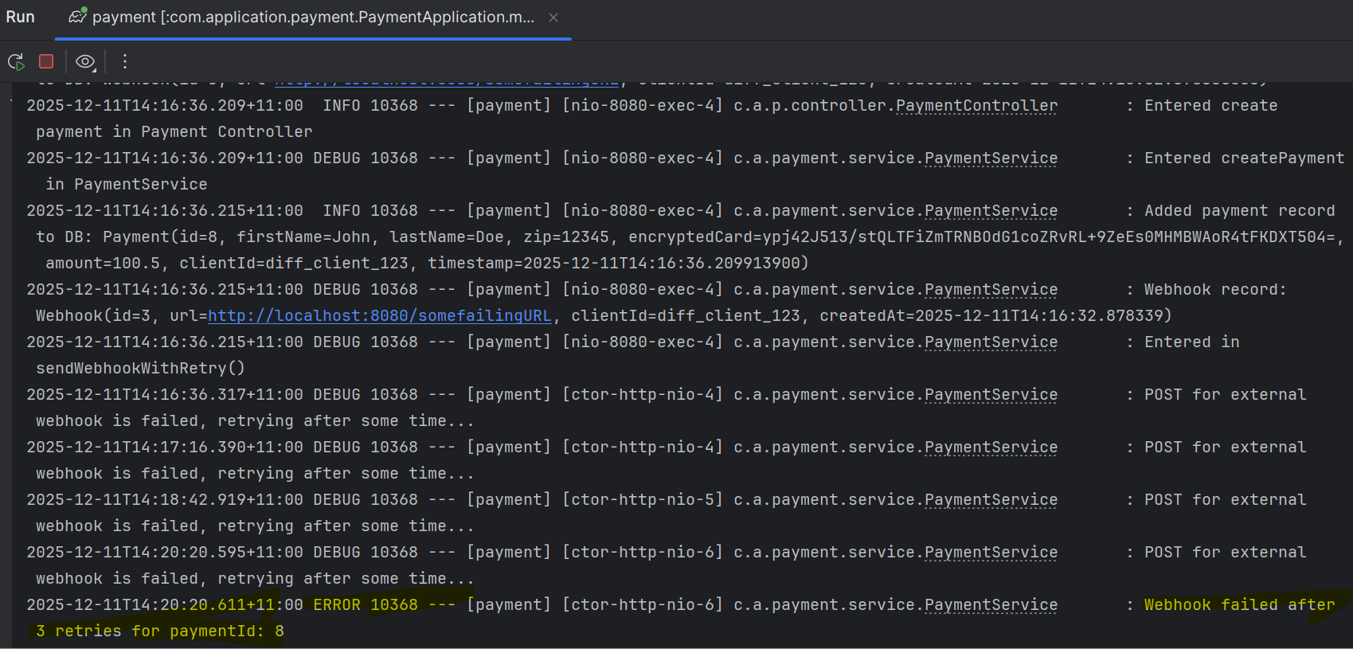
- Note: maximum retry and duration customizable
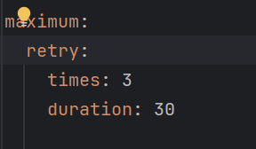

Data Integrity Check
- API Endpoint: POST /api/payments
- Steps:
  - Create a payment.
  - Check the database.
- Expected Result:
  - All fields match the request.
  - Card number is stored encrypted.
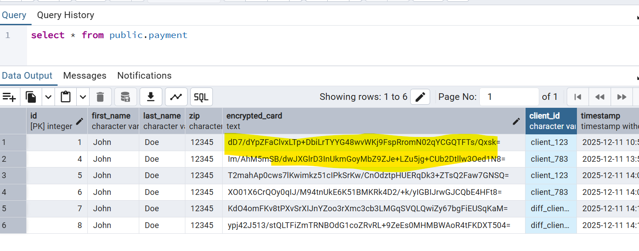

Asynchronous Behavior Verification
- API Endpoint: POST /api/payments
- Steps:
  - Create a payment.
  - Check the API response immediately.
- Expected Result:
  - Payment API responds immediately.
  - Webhook processing happens in the background.

5. Notes for Tester
- /mockWebhook/receive is not for normal API usage, only for testing.
- Webhook POST calls are asynchronous — allow a few seconds for background processing.
- Verify the payment, webhook, and retry_webhook tables after operations.
- Follow the scenarios in order: register webhook → create payment → check webhook → test retries.
- Use the Draw.io architectural diagram to understand component interactions and async workflow.

