Real Estate House Price Prediction
Machine Learning Project Report
Dataset: Taiwan Real Estate Valuation Dataset | Tools: Python, scikit-learn, Streamlit, pandas, Matplotlib, Seaborn
1. Project Overview
This project builds a Real Estate House Price Prediction system using machine learning techniques applied to historical property transaction and location data from Taiwan. The goal is to predict the price per unit area (10,000 NTD per Ping) of residential properties based on six key input features.
The project includes a complete ML pipeline: data preprocessing, feature engineering, training four regression models, automatic selection of the best model, and an interactive Streamlit web application for making real-time predictions.
Key Objectives
- Explore and preprocess the Taiwan real estate dataset
- Engineer meaningful features to improve model accuracy
- Train and compare four ML regression models
- Automatically select and persist the best-performing model
- Build an interactive web UI for live price predictions
2. Dataset Description
The dataset is sourced from the UCI Machine Learning Repository. It contains 414 real estate transaction records from the Sindian District, New Taipei City, Taiwan, collected between August 2012 and July 2013.
Dataset Features
Feature | Description | Type
X1 transaction date | Year.Month fractional date (e.g. 2013.5 = July 2013) | Numeric
X2 house age | Age of the property in years | Numeric
X3 distance to MRT | Distance (meters) to the nearest MRT station | Numeric
X4 convenience stores | Number of convenience stores within walking distance | Integer
X5 latitude | GPS latitude coordinate of the property | Numeric
X6 longitude | GPS longitude coordinate of the property | Numeric
Y house price | Price per unit area (10,000 NTD / Ping) - TARGET | Numeric
Dataset Statistics
Statistic | Value | Notes
Total Records | 414 | No missing values
Price Range | 7.6 to 117.5 | 10,000 NTD/Ping
Mean Price | 37.98 | 10,000 NTD/Ping
Time Period | Aug 2012 to Jul 2013 | Sindian Dist., New Taipei City
3. Data Preprocessing and Feature Engineering
The raw dataset was cleaned and enriched with engineered features to improve model performance. All preprocessing is implemented in train_model.py.
Preprocessing Steps
- Removed the index column (No)
- Renamed all columns to clean snake_case names
- Verified zero missing values across all columns
- Applied log transformation to distance_to_mrt to reduce right-skew
- Extracted transaction_year and transaction_month from the fractional date feature
- Applied StandardScaler for linear regression models (tree models use raw features)
Final Feature Set (8 features)
Feature Name | Origin
transaction_date | Original
house_age | Original
distance_to_mrt_log | Engineered: log1p(distance_to_mrt)
convenience_stores | Original
latitude | Original
longitude | Original
transaction_year | Engineered: int(transaction_date)
transaction_month | Engineered: fractional month extracted
4. Model Development
Four regression algorithms were trained and evaluated on an 80/20 train-test split (random_state=42). The best model (highest R2 score) is automatically saved for use in the web application.
Models Trained
Model | Library | Key Parameters
Linear Regression | sklearn.linear_model | Default; scaled input
Ridge Regression | sklearn.linear_model | alpha=1.0; scaled input
Random Forest | sklearn.ensemble | n_estimators=200; random_state=42
Gradient Boosting | sklearn.ensemble | n_estimators=200; random_state=42
5. Model Performance Results
All four models were evaluated on the held-out test set (83 samples) using three standard regression metrics: Mean Absolute Error (MAE), Root Mean Squared Error (RMSE), and R2 Score.
Model | MAE | RMSE | R2 Score | Best?
Linear Regression | 4.45 | 6.82 | 0.7227
Ridge Regression | 4.41 | 6.82 | 0.7225
Random Forest | 3.90 | 5.66 | 0.8093 | YES
Gradient Boosting | 4.09 | 5.89 | 0.7935
Improvement (RF vs LR) | -12.4% | -17.0% | +12.0%
The Random Forest model achieved the best performance with R2 = 0.8093, meaning it explains 80.93% of the variance in property prices. It achieved the lowest MAE (3.90) and RMSE (5.66), a 12% improvement over the Linear Regression baseline.
6. Visualisations
Four charts were automatically generated during model training and saved to the static/ directory.
6.1 Model Comparison Chart
Compares MAE, RMSE, and R2 across all four trained models side-by-side.
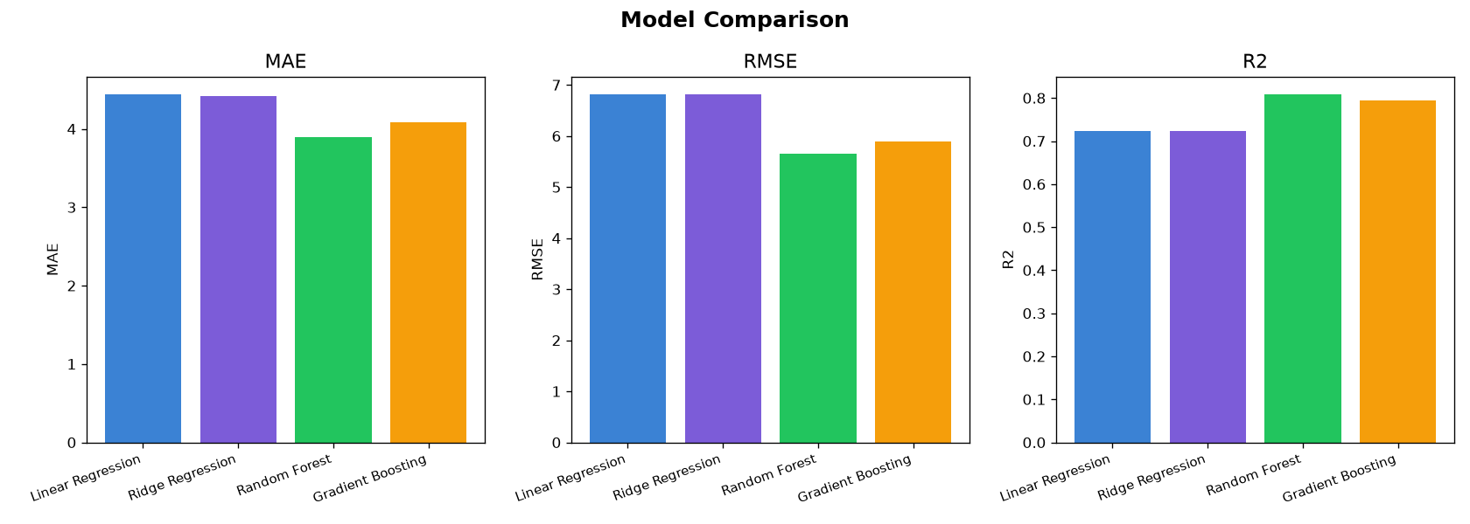
6.2 Actual vs Predicted Prices
Scatter plot of actual vs predicted prices for the Random Forest model on the test set. Points close to the red dashed diagonal indicate accurate predictions.
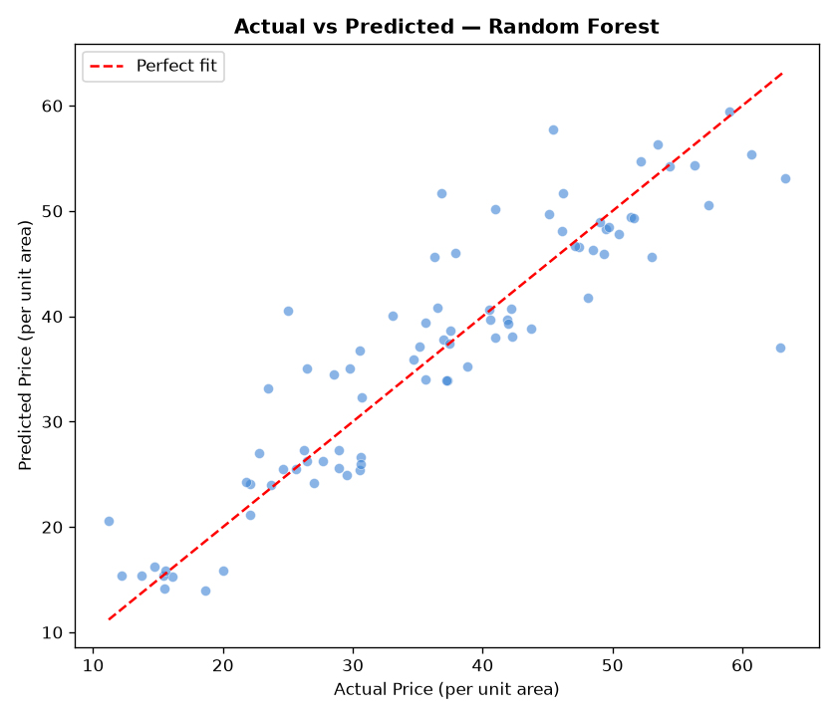
6.3 Feature Importance
Horizontal bar chart showing the relative importance of each feature in the Random Forest model. Distance to MRT station (log-transformed) and latitude are the strongest predictors of price.
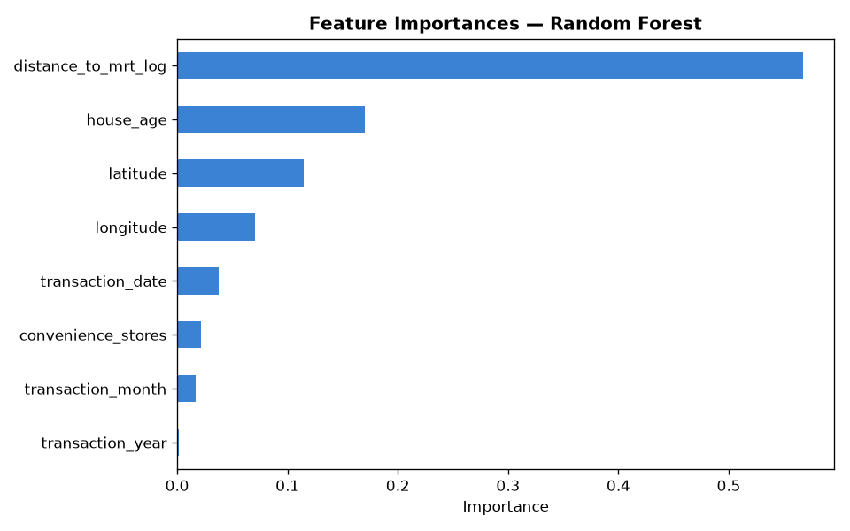
6.4 Correlation Heatmap
Pearson correlation matrix between all features and the target variable. Strong negative correlation between distance_to_mrt and price, and positive correlation between convenience_stores and price.
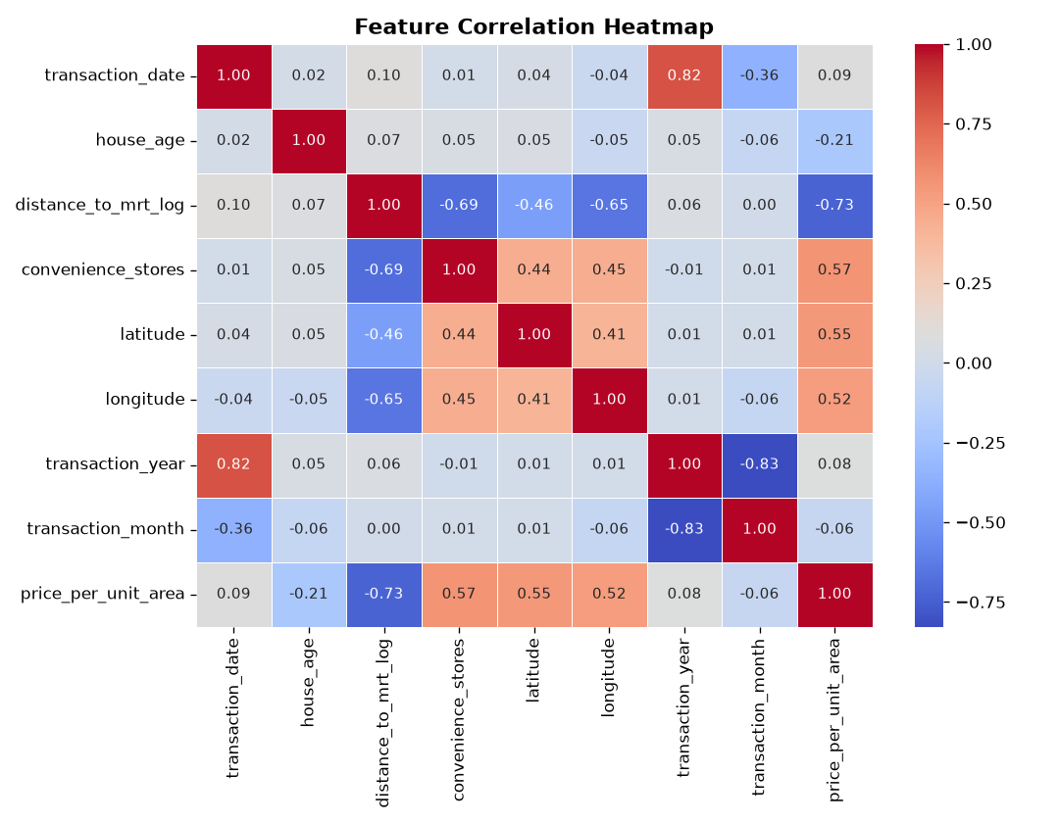
7. Streamlit Frontend Application
The web application is built with Streamlit and provides a fully interactive interface for exploring the dataset and making real-time price predictions. It is implemented in app.py.
Application Tabs
Tab | Contents
Prediction | Sidebar sliders; live price prediction; comparable properties; actual vs predicted chart
Model Performance | Metrics table; model comparison chart; feature importances; coefficients
Data Insights | Price distribution; scatter plots; geographic price map; correlation heatmap
Dataset | Filterable full dataset table with price range slider and CSV download
The sidebar provides interactive sliders for: Transaction Date (2012-2014), House Age (0-45 yrs), Distance to MRT (23-6500 m), Convenience Stores (0-10), Latitude, and Longitude. A Predict Price button triggers the prediction.
8. Project Structure
File / Folder | Purpose
data/real_estate.csv | Source dataset (414 records, 7 columns)
train_model.py | ML pipeline: preprocessing, training, evaluation, chart generation
app.py | Streamlit web application (frontend)
models/best_model.pkl | Serialised best Random Forest model (joblib)
models/scaler.pkl | Fitted StandardScaler for linear models
models/features.pkl | Ordered list of 8 feature names
models/best_model_name.pkl | Name of the selected best model
static/*.png | 4 auto-generated performance and insight charts
requirements.txt | Python package dependencies
9. How to Run
Step 1: Install dependencies
pip install -r requirements.txt
Step 2: Train the models (run once from the real_estate_project folder)
python train_model.py
This trains all four models, selects the best one, saves artefacts to models/ and generates charts in static/.
Step 3: Launch the web application
python -m streamlit run app.py
Then open http://localhost:8501 in your browser. Use python -m streamlit instead of streamlit if streamlit.exe is not on your system PATH.
10. Conclusion
This project successfully demonstrates the application of machine learning to real estate price prediction. The Random Forest model achieved the best performance with an R2 score of 0.8093, explaining over 80% of the variation in property prices.
Key findings:
- Distance to the nearest MRT station is the strongest single predictor of house price.
- Log-transforming the MRT distance feature improved model performance by normalising its right-skewed distribution.
- Number of nearby convenience stores shows a positive correlation with price.
- Latitude and longitude encode location-based price patterns beyond individual features.
- Ensemble models (Random Forest, Gradient Boosting) significantly outperformed linear models on this dataset.
The Streamlit application provides a practical, user-friendly interface for stakeholders to interact with the model, adjusting property parameters and receiving instant price estimates alongside comparable property data and full data exploration capabilities.

