**Elevator Pitch**

**Securing vaccines from factory to patient** with Blockchain, Quantum-Safe Encryption, IoT, and AI.  
Transparent, tamper-proof, and immune to future cyber threats.

**🎯 The Problem**

* ❌ Counterfeit vaccines in supply chains
* ❌ Cold chain failures during transport
* ❌ Future quantum computing threats to data security

**💡 Our Solution**

| **Technology** | **Role** |
| --- | --- |
| **Blockchain** | Immutable supply chain traceability |
| **Post-Quantum Cryptography** | Protects against quantum attacks |
| **IoT Sensors** | Real-time temperature & GPS tracking |
| **AI Alerts** | Detects delays, route changes, and temp breaches |

**🛠️ Tech Stack**

**Blockchain:** Hyperledger Besu, MultiChain  
**Quantum Security:** PQC (lattice/hash-based), QKD-ready, Qiskit  
**IoT:** LoRaWAN / NB-IoT, GPS, Temp & Humidity Sensors  
**AI/Analytics:** Python, Grafana, Kibana

**🚀 Hackathon MVP Goals**

✅ IoT → Blockchain → Dashboard pipeline  
✅ Quantum-safe encryption demo  
✅ Real-time anomaly alerts  
✅ Scalable architecture for healthcare logistics

**🖼️ Architecture**

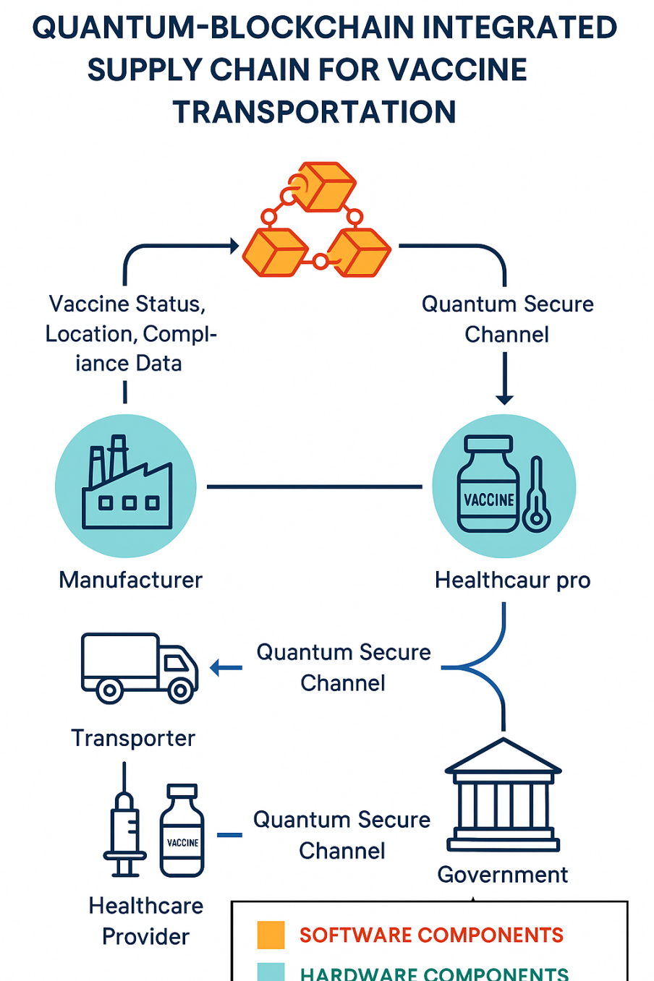

Overall Architecture of the project

**👥 Team Roles**

🖋️ Blockchain Devs | 🔐 Quantum Experts | 📡 IoT Engineers | 📊 Data Scientists | ⚙️ DevOps | 📜 Compliance

**📜 License**

MIT License – see LICENSE