**Abstract**

This project report presents the design and development of a **Breakout Game** using Java, specifically leveraging the Abstract Window Toolkit (AWT) and Swing libraries for graphical user interface components. The game is a modern recreation of the classic arcade game "Breakout," in which the player controls a paddle to bounce a ball upward with the objective of breaking all the bricks arranged at the top of the screen. The project serves as a practical application of core programming concepts, object-oriented design, and user interaction in a 2D game environment.

The implementation consists of two primary Java classes: BreakoutGame.java, which handles game logic, user input, and rendering, and BrickGenerator.java, which manages the generation and drawing of bricks. Key features include real-time rendering, score tracking, collision detection, game win and loss conditions, and a restart mechanism. The game was designed to be responsive and intuitive, ensuring smooth paddle and ball movement and accurate physics simulation within the constraints of basic 2D graphics.

This project demonstrates how simple tools within the Java ecosystem can be used to develop engaging graphical applications. It reflects a strong understanding of Java programming, event-driven programming, and the principles of object-oriented software design. Furthermore, it provides a foundation for further expansion into more complex game development, including animations, sound integration, and multiple levels. The development process, including the challenges faced and solutions adopted, is thoroughly documented, making this report a comprehensive reference for beginner game developers and students interested in applying their programming knowledge to interactive applications.

**Introduction**

In recent years, digital games have evolved from simple recreational pastimes into powerful tools for education, simulation, and entertainment. The development of such games not only demands creativity and design thinking but also fosters deep understanding of programming languages, user interfaces, event handling, and object-oriented principles. This project—**Breakout Game using Java, AWT, and Swing**—was undertaken as a minor project for academic purposes, with the objective of implementing a 2D arcade-style game from scratch.

**Breakout**, originally developed by Atari in the 1970s, is a single-player game where the player controls a paddle to bounce a ball against a wall of bricks. Each time the ball hits a brick, the brick is destroyed and the player earns points. The game is won when all bricks are cleared and lost if the ball falls below the paddle. This timeless concept offers an excellent foundation for learning essential programming skills while working on a real-world, interactive application.

The primary aim of this project is to simulate the classic Breakout game using **Java**, utilizing its built-in libraries such as **AWT (Abstract Window Toolkit)** and **Swing** for GUI development. Java was selected due to its platform independence, extensive library support, and robustness in handling object-oriented design. The use of AWT and Swing allows for the creation of windows, handling user input via keyboard events, and drawing 2D shapes and animations with minimal external dependencies.

This project also explores game development concepts such as:

* **Event-driven programming**: responding to user inputs and timer events.
* **Rendering and animation**: drawing and refreshing graphical elements on screen.
* **Collision detection**: identifying interactions between the ball, paddle, and bricks.
* **Game loop mechanics**: managing continuous updates and repainting at fixed intervals.

By undertaking this project, the developer gained hands-on experience in developing user-friendly graphical applications, understanding real-time interaction, and building a complete software product from design to execution. The simplicity of the game mechanics provides clarity, while the underlying implementation offers substantial educational value for understanding core Java concepts and GUI programming.

This report documents every phase of the project—from conceptualization and design to implementation and testing—offering a comprehensive resource for students and enthusiasts aiming to develop similar applications or enhance their programming skills through practical, project-based learning.

**Technology Stack**

This project was developed using a carefully chosen set of technologies that provided a balance between functionality, ease of use, and learning value. The primary objective was to build the Breakout game using only core Java technologies, without relying on third-party libraries or game engines, to gain a deeper understanding of game mechanics, rendering, and event handling.

**1. Java Programming Language**

* **Version Used**: Java SE 8 and above
* Java is a widely-used, platform-independent, object-oriented programming language. It provides built-in support for creating graphical user interfaces and handling real-time events, which are essential for game development.
* Key features used in this project:
  + Object-Oriented Programming (OOP)
  + Exception Handling
  + Java Collections
  + Class and Interface Design

**2. AWT (Abstract Window Toolkit)**

* AWT is a part of Java's standard library used for creating basic graphical user interfaces.
* It includes the fundamental classes for:
  + Drawing graphics (like rectangles, ovals)
  + Handling events (such as keyboard input)
  + Managing windows and components

**3. Swing**

* Swing is a more advanced GUI toolkit in Java that builds upon AWT and provides a richer set of components.
* In this project, Swing was used for:
  + Creating the main game window (JFrame)
  + Custom painting via JPanel
  + Handling graphics with the paint() method
  + Showing dialog boxes (JOptionPane) for player input

**4. Integrated Development Environment (IDE)**

* **IDE Used**: Eclipse / IntelliJ IDEA (any IDE that supports Java)
* The IDE provided tools for writing, compiling, debugging, and testing Java code effectively. Features such as syntax highlighting, auto-completion, and error checking were especially useful during development.

**5. System Requirements**

* **Operating System**: Windows/Linux/macOS (Java is cross-platform)
* **Java Development Kit (JDK)**: Version 8 or later
* **Memory**: Minimum 2 GB RAM
* **Display**: 1280x720 or higher for proper window rendering

This minimal yet powerful technology stack allowed for the successful creation of a fully functional 2D game while maintaining the educational value of working directly with core Java APIs. It also ensures portability across different systems without the need for external tools or plugins.

**Game Description and Features**

**1. Game Overview**

The **Breakout Game** is a classic 2D arcade-style game where the player controls a horizontal paddle at the bottom of the screen and uses it to bounce a ball toward a wall of bricks. The objective is to destroy all the bricks by striking them with the ball, while preventing the ball from falling below the paddle. The game challenges the player's reflexes and precision, combining real-time interaction with simple yet engaging mechanics.

The game begins with a fixed layout of bricks, a ball, and a paddle. The player uses the **left** and **right arrow keys** to move the paddle horizontally. When the ball hits a brick, the brick disappears, and the player scores points. If the ball misses the paddle and falls below the screen, the game ends with a **Game Over** message. If all bricks are cleared, the player wins.

**2. Core Features**

The game includes several core features that enhance its functionality and user experience:

**a. Paddle Control**

* The paddle is controlled via the keyboard’s **left (←)** and **right (→)** arrow keys.
* The movement is bounded within the game screen to prevent it from going off-screen.

**b. Ball Movement and Physics**

* The ball continuously moves diagonally across the screen.
* It bounces off the walls, the paddle, and the bricks.
* The direction of the ball changes depending on the surface it hits, simulating simple collision physics.

**c. Brick Layout**

* Bricks are arranged in a grid layout (3 rows and 7 columns by default).
* Each brick has a visible border and disappears when hit.
* The layout is generated using a custom class (BrickGenerator.java).

**d. Scoring System**

* Each brick destroyed increases the player's score by **5 points**.
* The current score is displayed on the screen in real-time.
* A **High Score** system is maintained within the session.

**e. Game Over and Win Conditions**

* If the ball drops below the paddle, the game ends with a **Game Over** message.
* If all bricks are destroyed, the game shows a **You Won!** message.
* In both cases, the user can press **Enter** to restart the game.

**f. Restart Mechanism**

* The player can restart the game by pressing the **Enter** key after a game ends.
* This resets the ball position, paddle, score, and brick layout.

**g. Player Name Input**

* At the start of the game, the user is prompted to enter their name via a dialog box.
* The player’s name is displayed on the screen during gameplay.

**h. Visual Design**

* The game screen has a fixed size of **700x600 pixels**.
* The background is black, with contrasting colors for the paddle, ball, and bricks to improve visibility.
* Graphics are rendered using Java’s Graphics and Graphics2D APIs.

**3. Game Dynamics Summary**

| **Feature** | **Description** |
| --- | --- |
| Paddle Movement | Controlled with keyboard arrow keys |
| Ball Behavior | Bounces off surfaces, destroys bricks |
| Bricks | 21 total, disappear on collision |
| Score | +5 points per brick, session-based high score |
| Game Over | Ball falls below paddle |
| Win Condition | All bricks cleared |
| Restart Option | Press Enter to restart game |
| Player Info | Name input, displayed with score |

This feature set captures the essence of the original Breakout game while offering an interactive and educational experience. The simplicity of gameplay ensures that players of all ages can enjoy it, while the modular and object-oriented code structure allows for future enhancements and feature additions.

**System Design**

The system design phase is crucial in translating the game concept into a well-structured and maintainable codebase. This section details the architecture, class structure, flow of control, and design diagrams used in the development of the Breakout game.

**1. Architectural Overview**

The game is built using a modular object-oriented design, where different components are responsible for distinct functionalities. The key components include:

* **Main Game Logic** (BreakoutGame.java): Handles the game loop, user inputs, rendering, and game state.
* **Brick Management** (BrickGenerator.java): Responsible for creating, drawing, and updating the brick layout.

The game utilizes **Java Swing** for the GUI and **AWT** for rendering graphics and handling key events.

**2. Class Diagram**

|  |
| --- |
|  |

**3. Flowchart: Game Loop**

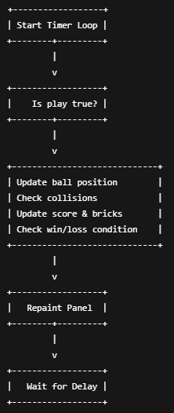

**4. Input Handling Design**

User inputs are captured using Java's KeyListener interface. The relevant key events include:

* **→ Arrow**: Move paddle right.
* **← Arrow**: Move paddle left.
* **Enter**: Restart the game if over.

This interaction model allows real-time control of the paddle and a smooth gameplay experience.

**5. Collision Detection Logic**

Collision detection is implemented using Java’s Rectangle class to determine intersections between:

* **Ball and Paddle**
* **Ball and Bricks**
* **Ball and Walls**

This ensures realistic bouncing behavior and accurate removal of bricks upon contact.

**6. Rendering and Graphics**

All drawing is handled within the paint(Graphics g) method in BreakoutGame.java. It includes:

* Drawing the background, paddle, ball, and bricks.
* Displaying the score, player name, and high score.
* Rendering win/loss messages.

Rendering is refreshed using repaint() inside the timer loop, simulating animation at a frame rate determined by the delay value.

**7. Modularity and Scalability**

The separation of concerns between the game logic and the brick rendering system (via BrickGenerator) supports code reusability and ease of future enhancements such as:

* Adding multiple levels
* Introducing different brick types
* Enhancing collision mechanics

**Code Explanation**

**1. BreakoutGame.java – Main Game Logic**

The BreakoutGame class is the core of the project. It handles the graphical rendering, user interaction, game loop, and gameplay logic. It extends JPanel and implements the KeyListener and ActionListener interfaces, which allows it to listen for keyboard inputs and handle timer events, respectively.

**1.1 Class Declaration and Initialization**

public class BreakoutGame extends JPanel implements KeyListener, ActionListener {

* JPanel: Allows custom painting of graphics and placement inside a JFrame.
* KeyListener: Captures keyboard inputs.
* ActionListener: Handles timer-driven actions.

**1.2 Variables and Game State**

private boolean play = false;

private int score = 0;

private int totalBricks = 21;

private Timer timer;

private int delay = 8;

private int playerX = 310;

private int ballPosX = 120;

private int ballPosY = 350;

private int ballDirX = -1;

private int ballDirY = -2;

private BrickGenerator map;

private static String playerName = "Player";

private static int highScore = 0;

* play: Tracks if the game is active.
* score: Stores the current player’s score.
* totalBricks: Number of remaining bricks.
* timer: Controls the game loop using a fixed interval (delay).
* playerX: X-coordinate of the paddle.
* ballPosX/Y: Coordinates of the ball.
* ballDirX/Y: Direction of ball movement.
* map: An instance of the BrickGenerator class to manage bricks.
* playerName and highScore: Store user name and best score.

**1.3 Constructor**

public BreakoutGame(String name) {

this.playerName = name;

map = new BrickGenerator(3, 7);

addKeyListener(this);

setFocusable(true);

setFocusTraversalKeysEnabled(false);

timer = new Timer(delay, this);

timer.start();

}

* Initializes the game environment.
* Creates a new grid of bricks (3 rows × 7 columns).
* Sets focus and key listener to capture input.
* Starts the game loop using a Swing Timer.

**1.4 Rendering (paint() Method)**

public void paint(Graphics g) {

// Background

g.setColor(Color.black);

g.fillRect(1, 1, 692, 592);

// Bricks

map.draw((Graphics2D) g);

...

}

The paint() method is responsible for:

* Clearing and redrawing the screen.
* Drawing all visual components: background, paddle, ball, bricks.
* Showing score, player name, and win/loss messages.
* Detecting and displaying game end states.

**Highlights:**

* Paddle is drawn in green.
* Ball is yellow and circular.
* Win and Game Over conditions are displayed using red-colored text.
* g.dispose() releases the graphics context after rendering.

**1.5 High Score Logic**

public void updateHighScore() {

if (score > highScore) {

highScore = score;

}

}

Ensures that the highest score is saved during the current session.

**1.6 Game Loop – actionPerformed() Method**

This method is automatically called repeatedly by the Timer object to update the game state and render changes.

@Override

public void actionPerformed(ActionEvent e) {

timer.start();

if (play) {

// Collision with paddle

if (new Rectangle(ballPosX, ballPosY, 20, 20)

.intersects(new Rectangle(playerX, 550, 100, 8))) {

ballDirY = -ballDirY;

}

...

ballPosX += ballDirX;

ballPosY += ballDirY;

// Wall collisions

if (ballPosX < 0) ballDirX = -ballDirX;

if (ballPosY < 0) ballDirY = -ballDirY;

if (ballPosX > 670) ballDirX = -ballDirX;

}

repaint();

}

**Key Components:**

* **Collision with Paddle**: If the ball rectangle intersects with the paddle rectangle, the ball bounces up.
* **Brick Collision**: (explained below)
* **Wall Collision**:
  + Left and right wall → reverse X-direction.
  + Top wall → reverse Y-direction.
* **repaint()**: Refreshes the screen with new positions and changes.

**1.7 Brick Collision Logic**

This block checks for intersections between the ball and bricks:

A:

for (int i = 0; i < map.map.length; i++) {

for (int j = 0; j < map.map[0].length; j++) {

if (map.map[i][j] > 0) {

int brickX = j * map.brickWidth + 80;

int brickY = i * map.brickHeight + 50;

int brickWidth = map.brickWidth;

int brickHeight = map.brickHeight;

Rectangle rect = new Rectangle(brickX, brickY, brickWidth, brickHeight);

Rectangle ballRect = new Rectangle(ballPosX, ballPosY, 20, 20);

if (ballRect.intersects(rect)) {

map.setBrickValue(0, i, j);

totalBricks--;

score += 5;

// Determine collision side

if (ballPosX + 19 <= rect.x || ballPosX + 1 >= rect.x + rect.width) {

ballDirX = -ballDirX;

} else {

ballDirY = -ballDirY;

}

break A;

}

}

}

}

**Key Elements:**

* The A: label and break A; allow breaking out of nested loops once a collision is detected.
* The collision side determines whether the ball bounces horizontally or vertically.
* totalBricks is decremented; if it reaches 0, the player wins.
* score is increased by 5 points per brick.

**1.8 Paddle Controls – keyPressed() Method**

This method responds to key inputs.

@Override

public void keyPressed(KeyEvent e) {

if (e.getKeyCode() == KeyEvent.VK_RIGHT) {

if (playerX < 600) playerX += 20;

play = true;

}

if (e.getKeyCode() == KeyEvent.VK_LEFT) {

if (playerX > 10) playerX -= 20;

play = true;

}

if (e.getKeyCode() == KeyEvent.VK_ENTER) {

if (!play) {

play = true;

ballPosX = 120;

ballPosY = 350;

ballDirX = -1;

ballDirY = -2;

playerX = 310;

score = 0;

totalBricks = 21;

map = new BrickGenerator(3, 7);

repaint();

}

}

}

**Highlights:**

* **Arrow Keys**: Move the paddle left/right within screen boundaries.
* **Enter Key**: Resets the game state and restarts play.

**1.9 Main Method – Program Entry Point**

public static void main(String[] args) {

String name = JOptionPane.showInputDialog(null, "Enter your name:", "Player Name", JOptionPane.PLAIN_MESSAGE);

if (name == null || name.trim().isEmpty()) {

name = "Player";

}

JFrame obj = new JFrame();

BreakoutGame gamePlay = new BreakoutGame(name);

obj.setBounds(10, 10, 700, 600);

obj.setTitle("Breakout Ball Game");

obj.setResizable(false);

obj.setDefaultCloseOperation(JFrame.EXIT_ON_CLOSE);

obj.add(gamePlay);

obj.setVisible(true);

}

**Key Aspects:**

* **Name Input**: The player is prompted to enter their name via a dialog box.
* **JFrame Setup**: Creates the game window with fixed size and title.
* Adds the custom BreakoutGame panel to the frame and makes it visible.

**1.10 Summary**

The BreakoutGame class effectively combines user interaction, rendering, and game mechanics in a structured and responsive way. It is modular enough to allow enhancements such as multiple levels, sound effects, and power-ups.

**2. BrickGenerator.java – Brick Management Class**

The BrickGenerator class is responsible for generating the grid of bricks, storing their status (active/inactive), and rendering them onto the screen. It encapsulates all brick-related logic, making the code modular and easier to manage.

**2.1 Class Declaration and Data Members**

public class BrickGenerator {

public int[][] map;

public int brickWidth;

public int brickHeight;

* map: A 2D array where each element represents a brick. A value of 1 means the brick is active (visible), and 0 means it has been destroyed.
* brickWidth: Width of each brick, calculated based on the number of columns.
* brickHeight: Height of each brick, calculated based on the number of rows.

**2.2 Constructor**

public BrickGenerator(int row, int col) {

map = new int[row][col];

for (int[] rowArr : map) {

java.util.Arrays.fill(rowArr, 1);

}

brickWidth = 540 / col;

brickHeight = 150 / row;

}

* Initializes the map with all bricks set to 1, meaning all bricks are present initially.
* Calculates the width and height of each brick so that all bricks fit neatly within the game panel.
* Example: new BrickGenerator(3, 7) creates a 3×7 grid (21 bricks).

**2.3 Drawing Method**

public void draw(Graphics2D g) {

for (int i = 0; i < map.length; i++) {

for (int j = 0; j < map[0].length; j++) {

if (map[i][j] > 0) {

g.setColor(Color.white);

g.fillRect(j * brickWidth + 80, i * brickHeight + 50,

brickWidth, brickHeight);

g.setStroke(new BasicStroke(3));

g.setColor(Color.black);

g.drawRect(j * brickWidth + 80, i * brickHeight + 50,

brickWidth, brickHeight);

}

}

}

}

**Breakdown:**

* Loops through the map to draw each active brick.
* Bricks are placed with an **x-offset of 80** and **y-offset of 50** to center them in the game window.
* Each brick is:
  + **Filled white**
  + **Outlined with a black border** for visibility

Graphics2D is used for better rendering control (e.g., setStroke for border thickness).

**2.4 Utility Method – setBrickValue()**

public void setBrickValue(int value, int row, int col) {

map[row][col] = value;

}

* Used to set the value of a specific brick.
* Called when the ball hits a brick (from BreakoutGame) to mark it as destroyed (0).

**2.5 Summary**

The BrickGenerator class:

* Keeps track of which bricks are still active.
* Handles all rendering logic for bricks.
* Provides a simple interface to update bricks when they are hit.
* Can be easily extended to include features like colored bricks, varying strengths, or power-ups.

**Testing and Debugging**

Testing is a vital part of any software development process. For this project, testing was carried out primarily through **manual testing** due to the graphical and interactive nature of the game. This section describes the different types of tests performed, bugs encountered, and how issues were diagnosed and resolved.

**1. Testing Approach**

The testing for the Breakout game focused on three main aspects:

* **Functional Testing**: Verifying that the game behaves as expected under normal gameplay.
* **Boundary Testing**: Ensuring that the paddle and ball remain within defined limits.
* **Game State Testing**: Verifying transitions between play, win, and game over states.

Due to the game's graphical nature, most tests were conducted by playing the game and visually confirming the correctness of behavior.

**2. Test Cases**

| **Test Case ID** | **Test Description** | **Expected Result** | **Status** |
| --- | --- | --- | --- |
| TC1 | Ball bounces off paddle | Ball reverses vertical direction | Pass |
| TC2 | Ball hits brick | Brick disappears, score increases by 5 | Pass |
| TC3 | Ball hits wall (left/right/top) | Ball reverses direction | Pass |
| TC4 | Ball falls below paddle | Game over message displayed | Pass |
| TC5 | All bricks are destroyed | You Won message displayed | Pass |
| TC6 | Pressing left/right arrows | Paddle moves accordingly within limits | Pass |
| TC7 | Paddle moves beyond game screen limits | Paddle remains within screen | Pass |
| TC8 | Press Enter after game over | Game resets and restarts | Pass |
| TC9 | Enter player name at start | Name appears correctly on screen | Pass |
| TC10 | Leave name empty or cancel | Default name “Player” used | Pass |

**3. Debugging Process**

Several issues were encountered and resolved during development. Below are some examples:

**a. Ball Sticking to Paddle**

* **Issue**: After collision with the paddle, the ball would sometimes get stuck and repeatedly bounce without moving upward.
* **Solution**: Adjusted the collision condition to reverse direction only once per frame and ensured consistent direction updates.

**b. Incorrect Brick Collision**

* **Issue**: Sometimes the ball would pass through bricks without detecting collision.
* **Cause**: Collision detection was skipping frames if the ball moved too quickly.
* **Solution**: Added proper collision checks and reduced the delay in the Timer to ensure smoother frame updates.

**c. Paddle Exiting Bounds**

* **Issue**: Paddle could be moved off-screen by pressing keys quickly.
* **Solution**: Enforced strict boundary conditions (playerX < 600 and playerX > 10) in keyPressed().

**d. Ball Not Bouncing Correctly**

* **Issue**: Ball bounced in an unexpected direction after hitting certain bricks.
* **Solution**: Analyzed collision sides using ball and brick boundaries to ensure proper X/Y direction inversion.

**4. Visual Debugging Aids**

To aid debugging, certain visual markers and print statements were temporarily added:

* Printed coordinates of the ball and paddle in the console.
* Highlighted active bricks with a different color during development (later removed).

**5. Performance Testing**

The game was tested on various systems to ensure consistent performance:

* **Frame rate**: Stable due to Timer delay of 8 ms (~125 FPS theoretical max).
* **Responsiveness**: No noticeable lag during key presses or rendering.
* **Compatibility**: Ran without issues on Windows and Linux systems with Java 8+.

**6. Lessons Learned from Testing**

* Real-time games require precise timing and consistent frame updates.
* Collision logic must account for all possible edge cases (e.g., corner hits).
* Manual testing is essential for interactive games but can be supported by logging and visual debugging tools.

This systematic approach to testing and debugging ensured that the game was reliable, bug-free during play, and provided a smooth user experience.

**Challenges Faced**

Throughout the development of the Breakout game, several challenges arose at different stages of the project. These challenges spanned technical difficulties, design decisions, logic implementation, and debugging. Addressing and overcoming these problems not only enhanced the quality of the game but also provided valuable learning experiences.

**1. Designing the Game Architecture**

**Challenge:**  
At the beginning, it was difficult to decide how to break the game into manageable components. Since the game involves real-time updates, rendering, and user interaction, keeping the code organized and modular was essential.

**Solution:**  
The project was divided into two major classes:

* BreakoutGame.java to handle the game loop, user input, and overall gameplay logic.
* BrickGenerator.java to manage the layout and state of the bricks separately.

This modular approach improved maintainability and scalability.

**2. Managing Real-Time Rendering**

**Challenge:**  
One of the core difficulties in game development is updating the screen at regular intervals while maintaining responsiveness. Inconsistent or delayed updates led to choppy gameplay.

**Solution:**  
A javax.swing.Timer was used to create a simple game loop with a delay of 8 milliseconds. This provided a consistent and smooth rendering of graphics and movement of the ball and paddle.

**3. Collision Detection**

**Challenge:**  
Getting the ball to accurately detect and respond to collisions with the paddle, walls, and bricks was complex. Especially tricky were edge cases where the ball would hit between two bricks or on corners.

**Solution:**  
Java's Rectangle class was used for defining collision areas. Careful conditional checks were implemented to determine whether the ball should reverse in the X or Y direction. Additionally, nested loops with labeled breaks ensured only one collision was processed per frame.

**4. Ball Direction Errors**

**Challenge:**  
In the early versions of the game, the ball would occasionally bounce in unexpected directions or get trapped between two bricks.

**Solution:**  
Precise logic was added to detect which side of the brick the ball had collided with. If it hit the left or right side, only the X-direction was reversed. If it hit the top or bottom, the Y-direction was reversed.

**5. User Input Handling**

**Challenge:**  
Ensuring smooth and immediate response to key presses (especially paddle movement) required careful configuration.

**Solution:**  
The game panel (JPanel) was set to focusable, and KeyListener was implemented correctly. Key events were handled to ensure the paddle stayed within bounds and the game started when movement occurred.

**6. Restart Mechanism**

**Challenge:**  
Restarting the game without restarting the application was essential for user experience but initially difficult to implement.

**Solution:**  
When the user presses Enter after the game ends, the game state is reset:

* Ball and paddle positions are restored.
* Bricks are regenerated.
* Score and flags are reset.

This eliminated the need to close and reopen the game for another round.

**7. User Input via Dialog Box**

**Challenge:**  
Getting the player's name and displaying it was a simple but unfamiliar concept at first.

**Solution:**  
JOptionPane was used to prompt for a player name at the start of the game. Basic validation was included to handle empty inputs or cancel actions.

**8. Performance Optimization**

**Challenge:**  
Frequent screen refreshes and collision checks could lead to performance bottlenecks, especially on older systems.

**Solution:**  
The game used efficient logic and rendering. The drawing area was kept minimal, and only necessary components were redrawn using repaint(). Redundant computations were avoided during collision detection.

**9. Learning Curve**

**Challenge:**  
Understanding how to work with Java Swing and AWT was a new experience, especially drawing custom graphics and managing a game loop.

**Solution:**  
Extensive practice and reading of Java documentation and online tutorials helped build familiarity. Experimentation with smaller test projects also helped clarify core concepts.

These challenges contributed significantly to the learning process. Each problem required analysis, research, and iterative testing, ultimately resulting in a more polished and functional game.

**Enhancements and Future Scope**

The current version of the Breakout game fulfills the core functionality of a playable and interactive arcade-style game. However, there are many potential enhancements that can improve gameplay, aesthetics, and user engagement. This section outlines several ideas for future improvements, categorized into functional, visual, and technical upgrades.

**1. Functional Enhancements**

**a. Multiple Levels**

* **Current Limitation**: The game has only one level with a fixed brick layout.
* **Enhancement**: Introduce level progression, where each level has a new brick arrangement and increased difficulty (e.g., faster ball, more rows).
* **Benefit**: Keeps the player engaged and adds a sense of achievement and progression.

**b. Power-Ups and Bonuses**

* **Examples**:
  + **Expand Paddle**: Temporarily increases paddle width.
  + **Multi-ball**: Splits the ball into two for faster brick destruction.
  + **Slow Motion**: Slows down ball speed for easier control.
* **Implementation**: Randomly drop a power-up from a brick and activate it upon paddle collision.

**c. Brick Types**

* **Current Limitation**: All bricks are identical and break with one hit.
* **Enhancement**: Add bricks with different properties:
  + **Strong bricks**: Require multiple hits.
  + **Unbreakable bricks**: Serve as obstacles.
  + **Exploding bricks**: Destroy nearby bricks on impact.

**d. Score Persistence**

* **Current Limitation**: High score is session-based only.
* **Enhancement**: Save high scores to a file or database to maintain scores across sessions.

**e. Sound Effects and Music**

* **Enhancement**: Add background music and sound effects for events such as:
  + Ball hitting paddle or brick
  + Brick destruction
  + Game over / victory
* **Tools**: Java Sound API or external libraries like JavaZoom.

**2. Visual Enhancements**

**a. Improved UI and Graphics**

* **Enhancement**: Replace basic shapes with better graphics (e.g., images for bricks and paddle).
* **Implementation**: Use BufferedImage or external sprite sheets.

**b. Animations**

* **Enhancement**: Smooth animations for brick destruction, paddle movement, and background effects.

**c. Themes and Skins**

* **Enhancement**: Allow players to choose different visual themes (e.g., classic, space, neon).

**3. User Experience Improvements**

**a. Pause and Resume**

* Add functionality to pause the game using a key (e.g., P) and resume it later.

**b. Lives System**

* Introduce a lives system where the player gets multiple chances before game over.

**c. Game Settings Menu**

* Allow users to configure:
  + Ball speed
  + Paddle size
  + Difficulty level

**d. Fullscreen Support**

* Enable fullscreen gameplay for better immersion.

**4. Platform Compatibility**

**a. Web Version**

* Convert the game into a web app using **Java Applets** (legacy) or modern alternatives like **JavaScript** for broader accessibility.

**b. Mobile Version**

* Port the game to **Android** using Java/Kotlin with touch controls for paddle movement.

**5. Multiplayer Mode (Advanced)**

* **Enhancement**: Add support for two-player competitive or cooperative gameplay.
* **Example**: Split screen or alternating turns.
* **Challenge**: Requires network handling and synchronization.

**Summary**

| **Enhancement Area** | **Example Features** |
| --- | --- |
| Gameplay | Levels, power-ups, brick types |
| Visuals | Improved graphics, themes, animations |
| User Experience | Pause/resume, lives, settings menu |
| Compatibility | Mobile and web version |
| Advanced Features | Multiplayer mode, persistent scoring |

Implementing these enhancements would not only make the game more engaging and replayable but also provide an opportunity to explore more advanced programming concepts such as file handling, concurrency, UI/UX design, and mobile development.

**Conclusion**

The development of the Breakout game as a minor project offered a comprehensive and enriching experience in software development, game design, and Java programming. From conceptualizing a simple arcade-style game to implementing it using core Java libraries like AWT and Swing, this project served as a practical application of many theoretical concepts learned in the classroom.

Through this project, several essential programming skills were put into practice, including:

* **Object-Oriented Programming (OOP)** for organizing code into logical classes and structures.
* **Graphical User Interface (GUI) Design** using Java Swing and AWT to render visual components and manage user interactions.
* **Event Handling** for responding to user input and updating game state in real time.
* **Collision Detection and Game Physics**, which formed the backbone of the gameplay mechanics.

In addition to technical skills, the project nurtured critical problem-solving abilities. Debugging issues like ball movement anomalies, paddle boundary conditions, and brick collision bugs provided valuable insights into how games operate behind the scenes. Designing the user experience, managing game state transitions, and adding features like scoring and restart functionality further improved both logic-building and design thinking.

Moreover, working on a hands-on, visual, and interactive application like this game made learning highly engaging. It emphasized the importance of user-centric design, responsive controls, and clean code structure — all of which are vital skills for software developers.

While the current version of the game is functional and fully playable, there remains significant potential for future enhancements. Adding features such as multiple levels, sound effects, and mobile compatibility would turn it into a more polished and professional product.

In conclusion, this project was not only a successful recreation of a classic arcade game but also an excellent platform for developing real-world programming expertise. It has laid a strong foundation for future projects involving advanced GUI development, game programming, and user interface design.

**References**

The successful development of this project was made possible through extensive learning, research, and practice. The following resources were instrumental in understanding Java programming, graphical rendering, game logic, and debugging techniques:

**Books and Documentation**

1. *The Java™ Programming Language* by Ken Arnold, James Gosling – Addison-Wesley
2. *Head First Java* by Kathy Sierra and Bert Bates – O'Reilly Media
3. [Official Java SE Documentation](https://docs.oracle.com/javase/8/docs/) – Oracle Corporation

**Online Tutorials and Guides**

1. [GeeksforGeeks – Java AWT and Swing](https://www.geeksforgeeks.org/java-awt-tutorial/)
2. [TutorialsPoint – Java Swing](https://www.tutorialspoint.com/swing/index.htm)
3. [w3schools – Java Basics](https://www.w3schools.com/java/)
4. [YouTube: Java Game Development Tutorials (Various Creators)] – Used for visualizing concepts such as repainting, key events, and animation loops.

**Technical Forums and Communities**

1. [Stack Overflow](https://stackoverflow.com/) – Community questions and answers related to key Java issues and bugs.
2. [Reddit – r/learnprogramming](https://www.reddit.com/r/learnprogramming/) – For general programming guidance and tips.
3. [Java Code Examples – GitHub and Gist Snippets] – Reviewed to understand implementation patterns for key listeners and game loops.

**Tools and IDEs**

1. [Eclipse IDE](https://www.eclipse.org/) / [IntelliJ IDEA](https://www.jetbrains.com/idea/) – Used for code development and debugging.
2. [Oracle JDK](https://www.oracle.com/java/technologies/javase-downloads.html) – Java Development Kit for compiling and running the game.

These references provided a solid theoretical foundation and practical insights that helped in building the Breakout game efficiently and effectively.

**Appendices**

**Appendix A: Source Code**

This appendix includes the full, well-formatted source code of the two main Java classes used in the Breakout game project: BreakoutGame.java and BrickGenerator.java.

**A.1 BreakoutGame.java**

package BreakoutBall;

import javax.swing.*;

import java.awt.*;

import java.awt.event.*;

public class BreakoutGame extends JPanel implements KeyListener, ActionListener {

private boolean play = false;

private int score = 0;

private int totalBricks = 21;

private Timer timer;

private int delay = 8;

private int playerX = 310;

private int ballPosX = 120;

private int ballPosY = 350;

private int ballDirX = -1;

private int ballDirY = -2;

private BrickGenerator map;

private static String playerName = "Player";

private static int highScore = 0;

public BreakoutGame(String name) {

this.playerName = name;

map = new BrickGenerator(3, 7);

addKeyListener(this);

setFocusable(true);

setFocusTraversalKeysEnabled(false);

timer = new Timer(delay, this);

timer.start();

}

public void paint(Graphics g) {

g.setColor(Color.black);

g.fillRect(1, 1, 692, 592);

map.draw((Graphics2D) g);

g.setColor(Color.yellow);

g.fillRect(0, 0, 3, 592);

g.fillRect(0, 0, 692, 3);

g.fillRect(691, 0, 3, 592);

g.setColor(Color.white);

g.setFont(new Font("serif", Font.BOLD, 20));

g.drawString("Score: " + score, 540, 30);

g.drawString("Player: " + playerName, 20, 30);

g.drawString("High Score: " + highScore, 270, 30);

g.setColor(Color.green);

g.fillRect(playerX, 550, 100, 8);

g.setColor(Color.yellow);

g.fillOval(ballPosX, ballPosY, 20, 20);

if (totalBricks <= 0) {

play = false;

ballDirX = 0;

ballDirY = 0;

g.setColor(Color.red);

g.setFont(new Font("serif", Font.BOLD, 30));

g.drawString("You Won!", 260, 300);

g.drawString("Press Enter to Restart", 230, 350);

updateHighScore();

}

if (ballPosY > 570) {

play = false;

ballDirX = 0;

ballDirY = 0;

g.setColor(Color.red);

g.setFont(new Font("serif", Font.BOLD, 30));

g.drawString("Game Over", 260, 300);

g.drawString("Press Enter to Restart", 230, 350);

updateHighScore();

}

g.dispose();

}

public void updateHighScore() {

if (score > highScore) {

highScore = score;

}

}

@Override

public void actionPerformed(ActionEvent e) {

timer.start();

if (play) {

if (new Rectangle(ballPosX, ballPosY, 20, 20)

.intersects(new Rectangle(playerX, 550, 100, 8))) {

ballDirY = -ballDirY;

}

A:

for (int i = 0; i < map.map.length; i++) {

for (int j = 0; j < map.map[0].length; j++) {

if (map.map[i][j] > 0) {

int brickX = j * map.brickWidth + 80;

int brickY = i * map.brickHeight + 50;

int brickWidth = map.brickWidth;

int brickHeight = map.brickHeight;

Rectangle rect = new Rectangle(brickX, brickY, brickWidth, brickHeight);

Rectangle ballRect = new Rectangle(ballPosX, ballPosY, 20, 20);

if (ballRect.intersects(rect)) {

map.setBrickValue(0, i, j);

totalBricks--;

score += 5;

if (ballPosX + 19 <= rect.x || ballPosX + 1 >= rect.x + rect.width) {

ballDirX = -ballDirX;

} else {

ballDirY = -ballDirY;

}

break A;

}

}

}

}

ballPosX += ballDirX;

ballPosY += ballDirY;

if (ballPosX < 0) ballDirX = -ballDirX;

if (ballPosY < 0) ballDirY = -ballDirY;

if (ballPosX > 670) ballDirX = -ballDirX;

}

repaint();

}

@Override

public void keyPressed(KeyEvent e) {

if (e.getKeyCode() == KeyEvent.VK_RIGHT) {

if (playerX < 600) playerX += 20;

play = true;

}

if (e.getKeyCode() == KeyEvent.VK_LEFT) {

if (playerX > 10) playerX -= 20;

play = true;

}

if (e.getKeyCode() == KeyEvent.VK_ENTER) {

if (!play) {

play = true;

ballPosX = 120;

ballPosY = 350;

ballDirX = -1;

ballDirY = -2;

playerX = 310;

score = 0;

totalBricks = 21;

map = new BrickGenerator(3, 7);

repaint();

}

}

}

@Override public void keyReleased(KeyEvent e) {}

@Override public void keyTyped(KeyEvent e) {}

public static void main(String[] args) {

String name = JOptionPane.showInputDialog(null, "Enter your name:", "Player Name", JOptionPane.PLAIN_MESSAGE);

if (name == null || name.trim().isEmpty()) {

name = "Player";

}

JFrame obj = new JFrame();

BreakoutGame gamePlay = new BreakoutGame(name);

obj.setBounds(10, 10, 700, 600);

obj.setTitle("Breakout Ball Game");

obj.setResizable(false);

obj.setDefaultCloseOperation(JFrame.EXIT_ON_CLOSE);

obj.add(gamePlay);

obj.setVisible(true);

}

}

**Appendix A.2: BrickGenerator.java**

package BreakoutBall;

import java.awt.*;

public class BrickGenerator {

public int[][] map;

public int brickWidth;

public int brickHeight;

public BrickGenerator(int row, int col) {

map = new int[row][col];

for (int[] rowArr : map) {

java.util.Arrays.fill(rowArr, 1);

}

brickWidth = 540 / col;

brickHeight = 150 / row;

}

public void draw(Graphics2D g) {

for (int i = 0; i < map.length; i++) {

for (int j = 0; j < map[0].length; j++) {

if (map[i][j] > 0) {

g.setColor(Color.white);

g.fillRect(j * brickWidth + 80, i * brickHeight + 50,

brickWidth, brickHeight);

g.setStroke(new BasicStroke(3));

g.setColor(Color.black);

g.drawRect(j * brickWidth + 80, i * brickHeight + 50,

brickWidth, brickHeight);

}

}

}

}

public void setBrickValue(int value, int row, int col) {

map[row][col] = value;

}

}

This class is responsible for:

* Initializing the grid of bricks.
* Drawing active bricks on the screen.
* Allowing the game to deactivate bricks when they are hit.

### Appendix B: Game Screenshots

### Screenshot B.1 – Game Launch Screen

Description: The initial state of the game window with paddle, ball, and bricks visible.  
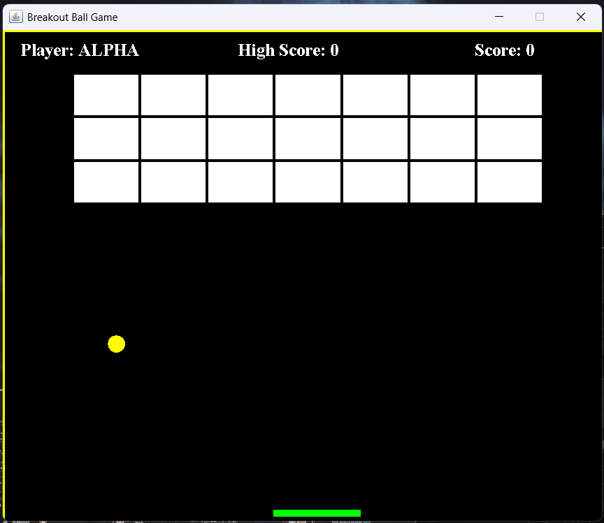

### Screenshot B.2 – Player Name Input

Description: The JOptionPane input dialog where the player enters their name.  
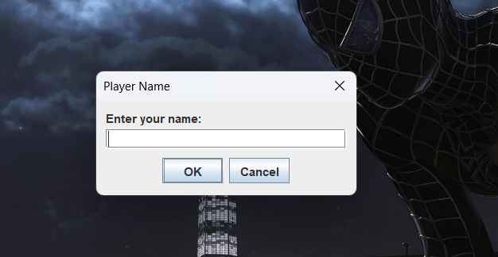

### Screenshot B.3 – Ball Hits Brick

Description: Mid-game moment where the ball collides with bricks and score is visible.  
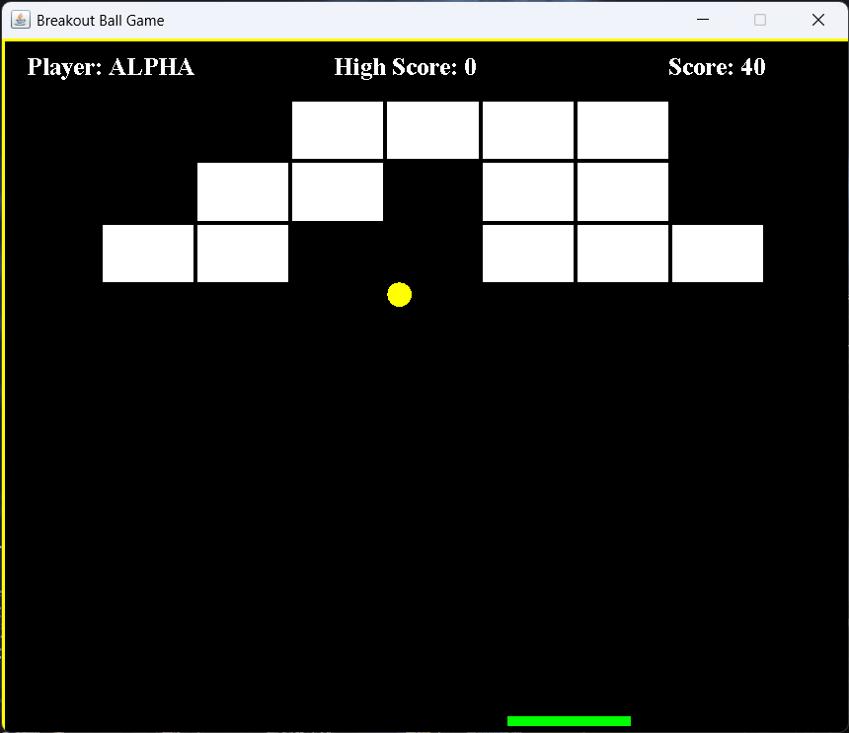

### Screenshot B.4 – Game Over

Description: The screen shown when the ball falls below the paddle.  
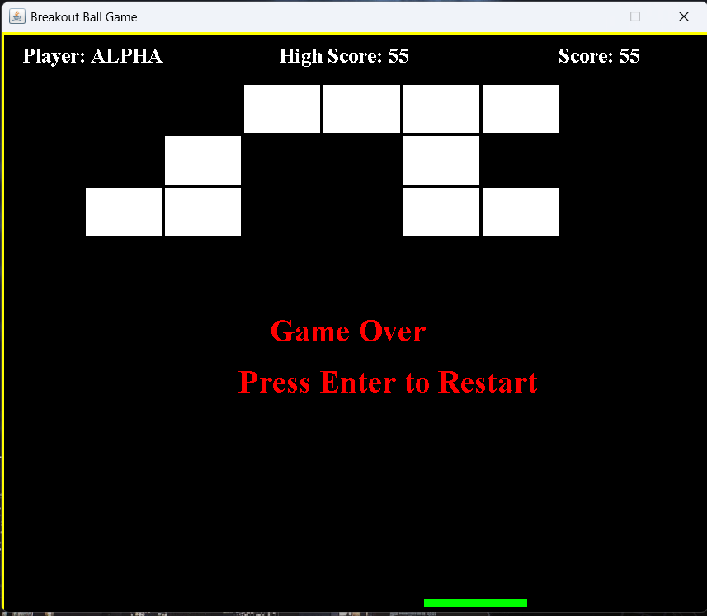

### Screenshot B.5 – You Won!

Description: Screen shown when all bricks are destroyed.  
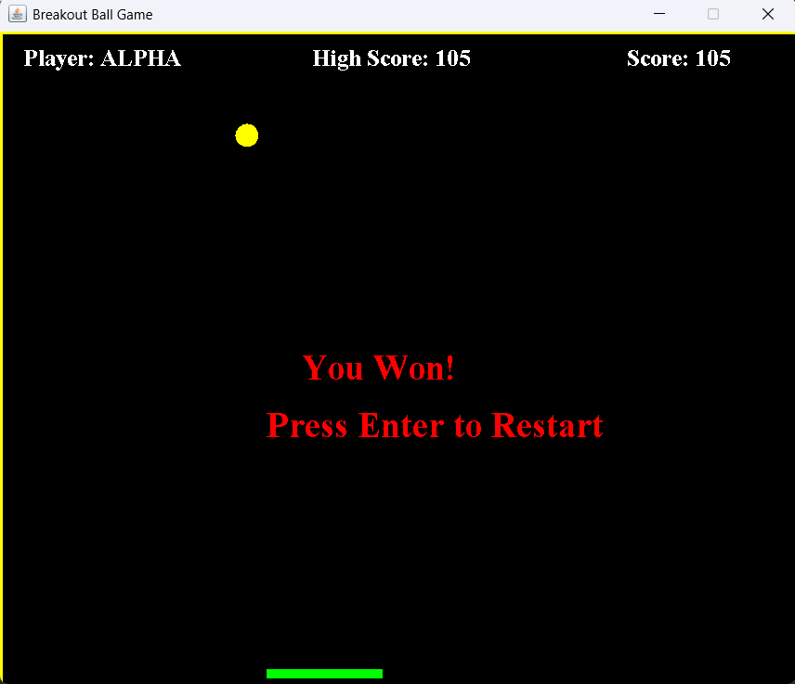

### Screenshot B.6 – Restarting Game

### Description: Game reset screen after pressing Enter to play again.

