ROR CARDS – PICTORIAL QUESTION BANK
Second Mate (Function 3) Oral Preparation
102 cards | 231 questions with answers
Each card has a small low-resolution diagram. Left panel: plan view, blue = own ship (heading up), orange = other vessel. Right black panel: the lights you see at night.
Own ship is power-driven in Parts A and B. In every card the bearing is steady and the range is decreasing.
These are drawn practice cards for the standard Collision Regulations situations, not copies of the official MMD cards.

Part A – Power-driven v Power-driven

Card 1 – Head-on
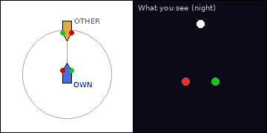
Situation: Night, open sea. A power-driven vessel under 50 m (orange) is right ahead, range 4 nm, bearing steady and range decreasing. You (blue) are power-driven. The black panel shows the lights you see.
Q1. Which lights do you see and what do they tell you about her aspect and direction of movement?
A. You see both her red and green sidelights, with her masthead light(s). She is heading almost directly toward you (end-on).
Q2. Which Rule applies, and what is your action?
A. Rule 14 (head-on). Both vessels give way: alter course to starboard in good time and substantially, and pass port to port. In doubt, assume head-on (Rule 14(c)).
Q3. What sound signal do you make when you alter?
A. One short blast (altering to starboard) – Rule 34(a).

Card 2 – Head-on
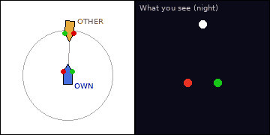
Situation: Night, open sea. A power-driven vessel under 50 m (orange) is right ahead, range 4 nm, bearing steady and range decreasing. You (blue) are power-driven. The black panel shows the lights you see.
Q1. Which lights do you see and what do they tell you about her aspect and direction of movement?
A. You see both her red and green sidelights, with her masthead light(s). She is heading almost directly toward you (end-on).
Q2. Which Rule applies, and what is your action?
A. Rule 14 (head-on). Both vessels give way: alter course to starboard in good time and substantially, and pass port to port. In doubt, assume head-on (Rule 14(c)).
Q3. What sound signal do you make when you alter?
A. One short blast (altering to starboard) – Rule 34(a).

Card 3 – Head-on
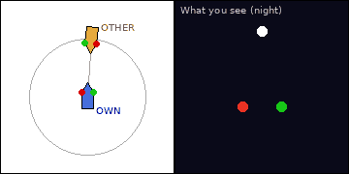
Situation: Night, open sea. A power-driven vessel under 50 m (orange) is right ahead, range 4 nm, bearing steady and range decreasing. You (blue) are power-driven. The black panel shows the lights you see.
Q1. Which lights do you see and what do they tell you about her aspect and direction of movement?
A. You see both her red and green sidelights, with her masthead light(s). She is heading almost directly toward you (end-on).
Q2. Which Rule applies, and what is your action?
A. Rule 14 (head-on). Both vessels give way: alter course to starboard in good time and substantially, and pass port to port. In doubt, assume head-on (Rule 14(c)).
Q3. What sound signal do you make when you alter?
A. One short blast (altering to starboard) – Rule 34(a).

Card 4 – Head-on
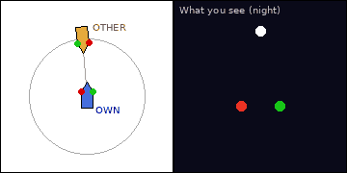
Situation: Night, open sea. A power-driven vessel under 50 m (orange) is right ahead, range 4 nm, bearing steady and range decreasing. You (blue) are power-driven. The black panel shows the lights you see.
Q1. Which lights do you see and what do they tell you about her aspect and direction of movement?
A. You see both her red and green sidelights, with her masthead light(s). She is heading almost directly toward you (end-on).
Q2. Which Rule applies, and what is your action?
A. Rule 14 (head-on). Both vessels give way: alter course to starboard in good time and substantially, and pass port to port. In doubt, assume head-on (Rule 14(c)).
Q3. What sound signal do you make when you alter?
A. One short blast (altering to starboard) – Rule 34(a).

Card 5 – Crossing – vessel on your starboard side
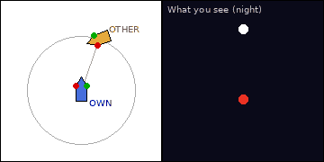
Situation: Night, open sea. A power-driven vessel under 50 m (orange) is 20° on your starboard bow, range 4 nm, bearing steady and range decreasing. You (blue) are power-driven. The black panel shows the lights you see.
Q1. Which lights do you see and what do they tell you about her aspect and direction of movement?
A. You see her red (port) sidelight and masthead light(s). She is crossing your bow from your starboard side to your port side.
Q2. Which Rule applies, what is your role and what is your action?
A. Rules 15 and 16: you have her on your starboard side, so you are give-way. Take early and substantial action, preferably a bold alteration to starboard to pass astern of her; avoid crossing ahead of her; slow down if needed. Sound one short blast when altering.

Card 6 – Crossing – vessel on your starboard side
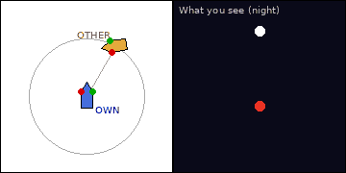
Situation: Night, open sea. A power-driven vessel under 50 m (orange) is 30° on your starboard bow, range 4 nm, bearing steady and range decreasing. You (blue) are power-driven. The black panel shows the lights you see.
Q1. Which lights do you see and what do they tell you about her aspect and direction of movement?
A. You see her red (port) sidelight and masthead light(s). She is crossing your bow from your starboard side to your port side.
Q2. Which Rule applies, what is your role and what is your action?
A. Rules 15 and 16: you have her on your starboard side, so you are give-way. Take early and substantial action, preferably a bold alteration to starboard to pass astern of her; avoid crossing ahead of her; slow down if needed. Sound one short blast when altering.

Card 7 – Crossing – vessel on your starboard side
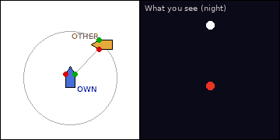
Situation: Night, open sea. A power-driven vessel under 50 m (orange) is 45° on your starboard bow, range 4 nm, bearing steady and range decreasing. You (blue) are power-driven. The black panel shows the lights you see.
Q1. Which lights do you see and what do they tell you about her aspect and direction of movement?
A. You see her red (port) sidelight and masthead light(s). She is crossing your bow from your starboard side to your port side.
Q2. Which Rule applies, what is your role and what is your action?
A. Rules 15 and 16: you have her on your starboard side, so you are give-way. Take early and substantial action, preferably a bold alteration to starboard to pass astern of her; avoid crossing ahead of her; slow down if needed. Sound one short blast when altering.

Card 8 – Crossing – vessel on your starboard side
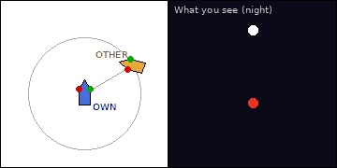
Situation: Night, open sea. A power-driven vessel under 50 m (orange) is 60° on your starboard bow, range 4 nm, bearing steady and range decreasing. You (blue) are power-driven. The black panel shows the lights you see.
Q1. Which lights do you see and what do they tell you about her aspect and direction of movement?
A. You see her red (port) sidelight and masthead light(s). She is crossing your bow from your starboard side to your port side.
Q2. Which Rule applies, what is your role and what is your action?
A. Rules 15 and 16: you have her on your starboard side, so you are give-way. Take early and substantial action, preferably a bold alteration to starboard to pass astern of her; avoid crossing ahead of her; slow down if needed. Sound one short blast when altering.

Card 9 – Crossing – vessel on your starboard side
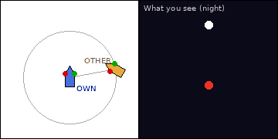
Situation: Night, open sea. A power-driven vessel under 50 m (orange) is 80° off your bow, on your starboard beam, range 4 nm, bearing steady and range decreasing. You (blue) are power-driven. The black panel shows the lights you see.
Q1. Which lights do you see and what do they tell you about her aspect and direction of movement?
A. You see her red (port) sidelight and masthead light(s). She is crossing your bow from your starboard side to your port side.
Q2. Which Rule applies, what is your role and what is your action?
A. Rules 15 and 16: you have her on your starboard side, so you are give-way. Take early and substantial action, preferably a bold alteration to starboard to pass astern of her; avoid crossing ahead of her; slow down if needed. Sound one short blast when altering.

Card 10 – Crossing – vessel on your starboard side
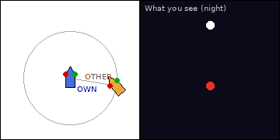
Situation: Night, open sea. A power-driven vessel under 50 m (orange) is 100° off your bow, on your starboard beam, range 4 nm, bearing steady and range decreasing. You (blue) are power-driven. The black panel shows the lights you see.
Q1. Which lights do you see and what do they tell you about her aspect and direction of movement?
A. You see her red (port) sidelight and masthead light(s). She is crossing your bow from your starboard side to your port side.
Q2. Which Rule applies, what is your role and what is your action?
A. Rules 15 and 16: you have her on your starboard side, so you are give-way. Take early and substantial action, preferably a bold alteration to starboard to pass astern of her; avoid crossing ahead of her; slow down if needed. Sound one short blast when altering.

Card 11 – Crossing – vessel on your starboard side
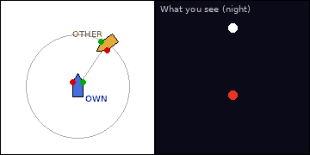
Situation: Night, open sea. A power-driven vessel under 50 m (orange) is 35° on your starboard bow, range 4 nm, bearing steady and range decreasing. You (blue) are power-driven. The black panel shows the lights you see.
Q1. Which lights do you see and what do they tell you about her aspect and direction of movement?
A. You see her red (port) sidelight and masthead light(s). She is crossing your bow from your starboard side to your port side.
Q2. Which Rule applies, what is your role and what is your action?
A. Rules 15 and 16: you have her on your starboard side, so you are give-way. Take early and substantial action, preferably a bold alteration to starboard to pass astern of her; avoid crossing ahead of her; slow down if needed. Sound one short blast when altering.

Card 12 – Crossing – vessel on your starboard side
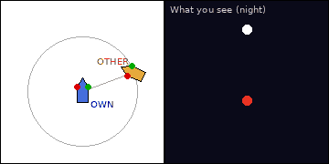
Situation: Night, open sea. A power-driven vessel under 50 m (orange) is 70° off your bow, on your starboard beam, range 4 nm, bearing steady and range decreasing. You (blue) are power-driven. The black panel shows the lights you see.
Q1. Which lights do you see and what do they tell you about her aspect and direction of movement?
A. You see her red (port) sidelight and masthead light(s). She is crossing your bow from your starboard side to your port side.
Q2. Which Rule applies, what is your role and what is your action?
A. Rules 15 and 16: you have her on your starboard side, so you are give-way. Take early and substantial action, preferably a bold alteration to starboard to pass astern of her; avoid crossing ahead of her; slow down if needed. Sound one short blast when altering.

Card 13 – Crossing – vessel on your port side
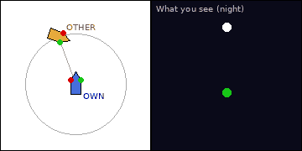
Situation: Night, open sea. A power-driven vessel under 50 m (orange) is 20° on your port bow, range 4 nm, bearing steady and range decreasing. You (blue) are power-driven. The black panel shows the lights you see.
Q1. Which lights do you see and what do they tell you about her aspect and direction of movement?
A. You see her green (starboard) sidelight and masthead light(s). She is crossing your bow from your port side to your starboard side.
Q2. Which Rule applies, what is your role and what is your action?
A. Rule 17: she has you on her starboard side, so you are stand-on. Maintain course and speed, watch her bearing. If she fails to act, you may act (17(a)(ii)); when collision cannot be avoided by her action alone you must take best action (17(b)) and do not alter to port for a vessel on your port side (17(c)). Sound five short blasts if in doubt.

Card 14 – Crossing – vessel on your port side
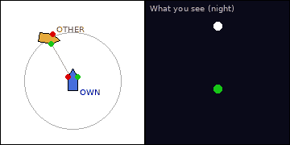
Situation: Night, open sea. A power-driven vessel under 50 m (orange) is 30° on your port bow, range 4 nm, bearing steady and range decreasing. You (blue) are power-driven. The black panel shows the lights you see.
Q1. Which lights do you see and what do they tell you about her aspect and direction of movement?
A. You see her green (starboard) sidelight and masthead light(s). She is crossing your bow from your port side to your starboard side.
Q2. Which Rule applies, what is your role and what is your action?
A. Rule 17: she has you on her starboard side, so you are stand-on. Maintain course and speed, watch her bearing. If she fails to act, you may act (17(a)(ii)); when collision cannot be avoided by her action alone you must take best action (17(b)) and do not alter to port for a vessel on your port side (17(c)). Sound five short blasts if in doubt.

Card 15 – Crossing – vessel on your port side
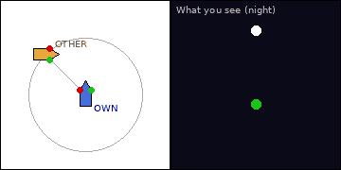
Situation: Night, open sea. A power-driven vessel under 50 m (orange) is 45° on your port bow, range 4 nm, bearing steady and range decreasing. You (blue) are power-driven. The black panel shows the lights you see.
Q1. Which lights do you see and what do they tell you about her aspect and direction of movement?
A. You see her green (starboard) sidelight and masthead light(s). She is crossing your bow from your port side to your starboard side.
Q2. Which Rule applies, what is your role and what is your action?
A. Rule 17: she has you on her starboard side, so you are stand-on. Maintain course and speed, watch her bearing. If she fails to act, you may act (17(a)(ii)); when collision cannot be avoided by her action alone you must take best action (17(b)) and do not alter to port for a vessel on your port side (17(c)). Sound five short blasts if in doubt.

Card 16 – Crossing – vessel on your port side
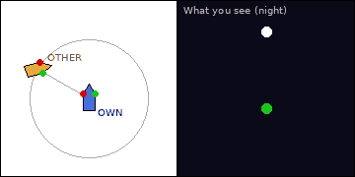
Situation: Night, open sea. A power-driven vessel under 50 m (orange) is 60° on your port bow, range 4 nm, bearing steady and range decreasing. You (blue) are power-driven. The black panel shows the lights you see.
Q1. Which lights do you see and what do they tell you about her aspect and direction of movement?
A. You see her green (starboard) sidelight and masthead light(s). She is crossing your bow from your port side to your starboard side.
Q2. Which Rule applies, what is your role and what is your action?
A. Rule 17: she has you on her starboard side, so you are stand-on. Maintain course and speed, watch her bearing. If she fails to act, you may act (17(a)(ii)); when collision cannot be avoided by her action alone you must take best action (17(b)) and do not alter to port for a vessel on your port side (17(c)). Sound five short blasts if in doubt.

Card 17 – Crossing – vessel on your port side
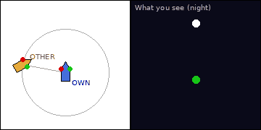
Situation: Night, open sea. A power-driven vessel under 50 m (orange) is 80° off your bow, on your port beam, range 4 nm, bearing steady and range decreasing. You (blue) are power-driven. The black panel shows the lights you see.
Q1. Which lights do you see and what do they tell you about her aspect and direction of movement?
A. You see her green (starboard) sidelight and masthead light(s). She is crossing your bow from your port side to your starboard side.
Q2. Which Rule applies, what is your role and what is your action?
A. Rule 17: she has you on her starboard side, so you are stand-on. Maintain course and speed, watch her bearing. If she fails to act, you may act (17(a)(ii)); when collision cannot be avoided by her action alone you must take best action (17(b)) and do not alter to port for a vessel on your port side (17(c)). Sound five short blasts if in doubt.

Card 18 – Crossing – vessel on your port side
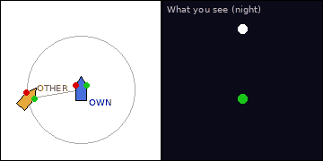
Situation: Night, open sea. A power-driven vessel under 50 m (orange) is 100° off your bow, on your port beam, range 4 nm, bearing steady and range decreasing. You (blue) are power-driven. The black panel shows the lights you see.
Q1. Which lights do you see and what do they tell you about her aspect and direction of movement?
A. You see her green (starboard) sidelight and masthead light(s). She is crossing your bow from your port side to your starboard side.
Q2. Which Rule applies, what is your role and what is your action?
A. Rule 17: she has you on her starboard side, so you are stand-on. Maintain course and speed, watch her bearing. If she fails to act, you may act (17(a)(ii)); when collision cannot be avoided by her action alone you must take best action (17(b)) and do not alter to port for a vessel on your port side (17(c)). Sound five short blasts if in doubt.

Card 19 – Crossing – vessel on your port side
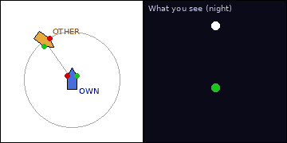
Situation: Night, open sea. A power-driven vessel under 50 m (orange) is 35° on your port bow, range 4 nm, bearing steady and range decreasing. You (blue) are power-driven. The black panel shows the lights you see.
Q1. Which lights do you see and what do they tell you about her aspect and direction of movement?
A. You see her green (starboard) sidelight and masthead light(s). She is crossing your bow from your port side to your starboard side.
Q2. Which Rule applies, what is your role and what is your action?
A. Rule 17: she has you on her starboard side, so you are stand-on. Maintain course and speed, watch her bearing. If she fails to act, you may act (17(a)(ii)); when collision cannot be avoided by her action alone you must take best action (17(b)) and do not alter to port for a vessel on your port side (17(c)). Sound five short blasts if in doubt.

Card 20 – Crossing – vessel on your port side
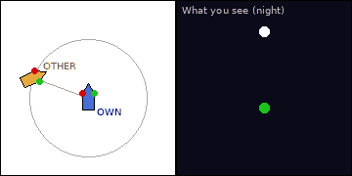
Situation: Night, open sea. A power-driven vessel under 50 m (orange) is 70° off your bow, on your port beam, range 4 nm, bearing steady and range decreasing. You (blue) are power-driven. The black panel shows the lights you see.
Q1. Which lights do you see and what do they tell you about her aspect and direction of movement?
A. You see her green (starboard) sidelight and masthead light(s). She is crossing your bow from your port side to your starboard side.
Q2. Which Rule applies, what is your role and what is your action?
A. Rule 17: she has you on her starboard side, so you are stand-on. Maintain course and speed, watch her bearing. If she fails to act, you may act (17(a)(ii)); when collision cannot be avoided by her action alone you must take best action (17(b)) and do not alter to port for a vessel on your port side (17(c)). Sound five short blasts if in doubt.

Card 21 – Overtaking – you are overtaking
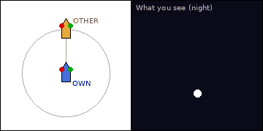
Situation: Night, open sea. A power-driven vessel under 50 m (orange) is right ahead, range 4 nm, bearing steady and range decreasing. You (blue) are power-driven. The black panel shows the lights you see.
Q1. Which lights do you see and what do they tell you about her aspect and direction of movement?
A. You see only her white sternlight. She is on the same heading ahead of you, moving away from you.
Q2. Which Rule applies and what is your duty?
A. Rule 13. You are the overtaking vessel and must keep out of the way until finally past and clear. Her sternlight arc is 135°; you are more than 22.5° abaft her beam. In doubt, assume you are overtaking (Rule 13(c)).

Card 22 – Overtaking – you are overtaking
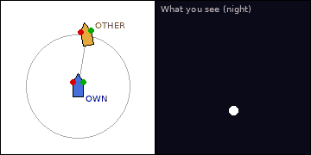
Situation: Night, open sea. A power-driven vessel under 50 m (orange) is 10° on your starboard bow, range 4 nm, bearing steady and range decreasing. You (blue) are power-driven. The black panel shows the lights you see.
Q1. Which lights do you see and what do they tell you about her aspect and direction of movement?
A. You see only her white sternlight. She is on the same heading ahead of you, moving away from you.
Q2. Which Rule applies and what is your duty?
A. Rule 13. You are the overtaking vessel and must keep out of the way until finally past and clear. Her sternlight arc is 135°; you are more than 22.5° abaft her beam. In doubt, assume you are overtaking (Rule 13(c)).

Card 23 – Overtaking – you are overtaking
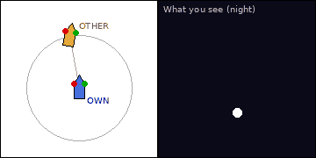
Situation: Night, open sea. A power-driven vessel under 50 m (orange) is 10° on your port bow, range 4 nm, bearing steady and range decreasing. You (blue) are power-driven. The black panel shows the lights you see.
Q1. Which lights do you see and what do they tell you about her aspect and direction of movement?
A. You see only her white sternlight. She is on the same heading ahead of you, moving away from you.
Q2. Which Rule applies and what is your duty?
A. Rule 13. You are the overtaking vessel and must keep out of the way until finally past and clear. Her sternlight arc is 135°; you are more than 22.5° abaft her beam. In doubt, assume you are overtaking (Rule 13(c)).

Card 24 – Overtaking – you are being overtaken
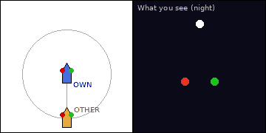
Situation: Night, open sea. A power-driven vessel under 50 m (orange) is astern, range 4 nm, bearing steady and range decreasing. You (blue) are power-driven. The black panel shows the lights you see.
Q1. Which lights do you see and what do they tell you about her aspect and direction of movement?
A. You see both her red and green sidelights, with her masthead light(s). She is on your quarter, closing from astern on a similar heading.
Q2. Which Rule applies, and what is your role?
A. Rule 13 puts the duty on her as the overtaking vessel; you are stand-on (Rule 17). Maintain course and speed, do not obstruct her, and she stays an overtaking vessel until finally past and clear (Rule 13(d)).

Card 25 – Overtaking – you are being overtaken
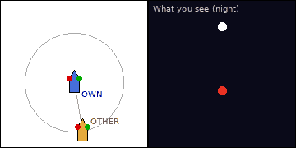
Situation: Night, open sea. A power-driven vessel under 50 m (orange) is astern, range 4 nm, bearing steady and range decreasing. You (blue) are power-driven. The black panel shows the lights you see.
Q1. Which lights do you see and what do they tell you about her aspect and direction of movement?
A. You see her red (port) sidelight and masthead light(s). She is on your quarter, closing from astern on a similar heading.
Q2. Which Rule applies, and what is your role?
A. Rule 13 puts the duty on her as the overtaking vessel; you are stand-on (Rule 17). Maintain course and speed, do not obstruct her, and she stays an overtaking vessel until finally past and clear (Rule 13(d)).

Card 26 – Overtaking – you are being overtaken
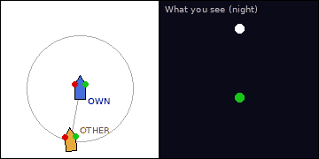
Situation: Night, open sea. A power-driven vessel under 50 m (orange) is astern, range 4 nm, bearing steady and range decreasing. You (blue) are power-driven. The black panel shows the lights you see.
Q1. Which lights do you see and what do they tell you about her aspect and direction of movement?
A. You see her green (starboard) sidelight and masthead light(s). She is on your quarter, closing from astern on a similar heading.
Q2. Which Rule applies, and what is your role?
A. Rule 13 puts the duty on her as the overtaking vessel; you are stand-on (Rule 17). Maintain course and speed, do not obstruct her, and she stays an overtaking vessel until finally past and clear (Rule 13(d)).

Card 27 – Overtaking – you are being overtaken
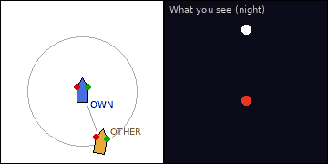
Situation: Night, open sea. A power-driven vessel under 50 m (orange) is astern, range 4 nm, bearing steady and range decreasing. You (blue) are power-driven. The black panel shows the lights you see.
Q1. Which lights do you see and what do they tell you about her aspect and direction of movement?
A. You see her red (port) sidelight and masthead light(s). She is on your quarter, closing from astern on a similar heading.
Q2. Which Rule applies, and what is your role?
A. Rule 13 puts the duty on her as the overtaking vessel; you are stand-on (Rule 17). Maintain course and speed, do not obstruct her, and she stays an overtaking vessel until finally past and clear (Rule 13(d)).

Card 28 – Overtaking – you are being overtaken
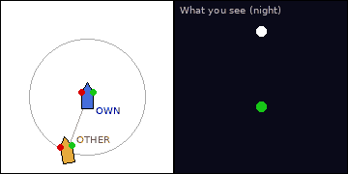
Situation: Night, open sea. A power-driven vessel under 50 m (orange) is astern, range 4 nm, bearing steady and range decreasing. You (blue) are power-driven. The black panel shows the lights you see.
Q1. Which lights do you see and what do they tell you about her aspect and direction of movement?
A. You see her green (starboard) sidelight and masthead light(s). She is on your quarter, closing from astern on a similar heading.
Q2. Which Rule applies, and what is your role?
A. Rule 13 puts the duty on her as the overtaking vessel; you are stand-on (Rule 17). Maintain course and speed, do not obstruct her, and she stays an overtaking vessel until finally past and clear (Rule 13(d)).

Part B – Special Vessels: Lights and Positions

Card 29 – Trawler making way (1/4)
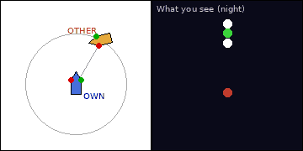
Situation: Night, open sea. A vessel (orange) is 30° on your starboard bow, range 4 nm, bearing steady and range decreasing. You (blue) are power-driven. The black panel shows the lights you see.
Q1. Identify the vessel from the lights shown and describe her aspect.
A. The lights show a green light over a white light (all-round), a masthead light abaft and higher (vessel of 50 m or more) and sidelights because she is making way. She is a vessel engaged in trawling. From your position you see her red (port) sidelight and masthead light(s); she is crossing your bow from your starboard side to your port side.
Q2. What are your Rule, role and action?
A. You are the give-way vessel (Rule 18(a)(iii)): a power-driven vessel keeps out of the way of a vessel engaged in fishing, whichever side she is on. Take early, substantial action (normally pass astern), reduce speed if needed, and keep clear of any gear or tow.
Q3. What is the day signal for this vessel?
A. Two cones with apexes together, one above the other; a vessel under 20 m may show a basket.

Card 30 – Trawler making way (2/4)
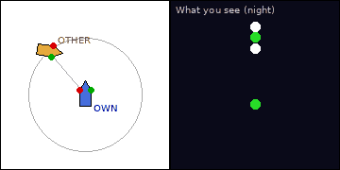
Situation: Night, open sea. A vessel (orange) is 40° on your port bow, range 4 nm, bearing steady and range decreasing. You (blue) are power-driven. The black panel shows the lights you see.
Q1. Identify the vessel from the lights shown and describe her aspect.
A. The lights show a green light over a white light (all-round), a masthead light abaft and higher (vessel of 50 m or more) and sidelights because she is making way. She is a vessel engaged in trawling. From your position you see her green (starboard) sidelight and masthead light(s); she is crossing your bow from your port side to your starboard side.
Q2. What are your Rule, role and action?
A. You are the give-way vessel (Rule 18(a)(iii)): a power-driven vessel keeps out of the way of a vessel engaged in fishing, whichever side she is on. Take early, substantial action (normally pass astern), reduce speed if needed, and keep clear of any gear or tow.

Card 31 – Trawler making way (3/4)
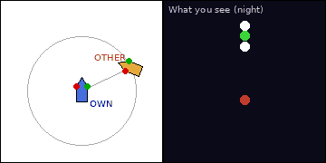
Situation: Night, open sea. A vessel (orange) is 65° on your starboard bow, range 4 nm, bearing steady and range decreasing. You (blue) are power-driven. The black panel shows the lights you see.
Q1. Identify the vessel from the lights shown and describe her aspect.
A. The lights show a green light over a white light (all-round), a masthead light abaft and higher (vessel of 50 m or more) and sidelights because she is making way. She is a vessel engaged in trawling. From your position you see her red (port) sidelight and masthead light(s); she is crossing your bow from your starboard side to your port side.
Q2. What are your Rule, role and action?
A. You are the give-way vessel (Rule 18(a)(iii)): a power-driven vessel keeps out of the way of a vessel engaged in fishing, whichever side she is on. Take early, substantial action (normally pass astern), reduce speed if needed, and keep clear of any gear or tow.

Card 32 – Trawler making way (4/4)
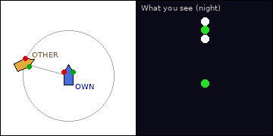
Situation: Night, open sea. A vessel (orange) is 75° off your bow, on your port beam, range 4 nm, bearing steady and range decreasing. You (blue) are power-driven. The black panel shows the lights you see.
Q1. Identify the vessel from the lights shown and describe her aspect.
A. The lights show a green light over a white light (all-round), a masthead light abaft and higher (vessel of 50 m or more) and sidelights because she is making way. She is a vessel engaged in trawling. From your position you see her green (starboard) sidelight and masthead light(s); she is crossing your bow from your port side to your starboard side.
Q2. What are your Rule, role and action?
A. You are the give-way vessel (Rule 18(a)(iii)): a power-driven vessel keeps out of the way of a vessel engaged in fishing, whichever side she is on. Take early, substantial action (normally pass astern), reduce speed if needed, and keep clear of any gear or tow.

Card 33 – Fishing vessel (not trawling) (1/4)
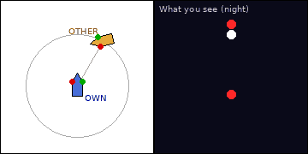
Situation: Night, open sea. A vessel (orange) is 30° on your starboard bow, range 4 nm, bearing steady and range decreasing. You (blue) are power-driven. The black panel shows the lights you see.
Q1. Identify the vessel from the lights shown and describe her aspect.
A. The lights show a red light over a white light (all-round) and sidelights because she is making way. She is a vessel engaged in fishing other than trawling. From your position you see her red (port) sidelight and masthead light(s); she is crossing your bow from your starboard side to your port side.
Q2. What are your Rule, role and action?
A. You are the give-way vessel (Rule 18(a)(iii)): a power-driven vessel keeps out of the way of a vessel engaged in fishing, whichever side she is on. Take early, substantial action (normally pass astern), reduce speed if needed, and keep clear of any gear or tow.
Q3. What additional signal shows outlying gear of more than 150 m?
A. By night an additional all-round white light in the direction of the gear; by day a cone apex upward.

Card 34 – Fishing vessel (not trawling) (2/4)
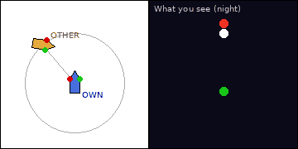
Situation: Night, open sea. A vessel (orange) is 40° on your port bow, range 4 nm, bearing steady and range decreasing. You (blue) are power-driven. The black panel shows the lights you see.
Q1. Identify the vessel from the lights shown and describe her aspect.
A. The lights show a red light over a white light (all-round) and sidelights because she is making way. She is a vessel engaged in fishing other than trawling. From your position you see her green (starboard) sidelight and masthead light(s); she is crossing your bow from your port side to your starboard side.
Q2. What are your Rule, role and action?
A. You are the give-way vessel (Rule 18(a)(iii)): a power-driven vessel keeps out of the way of a vessel engaged in fishing, whichever side she is on. Take early, substantial action (normally pass astern), reduce speed if needed, and keep clear of any gear or tow.

Card 35 – Fishing vessel (not trawling) (3/4)
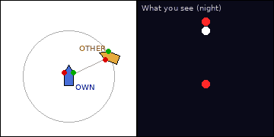
Situation: Night, open sea. A vessel (orange) is 65° on your starboard bow, range 4 nm, bearing steady and range decreasing. You (blue) are power-driven. The black panel shows the lights you see.
Q1. Identify the vessel from the lights shown and describe her aspect.
A. The lights show a red light over a white light (all-round) and sidelights because she is making way. She is a vessel engaged in fishing other than trawling. From your position you see her red (port) sidelight and masthead light(s); she is crossing your bow from your starboard side to your port side.
Q2. What are your Rule, role and action?
A. You are the give-way vessel (Rule 18(a)(iii)): a power-driven vessel keeps out of the way of a vessel engaged in fishing, whichever side she is on. Take early, substantial action (normally pass astern), reduce speed if needed, and keep clear of any gear or tow.

Card 36 – Fishing vessel (not trawling) (4/4)
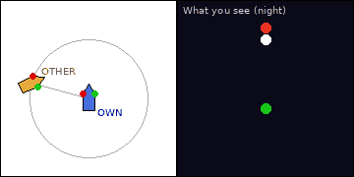
Situation: Night, open sea. A vessel (orange) is 75° off your bow, on your port beam, range 4 nm, bearing steady and range decreasing. You (blue) are power-driven. The black panel shows the lights you see.
Q1. Identify the vessel from the lights shown and describe her aspect.
A. The lights show a red light over a white light (all-round) and sidelights because she is making way. She is a vessel engaged in fishing other than trawling. From your position you see her green (starboard) sidelight and masthead light(s); she is crossing your bow from your port side to your starboard side.
Q2. What are your Rule, role and action?
A. You are the give-way vessel (Rule 18(a)(iii)): a power-driven vessel keeps out of the way of a vessel engaged in fishing, whichever side she is on. Take early, substantial action (normally pass astern), reduce speed if needed, and keep clear of any gear or tow.

Card 37 – Not under command – making way (1/4)
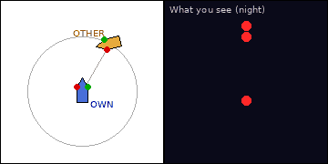
Situation: Night, open sea. A vessel (orange) is 30° on your starboard bow, range 4 nm, bearing steady and range decreasing. You (blue) are power-driven. The black panel shows the lights you see.
Q1. Identify the vessel from the lights shown and describe her aspect.
A. The lights show two red all-round lights in a vertical line plus sidelights, since she is making way. She is a vessel not under command. From your position you see her red (port) sidelight and masthead light(s); she is crossing your bow from your starboard side to your port side.
Q2. What are your Rule, role and action?
A. You are the give-way vessel (Rule 18(a)(i)): a power-driven vessel keeps out of the way of a vessel not under command, whichever side she is on. Take early, substantial action (normally pass astern), reduce speed if needed, and keep clear of any gear or tow.
Q3. What is the day signal?
A. Two black balls in a vertical line where best seen.

Card 38 – Not under command – making way (2/4)
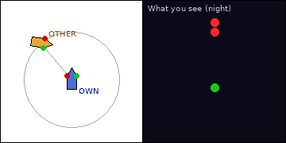
Situation: Night, open sea. A vessel (orange) is 40° on your port bow, range 4 nm, bearing steady and range decreasing. You (blue) are power-driven. The black panel shows the lights you see.
Q1. Identify the vessel from the lights shown and describe her aspect.
A. The lights show two red all-round lights in a vertical line plus sidelights, since she is making way. She is a vessel not under command. From your position you see her green (starboard) sidelight and masthead light(s); she is crossing your bow from your port side to your starboard side.
Q2. What are your Rule, role and action?
A. You are the give-way vessel (Rule 18(a)(i)): a power-driven vessel keeps out of the way of a vessel not under command, whichever side she is on. Take early, substantial action (normally pass astern), reduce speed if needed, and keep clear of any gear or tow.

Card 39 – Not under command – making way (3/4)
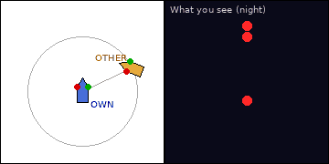
Situation: Night, open sea. A vessel (orange) is 65° on your starboard bow, range 4 nm, bearing steady and range decreasing. You (blue) are power-driven. The black panel shows the lights you see.
Q1. Identify the vessel from the lights shown and describe her aspect.
A. The lights show two red all-round lights in a vertical line plus sidelights, since she is making way. She is a vessel not under command. From your position you see her red (port) sidelight and masthead light(s); she is crossing your bow from your starboard side to your port side.
Q2. What are your Rule, role and action?
A. You are the give-way vessel (Rule 18(a)(i)): a power-driven vessel keeps out of the way of a vessel not under command, whichever side she is on. Take early, substantial action (normally pass astern), reduce speed if needed, and keep clear of any gear or tow.

Card 40 – Not under command – making way (4/4)
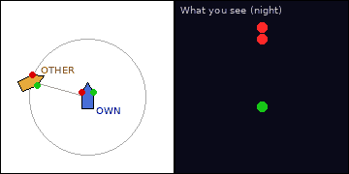
Situation: Night, open sea. A vessel (orange) is 75° off your bow, on your port beam, range 4 nm, bearing steady and range decreasing. You (blue) are power-driven. The black panel shows the lights you see.
Q1. Identify the vessel from the lights shown and describe her aspect.
A. The lights show two red all-round lights in a vertical line plus sidelights, since she is making way. She is a vessel not under command. From your position you see her green (starboard) sidelight and masthead light(s); she is crossing your bow from your port side to your starboard side.
Q2. What are your Rule, role and action?
A. You are the give-way vessel (Rule 18(a)(i)): a power-driven vessel keeps out of the way of a vessel not under command, whichever side she is on. Take early, substantial action (normally pass astern), reduce speed if needed, and keep clear of any gear or tow.

Card 41 – Not under command – stopped (1/4)
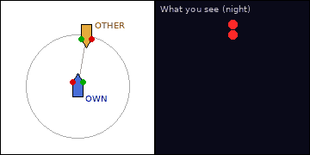
Situation: Night, open sea. A vessel (orange) is 10° on your starboard bow, range 4 nm, bearing steady and range decreasing. You (blue) are power-driven. The black panel shows the lights you see.
Q1. Identify the vessel from the lights shown.
A. The lights show two red all-round lights only, with no sidelights or sternlight, so she has no way on. She is a vessel not under command.
Q2. What are your Rule, role and action?
A. You are the give-way vessel (Rule 18(a)(i)): a power-driven vessel keeps out of the way of a vessel not under command, whichever side she is on. Take early, substantial action (normally pass astern), reduce speed if needed, and keep clear of any gear or tow.
Q3. Why are no sidelights visible?
A. Sidelights and sternlight are shown only when making way; she is stopped.

Card 42 – Not under command – stopped (2/4)
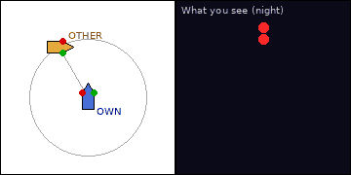
Situation: Night, open sea. A vessel (orange) is 30° on your port bow, range 4 nm, bearing steady and range decreasing. You (blue) are power-driven. The black panel shows the lights you see.
Q1. Identify the vessel from the lights shown.
A. The lights show two red all-round lights only, with no sidelights or sternlight, so she has no way on. She is a vessel not under command.
Q2. What are your Rule, role and action?
A. You are the give-way vessel (Rule 18(a)(i)): a power-driven vessel keeps out of the way of a vessel not under command, whichever side she is on. Take early, substantial action (normally pass astern), reduce speed if needed, and keep clear of any gear or tow.

Card 43 – Not under command – stopped (3/4)
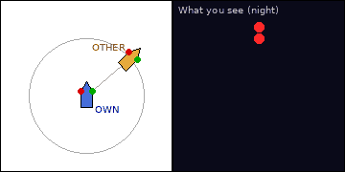
Situation: Night, open sea. A vessel (orange) is 50° on your starboard bow, range 4 nm, bearing steady and range decreasing. You (blue) are power-driven. The black panel shows the lights you see.
Q1. Identify the vessel from the lights shown.
A. The lights show two red all-round lights only, with no sidelights or sternlight, so she has no way on. She is a vessel not under command.
Q2. What are your Rule, role and action?
A. You are overtaking her, so Rule 13 requires you to keep clear until finally past and clear; in any case Rule 18(a)(i) makes you give way to a vessel not under command.

Card 44 – Not under command – stopped (4/4)
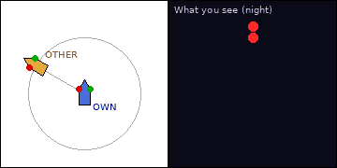
Situation: Night, open sea. A vessel (orange) is 60° on your port bow, range 4 nm, bearing steady and range decreasing. You (blue) are power-driven. The black panel shows the lights you see.
Q1. Identify the vessel from the lights shown.
A. The lights show two red all-round lights only, with no sidelights or sternlight, so she has no way on. She is a vessel not under command.
Q2. What are your Rule, role and action?
A. You are overtaking her, so Rule 13 requires you to keep clear until finally past and clear; in any case Rule 18(a)(i) makes you give way to a vessel not under command.

Card 45 – Restricted in ability to manoeuvre – making way (1/4)
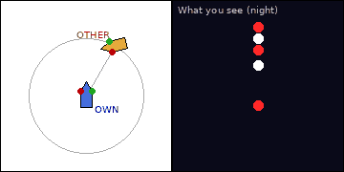
Situation: Night, open sea. A vessel (orange) is 30° on your starboard bow, range 4 nm, bearing steady and range decreasing. You (blue) are power-driven. The black panel shows the lights you see.
Q1. Identify the vessel from the lights shown and describe her aspect.
A. The lights show three all-round lights in a vertical line (red, white, red), masthead light(s) and sidelights. She is a vessel restricted in her ability to manoeuvre, making way. From your position you see her red (port) sidelight and masthead light(s); she is crossing your bow from your starboard side to your port side.
Q2. What are your Rule, role and action?
A. You are the give-way vessel (Rule 18(a)(ii)): a power-driven vessel keeps out of the way of a vessel restricted in her ability to manoeuvre, whichever side she is on. Take early, substantial action (normally pass astern), reduce speed if needed, and keep clear of any gear or tow.
Q3. What is the day signal?
A. Three shapes in a vertical line: ball, diamond, ball.

Card 46 – Restricted in ability to manoeuvre – making way (2/4)
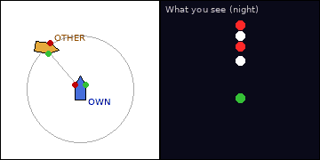
Situation: Night, open sea. A vessel (orange) is 40° on your port bow, range 4 nm, bearing steady and range decreasing. You (blue) are power-driven. The black panel shows the lights you see.
Q1. Identify the vessel from the lights shown and describe her aspect.
A. The lights show three all-round lights in a vertical line (red, white, red), masthead light(s) and sidelights. She is a vessel restricted in her ability to manoeuvre, making way. From your position you see her green (starboard) sidelight and masthead light(s); she is crossing your bow from your port side to your starboard side.
Q2. What are your Rule, role and action?
A. You are the give-way vessel (Rule 18(a)(ii)): a power-driven vessel keeps out of the way of a vessel restricted in her ability to manoeuvre, whichever side she is on. Take early, substantial action (normally pass astern), reduce speed if needed, and keep clear of any gear or tow.

Card 47 – Restricted in ability to manoeuvre – making way (3/4)
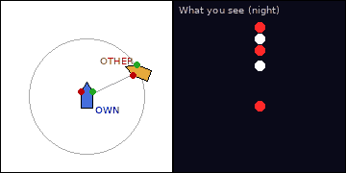
Situation: Night, open sea. A vessel (orange) is 65° on your starboard bow, range 4 nm, bearing steady and range decreasing. You (blue) are power-driven. The black panel shows the lights you see.
Q1. Identify the vessel from the lights shown and describe her aspect.
A. The lights show three all-round lights in a vertical line (red, white, red), masthead light(s) and sidelights. She is a vessel restricted in her ability to manoeuvre, making way. From your position you see her red (port) sidelight and masthead light(s); she is crossing your bow from your starboard side to your port side.
Q2. What are your Rule, role and action?
A. You are the give-way vessel (Rule 18(a)(ii)): a power-driven vessel keeps out of the way of a vessel restricted in her ability to manoeuvre, whichever side she is on. Take early, substantial action (normally pass astern), reduce speed if needed, and keep clear of any gear or tow.

Card 48 – Restricted in ability to manoeuvre – making way (4/4)
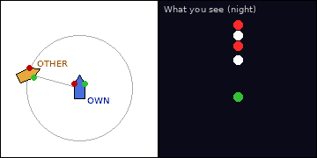
Situation: Night, open sea. A vessel (orange) is 75° off your bow, on your port beam, range 4 nm, bearing steady and range decreasing. You (blue) are power-driven. The black panel shows the lights you see.
Q1. Identify the vessel from the lights shown and describe her aspect.
A. The lights show three all-round lights in a vertical line (red, white, red), masthead light(s) and sidelights. She is a vessel restricted in her ability to manoeuvre, making way. From your position you see her green (starboard) sidelight and masthead light(s); she is crossing your bow from your port side to your starboard side.
Q2. What are your Rule, role and action?
A. You are the give-way vessel (Rule 18(a)(ii)): a power-driven vessel keeps out of the way of a vessel restricted in her ability to manoeuvre, whichever side she is on. Take early, substantial action (normally pass astern), reduce speed if needed, and keep clear of any gear or tow.

Card 49 – Restricted in ability to manoeuvre – stopped (1/4)
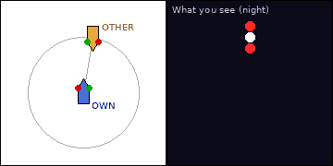
Situation: Night, open sea. A vessel (orange) is 10° on your starboard bow, range 4 nm, bearing steady and range decreasing. You (blue) are power-driven. The black panel shows the lights you see.
Q1. Identify the vessel from the lights shown.
A. The lights show three all-round lights in a vertical line (red, white, red) and no sidelights. She is a vessel restricted in her ability to manoeuvre with no way on.
Q2. What are your Rule, role and action?
A. You are the give-way vessel (Rule 18(a)(ii)): a power-driven vessel keeps out of the way of a vessel restricted in her ability to manoeuvre, whichever side she is on. Take early, substantial action (normally pass astern), reduce speed if needed, and keep clear of any gear or tow.
Q3. Give four examples of vessels restricted in ability to manoeuvre.
A. Cable layer, dredger or survey vessel, vessel replenishing at sea, vessel launching or recovering aircraft, mine clearance, towing that severely restricts deviation (Rule 3(g)).

Card 50 – Restricted in ability to manoeuvre – stopped (2/4)
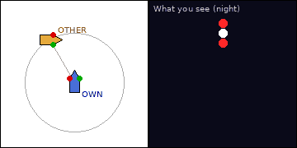
Situation: Night, open sea. A vessel (orange) is 30° on your port bow, range 4 nm, bearing steady and range decreasing. You (blue) are power-driven. The black panel shows the lights you see.
Q1. Identify the vessel from the lights shown.
A. The lights show three all-round lights in a vertical line (red, white, red) and no sidelights. She is a vessel restricted in her ability to manoeuvre with no way on.
Q2. What are your Rule, role and action?
A. You are the give-way vessel (Rule 18(a)(ii)): a power-driven vessel keeps out of the way of a vessel restricted in her ability to manoeuvre, whichever side she is on. Take early, substantial action (normally pass astern), reduce speed if needed, and keep clear of any gear or tow.

Card 51 – Restricted in ability to manoeuvre – stopped (3/4)
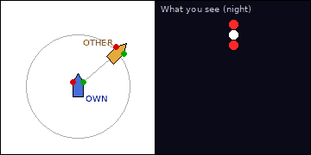
Situation: Night, open sea. A vessel (orange) is 50° on your starboard bow, range 4 nm, bearing steady and range decreasing. You (blue) are power-driven. The black panel shows the lights you see.
Q1. Identify the vessel from the lights shown.
A. The lights show three all-round lights in a vertical line (red, white, red) and no sidelights. She is a vessel restricted in her ability to manoeuvre with no way on.
Q2. What are your Rule, role and action?
A. You are overtaking her, so Rule 13 requires you to keep clear until finally past and clear; in any case Rule 18(a)(ii) makes you give way to a vessel restricted in her ability to manoeuvre.

Card 52 – Restricted in ability to manoeuvre – stopped (4/4)
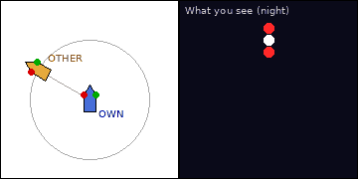
Situation: Night, open sea. A vessel (orange) is 60° on your port bow, range 4 nm, bearing steady and range decreasing. You (blue) are power-driven. The black panel shows the lights you see.
Q1. Identify the vessel from the lights shown.
A. The lights show three all-round lights in a vertical line (red, white, red) and no sidelights. She is a vessel restricted in her ability to manoeuvre with no way on.
Q2. What are your Rule, role and action?
A. You are overtaking her, so Rule 13 requires you to keep clear until finally past and clear; in any case Rule 18(a)(ii) makes you give way to a vessel restricted in her ability to manoeuvre.

Card 53 – Constrained by her draught (1/4)
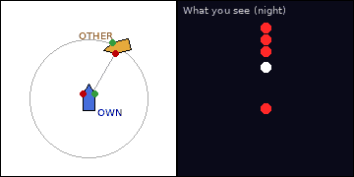
Situation: Night, open sea. A vessel (orange) is 30° on your starboard bow, range 4 nm, bearing steady and range decreasing. You (blue) are power-driven. The black panel shows the lights you see.
Q1. Identify the vessel from the lights shown and describe her aspect.
A. The lights show three red all-round lights in a vertical line above the normal power-driven lights (masthead and sidelights). She is a vessel constrained by her draught. From your position you see her red (port) sidelight and masthead light(s); she is crossing your bow from your starboard side to your port side.
Q2. What are your Rule, role and action?
A. Rule 18(d): avoid impeding her safe passage if circumstances admit; she navigates with particular caution having regard to her special condition. Otherwise Rules 14–17 still apply between the two power-driven vessels; do not cross close ahead and give her sea room.
Q3. What is the day signal and who may show it?
A. A black cylinder; only a power-driven vessel may show it (Rules 28 and 3(h)).

Card 54 – Constrained by her draught (2/4)
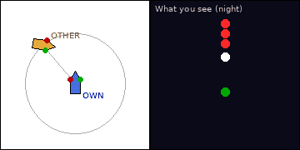
Situation: Night, open sea. A vessel (orange) is 40° on your port bow, range 4 nm, bearing steady and range decreasing. You (blue) are power-driven. The black panel shows the lights you see.
Q1. Identify the vessel from the lights shown and describe her aspect.
A. The lights show three red all-round lights in a vertical line above the normal power-driven lights (masthead and sidelights). She is a vessel constrained by her draught. From your position you see her green (starboard) sidelight and masthead light(s); she is crossing your bow from your port side to your starboard side.
Q2. What are your Rule, role and action?
A. Rule 18(d): avoid impeding her safe passage if circumstances admit; she navigates with particular caution having regard to her special condition. Otherwise Rules 14–17 still apply between the two power-driven vessels; do not cross close ahead and give her sea room.

Card 55 – Constrained by her draught (3/4)
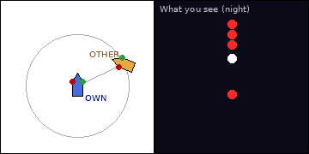
Situation: Night, open sea. A vessel (orange) is 65° on your starboard bow, range 4 nm, bearing steady and range decreasing. You (blue) are power-driven. The black panel shows the lights you see.
Q1. Identify the vessel from the lights shown and describe her aspect.
A. The lights show three red all-round lights in a vertical line above the normal power-driven lights (masthead and sidelights). She is a vessel constrained by her draught. From your position you see her red (port) sidelight and masthead light(s); she is crossing your bow from your starboard side to your port side.
Q2. What are your Rule, role and action?
A. Rule 18(d): avoid impeding her safe passage if circumstances admit; she navigates with particular caution having regard to her special condition. Otherwise Rules 14–17 still apply between the two power-driven vessels; do not cross close ahead and give her sea room.

Card 56 – Constrained by her draught (4/4)
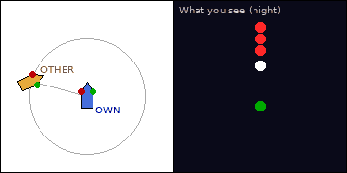
Situation: Night, open sea. A vessel (orange) is 75° off your bow, on your port beam, range 4 nm, bearing steady and range decreasing. You (blue) are power-driven. The black panel shows the lights you see.
Q1. Identify the vessel from the lights shown and describe her aspect.
A. The lights show three red all-round lights in a vertical line above the normal power-driven lights (masthead and sidelights). She is a vessel constrained by her draught. From your position you see her green (starboard) sidelight and masthead light(s); she is crossing your bow from your port side to your starboard side.
Q2. What are your Rule, role and action?
A. Rule 18(d): avoid impeding her safe passage if circumstances admit; she navigates with particular caution having regard to her special condition. Otherwise Rules 14–17 still apply between the two power-driven vessels; do not cross close ahead and give her sea room.

Card 57 – Tug with tow of 200 m or less (1/4)
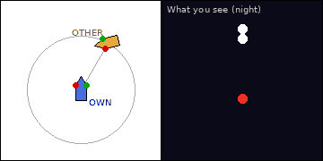
Situation: Night, open sea. A vessel (orange) is 30° on your starboard bow, range 4 nm, bearing steady and range decreasing. You (blue) are power-driven. The black panel shows the lights you see.
Q1. Identify the vessel from the lights shown and describe her aspect.
A. The lights show two masthead lights in a vertical line with sidelights; from astern she would also show a yellow towing light above her sternlight. She is a towing vessel with a tow not exceeding 200 m. From your position you see her red (port) sidelight and masthead light(s); she is crossing your bow from your starboard side to your port side.
Q2. What are your Rule, role and action?
A. Rules 15 and 16: she is on your starboard side, so you give way; alter to starboard and pass astern. Also keep clear of the tow and towline: pass astern of the whole tow, never between tug and tow.
Q3. What is the day signal for this tow?
A. None is required when the tow is 200 m or less; a diamond shape is shown on the tug and the tow when it exceeds 200 m.

Card 58 – Tug with tow of 200 m or less (2/4)
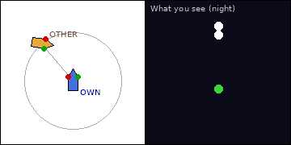
Situation: Night, open sea. A vessel (orange) is 40° on your port bow, range 4 nm, bearing steady and range decreasing. You (blue) are power-driven. The black panel shows the lights you see.
Q1. Identify the vessel from the lights shown and describe her aspect.
A. The lights show two masthead lights in a vertical line with sidelights; from astern she would also show a yellow towing light above her sternlight. She is a towing vessel with a tow not exceeding 200 m. From your position you see her green (starboard) sidelight and masthead light(s); she is crossing your bow from your port side to your starboard side.
Q2. What are your Rule, role and action?
A. Rule 17: she is on your port side with you on her starboard side, so you are stand-on; maintain course and speed. Also keep clear of the tow and towline: pass astern of the whole tow, never between tug and tow.

Card 59 – Tug with tow of 200 m or less (3/4)
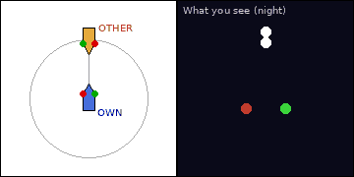
Situation: Night, open sea. A vessel (orange) is right ahead, range 4 nm, bearing steady and range decreasing. You (blue) are power-driven. The black panel shows the lights you see.
Q1. Identify the vessel from the lights shown and describe her aspect.
A. The lights show two masthead lights in a vertical line with sidelights; from astern she would also show a yellow towing light above her sternlight. She is a towing vessel with a tow not exceeding 200 m. From your position you see both her red and green sidelights, with her masthead light(s); she is heading almost directly toward you (end-on).
Q2. What are your Rule, role and action?
A. Rule 14 head-on: both alter to starboard and pass port to port. Also keep clear of the tow and towline: pass astern of the whole tow, never between tug and tow.

Card 60 – Tug with tow of 200 m or less (4/4)
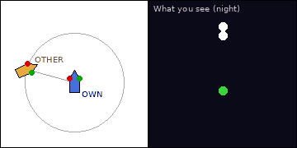
Situation: Night, open sea. A vessel (orange) is 75° off your bow, on your port beam, range 4 nm, bearing steady and range decreasing. You (blue) are power-driven. The black panel shows the lights you see.
Q1. Identify the vessel from the lights shown and describe her aspect.
A. The lights show two masthead lights in a vertical line with sidelights; from astern she would also show a yellow towing light above her sternlight. She is a towing vessel with a tow not exceeding 200 m. From your position you see her green (starboard) sidelight and masthead light(s); she is crossing your bow from your port side to your starboard side.
Q2. What are your Rule, role and action?
A. Rule 17: she is on your port side with you on her starboard side, so you are stand-on; maintain course and speed. Also keep clear of the tow and towline: pass astern of the whole tow, never between tug and tow.

Card 61 – Tug with tow exceeding 200 m (1/4)
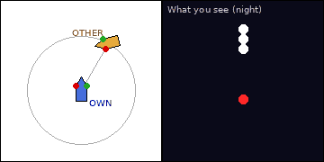
Situation: Night, open sea. A vessel (orange) is 30° on your starboard bow, range 4 nm, bearing steady and range decreasing. You (blue) are power-driven. The black panel shows the lights you see.
Q1. Identify the vessel from the lights shown and describe her aspect.
A. The lights show three masthead lights in a vertical line with sidelights; from astern a yellow towing light above the sternlight. She is a towing vessel with a tow exceeding 200 m. From your position you see her red (port) sidelight and masthead light(s); she is crossing your bow from your starboard side to your port side.
Q2. What are your Rule, role and action?
A. Rules 15 and 16: she is on your starboard side, so you give way; alter to starboard and pass astern. Allow extra room: the tow can extend more than 200 m astern and cannot readily alter.
Q3. What is the day signal?
A. A diamond shape where best seen on the tug and on the tow.

Card 62 – Tug with tow exceeding 200 m (2/4)
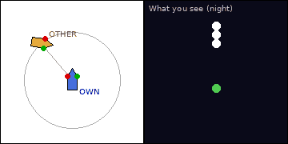
Situation: Night, open sea. A vessel (orange) is 40° on your port bow, range 4 nm, bearing steady and range decreasing. You (blue) are power-driven. The black panel shows the lights you see.
Q1. Identify the vessel from the lights shown and describe her aspect.
A. The lights show three masthead lights in a vertical line with sidelights; from astern a yellow towing light above the sternlight. She is a towing vessel with a tow exceeding 200 m. From your position you see her green (starboard) sidelight and masthead light(s); she is crossing your bow from your port side to your starboard side.
Q2. What are your Rule, role and action?
A. Rule 17: she is on your port side with you on her starboard side, so you are stand-on; maintain course and speed. Allow extra room: the tow can extend more than 200 m astern and cannot readily alter.

Card 63 – Tug with tow exceeding 200 m (3/4)
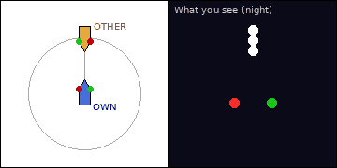
Situation: Night, open sea. A vessel (orange) is right ahead, range 4 nm, bearing steady and range decreasing. You (blue) are power-driven. The black panel shows the lights you see.
Q1. Identify the vessel from the lights shown and describe her aspect.
A. The lights show three masthead lights in a vertical line with sidelights; from astern a yellow towing light above the sternlight. She is a towing vessel with a tow exceeding 200 m. From your position you see both her red and green sidelights, with her masthead light(s); she is heading almost directly toward you (end-on).
Q2. What are your Rule, role and action?
A. Rule 14 head-on: both alter to starboard and pass port to port. Allow extra room: the tow can extend more than 200 m astern and cannot readily alter.

Card 64 – Tug with tow exceeding 200 m (4/4)
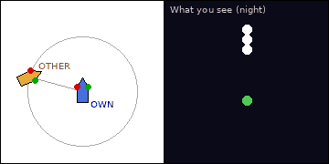
Situation: Night, open sea. A vessel (orange) is 75° off your bow, on your port beam, range 4 nm, bearing steady and range decreasing. You (blue) are power-driven. The black panel shows the lights you see.
Q1. Identify the vessel from the lights shown and describe her aspect.
A. The lights show three masthead lights in a vertical line with sidelights; from astern a yellow towing light above the sternlight. She is a towing vessel with a tow exceeding 200 m. From your position you see her green (starboard) sidelight and masthead light(s); she is crossing your bow from your port side to your starboard side.
Q2. What are your Rule, role and action?
A. Rule 17: she is on your port side with you on her starboard side, so you are stand-on; maintain course and speed. Allow extra room: the tow can extend more than 200 m astern and cannot readily alter.

Card 65 – Vessel pushing ahead (1/4)
Situation: Night, open sea. A vessel (orange) is 30° on your starboard bow, range 4 nm, bearing steady and range decreasing. You (blue) are power-driven. The black panel shows the lights you see.
Q1. Identify the vessel from the lights shown and describe her aspect.
A. The lights show two masthead lights in a vertical line with sidelights and no yellow towing light. She is a power-driven vessel pushing ahead or towing alongside. From your position you see her red (port) sidelight and masthead light(s); she is crossing your bow from your starboard side to your port side.
Q2. What are your Rule, role and action?
A. Rules 15 and 16: she is on your starboard side, so you give way; alter to starboard and pass astern. If pusher and pushed vessel are rigidly connected they are one power-driven vessel.
Q3. Which lights are shown by rigidly connected composite units?
A. The lights of a single power-driven vessel (Rule 24(b)).

Card 66 – Vessel pushing ahead (2/4)
Situation: Night, open sea. A vessel (orange) is 40° on your port bow, range 4 nm, bearing steady and range decreasing. You (blue) are power-driven. The black panel shows the lights you see.
Q1. Identify the vessel from the lights shown and describe her aspect.
A. The lights show two masthead lights in a vertical line with sidelights and no yellow towing light. She is a power-driven vessel pushing ahead or towing alongside. From your position you see her green (starboard) sidelight and masthead light(s); she is crossing your bow from your port side to your starboard side.
Q2. What are your Rule, role and action?
A. Rule 17: she is on your port side with you on her starboard side, so you are stand-on; maintain course and speed. If pusher and pushed vessel are rigidly connected they are one power-driven vessel.

Card 67 – Vessel pushing ahead (3/4)
Situation: Night, open sea. A vessel (orange) is right ahead, range 4 nm, bearing steady and range decreasing. You (blue) are power-driven. The black panel shows the lights you see.
Q1. Identify the vessel from the lights shown and describe her aspect.
A. The lights show two masthead lights in a vertical line with sidelights and no yellow towing light. She is a power-driven vessel pushing ahead or towing alongside. From your position you see both her red and green sidelights, with her masthead light(s); she is heading almost directly toward you (end-on).
Q2. What are your Rule, role and action?
A. Rule 14 head-on: both alter to starboard and pass port to port. If pusher and pushed vessel are rigidly connected they are one power-driven vessel.

Card 68 – Vessel pushing ahead (4/4)
Situation: Night, open sea. A vessel (orange) is 75° off your bow, on your port beam, range 4 nm, bearing steady and range decreasing. You (blue) are power-driven. The black panel shows the lights you see.
Q1. Identify the vessel from the lights shown and describe her aspect.
A. The lights show two masthead lights in a vertical line with sidelights and no yellow towing light. She is a power-driven vessel pushing ahead or towing alongside. From your position you see her green (starboard) sidelight and masthead light(s); she is crossing your bow from your port side to your starboard side.
Q2. What are your Rule, role and action?
A. Rule 17: she is on your port side with you on her starboard side, so you are stand-on; maintain course and speed. If pusher and pushed vessel are rigidly connected they are one power-driven vessel.

Card 69 – Sailing vessel (1/4)
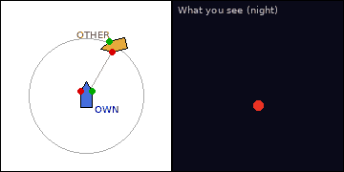
Situation: Night, open sea. A vessel (orange) is 30° on your starboard bow, range 4 nm, bearing steady and range decreasing. You (blue) are power-driven. The black panel shows the lights you see.
Q1. Identify the vessel from the lights shown and describe her aspect.
A. The lights show only sidelights, with no masthead light (and a sternlight from astern). She is a sailing vessel underway. From your position you see her red (port) sidelight and masthead light(s); she is crossing your bow from your starboard side to your port side.
Q2. What are your Rule, role and action?
A. You are the give-way vessel (Rule 18(a)(iv)): a power-driven vessel keeps out of the way of a sailing vessel, whichever side she is on. Take early, substantial action (normally pass astern), reduce speed if needed, and keep clear of any gear or tow.
Q3. What does a cone apex down in her rigging mean?
A. She is under sail and engine; she is treated as a power-driven vessel (Rule 25(e)).

Card 70 – Sailing vessel (2/4)
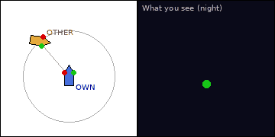
Situation: Night, open sea. A vessel (orange) is 40° on your port bow, range 4 nm, bearing steady and range decreasing. You (blue) are power-driven. The black panel shows the lights you see.
Q1. Identify the vessel from the lights shown and describe her aspect.
A. The lights show only sidelights, with no masthead light (and a sternlight from astern). She is a sailing vessel underway. From your position you see her green (starboard) sidelight and masthead light(s); she is crossing your bow from your port side to your starboard side.
Q2. What are your Rule, role and action?
A. You are the give-way vessel (Rule 18(a)(iv)): a power-driven vessel keeps out of the way of a sailing vessel, whichever side she is on. Take early, substantial action (normally pass astern), reduce speed if needed, and keep clear of any gear or tow.

Card 71 – Sailing vessel (3/4)
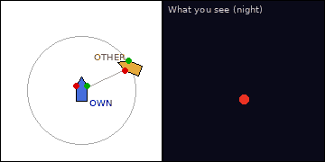
Situation: Night, open sea. A vessel (orange) is 65° on your starboard bow, range 4 nm, bearing steady and range decreasing. You (blue) are power-driven. The black panel shows the lights you see.
Q1. Identify the vessel from the lights shown and describe her aspect.
A. The lights show only sidelights, with no masthead light (and a sternlight from astern). She is a sailing vessel underway. From your position you see her red (port) sidelight and masthead light(s); she is crossing your bow from your starboard side to your port side.
Q2. What are your Rule, role and action?
A. You are the give-way vessel (Rule 18(a)(iv)): a power-driven vessel keeps out of the way of a sailing vessel, whichever side she is on. Take early, substantial action (normally pass astern), reduce speed if needed, and keep clear of any gear or tow.

Card 72 – Sailing vessel (4/4)
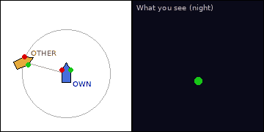
Situation: Night, open sea. A vessel (orange) is 75° off your bow, on your port beam, range 4 nm, bearing steady and range decreasing. You (blue) are power-driven. The black panel shows the lights you see.
Q1. Identify the vessel from the lights shown and describe her aspect.
A. The lights show only sidelights, with no masthead light (and a sternlight from astern). She is a sailing vessel underway. From your position you see her green (starboard) sidelight and masthead light(s); she is crossing your bow from your port side to your starboard side.
Q2. What are your Rule, role and action?
A. You are the give-way vessel (Rule 18(a)(iv)): a power-driven vessel keeps out of the way of a sailing vessel, whichever side she is on. Take early, substantial action (normally pass astern), reduce speed if needed, and keep clear of any gear or tow.

Card 73 – Pilot vessel on duty (1/4)
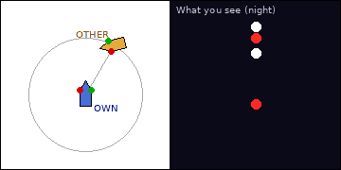
Situation: Night, open sea. A vessel (orange) is 30° on your starboard bow, range 4 nm, bearing steady and range decreasing. You (blue) are power-driven. The black panel shows the lights you see.
Q1. Identify the vessel from the lights shown and describe her aspect.
A. The lights show a white light over a red light (all-round) plus masthead and sidelights. She is a pilot vessel on duty, underway. From your position you see her red (port) sidelight and masthead light(s); she is crossing your bow from your starboard side to your port side.
Q2. What are your Rule, role and action?
A. Rules 15 and 16: she is on your starboard side, so you give way; alter to starboard and pass astern. Give her room: she may be manoeuvring to embark or disembark a pilot.
Q3. What is her identity sound signal in restricted visibility?
A. Four short blasts (Rule 35(j)).

Card 74 – Pilot vessel on duty (2/4)
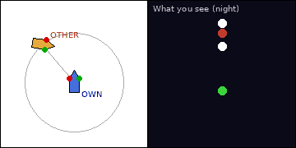
Situation: Night, open sea. A vessel (orange) is 40° on your port bow, range 4 nm, bearing steady and range decreasing. You (blue) are power-driven. The black panel shows the lights you see.
Q1. Identify the vessel from the lights shown and describe her aspect.
A. The lights show a white light over a red light (all-round) plus masthead and sidelights. She is a pilot vessel on duty, underway. From your position you see her green (starboard) sidelight and masthead light(s); she is crossing your bow from your port side to your starboard side.
Q2. What are your Rule, role and action?
A. Rule 17: she is on your port side with you on her starboard side, so you are stand-on; maintain course and speed. Give her room: she may be manoeuvring to embark or disembark a pilot.

Card 75 – Pilot vessel on duty (3/4)
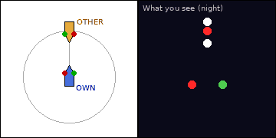
Situation: Night, open sea. A vessel (orange) is right ahead, range 4 nm, bearing steady and range decreasing. You (blue) are power-driven. The black panel shows the lights you see.
Q1. Identify the vessel from the lights shown and describe her aspect.
A. The lights show a white light over a red light (all-round) plus masthead and sidelights. She is a pilot vessel on duty, underway. From your position you see both her red and green sidelights, with her masthead light(s); she is heading almost directly toward you (end-on).
Q2. What are your Rule, role and action?
A. Rule 14 head-on: both alter to starboard and pass port to port. Give her room: she may be manoeuvring to embark or disembark a pilot.

Card 76 – Pilot vessel on duty (4/4)
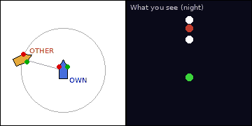
Situation: Night, open sea. A vessel (orange) is 75° off your bow, on your port beam, range 4 nm, bearing steady and range decreasing. You (blue) are power-driven. The black panel shows the lights you see.
Q1. Identify the vessel from the lights shown and describe her aspect.
A. The lights show a white light over a red light (all-round) plus masthead and sidelights. She is a pilot vessel on duty, underway. From your position you see her green (starboard) sidelight and masthead light(s); she is crossing your bow from your port side to your starboard side.
Q2. What are your Rule, role and action?
A. Rule 17: she is on your port side with you on her starboard side, so you are stand-on; maintain course and speed. Give her room: she may be manoeuvring to embark or disembark a pilot.

Card 77 – Vessel at anchor (50 m or more) (1/4)
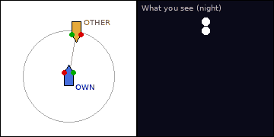
Situation: Night, open sea. A vessel (orange) is 10° on your starboard bow, range 4 nm, bearing steady and range decreasing. You (blue) are power-driven. The black panel shows the lights you see.
Q1. Identify the vessel from the lights shown.
A. The lights show two white all-round lights, the after one lower, and no sidelights. She is a vessel at anchor, 50 m or more in length.
Q2. What are your Rule, role and action?
A. Rules 13–18 do not designate her as stand-on or give-way because she is not underway, but you are underway and must keep well clear: proceed at safe speed (Rule 6), alter early and by a readily apparent amount (Rule 8), and mind your wash.
Q3. What is the day signal?
A. One black ball in the forepart; a vessel of 100 m or more also illuminates her decks at night.

Card 78 – Vessel at anchor (50 m or more) (2/4)
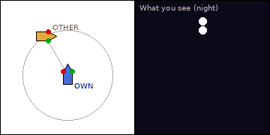
Situation: Night, open sea. A vessel (orange) is 30° on your port bow, range 4 nm, bearing steady and range decreasing. You (blue) are power-driven. The black panel shows the lights you see.
Q1. Identify the vessel from the lights shown.
A. The lights show two white all-round lights, the after one lower, and no sidelights. She is a vessel at anchor, 50 m or more in length.
Q2. What are your Rule, role and action?
A. Rules 13–18 do not designate her as stand-on or give-way because she is not underway, but you are underway and must keep well clear: proceed at safe speed (Rule 6), alter early and by a readily apparent amount (Rule 8), and mind your wash.

Card 79 – Vessel at anchor (50 m or more) (3/4)
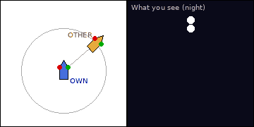
Situation: Night, open sea. A vessel (orange) is 50° on your starboard bow, range 4 nm, bearing steady and range decreasing. You (blue) are power-driven. The black panel shows the lights you see.
Q1. Identify the vessel from the lights shown.
A. The lights show two white all-round lights, the after one lower, and no sidelights. She is a vessel at anchor, 50 m or more in length.
Q2. What are your Rule, role and action?
A. Rules 13–18 do not designate her as stand-on or give-way because she is not underway, but you are underway and must keep well clear: proceed at safe speed (Rule 6), alter early and by a readily apparent amount (Rule 8), and mind your wash.

Card 80 – Vessel at anchor (50 m or more) (4/4)
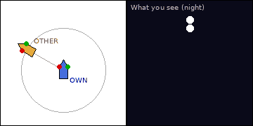
Situation: Night, open sea. A vessel (orange) is 60° on your port bow, range 4 nm, bearing steady and range decreasing. You (blue) are power-driven. The black panel shows the lights you see.
Q1. Identify the vessel from the lights shown.
A. The lights show two white all-round lights, the after one lower, and no sidelights. She is a vessel at anchor, 50 m or more in length.
Q2. What are your Rule, role and action?
A. Rules 13–18 do not designate her as stand-on or give-way because she is not underway, but you are underway and must keep well clear: proceed at safe speed (Rule 6), alter early and by a readily apparent amount (Rule 8), and mind your wash.

Card 81 – Vessel at anchor (under 50 m) (1/4)
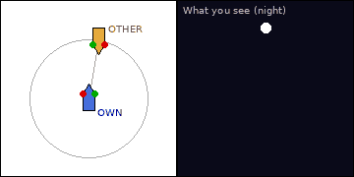
Situation: Night, open sea. A vessel (orange) is 10° on your starboard bow, range 4 nm, bearing steady and range decreasing. You (blue) are power-driven. The black panel shows the lights you see.
Q1. Identify the vessel from the lights shown.
A. The lights show one white all-round light and no sidelights. She is a vessel at anchor, under 50 m in length.
Q2. What are your Rule, role and action?
A. She is not underway; you must keep well clear: reduce to a safe speed (Rule 6), alter early (Rule 8), and mind your wash.
Q3. What is the day signal?
A. One black ball in the forepart (Rule 30).

Card 82 – Vessel at anchor (under 50 m) (2/4)
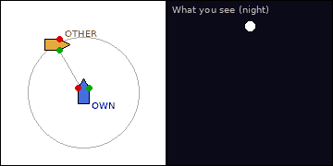
Situation: Night, open sea. A vessel (orange) is 30° on your port bow, range 4 nm, bearing steady and range decreasing. You (blue) are power-driven. The black panel shows the lights you see.
Q1. Identify the vessel from the lights shown.
A. The lights show one white all-round light and no sidelights. She is a vessel at anchor, under 50 m in length.
Q2. What are your Rule, role and action?
A. She is not underway; you must keep well clear: reduce to a safe speed (Rule 6), alter early (Rule 8), and mind your wash.

Card 83 – Vessel at anchor (under 50 m) (3/4)
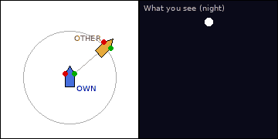
Situation: Night, open sea. A vessel (orange) is 50° on your starboard bow, range 4 nm, bearing steady and range decreasing. You (blue) are power-driven. The black panel shows the lights you see.
Q1. Identify the vessel from the lights shown.
A. The lights show one white all-round light and no sidelights. She is a vessel at anchor, under 50 m in length.
Q2. What are your Rule, role and action?
A. She is not underway; you must keep well clear: reduce to a safe speed (Rule 6), alter early (Rule 8), and mind your wash.

Card 84 – Vessel at anchor (under 50 m) (4/4)
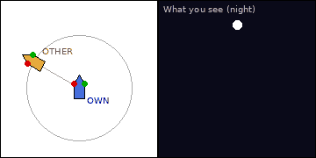
Situation: Night, open sea. A vessel (orange) is 60° on your port bow, range 4 nm, bearing steady and range decreasing. You (blue) are power-driven. The black panel shows the lights you see.
Q1. Identify the vessel from the lights shown.
A. The lights show one white all-round light and no sidelights. She is a vessel at anchor, under 50 m in length.
Q2. What are your Rule, role and action?
A. She is not underway; you must keep well clear: reduce to a safe speed (Rule 6), alter early (Rule 8), and mind your wash.

Card 85 – Vessel aground (1/4)
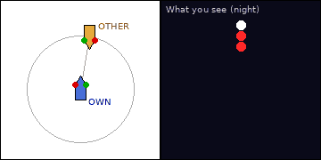
Situation: Night, open sea. A vessel (orange) is 10° on your starboard bow, range 4 nm, bearing steady and range decreasing. You (blue) are power-driven. The black panel shows the lights you see.
Q1. Identify the vessel from the lights shown.
A. The lights show an anchor light with two red all-round lights below it in a vertical line. She is a vessel aground.
Q2. What are your Rule, role and action?
A. Keep well clear: alter early, slow down to avoid wash or squat worsening her position, stay in safe water yourself (Rules 2, 6 and 8).
Q3. What is the day signal?
A. Three black balls in a vertical line.

Card 86 – Vessel aground (2/4)
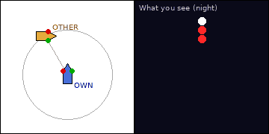
Situation: Night, open sea. A vessel (orange) is 30° on your port bow, range 4 nm, bearing steady and range decreasing. You (blue) are power-driven. The black panel shows the lights you see.
Q1. Identify the vessel from the lights shown.
A. The lights show an anchor light with two red all-round lights below it in a vertical line. She is a vessel aground.
Q2. What are your Rule, role and action?
A. Keep well clear: alter early, slow down to avoid wash or squat worsening her position, stay in safe water yourself (Rules 2, 6 and 8).

Card 87 – Vessel aground (3/4)
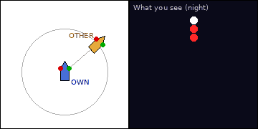
Situation: Night, open sea. A vessel (orange) is 50° on your starboard bow, range 4 nm, bearing steady and range decreasing. You (blue) are power-driven. The black panel shows the lights you see.
Q1. Identify the vessel from the lights shown.
A. The lights show an anchor light with two red all-round lights below it in a vertical line. She is a vessel aground.
Q2. What are your Rule, role and action?
A. Keep well clear: alter early, slow down to avoid wash or squat worsening her position, stay in safe water yourself (Rules 2, 6 and 8).

Card 88 – Vessel aground (4/4)
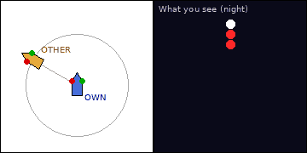
Situation: Night, open sea. A vessel (orange) is 60° on your port bow, range 4 nm, bearing steady and range decreasing. You (blue) are power-driven. The black panel shows the lights you see.
Q1. Identify the vessel from the lights shown.
A. The lights show an anchor light with two red all-round lights below it in a vertical line. She is a vessel aground.
Q2. What are your Rule, role and action?
A. Keep well clear: alter early, slow down to avoid wash or squat worsening her position, stay in safe water yourself (Rules 2, 6 and 8).

Card 89 – Mine clearance vessel (1/4)
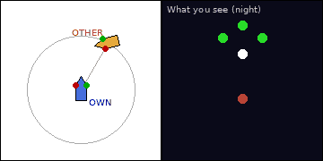
Situation: Night, open sea. A vessel (orange) is 30° on your starboard bow, range 4 nm, bearing steady and range decreasing. You (blue) are power-driven. The black panel shows the lights you see.
Q1. Identify the vessel from the lights shown and describe her aspect.
A. The lights show three green all-round lights (one at the foremast head and one at each end of the fore yard) in addition to normal power-driven lights. She is a vessel engaged in mine clearance. From your position you see her red (port) sidelight and masthead light(s); she is crossing your bow from your starboard side to your port side.
Q2. What are your Rule, role and action?
A. She is restricted in her ability to manoeuvre, so you give way (Rule 18(a)(ii)). It is dangerous to approach within 1000 m: keep well outside that distance (Rule 27(f)).
Q3. What is the day signal?
A. Three black balls, one at the foremast head and one at each end of the fore yard.

Card 90 – Mine clearance vessel (2/4)
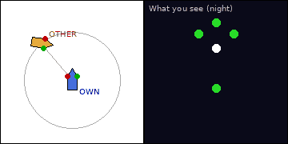
Situation: Night, open sea. A vessel (orange) is 40° on your port bow, range 4 nm, bearing steady and range decreasing. You (blue) are power-driven. The black panel shows the lights you see.
Q1. Identify the vessel from the lights shown and describe her aspect.
A. The lights show three green all-round lights (one at the foremast head and one at each end of the fore yard) in addition to normal power-driven lights. She is a vessel engaged in mine clearance. From your position you see her green (starboard) sidelight and masthead light(s); she is crossing your bow from your port side to your starboard side.
Q2. What are your Rule, role and action?
A. She is restricted in her ability to manoeuvre, so you give way (Rule 18(a)(ii)). It is dangerous to approach within 1000 m: keep well outside that distance (Rule 27(f)).

Card 91 – Mine clearance vessel (3/4)
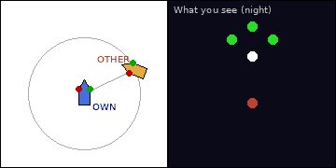
Situation: Night, open sea. A vessel (orange) is 65° on your starboard bow, range 4 nm, bearing steady and range decreasing. You (blue) are power-driven. The black panel shows the lights you see.
Q1. Identify the vessel from the lights shown and describe her aspect.
A. The lights show three green all-round lights (one at the foremast head and one at each end of the fore yard) in addition to normal power-driven lights. She is a vessel engaged in mine clearance. From your position you see her red (port) sidelight and masthead light(s); she is crossing your bow from your starboard side to your port side.
Q2. What are your Rule, role and action?
A. She is restricted in her ability to manoeuvre, so you give way (Rule 18(a)(ii)). It is dangerous to approach within 1000 m: keep well outside that distance (Rule 27(f)).

Card 92 – Mine clearance vessel (4/4)
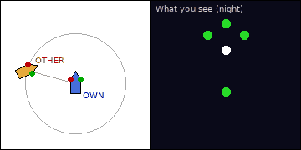
Situation: Night, open sea. A vessel (orange) is 75° off your bow, on your port beam, range 4 nm, bearing steady and range decreasing. You (blue) are power-driven. The black panel shows the lights you see.
Q1. Identify the vessel from the lights shown and describe her aspect.
A. The lights show three green all-round lights (one at the foremast head and one at each end of the fore yard) in addition to normal power-driven lights. She is a vessel engaged in mine clearance. From your position you see her green (starboard) sidelight and masthead light(s); she is crossing your bow from your port side to your starboard side.
Q2. What are your Rule, role and action?
A. She is restricted in her ability to manoeuvre, so you give way (Rule 18(a)(ii)). It is dangerous to approach within 1000 m: keep well outside that distance (Rule 27(f)).

Card 93 – Air-cushion vessel (1/4)
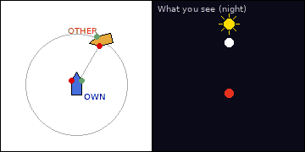
Situation: Night, open sea. A vessel (orange) is 30° on your starboard bow, range 4 nm, bearing steady and range decreasing. You (blue) are power-driven. The black panel shows the lights you see.
Q1. Identify the vessel from the lights shown and describe her aspect.
A. The lights show an all-round flashing yellow light in addition to normal power-driven lights. She is an air-cushion vessel in the non-displacement mode. From your position you see her red (port) sidelight and masthead light(s); she is crossing your bow from your starboard side to your port side.
Q2. What are your Rule, role and action?
A. Rules 15 and 16: she is on your starboard side, so you give way; alter to starboard and pass astern. She can move fast and change direction suddenly: act early.
Q3. Which light identifies an air-cushion vessel?
A. An all-round flashing yellow light (Rule 23(b)).

Card 94 – Air-cushion vessel (2/4)
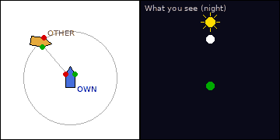
Situation: Night, open sea. A vessel (orange) is 40° on your port bow, range 4 nm, bearing steady and range decreasing. You (blue) are power-driven. The black panel shows the lights you see.
Q1. Identify the vessel from the lights shown and describe her aspect.
A. The lights show an all-round flashing yellow light in addition to normal power-driven lights. She is an air-cushion vessel in the non-displacement mode. From your position you see her green (starboard) sidelight and masthead light(s); she is crossing your bow from your port side to your starboard side.
Q2. What are your Rule, role and action?
A. Rule 17: she is on your port side with you on her starboard side, so you are stand-on; maintain course and speed. She can move fast and change direction suddenly: act early.

Card 95 – Air-cushion vessel (3/4)
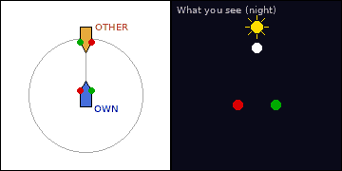
Situation: Night, open sea. A vessel (orange) is right ahead, range 4 nm, bearing steady and range decreasing. You (blue) are power-driven. The black panel shows the lights you see.
Q1. Identify the vessel from the lights shown and describe her aspect.
A. The lights show an all-round flashing yellow light in addition to normal power-driven lights. She is an air-cushion vessel in the non-displacement mode. From your position you see both her red and green sidelights, with her masthead light(s); she is heading almost directly toward you (end-on).
Q2. What are your Rule, role and action?
A. Rule 14 head-on: both alter to starboard and pass port to port. She can move fast and change direction suddenly: act early.

Card 96 – Air-cushion vessel (4/4)
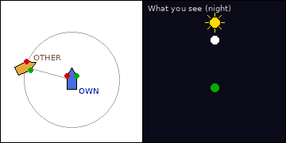
Situation: Night, open sea. A vessel (orange) is 75° off your bow, on your port beam, range 4 nm, bearing steady and range decreasing. You (blue) are power-driven. The black panel shows the lights you see.
Q1. Identify the vessel from the lights shown and describe her aspect.
A. The lights show an all-round flashing yellow light in addition to normal power-driven lights. She is an air-cushion vessel in the non-displacement mode. From your position you see her green (starboard) sidelight and masthead light(s); she is crossing your bow from your port side to your starboard side.
Q2. What are your Rule, role and action?
A. Rule 17: she is on your port side with you on her starboard side, so you are stand-on; maintain course and speed. She can move fast and change direction suddenly: act early.

Part C – Sailing Vessels (Rule 12)

Card 97 – Sailing v sailing – port tack v starboard tack
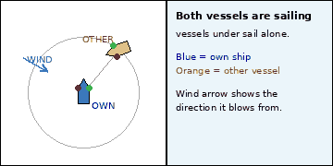
Situation: Day, open sea. Both vessels are sailing vessels under sail alone, with the wind as shown. The other vessel is 40° on your starboard bow, range 1 nm, bearing steady. You are the blue vessel.
Q1. On which side is the wind for each vessel, and which is on which tack?
A. Own ship has the wind on her port side (port tack); the other vessel has the wind on her starboard side (starboard tack).
Q2. Which Rule applies and who gives way?
A. Rule 12(a)(i): when each has the wind on a different side, the vessel with the wind on the port side keeps out of the way. So own ship gives way and the other vessel is stand-on.
Q3. What is your action as give-way vessel?
A. Alter course early and substantially (bear away or tack as appropriate) and keep well clear; do not cross close ahead.

Card 98 – Sailing v sailing – starboard tack v port tack
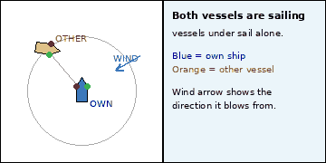
Situation: Day, open sea. Both vessels are sailing vessels under sail alone, with the wind as shown. The other vessel is 40° on your port bow, range 1 nm, bearing steady. You are the blue vessel.
Q1. On which side is the wind for each vessel, and which is on which tack?
A. Own ship has the wind on her starboard side (starboard tack); the other vessel has the wind on her port side (port tack).
Q2. Which Rule applies and who gives way?
A. Rule 12(a)(i): when each has the wind on a different side, the vessel with the wind on the port side keeps out of the way. So the other vessel gives way and own ship is stand-on.
Q3. What is your action as stand-on vessel?
A. Hold course and speed (Rule 17), watch her closely, and be ready to act if she does not (17(a)(ii), 17(b)).

Card 99 – Sailing v sailing – port tack v port tack
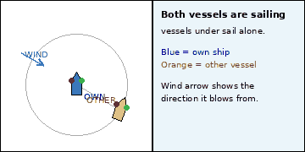
Situation: Day, open sea. Both vessels are sailing vessels under sail alone, with the wind as shown. The other vessel is 120° off your bow, on your starboard quarter, range 1 nm, bearing steady. You are the blue vessel.
Q1. On which side is the wind for each vessel, and which is on which tack?
A. Own ship has the wind on her port side (port tack); the other vessel has the wind on her port side (port tack).
Q2. Which Rule applies and who gives way?
A. Rule 12(a)(ii): when both have the wind on the same side, the vessel to windward keeps out of the way of the one to leeward. The other vessel is to leeward, so you, to windward, give way.
Q3. What is your action as give-way vessel?
A. Alter course early and substantially (bear away or tack as appropriate) and keep well clear; do not cross close ahead.

Card 100 – Sailing v sailing – port tack v port tack
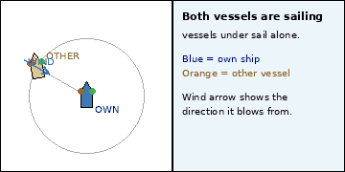
Situation: Day, open sea. Both vessels are sailing vessels under sail alone, with the wind as shown. The other vessel is 60° on your port bow, range 1 nm, bearing steady. You are the blue vessel.
Q1. On which side is the wind for each vessel, and which is on which tack?
A. Own ship has the wind on her port side (port tack); the other vessel has the wind on her port side (port tack).
Q2. Which Rule applies and who gives way?
A. Rule 12(a)(ii): when both have the wind on the same side, the vessel to windward keeps out of the way of the one to leeward. The other vessel is to windward, so she gives way.
Q3. What is your action as stand-on vessel?
A. Hold course and speed (Rule 17), watch her closely, and be ready to act if she does not (17(a)(ii), 17(b)).

Card 101 – Sailing v sailing – starboard tack v starboard tack
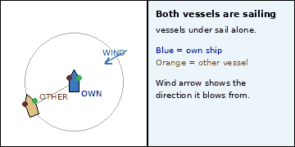
Situation: Day, open sea. Both vessels are sailing vessels under sail alone, with the wind as shown. The other vessel is 120° off your bow, on your port quarter, range 1 nm, bearing steady. You are the blue vessel.
Q1. On which side is the wind for each vessel, and which is on which tack?
A. Own ship has the wind on her starboard side (starboard tack); the other vessel has the wind on her starboard side (starboard tack).
Q2. Which Rule applies and who gives way?
A. Rule 12(a)(ii): when both have the wind on the same side, the vessel to windward keeps out of the way of the one to leeward. The other vessel is to leeward, so you, to windward, give way.
Q3. What is your action as give-way vessel?
A. Alter course early and substantially (bear away or tack as appropriate) and keep well clear; do not cross close ahead.

Card 102 – Sailing v sailing – port tack v starboard tack
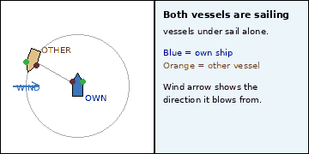
Situation: Day, open sea. Both vessels are sailing vessels under sail alone, with the wind as shown. The other vessel is 60° on your port bow, range 1 nm, bearing steady. You are the blue vessel.
Q1. On which side is the wind for each vessel, and which is on which tack?
A. Own ship has the wind on her port side (port tack); the other vessel has the wind on her starboard side (starboard tack).
Q2. Which Rule applies and who gives way?
A. Rule 12(a)(i): when each has the wind on a different side, the vessel with the wind on the port side keeps out of the way. So own ship gives way and the other vessel is stand-on.
Q3. What is your action as give-way vessel?
A. Alter course early and substantially (bear away or tack as appropriate) and keep well clear; do not cross close ahead.

