SESSION 1 — Introduction to Statistics
(Descriptive vs Inferential Statistics)

What is Statistics?
Definition
Statistics is the science of:
Collecting, organizing, analyzing, and interpreting data to make decisions.
In simple words:
Statistics helps us convert raw data into useful information.

Real-World Examples
- Netflix analyzes watch-time data to recommend movies
- Amazon studies customer purchases to suggest products
- Hospitals analyze patient data to predict disease
- Banks analyze transactions to detect fraud
- Governments analyze census data for planning

For a Data Analyst
Statistics helps you:
Understand data
Summarize large datasets
Find patterns
Make predictions
Take business decisions

Types of Statistics
There are TWO main types:

A) Descriptive Statistics
Definition
Descriptive statistics describe and summarize data.
It answers:
What happened?
Examples of Descriptive Stats
• Mean (average)
• Median
• Mode
• Standard deviation
• Charts (bar chart, pie chart, histogram)

Real Example
A company records daily sales:
100, 120, 130, 150, 200
Descriptive stats:
• Mean = 140
• Max = 200
• Min = 100
It only describes past data.

Data Analyst Use
Dashboards
KPI reports
Monthly sales reports
Customer summary
Excel / Power BI charts

B) Inferential Statistics
Definition
Inferential statistics draw conclusions about a population using a sample.
It answers:
What will happen?
Is this change real or by chance?

Examples
• Hypothesis testing
• Confidence intervals
• t-test
• Regression
• ANOVA

Real Example
You test a new price on 100 customers (sample)
You conclude it will work for all customers (population).

Data Analyst Use
A/B testing
Marketing impact analysis
Churn prediction
Revenue forecasting
Product experiments

Population vs Sample

Population
Entire group of interest
Example:
All customers of Amazon = population

Sample
Small subset taken from population
Example:
1000 customers selected from Amazon users

Why sample?
• Cheaper
• Faster
• Sometimes population is too large
• Sometimes impossible to measure whole population

Example
Population = all Indian voters
Sample = 5000 voters surveyed

Parameter vs Statistic
Concept | Meaning | Symbol
Parameter | Measure from population | μ (mu), σ
Statistic | Measure from sample | x̄ (mean), s

Example
Population average salary = μ = ₹50,000
Sample average salary = x̄ = ₹48,000

Business Use of Statistics
Companies use statistics to:
Forecast sales
Improve quality
Reduce risk
Understand customers
Detect fraud
Optimize pricing

Excel Demo (Concept)
Dataset: Customer purchases
Columns:
CustomerID | Spend
Steps:
- Treat all data = population
- Randomly pick 20 rows = sample
- Compare:
• Mean of population
• Mean of sample
- Observe difference

Math Formulas
Sample Mean:
xˉ=∑xn\bar{x} = \frac{\sum x}{n}xˉ=n∑x​
Population Mean:
μ=∑XN\mu = \frac{\sum X}{N}μ=N∑X​
Where:
x = sample values
X = population values
n = sample size
N = population size

Examples
Example 1
Sales of 5 days: 100, 120, 130, 150, 200
Mean = (700)/5 = 140

Example 2
Company surveys 100 customers out of 10,000
100 = sample
10,000 = population

Example 3
Average height of class = statistic
Average height of all students in college = parameter

Example 4
You analyze last year’s revenue (descriptive)
You predict next year’s revenue (inferential)

Example 5
Churn rate from sample = 5%
Estimated churn of population = 5%

Mini Project – Session 1
Project: Customer Sales Summary
Dataset (create in Excel):
CustomerID | Sales
Tasks:
- Treat full data as population
- Take random 10 customers as sample
- Compute:
• Population mean
• Sample mean
- Compare both
- Write 3 insights:
• Is sample close to population?
• Is sampling reliable?
• Business decision

10 Questions
Theory (5)
- Define statistics : It is the science of collecting, organizing, analyzing and interpreting raw data into useful insights.
- Difference between descriptive and inferential statistics : Descriptive stats tells us what happened from the past data, and inferential stats predicts what will happen from a small selected data.
- What is population? : In inferential stats the overall data taken is known as population.
- What is sample? : It is a small part of the population used to do inferential stats.
- Difference between parameter and statistic : The answer we get from population is known as parameter and the answer from sample is known as statistic.

Practical (5)
- Identify population and sample: Survey of 200 voters out of 50,000
Population : 50000, Sample : 200
- Sales data of last year → descriptive or inferential? : descriptive because data from past
- Predicting next month sales → which type? : Inferential because prediction
- Mean of sample = 500, population mean = 520 → which is parameter? : 520
- Give one business example of inferential statistics : beta testing in games.

SESSION 2 — Types of Data & Measurement Scales

What Do We Mean by “Types of Data”?
Definition
Data types tell us:
- What kind of values a column contains
- What calculations are allowed
- Which charts, tests, and models we can use
Choosing the wrong data type = wrong analysis

Major Classification of Data
There are two broad types of data:
A) Numerical (Quantitative Data)
B) Categorical (Qualitative Data)

A) Numerical (Quantitative Data)
Definition
Numerical data consists of numbers on which mathematical operations like addition, subtraction, average, etc., make sense.
It answers:
- How many?
- How much?
Types of Numerical Data

1.Discrete Data
Definition
Discrete data consists of countable values.
It is obtained by counting.
Key Property
No intermediate values are possible.

Examples
- Number of customers = 120
- Number of orders = 45
- Number of employees = 300
- Number of defective products = 7
You cannot have 2.5 customers

Real-World Use Case
- Bank: number of transactions per day
- Call center: number of calls received
- Factory: number of items produced

For a Data Analyst
- Used in bar charts
- Used in frequency tables
- Used in Poisson & Binomial distributions

2.Continuous Data
Definition
Continuous data can take any value within a range, including decimals.
It is obtained by measurement.

Examples
- Salary = 45,678.75
- Height = 170.4 cm
- Time = 2.35 hours
- Temperature = 36.6°C

Real-World Use Case
- Daily revenue
- Customer spending
- Sensor readings
- Delivery time

For a Data Analyst
- Used in histograms
- Used in Normal distribution
- Used in regression analysis

B) Categorical (Qualitative Data)
Definition
Categorical data represents labels or groups, not numeric magnitude.
It answers:
- Which type?

Types of Categorical Data

3.Nominal Data
Definition
Nominal data has categories with no natural order.

Examples
- Gender (Male, Female)
- Blood group (A, B, AB, O)
- Country (India, USA, UK)
- Product category (Electronics, Clothing)

Key Rule
No ranking
No average

For a Data Analyst
- Used in pie charts
- Used in bar charts
- Used in Chi-square test

4.Ordinal Data
Definition
Ordinal data has categories with order, but the difference between them is not measurable.

Examples
- Customer satisfaction (Low, Medium, High)
- Education level (School, College, PG)
- Hotel ratings (1-star to 5-star)

Key Rule
Order matters
Mean is not meaningful

For a Data Analyst
- Used in survey analysis
- Used in ranking problems
- Used in non-parametric tests

3. Time-Series Data
Definition
Time-series data is collected over time at regular intervals.

Examples
- Daily sales
- Monthly profit
- Yearly population
- Hourly website traffic

For a Data Analyst
- Trend analysis
- Forecasting
- Seasonality detection

4. Measurement Scales
Measurement scales define what operations are allowed on data.
There are four scales:

1. Nominal Scale
- Labels only
- No order
Examples: Gender, City, Product type
Frequency count
Mean, median

2. Ordinal Scale
- Ordered categories
Examples: Ratings, Satisfaction level
Median
Mean

3. Interval Scale
- Equal intervals
- No true zero
Examples: Temperature (°C), Calendar years
Addition, subtraction
Ratios

4. Ratio Scale
- Equal intervals
- True zero exists
Examples: Salary, Age, Sales
All arithmetic operations

Business Dataset Example
Telecom Dataset Columns
Column | Data Type | Scale
CustomerID | Categorical | Nominal
Gender | Categorical | Nominal
Tenure | Numerical | Ratio
MonthlyCharges | Numerical | Ratio
Contract | Categorical | Nominal
Churn | Categorical | Nominal
Correct classification helps choose:
- Charts
- Statistical tests
- ML models

Five Worked Examples
Example 1
Number of students → Discrete numerical
Example 2
Height of students → Continuous numerical
Example 3
Education level → Ordinal
Example 4
Temperature in Celsius → Interval
Example 5
Monthly income → Ratio

Mini Project — Session 2
Project: Customer Data Classification
Dataset (Excel):
- CustomerID
- Age
- Gender
- City
- SatisfactionLevel
- MonthlySpend
Tasks
- Identify numerical vs categorical
- Identify discrete vs continuous
- Identify nominal vs ordinal
- Identify measurement scale
- Suggest best chart for each column
- Write 5 business insights

10 Practice Questions
Theory (5)
- Define numerical data : They are the countable values on which arithmetic operations can be perrformed
- Difference between discrete and continuous : Discrete data contains whole number values and continuous data contains point values
- What is nominal data? : They are the categorized data with no order
- Difference between ordinal and interval : Ordinal data has categorized data with order but cannot be measured and interval data are non zero data with equal intervals.
- What is ratio scale? : Ratio scale is same as interval but here true zero value exist.

Practical (5)
- Classify: number of website visits : Discrete
- Classify: customer rating (Poor–Excellent) : Ratio scale, ordinal
- Classify: temperature in Celsius : Interval scale
- Classify: blood group : Nominal data
- Classify: annual income : time series data
SESSION 3 — Measures of Central Tendency
(Mean, Median, Mode)

What Are Measures of Central Tendency?
Definition
Measures of central tendency describe the center or typical value of a dataset.
They answer:
What is a “normal” or “representative” value?
The three most important measures are:
- Mean
- Median
- Mode

Mean (Arithmetic Average)
Definition
The mean is the sum of all values divided by the total number of observations.
Formula
Mean=xˉ=∑xn\text{Mean} = \bar{x} = \frac{\sum x}{n}Mean=xˉ=n∑x​
Where:
- xyz = individual values
- nnn = number of observations

Example 1
Daily sales (₹):
100, 120, 130, 150, 200
Mean=100+120+130+150+2005=140\text{Mean} = \frac{100+120+130+150+200}{5} = 140Mean=5100+120+130+150+200​=140

Example 2
Monthly revenue (₹ in thousands):
50, 52, 55, 60
Mean = 54.25

Real-World Use Case
- Average salary in a company
- Average daily sales
- Average customer spend
- Average delivery time

Sensitivity to Outliers
Mean is highly affected by extreme values.
Example:
Salaries:
25k, 30k, 35k, 40k, 5,00,000
Mean becomes misleading.

For a Data Analyst
- Used in KPI reports
- Used in dashboards
- Used in regression and ML models
- Not suitable when outliers exist

Median (Middle Value)
Definition
The median is the middle value when data is arranged in ascending order.

Rules
- If n is odd → middle value
- If n is even → average of two middle values

Example 3 (Odd)
Sales:
100, 120, 130, 150, 200
Median = 130

Example 4 (Even)
Sales:
100, 120, 130, 150
Median = (120 + 130)/2 = 125

Real-World Use Case
- Median income
- Median house price
- Median delivery time
- Median customer spend

Advantage
Median is robust to outliers.
Example:
25k, 30k, 35k, 40k, 5,00,000
Median = 35k (realistic)

For a Data Analyst
- Used in income analysis
- Used in real-estate analytics
- Used in skewed datasets
- Preferred when data has outliers

Mode (Most Frequent Value)
Definition
The mode is the value that appears most frequently.

Example 5
Product sales:
Mobile, Laptop, Mobile, Tablet, Mobile
Mode = Mobile

Numerical Example
Data:
2, 3, 3, 4, 5
Mode = 3

Real-World Use Case
- Most sold product
- Most common customer age
- Most frequent complaint type

For a Data Analyst
- Useful for categorical data
- Helps identify popular items
- Used in market basket analysis

Comparison: Mean vs Median vs Mode
Measure | Best Used When | Outlier Effect
Mean | Data is symmetric | High
Median | Data is skewed | Low
Mode | Categories or popularity | None

When to Use What?
Use Mean when:
- Data is evenly distributed
- No extreme outliers
- Example: exam scores
Use Median when:
- Data is skewed
- Outliers exist
- Example: income
Use Mode when:
- Data is categorical
- You want popularity
- Example: product preference

Business Demo Idea (Excel)
Monthly Sales Example
Sales (₹):
10k, 12k, 13k, 15k, 1,00,000
- Mean = High (misleading)
- Median = Realistic
- Mode = May not exist
Insight: Median gives better business picture

Mini Project — Session 3
Project: Sales Performance Analysis
Dataset:
- Month
- Sales Amount
Tasks
- Calculate mean sales
- Calculate median sales
- Identify mode (if any)
- Add one outlier value
- Compare before & after
- Write 5 business insights

10 Practice Questions
Theory (5)
- Define mean : It is the average of all data, calculated by adding all values and then dividing it by number of total values
- Define median : It is the center value of all values, if odd the centermost and if even then the mean of 2 centermost values.
- Define mode : It is calculated by seeing the maximum number of times occurring values.
- Why is mean affected by outliers? : Because outliers increase the broadness of data which affects mean.
- When is median preferred over mean? : Median is accurate then mean because it is the center value of asc or desc values and does not depend on outliers or any big values.

Practical (5)
- Find mean of: 10, 20, 30, 40 : 25
- Find median of: 5, 10, 15 : 10
- Find median of: 5, 10, 15, 20 : 12.5
- Find mode of: 2, 3, 3, 4 : 3
- Identify best measure for income data : Median is the best because it ranges the data values and find its middle value.

SESSION 4 — Measures of Dispersion
(Range, Variance, Standard Deviation, Coefficient of Variation)

What Are Measures of Dispersion?
Definition
Measures of dispersion describe how spread out or scattered the data values are around the center (mean or median).
They answer:
How consistent is the data?
How much do values vary from each other?
Two datasets can have the same mean but very different variability.

Range
Definition
The range is the difference between the maximum and minimum value in a dataset.
Formula
Range=Max−Min

Example 1
Customer spend (₹):
200, 300, 400, 800
Range = 800 − 200 = 600

Real-World Use Case
- Price range of products
- Temperature variation in a city
- Salary range in a company

Limitation
Range depends only on two values and ignores the rest of the data.

For a Data Analyst
- Quick variability check
- Used in early data exploration
- Not reliable for final analysis

Variance
Definition
Variance measures the average squared deviation of each data point from the mean.
It tells us how far data points are from the average.

Formula
Population Variance
σ2 =N∑(X−μ)2​
Sample Variance
s2 =n−1∑(x−xˉ)2​

Example 2
Customer spend (₹):
10, 12, 14
Step 1: Mean = 12
Step 2: Deviations:
(10 − 12)² = 4
(12 − 12)² = 0
(14 − 12)² = 4
Step 3: Variance = (4 + 0 + 4) / 3 = 2.67

Limitation
Variance is expressed in squared units, which is hard to interpret.

For a Data Analyst
- Used internally in statistics
- Base for standard deviation
- Used in regression and ML algorithms

Standard Deviation
Definition
The standard deviation (SD) is the square root of variance.
It measures how much data typically deviates from the mean.

Formula
SD= sqrt {Variance}

Example 3
Variance = 2.67
SD = √2.67 ≈ 1.63

Real-World Use Case
- Volatility in stock prices
- Risk in investment returns
- Consistency of manufacturing quality
- Customer spending behavior

Interpretation
- Low SD → data is consistent
- High SD → data is spread out

For a Data Analyst
- Used in performance analysis
- Used in anomaly detection
- Used in forecasting and risk analysis

Coefficient of Variation (CV)
Definition
The coefficient of variation measures relative variability.
It tells us how large the SD is relative to the mean.

Formula
CV= (SD / Mean) ×100

Example 4
Mean spend = 500
SD = 50
CV = (50 / 500) × 100 = 10%

Real-World Use Case
- Compare variability between datasets
- Compare risk across investments
- Compare sales stability across regions

For a Data Analyst
- Useful for comparison
- Helps rank consistency
- Used in financial analytics

Five Worked Examples
Example 1
Sales data: 100, 110, 120
Low SD → stable sales
Example 2
Sales data: 50, 200, 500
High SD → unstable sales
Example 3
Two stores with same average sales
Store A: low SD → reliable
Store B: high SD → risky
Example 4
Product price variation analysis using CV
Example 5
Customer spend dispersion analysis

Business Demo Idea (Excel)
Dataset: Customer spending
Steps:
- Calculate mean
- Calculate variance
- Calculate SD
- Compare two customer segments
- Identify which segment is more consistent

Mini Project — Session 4
Project: Customer Spending Consistency
Dataset:
- CustomerID
- MonthlySpend
Tasks:
- Calculate range
- Calculate variance
- Calculate SD
- Calculate CV
- Identify high-variability customers
- Write 5 business insights

10 Practice Questions
Theory (5)
- Define dispersion : It tells us how scattered the values are from the mean .
- What is range? : It is the difference between the max and min value of the data.
- Difference between variance and SD : Variance is the square of SD.
- Why is variance squared? : To remove all the negative values which might act as outliers and calculate the dispersion accurately.
- What does CV measure? : It measures how far is SD from mean. Lower the SD lower is the CV and higher is the accuracy of the data.

Practical (5)
- Find range of: 10, 20, 50 : 40
- Calculate variance of: 2, 4, 6 : 2.67
- Calculate SD if variance = 9 : 3
- Compare two datasets using CV
- Identify which dataset is more stable

SESSION 5 — Percentiles, Quartiles & Boxplots
Outlier detection |Salary analysis |Customer segmentation |Business decision making

Percentiles
A percentile tells us the value below which a given percentage of observations fall.
->It divides data into 100 equal parts.

Conceptual Formula
Position of percentile:
Pk​=k/100 ​×(n+1)
Where:
- k = percentile number
- n = number of observations

Example 1
Test scores:
50, 60, 70, 80, 90
50th percentile = Median = 70
90th percentile ≈ 90
Interpretation:
90% of students scored below 90.

Real-World Use Cases
- 90th percentile income
- 95th percentile response time
- Top 10% customers
- Top-performing employees

For Data Analysts
- Used in customer ranking
- Used in salary benchmarking
- Used in performance analytics
- Used in ML feature scaling

Quartiles
Quartiles divide data into 4 equal parts.
- Q1 → 25th percentile
- Q2 → 50th percentile (Median)
- Q3 → 75th percentile

Example 2
Data:
10, 20, 30, 40, 50, 60, 70
Q2 (Median) = 40
Lower half: 10, 20, 30
Q1 = 20
Upper half: 50, 60, 70
Q3 = 60

Interpretation
- Q1 → bottom 25%
- Q2 → middle
- Q3 → top 25%

Real-World Example
Customer spending:
Q1 = 500
Q3 = 2000
Top 25% customers spend more than 2000.

Interquartile Range (IQR)
IQR measures the spread of the middle 50% of data.
IQR=Q3−Q1

Example 3
If:
Q1 = 20
Q3 = 60
IQR = 60 − 20 = 40

Why IQR Is Important
IQR helps detect outliers.
Outlier Rule:
Lower bound: Q1−1.5×IQR
Upper bound: Q3+1.5×IQR
Any value outside this range = Outlier.

Example 4
Q1 = 20
Q3 = 60
IQR = 40
Lower bound = 20 − 60 = −40
Upper bound = 60 + 60 = 120
Values outside (−40, 120) are outliers.

Boxplot (Box-and-Whisker Plot)
A boxplot visually shows:
- Minimum
- Q1
- Median
- Q3
- Maximum
- Outliers

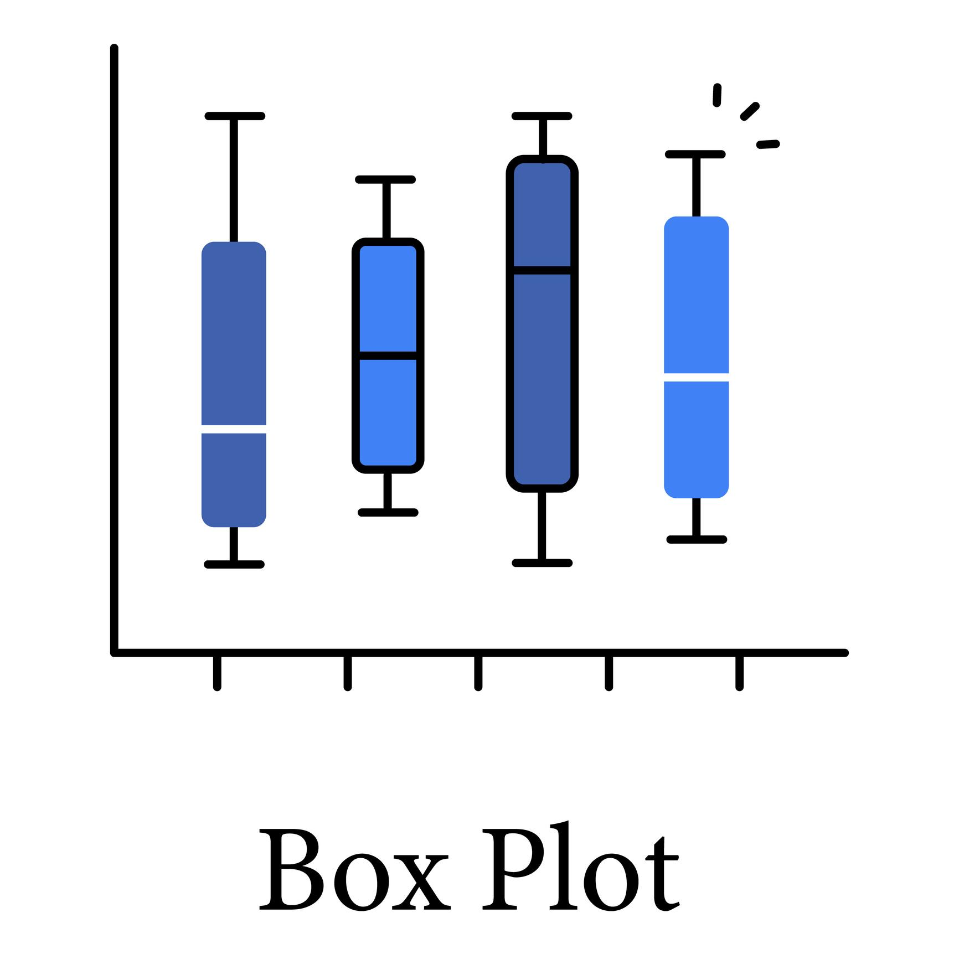
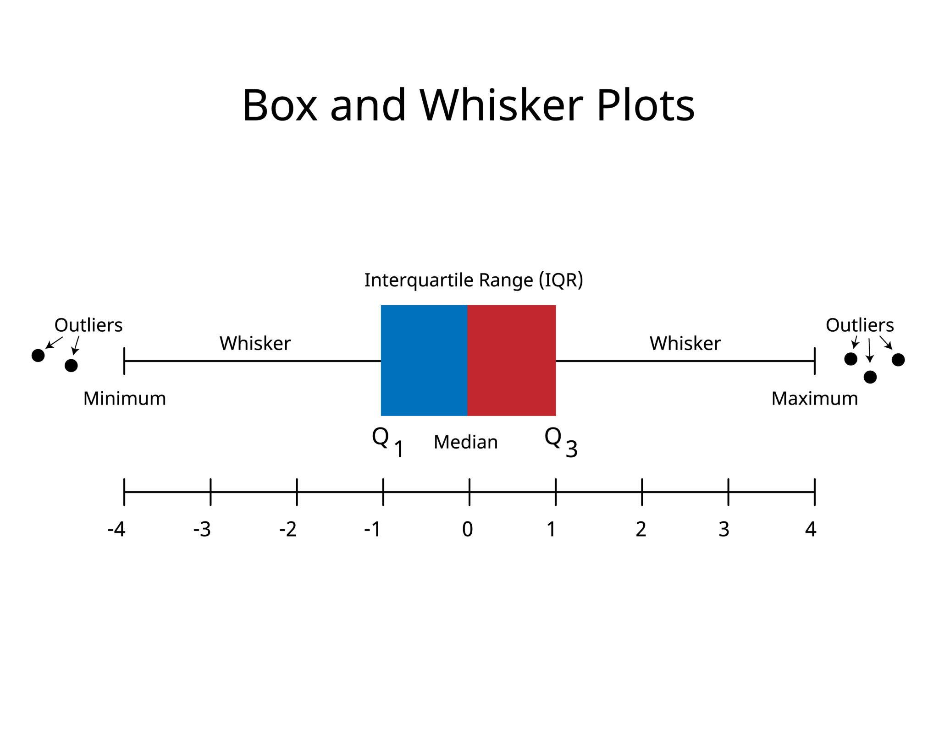
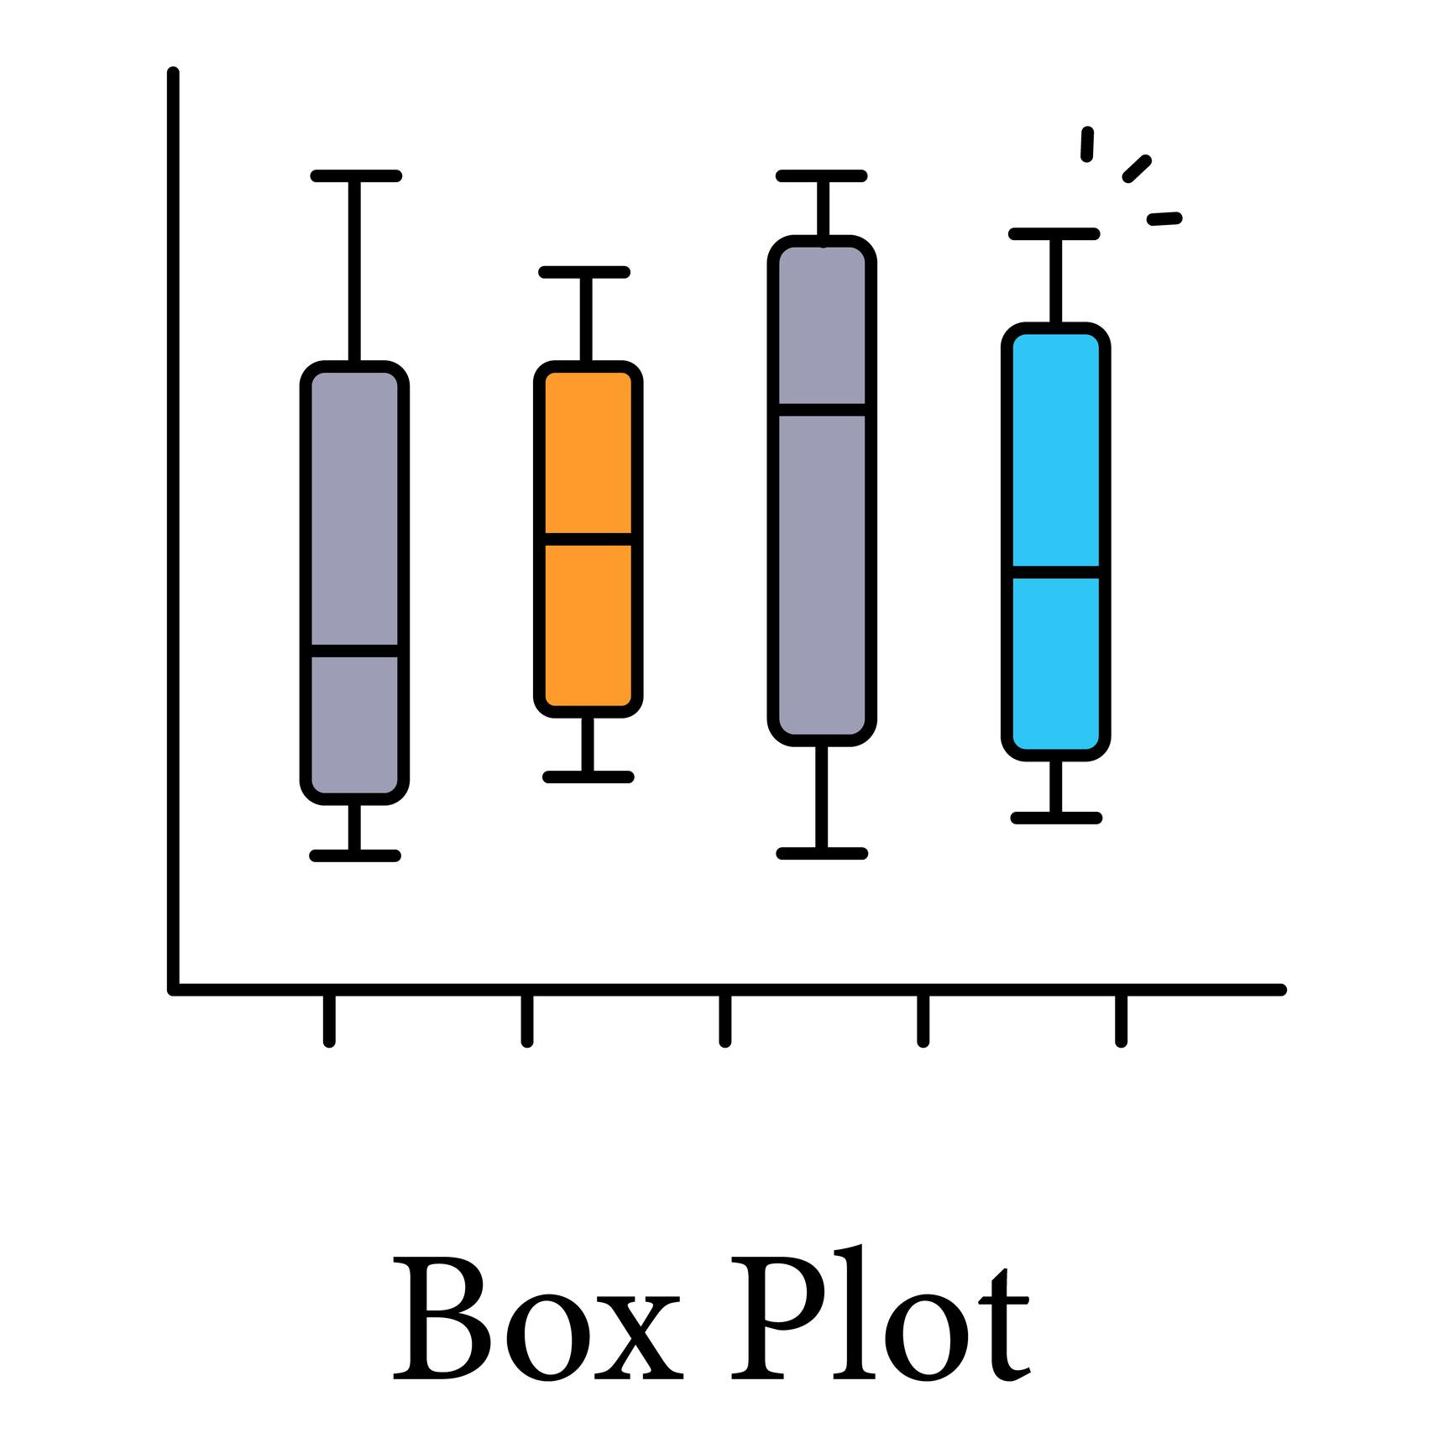
4

Parts of Boxplot
- Left whisker → Minimum
- Left box edge → Q1
- Line inside box → Median
- Right box edge → Q3
- Right whisker → Maximum
- Dots outside → Outliers

Business Example
Company compares customer spending:
Segment A → tight box → consistent
Segment B → wide box → high variability

Five Worked Examples
Example 1
Find Q1, Q2, Q3 for:
5, 10, 15, 20, 25

Example 2
Identify top 10% customers using percentile

Example 3
Detect outliers in salary dataset

Example 4
Compare IQR of two stores

Example 5
Create boxplot of daily revenue

Business Demo (Python Idea)
Steps:
- Load customer spend data
- Calculate percentiles using numpy
- Compute Q1, Q3, IQR
- Detect outliers
- Plot boxplot

Mini Project — Session 5
Project: Customer Spending Segmentation
Dataset:
CustomerID | MonthlySpend
Tasks:
- Calculate Q1, Q2, Q3
- Compute IQR
- Detect outliers
- Identify top 25% customers
- Create boxplot
- Write 5 business insights

10 Practice Questions
Theory (5)
- What is percentile? : It ranks the data amongst all the other data.
- Define quartiles : It is the process in which the total data in asc or desc order is divided into 4 equal parts.
- What is IQR? : After dividing the data into quartiles, the middle two data is used to find the IQR value by subracting them.
- Why is IQR useful? : It helps to remove outliers and measure data accurately.
- What does a boxplot show? : It shows the all values of the data such as the quartiles, IQR, max, min, outliers.

🧮 Practical (5)
- Find Q1, Q2, Q3 of: 2, 4, 6, 8, 10 : Q1: 3, O3: 9, Q2: 6
- Calculate IQR : Q3 – Q1 = 9 - 3 = 6
- Identify outlier using 1.5×IQR rule : Lower bound = q1 - 1.5 * IQR = -6, Upper bound = q3 + 1.5 * IQR = 18, any values outside -6 to 18 is outlier
- Find 90th percentile of dataset : P(90) = 90(5+1) / 100 = 5.4 = 5th position , so in dataset it is 10
- Interpret a boxplot : It shows the all values of the data such as the quartiles, IQR, max, min, outliers.

SESSION 6 — Probability Basics
Probability is the backbone of:
- Machine Learning
- Risk analysis
- Forecasting
- Decision science
- A/B testing

What is Probability?
Probability measures the likelihood that an event will occur.
It ranges between:
0≤P(E)≤1
- 0 → Impossible event
- 1 → Certain event

Example
- Probability of sun rising tomorrow ≈ 1
- Probability of getting 7 on a dice = 0

Real-World Business Use
- Probability customer will churn
- Probability loan default
- Probability product defect
- Probability fraud

Key Terms in Probability

Experiment
An action with uncertain outcome.
Examples:
- Tossing a coin
- Rolling a dice
- Customer visiting website

Outcome
Single possible result of an experiment.
Example:
Dice roll → 3

Sample Space (S)
All possible outcomes.
For dice:
S={1,2,3,4,5,6}

Event (E)
Subset of sample space.
Example:
Getting even number:
E={2,4,6}

Classical Probability
If outcomes are equally likely:
P(E)=Number of favorable outcomes / Total outcomes

Example 1 — Dice
Probability of getting 4:
P(4)=1/6

Example 2 — Coin
Sample space:
{H,T} P(H)=1/2

Example 3 — Business Case
100 customers
30 buy Product A
P(Buy A)=30/100=0.3

Addition Rule of Probability
Used when finding probability of:
Event A OR Event B

Formula
If A and B are mutually exclusive:
P(A∪B)=P(A)+P(B)
If not mutually exclusive:
P(A∪B)=P(A)+P(B)−P(A∩B)

Example 4
Probability customer buys:
- Product A = 0.4
- Product B = 0.3
- Both = 0.1
P(A∪B)=0.4+0.3−0.1=0.6P

Conditional Probability (Basic Idea)
Probability of A given B happened.
P(A∣B)

Formula
P(A∣B)=P(A∩B)/P(B)

Example 5
100 customers
40 bought accessories
20 bought phone AND accessories
P(Phone∣Accessories)=20/40=0.5
Interpretation:
If customer bought accessories, there is 50% chance they buy phone.

Real Business Example — E-Commerce
Suppose:
- 1000 customers
- 300 buy Product A
- 200 buy Product B
- 100 buy both
Find probability customer buys A OR B:
0.3+0.2−0.1=0.4
So 40% customers buy at least one.

Five Practical Examples
Example 1
Probability of red card from deck

Example 2
Probability customer churn if 50 out of 200 churn

Example 3
Probability of at least one success

Example 4
Probability of even number on dice

Example 5
Probability user clicks ad

Business Demo Idea (Excel)
Dataset:
CustomerID | BoughtProductA | BoughtProductB
Tasks:
- Count customers buying A
- Count customers buying B
- Count customers buying both
- Compute:
  - P(A)
  - P(B)
  - P(A OR B)
  - P(A|B)

Mini Project — Session 6
Project: Product Purchase Probability
Dataset:
CustomerID | PurchasedPhone | PurchasedAccessories
Tasks:
- Calculate P(Phone)
- Calculate P(Accessories)
- Calculate P(Phone OR Accessories)
- Calculate P(Phone | Accessories)
- Write 5 business insights

10 Practice Questions
Theory (5)
- Define probability : It is likelihood of the event to occurr.
- What is sample space? : It is the all possible outcomes.
- What is an event? : It is a subset of sample space which fulfils specific condition.
- State addition rule : It is the probability of event A or event B.
- Define conditional probability : It is the probability of an event A given that event B has occurred.

Practical (5)
- Find probability of rolling 3 on dice : 1/6
- Find probability of even number on dice : 3/6 = 1/2
- 60 out of 200 customers churn. Find probability : 0.3
- Calculate P(A OR B) if given P(A), P(B), P(A∩B) : P(A or B) = P(A) + P(B) - P(A∩B)
- Compute conditional probability example : P(A|B) = P(A∩B) / P(B)

SESSION 7 — Conditional Probability & Bayes’ Theorem
This session is the backbone of:
- Churn prediction
- Fraud detection
- Spam filtering
- Medical diagnosis
- Machine learning classification

Conditional Probability (Deep Understanding)
Conditional probability measures the probability of an event given that another event has already occurred.
We write it as:
P(A∣B)
Read as:
Probability of A given B.

Formula
P(A∣B)=P(A∩B)/P(B)
Where:
- P(A∩B) = probability of both A and B
- P(B) = probability of B

Example 1 — Basic Dice Example
What is probability of getting even number given that number is greater than 3?
Sample space:
{1,2,3,4,5,6}
B = greater than 3 → {4,5,6}
A = even → {2,4,6}
A ∩ B = {4,6}
P(A∣B)=2/3

Business Example — E-Commerce
Suppose:
- 1000 customers
- 400 bought accessories
- 200 bought phone
- 150 bought both
Find:
P(Phone | Accessories) = 150 / 400 ​=0.375
Interpretation:
If customer bought accessories, there is 37.5% chance they buy phone.

Why This Matters for Data Analysts
This helps in:
- Cross-selling
- Recommendation systems
- Customer targeting
- Association rule mining

Bayes’ Theorem
Now we go one level deeper.
Bayes' Theorem helps us reverse conditional probability.
Instead of:
P(A∣B)
We calculate:
P(B∣A)

Bayes’ Formula
P(A∣B)=P(B∣A)⋅P(A)/P(B)
Where:
- P(A) = Prior probability
- P(B∣A) = Likelihood
- P(B) = Evidence
- P(A∣B) = Posterior probability

Medical Diagnosis Example
Suppose:
- 1% population has disease
- Test accuracy:
  - 95% detects disease if present
  - 5% false positive
Find probability that person actually has disease given test is positive.

Let:
A = Has disease
B = Test positive
Given:
P(A) = 0.01
P(B|A) = 0.95
P(B|¬A) = 0.05
First find P(B):
P(B)=P(B∣A)P(A)+P(B∣¬A)P(¬A)
=(0.95)(0.01)+(0.05)(0.99)
=0.0095+0.0495=0.059
Now apply Bayes:
P(A∣B)=0.95×0.01/0.059 = 0.161
Final Answer:
Even if test is positive, probability of actual disease is only 16.1%.

Important Insight
Base rate (prior probability) matters a lot.
This is called Base Rate Fallacy.

Fraud Detection Example
Suppose:
- 2% transactions are fraud
- Model detects fraud correctly 90%
- False positive rate 5%
You can compute probability that flagged transaction is actually fraud using Bayes.
This is exactly how:
- Credit card fraud systems work
- Spam filters work
- ML classifiers update probabilities

Five Worked Examples
Example 1
Probability customer churn given contract type

Example 2
Probability loan default given low credit score

Example 3
Probability customer buys product given email opened

Example 4
Medical testing probability

Example 5
Spam email detection probability

Business Demo Idea (Excel or Python)
Dataset:
CustomerID
BoughtAccessories
BoughtPhone
Tasks:
- Calculate P(Phone)
- Calculate P(Accessories)
- Calculate P(Phone | Accessories)
- Reverse it using Bayes

Mini Project — Session 7
Project: Customer Purchase Probability Analysis
Dataset:
CustomerID | BoughtPhone | BoughtAccessories | HighIncome
Tasks:
- Calculate conditional probabilities
- Apply Bayes theorem
- Identify high-probability segments
- Recommend targeting strategy
- Write 5 business insights

10 Practice Questions
Theory (5)
- Define conditional probability : It is the probability to be found given one event condition
- State formula of P(A|B) : P(A|B) = P(A INTERSECTION B) / P(B)
- What is Bayes’ theorem? : It is the reverse of conditional probability
- What is prior probability? : It is the given probability
- What is posterior probability? : It is the probability to be found

Practical (5)
- Compute P(A|B) if P(A∩B)=0.2 and P(B)=0.5 : ans = 0.4
- Apply Bayes formula : P(A∣B)=P(B∣A)⋅P(A)/P(B)
- Solve simple medical test problem
- Find fraud probability example
- Interpret business conditional probability

