SMS Spam Message Detector

AIML Minor Project Report
Student: [Your Name]
Roll Number: [Your Roll Number]
Course / Branch: [Course and Branch]
Semester: [Semester]
Institute: [College Name]
Guide: [Faculty Guide]
Academic Year: [Academic Year]

Abstract
SMS spam can expose users to scams, unwanted advertising, and fraudulent links. This project develops a supervised machine-learning prototype that classifies a text message as spam or legitimate (ham). The text is represented with Term Frequency–Inverse Document Frequency (TF-IDF) features. Word and character n-gram TF-IDF features are combined with hand-crafted text cues, and Multinomial Naive Bayes, Logistic Regression and a calibrated Linear SVM are compared by 5-fold cross-validation on training data. The selected model (Logistic Regression) has its decision threshold tuned for high spam precision and is evaluated once on a held-out test set of 1,032 unique messages, reaching 99.4% accuracy, 99.2% spam precision, 96.1% spam recall and a spam F1 of 0.976. The model is served through a Streamlit dashboard with word-level explanations and batch scoring, and through a command-line tool. A data-leakage problem in the original design (414 duplicate messages shared between train and test) was found and corrected.

1. Introduction
Short-message services remain useful for personal communication and notifications, but they are also used for unsolicited promotions and fraud attempts. A rule-only filter may fail when message wording changes. Machine-learning classification can learn patterns from labelled examples and generalize to some unseen messages. This project demonstrates a compact, reproducible text-classification pipeline.

2. Problem statement
To design and implement a user-friendly application that predicts whether an input SMS resembles spam or legitimate messages, and to evaluate the model on unseen labelled examples.

3. Objectives
- Prepare labelled text data for supervised learning.
- Convert raw text into TF-IDF feature vectors.
- Compare Naive Bayes and Logistic Regression.
- Evaluate classification performance using multiple metrics.
- Provide a simple interactive web interface.
- Document limitations and responsible use.

4. Scope
The prototype focuses on English SMS text and a binary spam/ham label. It does not verify URLs, sender identity, phone numbers, or real-time threat intelligence. It should not automatically delete or block messages.

5. Dataset
Use the SMS Spam Collection dataset from the UCI Machine Learning Repository. It contains labelled messages. The application expects a CSV with label and message columns, where label is spam or ham. The full dataset is bundled in data/SMSSpamCollection.csv (see data/README_DATA.md). It has 5,574 rows (4,827 ham, 747 spam). Of these, 414 are exact duplicate messages; they are removed, leaving 5,160 unique messages (4,518 ham, 642 spam). Duplicates must be removed before splitting, otherwise identical texts appear in both train and test and inflate the scores.

6. Tools and technologies
- Language: Python
- Data processing: pandas
- Machine learning: scikit-learn
- Text representation: word and character TF-IDF plus text-style cues
- Interface and charts: Streamlit and Matplotlib
- Model persistence: joblib

7. Methodology

7.1 Data preparation
Rows with missing label or message are removed, labels are normalized to spam and ham, and exact duplicate messages are dropped. A stratified 80/20 split (random seed 42) gives 4,128 training and 1,032 test messages with the same class proportions.

7.2 Feature extraction
Three feature groups are concatenated:
- Word TF-IDF with unigrams and bigrams. Stop words are kept because words such as *now*, *free* and *call* are strong spam signals.
- Character TF-IDF (2–5 character n-grams inside word boundaries), which is robust to obfuscation such as fr33 or txt4.
- Style cues: presence of a URL, a long digit string (phone/short code), a currency symbol, urgency-word count, upper-case ratio, digit ratio, exclamation marks and message length.
All vectorizers are fitted inside a scikit-learn Pipeline, so only training text is used when fitting and test vocabulary never leaks.

7.3 Models
Multinomial Naive Bayes: a probabilistic text classifier (word features only).
Logistic Regression: a linear model with class-balanced weights and probability output.
Linear SVM (calibrated): a margin-based linear model with probabilities from sigmoid calibration.
The original word-TF-IDF Logistic Regression is kept as a baseline for comparison.

7.4 Model selection and threshold tuning
Each candidate is scored with stratified 5-fold cross-validation on the training set only. The candidate with the best out-of-fold spam F1 is selected. Its decision threshold is then tuned on the out-of-fold probabilities to maximize F1 subject to spam precision of at least 98%, because wrongly blocking a legitimate message is costlier than missing a spam. The test set is used once, for the final report. The deployed model is the same recipe refit on all 5,160 messages.

7.5 Evaluation
- Accuracy: fraction of all predictions that are correct.
- Precision (spam): fraction of predicted spam messages that are truly spam.
- Recall (spam): fraction of actual spam messages detected.
- F1-score (spam): harmonic mean of spam precision and recall.
- ROC-AUC: ranking quality independent of the threshold.
- Confusion matrix: counts true/false predictions for each class.

8. System architecture
Input SMS → word TF-IDF + character TF-IDF + style cues → Logistic Regression → spam probability → tuned threshold (0.48) → spam/ham label with word-level explanation → Streamlit dashboard or command line.

9. Implementation
- spam_detector/core.py: data loading and cleaning, feature pipeline, candidate models, prediction and occlusion-based explanations (shared by every entry point).
- train_model.py: cross-validated model comparison, threshold tuning, final evaluation, and saving the model plus metrics.json, model_comparison.csv, classification_report.txt, confusion_matrix.png and misclassified.csv to outputs/.
- app.py: Streamlit dashboard that loads the saved model at start-up (training once automatically if it is missing). Tabs: classify a message with explanation, batch CSV scoring with download, evaluation, dataset.
- predict.py: command-line single and batch prediction.
- tests/test_core.py: unit tests for data cleaning, predictions, edge-case input and a quality floor.
Explanations remove each word in turn and report the change in spam log-odds, which works with any model and stays informative when the score is saturated near 0% or 100%.

10. Results
Test set: 1,032 unique messages (904 ham, 128 spam), never used for model or threshold selection.
Metric | Value
Dataset rows after cleaning | 5,160 (from 5,574; 414 duplicates removed)
Train examples | 4,128
Test examples | 1,032
Selected model | Logistic Regression (word + char TF-IDF + style cues), threshold 0.479
Accuracy | 99.4%
Spam precision | 99.2%
Spam recall | 96.1%
Spam F1-score | 0.976
ROC-AUC | 0.999

Confusion matrix: 903 true ham, 1 false positive, 5 false negatives, 123 true spam.

10.1 Model comparison
Model | CV spam F1 (tuned) | Test precision | Test recall | Test F1
Baseline: word TF-IDF + LR (original) | 0.837 | 0.990 | 0.766 | 0.863
Multinomial Naive Bayes | 0.946 | 0.944 | 0.914 | 0.929
Logistic Regression | 0.951 | 0.992 | 0.961 | 0.976
Linear SVM (calibrated) | 0.948 | 0.992 | 0.953 | 0.972

The upgrade lifts spam recall from 76.6% to 96.1% at the same precision. The original code reported F1 0.925, but that figure was inflated by duplicate messages appearing in both train and test; on the de-duplicated split the same model scores 0.863. The test set holds only 128 spam messages, so one split can differ from the next by a point or two. The cross-validated F1 of 0.951 is the more conservative figure; the three upgraded models are close to one another.

10.2 Screenshots
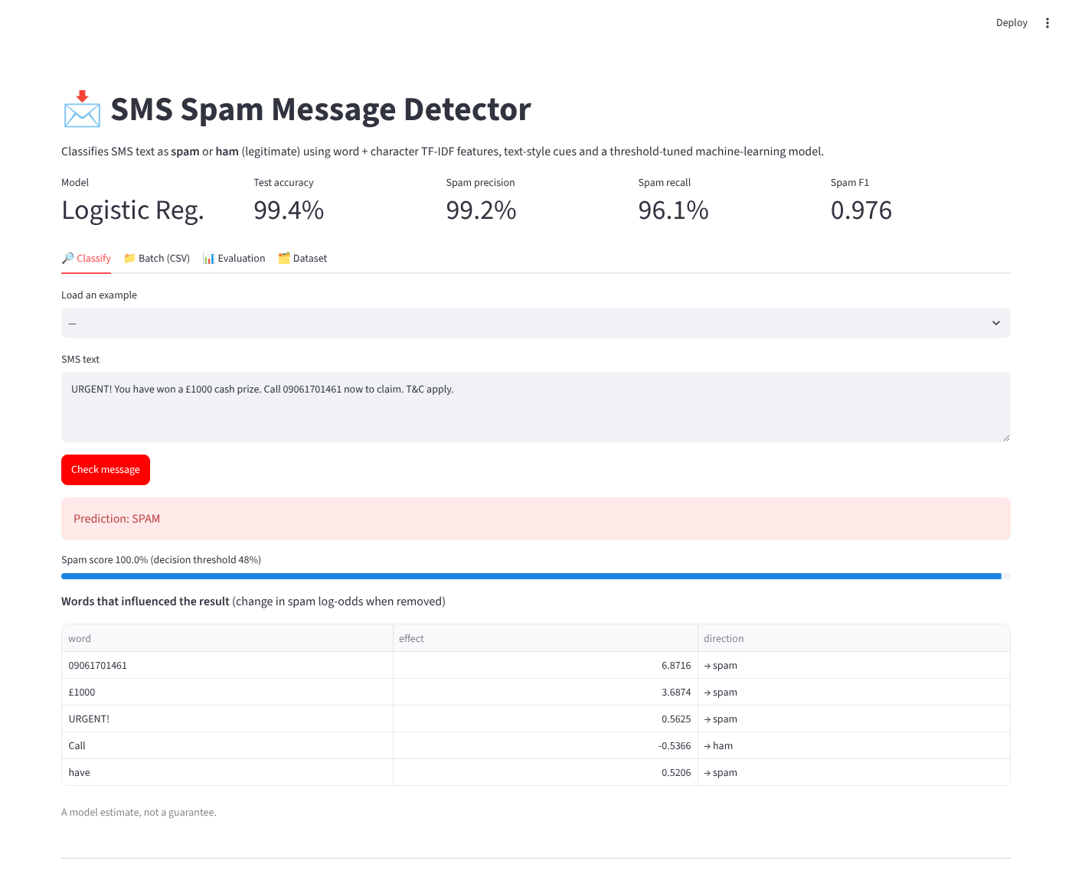
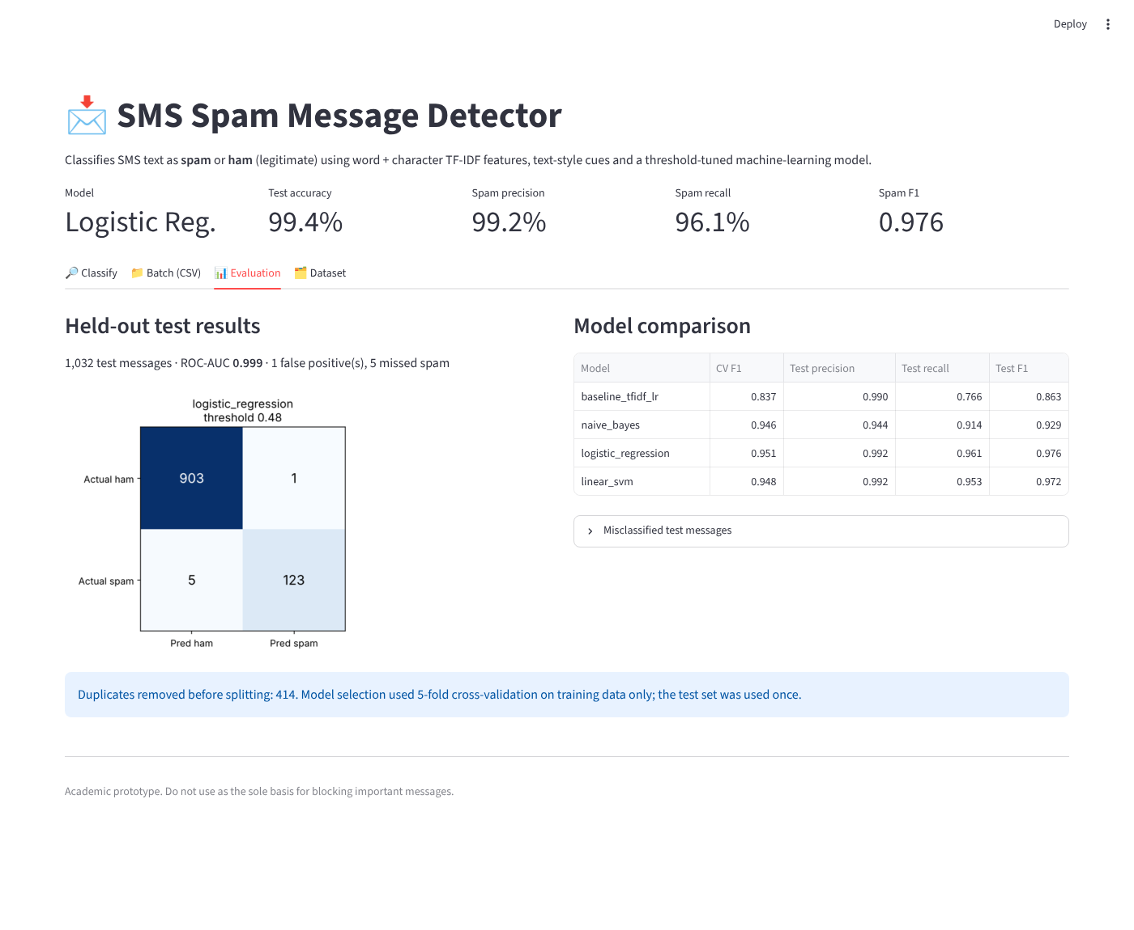

10.3 Error analysis
The single false positive is a legitimate message from a social site that quotes "send FREE SMS" and "sms NO", wording typical of promotions. The five missed spam messages are atypical: a conversational "dating" message, two adult-content messages, a stock-pump promotion, and a subscription-service reply that reads like an ordinary notification. They avoid the usual urgency, prize and phone-number cues. All are listed in outputs/misclassified.csv.

11. Limitations
- Performance depends on the dataset and may decline on new slang, languages, or changing scam tactics.
- A probability/score is not a guarantee that a message is malicious.
- A model may learn dataset-specific patterns.
- The application does not scan URLs or verify senders.
- The dataset is small (5,160 unique messages) and dates from the mid-2000s, so current scams may look different.

12. Future enhancements
- Add multilingual text support and more recent labelled data.
- Retrain on larger and more recent labelled data and re-tune the threshold for each deployment.
- Try transformer embeddings and compare with the linear models.
- Add URL and sender reputation checks.
- Test robustness against obfuscated words and adversarial spelling.
- Deploy with authentication, monitoring, and privacy controls if used beyond a classroom demo.

13. Conclusion
The project demonstrates an end-to-end text-classification workflow, from labelled data and TF-IDF features to model comparison, evaluation, and a web interface. On the full dataset the final model reaches a spam F1 of 0.976 with only one legitimate message wrongly flagged on the test set. Fixing the duplicate-leakage flaw and adding character n-grams, style cues and threshold tuning improved spam recall from 76.6% to 96.1% over the original design, and the honest limits of the evaluation are documented above.

References
- Almeida, T. A., Gómez Hidalgo, J. M., & Yamakami, T. (2011). Contributions to the Study of SMS Spam Filtering: New Collection and Results. ACM Symposium on Document Engineering. DOI: 10.1145/2034691.2034742.
- UCI Machine Learning Repository, SMS Spam Collection: https://archive.ics.uci.edu/dataset/228/sms+spam+collection
- scikit-learn documentation: https://scikit-learn.org/stable/
- Streamlit documentation: https://docs.streamlit.io/

