**Python Assignment – JSON**

**Name: PRIYESHWAR**

**Mail:** [**priyesh2664@gmail.com**](mailto:priyesh2664@gmail.com)

**What is JSON?**

JSON (JavaScript Object Notation) is a lightweight data-interchange format. It is easy for humans to read and write and easy for machines to parse and generate. JSON is language-independent but uses conventions familiar to programmers of the C family of languages, including C, C++, C#, Java, JavaScript, Perl, Python, and many others.

**Key Features of JSON**

* **Lightweight and Text-Based:** Data is stored as plain text.
* **Language-Independent:** Can be used with virtually all modern programming languages.
* **Structured Data:** Represents structured data using key-value pairs and ordered lists.
* **Human-Readable:** Easy to read and understand compared to binary data formats.
* **Widely Used:** Commonly used for APIs, configuration files, and data exchange between client and server.

**JSON Data Types**

| **Type** | **Example** | **Notes** |
| --- | --- | --- |
| string | "hello" | Always double-quoted, supports Unicode escape \uXXXX. |
| number | 42, 3.14, -1e-9 | No NaN, Infinity, or hex. |
| boolean | true, false | Lowercase only. |
| null | null | Represents absence of value. |
| object | { "k": "v" } | Unordered key/value pairs. |
| array | [1, 2, 3] | Ordered, zero-based indexing conceptually. |

**Example of JSON**

{

"name": "Alice",

"age": 25,

"isStudent": false,

"skills": ["Python", "JavaScript", "SQL"],

"address": {

"city": "New York",

"zip": "10001"

}

}

**Converting JSON to Python**

Python provides a built-in module called json for working with JSON data. Here's how you can convert between JSON and Python objects.

**Importing the JSON Module**

import json

**JSON to Python**

You can parse a JSON string and convert it into a Python object using json.loads():

import json

json_data = '{"name": "Alice", "age": 25, "is_student": false}'

python_obj = json.loads(json_data)

print(python_obj)

print(type(python_obj))

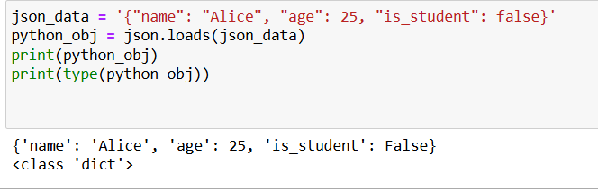

**Python to JSON**

To convert a Python object into a JSON-formatted string, use json.dumps():

import json

python_obj = {

"name": "Bob",

"age": 30,

"is_student": True,

"skills": ["Python", "Django"]

}

json_data = json.dumps(python_obj)

print(json_data)

print(type(json_data))

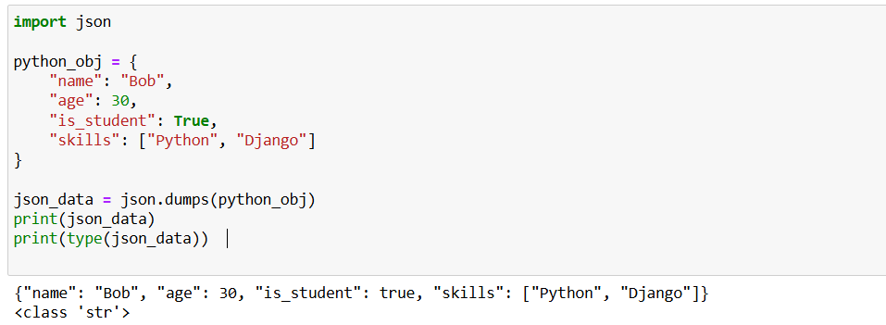

**Reading from and Writing to Files**

**Read JSON from a File**

with open('data.json', 'r') as f:

data = json.load(f)

print("Type:" ,type(data))



**Write JSON to a File**

with open('data.json', 'w') as f:

json.dump(python_obj, f, indent=4)

Use json.load() and json.dump() for file operations (not loads() / dumps() which are for strings).