**Burger Bash**

**Name: PRIYESHWAR M D**

**Mail:** [**priyesh2664@gmail.com**](mailto:priyesh2664@gmail.com)

**INTRODUCTION:**

I have a started a new business of selling burger because I read on my Instagram

feed that „Burger Is the Future!

But I knew that burger alone was not going to help me get seed funding to expand

my new Burger Empire - so I had one more genius idea to combine with it - I was

going to Uberize it - and so Burger Runner was launched!

I started by recruiting “runners” to deliver fresh burger from Burger Runner

Headquarters and also maxed out my credit card to pay freelance developers to

build a mobile app to accept orders from customers.

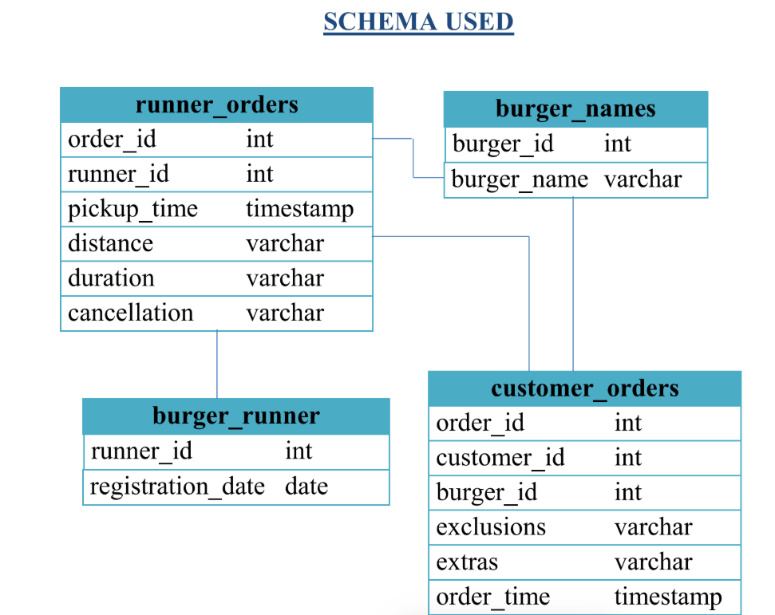

**CASE STUDY QUESTIONS**

**1. How many burgers were ordered?**

select count(burger_id) burger from customer_orders;



**2. How many unique customer orders were made?**

select count(distinct customer_id) Unique_customer from customer_orders;



**3. How many successful orders were delivered by each runner?**

select runner_id,count(*) as orders from runner_orders

where cancellation is NULL

group by runner_id;

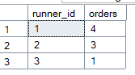

**4. How many of each type of burger was delivered?**

select c.burger_id,burger_name,count(*) Burger_count

from customer_orders c join burger_names b on c.burger_id =b.burger_id join runner_orders r on c.order_id=r.order_id

where r.cancellation is NULL

group by c.burger_id,b.burger_name;



**5. How many Vegetarian and Meatlovers were ordered by each customer?**

select customer_id,burger_name, count(c.burger_id) as No_of_burgers from customer_orders c join burger_names b on c.burger_id = b.burger_id

group by c.burger_id,customer_id,burger_name;

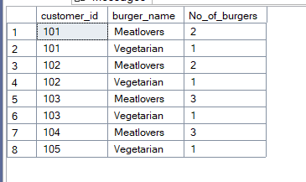

**6. What was the maximum number of burgers delivered in a single order?**

select max(burger_count) Max_count from (select order_id,count(*) as burger_count from customer_orders

group by order_id)a



**7. For each customer, how many delivered burgers had at least 1 change and how many had no changes?**

select customer_id,sum(case when (exclusions is NULL and extras is null )then 1 else 0 end) as without_Changes,

sum(case when (exclusions is not NULL or extras is not null )then 1 else 0 end) as with_changes

from customer_orders c join runner_orders r on c.order_id=r.order_id

where cancellation is null

group by customer_id;

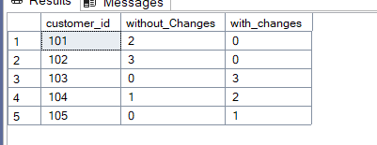

**8. What was the total volume of burgers ordered for each hour of the day?**

select DATEPART(HOUR,order_time) as Order_hour, count(*) as Burger from customer_orders

group by DATEPART(HOUR,order_time)

order by 1;

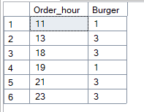

**9. How many runners signed up for each 1 week period?**

select datepart(week, registration_date) as reg_week,count(*) as runners_signed_up

from burger_runner

group by datepart(year, registration_date), datepart(week, registration_date)

order by reg_week;

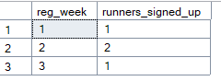

**10. What was the average distance travelled for each customer?**

select c.customer_id,avg(try_cast(replace(replace(r.distance, 'km', ''), ' ', '') as float)) as avg_distance_km

from customer_orders c join runner_orders r on c.order_id = r.order_id

where r.cancellation is null

group by c.customer_id;

