**SQL Case Study: Texture Tales**

**Name: PRIYESHWAR M D**

**Mail:** [**priyesh2664@gmail.com**](mailto:priyesh2664@gmail.com)

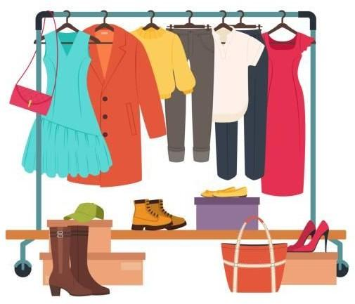

**INTRODUCTION:**

Texture Tales Clothing Company prides themselves on providing an optimized range of clothing and lifestyle wear for the modern adventurer!

I, the CEO of this trendy fashion company is asking you to assist the team’s merchandising teams analyze their sales performance and generate a basic financial report to share with the wider business

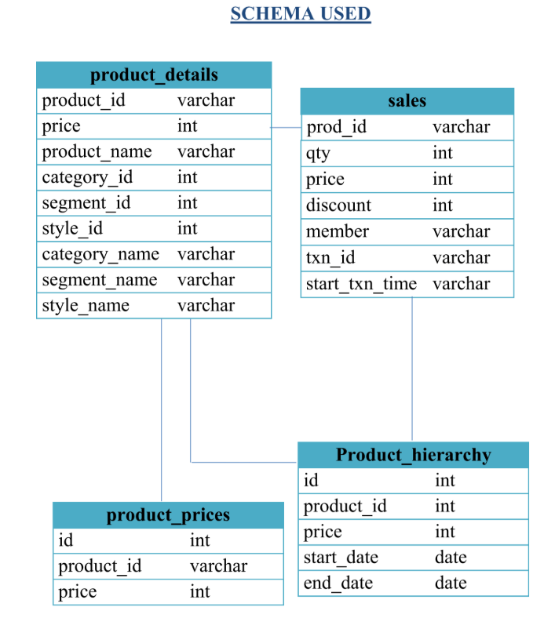

**CASE STUDY QUESTIONS**

1. **What was the total quantity sold for all products?**

select product_name,sum(qty) as total from sales join product_details on prod_id=product_id

group by product_name

order by 2 desc;

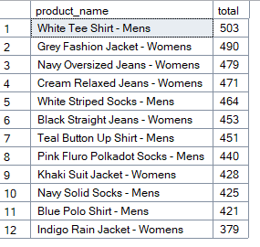

1. **What is the total generated revenue for all products before discounts?**

select sum(qty*price) as total_revenue from sales;



1. **What was the total discount amount for all products?**

select sum(qty*price*discount)/100 as total_discount_amount from sales;



1. **How many unique transactions were there?**

select count(distinct txn_id) as Unique_transactions from sales;



1. **What are the average unique products purchased in each transaction?**

select avg(product_count) from (select txn_id, count(distinct prod_id)as product_count from sales

group by txn_id)a



1. **What is the average discount value per transaction?**

select avg(total_discount_amount) from (select txn_id,sum(qty*price*discount)/100 as total_discount_amount from sales

group by txn_id)a



1. **What is the average revenue for member transactions and non- member transactions?**

select case when member = 'true' then 'member' else 'non-member' end as member_status, avg(qty * price * (1 - discount / 100.0)) as avg_revenue

from sales

group by case when member = 'true' then 'member' else 'non-member' end;

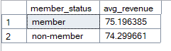

1. **What are the top 3 products by total revenue before discount?**

select top 3 prod_id,sum(qty * price) as total_revenue_before_discount from sales

group by prod_id

order by total_revenue_before_discount desc;

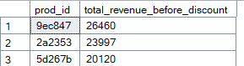

1. **What are the total quantity, revenue and discount for each segment?**

select pd.segment_name, sum(s.qty) as total_quantity, sum(s.qty * s.price * (1 - s.discount / 100.0)) as total_revenue,sum(s.qty * s.price * s.discount / 100.0) as total_discount

from sales s join product_details pd on s.prod_id = pd.product_id

group by pd.segment_name;

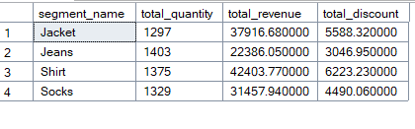

1. **What is the top selling product for each segment?**

select b.segment_id,b.segment_name,b.product_id,b.product_name,sum(a.qty) as Product_Qty

from sales as a join product_details as b on a.prod_id = b.product_id

group by b.segment_id,b.segment_name,b.product_id,b.product_name

order by Product_Qty desc;

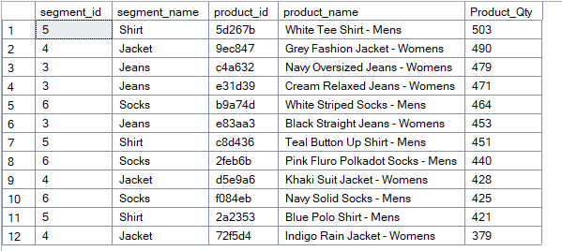

1. **What are the total quantity, revenue and discount for each category?**

select pd.category_name, sum(s.qty) as total_quantity, sum(s.qty * s.price * (1 - s.discount / 100.0)) as total_revenue,sum(s.qty * s.price * s.discount / 100.0) as total_discount

from sales s join product_details pd on s.prod_id = pd.product_id

group by pd.category_name;



1. **What is the top selling product for each category?**

select category_id,category_name,product_id,product_name,sum(qty) from product_details join sales on product_id=prod_id

group by category_id,category_name,product_id,product_name

order by 5 desc;

