**Support information for:**

**Principles, evaluation metrics and method for planned regulatory inspection targeting**

In Section 5. Application of the Proposed Method, we used the number of consumer complaints referring to PCS in each municipality in Brazil (Anatel 2022), and the number of PCS consumers by municipality in Brazil (Anatel 2022a), to generate an initial average graph signal 𝒖(0), with 𝒖 defined as 𝒖(𝑛) = [𝑢1(𝑛), 𝑢2(𝑛), ..., 𝑢𝑁(𝑛)]ᵀ ∈ ℝᴺ, where element 𝑢𝑖(𝑛) represents the average graph signal related to vertex 𝑣𝑖 for inspection round 𝑛. 𝑢𝑖(0) is the average consumer complaint rate of Brazilian municipality 𝑣𝑖 on July 2022.

The Anatel’s Consumer Complaints Data Dashboard are available in internet at this [page](https://informacoes.anatel.gov.br/paineis/consumidor/reclamacoes). Figure S1 shows this dashboard and how to select the necessary data to generate 𝒖(0).

**Figure S1.** Selecting data in Anatel’s Consumer Complaints Data Dashboard.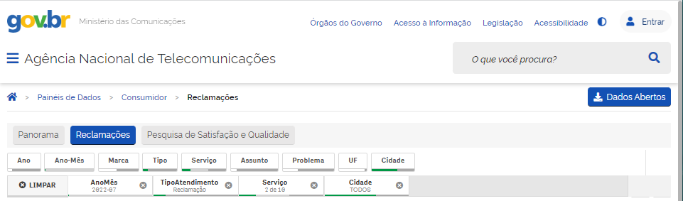

To properly select the data, we have chosen:

1. “Ano-Mês”: “2022-07” (Year-Month: 2022-07)
2. “Tipo”: “Reclamações” (Type: Complaints)
3. “Serviço”: “SMP_Pós” and “SMP_Pré” (Service: PCS_postpaid and PCS_prepaid)
4. “Cidade”: “Selecionar todos” (Municipality: Select all)

Figure S2 shows how to export the necessary data.

**Figure S2.** Exporting data from Anatel’s Consumer Complaints Data Dashboard.

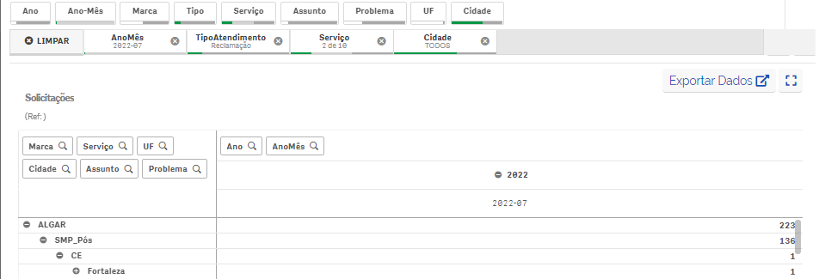

To properly export the data, we scroll down the page until “Solicitações” (Requests) and expand all filters but the municipality. After that, we click on “Exportar Dados” (Export Data). The data were downloaded in a .xlsx file with the format showed in Figure S3.

**Figure S3.** Format of consumer complaints data exported to a .xlsx file.

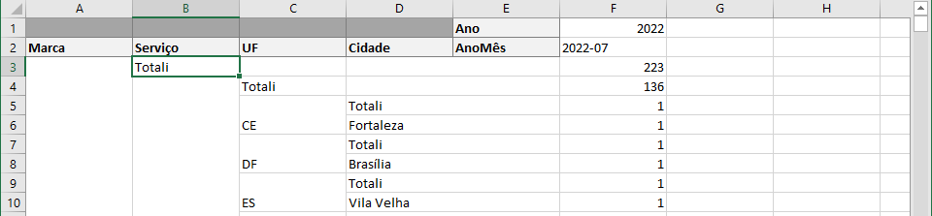

We sum the numbers of complaints, in column F, according state and municipalities, in columns C and D, to determine the total complains per municipality of Brazil.

The Anatel’s PCS Access Data Dashboard are available in internet at this [page](https://informacoes.anatel.gov.br/paineis/acessos/telefonia-movel). Figure S4 shows this dashboard and how to select the necessary data to generate 𝒖(0).

**Figure S4.** Selecting data in Anatel’s PCS Access Data Dashboard.

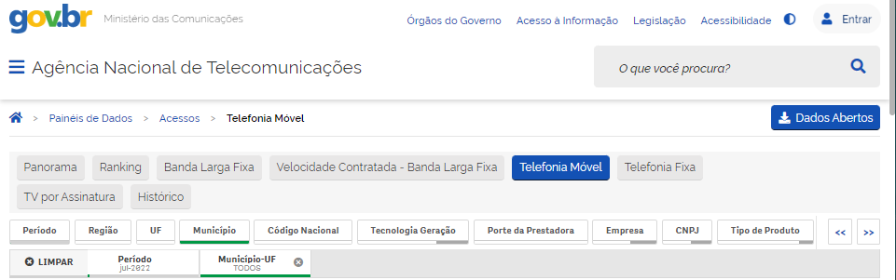

To properly select the data, we have chosen:

1. “Período”: “jul-2022” (Period: July-2022)
2. “Município”: “Selecionar todos” (Municipality: Select all)

Figure S5 shows how to export the necessary data.

**Figure S5.** Exporting data from Anatel’s PCS Access Data Dashboard.

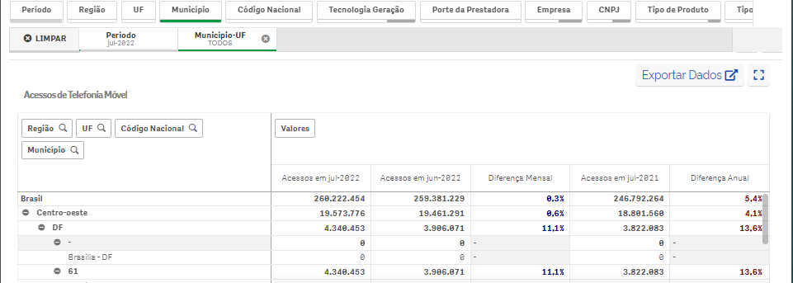

To properly export the data, we scroll down the page until “Acessos de Telefonia Móvel” (Mobile Phone Accesses) and expand all filters. After that, we click on “Exportar Dados” (Export Data). The data were downloaded in a .xlsx file with the format showed in Figure S6.

**Figure S6.** Format of PCS consumers data exported to a .xlsx file.

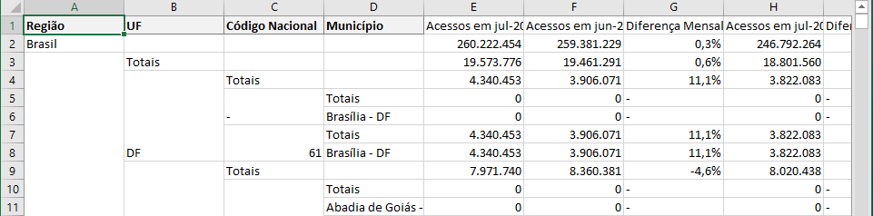

We sum the numbers of PCS consumers, in column E, according municipalities, in column D, to determine the total number of PCS consumers per municipality of Brazil. Dividing the number of consumer complaints referring to PCS by the number of PCS consumers, for each municipality in Brazil, we generate 𝒖(0).

Still in Section 5., we need to model Anatel’s expectation of PCS consumer dissatisfaction at each influenced municipality based on the PCS consumer dissatisfaction at their influencing municipalities. The adjacency matrix 𝑾 of 𝒢 was defined to adequately model Anatel’s expectation.

Assume that Anatel's real expectation during the evolution of PCS quality is that:

1. For municipalities where the external search for goods or services is characterized by urban relations of proximity, the influences between municipalities must be proportional to the displacements of consumers from an influenced municipality to influencing municipalities in the search for goods and services in general, and;
2. For municipalities where the external search for goods or services is characterized by long-distance relations, the influences between municipalities must be proportional to the importance of the relations in public and business management.

In 2020, the IBGE published the study Areas of Influence of Cities 2018, in which it identifies and analyzes the Brazilian urban network, establishing the hierarchy and areas of influence of urban centers. The Brazilian urban network is characterized by small urban centers being influenced by one or more larger urban centers. To establish the hierarchy and areas of influence of urban centers, the IBGE considered the urban relations of proximity and the long-distance relations between these centers (IBGE 2020a).

For 5503 out of the 5570 municipalities in Brazil, the external search for goods or services is characterized by urban relations of proximity. For these municipalities, IBGE researched the relations in ten themes: clothing and footwear, furniture and electronics, low- and medium-complexity healthcare, high-complexity healthcare, higher education, cultural activities, sports activities, airport, newspapers, and public transportation. For these municipalities we used the available information in REGIC 2018 – Municipalities Connections and Attraction (IBGE 2020b) to calculate their received influences.

The REGIC 2018 – Municipalities Connections and Attraction data are available in internet at this [page](https://geoftp.ibge.gov.br/organizacao_do_territorio/divisao_regional/regioes_de_influencia_das_cidades/Regioes_de_influencia_das_cidades_2018_Resultados_definitivos/base_tabular/%20REGIC2018_Municipios_Ligacoes_e_atracao_xlsx.zip), and the file REGIC2018_Quest_Ligacoes_entre_Municipios.xlsx has the data of interest, with the format showed in Figure S7.

**Figure S7.** Format of REGIC 2018 – Municipalities Connections and Attraction data.

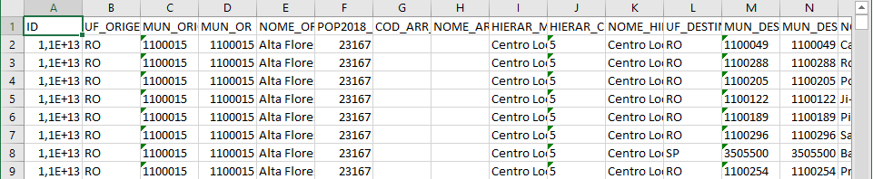

We calculated the influences in municipalities that search for goods and services in other municipalities as the estimated percentage of the participation (column AP) of the influencing municipality (which code is in column M) on the total displacements of consumers from the influenced municipality (which code is in column C).

For the remaining 67 municipalities, which tend to satisfactorily supply goods and services to the consumers who inhabit them, the external search for goods or services is characterized by long-distance relations. For these municipalities, IBGE researched the relations in two themes: public management and business management.

16 of these 67 municipalities are not the main municipality of the population arrangement to which they were grouped by the IBGE. We considered that all the influence received by these 16 municipalities comes from the main municipality of the arrangement to which they belong. For these municipalities we used the available information in REGIC 2018 – Population Arrangements (IBGE 2020c) to set their received influences.

The REGIC 2018 – Population Arrangements data are available in internet at this [page](https://geoftp.ibge.gov.br/organizacao_do_territorio/divisao_regional/regioes_de_influencia_das_cidades/Regioes_de_influencia_das_cidades_2018_Resultados_definitivos/base_tabular/REGIC2018_Arranjos_Populacionais.xlsx). The data were downloaded in a .xlsx file with the format showed in Figure S8.

**Figure S8.** Format of REGIC 2018 – Population Arrangements data.



We set the influences to 1 in that 16 of 67 municipalities using the code of the influenced municipality (column B) and the code of the main municipality of the population arrangement (column C).

36 of these 67 municipalities are the main municipality of the population arrangement to which they were grouped by the IBGE, but are not metropolises. It was considered that all the influence received by these 36 municipalities comes from the metropolis to which they are linked by IBGE. For these municipalities we used the available information in REGIC 2018 – Connection Between Cities (IBGE 2020d) to set their received influences.

The REGIC 2018 – Connection Between Cities data are available in internet at this [page](https://geoftp.ibge.gov.br/organizacao_do_territorio/divisao_regional/regioes_de_influencia_das_cidades/Regioes_de_influencia_das_cidades_2018_Resultados_definitivos/base_tabular/REGIC2018_Ligacoes_entre_Cidades.xlsx). The data were downloaded in a .xlsx file with the format showed in Figure S9.

**Figure S9.** Format of REGIC 2018 – Connection Between Cities data.

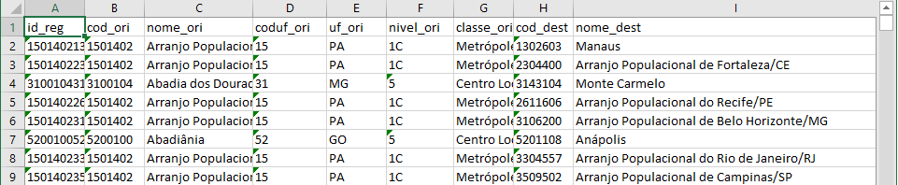

We set the influences to 1 in that 36 of 67 municipalities using the information “sim” (yes) of the link (column O) according the code of the influenced municipality (column B) and the code of the metropolis to which they are linked (column H).

The last 15 of these 67 municipalities are metropolises. It was considered that the influences received by these 15 municipalities comes from the relations of public and business management. For these municipalities we used the available information in REGIC 2018 – Connection Between Cities (IBGE 2020d) to set their received influences. These relations between metropolises are set by IBGE from 0 to 3, meaning: 0 – no relation, 1 – first order relation, 2 – second order relation, and 3 – third order relation. The second and the third relations are equivalent, respectively, to 95% and 90% of the influence of the first order relation (IBGE 2020a). We calculated the influences on influenced municipalities that are metropolises (column B) as the average influence on public management (column W) and business management (column X) of influencing municipality (column H), that are also metropolis.

The average consumer complaint rate of Brazilian municipality 𝑣𝑖 on July 2022 (the graph signal 𝒖(0)), the influences between municipalities to model the Anatel’s expectation of PCS consumer dissatisfaction at each influenced municipality (the adjacency matrix 𝑾 of 𝒢), and the number of consumers per municipality, the vector 𝒄 = [𝑐1, 𝑐2, ..., 𝑐𝑁]ᵀ, with 50.000𝑐𝑖 the number of consumers in municipality 𝑣𝑖, are already properly organized in the file data_for_print_simulations.npz, available at https://github.com/PRInT2023. File print_simulations.ipynb contains the script in Python language for reproduction of simulations, results and figures presented in article Principles, Evaluation Metrics and Method for Planned Regulatory Inspection Targeting.

**References**

Anatel (2022) *Consumer Complaints Data Dashboard*. National Telecommunications Agency, Brazil. [Last accessed October 19, 2022.] Available from URL: https://informacoes.anatel.gov.br/paineis/consumidor/reclamacoes.

Anatel (2022a) *PCS Access Data Dashboard*. National Telecommunications Agency, Brazil. [Last accessed October 19, 2022.] Available from URL: https://informacoes.anatel.gov.br/paineis/acessos/telefonia-movel.

IBGE (2020a) *Areas of Influence of Cities* *2018 - REGIC 2018*. [Last accessed October 19, 2022.] Available from URL: https://www.ibge.gov.br/en/geosciences/territorial-organization/geographic-networks-and-flows/19332-areas-of-influence-of-cities.html?=&t=publicacoes.

IBGE (2020b) *REGIC 2018 - Municipalities Connections and Attraction*. [Last accessed October 19, 2022.] Available from URL: https://geoftp.ibge.gov.br/organizacao_do_territorio/divisao_regional/regioes_de_influencia_das_cidades/Regioes_de_influencia_das_cidades_2018_Resultados_definitivos/base_tabular/ REGIC2018_Municipios_Ligacoes_e_atracao_xlsx.zip.

IBGE (2020c) *REGIC 2018 - Population Arrangements.* [Last accessed October 19, 2022.] Available from URL: *https*://geoftp.ibge.gov.br/organizacao_do_territorio/divisao_regional/regioes_de_influencia_das_cidades/Regioes_de_influencia_das_cidades_2018_Resultados_definitivos/base_tabular/REGIC2018_Arranjos_Populacionais.xlsx.

IBGE (2020d) *REGIC 2018 -* *Connection Between Cities*. [Last accessed October 19, 2022.] Available from URL: https://geoftp.ibge.gov.br/organizacao_do_territorio/divisao_regional/regioes_de_influencia_das_cidades/Regioes_de_influencia_das_cidades_2018_Resultados_definitivos/base_tabular/REGIC2018_Ligacoes_entre_Cidades.xlsx.