Project: An AI Grading Tool for Lecturers

1. General Requirements
• A beautifully designed UX/UI Website suitable for various operating systems and a separate executable (.exe) application for internal use.
• Use Java + database (SQL...).
• Full Front-end and Back-end.

2. Database
LOGIN PERMISSION REQUIREMENTS:
• Create accounts for Teachers and Students.
• Students submit assignments and are graded by Teachers.
[Database Model Plac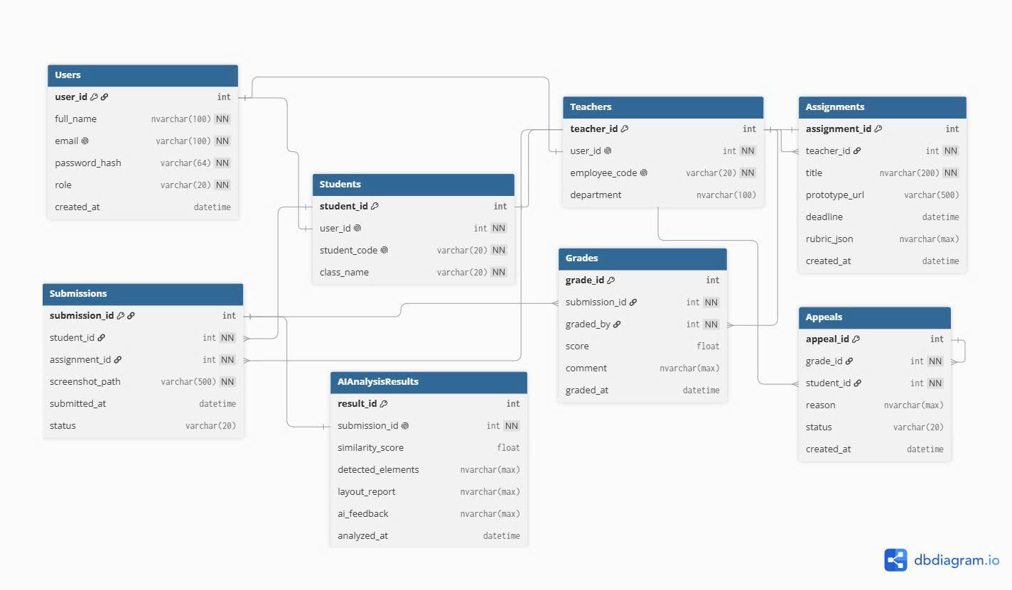eholder]

3. Website and .exe App Features
The Website/App will require account login if available, with sections for account creation and forgotten passwords. An OTP code will be sent to Gmail or a phone number for account creation and password recovery.

For Students:
• It will display the subjects assigned by the school, for example: Semester 1: ANC111, ABC222...
• Upon login, if there are subjects requiring assignment submissions, a notification will be displayed immediately.

For Lecturers:
• It will display tools to create classes, create assignments, and upload assignment prompts for students to download.
• There will be a section to grade each assignment submitted by students, featuring AI tools (requires API key). When the API key is entered, it will read the lecturer's prompt requirements and grade the assignment automatically. Additionally, it will analyze errors and summarize the assignment if necessary.
• Furthermore, there are sections for lecturer feedback/comments.

4. Tool and Feature Requirements
• Tools such as automatic deadline notifications, sending an email to the student's registered email if the deadline is approaching and no submission has been made.

5. Website Requirements Checklist (1-100)

A. UX/UI
1. Homepage works
2. Logo displays correctly
3. Navbar works
4. Footer is complete
5. No broken links
6. Buttons work
7. Forms display correctly
8. Consistent fonts
9. Consistent colors
10. Reasonable spacing/padding
11. No screen overflow
12. Responsive on laptop
13. Responsive on mobile
14. Responsive on tablet
15. Images are not distorted
16. Loading indicator for long processes
17. Success notifications
18. Error notifications
19. Empty state when there is no data
20. Confirmation on data deletion

B. Authentication
21. Register
22. Login
23. Logout
24. Password is encrypted
25. No plaintext password storage
26. Valid email check
27. Password validation
28. Prevent login with incorrect info
29. Session/token works
30. Prevent unauthenticated users from accessing private pages

C. Authorization
31. Roles exist
32. Admin has specific permissions
33. User has specific permissions
34. Cannot access unauthorized APIs
35. Not just hiding buttons, backend permission checks required
36. Cannot edit other users' data without permission

D. Database / SQL
37. Database runs successfully
38. Tables are logically designed
39. Primary Keys exist
40. Foreign Keys are correct
41. Relationships are correct
42. Reasonable data types
43. NOT NULL used correctly
44. UNIQUE used correctly
45. No unnecessary data duplication
46. Sample data exists
47. Queries work
48. Inserts work
49. Updates work
50. Deletes work

E. Backend / API
51. Backend runs without errors
52. API GET
53. API POST
54. API PUT/PATCH
55. API DELETE
56. Correct HTTP status codes
57. Response has a clear structure
58. Validate requests
59. Exception handling
60. Do not return stack trace to users
61. APIs require authentication when necessary
62. APIs check authorization
63. No hard-coded secrets
64. Environment variables used
65. API does not crash on invalid input

F. CRUD
Each main entity should check: CREATE -> READ -> UPDATE -> DELETE
66. Create
67. Read
68. Update
69. Delete
70. Search
71. Filter
72. Sort
73. Pagination

G. Security
74. Prevent SQL Injection
75. Prevent XSS
76. Validate frontend input
77. Validate backend input
78. Password hashing
79. Do not commit .env
80. No API keys in source code
81. Do not expose database credentials
82. Backend permission checks

H. Testing
Intentionally input incorrect data:
83. Empty forms
84. Invalid emails
85. Incorrect passwords
86. Negative numbers
87. Text too long
88. Special characters
89. Non-existent IDs
90. Delete referenced data
91. Database offline
92. API errors

I. Git / Deploy / Documentation
93. Project pushed to Git
94. Correct .gitignore
95. README with run instructions
96. Database setup instructions
97. Demo account if needed
98. Production runs successfully
99. No severe console errors
100. Can clone project -> setup -> run successfully

