The Stolen Szechaun Sauce
DFIR Project 10-Case-001



Created By:
Shawn Perreault
For:
Lighthouse Labs

Table of contents

Introduction 1

Downloaded Files 1

Tools 1

File Hash 2

Attack Stage Process 3

Questions 4-10

Citations 11

Introduction:

For this assignment we will be analyzing the CASE-001 The Stolen Szechaun sauce provided by DFIR Madness. It is an important practice to work off a copy of the disk image to ensure that you do not change or alter the data as it could never be recovered and may be needed as evidence. I will be downloading the files from the DFIR Madness website for analysis.
https://dfirmadness.com/the-stolen-szechuan-sauce/

Downloaded files:

DC01 Disk Image(E01)
DC01 Memory and Page File
DC01 Autoruns
DC01 Protected Files
Case001 PCAP Files
Desktop Disk Image (E01)
Desktop Memory and Page File

Tools:
To Answer the question of the assignment, identify the machines used, the attacker and methods we will be using some forensics tools.

FTK Imager
Autopsy
Registry Explorer
Wireshark Packet Analyzer

1

It is important verify the integrity of the files by checking the hash values of the downloads to ensure using the correct data.

Using Powershell and the Get-FileHash command on the command line, we able to verify the files are original.

Powershell

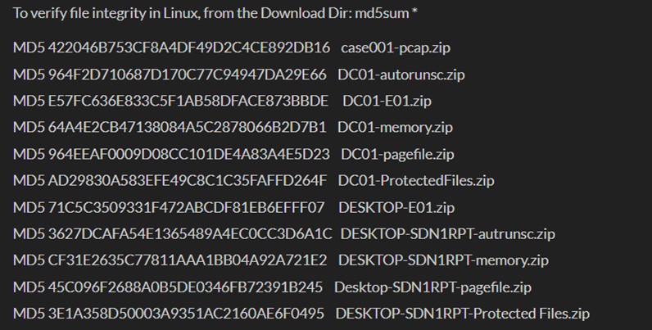
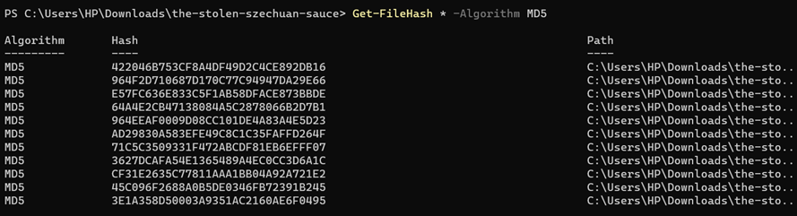

Original File Hash

2

Part of the forensic process is to recreate the event using a timeline. I will try to identify the stages of the attack with the help of a resource found at https://walshcat.medium.com/case-write-up-the-stolen-szechuan-sauce-2409344264c3

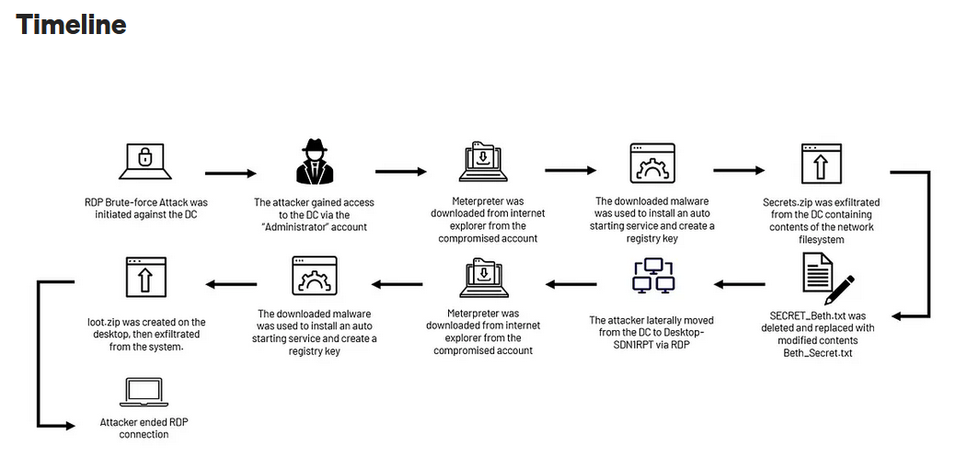

3

Questions to Answer / Goals
- What’s the Operating System of the Server? Windows server 2012
Using Autopsy I was able to identify the OS in the file tree.
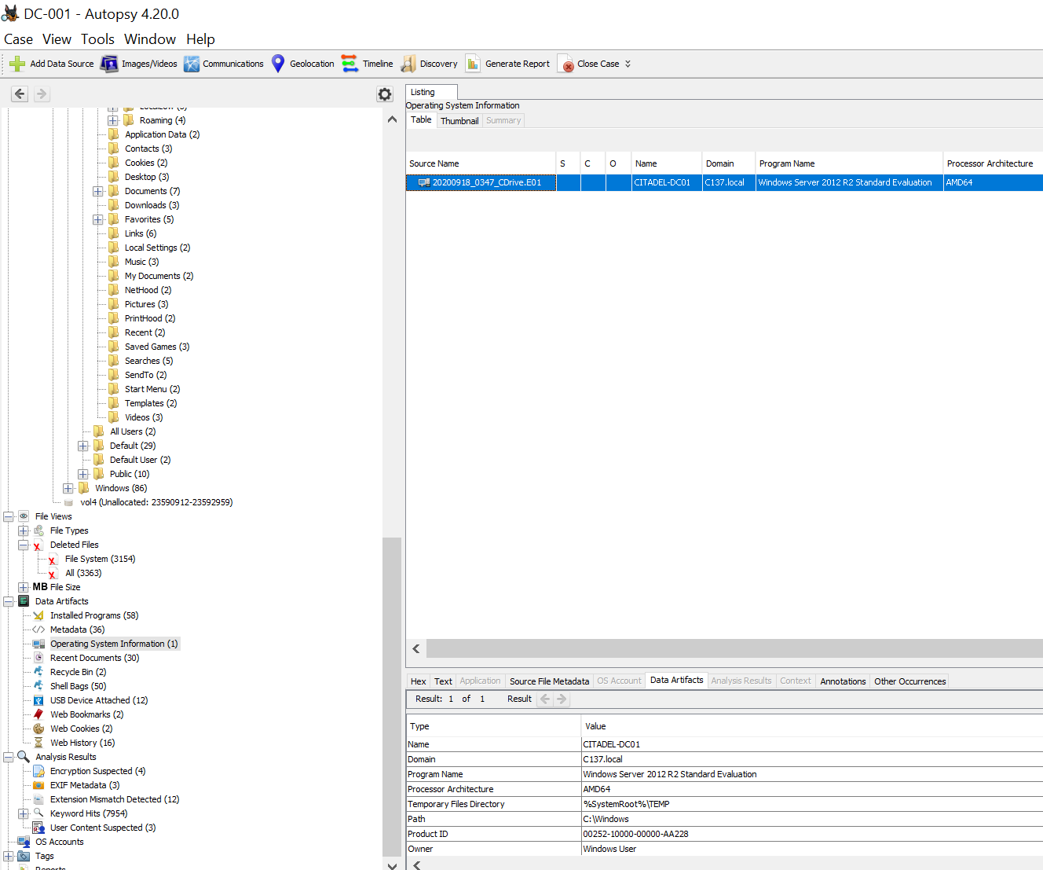

- What was the servers Local time? The server local time was EST, located by clicking on the source file metadata tab. However there are conflicting times as i noticed the wireshark capture showing GMT.

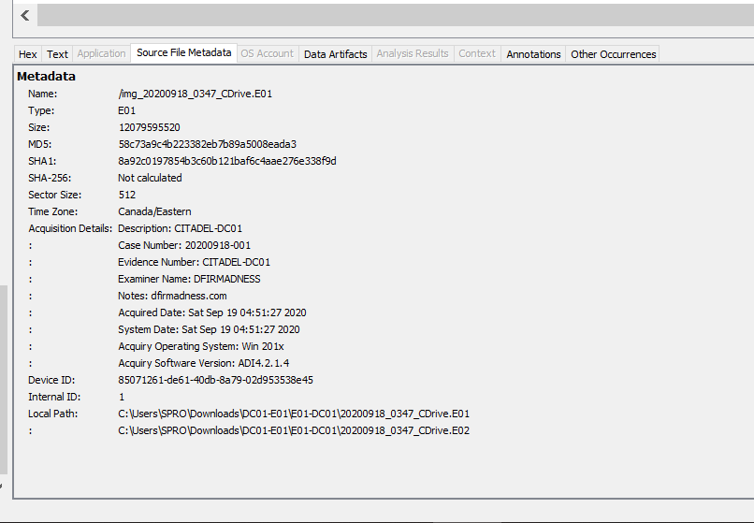

4

3. What was the OS of the Desktop? The desktop operating system was identified using Autopsy.
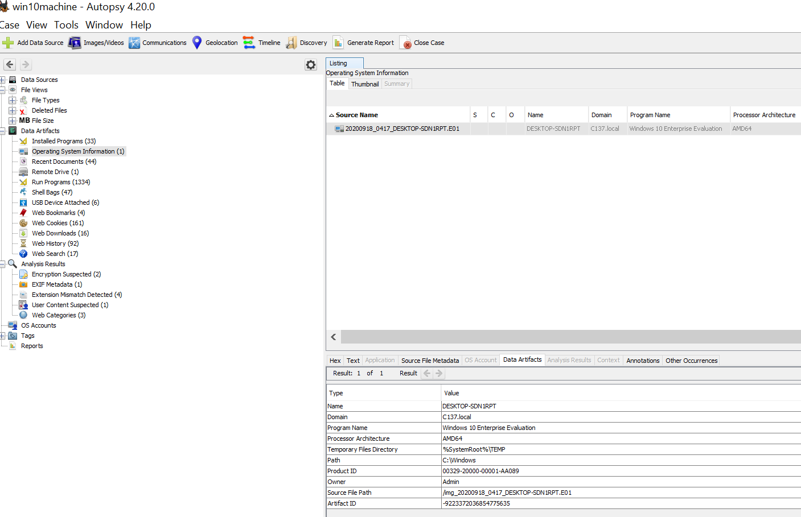

4. Was there a breach? Yes. They accessed the system through the RDP protocol.

5.What was the initial entry vector?
There was a breach initiated by the attacker using a brute for attack. From IP address 194.61.24.102. In this wireshark capture, I have identified multiple attempts from the attackers Ip targeting port 3389. The RDP protocol.
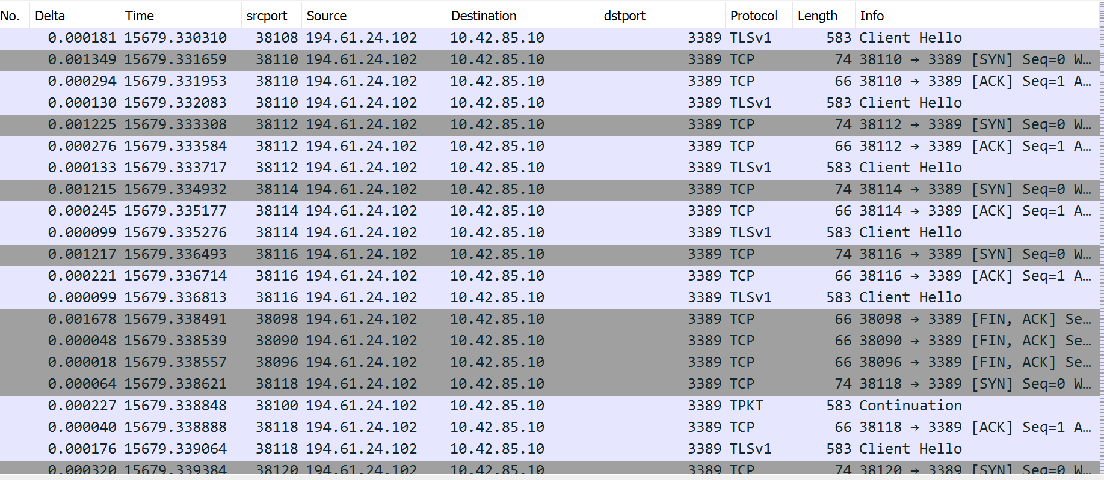
5

6. Was malware used? Yes. Using wire shark I was able to identify multiple get requests.

Wireshark Packet Analysis:
Using the find packet option in the edit tab, I was able to search for a .exe files contained in the packets.

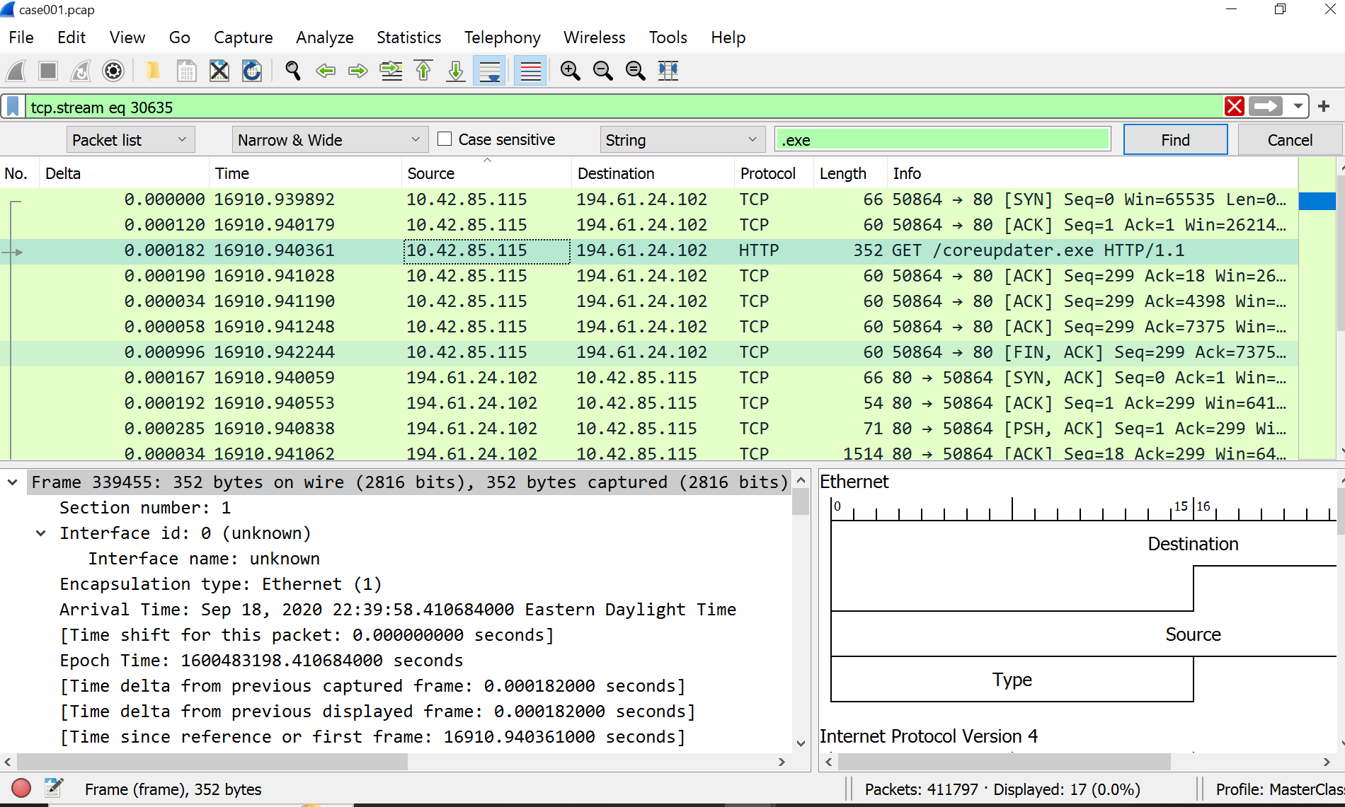
Once the specific packet containing the .exe file was discovered. I right clicked on the line that displayed the file opening a tab that allowed me to select the follow TCP Stream option. It displayed the payload file as well as the header details showing the GET request for the coreupdater,exe file to be sent back to the victim server. I also identified this was coming from a Python server.

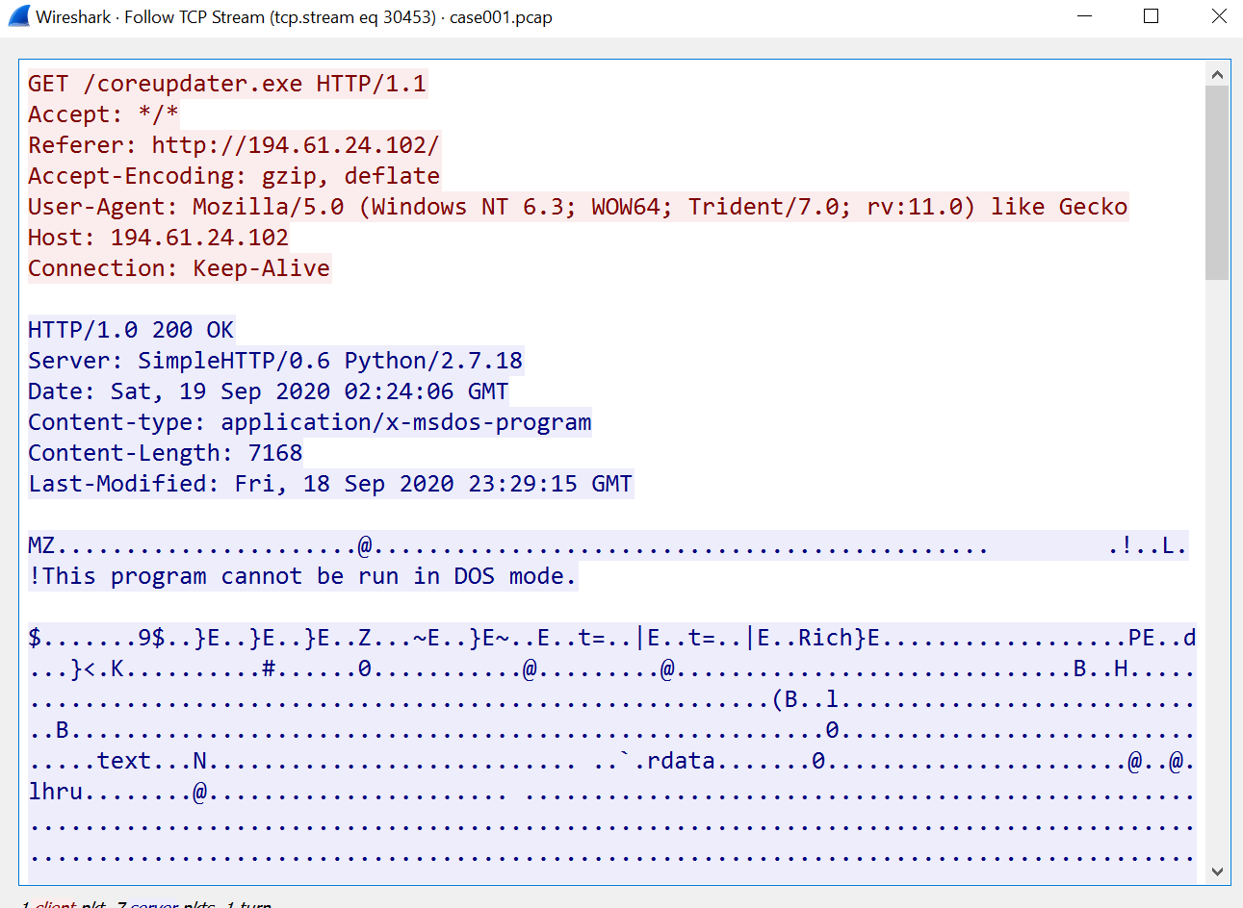

6
6.
b)What was the IP that delivered the payload? The IP was 194.61.24.102.

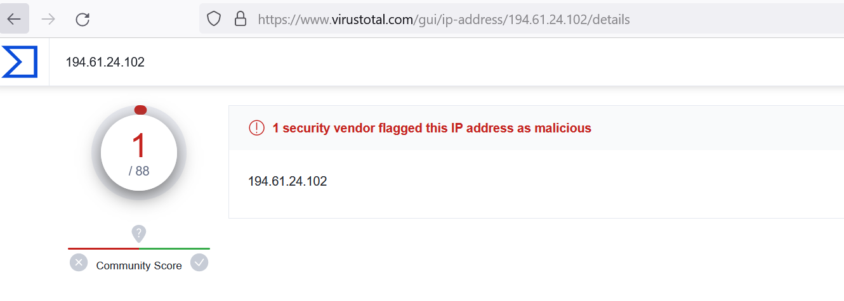

Malicious payload from IP 194.61.24.102 verified by virus total. Coreupdater.exe

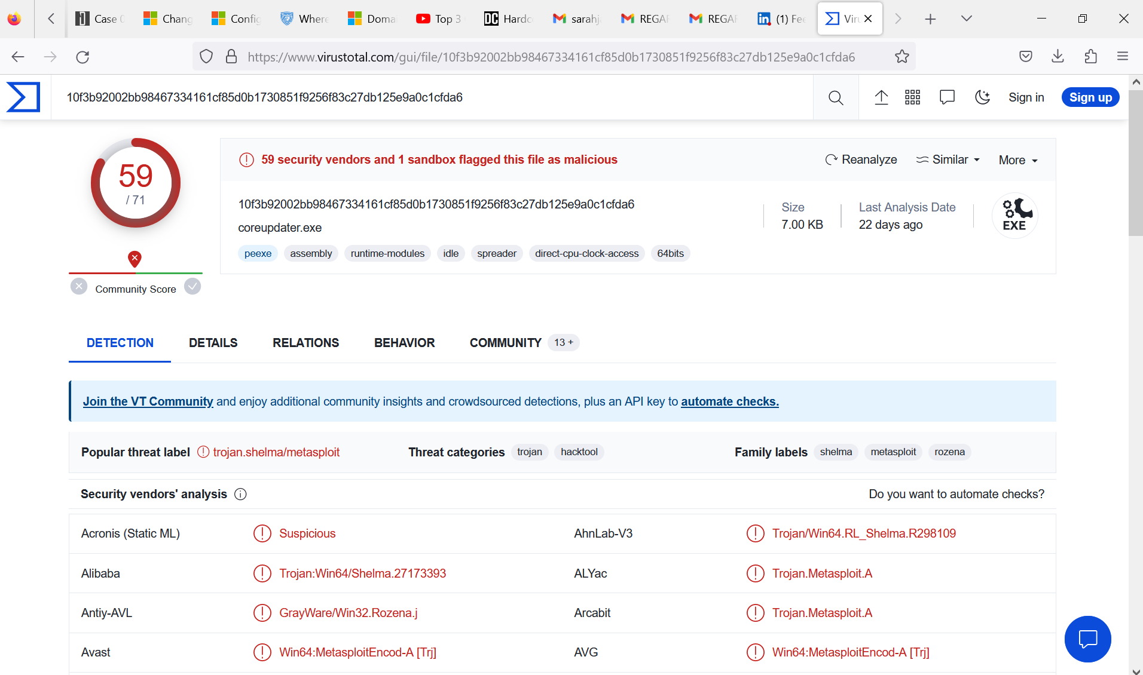
7

c) What IP was the Malware calling to? The Malware was calling to 203.78.103.109.

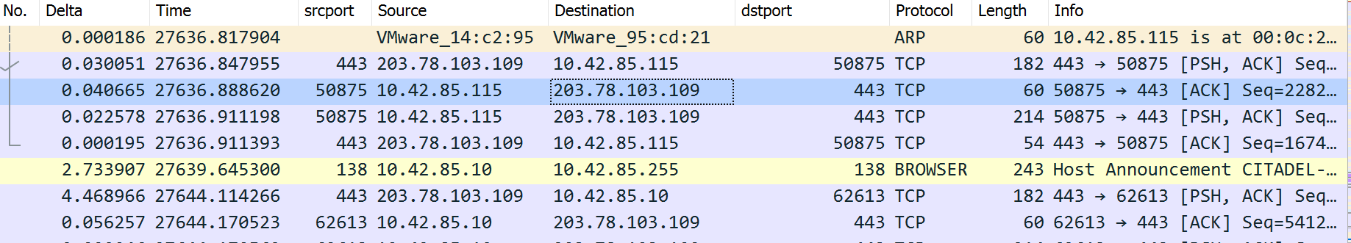
Using the file hash value entered into virus total the malware was identified to be Metasploit.

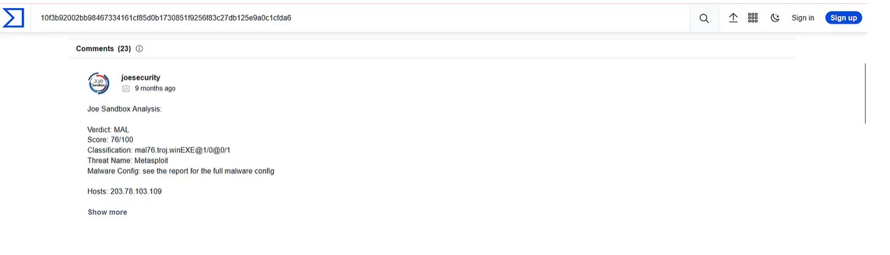

Metasploit is an easily obtain application with many uses. In this case it was used to as a shell to call back to its C2.

8

Was the Malware installed with persistence? I was unable to Identify if Malware was installed with persistence. I do however under stand the concept of why it would be.

Auto run Files:
I did not find any anomalies within the auto run files however, I understand the concept and purpose of these files in the context of the Malware analysis. Even if the Malware was detected and the security team has patched the system and removed the Malware it is imperative to check registries and auto run files to ensure that any changes made have been noticed and mitigated. The threat actors can use these files to hold their persistence on a system and if not detected and the issue is not properly resolved the Malware can startup at a system reboot and relaunch or execute.

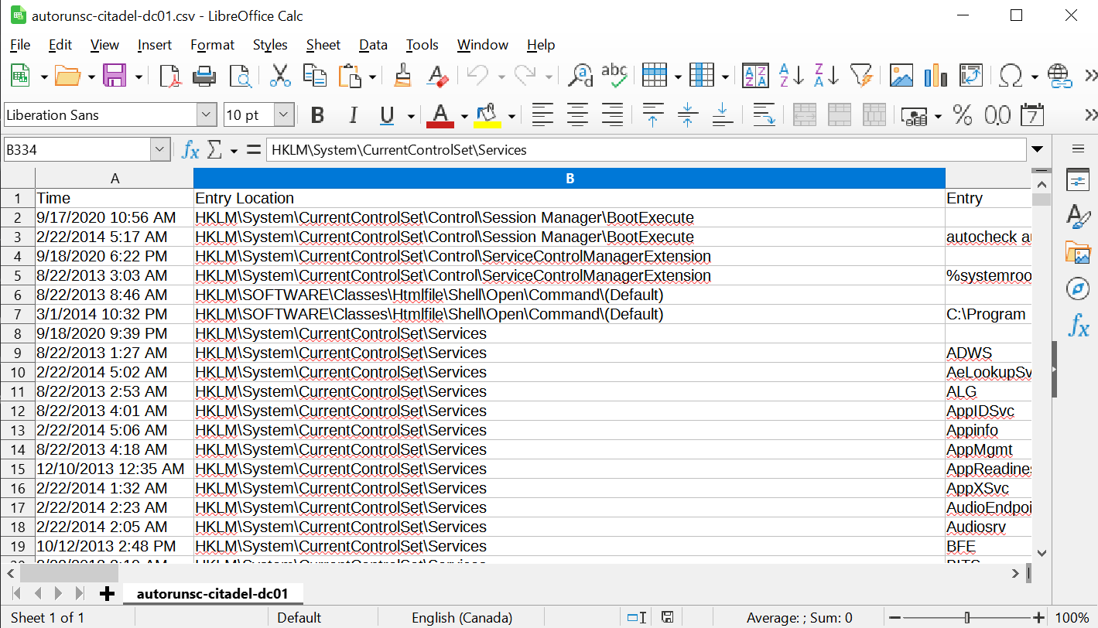

What was the network architecture of the victim?

The victims network architecture was:
10.42.85.0/24/ Server IP: 10.42.85.10/ Desktop IP: 10.42.85.115

9

What major architecture improvements could be made?

The main architecture improvement that should be made is installing a firewall and an Intrusion detection system. This could have helped with an attack being identified and stopped at the perimeter. Installing anti-virus software to detect any malicious files being installed on the system should be a standard and would have made a great difference in this case. Adding a jump-host login using multi factor authentication would force the verification of credentials for those trying to access the network remotely. Also, changing the port of the RDP protocol to a higher port could have made a difference to scan results of an attacker as most default scans search for know parameters like RDP on port 3389. RDP should

Routine updates of operating systems and applications is always recommended using the proper configuration settings for any remote and server connections. Encrypting data and sensitive information is always a good practice for securing data at rest. Monitoring traffic and systems for registry changes are some proactive measures any organization can take to improve their security posture.

10

Citations:

DFIR Madness Stole Szechaun Sauce Case 001 https://dfirmadness.com/the-stolen-szechuan-sauce/
Virus Total https://www.virustotal.com/gui/home/search

References:
Microsoft troubleshooting documentation https://learn.microsoft.com/en-ca/troubleshoot/
iblue team https://www.iblue.team/ctf-challenges/dfir-madness-ctf-challenges/case-001-szechuan-sauce

11

