Wireshark BlackWhitebox Box Assignment

As you can see, this is the Kali machine’s MAC and IP

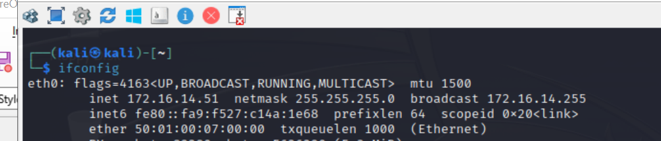
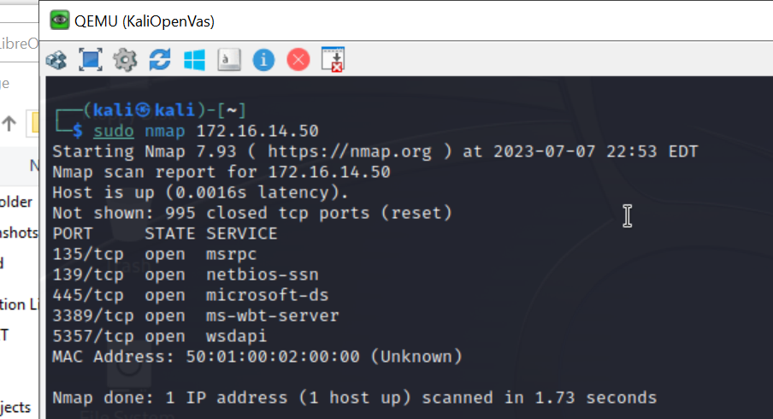
Scan host: 172.16.14.50
$ sudo nmap 172.16.14.50

Notice the open ports/services
and MAC

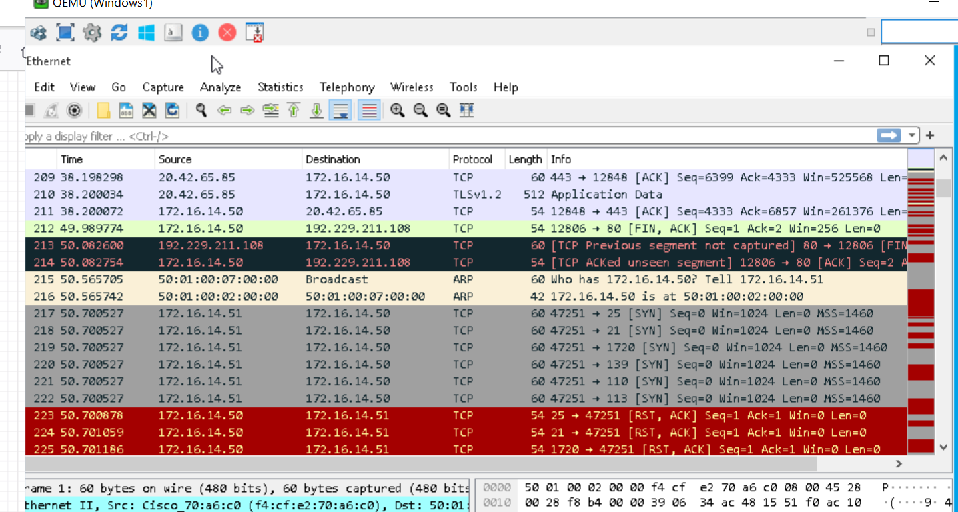
You can see the request from
Host to Destination line 215.
Line 216 : Response with MAC

The first echo request is the broadcast
ARP Protocol on Layer 1 then response
ARP bask to host...

Capture 1 shows mulitiple
request from Dest. To Host
217-222
Using TCP Protocol on Layer 2
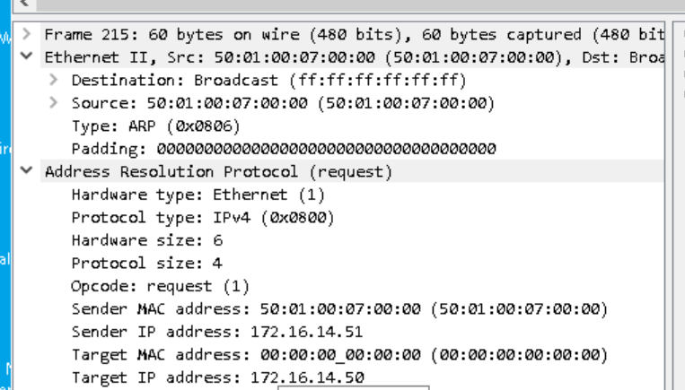
The frames highlighted in red show the
response back but what does it mean? Q

Note: the MAC and IP

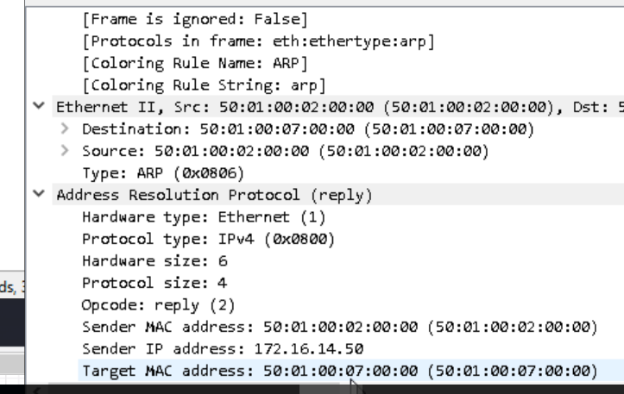
Frame 216 shows us the response MAC and IP

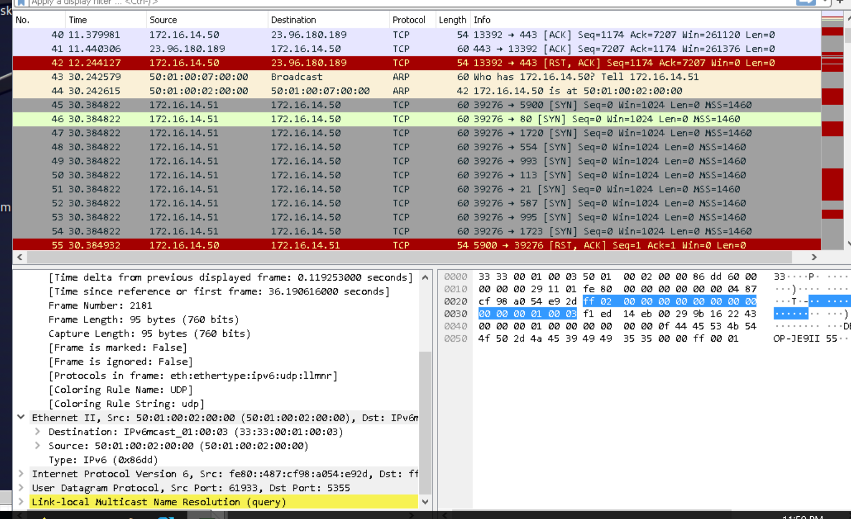
OS Scan: $ nmap -O 172.16.14.50

Still TCP but many more requests

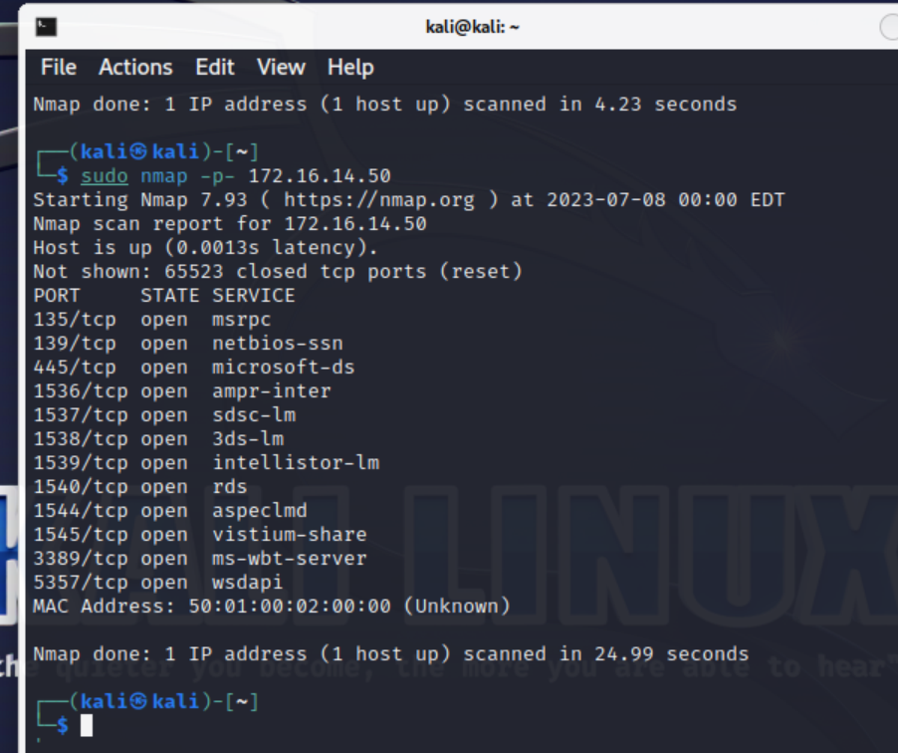
Deep scan : $ sudo nmap -p- 172.16.14.50

Note the extra the port that seem to be open
with this scan compared to just $ sudo nmap

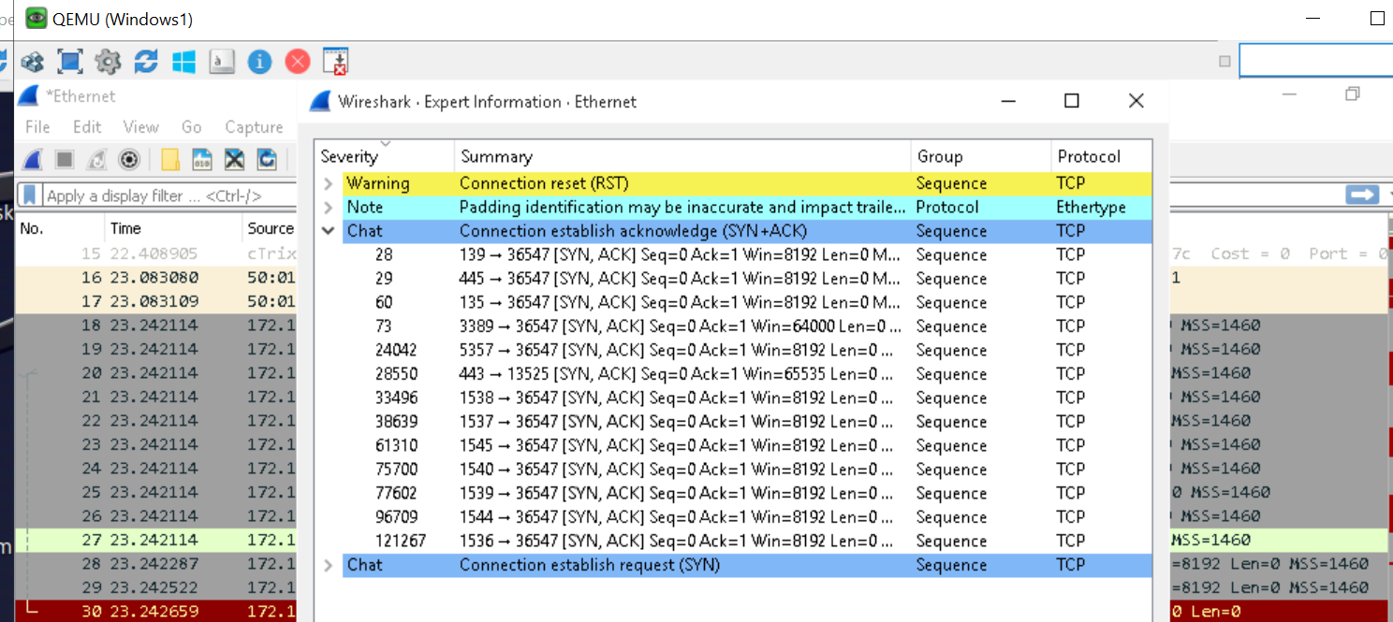
By analyzing the data from a wireshark
packet capture we are able to see the highlighted colour scheme from when there is an arp in yellow: broadcast. To where the attacker scans for ports in grey to where there is a return. Of the packet request that shows they are close based upon the rules stated below.
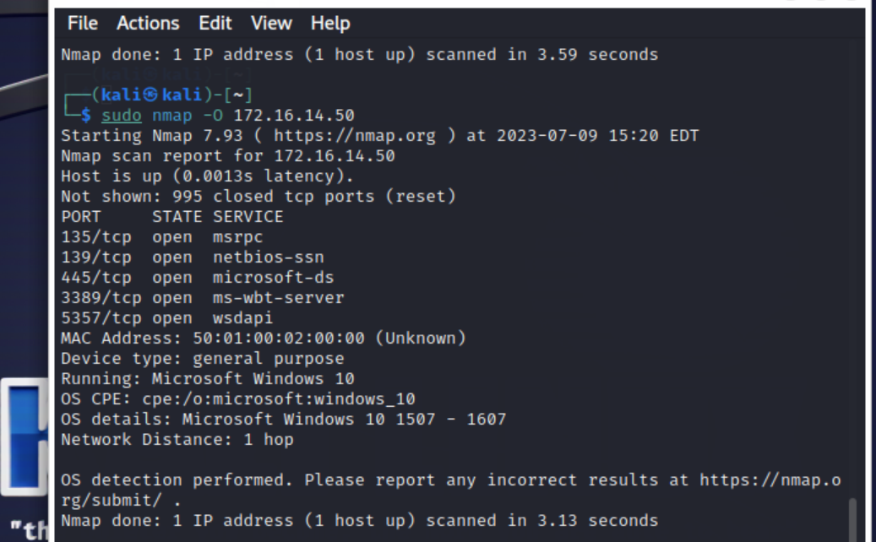

By running an OS scan in nmap
sudo nmap -O 172.16.14.0 . You can determine the OS type. It does not show as many open ports but verifies the OS and version

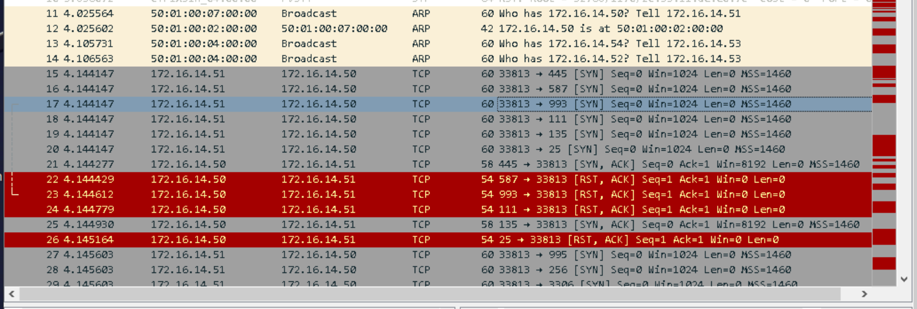
A capture of the Os scan on the target machine. Once again shows the broadcast from the attacker in yellow,
scanning for ports and the returned request packets in red showing the closed ports.

A:
One helpful feature of the TCP protocol is that systems are required by RFC 793 to send a negative response to unexpected connection requests in the form of a TCP RST (reset) packet. The RST packet makes closed ports easy for Nmap to recognize. Filtering devices such as firewalls, on the other hand, tend to drop packets destined for disallowed ports. In some cases they send ICMP error messages (usually port unreachable) instead. Because dropped packets and ICMP errors are easily distinguishable from RST packets, Nmap can reliably detect filtered TCP ports from open or closed ones, and it does so automatically.

Many thanks the good people at nmap fro providing such grand information. Consult: https://nmap.org/book/port-scanning-intro for more information

