STUXNET: THE ULTIMATE MALWARE

CREATED BY :
SHAWN PERREAULT
FOR:
LIGHTHOUSE LABS
AUGUST 2OTH,2023

TABLE OF CONTENTS

Introduction_______________________________________________________________1-2
Victims of Attack____________________________________________________________3
Technologies Used___________________________________________________________3
Timeline___________________________________________________________________4
Targeted Systems____________________________________________________________5
Impact of Malware__________________________________________________________5-6
Motivations of Attack________________________________________________________7
Outcome and Impact_________________________________________________________7
Mitigation Techniques and Procedures___________________________________________7
Security Controls____________________________________________________________7
Citations__________________________________________________________________8

STUXNET PROGRAM REPORT

Introduction

When diplomacy fails to settle major conflicts between nations it usually leads to war. Most nations will go to any length to win and utilize any means necessary. When you use the term “means”, we think of air force, navy, ground forces and even satellites. We live in the digital age, data grows by the masses in real time on servers and databases around the globe. We have now utilized and weaponized our new biggest asset. Information.

In this report we will delve into the depths of the most advanced developed malware, top secret intelligence agency programs and how a secret uranium enrichment facility taken down by a 1/2 GB of data that sabotaged a secret nuclear arms program in the middle east. It all began in 1998 when Pakistan and India developed the nuclear arms testing treaty and detonated 6 nuclear bombs. It drew the attention of the western powers specifically the CIA who determined they needed to keep an eye out for the A Q Khan Network in Pakistan. They began to collect intelligence and determined their strategy for infiltration. They focused their attention on the supply network, the people who had the knowledge and the capabilities of designing and selling the materials used to make these WMD’s.
They developed assets in the network and what they found out laid the path to the beginning of Stuxnet. The CIA discovered Pakistan had trade deals with Lebanon, Libya, north Korea and Iran.
The CIA and MI6 targeted a shipment of materials and seized the cargo headed to Libya from the United Arab Emirates. In the shipment contained all that they needed to design and construct their facility and the plans and equipment needed to build centrifuges for nuclear enrichment.

The United Nations International Atomic Energy Agency went to Libya and pressured them to give up the program. The CIA shipped these seized materials to a secret facility in Tennessee. Working with
Israeli intelligence and some of the worlds best Physicist's, the American's were able to determine what grade of uranium the Iranians were capable of producing and how much. They all went to work constructing a replica of the centrifuge facility in Demona, Israel. While the American’s built a model of the centrifuges in US. In the same facility where the Manhattan project was created. Top scientists and researchers conducted multiple tests in many ways ultimately creating Malware based upon the research. They decided to present president Busch with the idea of infecting the systems that control the centrifuges. This malware was a masterpiece, with an unheard of 4 zero day vulnerabilities. This was the first developed digital weapon. The target was a facility 10,000 kilometres away in Natanz, Iran.

The plan was to infiltrate the facilities and infect the system that ran the industrial control systems for the centrifuges. Using the Malware to physically damage the centrifuges without tipping off the Iranian Government was a challenge. It took some time and at this point the full program for the malware was not ready. The Iranian Government had built a pilot project with approximately 150 centrifuges and were starting to produce uranium hex o-floric gas. Stuxnet was not ready but they had another method of disrupting their program. They gained access to equipment being supplied from Turkey and were able corrupt the uninterruptible power supplies. The centrifuges were operating normally then start to spin out of control and caused permanent damage to the centrifuges.
The CIA using their known methods and spying techniques now had enough information to identify and categorize the exact hardware being used in the main facility in Natanz. They were finalizing the design of the malware and determining their strategy to infect the systems in the facility. 1

Israel was increasingly concerned that as Iran was their enemy they would soon be able to create a nuclear bomb and could use it against them. They asked permission of the United States to launch an airstrike targeting the enrichment facility. After the war in Iraq and the recent tensions finally settling the Americans cautioned Israel to be patient and not cause any further unrest. The US had other plans. They shared their plans with Israel and began work together to devise a plan to get the virus into the facility.

The US and Israel flooded the area with infected USB Drives as a means to infiltrate the systems in the facility. They tested the malware on the recreated facility in Israel. The Malware firstly infected a windows system exploiting an unknown vulnerability. To do this the software used an authentic digitally signed certificate stolen from Taiwan to appear legitimate. Once the computer was infected it seeked out the SCADA software monitoring the centrifuges. Another layer of malware was added the to control the speeds at which the centrifuges were spinning. This Malware was rather complex but even though the US thought they were done, they waited and nothing happened. They needed to figure out a method to infect the systems in the facility. With the system completely airgapped and secured with armed security there was no way to enter the facility. They needed a new plan. The Us and Israel developed a plan to introduce the virus to the network that the private contractor’s used. They implanted the a worm within the malware that would sit and wait until the malware was introduced to the environment of the facility to spread. They spread this malware to the systems of the contractor’s and waited for someone to bring in their computer in from outside the facility. Eventually, the virus made it inside the facility and affected the systems controlling the centrifuges. The Malware took stock of the behaviour of the centrifuges to determine what was normal. It would make the centrifuges spin incredible fast and then resume its normal operations. This behaviour confused the scientists trying to determine the cause and fix the problem. The damage had already been done to the centrifuges and caused them to be damaged further when they spun at normal speed. Then centrifuges spin intervals caused them to spin off access and damage internal component eventually causing them permanent damage. The monitoring system showed that they were spinning normally however after approximately 30 days. There were over 1000 damaged centrifuges that had to be taken off line. The loss of the gas being produced and the damaged centrifuges was a huge setback for Iran.

Not only was this a problem for Iran the Malware had spread from system to system and infected host after host when finally spread outside of Iran to the entire world. The US Government grew concerned they would have been compromised because the virus had spread beyond their intentional target and at this point, was not stopping. Security researcher’s at Symantec began to notice this virus and conduct research. They were amazed at the complexity and sophistication of this Malware and concluded it could only have come from a state actor group. They new that publishing their findings would blow the cover of the operation. As reluctant as they were, they had a job to do. They published there results.
The Iranians were tipped off. They shut down their facilities and went to work wiping their systems clean. They had gotten back on line and restarted the program. After that there were multiple bombings targeting the Director of the Nuclear prom at Natanz and multiple physicist's. Apparently the adversaries did not approve. This virus was the first of it’s kind and a real testament of the use of digital weapons that engage an enemy and can damage systems from miles away. Without being detected or firing a single shot. These weapons can cause serious damage to infrastructure and critical systems. 2

Who were the victims of the attacks?
The Victims of this Malware was the Iranian Nuclear Enrichment Program and the Iranian Government. Subsequently, The virus spread to other systems around the world. The virus did not cause much harm further but could have if found its way onto military systems or critical infrastructure.
Technologies and tools used in the attack:
The tools used in this attack were a combination of sophisticated malware over taking the control protocols in scada systems combined with a worm. Here is an extensive list from the security research of Semantec:

- Self-replicates through removable drives exploiting a vulnerability allowing auto-execution.
- Microsoft Windows Shortcut ‘LNK/PIF’ Files Automatic File Execution Vulnerability (BID 41732)
- Spreads in a LAN through a vulnerability in the Windows Print Spooler.
- Microsoft Windows Print Spooler Service Remote Code Execution Vulnerability (BID 43073)
- Spreads through SMB by exploiting the• Microsoft Windows Server Service RPC Handling Remote Code Execution Vulnerability (BID 31874)
- Copies and executes itself on remote computers through network shares.
- Copies and executes itself on remote computers running a WinCC database server.
- Copies itself into Step 7 projects in such a way that it automatically executes when the Step 7 project isloaded.
- Updates itself through a peer-to-peer mechanism within a LAN.
- Exploits a total of four unpatched Microsoft vulnerabilities, two of which are previously mentioned vulnerabilities for self-replication and the other two are escalation of privilege vulnerabilities that have yet to be disclosed.
- Contacts a command and control server that allows the hacker to download and execute code, including updated versions
- Contains a Windows rootkit that hide its binaries.
- Attempts to bypass security products. Fingerprints a specific industrial control system and modifies code on the Siemens PLCs to potentially sabotage the system.
- Hides modified code on PLCs, essentially a rootkit for PLCs.

3

Timeline:
- The attack date could not be determined but fell around 30 days before the Iranians reported critical systems being damaged within their facilities.

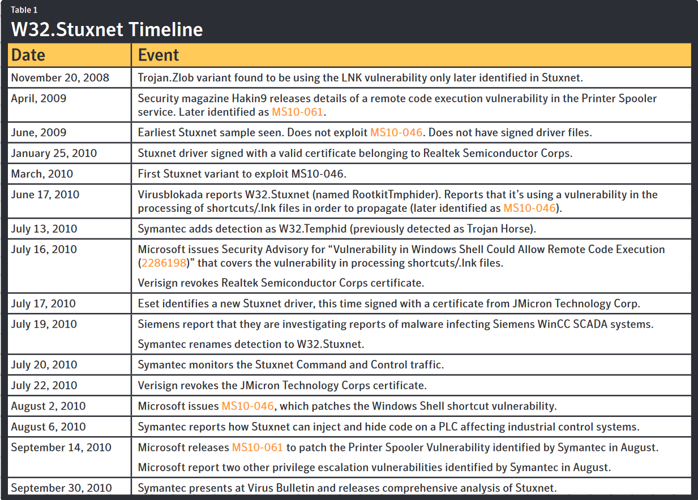
Targeted Systems:
The attackers targeted the windows systems of the contractor’s eventually spreading to the systems inside the facility controlling the centrifuges.

- It specifically exploited vulnerabilities in Siemens' WinCC SCADA (Supervisory Control and Data Acquisition) systems and Simatic WinCC and PCS 7 PLCs. The attack aimed to manipulate the industrial control systems responsible for controlling centrifuges in Iran's uranium enrichment facilities.

4
- The Malware took advantage of multiple zero-day vulnerabilities in Windows operating systems, primarily Windows XP and Windows Server 2003. The specific version numbers of the
targeted operating systems can vary due to the different variants and updates that were used in the attack.

- The PLCs targeted by Stuxnet were Siemens Simatic S7-300 and S7-400 series controllers. These PLCs were used in conjunction with the Windows-based SCADA systems to control and monitor industrial processes, including the centrifuges in the uranium enrichment process.

Impact of the Malware:

The Malware had not only affected the system of the Iranian Nuclear Enrichment Facility but spread to systems around the world. Here are some tables that represent infection rates.

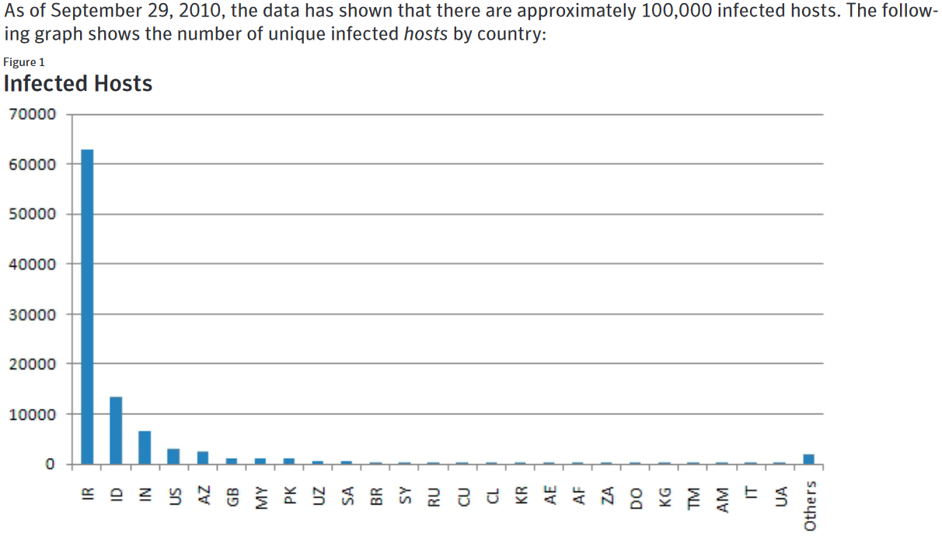

5
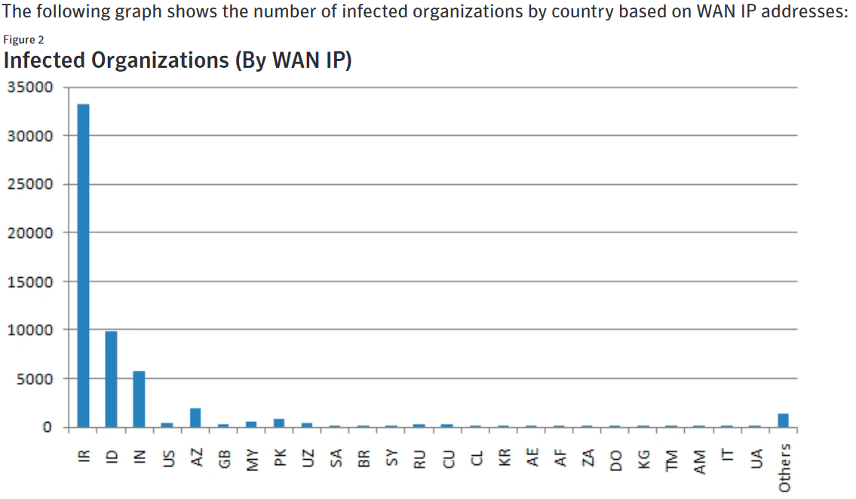

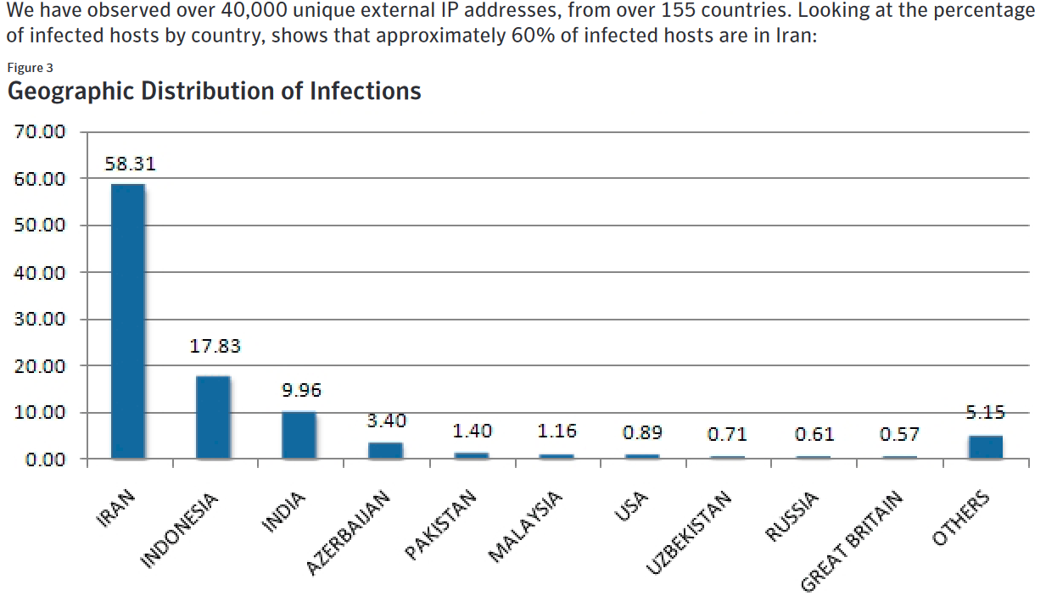

6

Motivation for the attack:

The motive was to deter Iran from the capability of creating nuclear arms and destroy their enrichment program. What ever Nation state that created and Implemented this program had their own Diplomatic agenda. Whether it was sociopolitical or Geo-political, they definitely did not want Iran having this nuclear capability. The hope was to affect and disrupt the program in a covert manner to avert further tensions in the middle east and potentially start another war.

The Outcome and Impact:

The outcome was a temporary halt to the Iranian nuclear enrichment program. The attacker had successfully damaged approximately 1000 centrifuges but ultimately the program took shape and was back up and running shortly after the breach. This creation of this type of Malware was the first of it’s kind and likely promoted others to think outside the box and create new version based upon the identity of exploits through threat intelligence reporting.

Mitigation techniques and procedures:

- The mitigation I would suggest would be to not allow any ones computer into the facility, cellphones, USB drives or any electronic device be permitted at all. These systems were airgapped for a reason and became affected by an outside system connecting.

Suggested security controls:
- The Security controls in this situation would have been helpful if strict measures of device security policies had been in place to not allow foreign devices into the facility. Although it is hard to update systems with out this. It was inevitably the downfall and could have been averted if better security protocols were in place and enforced
- Zero trust policies for all software and programs to be implemented. Only after testing in secure environments and scanned for any anomalies should these new programs be introduced into the program. 7

Citations:

W.32 Stuxnet Dossier 2011
https://docs.broadcom.com/doc/security-response-w32-stuxnet-dossier-11-en

Jack Rhysider, The Most Sophisticated Malware Ever Made (That We Know Of)🎙Darknet Diaries Ep. 29: Stuxnet
https://www.youtube.com/watch?v=9DCwyuH29SI

An Unprecedented Look at Stuxnet, the World's First Digital Weapon
https://www.wired.com/2014/11/countdown-to-zero-day-stuxnet/

Stuxnet explained: What it is, who created it and how it works
https://www.kaspersky.com/resource-center/definitions/what-is-stuxnet

Stuxnet’ Worm Far More Sophisticated Than Previously Thought
https://krebsonsecurity.com/tag/stuxnet/

All Images Provided By Semantec W.32 Stuxnet Dossier 2011

8

